VOICE ACTIVITY DETECTION ANALYSIS REPORT
A professional AI-driven audio segmentation & acoustic analytics overview

Acoustic File Metadata
Acoustic Target File | pure-tone.wav
File Size | 3.4 MB
Audio Duration | 40.00 seconds
Total Speech Detected | 10.39 seconds (26.0%)
Total Silence Detected | 29.61 seconds (74.0%)

Speech Statistics Summary
Speech Segments | 2 | Silence Segments | 3
Longest Speech | 7.772 s | Average Speech | 5.196 s
Shortest Speech | 2.62 s | Average Silence | 9.869 s
Estimated Speaking Speed | 140 WPM | Word Count Estimate | 24 words

Acoustic Timeline Visualization
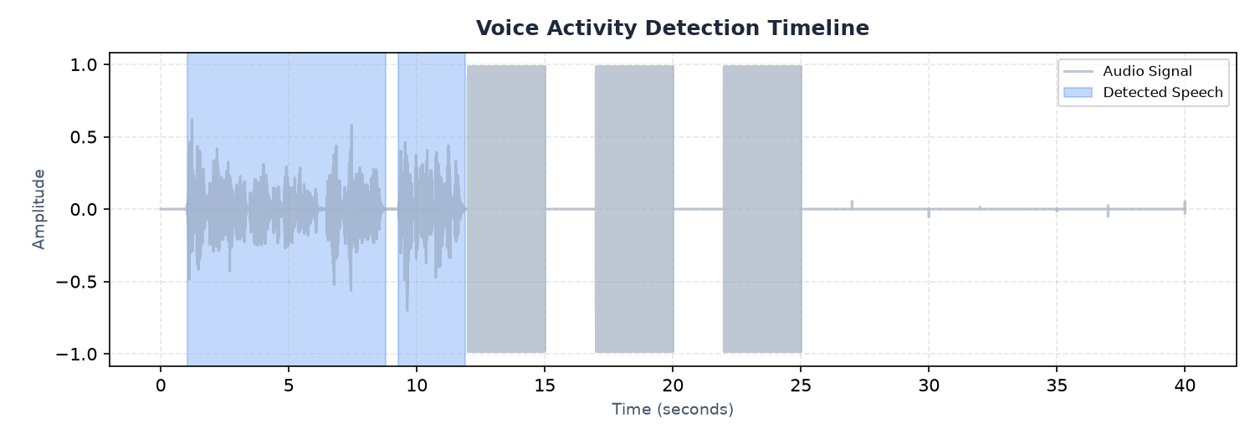
Figure 1: Voice Activity Detection (VAD) audio signal highlighting speech sections
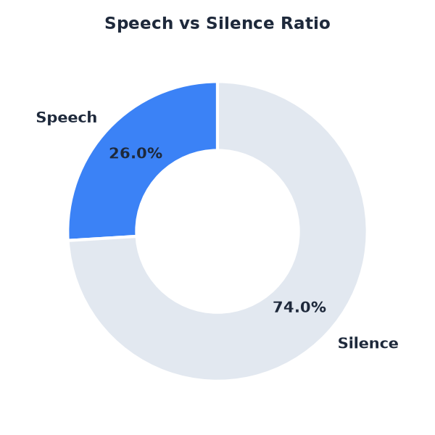
Figure 2: Ratio share of active vocal speech versus quiet silence

AI-Generated Observations & Insights
- This recording contains frequent pauses. Silence is common, indicating potential hesitations or a structured turn-taking dialogue.
- Long uninterrupted speech segments indicate a monologue, lecture, or single-speaker narrative style.
- Pauses between speech are long. This structure is typical of Q&A sessions, language learning exercises, or dictated text.
- The recording is suitable for transcription; however, filtering out silence sections will improve transcription efficiency.
- Background silence is clean and well-structured, with clear boundaries between speech and non-speech regions.

System Final Conclusion
Based on voice activity evaluation, this audio file represents a clean recording with structured segments. Silence profiles indicate no major communication dropouts, and speech rate estimates suggest a standard rhythm. Export files containing isolated audio components can be reviewed individually.

Acoustic Speech Segments List (First 50)
Seg ID | Start Time (s) | End Time (s) | Duration (s)
001 | 1.03 | 8.80 | 7.77
002 | 9.28 | 11.90 | 2.62

