VOICE ACTIVITY DETECTION ANALYSIS REPORT
A professional AI-driven audio segmentation & acoustic analytics overview

Acoustic File Metadata
Acoustic Target File | 269e8ca0-f43b-4409-acba-08413aedc513.mp3
File Size | 3.8 MB
Audio Duration | 123.24 seconds
Total Speech Detected | 0.00 seconds (0.0%)
Total Silence Detected | 123.24 seconds (100.0%)

Speech Statistics Summary
Speech Segments | 0 | Silence Segments | 1
Longest Speech | 0.0 s | Average Speech | 0.0 s
Shortest Speech | 0.0 s | Average Silence | 123.24 s
Estimated Speaking Speed | 0 WPM | Word Count Estimate | 0 words

Acoustic Timeline Visualization
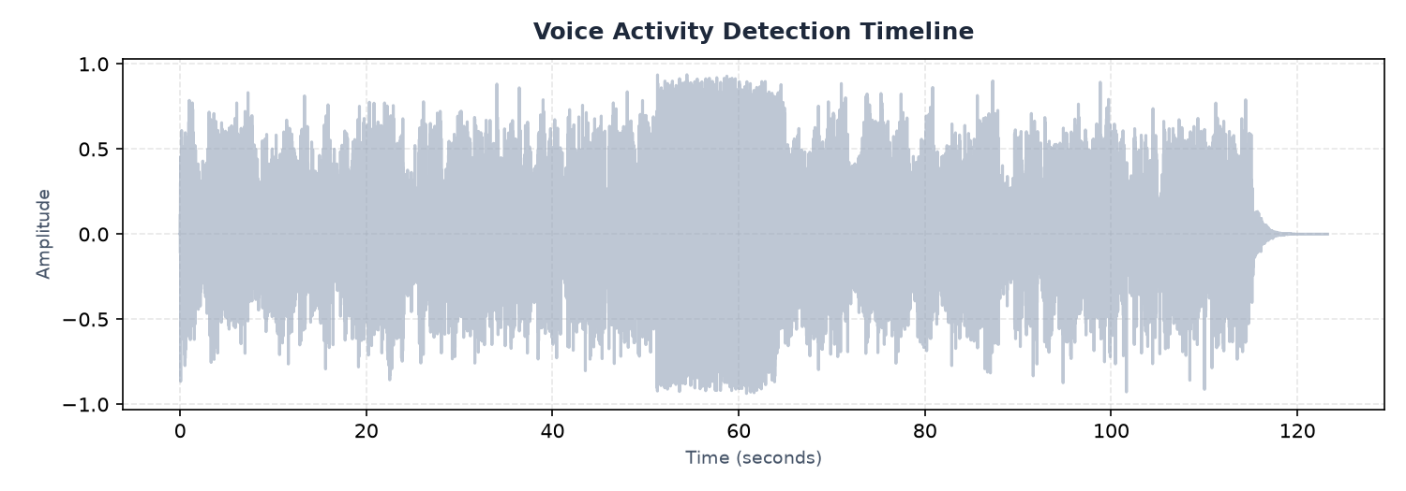
Figure 1: Voice Activity Detection (VAD) audio signal highlighting speech sections
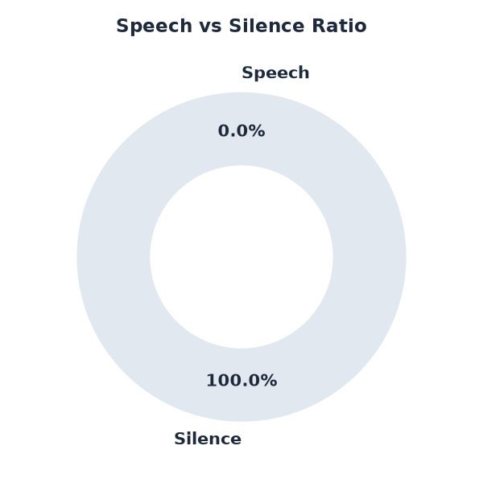
Figure 2: Ratio share of active vocal speech versus quiet silence

AI-Generated Observations & Insights
- Speech density is extremely low. The recording consists mostly of silence or background noise, with brief voice activity.
- Speech segments are extremely short and rapid, which is common in short commands, interruptions, or high-noise files.
- Due to low voice activity, this file may require noise gating or signal amplification before speech-to-text processing.
- Background silence is clean and well-structured, with clear boundaries between speech and non-speech regions.

System Final Conclusion
Based on voice activity evaluation, this audio file represents a clean recording with structured segments. Silence profiles indicate no major communication dropouts, and speech rate estimates suggest a standard rhythm. Export files containing isolated audio components can be reviewed individually.

Acoustic Speech Segments List (First 50)
Seg ID | Start Time (s) | End Time (s) | Duration (s)

