VOICE ACTIVITY DETECTION ANALYSIS REPORT
A professional AI-driven audio segmentation & acoustic analytics overview

Acoustic File Metadata
Acoustic Target File | fd9f68de-6f17-498f-9e68-2edf49163c59.mp3
File Size | 4.0 MB
Audio Duration | 131.71 seconds
Total Speech Detected | 119.50 seconds (90.7%)
Total Silence Detected | 12.21 seconds (9.3%)

Speech Statistics Summary
Speech Segments | 4 | Silence Segments | 5
Longest Speech | 50.78 s | Average Speech | 29.876 s
Shortest Speech | 0.828 s | Average Silence | 2.441 s
Estimated Speaking Speed | 140 WPM | Word Count Estimate | 278 words

Acoustic Timeline Visualization
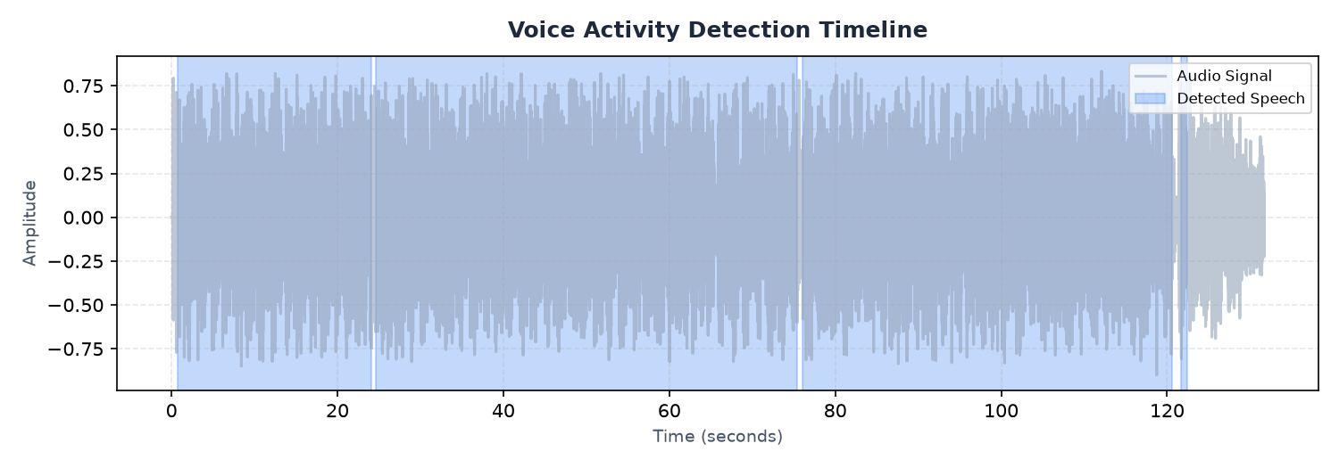
Figure 1: Voice Activity Detection (VAD) audio signal highlighting speech sections
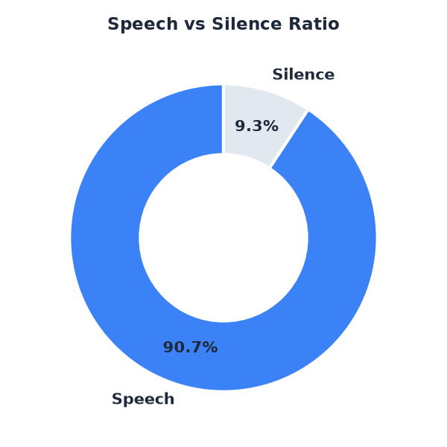
Figure 2: Ratio share of active vocal speech versus quiet silence

AI-Generated Observations & Insights
- Speech density is exceptionally high. The speaker talks continuously with minimal pause time.
- Long uninterrupted speech segments indicate a monologue, lecture, or single-speaker narrative style.
- The recording is suitable for transcription; however, filtering out silence sections will improve transcription efficiency.
- Background silence is clean and well-structured, with clear boundaries between speech and non-speech regions.

System Final Conclusion
Based on voice activity evaluation, this audio file represents a clean recording with structured segments. Silence profiles indicate no major communication dropouts, and speech rate estimates suggest a standard rhythm. Export files containing isolated audio components can be reviewed individually.

Acoustic Speech Segments List (First 50)
Seg ID | Start Time (s) | End Time (s) | Duration (s)
001 | 0.77 | 24.09 | 23.32
002 | 24.67 | 75.45 | 50.78
003 | 76.07 | 120.64 | 44.57
004 | 121.63 | 122.46 | 0.83

