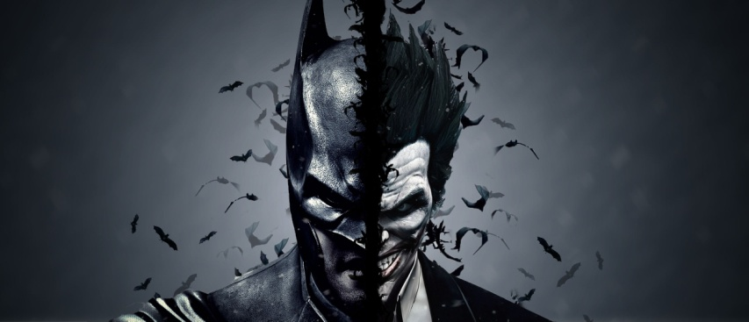**Batman** is a fictional [superhero](https://en.wikipedia.org/wiki/Superhero) appearing in [American comic books](https://en.wikipedia.org/wiki/American_comic_book) published by [DC Comics](https://en.wikipedia.org/wiki/DC_Comics). The character was created by artist [Bob Kane](https://en.wikipedia.org/wiki/Bob_Kane) and writer [Bill Finger](https://en.wikipedia.org/wiki/Bill_Finger),[[5]](https://en.wikipedia.org/wiki/Batman#cite_note-FingerSep2015-5)[[6]](https://en.wikipedia.org/wiki/Batman#cite_note-FingerOct2015-6) and first appeared in [*Detective Comics*](https://en.wikipedia.org/wiki/Detective_Comics) #27 (May 1939). Originally named the "Bat-Man", the character is also referred to by such epithets as the Caped Crusader, the [Dark Knight](https://en.wikipedia.org/wiki/Dark_Knight_(nickname)), and the World's Greatest Detective. Batman's [secret identity](https://en.wikipedia.org/wiki/Secret_identity) is **Bruce Wayne**, an American [billionaire](https://en.wikipedia.org/wiki/Billionaire), [playboy](https://en.wikipedia.org/wiki/Playboy_(lifestyle)), [philanthropist](https://en.wikipedia.org/wiki/Philanthropy), and owner of [Wayne Enterprises](https://en.wikipedia.org/wiki/Wayne_Enterprises). After witnessing the murder of his parents [Thomas Wayne](https://en.wikipedia.org/wiki/Thomas_Wayne) and [Martha Wayne](https://en.wikipedia.org/wiki/Martha_Wayne) as a child, he swore revenge on criminals, an oath tempered by a sense of justice. Wayne trains himself physically and intellectually and crafts a [bat-inspired](https://en.wikipedia.org/wiki/Batsuit) persona to fight crime.[[8]](https://en.wikipedia.org/wiki/Batman#cite_note-dc-ency-8) Batman operates in the fictional [Gotham City](https://en.wikipedia.org/wiki/Gotham_City), with assistance from various supporting characters, including his butler[Alfred](https://en.wikipedia.org/wiki/Alfred_Pennyworth), police commissioner [Gordon](https://en.wikipedia.org/wiki/James_Gordon_(comics)), and vigilante allies such as [Robin](https://en.wikipedia.org/wiki/Robin_(comics)). Unlike most superheroes, Batman does not possess any[superpowers](https://en.wikipedia.org/wiki/Superpower_(ability)); rather, he relies on his genius intellect, physical prowess, martial arts abilities, detective skills, science and technology, vast wealth, intimidation, and indomitable will. A large assortment of villains make up Batman's [rogues gallery](https://en.wikipedia.org/wiki/List_of_Batman_Family_adversaries), including his [archenemy](https://en.wikipedia.org/wiki/Archenemy), the [Joker](https://en.wikipedia.org/wiki/Joker_(comics)).