|  |  |  |  |
| --- | --- | --- | --- |
| *A CFD Write Up by Dev Patel* | | | Description: Description: sw_vert_gray_short |
| Robot Uprising FTC 14607 | Alexandria, VA | robotuprising.org | Fluid Flow Simulation Project Report |
| |  |  |  | | --- | --- | --- | | Dev Patel ∙ | 2021dpatel@gmail.com |  | | | | |
| **SOLIDWORKS Flow Simulation**  **Project Report**  January 1, 2021 | | | |
| [**Learn more about SOLIDWORKS Flow Simulation**](https://www.solidworks.com/sw/products/simulation/flow-simulation.htm) | | | |

Table of Contents

[1 General Information 1](#_Toc353195475)

[1.1 Analysis Environment 1](#_Toc353195476)

[1.2 Model Information 1](#_Toc353195477)

[1.3 Project Comments: 1](#_Toc353195478)

[1.4 Size of Computational Domain 1](#_Toc353195479)

[1.5 Simulation Parameters 1](#_Toc353195480)

[1.5.1 Mesh Settings 1](#_Toc353195481)

[1.5.2 Material Settings 2](#_Toc353195482)

[1.5.3 Initial Conditions 2](#_Toc353195483)

[1.5.4 Boundary Conditions 2](#_Toc353195484)

[1.5.5 Volumetric Heat Sources 2](#_Toc353195485)

[1.5.6 Engineering Goals 2](#_Toc353195486)

[1.6 Analysis Time 2](#_Toc353195487)

[2 Results 2](#_Toc353195488)

[2.1 Analysis Goals 2](#_Toc353195489)

[2.2 Global Min-Max-Table 2](#_Toc353195490)

[2.3 Results 2](#_Toc353195491)

[3 Appendix 2](#_Toc353195493)

[3.1 Material Data 2](#_Toc353195494)

# General Information

Objective of the simulation: The objective of this simulation was to determine the drag coefficient of the Ultimate Goal FTC Ring, and to visualize airflow of the ring at launch speed.

## Analysis Environment

Software Product: Flow Simulation 2020 3.0. Build: 4921

CPU Type: Intel(R) Xeon(R) CPU E5-1620 v3 @ 3.50GHz

CPU Speed: 3501 MHz

RAM: 32690 MB / 18463 MB

Operating System: Windows 10 (or higher) (Version 10.0.18362)

## Model Information

Model Name: Drag-Ring.SLDPRT

Project Name: Project(1)

## Project Comments:

Unit System: SI (m-kg-s)

Analysis Type: External (not exclude internal spaces)

## Size of Computational Domain

Size

|  |  |
| --- | --- |
| X min | -0.121 m |
| X max | 0.159 m |
| Y min | -0.067 m |
| Y max | 0.067 m |
| Z min | -0.121 m |
| Z max | 0.121 m |
| X size | 0.279 m |
| Y size | 0.133 m |
| Z size | 0.241 m |

## Simulation Parameters

### Mesh Settings

#### Basic Mesh

Basic Mesh Dimensions

|  |  |
| --- | --- |
| Number of cells in X | 68 |
| Number of cells in Y | 32 |
| Number of cells in Z | 58 |

#### Analysis Mesh

Total Cell count: 124136

Fluid Cells: 124136

Solid Cells: 4836

Partial Cells: 2764

Trimmed Cells: 0

#### Additional Physical Calculation Options

Heat Transfer Analysis: Heat conduction in solids: Off

Flow Type: Laminar and turbulent

Time-Dependent Analysis: Off

Gravity: Off

Radiation:

Humidity: Off

Default Wall Roughness: 0 micrometer

### Material Settings

Material Settings

Fluids

[Air](#DED6BB3486CE468C9117E708574D865C)

### Initial Conditions

Ambient Conditions

|  |  |
| --- | --- |
| Thermodynamic parameters | Static Pressure: 101325.00 Pa  Temperature: 293.20 K |
| Velocity parameters | Velocity vector  Velocity in X direction: 5.500 m/s  Velocity in Y direction: 0 m/s  Velocity in Z direction: 0 m/s |
| Turbulence parameters | Turbulence intensity and length  Intensity: 0.10 %  Length: 1.905e-04 m |

### Engineering Goals

Goals

Global Goals

GG Force (X) 1

|  |  |
| --- | --- |
| Type | Global Goal |
| Goal type | Force (X) |
| Coordinate system | Global coordinate system |
| Use in convergence | On |

Equation Goals

Equation Goal 1

|  |  |
| --- | --- |
| Type | Equation Goal |
| Formula | GG Force (X) 1\*2/(0.0249\*1.204\*(5.5)^2) |
| Dimensionality | Force |
| Use in convergence | On |

## Analysis Time

Calculation Time: 0 s

Number of Iterations: 182

Warnings:

# Results

## Analysis Goals

Goals

|  |  |  |  |  |  |  |
| --- | --- | --- | --- | --- | --- | --- |
| Name | Unit | Value | Progress | Criteria | Delta | Use in convergence |
| GG Force (X) 1 | N | 0.025 | 100 | 0.000698638676 | 0.000630624299 | On |
| Equation Goal 1 | N | 0.055 | 100 | 0.00154074727 | 0.00139075133 | On |

## Global Min-Max-Table

Min/Max Table

|  |  |  |
| --- | --- | --- |
| Name | Minimum | Maximum |
| Density (Fluid) [kg/m^3] | 1.20 | 1.20 |
| Pressure [Pa] | 101290.97 | 101345.85 |
| Temperature [K] | 293.19 | 293.21 |
| Temperature (Fluid) [K] | 293.19 | 293.21 |
| Velocity [m/s] | 0 | 7.204 |
| Velocity (X) [m/s] | -0.919 | 6.876 |
| Velocity (Y) [m/s] | -4.386 | 4.578 |
| Velocity (Z) [m/s] | -3.491 | 3.434 |
| Mach Number [ ] | 0 | 0.02 |
| Velocity RRF [m/s] | 0 | 7.204 |
| Velocity RRF (X) [m/s] | -0.919 | 6.876 |
| Velocity RRF (Y) [m/s] | -4.386 | 4.578 |
| Velocity RRF (Z) [m/s] | -3.491 | 3.434 |
| Vorticity [1/s] | 0.20 | 1843.14 |
| Relative Pressure [Pa] | -34.03 | 20.85 |
| Shear Stress [Pa] | 0 | 0.85 |
| Bottleneck Number [ ] | 4.1642142e-13 | 1.0000000 |
| Heat Transfer Coefficient [W/m^2/K] | 0 | 0 |
| ShortCut Number [ ] | 9.7415646e-13 | 1.0000000 |
| Surface Heat Flux [W/m^2] | 0 | 0 |
| Surface Heat Flux (Convective) [W/m^2] | 0 | 0 |
| Acoustic Power [W/m^3] | 0 | 3.066e-10 |
| Acoustic Power Level [dB] | 0 | 24.87 |

## Results

As shown in our analysis goals, we found that the overall Drag Coefficient at 5.5 m/s of the ring was about 0.055. We also found interesting results with the flow trajectory visualization. The air is at its fastest (6.2 m/s) as it scales the furthest edge of the cylinder. That high speed movement creates a wind vortex behind the cylinder. The spiraling of the airflow (dirty air) can create turbulence for an object behind it, especially if the object is travelling very close to it. In addition to the dirty air vortex, we also see a pool of slower air inside the cylinder cavity. This pool of air eventually leaks out from the top and bottom of the cylinder, speeding up and entering the vortex. This air pool may affect another cylinder or object travelling just above the cylinder. The air pool has a speed of almost .17 m/s, so it is much slower than the cylinder edge.

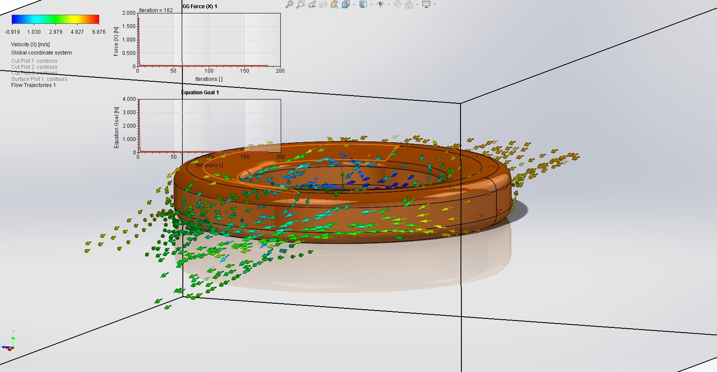

# Appendix

## Material Data

Engineering Database

Gases

Air

Path: Gases Pre-Defined

Specific heat ratio (Cp/Cv): 1.399

Molecular mass: 0.0290 kg/mol

Dynamic viscosity

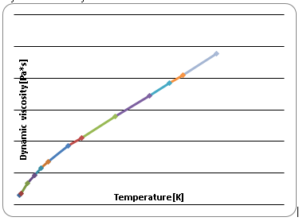

Specific heat (Cp)

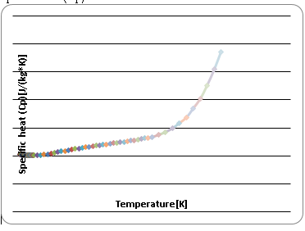

Thermal conductivity

