1. ------IND- 2020 0059 SK- EN- ------ 20200930 --- --- FINAL

Ministry of Transport and Construction of the Slovak Republic
Department of Road Transport and Roads
TS 115
TECHNICAL SPECIFICATIONS
Road tunnel lighting

Effective from: 1 June 2020
TABLE OF CONTENTS
1 Introductory chapter 3
1.1 Mutual recognition 3
1.2 Subject of the technical specifications (TS) 3
1.3 Purpose of the TS 3
1.4 Use of the TS 3
1.5 Preparation of the TS 3
1.6 Distribution of the TS 4
1.7 Effective date of the TS 4
1.8 Replacement of previous regulations 4
1.9 Related and cited statutory regulations 4
1.10 Related and cited standards 4
1.11 Related and cited departmental technical regulations 5
1.12 Applicable foreign regulations 5
1.13 Literature used 6
1.14 Abbreviations used 6
1.15 Terms and definitions 7
2 General 10
3 Design and requirements for road tunnel lighting 11
3.1 Tunnel lighting method 11
3.2 Determination of total braking distance 12
3.3 Determination of approach zone luminance L₂₀ 13
3.4 Lighting class determination 15
3.5 Flicker limitation 15
3.6 Glare limitation 16
3.7 Calculation grid for calculating individual lighting parameters 16
3.8 Tunnel wall lighting 18
3.9 Uniformity of luminance 19
3.10 Requirements for adaptation road tunnel lighting 19
3.11 Requirements for interior (passage) road tunnel lighting 21
3.12 Requirements for lighting road tunnel emergency bays 21
3.13 Requirements for lighting entrances to cross connections in road tunnels 22
3.14 Requirements for illuminating cross connections of road tunnels 23
3.15 Requirements for backup (safety) lighting in road tunnels 24
3.16 Requirements for emergency fire lighting in road tunnels 24
3.17 Requirements for illuminating short road tunnels 25
3.18 Requirements for lighting in areas before tunnel portals 29
3.19 Requirements for requirement guidance lighting 30
3.20 Requirements for lighting interior work areas in road tunnels and associated objects 31
3.21 Requirements for other light-emitting radiation installed in the tunnel in terms of lighting in tunnels and drivers’ visual comfort 33
4 Minimum requirements for lighting control systems 35
5 Minimum requirements for lighting system energy efficiency 37
5.1 Requirements for luminaires for lighting in front of the portal 38
5.2 Requirements for luminaires for main tunnel lighting 38
6 Minimum requirements for initial measuring and control measuring of tunnel lighting 39
6.1 Requirements for measuring instruments 40
6.2 Requirements for initial tunnel lighting measurement 42
6.3 Requirements for tunnel lighting control measurement 43
6.4 Measurement uncertainty and error 44
6.5 Measurement evaluation 45
7 The minimum requirements and method of conducting inspections and maintenance of road tunnel lighting. 47
7.1 Monthly inspections 47

Introductory chapter

Mutual recognition
Where these specifications lay down a requirement for conformity with any part of a Slovak standard (‘Slovak Technical Standard’) or other technical specifications, such requirement may be satisfied by ensuring conformity with:

the standard or codex of certified procedures issued by the national standardisation body or an equivalent body from the European Economic Area (EEA) and Turkey;

any international standard acknowledged by any EEA state and Turkey as the best practice standard or codex;

technical specification stated by a public body from any EEA state and Turkey that is acknowledged as a standard; or

European technical assessment issued in accordance with the procedure established in Regulation (EU) No 305/2011 of the European Parliament and of the Council of 9 March 2011 laying down harmonised conditions for the marketing of construction products and repealing Council Directive 89/106/EEC, as amended.

The above-mentioned subsections a), b), c) and d) shall not be applied if it can be proven that the standard concerned does not ensure the required level of functionality and safety.
‘EEA State’ means a state party to the Agreement on the European Economic Area signed in Oporto on 2 May 1992, as amended.
‘Slovak standard’ (‘Slovak Technical Standard’) means any standard issued by the Office of Standards, Metrology and Testing of the Slovak Republic, including transposed European or other international or foreign standards.

Subject of the technical specifications (TS)
The subject of these technical specifications (TS) is the principles and procedures for the requirements for designing and implementing lighting systems, requirements for the material establishment of lighting systems, requirements for the photometric and colorimetric parameters of luminaires which are road lighting equipment in all tunnel zones, and requirements for measuring instruments used to measure lighting parameters of tunnel lighting systems. Further subjects of these TS are requirements for lighting systems of interior workstations of technical and associated tunnel areas in accordance with the legislation in effect in the Slovak Republic. The subject of these TS also includes procedures for verifying calculated parameters and continuous checking of lighting parameters for road tunnels via terrain measurements.

Purpose of the TS
The purpose of these TS is to propose and verify the parameters of lighting in road tunnels which are associated with transportation safety.

Use of the TS
These TS are intended for project engineers, programmers, investors, builders, administrators of road tunnels on motorways, expressways, Class I, II and III roads, and local roads. These TS are applicable to any tunnels or underpasses in which lighting has to be installed.

Preparation of the TS
The TS were compiled on the basis of an order from the Slovak Road Administration (Slovenská správa ciest – SSC) by the company FEI STU in Bratislava, Ilkovičova 3, 812 19 Bratislava 1.
Project manager:
Mgr. Roman Dubnička, PhD., tel. no.: +421 903 228 678, email: roman.dubnicka@stuba.sk
Co-researchers:
Ing. Lukáš Lipnický, PhD., Národná diaľničná spoločnosť, a.s.
Ing. Peter Hajduček, Národná diaľničná spoločnosť, a.s.
Ing. Peter Schmidt, Národná diaľničná spoločnosť, a.s.
Ing. Dušan Ondrejčík, Národná diaľničná spoločnosť, a.s.
Ing. Dušan Šesták, Národná diaľničná spoločnosť, a.s.

Distribution of the TS
After approval, the electronic version of the TS will be published on the SCC website: www.ssc.sk (Technické predpisy rezortu [Departmental Technical Regulations]).

Effective date of the TS
These TS enter into force on the date stated on the cover page.

Replacement of previous regulations
These technical specifications do not replace any other regulations. These TS supplement the requirements specified in TS 029, TS 082 and TS 093.

Related and cited statutory regulations
[Z1] | Act No 8/2009 on road traffic and on amendments and addenda to certain acts;
[Z2] | Act No 135/1961 on roads (the Road Act), as amended;
[Z3] | Act No 157/2018 on metrology and on amendments and addenda to certain acts;
[Z4] | Directive 2004/54/EC of the European Parliament and of the Council on minimum safety requirements for tunnels in the Trans-European Road Network;
[Z5] | Government Regulation of the Slovak Republic No 344/2006 on the minimum safety requirements for tunnels in the road network;
[Z6] | Ministry of Interior of the Slovak Republic Decree No 9/2009 implementing the act on road traffic and on amendments to certain acts;
[Z7] | Federal Ministry of Transport Decree No 35/1984 implementing the Road Act;
[Z8] | ÚNMS SR [Slovak Office of Standards, Metrology and Testing] Decree No 161/2019 on measuring instruments and metrological inspection;
[Z9] | MZ SR [Slovak Ministry of Health] Decree 541/2007 on detailed requirements on lighting of workspaces, as amended;
[Z10] | Implementing Decree No 30/2020 of the Ministry of the Interior on fire prevention.

Related and cited standards
STN 01 8020 | Traffic signs on roads
STN 36 0410 | Road lighting. Selection of lighting classes
STN 73 6100 | Terminology for roads and highways
STN 73 6101 | Design of roads and highways
STN 73 6195 | Evaluation of anti-skid characteristics of road surfaces
STN 73 7501 | Design of underground structures for driven tunnels. Common provisions
STN 73 7507 | Road tunnel design
STN EN 1463-1  (73 7015) | Horizontal roadway marking materials. Retroreflective road studs. Part 1: Initial performance requirements
STN EN 1463-2  (73 7015) | Horizontal roadway marking materials. Retroreflective road studs. Part 2: Road test on testing stretch
STN EN 1838  (36 0075) | Light and lighting. Emergency lighting
STN EN 12368  (73 6022) | Traffic control equipment. Signal device
STN EN 12464-1  (36 0074) | Light and lighting. Illumination of work places. Part 1: Indoor work places
STN EN 12665  (36 0070) | Light and lighting. Basic terms and criteria for specifying lighting requirements
STN EN 12899  (73 7021) | Fixed, vertical road traffic signs. Part 1: Fixed traffic signs
STN EN 12966  (73 7040) | Vertical traffic signs. Traffic signs with variable symbols
STN EN 13032-1+A1 (36 0401) | Light and lighting. Measurement and evaluation of photometric data of lamps and luminaires. Part 1: Measurement and file format
STN EN 13032-2 (36 0401) | Light and lighting. Measurement and evaluation of photometric data of lamps and luminaires. Part 2: Presentation of data for indoor and outdoor work places
STN EN 13032-3 (36 0401) | Light and lighting. Measurement and evaluation of photometric data of lamps and luminaires. Part 3: Presentation of data for emergency lighting of work places
STN EN 13032-4+A1 (36 0401) | Light and lighting. Measurement and evaluation of photometric data of lamps and luminaires. Part 4: LED lamps, modules and luminaires
STN EN 13032-5 (36 0401) | Light and lighting. Measurement and evaluation of photometric data of lamps and luminaires. Part 5: Presentation of data for luminaires used for road lighting
STN EN 13201-2  (36 0410) | Road lighting. Part 2: Light performance requirements
STN EN 13201-3  (36 0410) | Road lighting. Part 3: Calculation of light performance
STN EN 13201-4  (36 0410) | Road lighting. Part 4: Methods of measuring lighting performance
STN EN 16276  (36 0077) | Evacuation lighting in road tunnels
STN EN 50172  (36 0640) | Emergency escape lighting systems
STN EN 62504  (36 0293) | General lighting. Light-emitting diode (LED) products and related equipment. Terms and definitions
TNI CEN/CR 14380  (36 0412) | Lighting. Lighting in tunnels.
TNI CEN/TR 13201-1  (36 0410) | Road lighting. Part 1: Selection of lighting classes
STN ISO 3864-1  (01 8012) | Graphical symbols. Safety colours and safety signs. Part 1: Design principles for safety signs and safety markings
STN ISO 3864-4  (01 8012) | Graphical symbols. Safety colours and safety signs. Part 4: Colorimetric and photometric properties of safety sign materials.
STN EN ISO 7010  (01 8012) | Graphical symbols. Safety colours and safety signs. Registered safety signs (ISO 7010: 2011)
STN EN ISO/IEC 17025  (01 5253) | General requirements for the competence of testing and calibration laboratories (ISO/IEC 17025: 2017)

Note: Applicable and cited standards, including actual changes, amendments and national amendments.

Related and cited departmental technical regulations
[T1] | TS 015 | General principles of use of retroreflective road studs, MDPT SR: 2005 + Addendum No 1, MDVRR SR [Ministry of Transport, Construction and Regional Development of the Slovak Republic]: 2015;
[T2] | TS 020 | Tunnel terminology, MDPT SR [Ministry of Transport, Post and Telecommunications of the Slovak Republic]: 2006;
[T3] | TS 025 | Measurement and evaluation of the coarseness of roadways using SKIDDOMETER BV11 and PROFILOGRAPH GE, MDPT SR: 2007;
[T4] | TS 082 | Road inspections, maintenance and repairs. Tunnels – technical equipment, MDVRR SR: 2014;
[T5] | TS 093 | Central Control System and Visualisation — Tunnels, MDV SR [Slovak Ministry of Transport, Construction and Regional Development]: 2020;
[T6] | TS 099 | Fire safety in road tunnels, MDVRR SR: 2011;
[T7] | TQC 0 | General, Ministry of Transport, Construction and Regional Development of the Slovak Republic: 2012;
[T8] | TKP 26 | Tunnels, Ministry of Transport, Construction and Regional Development of the Slovak Republic: 2017.

Applicable foreign regulations
[T9] | TS ČR 98 + TS ČR 98 - Z1 | Technological equipment – Road tunnels, MD ČR [Ministry of Transport of the Czech Republic]: 2003 + Z1, MD ČR: 2010
[T10] | RVS 09/02/1941 | Tunnelausrüstung Lichttechnik, [Tunnel equipment – Lighting]
[T11] | DIN 67524-1 | Beleuchtung von Straßentunneln und Unterführungen.  Part 1: Allgemeine Gütemerkmale und Richtwerte, [Lighting of road tunnels and underpasses. Part 1: General quality characteristics and benchmarks]
[T12] | DIN 67524-2 | Beleuchtung von Straßentunneln und Unterführungen.  Part 2: Berechnung und Messung, [Lighting of road tunnels and underpasses. Part 2: Calculation and measuring]
[T13] | SN 640551-1 | Öffentliche Beleuchtung in Strassentunneln, Galerien und Unterführungen – Teil 1: Lichttechnische Anforderungen - Begriffe und Gütemerkmale, [Public lighting in road tunnels, galleries and underpasses. Part 1: Requirements for lighting – terms and quality characteristics]
[T14] | SN 640551-2 | Öffentliche Beleuchtung in Strassentunneln, Galerien und Unterführungen – Teil 2: Planung und Bemessung der Beleuchtungsanlage, [Public lighting in road tunnels, galleries and underpasses. Part 2: Planning and project engineering of lighting systems]
[T15] | SN 640551-3 | Öffentliche Beleuchtung in Strassentunneln, Galerien und Unterführungen – Teil 3: Methoden zur Messung und Beurteilung der Gütemerkmale, [Public lighting in road tunnels, galleries and underpasses. Part 3: Methods of measurement and evaluating quality characteristics]
[T16] | EABT-80/100 | Empfehlungen fur die Ausstattung und den Betrieb von Strasentunneln mit einer Planungsg  eschwindigkeit von 80 km/h oder 100 km/h, [Recommendations for equipment and operation of road tunnels with design speed of 80 or 100 km/h];
[T17] | CIE 015 | Colorimetry, 4th edition
[T18] | CIE 061 | Tunnel entrance lighting: A survey of fundamentals for determining the luminance in the threshold zone
[T19] | CIE 066 | Road surfaces and lighting
[T20] | CIE 088:2004 | Guide for the lighting of road tunnels and underpasses, 2nd ed
[T21] | CIE 97 | Guide on the maintenance of indoor electric lighting systems, 2nd ed.
[T22] | CIE 140 | Road Lighting Calculations, 2nd Edition
[T23] | CIE 154 | Maintenance of outdoor lighting systems
[T24] | CIE 189 | Calculation of tunnel lighting quality criteria
[T25] | CIE 193 | Emergency Lighting in Road Tunnels
[T26] | CIE 194: 2011 | On Site Measurement of the Photometric Properties of Road and Tunnel Lighting
[T27] | CIE S 004/E:2001 | Colours of light signals
[T28] | CIE DIS 024/E:2013 | Light-Emitting Diodes (LEDs) and LED Assemblies – Terms and Definitions

Literature used
HORŇÁK, P.: Výpočet a meranie svetelnotechnických vlastností osvetľovacích zariadení tunelov. [Calculation and measurement of technical light properties of tunnel lighting equipment. In: EE časopis pre elektrorechniku, elektroenergetiku, informačné a komunikačné technológie, 2009, [EE Journal for Electrical and Energy Engineering, Information and Communication Technology 2009], volume 15, no. 5, p. 12–1;

CETU - Tunnel lighting guidelines;

CETU – Signalling and support measures for self-evacuation of users from road tunnels;

Schréder – Tunnels and underpasses;
https://www.technoteam.de/;

INDALUX – LIGHTING ENGINEERING 2002, [INDALUX – lighting manual].

Abbreviations used
Abbreviations as per the cited standards and the following are used:
CEN | European Committee for Standardisation
CETU | Centre for Tunnel Studies in France
CIE | International Commission on Illumination
EN | European standard
PDZ | Traffic signs with variable symbols
SNAS | Slovak National Accreditation Service
STN | Slovak technical standard
TNI | Technical standardisation information

Terms and definitions
In addition to the terms specified in STN 73 6100, STN 73 6101, STN EN 12665 and STN EN 13032-4 + A1 and the applicable TPR, the following further terms and definitions are used for the purposes of these TS:
road traffic intensity: the number of vehicles which pass in one lane in one hour during peak traffic
design speed: proposed maximum speed of a vehicle from which the design parameters of illumination are determined
total braking distance (SD): the distance needed for a vehicle driving at a particular speed to come to a complete stop
mixed traffic: traffic consisting of motor vehicles, cyclists and pedestrians
motor traffic: traffic consisting solely of motor vehicles
approach zone: part of an open road immediately before an entry portal comprising the distance from which an approaching driver has to see into the tunnel (Figure 1)
threshold zone: first part of a tunnel immediately after the entry portal; the threshold zone begins at the entry portal (Figure 1)
transition zone: the part of the tunnel after the threshold zone; the transition zone is demarcated from the end of the threshold zone to the beginning of the interior zone; in the transition zone, the luminance level existing at the end of the threshold zone is reduced to the luminance level of the interior zone (Figure 1)
entrance zone: a combination of the threshold zone and the transition zone
interior zone: the part of the tunnel which comes after the transition zone; the interior zone is demarcated from the end of the transition zone to the beginning of the exit zone (Figure 1)
exit zone: the part of the tunnel in which the vision of a driver approaching the exit from the tunnel is influenced by the luminance of the area beyond the tunnel; the exit zone is demarcated by the end of the interior zone to the exit portal (Figure 1)
departure zone: the first part of the open road beyond the exit portal; this part, which starts after the exit portal, is not part of the tunnel, but is closely connected to the tunnel’s lighting (Figure 1)

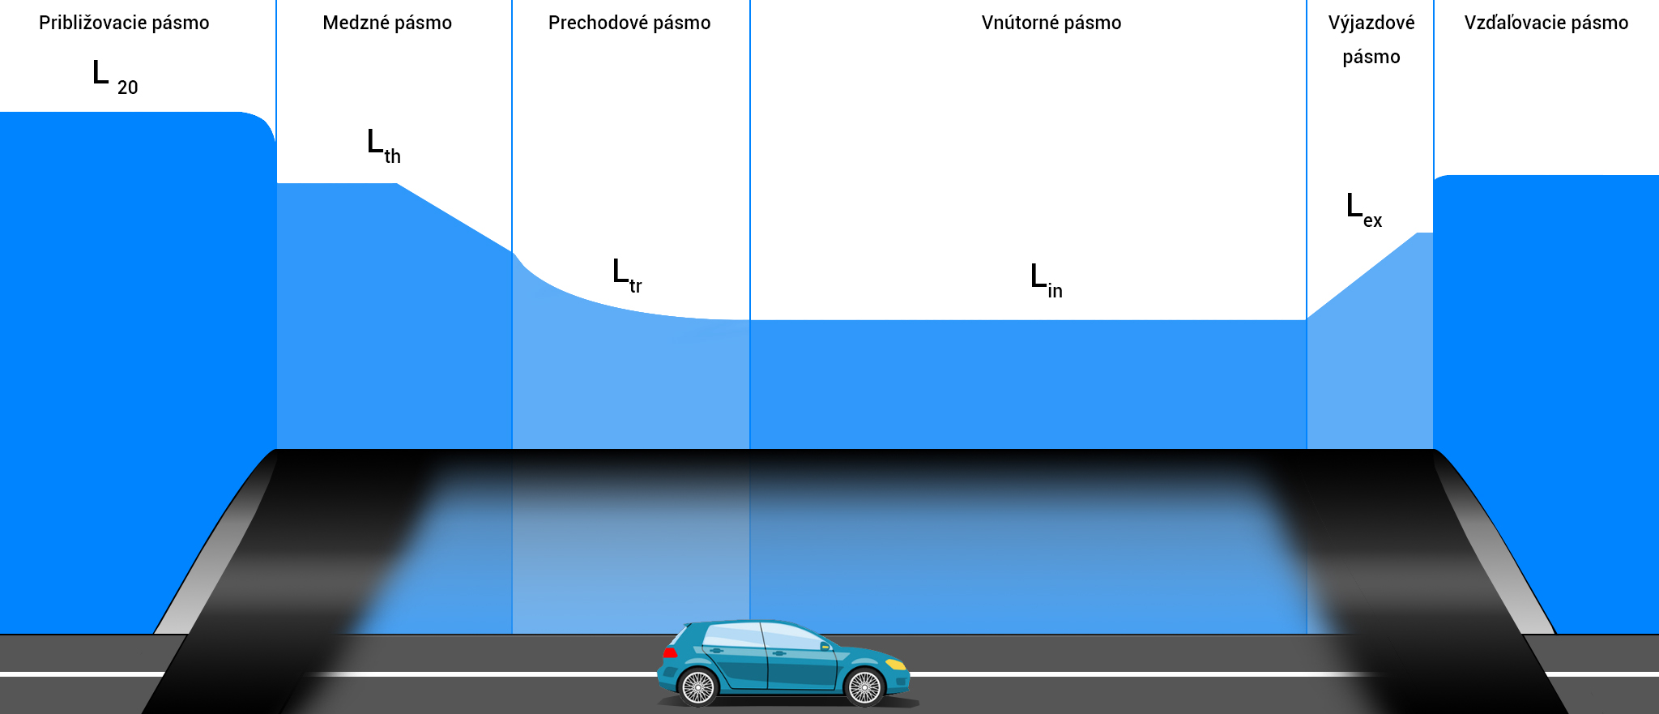

Figure 1 Zones in a road tunnel

Približovacie pásmo | Approach zone
Medzné pásmo | Threshold zone
Prechodové pásmo | Transition zone
Vnútorné pásmo | Interior zone
Výjazdové pásmo | Exit zone
Vzďaľovanie pásmo | Departure zone

threshold zone lighting: lighting which illuminates the threshold zone and enables the driver to see into the interior of the tunnel from the approach zone
transition zone lighting: lighting which illuminates the transition zone and makes it easier for vision to adapt to the luminance level of the interior zone
interior zone lighting: lighting which illuminates the interior zone and enables adequate visibility inside the tunnel regardless of whether or not the vehicle’s headlights are being used
exit zone lighting: lighting which illuminates the exit zone and improves the driver’s vision during the transition from the interior zone to the area beyond the tunnel
visual guidance: lighting elements which provide the driver with adequate information while driving in the tunnel
approach zone luminance L₂₀: the average luminance of the conical field of vision bordered by an angle of vertex of 20° with a vertex in the centre of the eye of the oncoming driver and aligned approximately up to one quarter of the height of the entrance portal; L₂₀ is determined from a distance equivalent to the total braking distance before the entrance to the tunnel in the axis of the road or lane
threshold zone luminance (L_{th}): the average luminance of the road surface at the beginning of the threshold zone (as a function of the calculation field of the relevant area)
transition zone luminance (L_{tr}): average luminance of the road surface at a defined point in the transition zone (as a function of the calculation field of the relevant area)
interior zone luminance (L_{in}): the average luminance of the road surface in the interior zone (as a function of the calculation field of the relevant area)
exit zone luminance (L_{ex}): the average luminance of the road surface in the exit zone (as a function of the calculation field of the relevant area)
vertical illuminance (E_{v}): illuminance of the vertical plane 0.2 m above the road surface; the vertical plane is oriented facing the direction of the oncoming traffic; the centre of the surface element with a height of 0.2 m above the road surface constitutes an object of 0.4 m x 0.4 m.
luminance coefficient (q_{c}): proportion of the luminance of the road surface element and the vertical illuminance E_{v} at a given point; $q_{c}= \frac{L}{E_{V}}$
ratio of threshold zone luminance and approach zone luminance (k): the ratio of the average luminance of the road surface at the beginning of the threshold zone L_{th} to the approach zone luminance L₂₀; $k= \frac{L_{th}}{L_{20}}$
average road surface luminance ($\overline{L}$): the averaged luminance of the pavement surface of a road
average illuminance (on a road) (Ē): the averaged horizontal illuminance on the pavement surface of a road
maintained value (average luminance of the road surface, average illuminance on a road): the level below which a value of a corresponding variable must not be reduced during operation
overall uniformity (road surface luminance, wall luminance, road surface illuminance, wall illuminance (U_{o}): ratio of minimum luminance value (illuminance) which appears at any point on the grid and the average luminance (illuminance)
longitudinal uniformity (road surface luminance) (U_{l}): ratio of the minimum and maximum luminance value in the longitudinal direction along the axis of each lane
traffic sign with variable symbols (VMS): sign serving to depict any of several informational messages, which can be changed, be turned on or be turned off as needed
LED fixture: a structural unit or set of LED modules and ballast for direct connection to a power supply system

Note 1 to the term: An LED fixture usually has to have a defined electrical, mechanical, temperature and control interface and characteristic photometric properties.

Note 2 to the term: An LED fixture may contain a radiator. [T28]

LED lamp: a lamp intended to be mounted with one or more LED light sources

Note 1 to the term: LED light source(s) may be an integral part of an LED lamp.
[STN EN 62504]

light colour: chromaticity coordinates of colours are defined in accordance with CIE 1931 standard colorimetric observer as specified in [T17]. The chromaticity coordinates of a class C1 colour must correspond to the values specified in Table 1. The chromaticity coordinates of a class C2 colour must correspond to the values specified in Table 2. The chromaticity fields in Tables 1 and 2 [T27] for red, orange, yellow, white, green and blue colours are recommended in [T27] for signal lamp colours
workstation: an area intended as workplaces in factories or other operating facilities and any other area in a factory or operating facility to which workers have access in the course of their work
visual task location: place where a visual task is carried out
immediate vicinity of visual task: area surrounding the place of a visual task
background: area contiguous to the immediate vicinity of visual task
retroreflective road stud (road stud): horizontal guidance device which reflects incident light via reflectors to warn and inform road users and provide them with guidance via light
Table 1 - Corner points of chromaticity field for class C1 colours
Colour | Trichromatic coordinates of corner points
 | Corner point | 1 | 2 | 3 | 4 | 5 | 6
Red | x | 0.660 | 0.680 | 0.735 | 0.721 | - | -
 | y | 0.320 | 0.320 | 0.265 | 0.259 | - | -
Yellow | x | 0.536 | 0.547 | 0.613 | 0.593 | - | -
 | y | 0.444 | 0.452 | 0.387 | 0.387 | - | -
White | x | 0.300 | 0.440 | 0.500 | 0.500 | 0.440 | 0.300
 | y | 0.342 | 0.432 | 0.440 | 0.382 | 0.382 | 0.276
Orange | x | 0.624 | 0.605 | 0.650 | 0.669 | - | -
 | y | 0.370 | 0.370 | 0.331 | 0.331 | - | -
Green | x | 0.310 | 0.310 | 0.209 | 0.028 | - | -
 | y | 0.684 | 0.562 | 0.400 | 0.400 | - | -
Blue | x | 0.109 | 0.204 | 0.233 | 0.149 | - | -
 | y | 0.087 | 0.196 | 0.167 | 0.025 | - | -

Table 2 - Corner points of chromaticity field for class C2 colours
Colour | Trichromatic coordinates of corner points
 | Corner point | 1 | 2 | 3 | 4
Red | x | 0.660 | 0.680 | 0.710 | 0.690
 | y | 0.320 | 0.320 | 0.290 | 0.290
Yellow | x | 0.536 | 0.547 | 0.613 | 0.593
 | y | 0.444 | 0.452 | 0.387 | 0.387
White | x | 0.300 | 0.440 | 0.440 | 0.300
 | y | 0.342 | 0.432 | 0.382 | 0.276
Orange | x | 0.624 | 0.605 | 0.650 | 0.669
 | y | 0.370 | 0.370 | 0.331 | 0.331
Green | x | 0.009 | 0.284 | 0.209 | 0.028
 | y | 0.720 | 0.520 | 0.400 | 0.400
Blue | x | 0.109 | 0.173 | 0.208 | 0.149
 | y | 0.087 | 0.160 | 0.125 | 0.025

General
When road tunnel lighting is required, one must make a distinction between a short tunnel (underpass) and a long tunnel. The requirements for lighting long and short tunnels differ depending on the ability of approaching drivers to see through the tunnel from a distance equivalent to the total braking distance before the entry portal.
Lighting of long tunnels during the day is based on the approach zone luminance, which the threshold zone luminance value also depends on. The approach zone luminance value is either the highest luminance value of the approach zone which occurs over the course of the year, or the value which occurs in a particular part of the year (e.g. at least 75 h). The values of the required photometric parameters for the individual zones of a tunnel (threshold, transition, interior, exit) depend on the luminance value of the approach zone and the class of the tunnel based on the road traffic intensity in the tunnel in question. At night, tunnel lighting is maintained at a constant value recommended for the interior zone.

The lighting of a short road tunnel (underpass) is derived from the tunnel user’s ability to see the exit portal during the day from the braking distance before the entry portal, either in full or predominately. The field of vision which appears to the tunnel user from the braking distance before the entry portal must fully cover at least the macula of the tunnel user’s eye. Each case of lighting of a short road tunnel requires a specific study, because the ability to see through the tunnel may be influenced by many factors. The ability to see through the tunnel primarily depends on the length, width and height of the tunnel, horizontal and vertical curvature, etc. Short tunnels appear where a road passes below another road or railway crossing, or is covered as in the case of urban streets. Tunnels shorter than 25 m do not need lighting during the daytime; tunnels longer than 200 m always require a particular type of artificial lighting during the day. The procedure for determining the need for artificial lighting for short tunnels with a length between 25 to 200 m is specified in Article 3.17 of these TS.

Design and requirements for road tunnel lighting
The purpose of tunnel lighting is to ensure that tunnel users can not only enter the tunnel and pass through it, but also exit the tunnel safely by day and night without changing direction or speed, and for this level of safety to be commensurate with the safety on the approach road. In order to achieve safe passage through a tunnel, it is essential for all users to have sufficient information on the continuation of the road in front of them, on any potential obstacles which may appear, including information on other users and their movements. Traffic signs must make drivers aware that they are approaching a tunnel. Trees or other screens may be used to prevent the effect of sunlight when entering a tunnel. Light surfaces should be limited at the entrance to the tunnel and the pavement surface before the portals should be darker. The pavement surface inside the tunnel should be light. Symmetrical lighting should be nearly diffuse, and opposite direction lighting should be more directed. Glare should be prevented at the exit from a tunnel by a suitable structural design or by planting vegetation.
The main parameters determining tunnel lighting quality are:

luminance and illuminance of the road surface,

luminance of the bottom part of the tunnel walls up to a height of 2 m from the road surface,

uniformity of luminance on the road surface and in the bottom part of the tunnel walls,

glare limitation,

flicker limitation.

Tunnel lighting method
The luminance contrast may be negative or positive, depending on the reflectiveness of the barrier and background, as well as on the tunnel lighting method. The method of lighting depends on the distribution of the luminous flux from the luminaires. Symmetrical lighting (symmetrical luminous intensity curve on C planes 0° – 180°) and opposite (asymmetrical) lighting are usually used for illuminating tunnels. An example of opposite lighting is depicted in Figure 2, and an example of symmetrical lighting is depicted in Figure 3.
With opposite lighting, the luminaires allow maximum luminous intensity in the direction opposing approaching tunnel users and a low luminous intensity value in the direction of traffic. This way, they achieve greater contrast of luminance, because the vertical illuminance Ev+ of an obstacle located on the road in the direction opposing approaching tunnel users is low. The effect of the lighting is characterised by the luminance coefficient value q_{c}. The luminance coefficient values for symmetrical and opposite lighting are specified in Table 3.
When the reflective properties of category R3, R4 and C2 road surfaces are applied according to the categorisation specified in [T19], the luminance on the road achieved is usually higher than it is with symmetrical lighting. Typical average luminance coefficient values Q₀ and mirror factor of the surface S1 are specified in Table 4.
Opposite lighting:

may increase the effect of a black hole, because certain lighting design methods for the threshold zone may reduce the average road surface luminance,

is not necessarily suitable for a portal with a high degree of daylight entry,

may be less effective in tunnels with high traffic intensity or for tunnels with a high per cent of cargo vehicles and buses.
Table 3 – Required luminance coefficient values for individual types of lighting [T10]
Lighting | Luminance coefficient qc
Symmetrical | ≤ 0.5 (cd/m²)/lx
Asymmetrical | ≥ 0.5 (cd/m²)/lx

Table 4 – Surface category as per [T19]
Surface type | Average luminance coefficient Q₀ | Mirror factor S1 | Surface description
C1 | 0.10 | 0.24 | CIE C1 – concrete
C2 | 0.07 | 0.97 | CIE C2 – asphalt
N1 | 0.10 | 0.18 | CIE class = 1, diffuse surface
N2 | 0.07 | 0.41 | CIE Class = 1, concrete
N3 | 0.07 | 0.88 | CIE Class = 3, asphalt
N4 | 0.08 | 1.55 | CIE Class = 4, shiny asphalt
R1 | 0.10 | 0.25 | lES RP-8 – diffusion characteristics of portland cement or asphalt together with min. 15% lighter stone components
R2 | 0.07 | 0.58 | lES RP-8 – combination of diffuse and mirror reflection of asphalts containing 60% gravel larger than 10 mm or asphalts containing 10%–15% lighter stone components.
R3 | 0.07 | 1.11 | lES RP-8 – slight mirror effect typical of asphalt surfaces containing dark stone and rough texture after several months
R4 | 0.08 | 1.55 | lES RP-8 – predominately reflective surface typical of very smooth asphalt

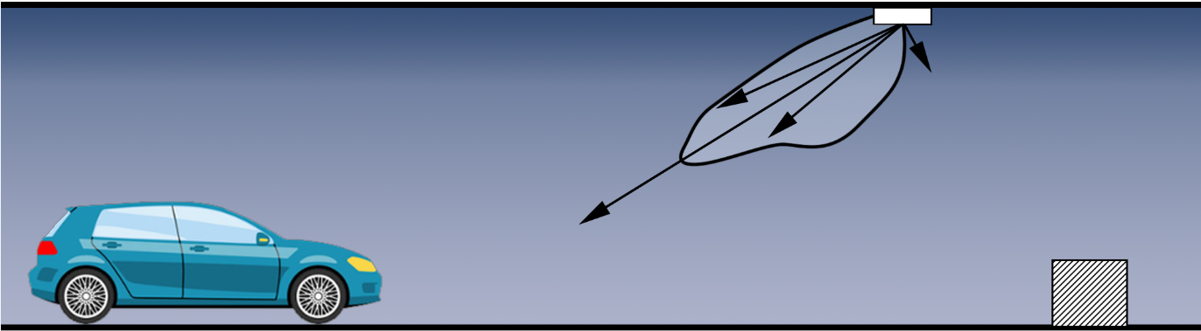
Figure 2 – Opposite lighting
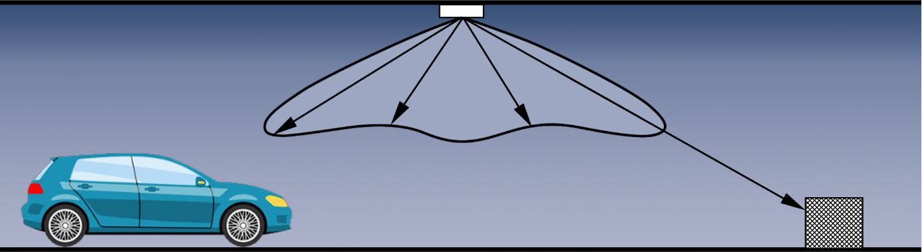
Figure 3 – Symmetrical lighting

Determination of total braking distance
Vehicle stopping distance is calculated according to (1). In the specified relation, the design speed v is expressed in m.s⁻¹, the road gradient in %, reaction time t₀ is 1 s, gravitational acceleration g is 9.81 m.s⁻² and friction coefficient f is 0.53.
$BD=v ×t_{0} + \frac{v^{2}}{2 × g × \left(f ± \frac{s}{100}\right)}$ (1)
where:
v is the design speed,
t₀ reaction time,
g gravitational acceleration,
f friction coefficient,
s road gradient (+ selected for an incline and – for a decline).

Determination of approach zone luminance L₂₀
The approach zone luminance value L₂₀ which is used when designing the lighting or controlling the tunnel illumination must represent the maximum luminance value L₂₀ which occurs with sufficient frequency over the course of the year.

3.3.1 Determination of approach zone luminance L₂₀ based on rough estimate
The method of determining luminance L₂₀ based on a rough estimate is only used for the low levels of project documentation, in which the design of the entrance to the tunnel is not known (there is no overview of the portal, or only a rough outline). The luminance value L₂₀ is determined via a rough estimate on the basis of Table 5 [TNI CEN/CR 14380] and the explanatory notes below the table. If an overview of the portal (outline, photography) exists, then the method specified in Chapter 3.3.2 must be used.
Table 5 - Typical luminance value of the approach zone
 | Average luminance value L20 in 20-degree field of vision (cd/m²)
 | Proportion of sky in per cent
 | 35% |  |  |  | 25% |  |  |  | 10% |  |  |  | 0%
 | normal |  | snow |  | normal |  | snow |  | normal |  | snow |  | normal |  | snow
 | low | high | low | high | low | high | low | high | low | high | low | high | low | high | low | high
Luminance in field of vision | 1) |  | 1) |  | 1) |  | 1) |  | 2) |  | 3) |  | 2) |  | 3)
Total braking distance 60 m | does not appear in practice |  | does not appear in practice |  | 4000 | 5000 | 4000 | 5000 | 2500 | 3500 | 3000 | 3500 | 1500 | 3000 | 1500 | 4000
Total braking distance 100 m to 160 m | 4000 | 6000 | 4000 | 6000 | 4000 | 6000 | 4000 | 6000 | 3000 | 5000 | 3000 | 5000 | 2500 | 4500 | 2500 | 5000

- Depends predominately on tunnel orientation:

a lower value is selected for a southern entrance (from the south);

a higher value is selected for a northern entrance (from the north);

for eastern and western entrances, the mean of the specified values is selected.

- This primarily depends on the luminance of the surrounding area:

a lower value is selected if the reflectiveness of the surrounding area is low;

a higher value is selected if the reflectiveness of the surrounding area is high.

- Depends predominately on tunnel orientation:

a lower value is selected for a northern entrance (from the north);

a higher value is selected for a southern entrance (from the south);

for eastern and western entrances, the mean of the specified values is selected.

3.3.2 Determination of approach zone luminance L₂₀ based on analysis of the approach zone 20° conical field of view
When designing the lighting of a new tunnel, it is necessary to use the method based on analysis of the approach zone 20° conical field of view to determine the luminance of the approach zone L₂₀ (see Figure 4 for example). Since the luminance value of the threshold zone is not known and the percentage proportion of the entrance zone $τ$ is small, these values can be neglected and the resulting luminance L₂₀ can be determined according to relation (2). The luminance value L₂₀ determined according to this method is the maximum value and can be corrected after analysing the data luminance value of the distribution of the relative frequency of occurrence of L₂₀. The factors γ, ρ, ε are determined with the help of outlines of the entrance to the tunnel to scale or with photography from a distance equal to the total stopping distance before the entrance to the tunnel. If it is not possible to measure the luminance L_{C}, L_{R}, L_{E}, then the values are determined from Table 6 [TNI CEN/CR 14380].
$L_{20}={γL}_{c}+{ρL}_{R}+{εL}_{E}$ (2)
in which: $γ+ρ+ε<1$
where:
L_{C} is the luminance of the sky;
L_{R} road luminance;
L_{E} luminance of the surrounding area;
γ proportion of the sky in per cent;
ρ proportion of the road in per cent;
ε proportion of the surrounding area in per cent.
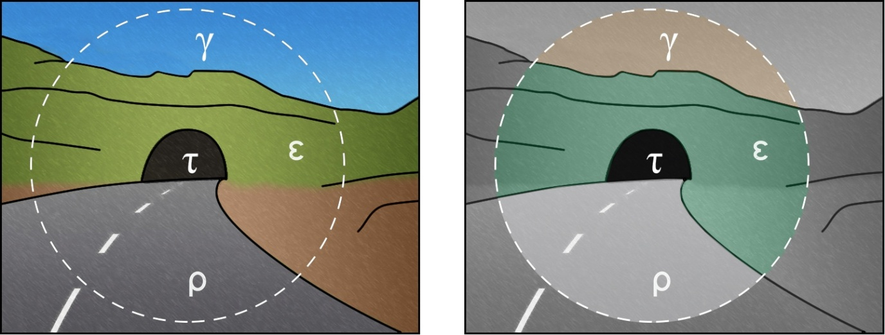
Figure 4 – Example of overview of tunnel portal with marking of 20° field of vision and individual percentage proportions v

Table 6 – Approximate luminance value (kcd/m²) for various tunnel entrances and surroundings in a 20° field of vision
Direction of travel | LC (sky) | LR (road) | LE (sky)
 |  |  | Rocks | Buildings | Snow | Meadows
From the north | 8 | 3 | 3 | 8 | 15 (V, H) | 2
Eastern and western entrance | 12 | 4 | 2 | 6 | 10 (V) | 2
 |  |  |  |  | 15 (H)
From the south | 16 | 5 | 1 | 4 | 5 (V) | 2
 |  |  |  |  | 15 (H)

Note: The values marked (V) are selected in the case of mountainous terrain with primarily steep surface; the values marked (H) are selected in the case of level terrain.

3.3.3 Determination of approach zone luminance L₂₀ based on measurement
When reconstructing the lighting of an existing road tunnel, it is necessary to determine the luminance value of the approach zone L₂₀ by means of a statistical evaluation of the existing record of luminance value measurements L₂₀ of the tunnel in question (over the course of one year). For these purposes, the records kept by the administrator of the measured luminance values from luminance meters positioned in front of the tunnel portals during the entire period of time from installation until the lighting system has been changed.
After the new road tunnel is put into operation, it is necessary to statistically evaluate the luminance values of the approach zone L₂₀ measured after one year of operation and, if necessary, adjust the lighting regulation in light of the given statistical evaluation.
The maximum luminance value of the approach zone L₂₀ is determined as the maximum value which occurs at least 75 h in the year.

Lighting class determination
The lighting classes defined in Table 8 [TNI CEN/CR 14380] relate to the road traffic intensity and type of transportation, which are specified in Table 7 [TNI CEN/CR 14380]. Visual guidance is taken into account for tunnels where the requirements are too low to justify ‘full’ tunnel illumination. If the intensity of the orientation in the road tunnel increases, it is necessary to design the tunnel lighting to be one class higher than that resulting from Table 8.
Table 7 – Road traffic intensity values
Road traffic intensity | One-way tunnel  (vehicles/hour. lane) | Two-way tunnel  (vehicles/hour. lane)
High | > 1 500 | > 400
Moderate | 500 – 1 500 | 100 - 400
Low | < 500 | < 100

Table 8 - Lighting class
Road traffic intensity | High |  | Moderate |  | Low
Transportation type | M | A | M | A | M | A
Lighting class | 4 | 3 | 3 | 2 | 2 | 1 (visual guidance)
Note: A – motorised transportation, M – mixed transportation (motorised transportation, pedestrians, cyclists).

Flicker limitation
Flicker occurs as a result of periodic changes of luminance in the driver’s field of vision, e.g. through the effect of daylight entering the tunnel tube through the baffles of light apertures or through the effect of incorrectly spaced luminaires. The disturbance of visual comfort caused by flicker depends on:

frequency of flicker,

total time of effect,

photometric characteristics of the luminaires used.

The frequency of flicker is calculated based on the following relation [TNI CEN/CR 14380]:
f_{flicker} = $\frac{návrhová rýchlosť (m/s) }{rozstup svietidiel (m)}$ (3)
návrhová rýchlosť (m/s) | design speed (m/s)
rozstup svietidiel (m) | spacing of luminaires (m)

In general, the disturbing effect of flicker is negligible at frequencies lower than 2.5 Hz and higher than 15 Hz. The disruption of visual comfort in the interior zone of a tunnel can be significant at flicker frequencies ranging from 4 Hz to 11 Hz with an overall effect time of over 20 s.
In tunnel zones where luminaires with a high degree of luminous intensity are used, flicker frequency within a range of 2.5 Hz and 15 Hz is permissible for the given design speed with a duration of less than 20 s.
In the case of impermeable sun shades, the flicker frequency must always be higher than 50 Hz, regardless of the length covered by the blinds.
Visual discomfort caused by flicker must be examined for all luminaires which are active during ordinary tunnel operation.

Glare limitation
If glare reduces visibility, it is important to minimise it. Physical (limiting) glare must be taken into account when lighting the tunnel. The degree of limiting glare is evaluated based on the relative increase in the threshold value TI specified in per cent.
In all zones of the tunnel and for all degrees of lighting regulation, the value of the relative increase in the threshold value TI must be less than 15%. The threshold increase is calculated based on the following relations [TNI CEN/CR 14380]:
$TI=65 \frac{L_{v}}{L_{cesta}^{0.8}}ak \overline{L}≤5 cd/m^{2}$ (4)
cesta | road

$TI=95 \frac{L_{v}}{L_{cesta}^{1.05}} ak \overline{L}>5 cd/m^{2}$ (5)
cesta | road

where:
$\overline{L}$ is the average luminance of the road surface,
L_{v} is the equivalent veiling luminance caused by all luminaires in the field of vision, in which the axis of vision is sloped 1° below horizontal on the vertical plane of the longitudinal direction passed over by the eye of the observer.
The calculations are made for the initial values of the lighting equipment parameters and for an angle of radiation of 20° above the axis of vision. Other luminaires must be excluded from the calculation, or are outside of the drivers’ field of vision.
For tunnels of lighting classes 4, 3 and 2, the increase in threshold value TI for the threshold zone and interior zone during the day and in all tunnel zones during the night must be less than 15%. No requirements are specified for tunnels of lighting class 1. There are no limiting threshold values TI for the exit zone during the daytime.

Calculation grid for calculating individual lighting parameters
Calculation grids are defined for calculating the lighting parameters in individual tunnel zones. The calculation grids in the individual zones must be harmonised with the measurement grids in order to verify the individual lighting parameters. A calculation of the required lighting parameters must be carried out for each zone of the tunnel. If the lighting system’s geometry changes in any zone of the tunnel, e.g. due to a detour in the ventilation system, an additional calculation must be carried out for this segment which verifies the retention of the individual parameters required in that segment.

The calculation of the individual lighting parameters in the approach zone is carried out in accordance with the calculation grid specified in STN EN 13201-3 in Figure 5. Distribution of the calculation points is carried out in accordance with the following formulas:

$D= \frac{S}{N}$ (6)
$d= \frac{W}{3}$ (7)
where:
D distance between points in the longitudinal direction (m)
d distance between points in the transverse direction (m)
S distance between points in a single row (m)
W lane width (m)
N number of calculation points in the longitudinal direction:
for S ≤ 30 m, N = 10
for S > 30 m, N = smallest whole value for which D ≤ 3 m holds true
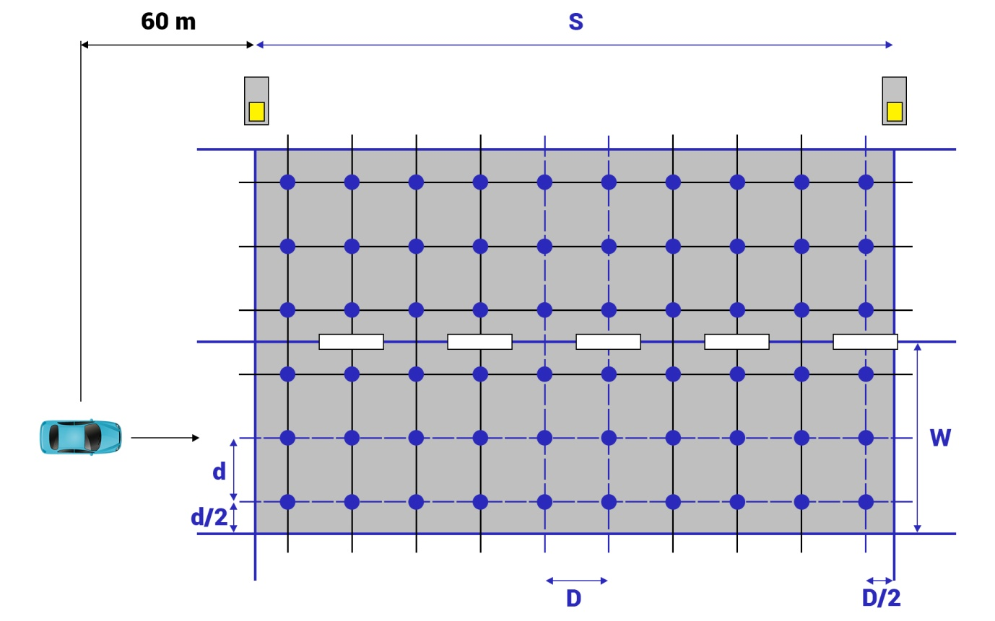
Figure 5 – Calculation grid for calculating the parameters on the road in the approach zone

The same distribution of measurement points as in the calculation must be used when verifying the individual lighting parameters. When calculating lighting parameters in tunnel zones with a constant level of lighting, it is necessary to use a distribution of calculation points in accordance with STN EN 13201-3 (Figure 6). When calculating lighting parameters on walls tunnel zones with a constant level of lighting, it is necessary to use an algorithm in accordance with STN EN 13201-3 in the longitudinal direction as well. The number and heights of the individual rows of points are specified in Figure 7. In tunnel zones with a declining level of lighting, the number of points in the longitudinal direction must be selected so that the distance between them in the longitudinal direction is ≤ 3 m.

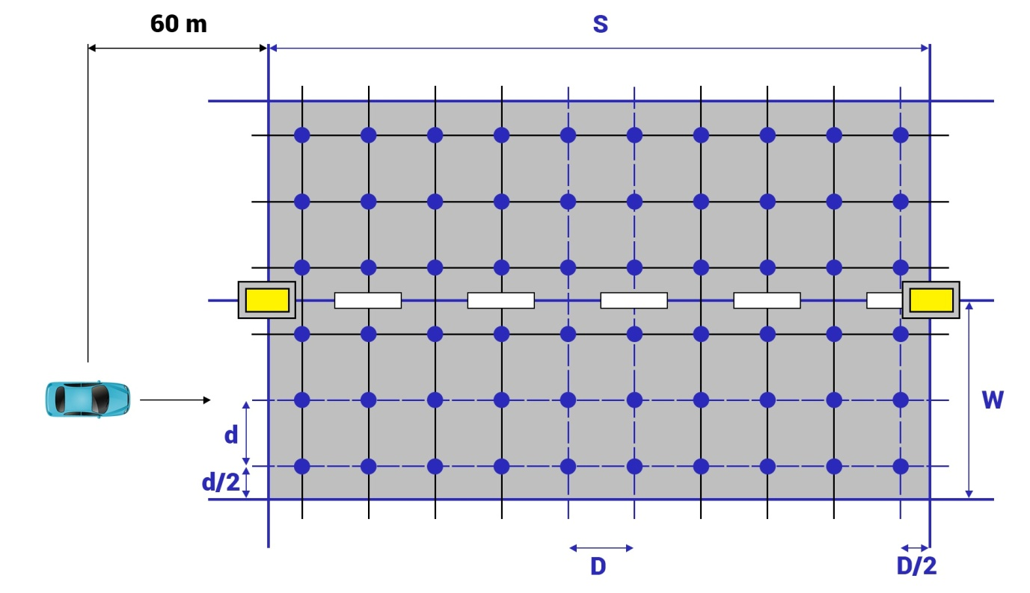
Figure 6 – Calculation grid for calculating the parameters on the road in the tunnel (first half of threshold zone and interior zone)

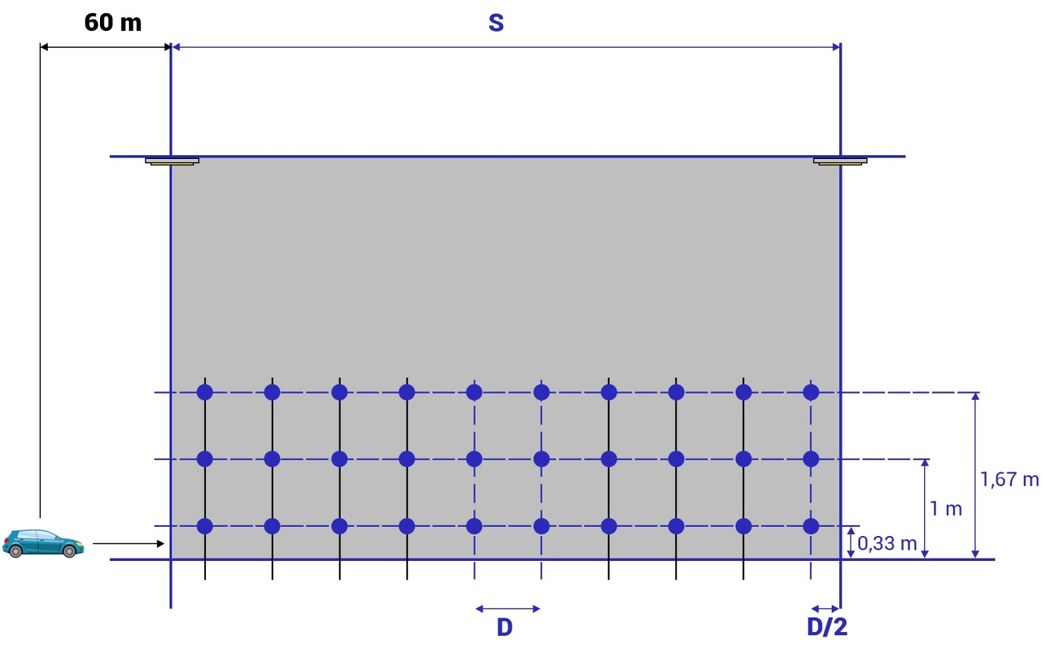
Figure 7 – Calculation grid for calculating the parameters on the wall in the tunnel (first half of threshold zone and interior zone)

Tunnel wall lighting
The walls of the tunnel form a part of the background for detecting obstacles in the tunnel, contribute to the level of adaptation and to visual guidance. For that reason, the luminance of the walls is an important element of lighting quality in the tunnel. The recommended average wall luminance values for individual zones in the tunnel depending on the lighting class are specified in Table 9 [TNI CEN/CR 14380].
Table 9 – Lowest average wall luminance values for individual zones
Lighting class | Average wall luminance up to a height of 2 m
4 | 100% of the average road luminance
3 | ≥ 60% of the average road luminance
2
1 | ≥ 25% of the average road luminance

Uniformity of luminance
The prescribed uniformity of luminance must be ensured on the road surface and walls up to a height of 2 m. The road and lower part of the walls serve as a background for tunnel users, so they are evaluated the same way.
During the daytime, the uniformity of luminance for various lighting classes must meet the values specified in Table 10 [TNI CEN/CR 14380]. The values are applicable for the entire width of the tunnel, i.e. for the lane(s) and for the emergency lanes, if located in the tunnel, for the first half of the threshold zone and interior zone. The overall uniformity U₀ and longitudinal uniformity U_{l} are not evaluated in zones in which the luminance level increases or decreases (second half of the threshold zone, transition zone, exit zone), because no uniformity values are defined for the given zones.
Table 10 – Lowest values for the uniformity of luminance of the road surface for the threshold zone, interior zone, emergency lanes
Lighting class | U0 | Ul
4 | 0.4 | 0.7
3 | 0.4 | 0.6
2 | 0.3 | 0.5
1 | - | -

For tunnels of lighting classes 4, 3 and 2, the uniformity of luminance at night must meet the same requirement as in the daytime. This also applies to tunnels longer than 100 m which are not illuminated during the daytime.

Requirements for adaptation road tunnel lighting
Adaptation lighting in road tunnels includes the lighting of the zones where the driver’s vision adapts. These zones include the threshold, transition and exit zones.

3.10.1 Requirements for threshold zone lighting
To limit the black hole effect and meet the minimum requirements for achieving adequate visibility of obstacles in the threshold zone, the luminance of the threshold zone must achieve certain minimal values. These values depend on the luminance of the approach zone L₂₀. The average luminance value which the road surface luminance may not fall below should be determined for the entire width of the tunnel, i.e. for the lane(s) and for the emergency lanes, if located in the tunnel. The value of the factor k depends on the design speed and lighting class (Table 11) [TNI CEN/CR 14380].
The luminance of the threshold zone L_{th} can be determined as:
$L_{th}=k.L_{20}$ (8)
where:
k is the ratio of the luminance of the threshold L_{th} and the luminance of the approach zone L₂₀.
The length of the threshold zone is equal to the total stopping distance. In the first half of its length, the constant luminance L_{th} is like at the beginning of the threshold zone. In the second half, the luminance L_{th} must drop linearly to a value of approximately 0.4 L_{th}.

Table 11 – Values of factor k for various design speeds and various lighting classes
 | Design speed (km/h)
Lighting class | ( 50 - 70 ) | ( 80 - 100 ) | ( 110 - 120 )
4 | 0.05 | 0.06 | 0.10
3 | 0.04 | 0.05 | 0.07
2 | 0.03 | 0.04 | 0.05
1 | no requirements (only visual guidance)

3.10.2 Requirements for transition zone lighting
In the transition zone, the luminance level is reduced in accordance with the curve specified in Figure 8 [L6]. The transition zone begins at the end of the threshold zone (t = 0). The decline in luminance at the transition from the transition zone to the interior zone is 3 : 1.
The following relation applies to the drop in luminance level specified in Figure 8 [TNI CEN/CR 14380]:
$L_{tr}=L_{th}{\left(1.9+t\right)}^{-1.4}$ (9)
where:
L_{th} is 100% and t is the time in seconds.
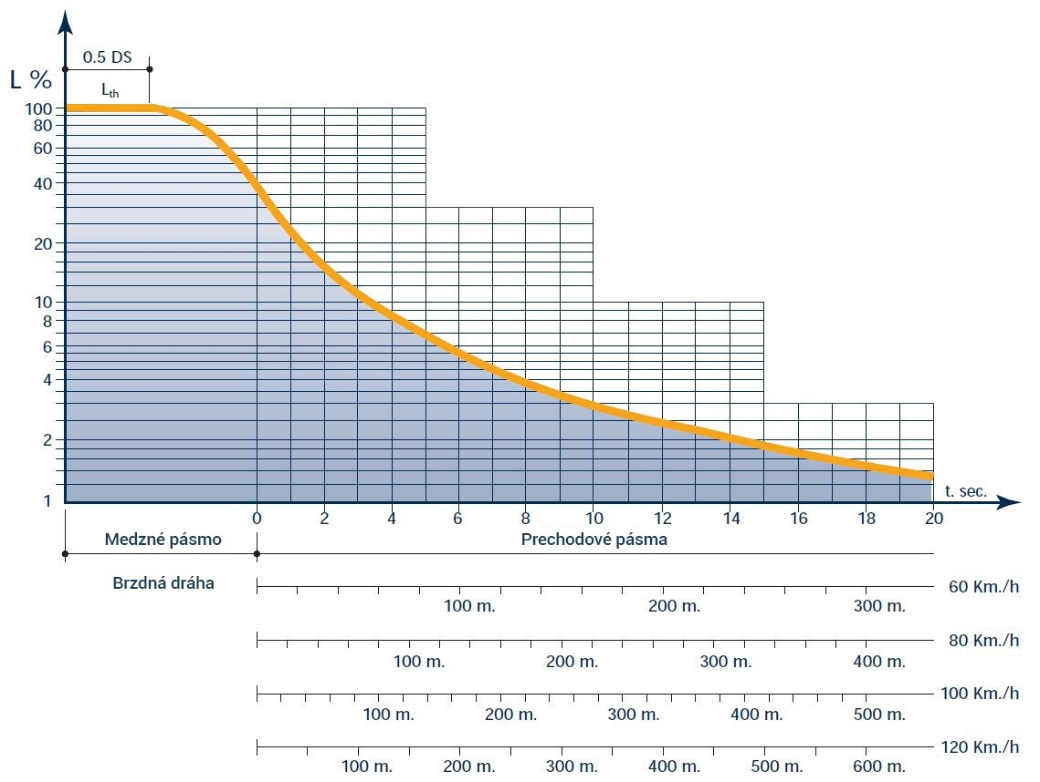
Figure 8 – Luminance curve in the threshold and transition zone
0.5 DS | 0.5 DS
L_{th} | L_{th}
Medzné pásmo | Threshold zone
Brzdná dráha | Braking distance
Prechodové pásma | Transition zones
t. sec. | t. sec.

Requirements for interior (passage) road tunnel lighting
The required maintained road surface luminance values for illuminating the interior zone of a tunnel by day depending on the design speed and lighting class are specified in Table 12 [TNI CEN/CR 14380]. The average road surface luminance is determined for the lane(s) in the tunnel. For lighting classes 1 to 3, specified in Table 13 [TNI CEN/CR 14380], the average road surface luminance in emergency lanes may be lower than in the adjacent lane(s).
Table 12 - Average road surface luminance of the interior zone in cd/m² by day
 | Design speed (km/h)
Lighting class | ( 50 - 70 ) | ( 80 - 100 ) | ( 110 - 120 )
4 | 3.0 | 6.0 | 10.0
3 | 2.0 | 4.0 | 6.0
2 | 1.5 | 2.0 | 4.0
1 | no requirements | 0.5 | 1.5

Table 13 – Average luminance of emergency lane(s)
Lighting class | Average luminance of emergency lane(s)
4 | 100% of the average road luminance in the driving lanes
3 | 50% of the average road luminance in the driving lanes
2
1 | no requirements

If the tunnel is located on an illuminated road or street, it is necessary to maintain the same lighting as in the approach zone inside the tunnel at night. The average road surface luminance of all zones in the tunnel for individual classes may not be less than the values specified in Table 14 [TNI CEN/CR 14380].
Table 14 - Average road surface luminance of the interior zone in cd/m² by night
Lighting class | Average road luminance by night (cd/m²)
4 | 2
3
2 | 1
1 | no requirements

Requirements for lighting road tunnel emergency bays
When lighting an emergency bay which is located in the exit zone of a road tunnel, the light sources used to illuminate the emergency bay must have the same parameters (correlated colour temperature etc.) as the light sources in the adjacent lane(s).
When lighting an emergency bay which is located in the interior zone of a road tunnel, the light sources used to illuminate the emergency bay must have a different correlated colour temperature than the light sources in the adjacent lane(s). The minimum correlated colour temperature interval is at a ratio of 1 : 1.5.
The average horizontal illuminance in the emergency bay must be three times that of the average horizontal illuminance in the adjacent lane(s) if light sources with the same parameters as the light sources in the adjacent driving lane(s) are used to illuminate the emergency bay.
If light sources with different parameters (with a minimum correlated colour temperature at a ratio of 1 : 1.5) are used, then the average horizontal illuminance in the emergency bay must be twice that of the average horizontal illuminance in the adjacent driving lane(s).
The overall uniformity of the horizontal illuminance U₀ in the emergency bay may not be less than the overall uniformity of the horizontal illuminance U₀ in the adjacent driving lane(s).
R_{a} of light sources used to light the emergency bay must be ≥ 60.
When calculating the threshold increase TI in the relevant area, the calculation must also include the luminaires which are used to illuminate the emergency bay.

Requirements for lighting entrances to cross connections in road tunnels
The light sources used to illuminate an emergency exit must have a sufficient colour rendering index to ensure good reproducibility of its green colour R_{a} ≥ 60.
It is mandatory to mark the emergency exit with a pair of luminous II 19a and II 19b traffic signs as per [Z6].
At least one luminous traffic sign no. II 20 a, b, c as per [Z6] must be located at a distance of 2 m away from each emergency exit from both sides. The design of safety signs must be in accordance with the requirements of standards STN ISO 3864-1, STN ISO 3864-4 and STN EN ISO 7010.
The bottom edge of the traffic sign no. II 20 a, b, c as per [Z6] must be 1.0 m to 1.5 m above the walking surface part of the escape route.
The luminous traffic sign no. II 20 a, b, c as per [Z6] must enable three stages of regulation, in which level 100% is active during extraordinary situations, 50% during daytime operation and 25% during night-time operation.
The luminous traffic sign may not have a ratio of the maximum luminance value to the minimum luminance value greater than 10 : 1 for white light or for green light.
The ratio of white light luminance to green light luminance may not be less than 5 : 1 and at the same time may not be greater than 15 : 1.
Green outline luminaires must be available along both sides of the emergency exit doors. A trio of green LED lamps (in accordance with colour class C1 or C2) along both sides of the exit is used to illuminate the emergency exit. These are positioned on the side wall of the tunnel tube (doorframe) at a height of 50 cm, 100 cm and 150 cm above sidewalk level (Figure 9).
The outline luminaires must enable flashing at a flash rate ranging from 0.5 Hz to 2 Hz. Luminous intensity of these luminaires is at least 100 cd in all directions. The outline luminaires must enable at least two-stage regulation. During normal operation, they operate at a level of 25% and at a level of 100% during extraordinary situations.
During normal operation, they must prevent drivers from being dazzled by reducing the maximum luminous intensity of the outline luminaires and luminous traffic signs in the critical radiation characteristic directions specified in STN EN 12676 to a maximum of 40 cd.
The area in front of the emergency exit doors must be visually highlighted by adequate illumination. The area adjacent to the emergency exit must be a different colour than the emergency exit. The maintained value of the average horizontal illuminance in the area in front of the emergency exit doors during an extraordinary situation must be at least 100 lx at floor level with an overall uniformity of U₀ ≥ 0.6. The light sources used must have a colour rendering index of R_{a} ≥ 60. The lighting for the area in front of the emergency exit is turned off during normal operation.
When calculating the threshold increase TI in the relevant area, the calculation must also include the luminaires which are used to illuminate the emergency exit.
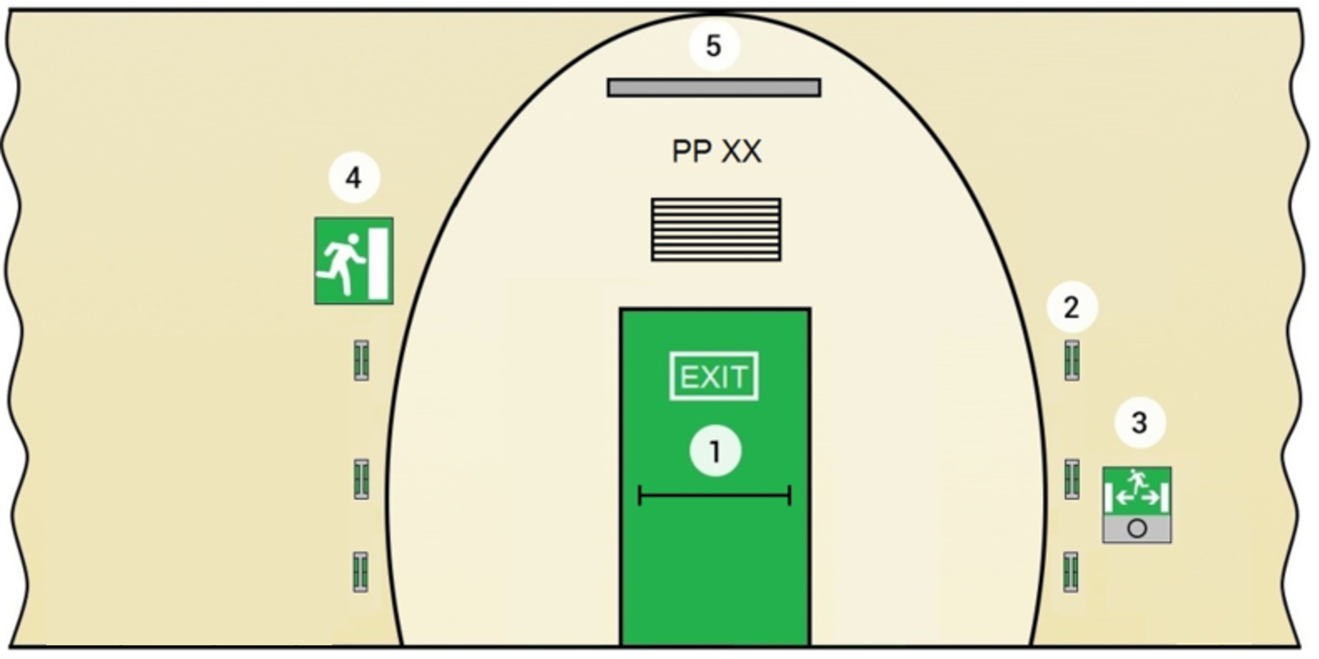
Figure 9 – Sample arrangement of elements for an entrance to a cross connection
1 – emergency exit, 2 – outline luminaire, 3 – combined luminaire for emergency fire lighting and luminous traffic sign no. II 20 a, b, c as per [Z6], 4 – pair of luminous II 19a and II 19b traffic signs as per [Z6], 5 – luminaire for illuminating the area in front of the emergency exit.

Requirements for illuminating cross connections of road tunnels
In case of cross connections in a road tunnel, one must distinguish between cross connections for vehicles and cross connections for pedestrians (Figure 10).
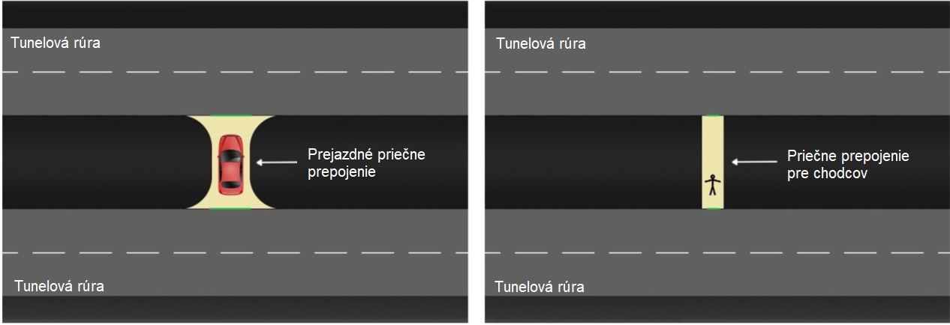
Figure 10 – Vehicle cross connection for (left), pedestrians cross connection (right)
Tunelová rúra | Tunnel tube
Prejazdné priečne prepojenie | Vehicle cross connection
Priečne prepojenie pre chodcov | Pedestrian cross connection

At the time of an extraordinary situation, the maintained value of the average horizontal illuminance of a cross connection may not be lower than the horizontal illuminance on the road in the interior zone of the tunnel tube by day.
The maintained value of the average horizontal illuminance of a vehicle cross connection may not be lower than 100 lx with an overall uniformity of U₀ ≥ 0.4.
The maintained value of the average horizontal illuminance of a pedestrian cross connection may not be lower than 100 lx with an overall uniformity of U₀ ≥ 0.2.
The light sources used to illuminate cross connections must have a colour rendering index of R_{a}≥ 40.
The lighting in cross connections is turned off under normal circumstances. All luminaires must light up in the following cases:

upon changeover to fire mode,

at the direct command of the system operator,

at the direct command of the central control system,

automatically upon opening of the emergency exit doors.
After activation due to any of the above-mentioned cases, the lighting may not automatically turn off; it may only be turned off at the direct command of the operator upon opening as long as nobody is remaining in the cross connection.

Requirements for backup (safety) lighting in road tunnels
If the power fails, drivers must be able to safely exit the tunnel by means of backup lighting of the tunnel tube. Backup lighting in the tunnel tube is ensured by luminaires which under normal circumstances ensure the main lighting of the tunnel tube and are permanently supplied from an uninterrupted power source which ensures its failsafe operation. Part of the passage lighting and selected luminaires in the exit zone to maintain the necessary level of backup lighting. The uninterrupted power source must be dimensioned so as to ensure the same value of passage lighting level as at night.
The backup lighting is also designed in selected utility rooms where an interruption of activities could jeopardise the safety of traffic, technological equipment or service. In such areas, backup lighting must be ensured with a level of at least 10% (at least 15 lx) of the average maintained illuminance with an overall uniformity of U₀ ≥ 0.1.

Requirements for emergency fire lighting in road tunnels
In addition to backup lighting, emergency fire lighting is to be designed which serves as emergency escape route lighting located in the tunnel tube in case of fire and at the same time serves to provide visual guidance to the emergency exit for escaping persons even if the area is full of smoke.
All emergency fire lighting parameters must be designed in accordance with STN EN 16276.
Luminaires which ensure the lighting of the main tunnel tube serve to light the rescue routes in the tunnel as per [T6]. In the event of a power failure, the lighting for the rescue routes in the tunnel tube is ensured by means of backup lighting. The maintained value of the average horizontal illuminance of a rescue route in the tunnel tube must be at least 15 lx with an overall uniformity of U₀ ≥ 0.1.
Destruction of one or more emergency fire lighting luminaires by heat may not cause loss of power and functionality of the entire section of luminaires.
The power supply for the emergency fire lighting must be functional in accordance with [T6].

3.16.1 Escape route in tunnel tube
In any extraordinary situation, the emergency fire luminaires must be activated to ensure lighting for the escape routes and guide escaping persons to the emergency exits.
The minimal level of horizontal illuminance at the axis of an unprotected escape route with a width of up to 2 m between two orientational luminaires should be ≥ 2 lx while maintaining uniformity of E_{min} / E_{max} ≥ 1 : 40. The median strip should be illuminated at half of this value for at least half of its width.
Point light sources are used for this purpose, which are installed in such a manner as to ensure visibility from one luminaire to the next. The maximum permissible distance between emergency fire luminaires may not exceed 25 m; the height of the emergency fire luminaires above the pavement should be in a range of 0.8 m – 1 m.
Emergency fire lighting luminaires may be integrated into luminous traffic signs no. II 20a, b, c as per [Z6].
Provided that the location of the emergency exits is obvious, then in tunnels with two driving lanes, emergency fire lighting luminaires and luminous traffic signs no. II 20a, b, c as per [Z6] shall be positioned on one side of the tunnel tube where the emergency exits are located.
If the tunnel has three or more driving lanes, it is necessary to proceed in accordance with STN EN 16276.

3.16.2 Escape tunnel
During an extraordinary situation, the horizontal illuminance of the pavement in an escape tunnel may not be lower than the horizontal illuminance on the pavement in the interior zone of the tunnel tube by day. The illuminance of the walls must be the same as the average horizontal illuminance on the pavement up to a height of 1.5 m.
The overall uniformity of the horizontal illuminance of the pavement in an escape tunnel must be U₀ ≥ 0.2.
The light sources used must have Ra ≥ 40.
Traffic signs no. II 20a, b, c as per [Z6] marking the distance to the portals must be placed at cross connection openings in the escape tunnel. The bottom edge of the sign must be 1.0 m to 1.5 m above the walking surface part of the escape route.

3.16.3 Lighting for SOS cabins or alcoves
An SOS cabin or alcove must be marked with a luminous traffic sign II 1a as per [Z6] on both sides. The maximum luminous intensity in the critical directions specified in STN EN 12676 may not exceed the maximum value of 40cd during normal operation. The luminous traffic sign must enable three stages of regulation, in which level 100% is active during extraordinary situations, 50% during daytime operation and 25% during night-time operation.
The luminous traffic sign may not have a ratio of the maximum luminance value to the minimum luminance value greater than 10 : 1 for white light or for blue light.
The ratio of white light luminance to blue light luminance may not be less than 5 : 1 and at the same time may not be greater than 15 : 1.
A yellow warning light which is turned off under normal circumstances must be positioned above the traffic sign. The opening of the doors to the SOS cabin must be visually signalled by an intermittent yellow warning light above the entrance to the cabin.
The required value of the average horizontal illuminance in an SOS cabin or alcove is 100 lx with an overall uniformity of U₀ ≥ 0.4. The light sources used must have Ra ≥ 40.
Under normal circumstances, the lighting in an SOS cabin or alcove is operated at a level of 10%. Lighting must smoothly transition to a level of 100%:

upon changeover to fire mode,

at the direct command of the system operator,

at the direct command of the central control system,

automatically upon opening of SOS cabins or alcoves.

After activation due to any of the above-mentioned cases, the lighting may not automatically be reduced to a level of 10%; it may only be reduced at the direct command of the operator upon opening as long as nobody is remaining in the SOS cabin or alcove.

Requirements for illuminating short road tunnels

The need for artificial lighting of short tunnels during the daytime is assessed on the basis of visibility of other road users from a distance which equals the total stopping distance in front of the entry portal as compared to the scene behind the exit portal, which is illuminated by daylight. Artificial lighting is not required if the exit portal forms a large part of the visible scene which is seen beyond other users and objects which appear to be dark compared to the lighter scene of the exit portal. Artificial lighting is required in the daytime if the exit from the tunnel forms a large dark field in which objects may be hidden. This may happen if the tunnel is relatively “long” or if a short tunnel curves in such a way that only part of the exit portal is visible, or if it is not visible at all. A critical factor for drivers approaching from a distance equal to the total stopping distance in front of the entry portal is the clarity of visibility of vehicles, other road users or obstacles. Tunnels shorter than 25 m do not require illumination by day. The necessity of artificial lighting by day must always be assessed for tunnels 25 m – 200 m long. Artificial lighting must always be established in tunnels longer than 200 m.

3.17.1 Illumination of short tunnels by day and by night
Ensuring a suitable means of illuminating short tunnels by day depends on the specific situation and may be done by:

using full entrance zone lighting as in long tunnels; the concept of this method is in accordance with [T20] and [TNI CEN/CR 14380],

using a strip of lighting for a short tunnel in accordance with [T10],

using ‘light pools’ in several places along the tunnel created in the ceiling transferring daylight or artificial light in such a manner that vehicles and other tunnel users can be seen as dark objects against the background of these ‘light pools’; the concept of this method is specified in [T11].

In short tunnels illuminated by daylight, it is necessary at night to maintain the lighting of the tunnel at a constant value for the interior zone as with long tunnels.
Lighting at night is necessary if a short tunnel longer than 25 m is located on an illuminated road, even if the tunnel does not require artificial lighting by day. The luminance inside the tunnel must be at least the same, but not more than twice as great as on the adjacent sections of the open road.

3.17.2 Use of full illumination of the entrance zone

Entrance zone lighting like that in long tunnels is preferable to use to illuminate short tunnels and underpasses. If full entrance zone lighting like that in long tunnels is used, then the need to illuminate a short road tunnel must be researched as long as the below-mentioned tunnel length limit value [L2] is not exceeded:

125 m for a one-way/two-way urban tunnel,

150 m for two-way intercity tunnel with high road traffic intensity or high speed,

200 m for one-way intercity tunnel with high road traffic intensity or high speed,

200 m for one-way/two-way intercity tunnel with low road traffic intensity and low speeds.

Tables 15 to 18 [L2] of these TS must be used to assess the necessity and level of artificial lighting of individual types of short tunnels (urban, intercity, one-way, two-way). The aforementioned tables are based on the visibility of the scene beyond the exit portal. Tables 17 and 18 [L2] are supplemented by the criteria of speed and traffic intensity density.
Table 15 - Urban tunnels
Tunnel length | 0 m – 25 m | 26 m – 75 m |  | 76 m – 125 m |  | over 125 m
Visible exit | Yes | Yes | No | Yes | No | Yes
 | No lighting necessary |  | 50% entrance zone lighting |  | 100% entrance zone lighting

Table 16 - Intercity tunnels with low traffic intensity and low speed
Tunnel length | 0 m – 100 m | 101 m – 150 m |  | 151 m – 200 m |  | over 200 m
Visible exit | Yes | Yes | No | Yes | No | Yes
 | No lighting necessary |  | 50% entrance zone lighting |  | 100% entrance zone lighting

Table 17 - Two-way intercity tunnel with high road traffic intensity or high speed
Tunnel length | 0 m – 80 m | 81 m – 120 m |  |  |  |  |  | 121 m – 150 m |  | over 150 m
Visible exit | Yes | Yes |  |  | No |  |  | Yes | No | Yes
Speed ≤ 70 km/h |  | Yes | No |  | Yes | No
Traffic intensity density ≤ 2 000 vehicles a day in one direction |  | Yes | Yes | No | Yes | Yes | No
 | No lighting necessary |  |  | 50% entrance zone lighting |  |  | 100% entrance zone lighting | 50% entrance zone lighting | 100% entrance zone lighting

Table 18 - One-way intercity tunnel with high road traffic intensity or high speed
Tunnel length | 0 m – 100 m | 101 m – 150 m |  |  |  |  |  | 151 m – 200 m |  | over 200 m
Visible exit | Yes | Yes |  |  | No |  |  | Yes | No | Yes
Speed ≤ 70 km/h |  | Yes | No |  | Yes | No
Traffic intensity density ≤ 2 000 vehicles a day in one direction |  | Yes | Yes | No | Yes | Yes | No
 | No lighting necessary |  |  | 50% entrance zone lighting |  |  | 100% entrance zone lighting | 50% entrance zone lighting | 100% entrance zone lighting

The graphic proportional view method must be used to assess the visibility of the scene beyond the exit portal LTP. A depiction of a short tunnel with points marked which are necessary for calculating the proportional view is provided in Figure 11.
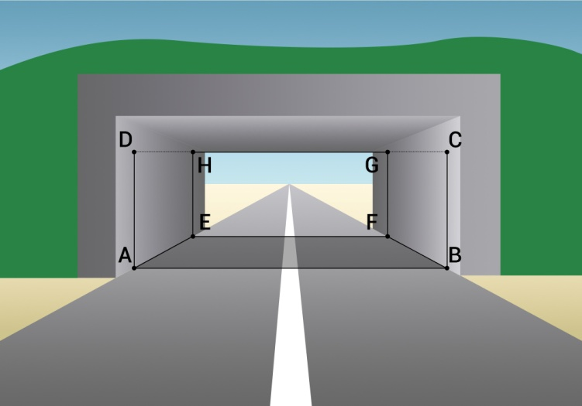
Figure 11 – View of short tunnel

The proportional view is defined as the proportion of the visible area of the exit portal and the visible area of the entrance portal expressed in per cent and depending on:

geometric parameters of the tunnel tube, such as width, height and length (length has a greater influence than width and height),

horizontal and vertical curves in the tunnel tube,

total braking distance,

effect of daylight on the illumination of the entrance and exit portal.

The proportional view LTP is defined by the relation [TNI CEN/CR 14380]:
$LTP=100.\frac{\left(plochaEFGH\right)}{(plochaABCD)}$ (10)
(𝑝𝑙𝑜𝑐ℎ𝑎𝐸𝐹𝐺𝐻) | (areaEFGH)
(𝑝𝑙𝑜𝑐ℎ𝑎𝐴𝐵𝐶𝐷) | (areaABCD)

The reference point for observation is positioned:

on a horizontal line 1.2 m above the road surface,

on the axis of the driving lane (if there are multiple driving lanes, this is determined for each of them, although the most critical situation takes place in the lane closest to the wall),

at a distance equal to the total stopping distance before the entrance to the tunnel.

The tunnel ceiling is not taken into account, because it normally does not form a background which road users or obstacles could merge into. Daylight entering the tunnel shortens the apparent visual length of the tunnel. Therefore, the apparent entrance and exit portal is taken as a basis when ascertaining the LTP. The apparent entrance portal is shifted 5 m into the tunnel and the apparent exit portal 10 m.
LTP for small angles of view, which are depicted in Figure 12 [TNI CEN/CR 14380] can be calculated using the following relation [TNI CEN/CR 14380]:
$LTP=100.\left(\frac{β_{u}}{β_{i}}\right).\left(\frac{α_{u}}{α_{i}}\right)$ (11)
where:
- α_{u} β_{u} are the angles of vision for the visible part of the apparent exit portal;
- α_{i} β_{i} are the angles of vision for the apparent entrance portal.
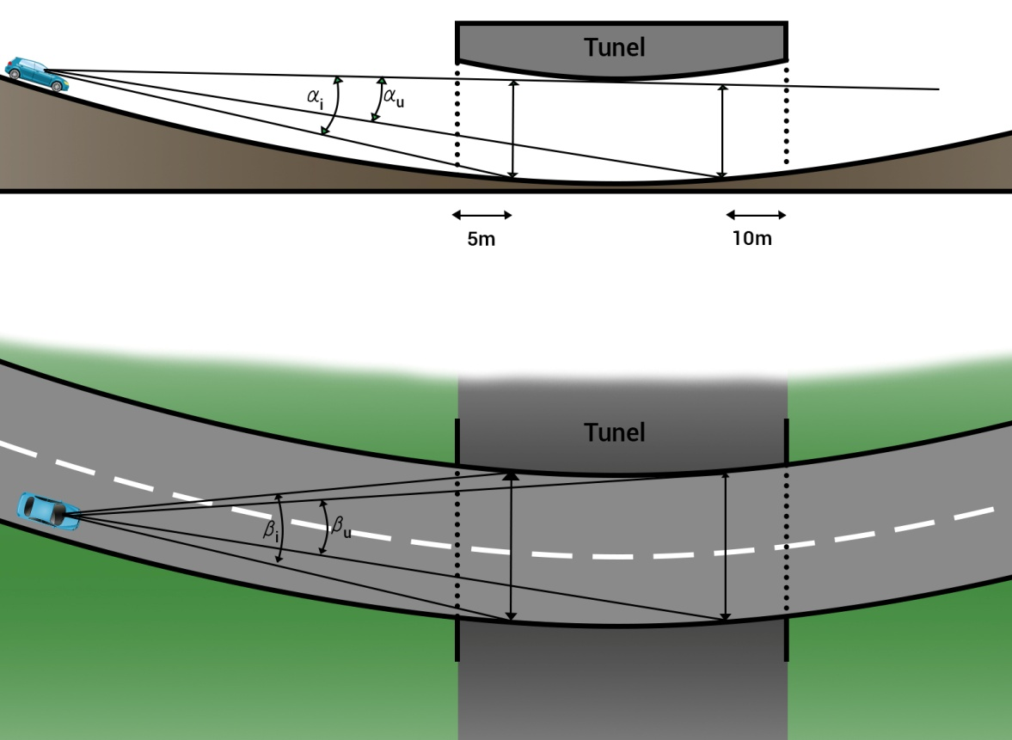
Figure 12 – Proportional view for small angles
Tunel | Tunnel

Based on the calculated values, the following applies:

- at LTP < 20%, artificial lighting is always necessary during the daytime,

- at LTP > 50%, artificial lighting is never necessary during the daytime,

- at 20% < LTP < 50%, the need for artificial lighting during the daytime must be assessed.

The visibility of a critical relevant object must be analysed to decide about the necessity for artificial lighting during the daytime at 20% < LTP < 50%. If motor transportation is the only allowed use for the road, this object is deemed to be a vehicle; in case of mixed transportation, the object consists of pedestrians or cyclists (Figure 13). The critical object is positioned in the centre of the driving lane. In case of a motor vehicle, the critical object is defined as a rectangle with a width of 1.6 m and a height of 1.4 m. In case of pedestrians/cyclists, the critical object is defined as a rectangle with a width of 0.5 m and a height of 1.8 m. In case of a cargo vehicle, the critical object is defined as a rectangle with a width of 2.5 m and a height of 4 m.
Artificial lighting is necessary during the day if at least one of the following conditions is met:

more than 30% of the critical object representing a vehicle cannot be recognised against the apparent exit portal,

more than 30% of the critical objects representing pedestrians/cyclists cannot be recognised against the apparent exit portal.
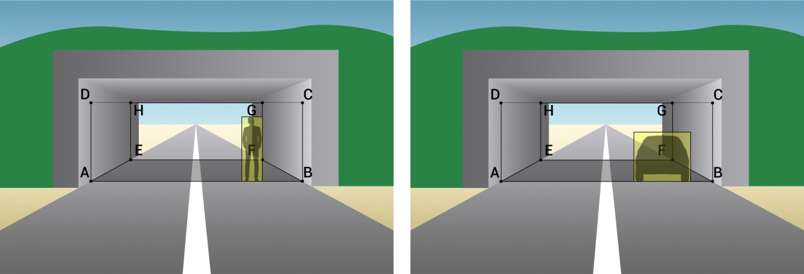
Figure 13 – Visibility of a critical relevant object (pedestrian left, vehicle right)

If it is necessary to illuminate a short tunnel during the day time based on Tables 15 to 18, it is necessary to proceed the same way as when designing the entrance lighting of a long tunnel. The braking distance is determined as per Chapter 3.2, the approach zone luminance ₂₀ as per Chapter 3.3 and the lighting class as per Chapter 3.4.
The threshold zone luminance is determined according to relation 8 and, in case of a result pursuant to Tables 15 to 18, it is adjusted to a level of 50%. Depending on the length of the tunnel after the threshold zone, the transition zone continues as per Chapter 3.10.2. The glare limitation must be in accordance with Chapter 3.6.

Requirements for lighting in areas before tunnel portals
Exterior lighting of the road before the tunnel portals serves at night to adapt the driver’s vision when entering into and exiting from the tunnel. It is necessary to establish exterior lighting in front of tunnel portals at a distance equal to twice the braking distance or max. 200 m before each portal if the road tunnel is located on a road which is not illuminated at night. The average road luminance in the zone before the tunnel portals must reach a value of at least $1/3$ of the average luminance of the road in the interior zone of the tunnel at night. The average road luminance in the zone before the tunnel portals may not be greater than the average luminance of the road in the interior zone of the tunnel at night.
STN 36 0410 defines lighting classes for roads on which only motor vehicles with designation M are present, classes for conflict points where other road users (such as motor vehicles with designation C) may be present, and classes for zones where there are no motor vehicles, or their speed is significantly limited by a P sign.
If the view is less than 60 m or if there are conflict points (intersections, cyclists and pedestrians, reduced number of driving lanes, reduced lane width) where lighting class M cannot be applied, it will be necessary to apply lighting class C.
Minimum requirement for photometric factors are defined for the individual lighting classes. In the case of lighting class M, the overall uniformity value is given for dry as well as wet road surfaces. Under conditions in Slovakia, only parameters for dry roads are taken into consideration.
Exterior road lighting before tunnel portals must be in accordance with the required parameters specified in STN EN 13201-2. The classification of roads into the specific classes specified in STN EN 13201-2 must be in accordance with STN 36 0410, in which instructions are specified for the authorities in charge of managing and operating the individual roads.
The lighting system on the road cannot be replaced by other lighting, such as lighting from shop display cases, advertising equipment and similar.

Requirements for requirement guidance lighting
Road guidance lighting in a tunnel is established by positioning active two-way LED road studs. The active road stud should be made so that the colour of the radiated light is yellow from one side and white from the other side in accordance with colours of class C1 or C2 (Table 1, 2).

In the threshold zone of the tunnel, active LED road studs are installed on the edges of the emergency sidewalks approx. 100 mm from the edge of the road at constant intervals of 12.5 m.

In the other zones of the tunnel, active LED road studs are installed on the edges of the emergency sidewalks approx. 100 mm from the edge of the road at constant intervals of 25 m in the centre between the emergency fire lighting luminaires or combined emergency fire lighting luminaires and traffic signs no. II 20a, b, c (Figure 14).

The active LED road stud control system must enable regulation in at least three stages. In case of an extraordinary situation, they are operated at 100%, at 50% during normal operation by day and at 25% during normal operation by night. The control system must allow slow (0.5 Hz) and rapid (2 Hz) flashing. It also must provide options for keeping them continuously turned off and for individual sides of the active road studs to be continuously turned off.
During normal operation, the drivers must be prevented from being dazzled by glare by keeping the maximum luminous intensity of the LED road studs in critical directions to a maximum of 40 cd.
White retroreflective road studs positioned in the centre of the gaps of the longitudinal interrupted lines are used to supplement the active guide lighting in the tunnel (Figure 14).
The positioning of the retroreflective road studs in individual tunnel zones and the requirement for their technical lighting characteristics must be in accordance with [T1].

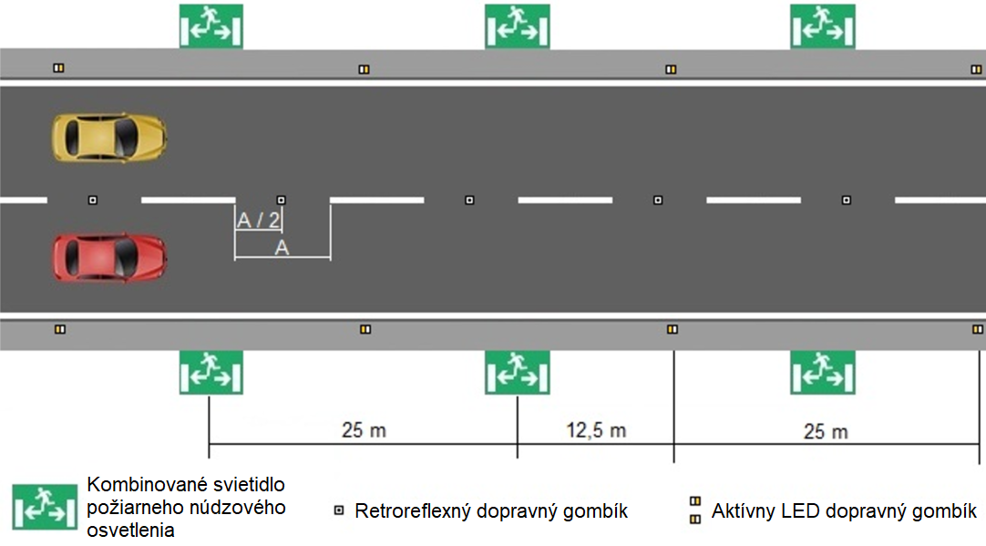

Figure 14 – Placement of guidance lighting elements and orientational luminaires
Kombinované svietidlo požiarneho núdzového osvetlenia | Combined emergency fire lighting luminaire
Retroreflexný dopravný gombík | Retroreflective road stud
Aktívny LED dopravný gombík | Active LED road stud

Requirements for lighting interior work areas in road tunnels and associated objects
The design of lighting systems in interior work areas should best reflect the needs of the people staying in these areas and performing specific visual tasks. The characteristics of the lighting systems in workplaces are assessed to evaluate the lighting in work areas in accordance with [Z1].
Persons’ stays in work areas are defined as follows in [Z9]:

long-term stay,

short-term stay,

occasional stay.

The levels of overall maintained lighting intensity defined in terms of persons’ stays in the work areas are taken into consideration based on this information. For long-term stays, it is necessary to consider before making the actual design whether the area has sufficient or partial daylight, or whether it has no daylight at all. This fact is important because, if persons will be staying for a long time, it will be necessary for the workers to have the greatest possible access to daylight wherever possible. In case of long-term stays, the overall maintained illuminance values in the work area are to be distinguished as follows:

200 lx for areas with sufficient daylight,

500 lx for areas with composite lighting,

areas with no daylight: 1500 lx or 500 lx, if backup measures are demonstrably ensured.

For short-term and occasional stays, the overall maintained illuminance levels are not distinguished for areas with sufficient daylight, composite light or areas with no daylight, because people move in these areas to a sufficiently low degree, so a lack of daylight will not significantly affect the workers’ health. The overall maintained illuminance values for short-term and occasional stays are:

short-term stay – 100 lx,

occasional stay – 20 lx.

The overall maintained illuminance values must be assessed on a reference plane. This lighting intensity should ensure that the entire area is illuminated so as to meet the minimum requirements of the decree. A second indicator, which takes into account the spatial positioning of the lights in the entire work area, is the uniformity of lighting, defined as the ratio of the minimum illuminance value on the calculation grid to the average lighting intensity value on the calculation grid, and this must be greater than 0.5 for the entire area in question. The overall lighting fulfils the function of good orientation for workers in the area for the entire workstation of the area in question. The reference plane is defined in [Z9] at a height of 0.85 m, except in cases in which the specific function of the area requires a different height. For passages in buildings, the reference plane is at floor level.
Sufficient daytime lighting as defined by [Z9] must be determined using the daytime illuminance factor (symbol D) on the reference plane at a height of 0.85 m; for various cases of light opening placement in the work area in questions, the minimum daytime illuminance factor values are as follows:

with side lighting D_{min} = 1.5%,

with top and combined lighting D_{min} = 1.5% and Dm = 3%,

where:
D_{min} is the minimum daytime illuminance factor value on the reference plane [%],
D_{m} is the average daytime illuminance factor value on the reference plane [%].

These minimum requirements pertain to the total work area in question at which the subsequent technical artificial lighting is to be carried out. In some work areas, if possible, the parts of the work area with defined functions which may have different requirement for the level of overall maintained illuminance may be different can be determined, again with consideration to the level of daylight in the given area. Afterwards, these lighting intensities apply to these parts with defined functions. If it is possible that the areas may have multiple parts with defined functions, such as with sufficient daylight, composite lighting, or without daylight, fulfilling the requirement of [Z9]. However, this is possible if the part of the work area with a defined function has more than 10 m² or $1/3$ of the floor area, whereby if it is under 10 m², then the part with a defined function is not defined.

After determining the overall maintained illuminance in the area as per [Z9], it is necessary to verify the minimum requirement for the workstation according to STN EN 12464-1 for interior workstations to which [Z9] refers. STN EN 12464-1 defines the minimum requirement for a specific type of area, visual task or activities carried out at the workstation. The minimum requirements for the selected work areas are specified in Table 19.
At places of visual tasks, it is necessary to also consider lighting of the immediate surroundings of the workstation defined as a strip of at least 0.5 m around the place of the visual task with an overall uniformity of lighting the same as at the workstation, in which it should be at least U₀ ≥ 0.4. The average lighting value of the immediate surroundings must be in accordance with Table 20.
Lighting of a large part of the area which surrounds the place of the visual task is required in interior workstations. This area, called the background, is defined as a strip with a width of at least 3 m, established in the immediate vicinity of the task, at the boundaries of the interior area. This area must be illuminated so that the maintained illuminance is at least $1/3$ of the value of the immediate vicinity with a overall uniformity of lighting of U₀ ≥ 0.1.
The reference plane of the place of the visual task may differ from the reference plane for the overall maintained illuminance; therefore it is necessary to consider the calculation area on the level above the floor of the place where the visual task is being carried out. In some cases, the reference plane may also be inclined. The selection of light colour is a question of psychology, aesthetics and that which is considered to be natural. The selection depends on the level of illumination, the colours of the room surfaces and furniture, the local climate and applications.
The lighting of workplaces with display equipment must be suitable for all tasks which take place at the workplace (reading from a screen, reading printed text, writing on paper, keyboard work). Reflections on the screen and sometimes on the keyboard as well may cause restrictive and disruptive glare. Therefore it is necessary to select, position and arrange the luminaires so as not to cause reflection of great luminance.
Table 19 - Overview of minimum lighting requirements for selected work areas
Type of area, task or activity | Ēm (lx) | UGRL | Uo | Ra | Special requirements
Passage areas and halls | 100 | 28 | 0.4 | 40 | * Illuminance on floor level  * Ra and UGR same as in adjacent areas  * 150 lx in case of vehicle passage  * Exit and entrance lighting must have a transition zone
Steps | 150 | 25 | 0.4 | 40 | Increased contrast is required on steps
Cargo ramps/areas | 150 | 25 | 0.4 | 40
Buffets, kitchenettes | 200 | 22 | 0.4 | 80
Rest areas | 100 | 22 | 0.4 | 80
Cloakrooms, washrooms, baths, lavatories | 200 | 25 | 0.4 | 80 | In each separate lavatory which is completely enclosed
Staircases and storerooms | 100 | 25 | 0.4 | 60 | 200 lx where people are present continuously
Operating rooms, interior switchgears | 200 | 25 | 0.4 | 60
Writing, typing, reading, data processing, DSE work | 500 | 19 | 0.6 | 80
Control rooms | 500 | 16 | 0.7 | 80 | * Control panels are often vertical  * May require dimmers

Table 20 - Relationship between illuminance of visual task and illuminance of the immediate vicinity
Illuminance of the visual task location (lx) | Illuminance of the immediate vicinity of the visual task (lx)
≥ 750 | 500
500 | 300
300 | 200
200 | 150
≤ 150 | the same as at the visual task location

Requirements for other light-emitting radiation installed in the tunnel in terms of lighting in tunnels and drivers’ visual comfort

Requirements for variable traffic signs
Variable-message signs (VMS) are divided as interrupted and uninterrupted. Uninterrupted VMS are for continuously displaying the traffic signs defined in STN EN 12899. Interrupted VMS are for displaying various information and must meet the requirements specified in STN EN 12966. The main requirements for displaying signs and information are good legibility, visibility and colour contrast.
VMS must be suitable for colour class C1 and potentially C2 (Table 1, 2). Class C2 colour provides better colour contrast.
The technical light parameters of variable-message signs must meet the requirements in STN EN 12966.
VMS must meet the limit luminances for the individual luminance classes in STN EN 12966, depending on the colour of the light radiated.
VMS which are intended for use in a road tunnel have luminance class designation L (T). There is no luminance ratio requirement for luminance classes L (T).
Depending on the purpose of use, VMS must meet the individual beam width classes specified in Table 21 [STN EN 12966], which are measured depending on the given class at the test angles specified in Figure 15 [STN EN 12966].
Proper selection of the combination of beam width, luminance and luminance ratio specified in Table 22 is essential for effective use of VMS [STN EN 12966].
The luminance class of a VMS must be selected in consideration of the installation site (interior or exterior).
The beam width class must be adequate for the necessary recognition time. Disruptive light must be assessed when selecting the beam width class.
To capture drivers’ attention, it is possible to continuously change the information displayed on the VMS (known as ‘breathing’) in the range of luminances specified in STN EN 12966 for individual colours of light, whereby the symbol (sign) being depicted must always be visible and recognisable. When luminances are changed, the luminance level of the VMS for the individual colours may not fall below the minimum level specified in STN EN 12966.

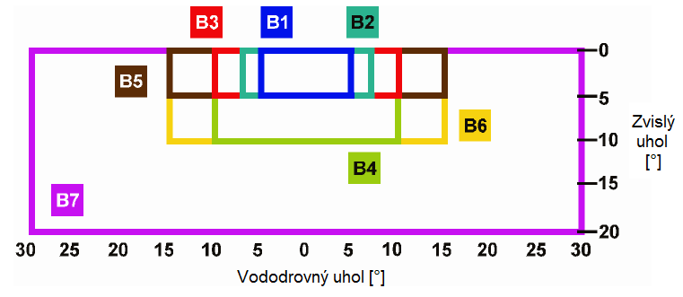
Figure 15 – Comparison of individual beam width classes depending on observance angles
Vododrovný uhol [°] | Horizontal angle [°]
Zvislý uhol [°] | Vertical angle [°]

Table 21- Example of beam width classes
Beam width class | Typical use
B1 | On motorways, in two-lane (plus one hard shoulder) roads, one lane uses a sign installed on the portal above the road traffic, typical size range D and E
B2 | On motorways, in three-lane (plus one hard shoulder) roads, one lane uses a sign installed on the portal above the road traffic, typical size range D and E
B3 | On motorways, in four-lane (plus one hard shoulder) roads, one lane uses a sign or medium-size VMS installed on the portal above the road traffic, a VMS installed on the side of the road requires a larger beam width to cover two lanes, typical size range D and E
B4 | Like B3, the sign is installed at a height, typical size range D and E
B5 | Like B3, but a very large sign covers more than two lanes, typical size range C, D and E
B6 | Like B5, the sign is installed at a height
B7 | For special use where a very wide horizontal and vertical beam widths are required.
NOTE 1: Class B7 should be used on urban streets where the approach speed is slow and the legibility distance is short, which would be of little significance to cyclists and pedestrians
NOTE 2: Class B7 could be used on motorways where an extreme curve in the road should be adapted to a circular motorway feeder road, for example
Note 3: motorway – such motorways on which 85% speed is higher than 100 km/h

Table 22 - Overview of VMS parameter classes
Optical function parameter | Class designation | Notes
Colour | C1, C2¹⁾ | C2 is more limiting
Luminance (La) | L1, L2, L3, L1(*), L2(*),L3(*)²⁾ | L3 has the highest luminance  (*) for specific situations
 | L1(T),L2(T),L3(T)³⁾ | Intended for use in tunnels
Luminance ratio (LR) | R1, R2, R3⁴⁾ | R3 has the highest luminance ratio
Beam width | B1, B2, B3, B4, B5, B6, B7 | B7 has the highest beam
1) If both classes are used for different colours on one VMS, then each colour shall be determined together with colour class
2) Only one luminance class may be used
3) The requirements for classes in tunnels are summarised in classes L1, L2, L3
4) Only one luminance ratio class may be specified

Minimum requirements for lighting control systems
The approach zone luminance changes depending on changes in the daylight. In the daytime, the luminance level in the threshold and transition zone is proportionate to the luminance of the approach zone. Therefore, it is essential to have automatic lighting control for the entrance zone. The control process must have a time delay of several minutes in order to avoid short-term changes caused by clouds. In tunnels with a camera detection system, it is necessary to design continuous (smooth) dimming which does not affect the function of the camera detection system when the lighting level changes. The basis of automatic lighting control is the proper positioning and orientation of a luminance meter, which measures the current luminance value L₂₀. A luminance meter with an opening angle of 20° (luminance meter with designation 1 in Figure 16) is centred approximately to one quarter of the height of the entrance portal from a distance equal to the braking distance. The luminance meter must be calibrated in installed position once a year (or more often, depending on the manufacturer’s instructions). The luminance level L₂₀ is measured separately for each portal. If one of the luminance meters measuring the luminance level L₂₀ fails, the value from the other luminance meter shall be used. To correct the currently set level of the entrance zone in light of soiling of the luminaires and tunnel surfaces, it is necessary to place a regulation luminance meter (luminance meter with designation 2 in Figure 16) in the first half of the threshold zone. This luminance meter must also be calibrated in installed position once a year (or more often, depending on the manufacturer’s instructions). The measurement values of the aforementioned luminance meters must be displayed on the associated technological screen in the form of analogue values. A fault condition of the measuring instrument is signalled in the operator’s workstation by generating an alarm, which is accompanied by an associated signal sound. Adaption lighting is possible to control automatically from the operator’s perspective in remote operation mode (on the basis of data from the luminance meter) or by manual setting. Switching the operation selection switch (local/remote) to the ‘local’ position enables the operator to control the adaption lighting directly from the local control panel. Remote control is deactivated during local operation. Switching to local control must be signalled in the CRS.
A change in the lighting level of the interior zone must be continuous (smooth) in road tunnels which are equipped with a camera detection system and may not affect the functioning of the camera detection system. To regulate the currently set intensity level of the interior zone, it is necessary to place a regulation luminance meter (luminance meter with designation 3 in Figure 16) in the interior zone. This luminance meter must be calibrated in installed position once a year (or more often, depending on the manufacturer’s instructions). Transitional lighting is possible to control automatically from the operator’s perspective in remote operation mode or by manual commands. Switching the operation selection switch (local/remote) to the ‘local’ position enables the operator to control the transitional lighting directly from the local control panel. Remote control is deactivated during local operation.

Incremental lighting regulation can be used in individual tunnel zones for tunnels without a camera detection system.

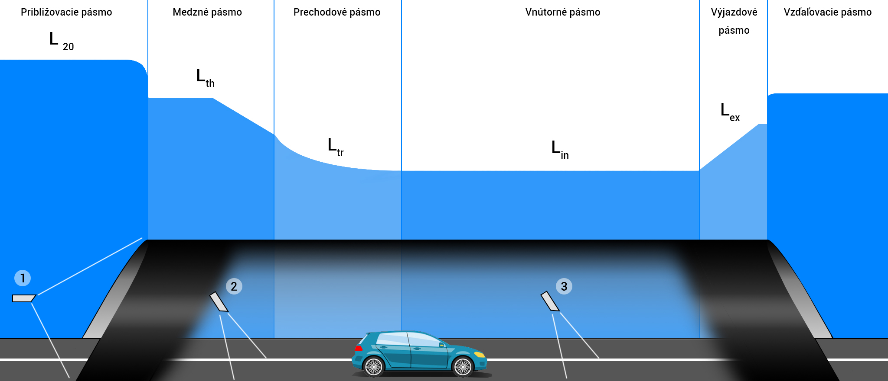
Figure 16 – Recommended arrangement of luminance meters in individual road tunnel zones 1 - exterior luminance meter with opening angle 20° (L₂₀), 2 - interior luminance meter for controlling luminance in the threshold zone, 3 - interior luminance meter for controlling luminance in the interior zone
Približovacie pásmo | Approach zone
Medzné pásmo | Threshold zone
Prechodové pásmo | Transition zone
Vnútorné pásmo | Interior zone
Výjazdové pásmo | Exit zone
Vzďaľovacie pásmo | Departure zone

Guidance lighting must enable three-stage regulation (100%, 50%, 25%) and rapid and slow flashing mode. The guidance lighting is possible to control automatically from the operator’s perspective in remote operation mode (based on the current traffic/operational situation, etc.) or by manual commands for individual sections. Switching the operation selection switch (local/remote) to the ‘local’ position enables the operator to control the guidance lighting directly from the local control unit. Remote control is deactivated during local operation.
Luminous traffic signs must have at least two-stage regulation (100% for extraordinary situations, 25% during normal operation), or three-stage regulation (100% for extraordinary situations, 50% for normal operation by day, 25% for normal operation at night).
Green outline luminaires for marking the emergency exit must have at least two-stage regulation (100% for extraordinary situations, 25% during normal operation), or three-stage regulation (100% for extraordinary situations, 50% for normal operation by day, 25% for normal operation at night).
The luminaire illuminating the floor in front of the emergency exit doors does not require a regulation option, because it is turned off during normal operation.
Emergency fire lighting is possible to control automatically from the operator’s perspective in remote operation mode (in case of fire, on the basis of a signal from the electronic fire system, traffic incident, etc. in accordance with [T5]) or by manual commands for individual sections. Switching the operation selection switch (local/remote) to the ‘local’ position enables the operator to control the fire lighting directly from the local control unit. Remote control is deactivated during local operation.
Escape route lighting is possible to control automatically from the operator’s perspective in remote operation mode (or by opening the doors to the escape routes in case of fire) or by manual commands for individual sections. Switching the operation selection switch (local/remote) to the ‘local’ position enables the operator to control the lighting directly from the local control unit. Remote control is deactivated during local operation.
Rescue route lighting is possible to control automatically (in case of fire) from the operator’s perspective in remote operation mode (or by opening the doors to the rescue routes the tunnel tube) or by manual commands for individual sections. Switching the operation selection switch (local/remote) to the ‘local’ position enables the operator to control the lighting directly from the local control unit. Remote control is deactivated during local operation.
The lighting intensity in the sections before the portals does not have to be regulated. Lighting of the sections before the portals is possible to control automatically from the operator’s perspective in remote operation mode (on the basis of data from the luminance meter, upon transition to night mode) or by manual command. Switching the operation selection switch (local/remote) to the ‘local’ position enables the operator to control the lighting of the sections before the portals directly from the local control unit. Remote control is deactivated during local operation.
Lighting control must be in accordance with [T5]

Minimum requirements for lighting system energy efficiency
It is already possible at present to illuminate all zones in a road tunnel with LED lamps. The rising popularity of LED is due to its ability to significantly reduce energy consumption and, thanks to its superior optical system, simultaneously provide more uniform lighting and a higher colour rendering index than the high-pressure sodium lamps traditionally used in tunnels. LED lamps also provide savings potential with better adaptation to the decline in luminance curve in the transition zone (Figure 8) through the use of continuous lighting control in the threshold and transition zone, which significantly reduces losses caused by excessive illumination. The use of LED technology minimises the costs of replacing light sources, which must be done approximately every 4 years to retain the required parameters when high-pressure sodium lamps are used (Figure 17).
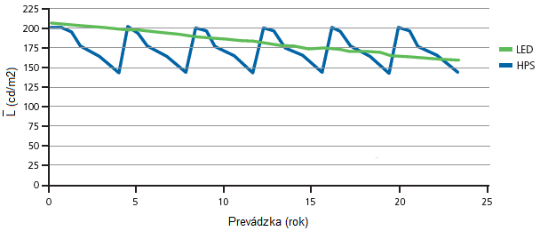
Figure 17 – Dependence of decline in luminous flux in the threshold zone on time of operation
Prevádzka (rok) | Operation (year)
LED | LED
HPS | HPS

The operation time must be recorded for each separately controlled section so that the need to replace the LED light sources can be predicted. The average daily operation time for the individual sections over the course of one day is recorded in a separate data file titled DD/MM/YY/OPERATING_TIME, which must be automatically backed up each day. The average monthly operating time of the individual sections is recorded to a separate data file titled MM/YY/SUMMARY, which must be automatically backed up each month.

Requirements for luminaires for lighting in front of the portal

- Light coverage must be at least IP 66.
- Luminaire ballast power supply exclusively via alternating current TN-S 230/400 V ± 10%.
- The power factor of the entire luminaire at 100% output is min. 0.95.
- In case of dimming, the ballasts must have an active power factor correction circuit.
- The coverings of the luminaires must be designed to effectively protect them from mechanical damage (at least IK06).
- The luminaire must be able to work in the temperature range according to the protocol on the determination of external effects.
- Minimal colour rendering index Ra = 70.
- Correlated colour temperature of LED lamp 2 700 – 5 000 K.
- The luminous flux pf the light source of the proposed LED lamps may not drop below 80% of the nominal luminous flux for a period of 100 000 hours, apply measured values LM-80.
- The luminaire must have a specific output of at least 120 lm/W.
- The luminaire must be equipped with a universal mount (Ø 60 mm) allowing the luminaire to be fastened to the frame of a boom, but also to the top of a steel pole without a boom.
- A CE and ENEC certificate as per EU legislation is required.
- The structural design of the luminaire must be modular, enabling components to be replaced separately.
- The structure of the luminaire must be such that the active light luminous part is mechanically separated from the ballast part.
- The luminaire must be openable without special tools.
- The luminaire must contain technology which prevents moisture from getting into the body of the luminaire.
- Each LED point must be mounted with an optic made of UV-resistant material.
- The luminous flux must be distributed directly without secondary reflections, i.e. without the use of reflectors and similar elements. The luminaire must radiate 100% of its luminous flux into the lower half-space, and 0% into the upper one. (ULOR 0%)
- Luminaire cooling – luminaire body made of aluminium allow, without upper vertical finning, which fulfils the function of a radiator. The luminaire must be passively cooled. The luminaire must be designed so that water drips off it (does not remain on it) and thus self-cleans it.
- The luminaire must have a system to protect it from overheating.
- The luminaire must enable the inclination of the mounting to be adjusted.
- EMC certificate for the use of electronic ballast.
- Test measurement protocol of photometric parameters of the luminaires used from an independently accredited testing laboratory in accordance with STN EN ISO/IEC 17025.
- Test measurement protocol on the temperature dependency of the photometric parameters as per LM-82-12.

Requirements for luminaires for main tunnel lighting

- Light coverage must be at least IP 66.
- Luminaire ballast power supply exclusively via alternating current TN-S 230/400 V ± 10%.
- The power factor of the entire luminaire at 100% output is min. 0.95.
- In case of dimming, the ballasts must have an active power factor correction circuit.
- The coverings of the luminaires must be designed to effectively protect them from mechanical damage (at least IK08).
- The luminaire must be able to work in the temperature range according to the protocol on the determination of external effects.
- Minimal colour rendering index Ra = 70.
- Correlated colour temperature of LED lamps for main tunnel lighting 2 700 – 5 000 K.
- The luminous flux pf the light source of the proposed LED lamps may not drop below 80% of the nominal luminous flux for a period of 100 000 h, apply measured values LM-80.
- The luminaire must have a specific output of at least 100 lm/W.
- A CE and ENEC certificate as per EU legislation is required.
- The structural design of the luminaire must be modular, enabling components to be replaced separately.
- The structure of the luminaire must be such that the active light luminous part is mechanically separated from the ballast part.
- The luminaire must contain technology which prevents moisture from getting into the body of the luminaire.
- The luminaire must be sealed in multiple stages to prevent water or dust from getting in.
- Each LED point must be mounted with an optic made of UV-resistant material and optical covering surfaces must be mounted in front of the LED field.
- The optics of the luminaires must be adjusted for symmetrical and opposite lighting.
- The degree of environmental aggressiveness and mechanical stress on the luminaires is very high in a tunnel, so it is essential for the material specifications of all structural parts of the luminaires which come into contact with this environment (frame, covering including cover/radiator body), including the fastening elements of the luminaires to respect the requirements of the minimum design service life specified in [T4]. When assessing the service of luminaires in accordance with [T4], the additional protection of the luminaires’ surface is not taken into account, only the service life of the material which they are made of itself.
- The luminaire must be passively cooled. The body of the luminaire must have a smooth surface without ribbing.
- The luminaire must have a system to protect it from overheating.
- EMC certificate for the entire LED fixture (definition pursuant to STN EN 13032-4 + A1), including connection cables.
- Test measurement protocol of photometric parameters of the luminaires used from an independently accredited testing laboratory in accordance with STN EN ISO/IEC 17025.
- Test measurement protocol on the temperature dependency of the photometric parameters as per LM-82-12.

Minimum requirements for initial measuring and control measuring of tunnel lighting
The lighting measurement can only be conducted by a testing laboratory accredited in accordance with STN EN ISO/IEC 17025. Before measuring the required lighting parameters in the road tunnel, it is necessary for the testing laboratory workers to familiarise themselves in detail with the road tunnel project documentation, including the positioning of technological equipment in the tunnel. In the case of segments where the geometry of the lighting system changes in order to circumvent an obstacle or in similar cases of a change in lighting system geometry, it may be required to measure the individual lighting parameters in the segment in question.
The individual parameters must be measured on the same point grid as the calculation was conducted on. In cases when the calculation was conducted in accordance with the measurement grid specified in TNI CEN/CR 14380, the measurement must be conducted on a grid with a greater number of points in accordance with STN EN 13201-3.
Before measuring, it is necessary to maintain the minimum lighting time of the individual light sources needed to stabilise their parameters. The minimum lighting time is different depending on the type of light source. Discharge lamps must be in operation for a minimum of 100 h. LED lamps must be in operation for a minimum of 100 h, or as recommended by the manufacturer. The parameters of the lighting system must have stabilised before measuring begins. The lighting system must be in operation for at least 20 min. Stabilisation can be verified by measuring the illuminance at the same point at intervals of several minutes. The lighting system is stabilised when the illuminance value measured at the same point at intervals of several minutes does not show any systematic changes three times in a row. If the lighting mode changes during a measurement (change from night to day), it will be necessary to stabilise the lighting system parameters again.
The individual parameters must be measured in accordance with suitable measurement methods, which are specified in the standardisation documents, international recommendations or scientific articles. The instruments may only be operated by qualified testing laboratory workers who are familiar with measuring methods and procedures.
All calibration sheets for the measuring instruments used for the measurement must be submitted before the measurement is conducted. The testing laboratory must check the condition and functioning of the measuring instruments used before the measurement is conducted.

Requirements for measuring instruments
This chapter describes the measuring equipment used for practical measurements of the photometric parameters of the public lighting of sections in front of portals and the photometric parameters of tunnel lighting during initial and control measurements which are conducted to verify the technical light calculations when designing a lighting system for illumination before the portals and in the tunnel.
Lux meters are used to measure the plane illuminance. These devices are integral measuring instruments where the detector’s sensitivity to CIE function is ensured by optical filters and a cosinusoidal attachment for correcting incident light from directions other than perpendicular. With these instruments, attention must be paid in particular to adjusting the detector to the sensitivity of the photopic or scotopic observer. The less precise the adjustment of this filter is, the greater the error the user will be making during the measurement (Figure 18).

In case of measurement in practice, a lux meter with a sandwich-type photometric head must be used. Attention must be paid to the directional error and the linearity of the entire measuring system to achieve the most accurate results possible. Lux meters in Slovakia belong to the category of controlled measuring instruments by law [Z3] and, depending to the purpose of use, such a measuring instrument is subject to regular metrological control in accordance with [Z8].

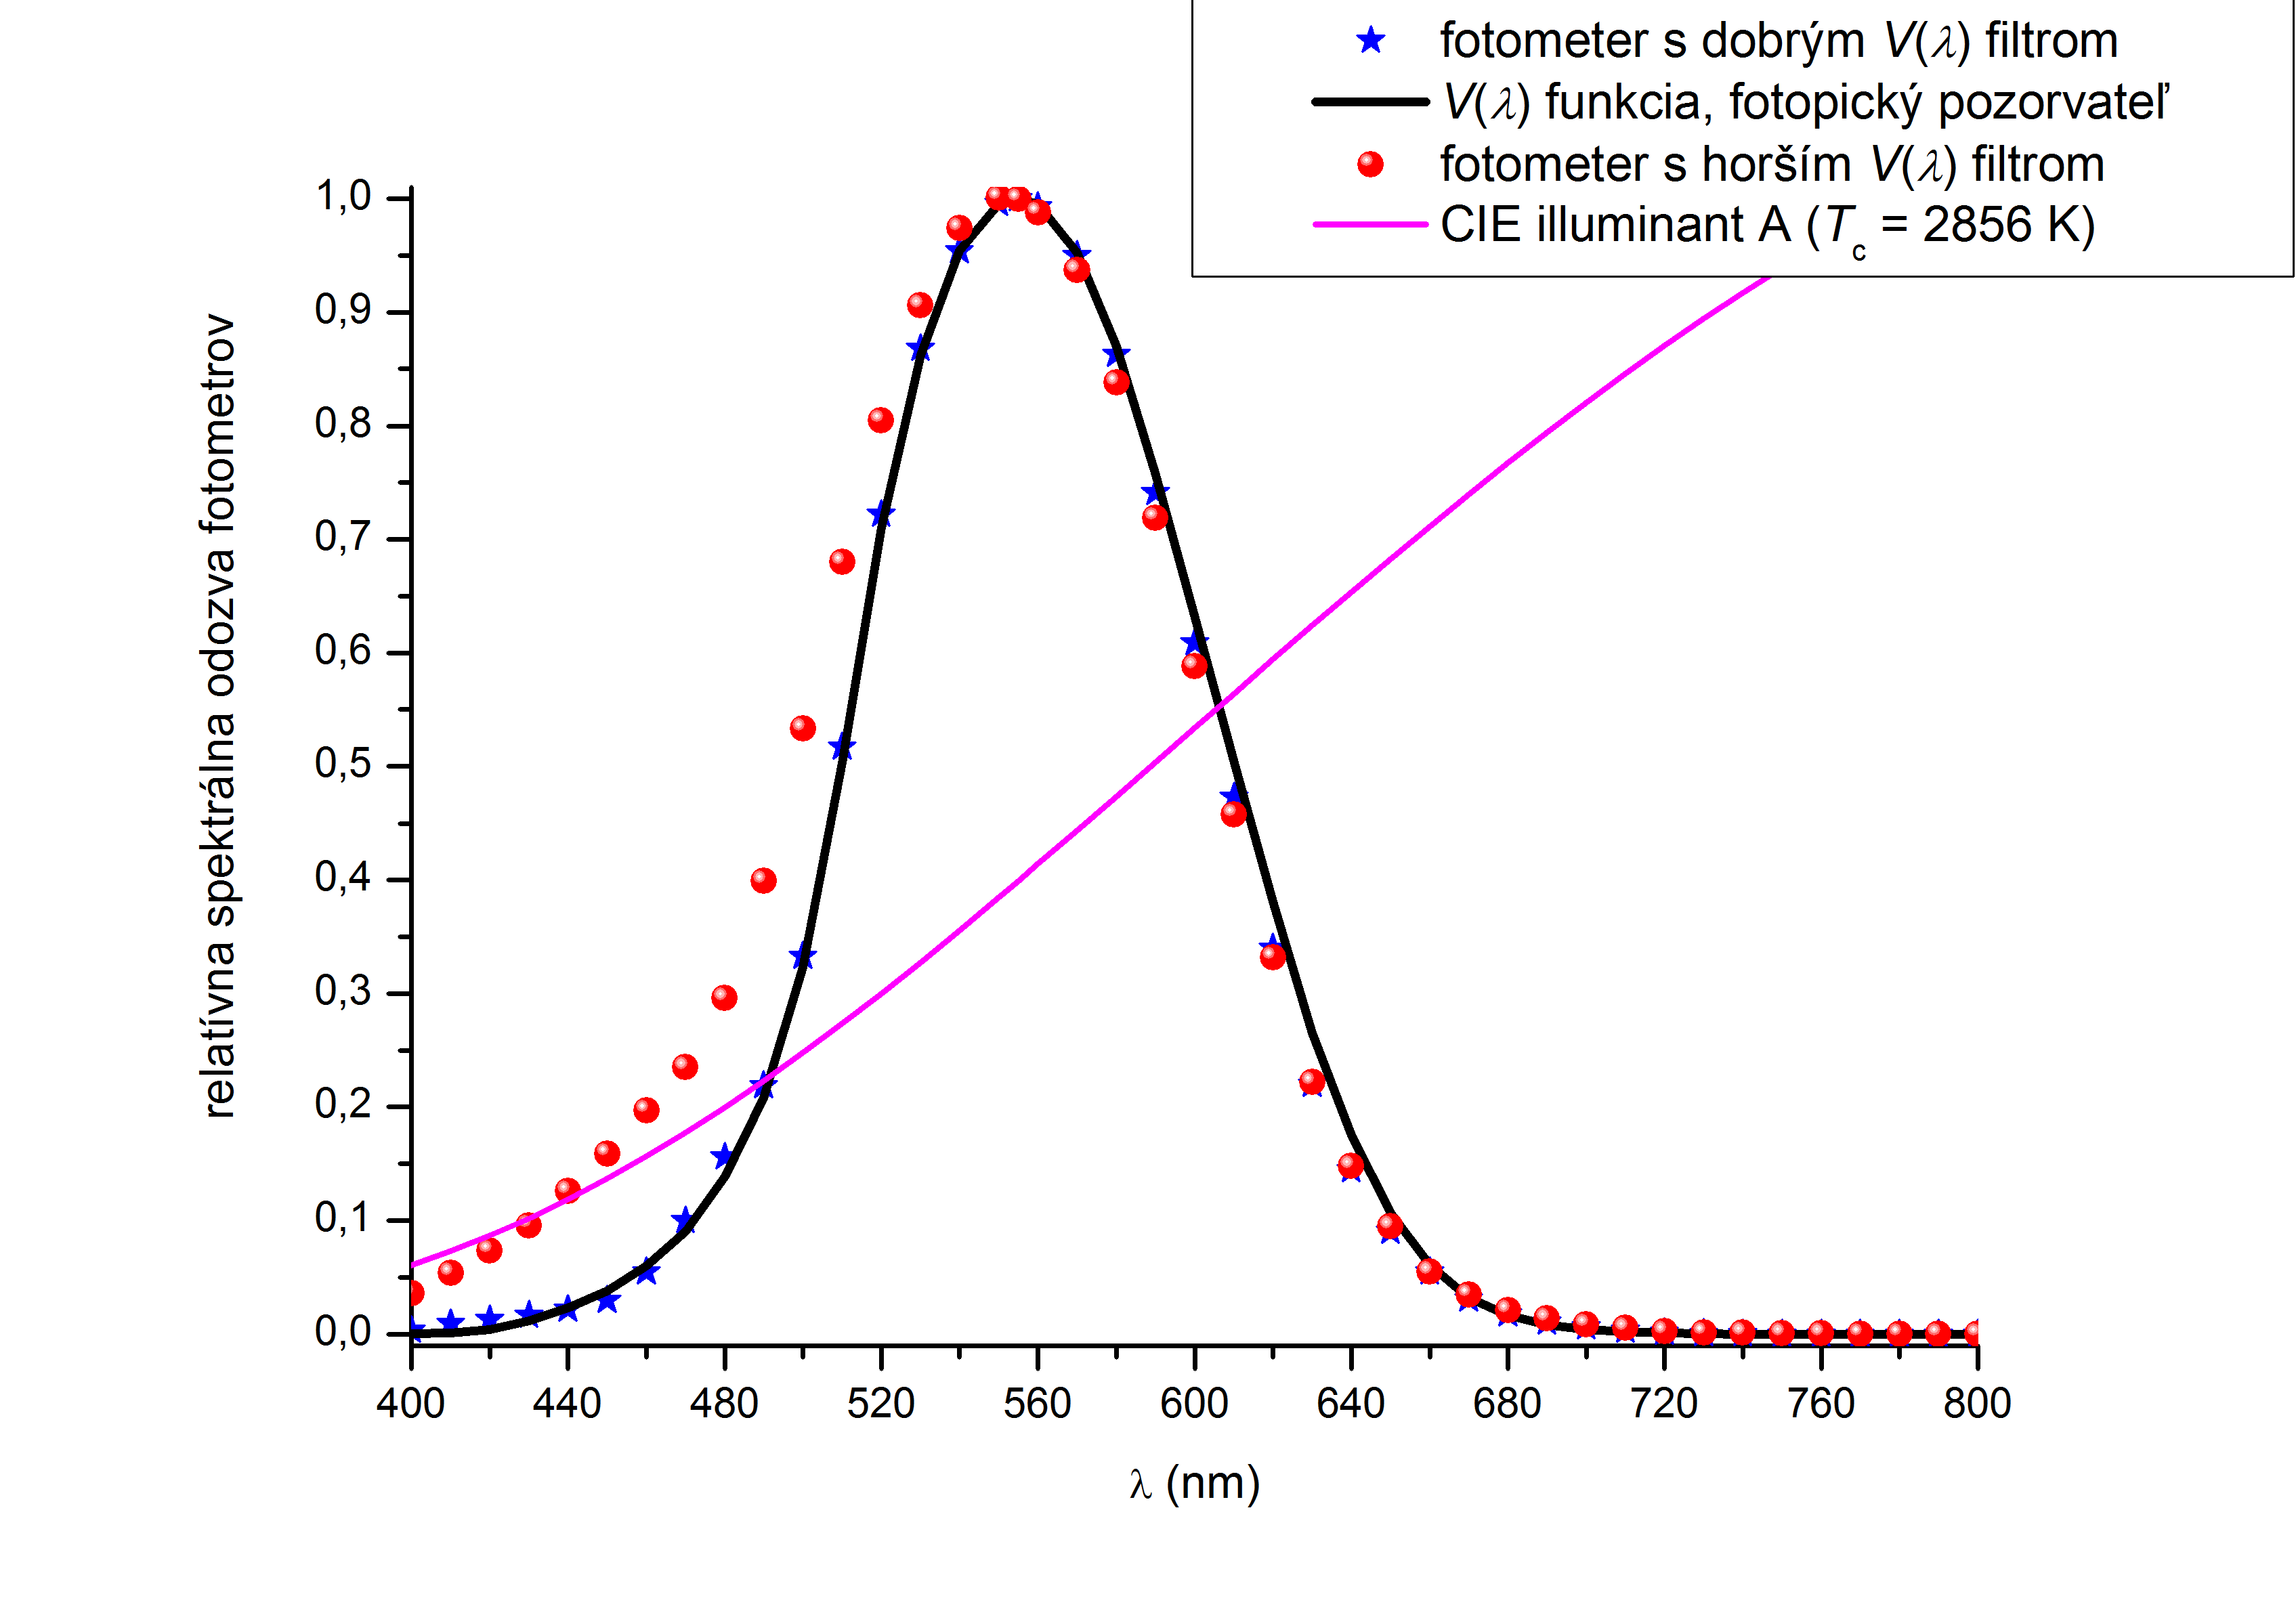
Figure 18 – Comparison of lux meters with various spectral responses
fotometer s dobrým V(λ) filtrom | photometer with good V(λ) filter
V(λ) funkcia, fotopický pozorvateľ | V(λ) function, photopic observer
fotometer s horším V(λ) filtrom | photometer with poorer V(λ) filter
CIE illuminant A (T_{c} = 2856 K) | CIE illuminant A (T_{c} = 2 856 K)
relatívna spektrálna odozva fotometrov | relative spectral response

Luminance is measured using luminance meters with a defined angle of view, which defines the size of the measured area of the measured object. The measurement principle is illustrated in Figure 19.
The quality of the optics (objective, lens) and the selected geometry influence the measured luminance results. As with lux meters, adjusting the optical filter before the detector for the CIE function of photopic or scotopic observer greatly affects the measurement results for various light sources with different spectral compositions.
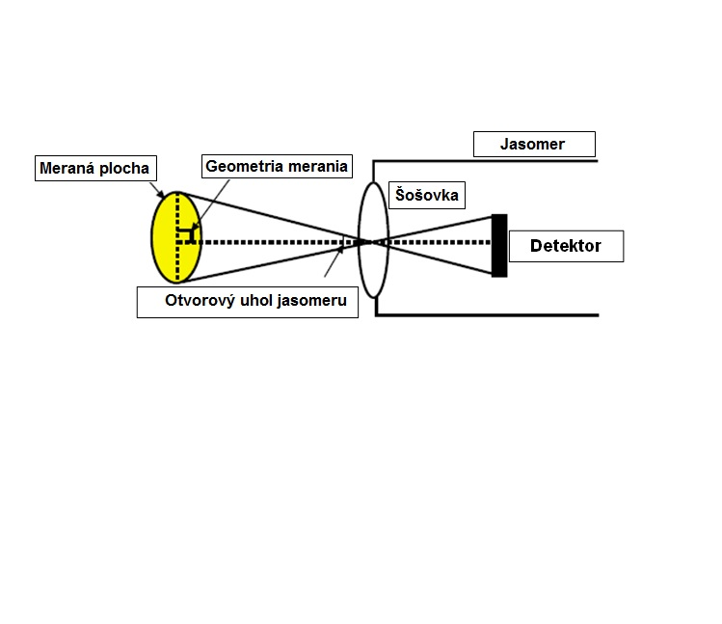
Figure 19 – Luminance measurement principle with a spot luminance meter
Meraná plocha | Measured area
Geometria merania | Measurement geometry
Jasomer | Luminance meter
Šošovka | Lens
Detektor | Detector
Otvorový uhol jasomeru | Luminance meter opening angle

Terrain measurements of the road surface can be carried out with a luminance meter with a defined opening angle of 20’x2’, which, at a height of 1.5 m above road level and a distance of 60 m from the measurement field, should simulate the area perceived by the observer. The measuring instrument’s observation angle must be 89° ± 0.5° to the normal road surface. Measuring the tunnel’s wall luminance requires a luminance meter with an opening angle of 1°. The position of the observer’s eye when measuring the luminance of the approach zone L₂₀ is taken into consideration 1.5 m above the road surface at a distance equal to the total stopping distance before the entrance to the tunnel.
In the transverse direction, the observer must be located at the axis of the tunnel tube. The opening angle of the luminance meter during this measurement must be 20°. Spot luminance meters can be used exclusively for static measurement of the photometric lighting parameters, and only for control measurements of lighting systems for tunnel lighting and lighting before portals.
A special case of a luminance meter which is used to measure the luminance distribution of the measured area is a luminance analyser. This device is currently used to measure luminance on roads and streets for the classes specified in the standard STN EN 13201-2, as well as to measure the luminance of road tunnel surfaces.
There are various types of luminance analysers, based on a common commercial reflex camera, which an RGBG mask on a CMOS element allows a suitable mathematical transformation into a photometric parameter to be obtained. These types of devices require caution, because mathematical interpolation is used when the image is processed, causing certain inaccuracies to appear during evaluation.
The second type is based on a CCD element as the detection part, in which trichromatic spatial filters CIE 1931 x, y are positioned before this element. This type eliminates the adverse effects of mathematical interpolation mentioned in the first case. A diagram of the luminance analyser with a description of the individual parts is depicted in Figure 20 [L5].

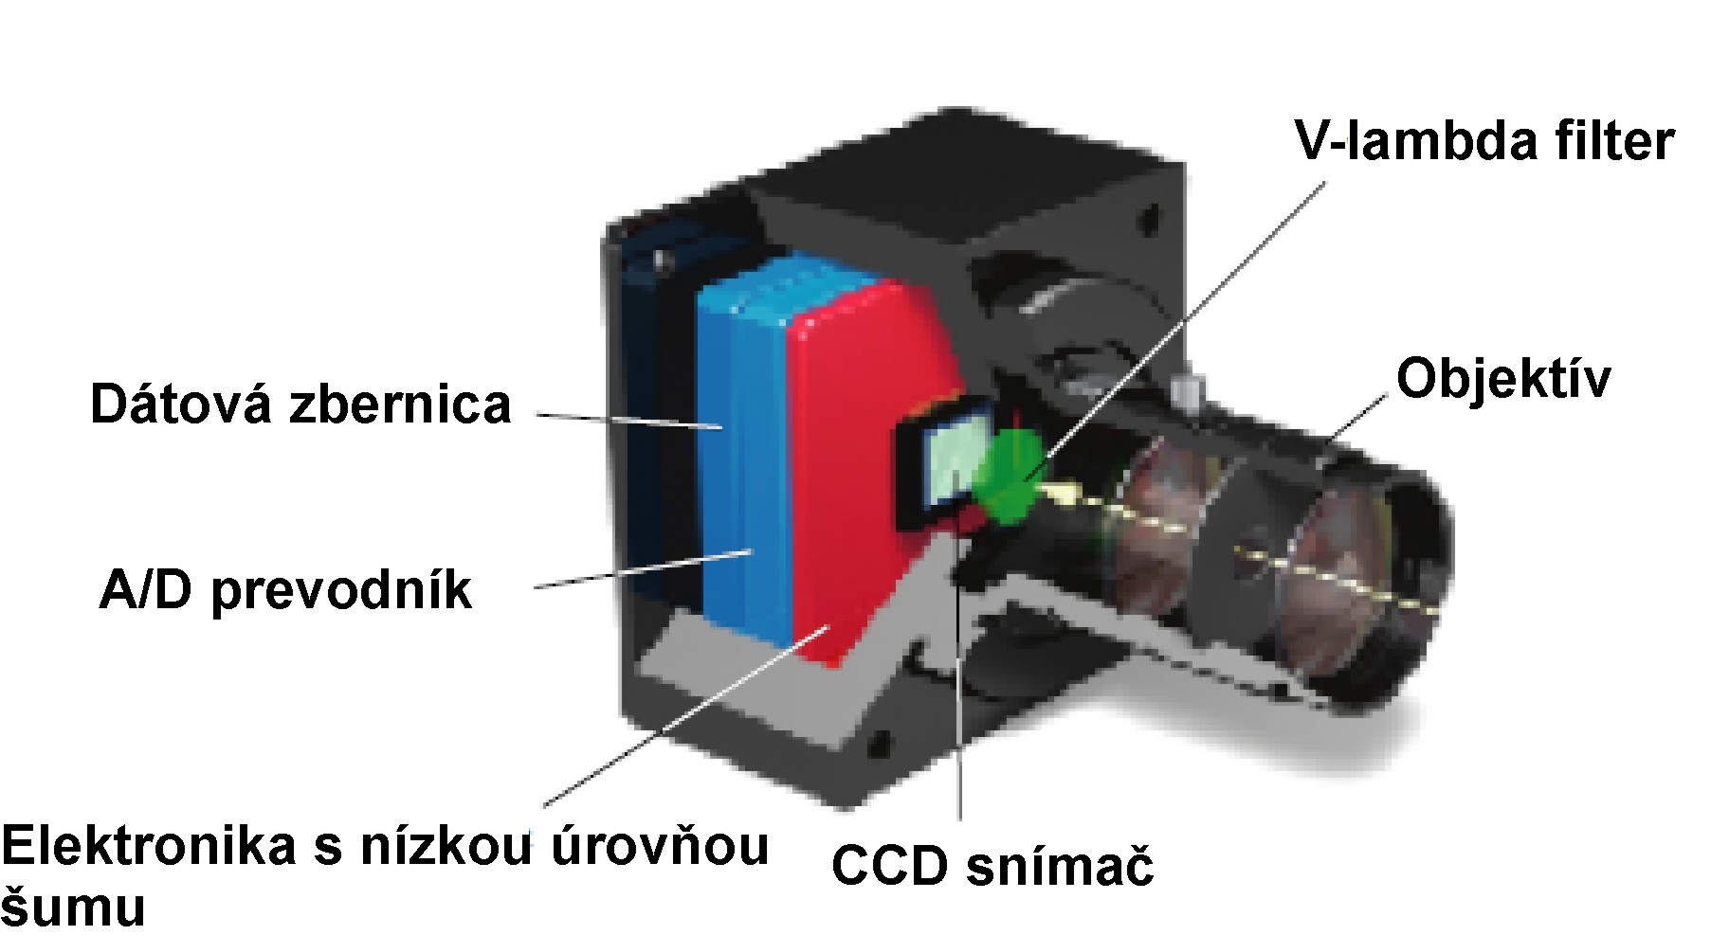

Figure 20 – Diagram of a luminance analyser with trichromatic filters
Dátová zbernica | Data bus bar
A/D prevodník | A/D converter
Elektronika s nízkou úrovňou šumu | Electronics with low noise level
CCD snímač | CCD sensor
Objektív | Objective
V-lambda filter | V-lambda filter

Luminance analysers can be used for static as well as dynamic measurement of photometric parameters of tunnel lighting and lighting before portals in the initial and control measurements specified in Articles 6.2 and 6.3. When using these instruments, it is necessary to consider the conditions of use of these devices for the static and dynamic measurements defined in [T26], which describes in detail the problematic issues of measuring using luminance analysers with respect to laws on optics, as well as static measurements with spot luminance meter.

Requirements for initial tunnel lighting measurement
An initial measurement of the luminance of the individual surfaces in the tunnel must be carried out for each new tunnel or for a tunnel in operation in which a change in lighting system elements has taken place, by means of a static method with the use of a luminance meter with the applicable opening angle or with the use of a luminance analyser. Illuminance measurements require the use of a lux meter with a photometric head for measuring plane illuminance. Initial lighting measurement before putting a road tunnel into operation must include:

illuminance measurement of the road surface in selected sections of all tunnel zones (in 100% and 50% mode), and potentially in conflict sections, which can be determined by a testing laboratory, or by the measurement sponsor,

luminance of the bottom part of the tunnel walls up to a height of 2 m in all tunnel zones, and potentially in conflict sections, which can be determined by a testing laboratory, or by the measurement sponsor,

measurement of the road surface luminance in selected sections before tunnel portals,

horizontal illuminance on the road,

vertical illuminance on the road in selected sections with symmetrical and opposite lighting,

horizontal illuminance in standardised emergency bay(s),

horizontal illuminance before the threshold of an emergency exit,

horizontal illuminance in standardised connection(s) for vehicle and pedestrian access,

horizontal illuminance of an unprotected escape route,

horizontal illuminance on a selected section of an escape route,

horizontal illuminance on a selected section of an escape route outside of the tunnel,

horizontal illuminance in a selected SOS cabin,

horizontal illuminance in workstations,

measurement of power supply for lighting circuits,

measurement of the temperature and humidity during lighting measurement,

measurement of other light-emitting devices which may dazzle drivers, after installation in all critical directions.

The luminance meter or luminance analyser must be positioned 60 m before the measurement field at a height of 1.5 m and the angle of observance must be 1° below the horizontal plane.
When measuring the horizontal illuminance on the road, the photometric head may not be any further than 100 mm from the road surface. When measuring the horizontal illuminance as per [Z9], the photometric head must be at a height of 850 mm. When measuring the horizontal illuminance at a workstation as per STN 12464-1, the measurement must be conducted at the height of the workstation.
When measuring the vertical illuminance, care must be taken to ensure that the photometric head is properly oriented with respect to the direction of traffic and for the centre of the photometric head to be positioned at a height of 200 mm above the ground on a shade with dimensions of 400 mm x 400 mm.
It is recommended to measure the power supply for lighting circuits in 100% mode during the daytime and 50% at night.
Measurements of the temperature and humidity during lighting measurement are recommended to be carried out at hourly intervals.
There must be a documented test report issued by an accredited testing laboratory as per STN EN ISO/IEC 17025 which demonstrates conformity with the applicable standards for each type of luminaire, outline luminaire, signal device and variable traffic sign used in the road tunnel before they are put into operation. On the basis of this report, it can be determined whether the devices in question meet the required parameters and whether or not they will dazzle road traffic participants during operation.

Requirements for tunnel lighting control measurement
Control measurement of the luminance of the individual surfaces in the tunnel must be carried out by means of static or dynamic methods using a luminance analyser. Control measurement via static methods is only conducted in case the tunnel is closed; in this case, it is also possible to conduct the control measurement using a luminance meter with the applicable opening angle. Lighting control measurements must be carried out every 4 years. Static or dynamic measurement must include:

illuminance measurement of the road surface in selected sections of all tunnel zones (in 100% and 50% mode), and potentially in conflict sections, which can be determined by a testing laboratory, or by the measurement sponsor,

measurement of the road surface luminance in selected sections before tunnel portals,

measurement of the temperature and humidity during lighting measurement.

If the tunnel is closed, it is also recommended to add the following points to the control measurement:

horizontal illuminance in standardised emergency bay(s),

horizontal illuminance before the threshold of an emergency exit,

horizontal illuminance in standardised connection(s) for vehicle and pedestrian access,

horizontal illuminance of an unprotected escape route,

horizontal illuminance on a selected section of an escape route,

horizontal illuminance on a selected section of an escape route outside of the tunnel,

horizontal illuminance in a selected SOS cabin,

horizontal illuminance in workstations,

measurement of power supply for lighting circuits,

measurement of the temperature and humidity during lighting measurement.

Illuminance measurements require the use of a lux meter with a photometric head for measuring plane illuminance.

Measurement uncertainty and error
Actual conditions when measuring any variables generally always vary more or less from the ideal conditions. For this reason, every measurement is burdened by errors. Measurement error designated as ε can be defined as the difference of the measured value x and its actual value x₀

$ε=x -x$ (12)

This error is called absolute or actual error. The proportion of the absolute error and the actual value of the measured variable is called the relative error, which is frequently expressed in per cent. Errors in measurements result from various causes during measurement. Therefore, basic errors which occur during measurements are divided into:

systematic errors,

random errors.

Systematic errors are errors which remain constant when the same variable is measured under reproducible conditions. This category of errors includes measuring instrument error, error of method, errors in various data used for the measurement and human error. These errors can be eliminated from the measured result by means of suitable corrections. The value of these corrections may be positive or negative.

Measuring instrument error is an error caused by an imperfection in the instrument. A systematic error caused by a measuring instrument during measurement under defined conditions is called a basic error. A secondary error is caused by a deviation in influencing variables from the prescribed variables. Measuring instrument errors can be eliminated by calibrating or verifying the instrument regularly.

An error of method is primarily caused by imprecision in applications of a certain method or imperfection of the method itself.

Human error is caused by the influences of a human agent (the user of the measuring instrument), such as an error in reading an analogue scale on the measuring instrument, and similar. This error can be eliminated by such means as special training or automating certain tasks during measurement.
When analysing uncertainties in lighting measurements, it is necessary to consider the individual contributions to the uncertainties resulting from the following possible sources of deviations:

uncertainty in instrument calibration (specified in the calibration or verification certificate),

uncertainties resulting from possible deviations in measuring instruments, especially the influence of a spectral, dimensional or linearity error, or an error with the display (or indication device), photometric sensor fatigue, temperature, light modulation, or sensitivity to UV and IR radiation,

uncertainties from errors in the method (procedure) of measurement, in particular through the influence of an error in the spatial and height positioning of the photometric head of the lux meter, luminance meter, luminance analyser, simultaneous reading of measured illuminance values, instable power supply, number and positioning of measurement points,

uncertainties resulting from the evaluation procedure, in particular the influence of an error in rounding, correction for calibration curve, correction for the type of light source measured.

Contributions to the standard uncertainty caused by individual possible sources of uncertainties can be evaluated either as type A uncertainties, designated u_{A}, or type B, designated u_{B}.

If, for a particular source of uncertainty, the lux meter user has a sufficiently large data set (more than 20 measured values) obtained from repeated measurements conducted under the same conditions, this uncertainty contribution can be assessed as type A uncertainty designated u_{A} from the equation for the standard deviation of the mean value from the data set in question according to the relation:

$u=\frac{100}{\overline{x}}.\sqrt{\frac{1}{N.(N-1)}.\sum_{i=1}^{N}{{(x_{i}-\overline{x})}^{2}}}$ (13)

where:
x_{i} is the measured value,
$\overline{x}$ mean (most probable) value from the given set,
N number of repeat measurements.

In other cases, the uncertainty contributions of individual errors are defined as type B standard uncertainties designated u_{B} according to the relation:

$u_{B}=\frac{z_{max}}{κ}$ (13)

where:
$z_{max}$ is the expected maximum deviation for the uncertainty contribution source in %,
$κ$ non-dimensional coefficient given by the probability of the statistical distribution of the observed contribution to the error. For normal Gaussian statistical distribution of errors, $κ$ = 2 is considered for a narrower interval, and $κ=\sqrt{3}=1.73$ for a uniform distribution.

The resulting combined uncertainty $u_{c}$ is determined for all individual uncertainty contributions ascertained according to the relation:

$u_{c}=\sqrt{u_{A1}+u_{A2}+…+u_{B1}+u_{B2}+u_{B3}}$ (14)

In order to increase the probability that the correct value of the variable ascertained appears within a defined interval < -u; +u > given by the determined uncertainty to 95%, the standard uncertainty is multiplied by the applicable coefficient, which determines the expanded uncertainty U. For a 95% probability that the measured variable is located within the defined interval, the standard uncertainty u is multiplied by the coefficient 2 (assuming normal distribution).

$U=2.u(\%)$ (15)
More detailed information on determining measurement uncertainty for the practical measuring of photometric parameters of road surfaces for lighting before a portal and of surfaces for tunnel lighting using the measuring instruments specified in Article 6.1 of these TS can be found in [T26].

Measurement evaluation
The results of each lighting measurement in a road tunnel must be clearly and unambiguously specified in the test report, which must be created in accordance with the applicable standards or regulations, and must include:

mark of accreditation,

report name,

numeration of every page of the report,

name and address of the organisation conducting the measurement,

unique identifier of the report,

name and address of the sponsor,

date and time of test performance,

names of the workers who conducted the measurement,

name, position and signature of the person approving the test report,

name and description of the tunnel,

information on the measuring instruments used,

information on the light sources: type of light source, input power, correlated colour temperature, colour rendering index,

information on the luminaires: manufacturer, type, optical system, luminous flux, installed height, inclination, boom length, quantity, number of non-functional luminaires, number of operating hours,

measurement point distribution,

power supply of the light circuit during measurement,

temperature and humidity during measurement,

results of the measured variables and potential conclusions,

total maintenance factor,

evaluation of the individual measured variables,

expression of measurement uncertainty,

date of acceptance of the test report.

The measured values must be specified in tables. The specified measured values must be based on the characteristics of the measuring instruments according to up-to-date calibration certificates. The measurement uncertainty must be evaluated for each measured parameter in the test report. The measured section must be clearly defined by a designation of the luminaires between which the measurement was conducted, any potential numerical designation of the panels located at the location of the measured section.
The resulting evaluated parameters factoring in the measurement uncertainty must be compared to the currently applicable requirements for road tunnel lighting specified in the regulatory documents and technical specifications. For each parameter, it must be clearly stated whether or not it meets the regulatory requirements in question. The following parameters must be evaluated in the test report before the tunnel is put into operation:

Evaluation of the average luminance of the road surface, overall uniformity, longitudinal uniformity for the selected section in threshold zone (100% and 50% mode).

Evaluation of the decline in luminance of the road surface for the selected section in the transition zone and its comparison with the decline curve as per Figure 10 (100% mode).

Evaluation of the average luminance of the road surface, overall uniformity, longitudinal uniformity for the selected section in interior zone (100% and 50% mode).

Evaluation of the average luminance and overall uniformity of the bottom part of the tunnel walls up to a height of 2 m in all tunnel zones measured.

Evaluation of the average luminance of the road surface, overall uniformity, longitudinal uniformity of the road surface in selected sections before tunnel portals.

Evaluation of the average horizontal illuminance and its overall uniformity on the road in all tunnel zones measured.

Evaluation of the threshold increase.

Evaluation of the luminance coefficient in selected sections with symmetrical and opposite lighting.

Evaluation of the average horizontal illuminance and its overall uniformity in a standardised emergency bay.

Evaluation of the average horizontal illuminance and its overall uniformity before the threshold of an emergency exit.

Evaluation of the average horizontal illuminance and its overall uniformity in a standardised connection for vehicle and pedestrian access.

Evaluation of the average horizontal illuminance and its overall uniformity in an unprotected escape route.

Evaluation of the average horizontal illuminance and its overall uniformity in a selected section of the rescue route.

Evaluation of the average horizontal illuminance and its overall uniformity in a selected section of the escape route outside of the tunnel.

Evaluation of the average horizontal illuminance and its overall uniformity in a selected SOS cabin.

Evaluation of the average horizontal illuminance and its overall uniformity in workstations.

Evaluation of power supply for lighting circuits.

Evaluation of the temperature and humidity during lighting measurement.

The evaluated lighting parameters in the test report of the control measurement must be in accordance with Article 6.3 of these TS.

The minimum requirements and method of conducting inspections and maintenance of road tunnel lighting.
Lighting maintenance requires above all regular cleaning of the luminaire and the tunnel wall. The maintenance cycle is based on the definition of the maintenance factor and determination of its components. Even though the effect of cleaning the tunnel walls may be small as far as the proportion of indirect lighting to the overall lighting of the road surface is concerned, clean walls are desirable, because their higher reflection factor influences the higher luminance contrast, which contributes to better visual guidance. Clean walls increase the average luminance of the walls.
In most cases when designing a lighting system for tunnels, the maintenance factor is defined with a value of 0.7, which means that the maintained illuminance of the road surface should not fall below the value of 0.7 of the initial luminance of a new lighting system. In order to ensure this, it is necessary to order cleaning of the luminaires and tunnel walls according to the instructions in the maintenance plan. The maintenance factor in the scope of design must be determined in accordance with [T21], including all of its components, which depend on the individual intervals for cleaning the surfaces and luminaires. The individual components of the maintenance factor, including the selected maintenance intervals, must be determined in the project documentation for the tunnel.
The maintenance factor is calculated according to the relation:
$MF= L_{LMF}.L_{MF}.L_{SF}.R_{SMF}$ (16)
where:
L_{LMF} is the ageing factor of the light source,
L_{SF} functional reliability factor of the light source,
L_{MF} fouling factor of the luminaire,
R_{SMF} fouling factor of the surfaces.
It is a good idea to clean the surfaces of the walls and luminaires at the same time, so the components of the maintenance factor L_{MF} and R_{SMF} are determined so that these tasks can be performed simultaneously. Every manufacturer specifies the typical luminaire fouling factor values, or they can be derived from publications [T21] depending on the covering of the luminaire. Putting light sources and luminaires into operation leads to their deterioration, which depends on the ageing factor and survival rate of the light sources. The ageing factor is the proportion of the luminous flux of a light source at the given time in its service life and its initial luminous flux. Current data on the ageing factor of the light source is provided by the manufacturer. The functional reliability factor of a light source (light source survival factor) is the proportion of the total number of light sources which remain in operation at the given time under defined conditions, and the switching frequency. The light sources must then be replaced so that burnt out light sources/luminaires do not cause a drop in maintenance factor or uniformity of luminance of the road surface. If these situations occur unpredictably (through the effect of a fault in the light source or upstream device), it is necessary to eliminate the fault in the shortest time possible.
Measuring and adjustment of the luminance meter and maintenance of the entire lighting control and regulation system must be carried out once a year on a regular basis.
A written record specifying the date of maintenance and description of the maintenance tasks must be made on each maintenance.

Monthly inspections
For safe tunnel operation in terms of lighting functionality and timely elimination of any faults which may occur, it is necessary to conduct the following inspections once a month:

Visual inspection of the functionality of the luminaires for the main lighting in the tunnel in 100% mode.

Visual inspection of the functionality of all emergency luminaires when turned on.

Visual inspection of the functionality of all emergency luminaires and other emergency lighting devices when turned off (cleanliness, damage, blackening).

Inspection of the functioning of the central battery system, check for error messages, extraordinary situations.

Briefly test all emergency lighting system, devices by simulating a disruption in the normal power supply source for the lighting. Check whether all devices are functioning properly. When restoring mains power supply, check all power status indicators.

A written record specifying the date of the inspection and the name of the person conducting the inspection must be made on each inspection.

