PHP Event Management System
(php-syslog-ng)

Contents
Contents 3
Tables 4
Figures 5
About This Document 6
History 6
Review 7
Introduction 8
Preface 8
Syslog Overview 9
Operational Goals and Requirements 9
PHP Event Management System 10
Accessing the Interface 10
Logging In 10
Main Menu 11
Log Tables 12
Caching 13
Menus 14
Selecting Hosts 15
Facilities Table 16
Priorities Table 17
Calendar Table 18
JavaScript Help 19
Record Types Table 20
Message Filters 21
Message De-Duplication 22
Submission Types 23
Performing Searches 24
Search Example 24
Search Results Example 25
Cisco Message Descriptions 26
Tail Results 28
Graphing 29
Common Graphs 33

Tables
Table 1 Revision History 6
Table 2 Revision Review 7

Figures
Figure 1 - Accessing the Website 10
Figure 2 - Main Menu 11
Figure 3 - Log Data Selection 12
Figure 4 - Cache Table 13
Figure 5 - Top Menu Items 14
Figure 6 - Hosts Table 15
Figure 7 - Facilities Table 16
Figure 8 - Priorities Table 17
Figure 9 - Calendar Table 18
Figure 10 - JavaScript Help Example 19
Figure 11 - Record Types Table 20
Figure 12 - Message Filters 21
Figure 13 - Filtering Identical Messages 22
Figure 14 - Submission Types 23
Figure 16 - Example Search Filter 24
Figure 17 - Search Results Example (SQL Query) 25
Figure 18 - Message Descriptions 26
Figure 19 - No Message Descriptions 27
Figure 20 - Tail 28
Figure 21 - Graph Filters 29
Figure 22 - Top 10 Results 30
Figure 23 - Pie Slices 31
Figure 24 - Host Message Count 32
Figure 15 - Common Graphs 33

About This
Author/Owner: Clayton Dukes
Change Authority:
Reference Number:

History
Table 1 Revision History
Version No. | Issue Date | Status | Reason for Change
1.0 | Jul 28 06 | C. Dukes | - First Draft
1.1 | Sep 23 06 | C. Dukes | - Scrubbed for Public release

Review
Table 2 Revision Review
Reviewer’s Name | Version No. | Date

Note:
This document was scrubbed for public consumption; therefore the following variables should be replaced:

1. {COMPANY} – Company Name

2. {URL} – URL to access the server

3. {DEFAULTPASS} – Login for the {URL} defined above in the form of: “username/password”

Many of the images have been masked to protect the company that I grabbed these screenshots from.

Introduction

Preface
This document is intended to provide the user with an overview of the PHP Syslog Event Manager. This guide is a simple walk-through of the web interface used to access incoming syslog events to {URL}

We will examine how to login to the website, search for events, gather live event data as well as how to set graphing criteria.

Syslog Overview

Operational Goals and Requirements
Based on the information gathered from various {COMPANY} stakeholders, the functional requirements for managing events between elements are intended to allow {COMPANY} to achieve the following operations goals:
  - Provide fast access to incoming Syslog event data
  - Provide an easy-to-use interface to incoming event data

Given the high-level manageability goals outlined by {COMPANY}, a tool is required to provide insight into incoming event data from various network elements. To that end, this tool was built to provide visibility in near real-time for incoming event data. It can also be used to search on past data.

Log Management (Syslog)

Logging is a critical part of network management. Good logs can help you find configuration errors, understand past intrusions, troubleshoot service disruptions, and react to probes and scans of your network. Cisco devices have the ability to log a great deal of their status.
The scope of Syslog messages typically includes interface, neighbor, node, and network.

NMS North and Southbound API Interfaces
Communication between multiple Network Management Systems is extremely important for event correlation and data aggregation. All NMS’s should be able to communicate bi-directionally. This ensures the ability to provide correlated events as well as the coordination of data sources throughout the network such as inventory, access, performance data, etc.
The PHP Event Management System uses an open systems architecture. On the back end, a MySQL table stores all information about hosts, log messages, date, time, etc. Accessing this information is as easy as performing an SQL query against the database.

PHP Event Management System

Accessing the Interface
To Access the PHP Syslog Event Manager, simply point your browser to {URL}. Upon accessing the URL, you should see a screen similar to the following:

Figure 1 - Accessing the Website
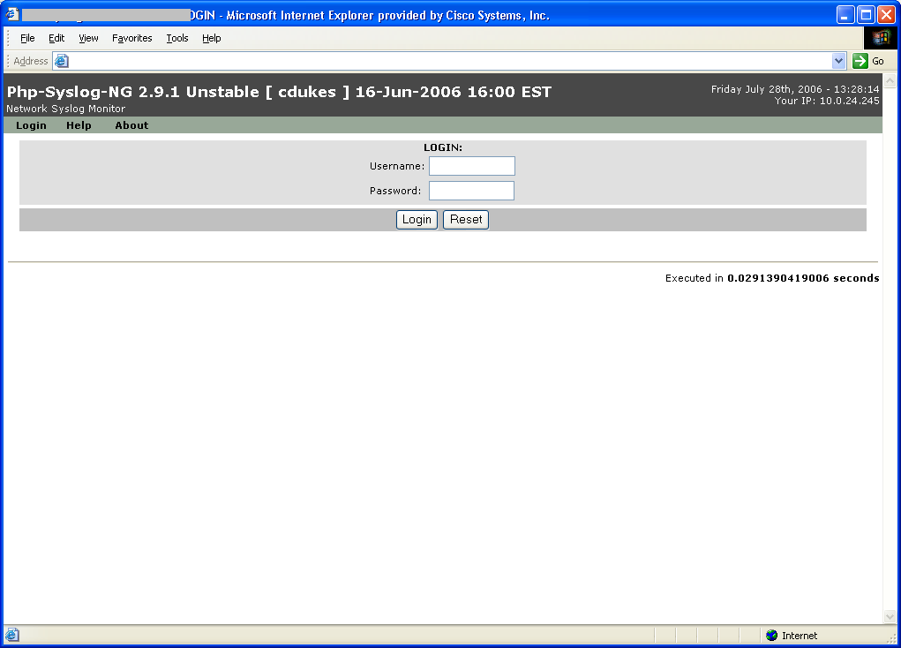

Logging In
The Default login/password combination for all users is {DEFAULTPASS}

Main Menu
After a successful login, you will be presented with a screen similar to the following:
Figure 2 - Main Menu
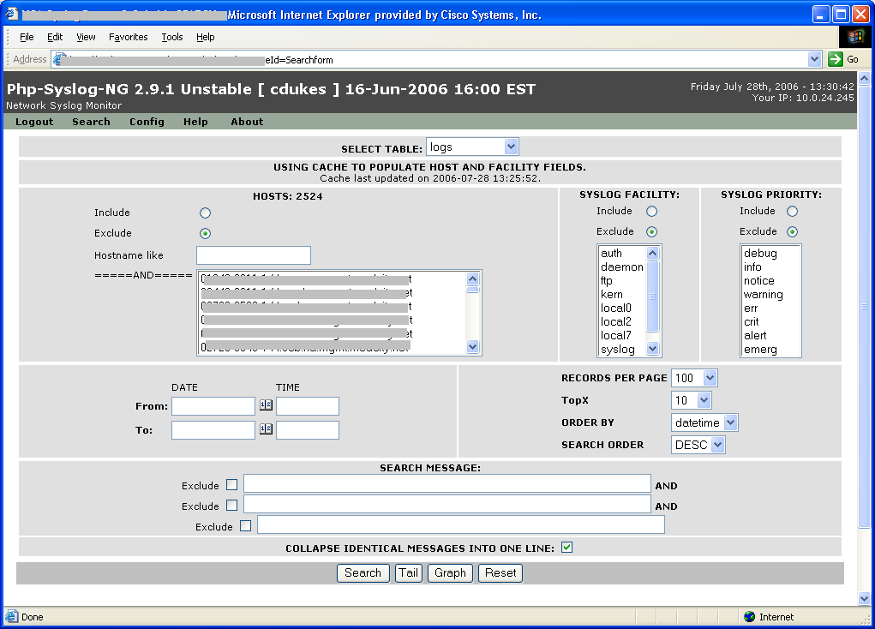

Log Tables
Under the “Select Table” section (See Figure 3), you will notice several drop-down menu selections.
For normal searching, there’s no need to select anything. The default menu selection of “logs” will search all data for the last day. Note that logs are rotated every day at midnight.
If you’d like to search past data, you may select the date from the menu or simply select the “ALL_LOGS” menu item. Note that if you select the “ALL_LOGS” searches will take a considerable amount of time.
Figure 3 - Log Data Selection
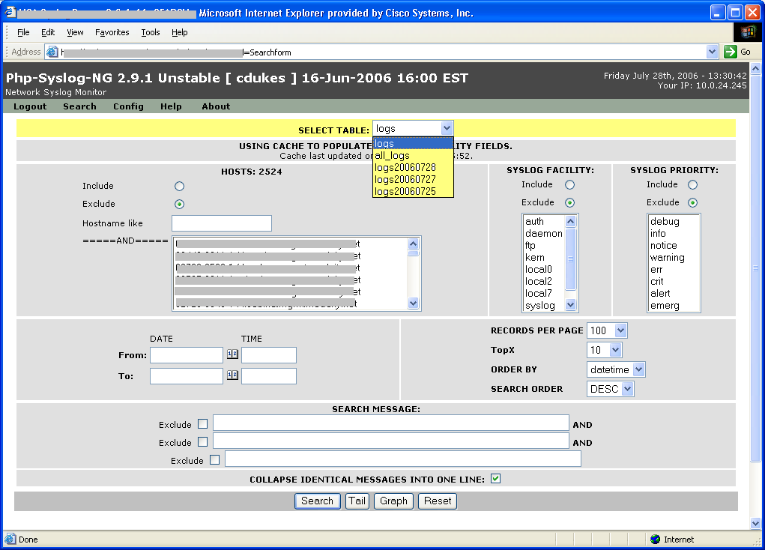

Caching
Some of the data on this server is cached in order to allow faster access to often used items.
The data cache is updated every 5 minutes and updates the host, facility and priority fields.
Note that if a new event comes into the server that has not been seen before, it may take up to 5 minutes before it will be displayed here.

Figure 4 - Cache Table
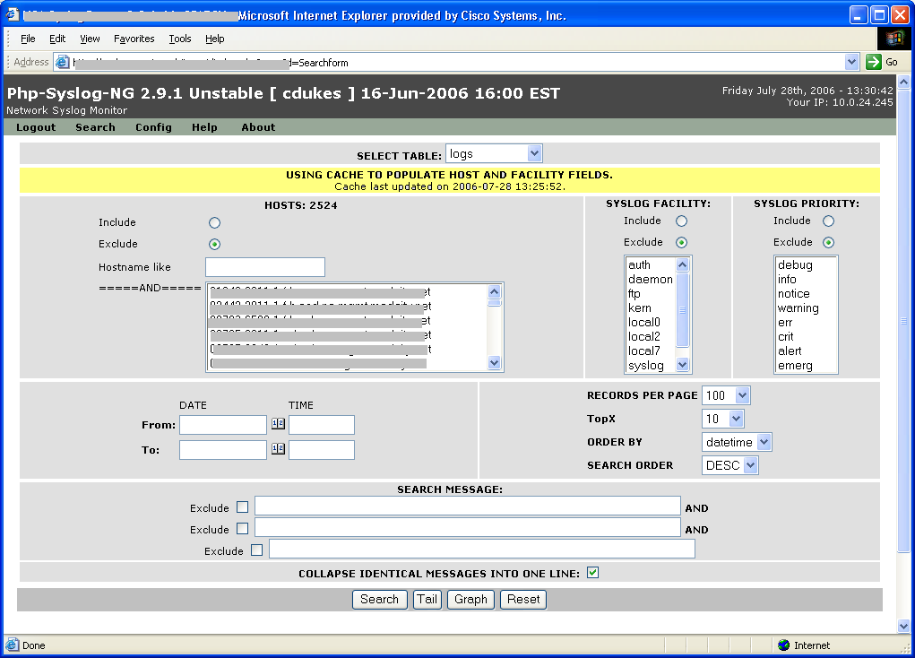

Menus
Across the top left of the screen you will see 5 menu items (See Figure 5).
- Logout – This option will log you out of the system.
- Search – This will return you to the main screen.
- Config – This menu item is used to administer user variables such as password changes, etc.
- Help – This item gives a brief overview of how to set up the PHP-Syslog-NG server.
- About – Selecting this menu item will give you information about the PHP-Syslog-NG Project

Figure 5 - Top Menu Items
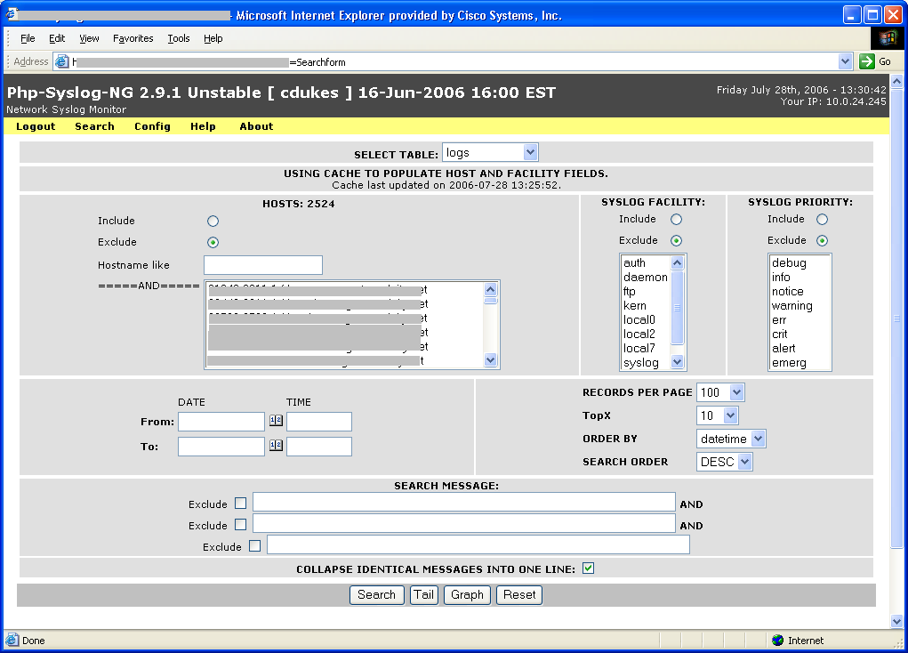

Selecting Hosts
The “Hosts” table allows you to perform searches/graphing based on host filters. Four types of filters are available:
- Include host(s) by full name
- Include host(s) by partial name
- Exclude host(s) by full name
- Exclude host(s) by partial name
The default selection will include all hosts.
To search/graph on partial name, select the include/exclude radio button and manually enter a partial host name in the text field named “Hostname like”.
Note that this section also includes a total count of all hosts reporting in. In figure 6 below, this is noted as “2524”

Figure 6 - Hosts Table
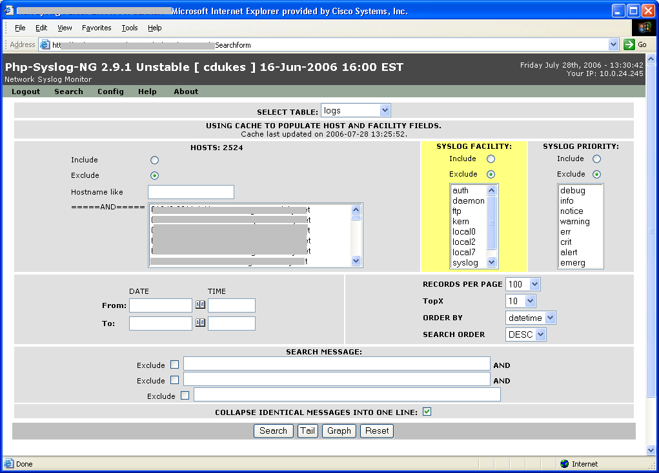

Facilities Table
The “Facilities” table allows you to perform searches/graphing based on Syslog facility filters. Two types of filters are available:
- Include facility(ies)
- Exclude facility(ies)
The default selection will include all facilities.
To search/graph on a single facility, select the include/exclude radio button and then click-select the desired facility name. Note that you may also drag-select this field.

Figure 7 - Facilities Table

Priorities Table
The “Priorities” table allows you to perform searches/graphing based on Syslog priority filters. Two types of filters are available:
- Include priority(ies)
- Exclude priority(ies)
The default selection will include all priorities.
To search/graph on a single priority, select the include/exclude radio button and then click-select the desired priority name. Note that you may also drag-select this field.

Figure 8 - Priorities Table
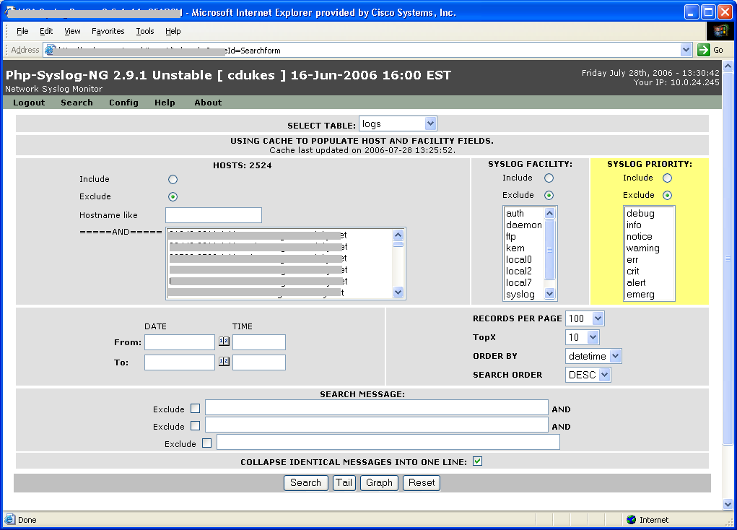

Calendar Table
The Calendar menu may be used to select specific date ranges.
Note that when using this field, you may want to select a different log table if your search spans multiple days.
Dates may be entered manually or by clicking on the calendar icon ()
Clicking the icon will open and close the calendar.
Note that if you decide to manually enter a date, the date must be entered in the form “YYYY-MM-DD”
If the time field is left blank, the search will assume you want “now” as the time. Otherwise, you may enter a time in the form “HH:MM:SS”
“Yesterday”, “today” and “now” may also be used as valid dates. “Now” may also be entered for the time.

Figure 9 - Calendar Table
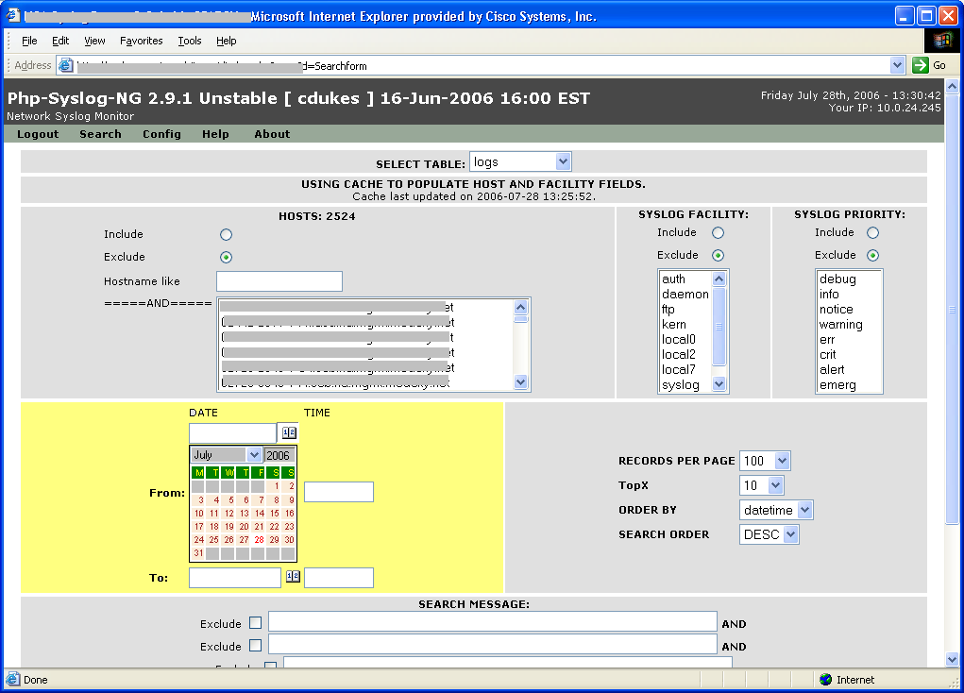

JavaScript Help
You will notice that several areas include a light blue popup. This is meant to provide you with extra information for the menu item selected (or hovered over). Please be sure to read the information provided. An example of this information is provided in Figure 10 below.

Figure 10 - JavaScript Help Example
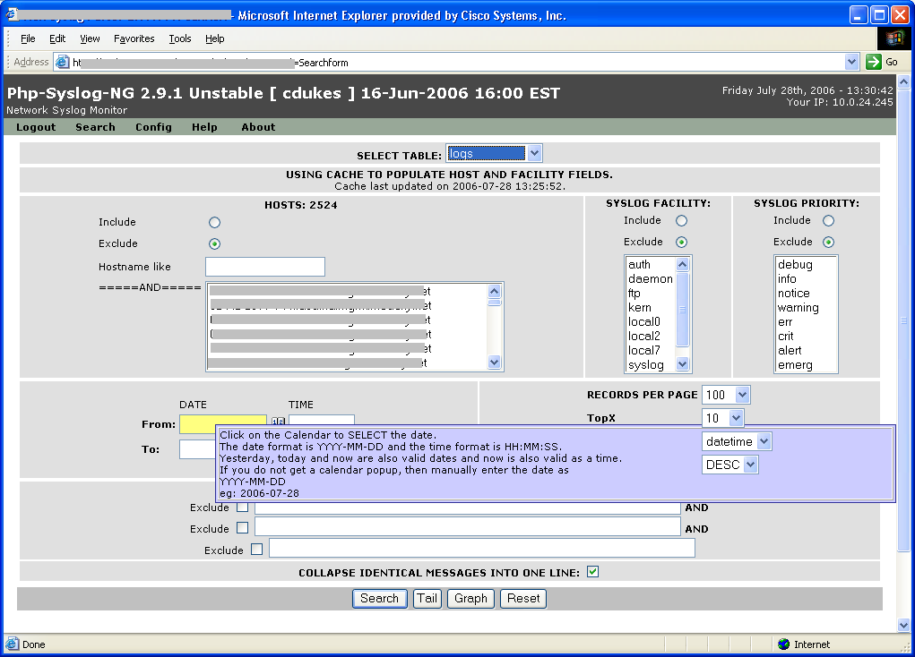

Record Types Table
Depending on whether you are searching or graphing, this table is used to modify the type and amount of information that will be returned.
When searching, you may select the amount of records per page to display, what to order the results by and how to order them.
When graphing, you may set the TopX amount for the graph. For example, to set the graph to display the Top 10 hosts, just leave it set to the default “10”. However, if you wanted to graph the top 20 hosts, you would select “20” from the TopX menu.

Figure 11 - Record Types Table
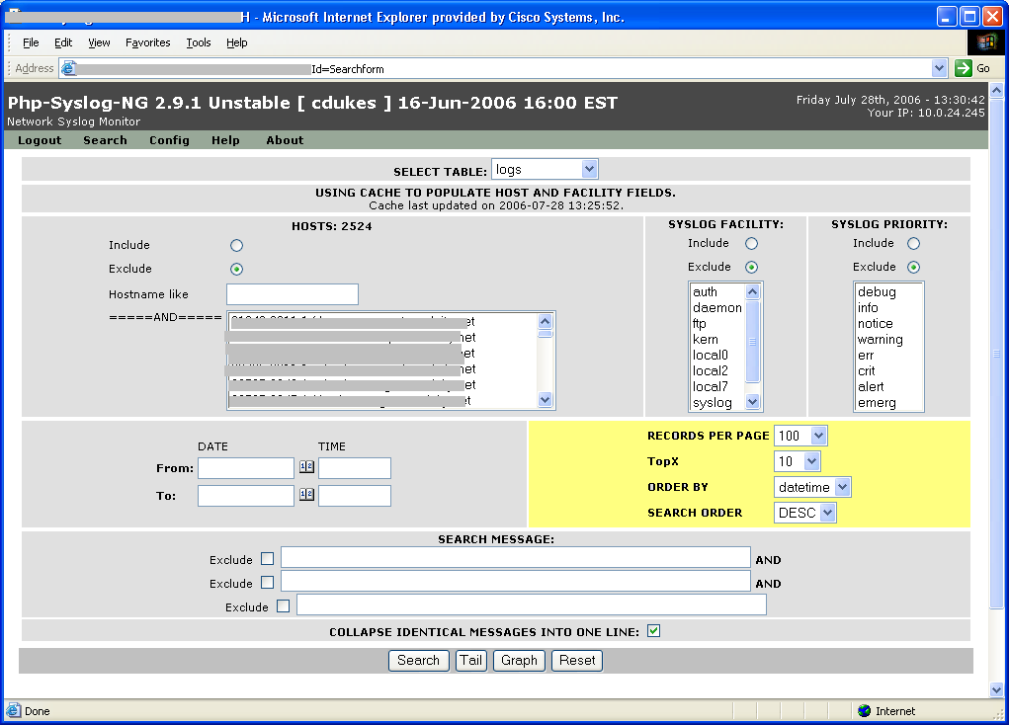

Message Filters
The “Search Message” section allows you to either include or exclude specific messages in your search/graph. For example, you may only want to search/graph messages that have the words “AUTH” in them. You may enter up to 3 separate message filters in this area.

Figure 12 - Message Filters
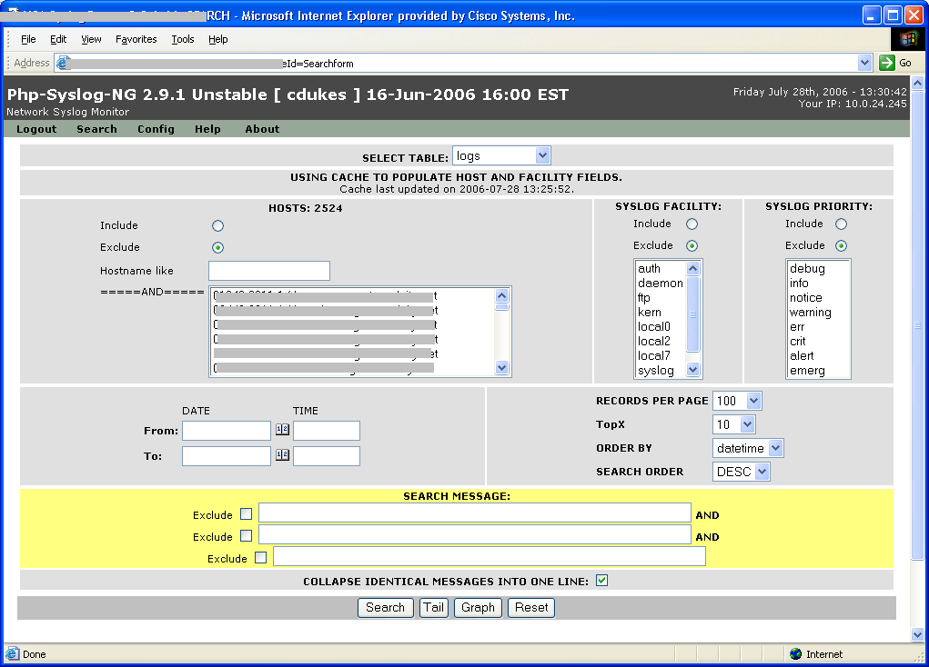

Message De-Duplication
When selected (default), the section labelled “Collapse identical messages into one line” will not display more than 1 of the same message on the results screen that are identical. This helps reduce the amount of screen space used to view identical messages.
Figure 13 - Filtering Identical Messages
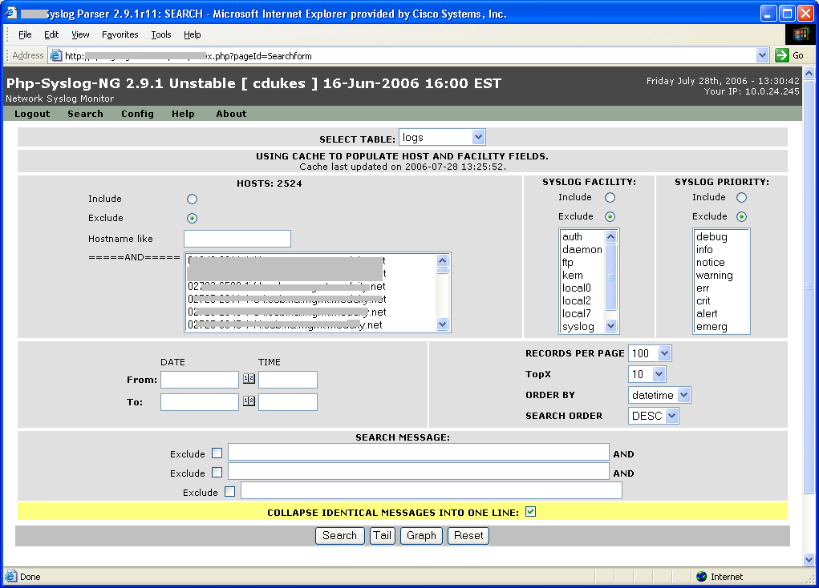

Submission Types
Three types of searches are available, they are:
- Search – Performs a regular search of the selected criteria
- Tail – This feature will show live, incoming data as it is entering the server and can be used to troubleshoot event data in real-time.
- Graph – This button will display a graph of the selected criteria. Note that any attempt to graph very large amounts of data may result in long delays or even non-displayable results. For example, trying to graph the top 100 logs for the last month, etc. This is dependant on the amount of data stored in the server. If the “ALL_LOGS” table is selected and has, for example, 50 Million messages, it is unlikely that the amount of time needed to process the information can be returned in a reasonable amount of time.
Figure 14 - Submission Types
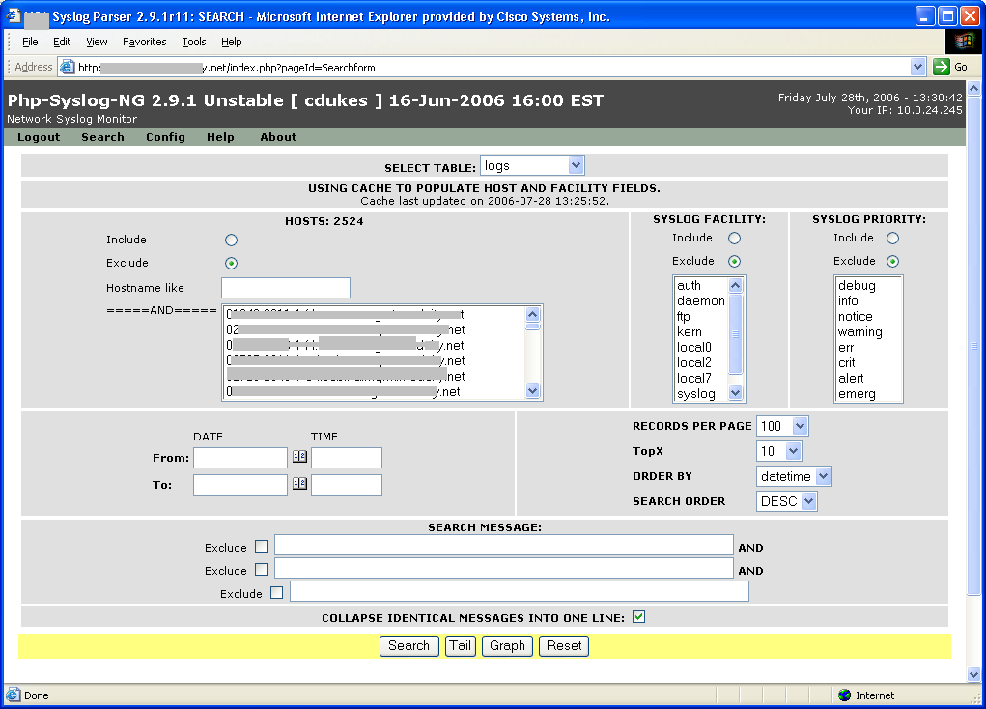

Performing Searches

Search Example
Specific data may be entered into any of the tables that will allow you to perform filtered searches. This is meant to help you find the exact messages you want and can be based on any of the criteria mentioned in the previous sections.

In the Figure below, I will perform a search for all hosts with “xyz” in their name who have message priorities of either err, crit, alert or emergency. Once the options are selected, click “Search”

Figure 15 - Example Search Filter
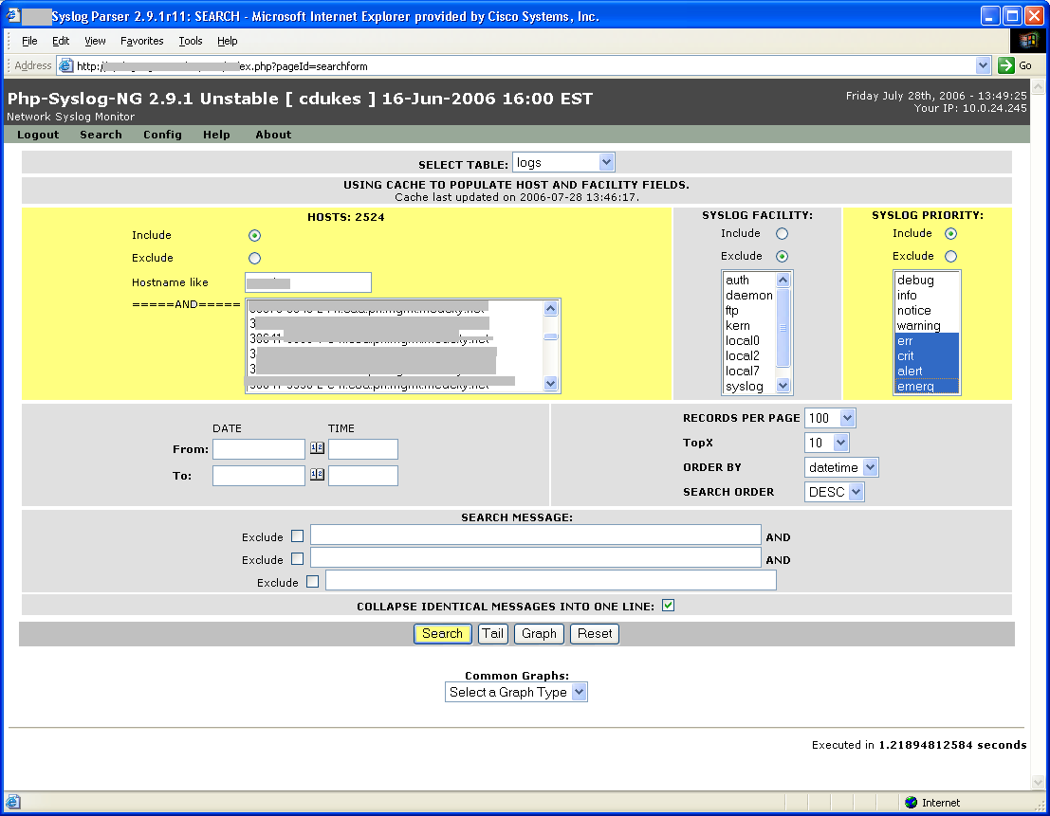

Search Results Example
The resulting page returned from the above search appears below.
The main items to note on this page are:
Figure 17 - The SQL Query – This displays the actual query used against the server in case an administrator would like to use it to manually gather these results directly from the server.
Figure 16 - Search Results Example (SQL Query)
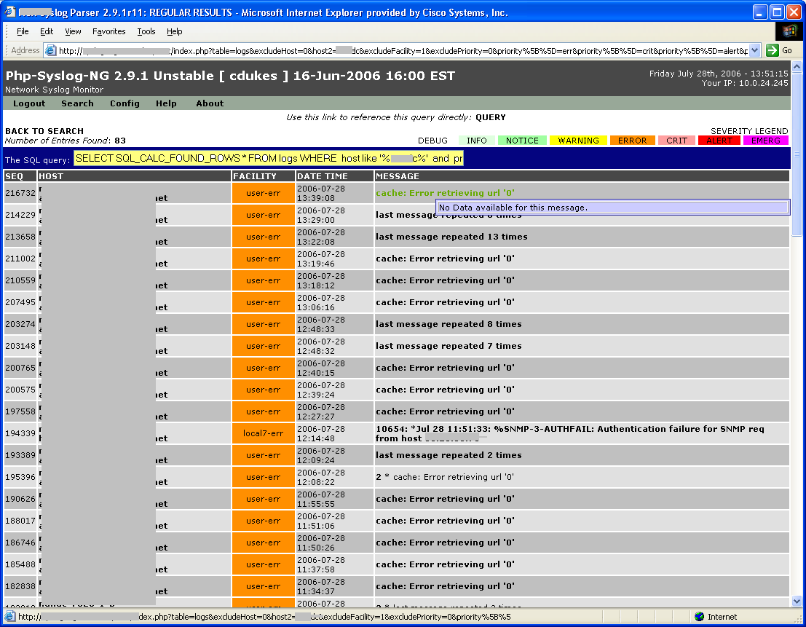

Cisco Message Descriptions
This will display any extended information on the error message when available. This server includes a database of more than 27,000 Cisco Syslog message types along with extended descriptions for that message. In the example below, you will see a popup for the message type “SNMP-3-AUTHFAIL” which included extended information from the Cisco Error Message Database (CEMDB).

Figure 17 - Message Descriptions
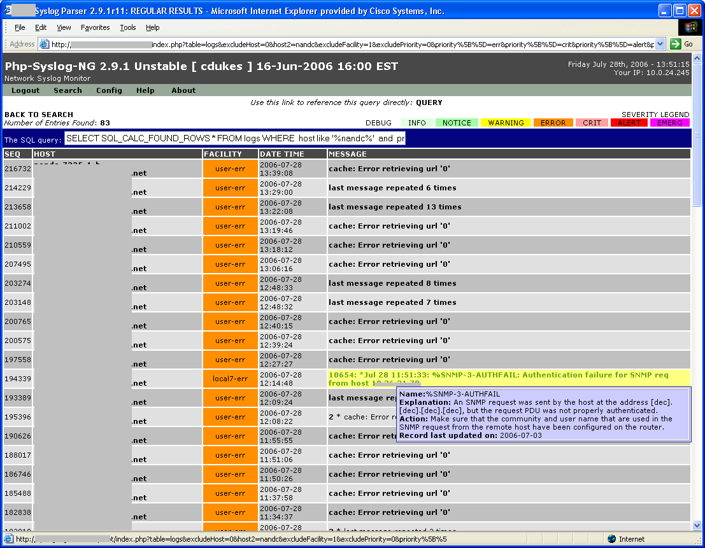

Note that not all messages will have extended information. When this occurs, the popup will simply display “No Data available for the message” as seen in Figure 19.

Figure 18 - No Message Descriptions
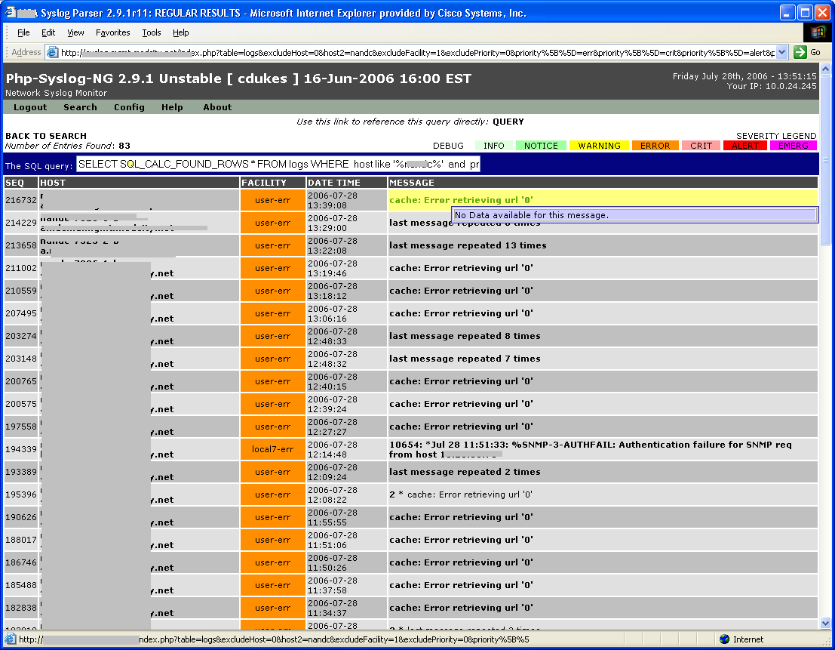

Tail Results
This feature will show live, incoming data as it is entering the server and can be used to troubleshoot event data in real-time.
You may either select search criteria or simply click “Tail” and it will display a page with filtered or unfiltered events in real-time as they are entering the server. Depending on server load, this is typically within 1 second of the event occurring.
The Tail page is set to automatically refresh every minute.

An example Tail result is seen below in figure 20.
Figure 19 - Tail
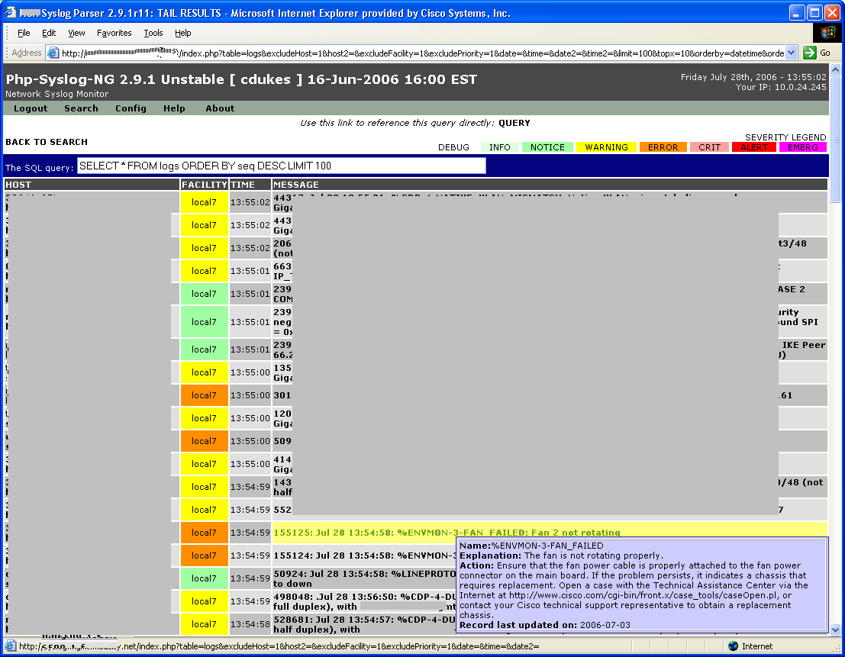

Graphing
Like the search and tail, Graphs can be generated based on any of the filter criteria set on the main page.
In the example below, I have selected to graph the top 10 hosts whose message priorities include either err, crit, alert or emerg.

Figure 20 - Graph Filters
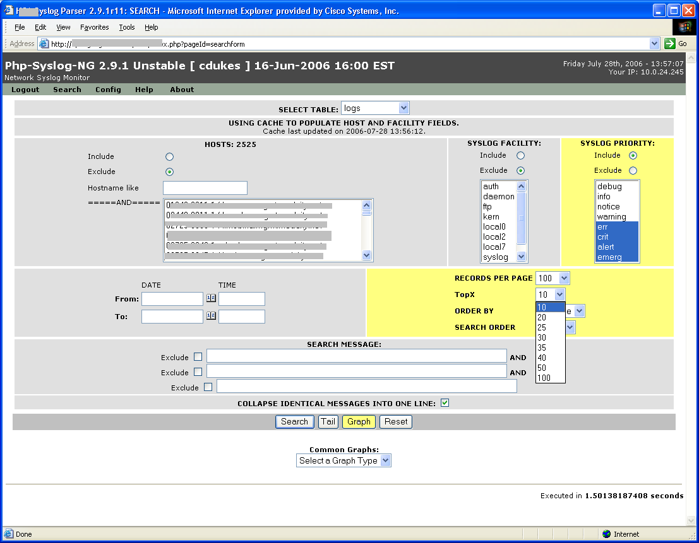

Once the “Graph” button is clicked, a graph will be built based on the entered criteria.
Figure 22 displays the result of the criteria entered above.

Figure 21 - Top 10 Results
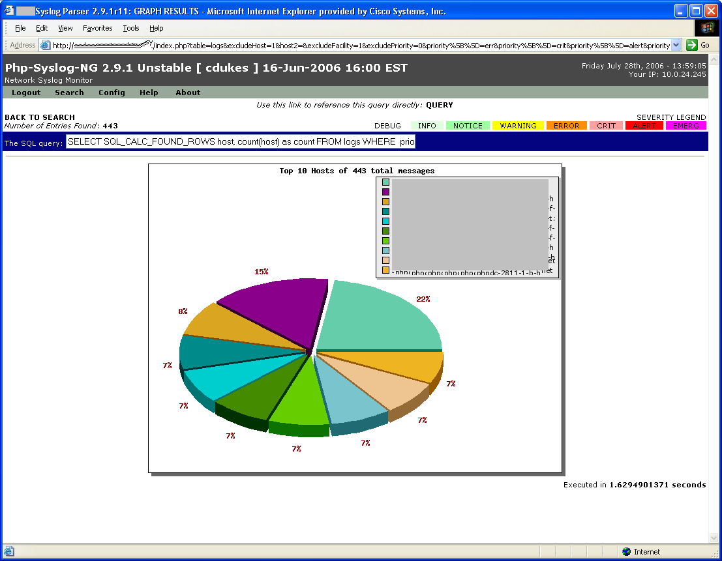
You may now select any one of the pie slices to drill down to the actual event message from that host.

Figure 22 - Pie Slices
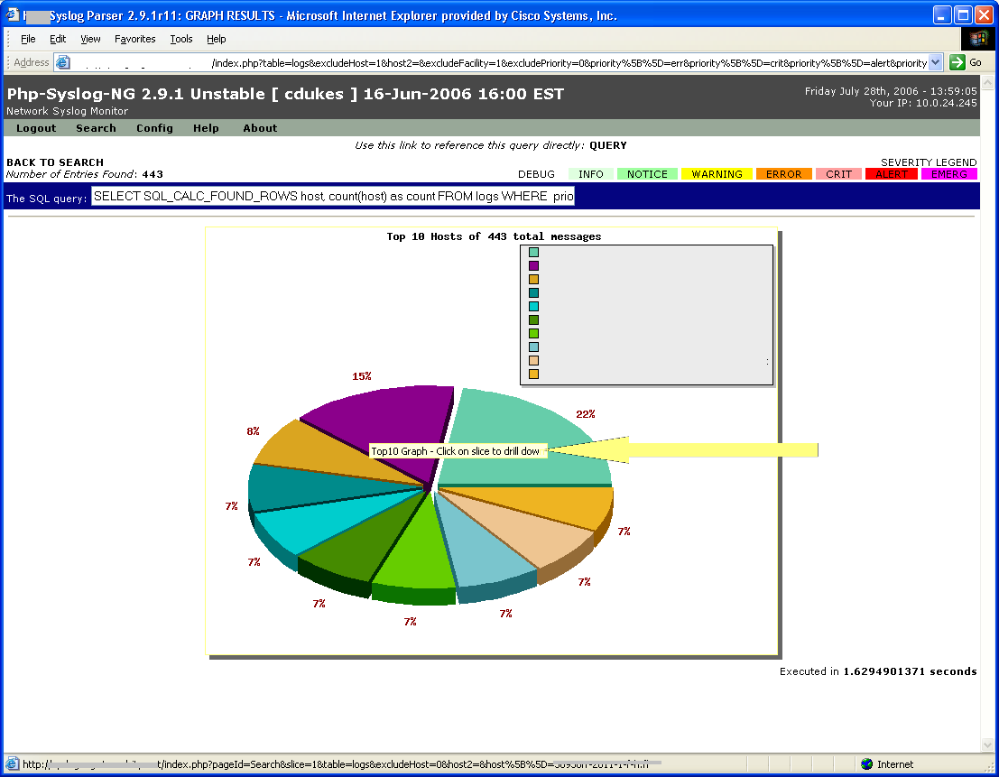

You may also hover over the host name in the key to obtain a count of the events from that individual host.

Figure 23 - Host Message Count
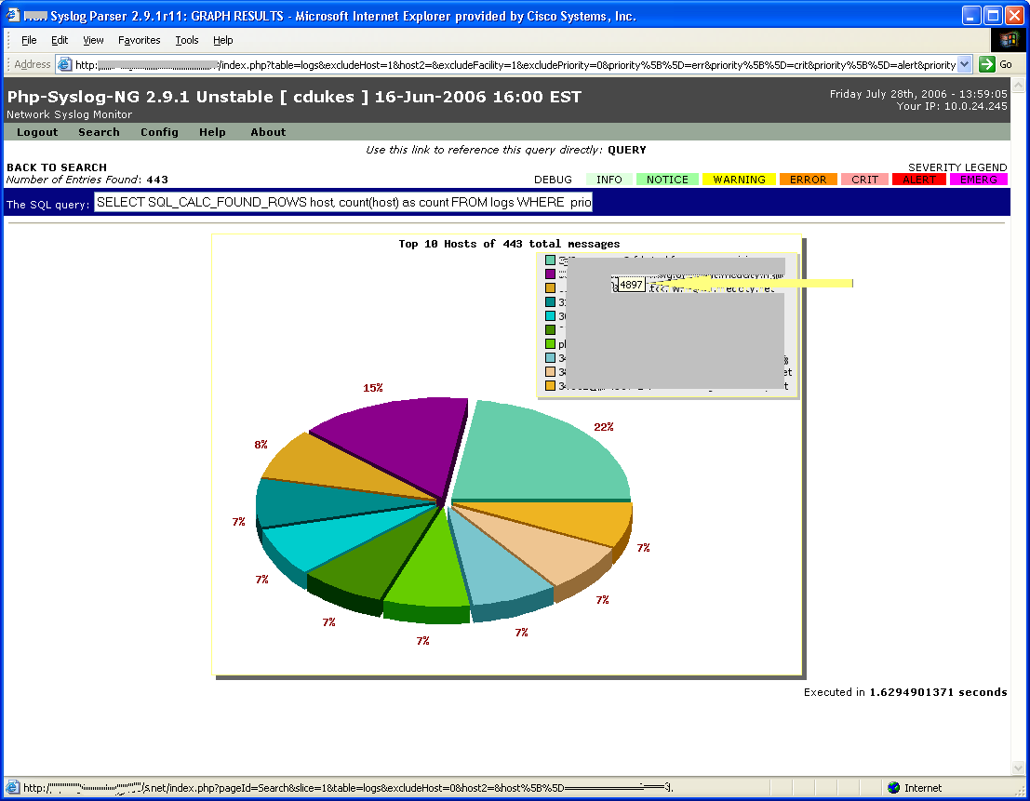

You may notice that the “Number of entries found” field differs from the number obtained when hovering over a host name. This is because the hover number is the amount of messages for that host in total which does not include the filtered criteria.

Common Graphs
The “Common Graphs” menu item on the main page will display a graph for some frequently used graphs such as today, this week and this month.

Figure 24 - Common Graphs
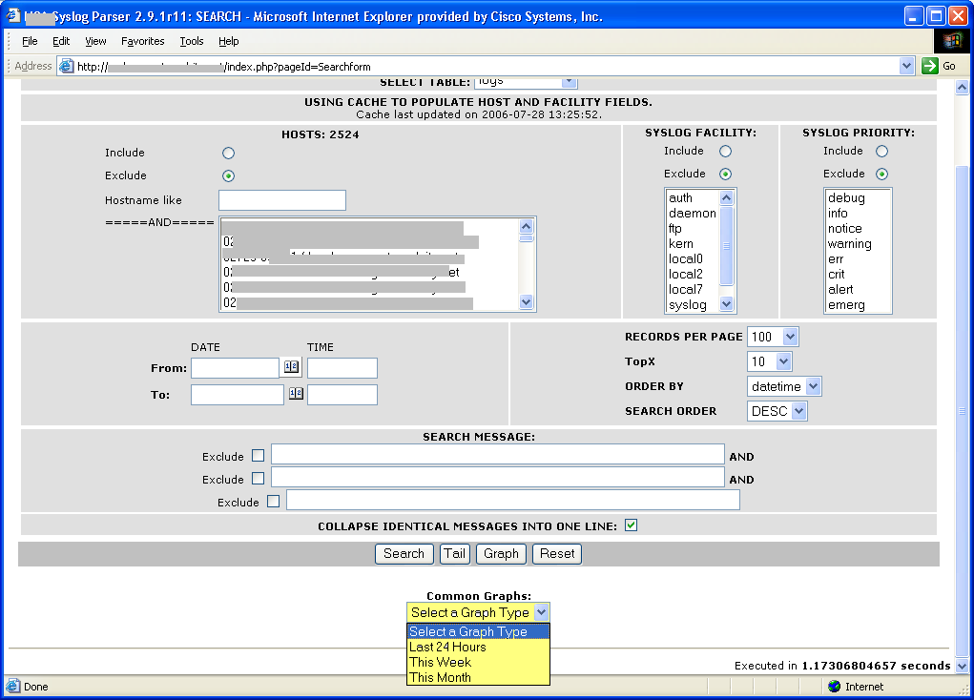
# END

