**Лабораторна робота 6**

ДОСЛІДЖЕННЯ РЕКУРЕНТНИХ НЕЙРОННИХ МЕРЕЖ

Мета роботи: використовуючи спеціалізовані бібліотеки та мову програмування Python навчитися дослідити деякі типи нейронних мереж.

**Завдання 2.1. Ознайомлення з Рекурентними нейронними мережами**

import numpy as np  
from numpy.random import randn  
import random  
from data import train_data, test_data  
  
  
class RNN:  
 # A many-to-one Vanilla Recurrent Neural Network.  
  
 def __init__(self, input_size, output_size, hidden_size=64):  
 # Weights  
 self.Whh = randn(hidden_size, hidden_size) / 1000  
 self.Wxh = randn(hidden_size, input_size) / 1000  
 self.Why = randn(output_size, hidden_size) / 1000  
  
 # Biases  
 self.bh = np.zeros((hidden_size, 1))  
 self.by = np.zeros((output_size, 1))  
  
 def forward(self, inputs):  
 *'''  
 Perform a forward pass of the RNN using the given inputs.  
 Returns the final output and hidden state.  
 - inputs is an array of one hot vectors with shape (input_size, 1).  
 '''* h = np.zeros((self.Whh.shape[0], 1))  
  
 self.last_inputs = inputs  
 self.last_hs = {0: h}  
  
 # Perform each step of the RNN  
 for i, x in enumerate(inputs):  
 h = np.tanh(self.Wxh @ x + self.Whh @ h + self.bh)  
 self.last_hs[i + 1] = h  
  
 # Compute the output  
 y = self.Why @ h + self.by  
  
 return y, h  
  
 def backprop(self, d_y, learn_rate=2e-2):  
 *'''  
 Perform a backward pass of the RNN.  
 - d_y (dL/dy) has shape (output_size, 1).  
 - learn_rate is a float.  
 '''* n = len(self.last_inputs)  
  
 # Calculate dL/dWhy and dL/dby.  
 d_Why = d_y @ self.last_hs[n].T  
 d_by = d_y  
  
 # Initialize dL/dWhh, dL/dWxh, and dL/dbh to zero.  
 d_Whh = np.zeros(self.Whh.shape)  
 d_Wxh = np.zeros(self.Wxh.shape)  
 d_bh = np.zeros(self.bh.shape)  
  
 # Calculate dL/dh for the last h.  
 # dL/dh = dL/dy * dy/dh  
 d_h = self.Why.T @ d_y  
  
 # Backpropagate through time.  
 for t in reversed(range(n)):  
 # An intermediate value: dL/dh * (1 - h^2)  
 temp = ((1 - self.last_hs[t + 1] ** 2) * d_h)  
  
 # dL/db = dL/dh * (1 - h^2)  
 d_bh += temp  
  
 # dL/dWhh = dL/dh * (1 - h^2) * h_{t-1}  
 d_Whh += temp @ self.last_hs[t].T  
  
 # dL/dWxh = dL/dh * (1 - h^2) * x  
 d_Wxh += temp @ self.last_inputs[t].T  
  
 # Next dL/dh = dL/dh * (1 - h^2) * Whh  
 d_h = self.Whh @ temp  
  
 # Clip to prevent exploding gradients.  
 for d in [d_Wxh, d_Whh, d_Why, d_bh, d_by]:  
 np.clip(d, -1, 1, out=d)  
  
 # Update weights and biases using gradient descent.  
 self.Whh -= learn_rate * d_Whh  
 self.Wxh -= learn_rate * d_Wxh  
 self.Why -= learn_rate * d_Why  
 self.bh -= learn_rate * d_bh  
 self.by -= learn_rate * d_by  
  
  
def createInputs(text):  
 *'''  
 Returns an array of one-hot vectors representing the words in the input text string.  
 - text is a string  
 - Each one-hot vector has shape (vocab_size, 1)  
 '''* inputs = []  
 for w in text.split(' '):  
 v = np.zeros((vocab_size, 1))  
 v[word_to_idx[w]] = 1  
 inputs.append(v)  
 return inputs  
  
  
def softmax(xs):  
 # Applies the Softmax Function to the input array.  
 return np.exp(xs) / sum(np.exp(xs))  
  
  
def processData(data, backprop=True):  
 *'''  
 Returns the RNN's loss and accuracy for the given data.  
 - data is a dictionary mapping text to True or False.  
 - backprop determines if the backward phase should be run.  
 '''* items = list(data.items())  
 random.shuffle(items)  
  
 loss = 0  
 num_correct = 0  
  
 for x, y in items:  
 inputs = createInputs(x)  
 target = int(y)  
  
 # Forward  
 out, _ = rnn.forward(inputs)  
 probs = softmax(out)  
  
 # Calculate loss / accuracy  
 loss -= np.log(probs[target])  
 num_correct += int(np.argmax(probs) == target)  
  
 if backprop:  
 # Build dL/dy  
 d_L_d_y = probs  
 d_L_d_y[target] -= 1  
  
 # Backward  
 rnn.backprop(d_L_d_y)  
  
 return loss / len(data), num_correct / len(data)  
  
  
# Create the vocabulary.  
vocab = list(set([w for text in train_data.keys() for w in text.split(' ')]))  
vocab_size = len(vocab)  
print('%d unique words found' % vocab_size)  
  
# Assign indices to each word.  
word_to_idx = {w: i for i, w in enumerate(vocab)}  
idx_to_word = {i: w for i, w in enumerate(vocab)}  
print(word_to_idx['good'])  
print(idx_to_word[0])  
  
# Initialize our RNN!  
rnn = RNN(vocab_size, 2)  
  
# Loop for every train instace  
input = createInputs('i am very good')  
out, _ = rnn.forward(input)  
probs = softmax(out)  
print(probs)  
  
for x, y in train_data.items():  
 inputs = createInputs(x)  
 target = int(y)  
  
 # Forward  
 out, _ = rnn.forward(inputs)  
 probs = softmax(out)  
  
 # Build dL/dy  
 d_L_d_y = probs  
 d_L_d_y[target] -= 1  
  
 # Backward  
 rnn.backprop(d_L_d_y)  
  
# Training loop  
for epoch in range(1000):  
 train_loss, train_acc = processData(train_data)  
  
 if epoch % 100 == 99:  
 print('--- Epoch %d' % (epoch + 1))  
 print('Train:\tLoss %.3f | Accuracy: %.3f' % (train_loss, train_acc))  
  
 test_loss, test_acc = processData(test_data, backprop=False)  
 print('Test:\tLoss %.3f | Accuracy: %.3f' % (test_loss, test_acc))

Результат:

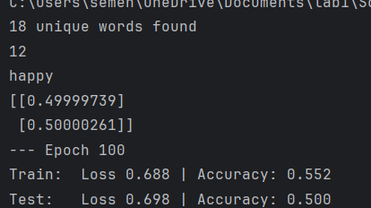

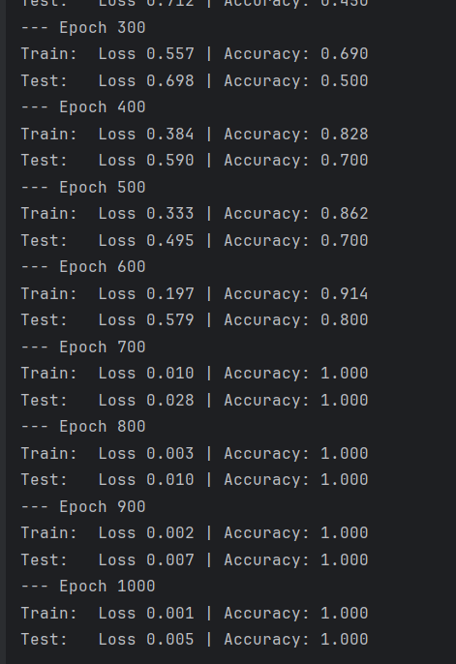

**Завдання 2.2. Дослідження рекурентної нейронної мережі Елмана**

**(Elman Recurrent network (newelm))**

import neurolab as nl  
import numpy as np  
import pylab as pl  
  
# Create signal models for trainign  
i1 = np.sin(np.arange(0, 20))  
i2 = np.sin(np.arange(0, 20)) * 2  
  
t1 = np.ones([1, 20])  
t2 = np.ones([1, 20]) * 2  
  
input = np.array([i1, i2, i1, i2]).reshape(20*4, 1)  
target = np.array([t1, t2, t1, t2]).reshape(20*4, 1)  
  
# Create network with 2 layers and random initialized  
net = nl.net.newelm([[-2, 2]], [10, 1], [nl.trans.TanSig(), nl.trans.PureLin()])  
  
# Set initialized functions and init  
net.layers[0].initf = nl.init.InitRand([-0.1, 0.1], 'wb')  
net.layers[1].initf = nl.init.InitRand([-0.1, 0.1], 'wb')  
net.init()  
  
# Train network  
error = net.train(input, target, epochs=500, show=100, goal=0.01)  
  
# Simulate network  
output = net.sim(input)  
  
# Plot result  
pl.subplot(211)  
pl.plot(error)  
pl.xlabel('Epoch number')  
pl.ylabel('Train error (default MSE)')  
  
pl.subplot(212)  
pl.plot(target.reshape(80))  
pl.plot(output.reshape(80))  
pl.legend(['train target', 'net output'])  
pl.show()

Результат:

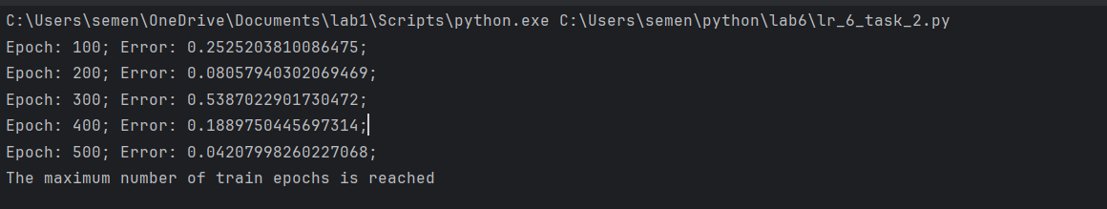

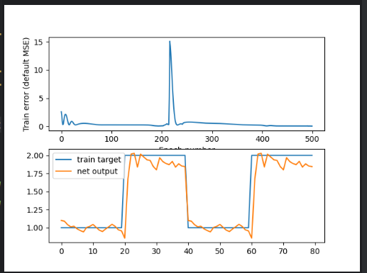

**Завдання 2.3. Дослідження нейронної мережі Хемінга (Hemming Recurrent network)**

Лістинг:

import numpy as np  
import neurolab as nl  
  
# Input data  
target = [[-1, 1, -1, -1, 1, -1, -1, 1, -1],  
 [1, 1, 1, 1, -1, 1, 1, -1, 1],  
 [1, -1, 1, 1, 1, 1, 1, -1, 1],  
 [1, 1, 1, 1, -1, -1, 1, -1, -1],  
 [-1, -1, -1, -1, 1, -1, -1, -1, -1]]  
  
input = [[-1, -1, 1, 1, 1, 1, 1, -1, 1],  
 [-1, -1, 1, -1, 1, -1, -1, -1, -1],  
 [-1, -1, -1, -1, 1, -1, -1, 1, -1]]  
  
# Create and train network  
net = nl.net.newhop(target)  
  
output = net.sim(target)  
print("Test on train samples:")  
print(np.argmax(output, axis=0))  
  
output = net.sim([input[0]])  
print("Outputs on recurent cycle:")  
print(np.array(net.layers[0].outs))  
  
output = net.sim(input)  
print("Outputs on test sample:")  
print(output)

Результат:

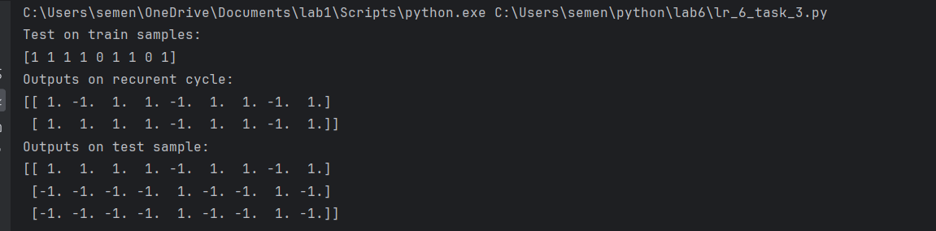

**Завдання 2.4. Дослідження рекурентної нейронної мережі Хопфілда**

**Hopfield Recurrent network (newhop)**

Лістинг:

import numpy as np  
import neurolab as nl  
  
# N E R O  
target = [[1, 0, 0, 0, 1,  
 1, 1, 0, 0, 1,  
 1, 0, 1, 0, 1,  
 1, 0, 0, 1, 1,  
 1, 0, 0, 0, 1],  
 [1, 1, 1, 1, 1,  
 1, 0, 0, 0, 0,  
 1, 1, 1, 1, 1,  
 1, 0, 0, 0, 0,  
 1, 1, 1, 1, 1],  
 [1, 1, 1, 1, 0,  
 1, 0, 0, 0, 1,  
 1, 1, 1, 1, 0,  
 1, 0, 0, 1, 0,  
 1, 0, 0, 0, 1],  
 [0, 1, 1, 1, 0,  
 1, 0, 0, 0, 1,  
 1, 0, 0, 0, 1,  
 1, 0, 0, 0, 1,  
 0, 1, 1, 1, 0]]  
  
chars = ['N', 'E', 'R', 'O']  
target = np.asfarray(target)  
target[target == 0] = -1  
  
# Create and train network  
net = nl.net.newhop(target)  
  
output = net.sim(target)  
print("Test on train samples:")  
for i in range(len(target)):  
 print(chars[i], (output[i] == target[i]).all())  
  
# Test network  
print("\nTest on defaced N:")  
test = np.asfarray([0, 0, 0, 0, 0,  
 1, 1, 0, 0, 1,  
 1, 1, 0, 0, 1,  
 1, 0, 1, 1, 1,  
 0, 0, 0, 1, 1])  
test[test == 0] = -1  
out = net.sim([test])  
print((out[0] == target[0]).all(), 'Sim. steps', len(net.layers[0].outs))  
  
print("\nTest on defaced E:")  
test = np.asfarray([1, 1, 0, 1, 1,  
 1, 0, 0, 0, 0,  
 1, 1, 1, 1, 1,  
 0, 0, 0, 1, 0,  
 1, 1, 1, 1, 1])  
test[test == 0] = -1  
out = net.sim([test])  
print((out[0] == target[1]).all(), 'Sim. steps', len(net.layers[0].outs))  
  
print("\nTest on defaced R:")  
test = np.asfarray([1, 1, 0, 1, 0,  
 1, 0, 1, 0, 1,  
 1, 1, 1, 1, 0,  
 0, 0, 0, 1, 0,  
 1, 0, 0, 1, 1])  
test[test == 0] = -1  
out = net.sim([test])  
print((out[0] == target[2]).all(), 'Sim. steps', len(net.layers[0].outs))  
  
print("\nTest on defaced D:")  
test = np.asfarray([0, 1, 1, 0, 0,  
 1, 0, 0, 0, 1,  
 1, 0, 1, 0, 1,  
 1, 0, 0, 0, 1,  
 0, 0, 1, 1, 0])  
test[test == 0] = -1  
out = net.sim([test])  
print((out[0] == target[3]).all(), 'Sim. steps', len(net.layers[0].outs))

Результат:

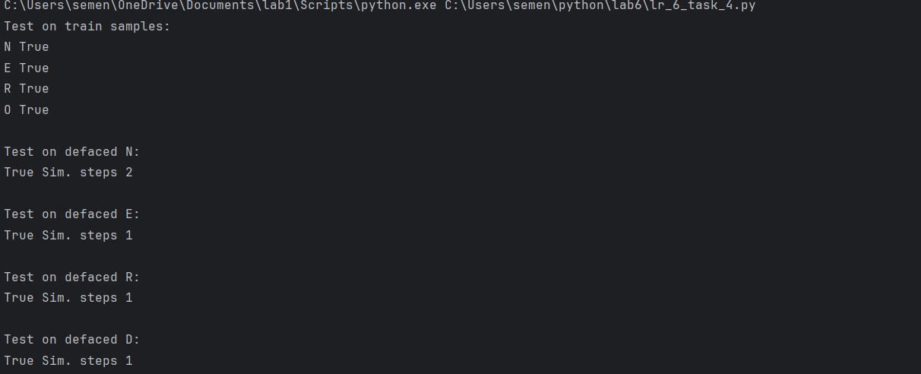

**Завдання 2.5. Дослідження рекурентної нейронної мережі Хопфілда для ваших персональних даних**

Лістинг:

import numpy as np  
import neurolab as nl  
  
# Н Є М  
target = [[1, 0, 0, 0, 1,  
 1, 0, 0, 0, 1,  
 1, 1, 1, 1, 1,  
 1, 0, 0, 0, 1,  
 1, 0, 0, 0, 1],  
 [0, 1, 1, 1, 1,  
 1, 0, 0, 0, 0,  
 1, 1, 1, 1, 1,  
 1, 0, 0, 0, 0,  
 0, 1, 1, 1, 1],  
 [1, 0, 0, 0, 1,  
 1, 1, 0, 1, 1,  
 1, 0, 1, 0, 1,  
 1, 0, 0, 0, 1,  
 1, 0, 0, 0, 1], ]  
  
chars = ['Н', 'Є', 'М']  
target = np.asfarray(target)  
target[target == 0] = -1  
  
# Create and train network  
net = nl.net.newhop(target)  
  
output = net.sim(target)  
print("Test on train samples:")  
for i in range(len(target)):  
 print(chars[i], (output[i] == target[i]).all())  
  
# Test network  
print("\nTest on defaced Н:")  
test_N = np.asfarray([1, 0, 1, 0, 1,  
 0, 1, 0, 0, 1,  
 1, 1, 0, 1, 0,  
 1, 0, 1, 0, 1,  
 0, 0, 0, 0, 1])  
test_N[test_N == 0] = -1  
out_N = net.sim([test_N])  
print((out_N[0] == target[0]).all(), 'Sim. steps', len(net.layers[0].outs))  
  
print("\nTest on defaced Є:")  
test_E = np.asfarray([0, 1, 1, 0, 1,  
 1, 0, 0, 0, 0,  
 1, 1, 1, 1, 1,  
 1, 0, 1, 0, 0,  
 0, 1, 1, 1, 0])  
test_E[test_E == 0] = -1  
out_E = net.sim([test_E])  
print((out_E[0] == target[1]).all(), 'Sim. steps', len(net.layers[0].outs))  
  
print("\nTest on defaced М:")  
test_M = np.asfarray([1, 0, 0, 0, 1,  
 1, 0, 0, 1, 1,  
 1, 0, 1, 0, 1,  
 0, 0, 0, 0, 1,  
 1, 0, 1, 0, 0])  
test_M[test_M == 0] = -1  
out_M = net.sim([test_M])  
print((out_M[0] == target[2]).all(), 'Sim. steps', len(net.layers[0].outs))

Результат:

