<http://localhost/phptest/Lap5/Lap5PrimaryColor.php>

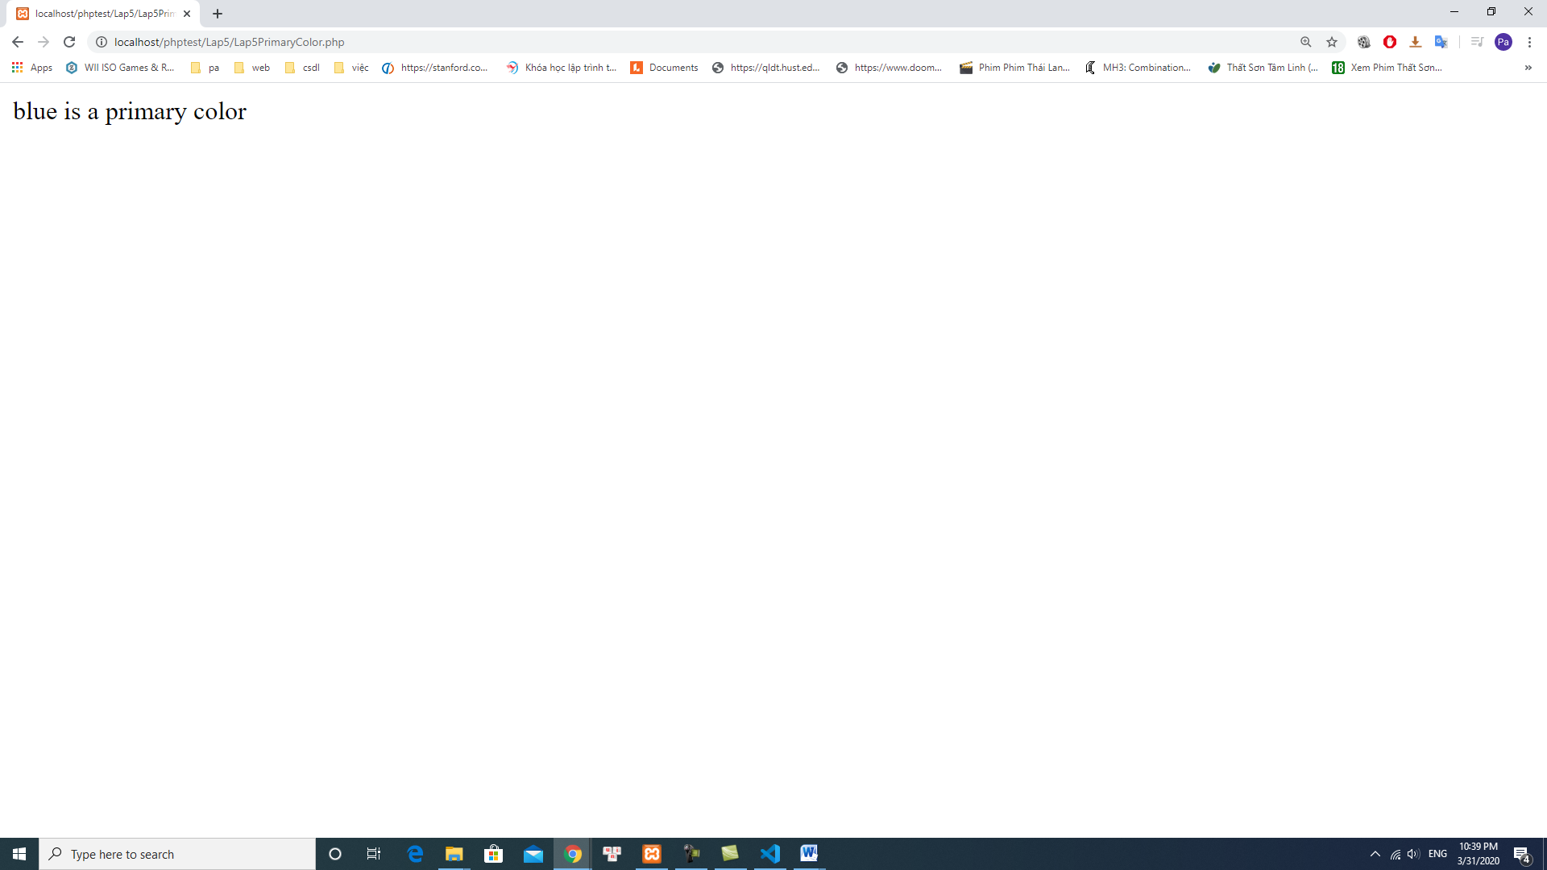

<http://localhost/phptest/Lap5/Lap5ColorFilter.php>

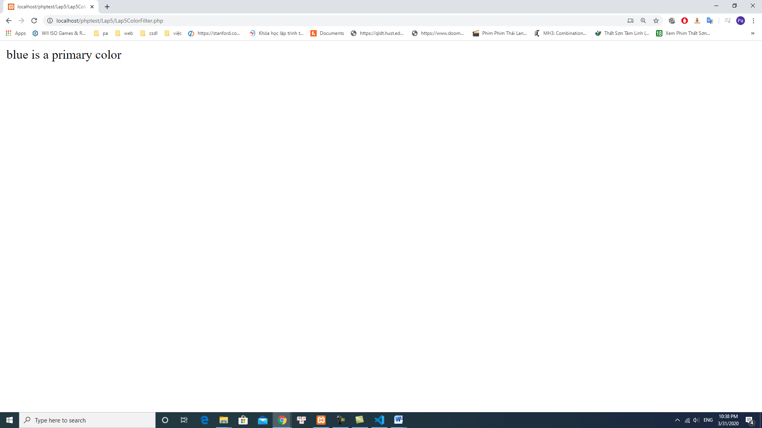

<http://localhost/phptest/Lap5/Lap5Example2.1.1.php>

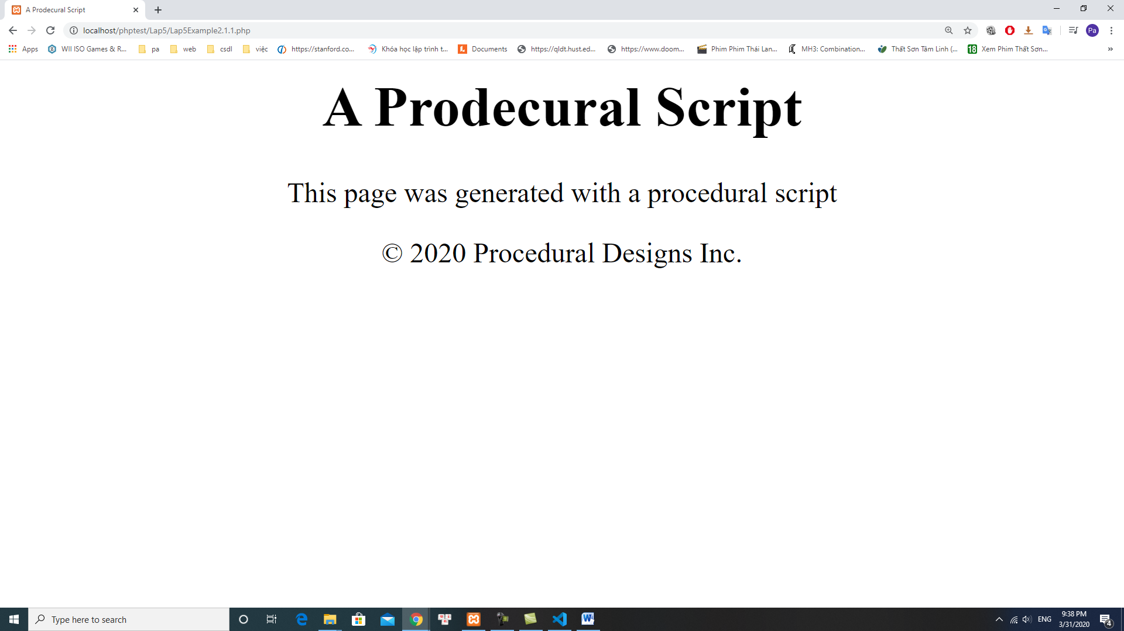

<http://localhost/phptest/Lap5/Lap5Example2.3.2.php>

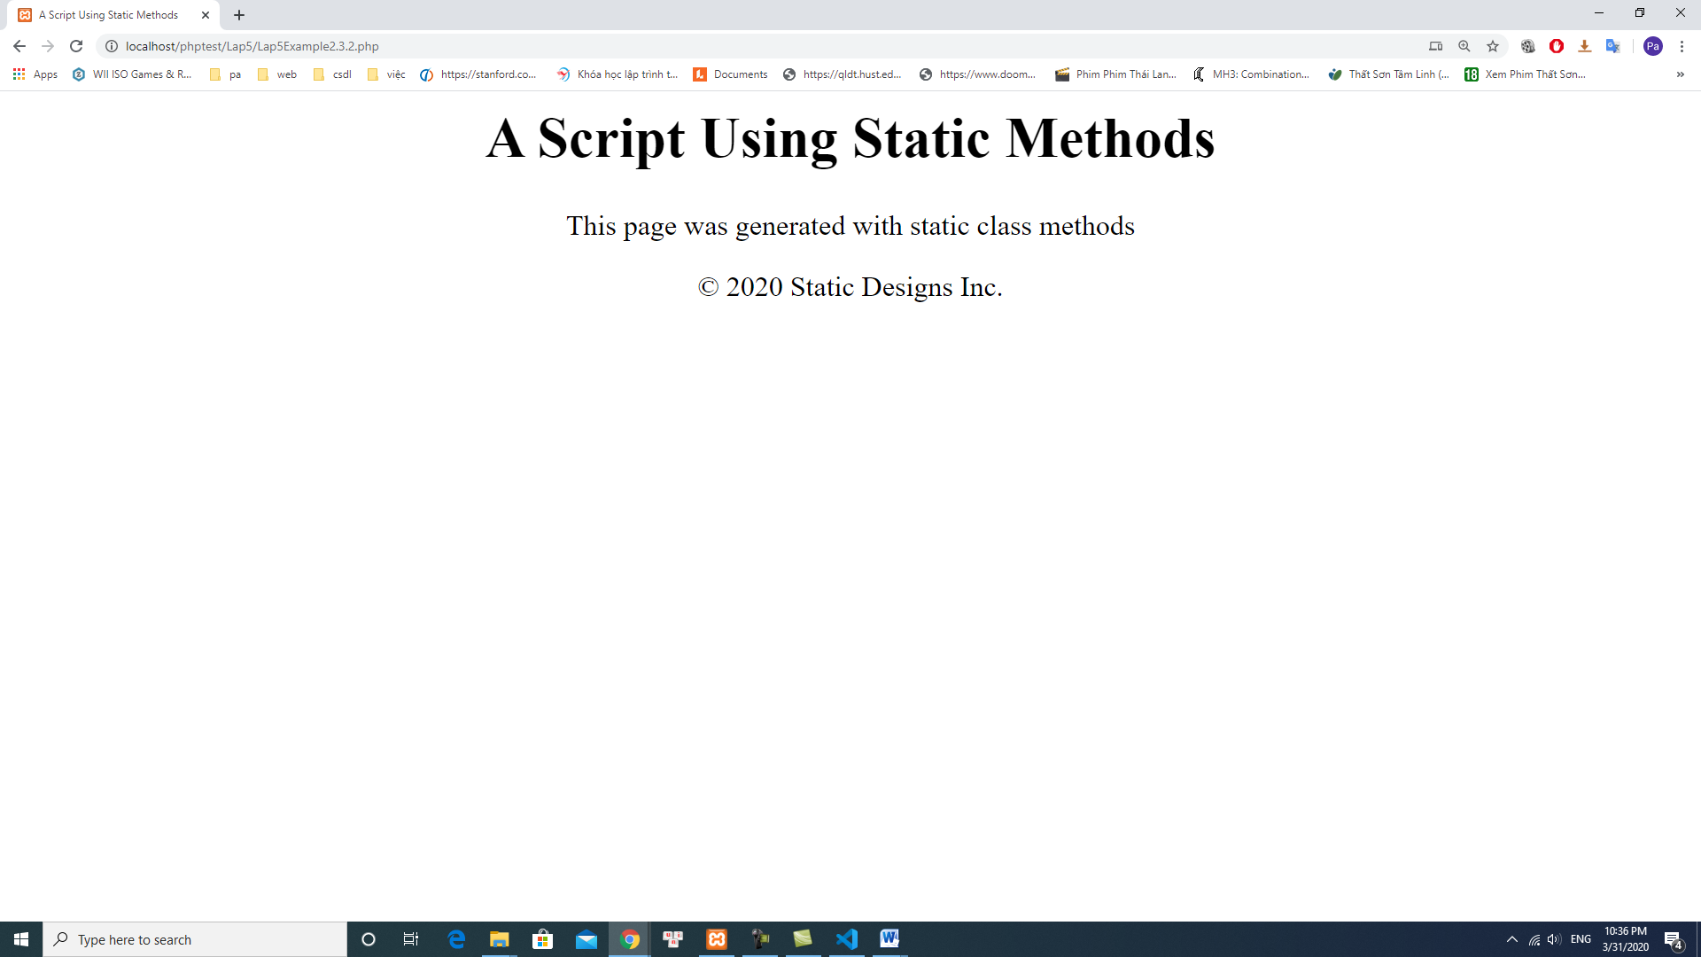

<http://localhost/phptest/Lap5/Lap5Example2.4.3.php>

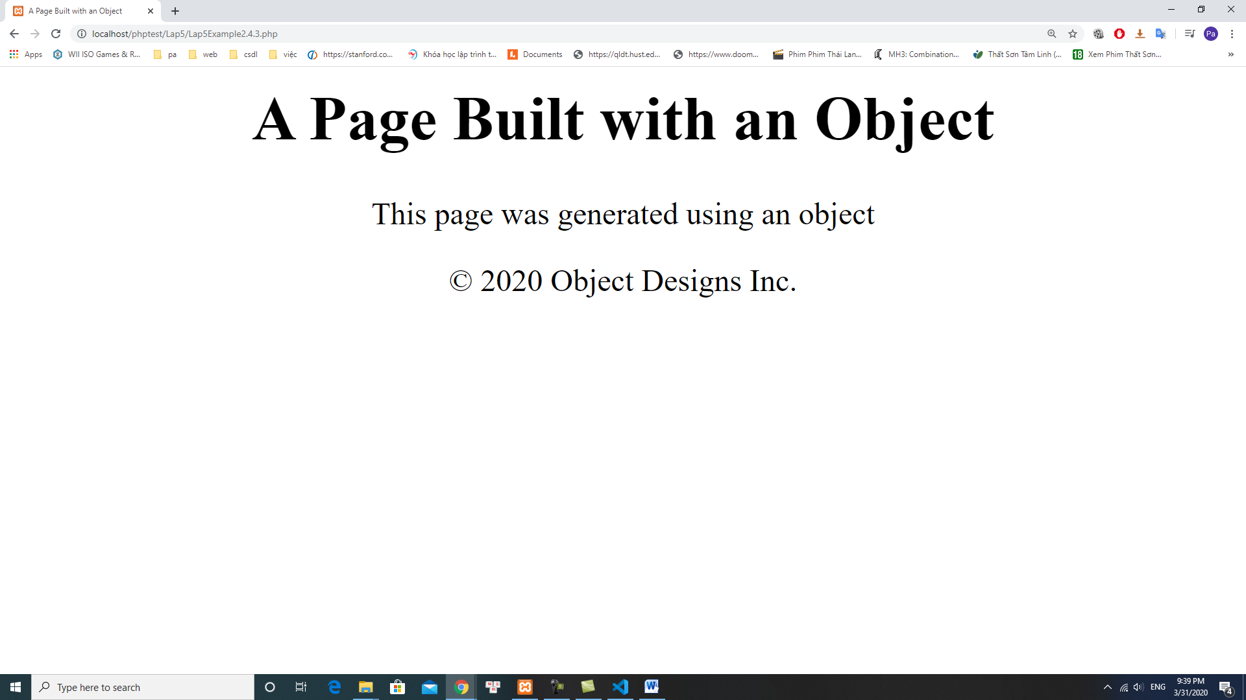

<http://localhost/phptest/Lap5/Lap5Example2.6.4.php>

