

Governance Effectiveness and Control of Corruption in Global Society: A Data-Driven Analysis (2013–2023)

Student Full Name | Adriana Soledad Yash
Student Number | 2025141
Module Title | Machine Learning for Business
Assessment Title | MachineLearning_SoledadYash.ipynb
Lector’s name | Dr. Muhammad Iqbal
Date of Submission | 02 November 2025
Declaration
By submitting this assessment, I confirm that I have read the CCT policy on academic misconduct and understand the implications of submitting work that is not my own or does not appropriately reference material taken from a third party or other source.
I declare it to be my own work and that all material from third parties has been appropriately referenced.
I further confirm that this work has not previously been submitted for assessment by myself or someone else in CCT College Dublin or any other higher education institution.

Table of Contents
1. Introduction 3
Purpose 3
2. Problem Definition 3
Theoretical Background 3
3. Data and Methods 3
Exploratory Data Analysis 3
Machine Learning process 4
4. Results and Interpretation 6
Time Forecasting 6
5. Discussion 8
6. Conclusion 8
7. References 8
8. Appendix (AI Reflection) 9
AI Prompts and Scripts Used 9

1. Introduction
This assignment explores how Governance, Risk and Compliance principles can be read through data to question the relationship between institutional strength and human development. It uses the World Governance Indicators and the Human Development Report from 2013 to 2023 to examine why some societies thrive while others stagnate despite formal structures of governance. The analysis joins machine learning models with social interpretation to open a space for reflection rather than to close an answer.

Purpose
It is an academic exercise that could be expanded into a thesis about the long rhythm of development and the limits of institutional measurement. The study aims to understand how systems of governance perform over time and how compliance or its absence affects real life outcomes.

2. Problem Definition
The paradox is simple and disturbing. Some nations have strong institutions but low human development, while others achieve progress with weak governance. In GRC terms, governance designs the rules, risk exposes fragility, and compliance shows whether promises turn into results. The question guiding this work is whether high institutional quality is enough to produce high human development or if hidden historical and social forces decide more than formal rules.

Theoretical Background
Halford Mackinder described how geography defines power, Raúl Prebisch saw dependency as a structural trap, and Jason Hickel exposed how inequality persists even in global growth. Together they remind that institutions grow from history and culture, not from administrative design alone.

3. Data and Methods
To merge the World Governance Indicators and the Human Development Report, both datasets had to be reshaped to share a common structure by country and year. The original governance data were stored in a wide format with each indicator split across multiple columns and years. To make the information compatible with the HDR dataset, a melting process was applied.

Exploratory Data Analysis
The correlation heatmap below summarizes how governance, education, and human development indicators relate to each other. The matrix reveals strong positive correlations among institutional quality variables and development outcomes such as HDI, education, and income. Conversely, gender inequality presents a clear negative relationship with governance strength and human development.

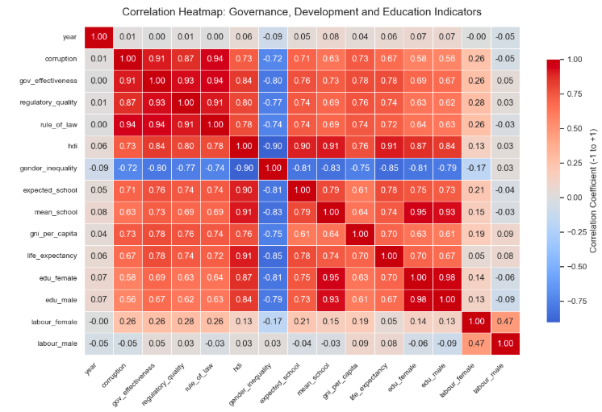

Machine Learning process
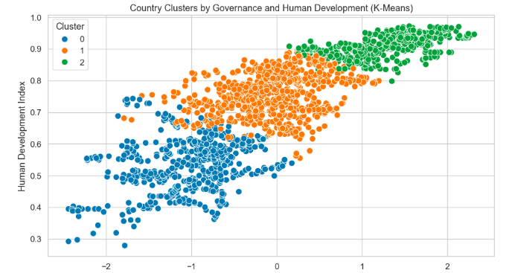
After confirming the internal coherence of the variables through the heatmap, the next step was to test whether countries form recognizable groups according to their governance and development profiles. To explore this, two unsupervised machine learning techniques were applied: K-Means and Agglomerative Clustering. The dataset included the variables most representative of institutional quality. All features were standardized to ensure fair distance calculation across different scales.

K-Means was used first to detect compact groupings, while Agglomerative Clustering served as a validation tool to test whether similar hierarchies appear without predefined k values. The Silhouette Score and Davies Bouldin Index were used to evaluate the quality of the clusters.
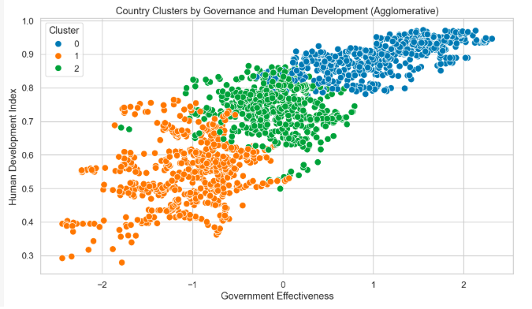
The previous clustering models revealed that some countries present a misalignment between institutional strength and human development. To visualize this pattern, a global map was created showing the level of institutional incongruence between governance quality and the Human Development Index. The colors range from red to blue. Red tones represent countries with high governance indicators but relatively weak human outcomes, while blue tones correspond to countries where governance and development progress move together in balance. The red zones often correspond to states with strong bureaucratic systems, low corruption, and solid rule of law scores but where living conditions, education, or income remain modest. These are systems that manage risk effectively yet fail to translate compliance into social improvement. They embody the GRC paradox: governance and formal control exist, but risk is managed inwardly rather than outwardly, and compliance measures internal order rather than collective well-being.
In contrast, the blue areas display coherence between governance and human development. Here institutions are not only efficient but also inclusive. Public policies tend to deliver consistent outcomes, and compliance extends beyond regulation into ethical and social responsibility. A few countries appear in intermediate shades, reflecting partial or unstable alignment. They might be undergoing institutional reforms or facing temporary shocks that

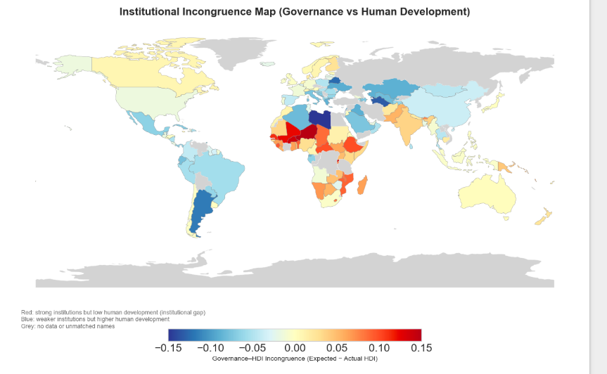

4. Results and Interpretation
After understanding how countries group spatially, the next step was to explore how global human development evolves through time. The goal was to determine whether the relationship between governance and well being follows a stable trend or if it behaves unpredictably.

Time Forecasting
To study its temporal pattern, an Auto ARIMA model was applied. This model automatically selects the most suitable parameters (p, d, q) based on the Akaike Information Criterion, ensuring both precision and simplicity. A SARIMA structure was also tested, but no seasonal component appeared, confirming that human development grows steadily rather than cyclically.
The model selected a configuration equivalent to ARIMA(1,1,0), meaning that each year’s development depends mainly on the previous year and one differencing step was required to remove long-term drift. Diagnostic tests confirmed that residuals behaved like white noise, showing no significant autocorrelation or bias. The forecast graph shows that the global Human Development Index followed a slow upward path from 2013 until around 2019, then experienced a temporary decline in 2020, followed by renewed growth until 2023. The initial rise reflects the steady post 2010 recovery of many economies after the global financial crisis and improvements in education and health indicators worldwide. The dip around 2020 aligns with the effects of the COVID19 pandemic, which disrupted income levels, access to education, and life expectancy, particularly in developing regions. After 2021, the HDI resumed its gradual rise, reflecting partial recovery in global income and social stability as health systems and labor markets adapted. The model projects that the index will stabilize around its current level, suggesting that while short term shocks can temporarily reduce human development, institutional resilience and compliance mechanisms help societies return to structural growth.

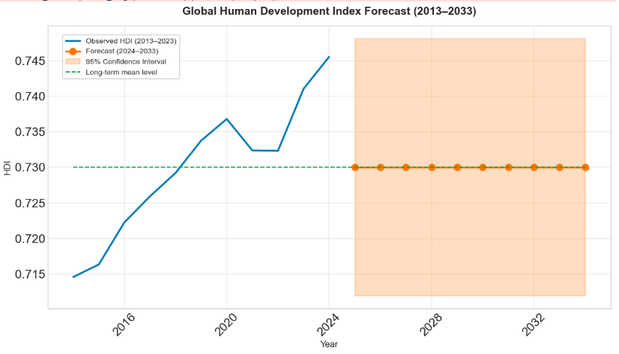
The forecast indicates that human development will continue to rise globally but at a slower rate. This slowing trend reflects saturation: as societies reach high levels of education, income, and life expectancy, further improvement becomes harder and requires greater institutional effort. From a GRC perspective, this suggests that the systems managing governance and compliance must innovate continuously to sustain progress. Without renewal, institutional fatigue may appear a state where compliance remains high, but the capacity for real transformation declines.
This pattern also implies that inequality between countries may persist. Regions with strong and adaptive governance structures will maintain steady progress, while others may stagnate despite institutional reforms. The projection reinforces the importance of aligning governance performance with genuine risk management and human-centered compliance.

5. Discussion
Roughly one third of the results concern the mismatch between institutions and outcomes. Countries with apparently strong institutions but low HDI tend to have hierarchical systems where governance is used to protect the state rather than to serve citizens. They manage risk but not redistribution. These forms of informal compliance substitute for absent structure but rarely scale into stable systems. From a GRC view, this asymmetry is central: governance without empathy becomes rigidity, while compliance without governance becomes improvisation. The Irish case suggests that transformation is possible when institutions learn to listen. Ireland moved from a history of oppression and poverty to one of strong institutions, not by sudden reform but through long learning, education, and integration into larger frameworks. This experience resonates with the forecast patterns. Change takes time, often decades, before it becomes visible in human development metrics.
The global projection suggests stability rather than revolution. HDI will likely continue increasing slowly. The inequality between nations will persist but not necessarily worsen. Strong governance regions will maintain progress, while fragile ones will oscillate. These findings, limited to social and institutional variables, exclude environmental or technological factors but still reveal inertia. Machine learning exposes the rhythm but not the reason. That reason, hidden in culture, politics and trust, remains open for human interpretation. This is the intention of this humble work, to invite further research and discussion about how governance can translate into lived progress.

6. Conclusion
The study demonstrates that institutional quality and human development are connected yet imperfectly aligned. The GRC framework helped interpret the data as more than numbers, showing that progress depends on the balance between governance, risk and compliance. Countries with strong governance but low HDI reveal that order alone does not guarantee fairness. Those with weak governance but social resilience show that cooperation can substitute for structure but not forever. At the global scale, the ARIMA forecast indicates a future of gradual, predictable improvement, but one that demands continuous institutional renewal. The reflection is open rather than closed. Progress must be maintained, and meaning must be built. This exercise invites deeper investigation into why some societies manage to transform governance into genuine human development while others remain trapped in forms without substance.

7. References
World Bank (2023) Worldwide Governance Indicators (2013–2023). Available at: https://databank.worldbank.org/source/worldwide-governance-indicators
United Nations Development Programme (2023) Human Development Data (2013–2023). Available at: https://hdr.undp.org/
Mackinder H J (1904) The Geographical Pivot of History. The Geographical Journal
Prebisch R (1950) The Economic Development of Latin America and its Principal Problems. United Nations New York.
Hickel J (2017) The Divide A Brief Guide to Global Inequality and its Solutions. Random House London.

8. Appendix (AI Reflection)
For this assignment I used OpenAI ChatGPT as a supportive assistant for editing code, organizing ideas and improving the clarity of English expression. The datasets used were public and contained no personal information. I maintained control over the analytical process, model selection and interpretation. The AI helped accelerate technical writing and format correction but did not replace human reasoning. All theoretical connections, the GRC framing and the reflections about inequality and history were developed by me. This collaboration clarified that while automation can simulate logic, meaning still requires human judgment. The distinction between tool and thinker became part of the learning experience, showing that ethics and responsibility remain human domains.

AI Prompts and Scripts Used
- Cleaning, merging and normalizing datasets (WGI + HDR, 2013–2023)
- Implementing K-Means and Agglomerative clustering with evaluation metrics
- Producing the map of institutional incongruence (governance vs. HDI)
- Drafting the AI Reflection, Harvard referencing, and structural editing of the final report

