Associations between Meteorological Conditions, Wild Bird Abundance, and Spillover of Highly Pathogenic Avian Influenza into Poultry Farms: A Case-Crossover Study in Minnesota, 2022

Authors: Fintan A. Mooney¹, Rishi Kowalski², Joshua L. Warren³, Kimberly A. Lehman⁴, Nicholas DeFelice^{2 *}, Sen Pei^{1 *}

Affiliations: ¹Columbia Mailman School of Public Health, Environmental Health Sciences; ²Ichan School of Medicine at Mount Sinai, Department of Environmental Medicine; ³ Yale School of Public Health, Department of Biostatistics; ⁴ United States Department of Agriculture

Contributions: * Asterisk denotes the senior authors

Target Journal: GeoHealth

Length requirements: “For most journals, Research Articles are allowed to be up to 25 publication units (PU), where 1 PU is 500 words or 1 display element (figure or table)”

Word Count (including titles/headings): 5,429 (~11 PU)
Figure Count: 4 (4 PU)
Table Count: 3 (3 PU)
Current PU = 18

Funding Source: This work was conducted as part of Subaward No. 29031, part of a USDA Nonassistance Cooperative Agreement with RCSA Federal Award No. 58-3022-0-005 (SP,ND,KL). This work was also supported in part by the USDA-APHIS. The funders had no role in study design, data collection, interpretation, or the decision to submit the work for publication. Mention of trade names or commercial products in this article is solely for the purpose of providing specific information and does not imply recommendation or endorsement by the USDA. USDA is an equal opportunity provider and employer. This research was additionally supported by the National Institute of General Medical Sciences R35GM156799 (SP) and the NICHD K25 HD109509 (ND).

Abstract

Highly pathogenic avian influenza (HPAI) H5N1 was first identified in North America in 2021 and has since emerged as a panzootic. The early transmission dynamics through which migratory wild birds transmit emerging HPAI strains into commercial and backyard poultry farms (spillover) is unclear. We conducted a case-crossover study utilizing distributed non-linear lag models (DLNMs) to investigate the short-term variations in meteorological conditions and wild bird abundance that potentially contributed to the high number of HPAI spillover events in Minnesota poultry farms in 2022 (N = 110). Our results suggest a two-stage process in which wetter conditions and elevated wild bird abundance approximately four weeks before a spillover event, followed by relatively drier conditions closer to the event, are associated with higher HPAI spillover risk. Specifically, lag-specific odds ratios show that in the three to four-weeks before an event soil moisture (Lag-3 Odds Ratio (OR): 1.50, 95% confidence interval (CI): 1.02, 2.21) and total wild bird abundance (Lag-4 OR: 3.86, 95% CI: 2.27, 6.56) were associated with increased odds of an HPAI spillover event. Acutely at the week of transmission, surface runoff showed an positive association (Lag-0 OR: 1.96, 95% CI: 1.34, 2.86), while an increase in snow density (Lag-0 OR: 0.60, 95% CI: 0.40, 0.91) and precipitation (Lag-0 OR: 0.57, 95% CI: 0.39, 0.84) had protective effects. Seasonal stratification suggested that colder conditions during the spillover week and high wind speeds throughout the four-week lag window increased risk. These findings underscore the role of interacting meteorological conditions and wild bird dynamics at fine spatiotemporal scales in driving the risk of HPAI spillover into farms.

Graphical Abstract: Theoretical transmission dynamics of HPAI in Minnesota backyard and commercial farms.

- Introduction
  - H5N1 Emergence
Highly pathogenic avian influenza (HPAI) H5N1 was first identified in North America in 2021 and has since emerged as a panzootic devastating avian and mammalian species and disrupting agriculture across the world. The recent uptick in spillover events, which are defined as the transmission of HPAI from wild bird reservoirs into domestic poultry and other farm animals, has caused significant economic and public health ramifications. According to the Centers for Disease Control and Prevention (CDC) and the United States Department of Agriculture (USDA) in 2024, the new HPAI strains have been detected in more than 10 thousand wild birds and have infected approximately 108 million birds in commercial and backyard poultry flocks in nearly all states within the United States. In 2024, H5N1 was first confirmed to have spread in dairy cattle, infecting up to 612 dairy herds in 15 states and leading to the USDA restricting cattle movement to curb the spread (Mena et al., 2025). As of March 2025, the CDC has confirmed 73 human cases of H5N1 and one death (CDC, 2025).

The last comparable impact of an emerging highly pathogenic strain in North America was in 2014, when the US resorted to culling 50.5 million commercial birds in response to the H5N8 strain introduced from Europe by wild migratory birds (Damodaran et al., 2025b). The H5 and H7 subtypes are especially concerning as they frequently undergo genetic reassortment and mutations, which can lead to increased genetic diversity and the emergence of novel viruses (Dhingra et al., 2018; Krammer et al., 2025). In particular, the “new” clade 2.3.4.4b H5N1 viruses have an improved ability to species-jump and survive in mammals, expanding the viruses host range. Unlike other HPAI strains, 2.3.4.4b H5N1 has been associated with increased infection in mammalian species such as cats and other carnivores after consuming infected birds, marine mammals, and among dairy cows (Krammer et al., 2025). As the virus continues to mutate and adapt in mammals, recent evidence has warned of increasing mammal-to-mammal transmission and, especially, cow-to-human transmission (Mena et al., 2025).

  - Wild Migratory Birds and H5N1
The significance of wild birds in current transmission is unlike that of past HPAI viruses. H5N1 has been historically linked to enzootic transmission in domestic poultry, as occurred in 2014, and only occasionally cross-continental movement by wild birds, especially Anseriformes (waterfowls). In contrast, unprecedented infection in wildlife beyond commercial poultry and the rapid dissemination across the Americas is linked to the increasing role of migratory flyovers as both sources and sinks for HPAI (Damodaran et al., 2025a; Jindal et al., 2025). The clade 2.3.4.4b viruses were likely first introduced into North America by migratory birds flying across the Arctic Circle from Europe. An analysis of Hemagglutinin sequences by Damodaran et al. (2025a) suggested that the H5N1 viruses were independently introduced approximately 9 times into North America, primarily into the Pacific flyway, and included a single introduction into the Atlantic flyway that spread across the continent within 5 months. Further, they found that wild birds repeatedly reseeded outbreaks in agriculture despite culling domestic poultry and consistently introduced the virus into backyard farms, which happened on average 9 days earlier than in commercial farms.

Wild aquatic birds in the avian orders Anseriformes (ducks, geese, swans) and Charadriiformes (gulls, terns, shorebirds) are the primary natural reservoirs for avian influenza. These species typically breed in wetlands, undertake long-distance migrations, and often live near human activity. Unlike in the low pathogenic strains and past HPAI outbreaks, a broader range of wild birds are being impacted, including predator species such as falcons, hawks, and pelicans (Harvey et al., 2023; Hill et al., 2022; Świętoń et al., 2017). Hill et al. (2022) suggests that despite gulls having the fastest dispersal rate of H5 clade 2.3.4.4, there may be some evidence that non-reservoir hosts can be effective at dispersing the virus under specific environmental conditions. Conversely, the Damodaran et al. (2025a) study reports that despite the new H5N1 viruses causing high cases in non-canonical species, wild Anseriformes are still overwhelmingly responsible for transmission into poultry farms.

1.3 Influence of Environmental Conditions on HPAI H5N1 Transmission

Meteorological and ecological conditions may play a substantial role in the rapid, large-scale transmission of H5N1 from wild birds to poultry flocks and farm animals. A study on HPAI outbreaks in Europe (Opata et al., 2025) reported associations with colder fall temperatures and high poultry density, while low availability of winter water and vegetation showed protective effects. Influenza viruses are known to survive longer outside the their host in cold environmental conditions (Islam et al., 2023; Liu et al., 2007; Opata et al., 2025; Shoham et al., 2012). Emerging HPAI strains in particular can persist in critical routes of infection: up to 8 weeks in wet and dry feces at 4°C (Kurmi et al., 2013); up to 19.2 days in surface water at 10°C (Keeler et al., 2014); and, up to 20 days in rain water or 7 days in lake and pond water at low temperatures (≤17°C) (Horm et al., 2012). Low availability of water and vegetation may deter incoming migration from waterfowl populations, thereby reducing the number of potential hosts in a region (Opata et al., 2025). However, when bird populations have already congregated around bodies of water, short-term reductions in water availability can drive wild birds into denser aggregations, increasing the likelihood of contact between susceptible and infected individuals(Ferenczi et al., 2021).Other research has indicated that anthropogenic factors, such as urban areas and distance to open water, are strongly associated with spillover risk (Azat et al., 2024; Chen et al., 2022). Studies based in Australia (Ferenczi et al., 2021; Firestone et al., 2012) similarly report a higher risk of infection with lower relative humidity, intense rainfall, and high wind speeds, a potentially critical medium of HPAI transmission into farms (Nagy et al., 2025; Zhao et al., 2019).

The timing of environmental fluctuations also relate to HPAI transmission via viral persistence and/or host availability and fitness. Ferenczi et al. (2021) found that risk increased up to two years after periods of high rainfall, which they suggest is due to these events stimulating waterfowl breeding, leading to an upswing of immunologically naïve juvenile birds that later concentrate around permanent water bodies once temporary wetlands dry out. The critical window of exposure may also operate at a finer temporal resolution. For example, higher average air temperatures two to four weeks before transmission and lower average wind speeds four weeks before have been associated with increased HPAI risk in Japan (Fujimoto & Haga, 2024). Non-linear lagged effects of meteorological conditions on human transmission of avian and related influenza have also been reported (Chen et al., 2022; Lau et al., 2018). Furthermore, HPAI occurrence has historically shown strong seasonal oscillations, for instance, in Europe, from November through the end of May. Although research by Jung Kjær et al. (2023) demonstrates an attenuated seasonal effect with the emerging HPAI strains since 2021.

Despite these prior studies, there is limited recent US research that conjointly examines wild-bird abundance and environmental predictors of HPAI spillover events. Llanos-Soto and colleagues (2025) found that the length of time that migratory mallards remained at “stopover sites” in the US was a determinant factor in HPAI spillover, and that this stopover duration can be shaped by snow conditions, low temperatures, and climate-induced effects on waterfowl phenology (Sauter et al., 2010; Weller et al., 2022). In the current study, we investigate the relationship between short-term changes in meteorological conditions, wild-bird abundance, and HPAI H5N1 spillover risk at the onset of the panzootic in the heavily affected state of Minnesota. Minnesota was chosen as the study area as it was the state with the highest number of confirmed HPAI-positive flocks throughout the 2022 study period (N = 110). This focused geographic scope also allowed for a closer examination of small spatiotemporal variations in meteorological conditions and wild bird abundance that could be obscured in a national-scale analysis.

2. Methods

2.1 Study Design

We conducted a case-crossover study with a distributed lag nonlinear model (DLNM) on weekly aggregated data within 0.09-degree (approximately 10km²) grid cells across Minnesota. Cases (n = 100) were defined as a grid cell (10km²) containing at least one HPAI-positive flock in any week during 2022, representing 110 individual spillover events. Seventeen grid cells contained multiple cases; however, these cases were treated as independent as they occurred at different farms within the same cell or they were a minimum of 12 weeks apart in instances when the same farm had more than one spillover event in 2022. Controls were drawn from the same cells within four weeks before each spillover week. Each case was matched with up to four controls from the same grid cell during which no transmission was confirmed. Control weeks that coincided with a spillover event in the same grid cell were excluded (n = 19), resulting in 381 total controls: 84 cases with 4 controls, 13 cases with 3 controls, and 3 cases with 2 controls.

2.2 Data Collection

The location and date of positive HPAI cases in commercial and backyard farms across the United Sates were collected from the USDA detection database. The location of feedlots was collected from the Minnesota Pollution Control Agency (2025) and used as a proxy for farms with no positive HPAI cases in 2022.

Meteorological variables were extracted from the ERA5-Land daily ECMWF Climate Reanalysis (Muñoz Sabater, 2019) and aggregated to the cells via Google Earth Engine (Gorelick et al., 2017). Total precipitation and runoff (sum of surface and sub-surface water) were summarized, while the weekly average was taken for volumetric soil moisture at a 0-7cm depth, air temperature at 2m above surface, relative humidity, high vegetation leaf area index (area fraction of green leaf per unit ground area), snow density (kg/m³), solar radiation (J/m²), longwave radiation (J/m²), and wind speed at 10m above the surface. Beyond the 2022 data, we also collected the 25-yr averages for each environmental variable (1997-2021).

Wild bird abundance was obtained from the Cornell Lab of Ornithology’s eBird Status and Trends data products (Fink et al., 2023) and aggregated at the 3x3km cell corresponding to the location of HPAI-positive farms. Bird species of interest were selected based on two criteria: 1) the top 10 most commonly positive wild bird species identified by USDA Animal and Plant Health Inspection Service (APHIS) in Minnesota in 2022; and 2) the top 15 most identified Anseriformes species in Minnesota reported via iNaturalist (Rodenborg, 2025). USDA APHIS-identified species included American White Pelican, Bald Eagle, Barred Owl, Great Horned Owl, Red-Tailed Hawk, and Trumpeter Swan. While, iNaturalist-identified species included American Black Duck, Common Goldeneye, Lesser Scaup, Ring-necked duck, Blue-winged Teal, Common Merganser, Mallard, Ruddy Duck, Bufflehead, Gadwall, Northern Shoveler, Wood Duck, Canada Goose, Green-winged Teal, and Red-Breasted Merganser.

Weighted Quantile Sum (WQS) regression was implemented to evaluate complex mixtures of bird species and relative species importance within the overall mixture of bird abundance at each farm. Wild bird abundance was extrapolated from the 3x3km cell to the 10x10km case cells and operationalized through three metrics: abundance of all bird species, abundance of avian predator species, and abundance of order Anseriformes. WQS results indicated that species across all groups contributed to spillover risk; we therefore used total bird abundance as the composite exposure metric in our main models.

For sensitivity analyses and descriptive purposes, we collected the meteorological and bird data for negative cells: cells that did not have a spillover event in 2022 but do contain a feedlot or farm, as attributed by the Minnesota Pollution Control Agency (2025). In addition, the most common landcover type in each cell was collected from the USGS National Land Cover Dataset (EROS Center, 2018).

2.3 Statistical Analysis

To model the association between bird populations and environmental variables in the four weeks prior to HPAI spillover events, we used a conditional logistic regression with a DLNM in a case-crossover design. The binary outcome was the occurrence of an HPAI spillover, and the primary environmental predictors included surface and sub-surface runoff, snow density, soil moisture, temperature, precipitation, wind speed, and total bird abundance. For each predictor, we specified a linear exposure response relationship and a nonlinear spline function (natural spline, degrees of freedom = 2) across a 4-week lag dimension to analyze delayed effects and critical windows of exposure. The 4-week lag was selected based on biological plausibility, as this duration captures peak viral shedding in wild birds (≤17 days), survival of H5N1 in water (≤20 days in rain; ≤7 days in pond/lake water), and the typical stopover period of migratory birds (7-28 days) (Hénaux et al., 2013; Horm et al., 2012; Lebarbenchon et al., 2010; Llanos-Soto et al., 2025). Moreover, although sensitivity analyses using longer lags (6 and 8 weeks) yielded lower Akaike information criterion (AIC) estimates, they consequently produced unstable estimates and extremely wide confidence intervals, indicating overfitting. Relative humidity, leaf area index, shortwave and longwave radiation were excluded from the model due to high multicollinearity with the other covariates. To control for skewness, surface runoff, precipitation, and total bird abundance were log-transformed. All covariates were scaled prior to model fitting. We report the lag-specific and cumulative odds ratios associated with a 0.5 standard deviation increase in each predictor on the risk of HPAI spillover events.

We conducted several sensitivity analyses: 1) Time series model including all cells that contained a farm or feedlot (n = 2,142 cells) using a DLNM with a negative binomial distribution, a Duchon spline (k = 200) spatial smoother on the center coordinates of the cell, and astronomical season as a fixed effect to identify potential effect modification by season; 2) A seasonally restricted case-crossover model limited to meteorological spring (March-May) and fall (September – November), to closer examine effects during migratory periods; and, 3) Bird order-specific models that separated total bird abundance into predator species and Anseriformes species to investigate potential divergent associations with HPAI spillover within a longer 8-week lag window. Model parameter modifications were also conducted: 4) an analysis using a reduced model provided by a cross-validated penalized conditional logistic regression with a LASSO penalty; 5) refitting of the model to a 2, 6, and 8-lag structures to test the influence of different lag structures on model performance and associations between covariates and HPAI spillover risk; and, 6) respecifying the model with more flexible cross-basis terms, increasing the degrees of freedom and allowing polynomial lag functions for runoff, snow density, and wind speed. Lastly, as an additional analysis, we explored potential significant differences (anomalies) between the 2022 seasonal conditions and the 25-year climatological means (1997-2021) by running linear mixed effect models for each meteorological variable with meteorological season as a fixed effect and random intercepts for zone and week.

Statistical analyses were conducted in R version 4.5.2 (R Core Team, 2025) and included the use of the DLNM package (Gasparrini, 2011). Maps were produced with the GeoPandas package for Python (Python Software Foundation, 2025; Jordahl et al., 2020).

3. Results

3.1 Environmental conditions and incidence of HPAI spillover events across Minnesota study cells

A total of 110 spillover events occurred in Minnesota from January 1st, 2022, to December 31st, 2022; most of which occurred in the spring (March – May; n = 71), followed by fall (September – November; n = 23), winter (December – February; n = 3), and summer (June – August; n = 3) (Table 2, Figure 1). The first confirmed spillover event occurred in week 12 (03/25/22) and last occurred in week 50 (12/12/22) (Figure 1). The spillover events occurred in 77 unique case cells, clustered in the central and southern parts of the state. Out of the 77 unique case cells, 17 had more than one event in 2022 (Figure 2). Case cells were majority covered by cultivated crop land (79%), followed by deciduous forest (9.1%), open water (3.9%), and pasture/hay (3.9%). In contrast, cells that did not have a spillover event but contained feedlots/farms (n = 2,065) had more diverse land cover, largely composed of cultivated crops (71%), deciduous forest (12%), and woody wetlands (7.9%) (Table 1).

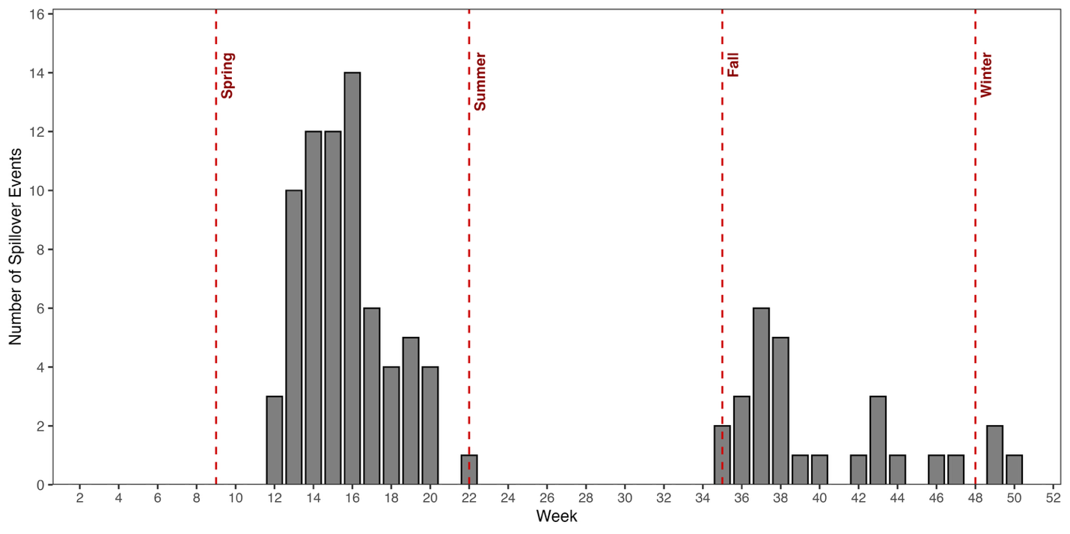
Figure 1. Weekly distribution of HPAI spillover events (N = 110) in Minnesota backyard and commercial farms in 2022. Dashed lines indicate meteorological season boundaries. The first confirmed event occurred in week 12 (03/25/22) and last occurred in week 50 (12/12/22).

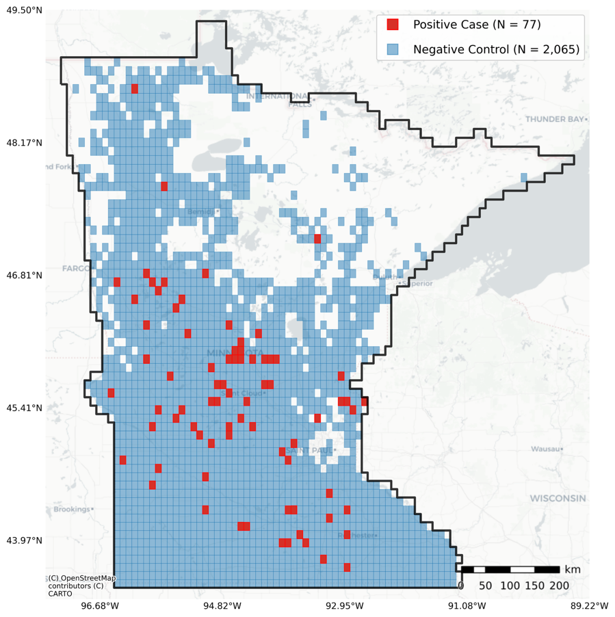

Figure 2. 10x10km Study Cells in Minnesota. Cells colored in red had a spillover event in 2022 (N = 77), while cells colored in blue had a farm or feedlot but did not have a confirmed spillover event (N = 2,065).

The mean relative humidity, surface and sub-surface runoff, and high-vegetation leaf area index was significantly higher in cells that had a spillover event in 2022 (n = 77) compared to cells that did not have an event in 2022 but contained feedlots (n = 2,065). Conversely, soil moisture and snow density were significantly lower in the study cells (Table 1). The mean abundance of both Anseriformes and predator birds was significantly higher in the study cells than in the negative cells; on average, the study cells see an estimated 19 more Anseriformes and over 2 more predators per week (Table 1).

3.2 Associations between metrological conditions, wild-bird abundance, and incidence of HPAI spillover events

The direction and significance of the associations between meteorological conditions and wild bird abundance on the risk of HPAI spillover events varied during the 4-week lag period. Specifically, our results indicate that wet conditions and high wild bird abundance four weeks before the spillover and dry conditions in the two weeks closer to the event are predictive of increased spillover risk (Table 3; Figure 3).

From the lag-specific odds ratios our results show that at the tail end of the lag window, soil moisture (OR at Lag 3: 1.50, 95% CI: 1.02, 2.21), and wild bird abundance (OR at Lag 4: 3.86, 95% CI: 2.27, 6.56) were strongly associated with an increase in the odds of an HPAI spillover event (Figure 3; Table 3). Closer to the spillover, surface runoff showed an acute effect. A 0.5 standard deviation increase in surface runoff was associated with an increase in spillover odds of 1.36 (95% CI: 1.09, 1.71) at the 2-week lag, 1.63 (95% CI: 1.22, 2.19) at the 1-week lag, and 1.96 (95% CI: 1.34, 2.86) in the event week. Conversely, at the 1-week lag, increased snow density (OR: 0.69, 95% CI: 0.52, 0.91) and precipitation (OR: 0.64, 95% CI: 0.48, 0.87) showed protective effects (Figure 3; Table 3).

The cumulative odds ratios indicate that an accumulation of high surface and subsurface runoff is consistently associated with higher spillover risk over the four-week lag period. Conversely, an accumulation of snow density and precipitation up to three to four weeks before a spillover event is protective. Taken together, these results are consistent with heightened HPAI spillover risk under abnormally dry conditions. Increased bird abundance up to two weeks before a spillover event is negatively associated with risk but becomes positively associated at the four-week lag (OR = 6.39, 95% CI: 2.47, 16.52), suggesting a relatively narrow temporal window in which elevated wild-bird abundance drives spillover risk (Table 3, Figure S1).

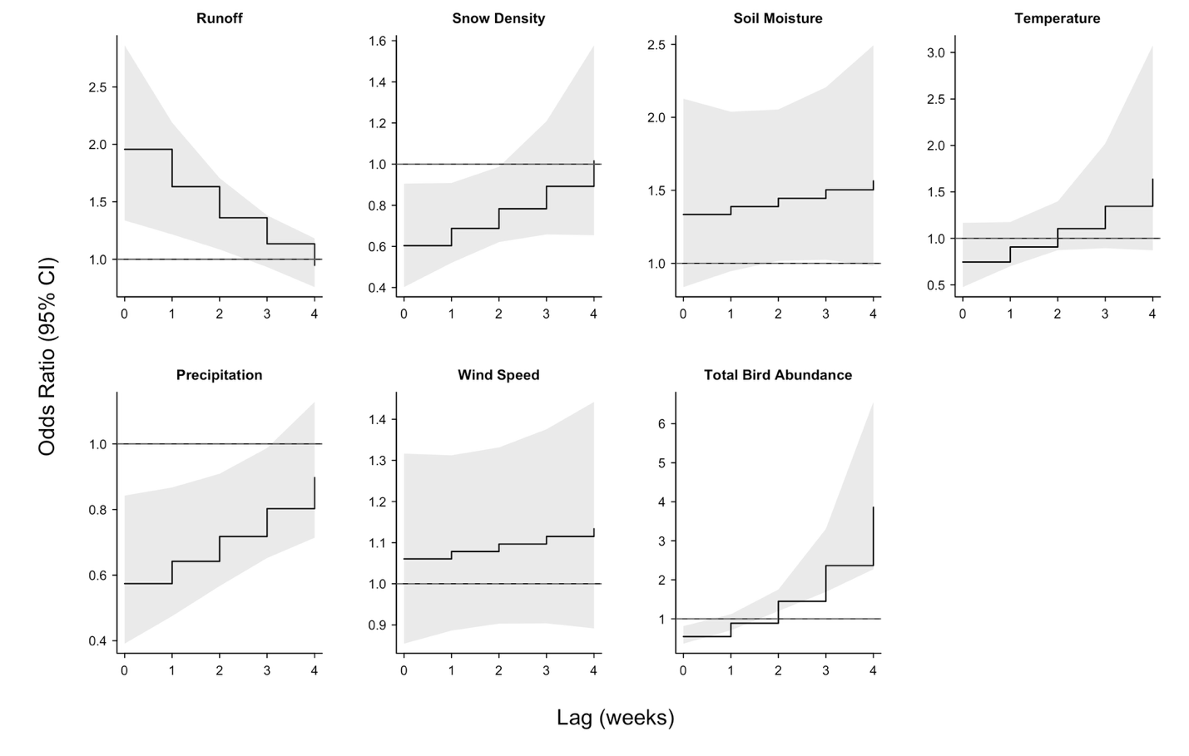
Figure 3. Lag-specific odds ratios for the association between meteorological conditions and
wild-bird abundance on odds of an HPAI spillover event. Solid lines represent the odds ratio in each lag week. Shaded areas show the respective 95% confidence intervals.

3.3. Seasonal effects and influence of climate anomalies

The spring had considerably more spillover events (n = 72) than the other seasons. Concurrently, spring had higher weekly surface & sub-surface runoff (average of 6.5 mm), soil moisture, and precipitation, which may have played a role in transmission (Table 2, Figure 3). Anseriformes abundance peaked in spring and fall (the second-most outbreaks, n = 23), consistent with seasonal migration of Anseriformes through Minnesota, which influences HPAI incidence. Along with the abundance of Anseriformes, extreme weather in spring 2022 may have contributed to the relatively higher number of outbreaks. Compared to 25-year climatological means, our seasonal anomaly models show Spring 2022 as having anomalously wet and cold conditions: soil moisture (MD = +0.02 m³/m³; 95% CI: 0.01, 0.03), runoff (MD = +1.91 mm; 95% CI: 0.64, 3.17), and snow density (MD = +6.20 kg/m³; 95% CI: 0.38, 12.02) were elevated, whereas temperature (MD = −1.96 °C; 95% CI: −3.77, −0.16), shortwave radiation, and high-vegetation leaf area index, a proxy for vegetative growth, were reduced (Table 2).

To address seasonal and migration effects, we reran the main case-crossover model after excluding cases that occurred in winter and summer (n = 6) (Table S1, Figure S2). The predictors related to water availability in the environment (runoff, precipitation, snow density, and soil moisture) had similar significant effects on HPAI spillover risk as in the main model. Stratifying to the spring and fall strengthened previously indeterminate associations between wind-speed, temperature, and total bird abundance and HPAI spillover risk. For example, warmer conditions increased HPAI spillover risk three to four weeks before an event but were associated with a ~58% reduction in the event week (OR: 0.42, 95% CI: 0.21, 0.85), consistent with appreciable viral persistence in colder conditions. Moreover, an increase in wind speed is positively associated with HPAI spillover risk in the fall and spring throughout the lag window, with the largest effect occurring at the 4-week lag (OR: 1.61, 95% CI: 1.14, 2.28), which may suggest that wind speed has a more significant role in transmission than previously observed from the main model.

We additionally fit a time-series model that included non-case cells (cells that contained a feedlot, but did not have a spillover event), a spatial Duchon spline on cell centroids and a fixed effect on the astronomical season to further evaluate seasonality (Table S2). Compared with the case-crossover model, the associations were largely attenuated; a possible consequence of the model specification, the introduction of non-case cells (n = 2,065), and the rarity of case cells (n = 77) among the total cells (N = 2,142). Nonetheless, distinct patterns emerged: higher temperatures were associated with reduced spillover risk at lags 0-1, and bird abundance remained positively associated with spillover risk in the 2-3 weeks prior (Table S2).

3.4. Sensitivity analyses: Bird order stratification and model specification

The sensitivity analysis that modeled Anseriformes and predator bird abundance exclusively across an 8-week lag window suggested that both groups of birds were associated with HPAI spillover events. However, associations were stronger for the Anseriformes and remained positive up to the 1-week lag. Predator abundance began showing a protective effect in the week of the spillover event (Figure 4, Table S3).

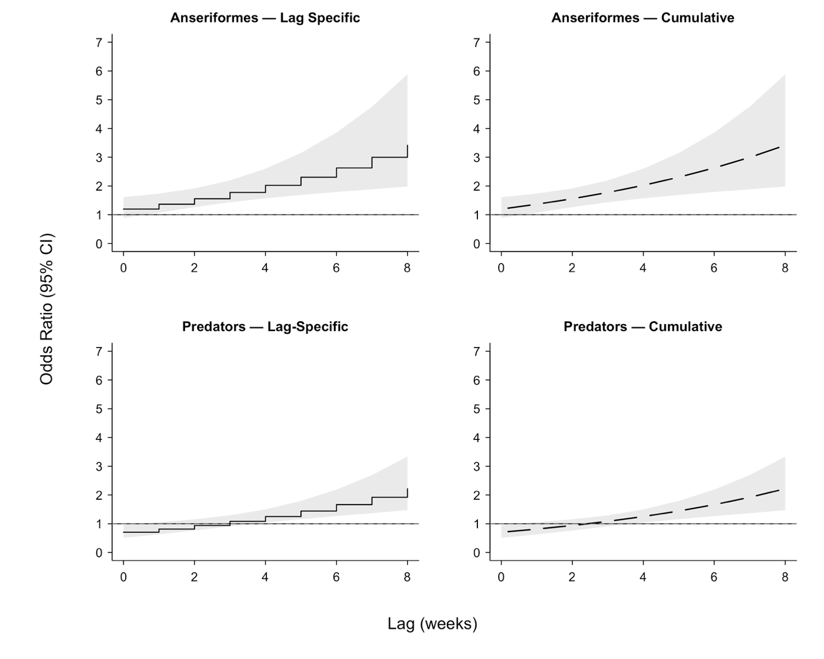
Figure 4. Lag-Specific and cumulative odds ratios for the association between wild-bird abundance of Anseriformes and predators on odds of an HPAI spillover event. Estimates are produced from the case-crossover model that used an 8-lag week window for Anseriformes and predator abundance. Odds ratios are per a 0.5 SD increase in abundance. Solid lines represent the odds ratio in each lag week. Shaded areas show the respective 95% confidence intervals.

The main results were largely consistent with the model that fit more flexible degrees of freedom and polynomials, rather than natural splines, for the spline functions of soil moisture, snow density, and wind speed (Figure S3). The flexible specification suggested additional curvature: a reversal in the snow-density association at lag 1, a more sustained positive association for soil moisture through lags 1–4, and stronger associations for total bird abundance. However, these additional results should be interpreted with caution, as the confidence intervals were considerably wider than those in the main model.

Lastly, we fit a LASSO-penalized conditional logistic regression to assess relative contribution of each environmental predictor in the model. The penalized model indicated that total bird abundance is the most influential predictor of spillover risk, followed by surface and subsurface runoff, soil moisture, precipitation, and snow density. Notably, temperature and wind speed have the weakest penalized effects (Table S4, Figure S4).

4. Discussion

4.1 Main Findings

The introduction of the H5N1 subtype of the highly pathogenic avian influenza (HPAI) of into the US in 2022 disproportionately impacted commercial and backyard farms in Minnesota. In this case-crossover study of Minnesota farms with a confirmed spillover event from wild-birds into poultry, we found that short-term variations in both wild bird abundance and meteorological conditions were strong predictors of spillover risk, particularly during the fall and spring. Our results suggest a two-stage process in which wetter conditions and elevated wild bird abundance approximately four weeks before an event, followed by relatively drier conditions closer to the event, are associated with higher HPAI spillover risk (Figure 2). For instance, at longer lags increased soil moisture and wild bird abundance were associated with higher spillover risk, while closer to the event surface and sub-surface runoff was associated with sharply elevated risk coupled with a protective effect of increased precipitation and snow density. Together, these findings reflect transitions from wetter to relatively dryer conditions facilitating the transmission dynamics through which the virus circulates in wild bird populations, is introduced into farms, and is eventually detected in poultry flocks.

Our results largely agree with the prior research that implicates colder conditions, increased wind speed, and relatively dryer wetlands as strong metrological drivers of HPAI transmission into poultry flocks (Ferenczi et al., 2021; Llanos-Soto et al., 2025; Nagy et al., 2025; Opata et al., 2025). Although this was not explicitly evident in the full-year model, when we restricted our analysis to the fall and spring cases we observed a protective effect of higher temperatures during the outbreak week, with approximately 58% lower spillover odds. Importantly, this may suggest that the influence of colder temperatures on heightened viral persistence in the environment (Kurmi et al., 2013; Si et al., 2013) is relatively short-lived, primarily impacting the final spillover pathway from wild birds into poultry rather than sustaining transmission within wild bird populations. Supporting this argument, we observed that warmer temperatures increased risk for transmission at three to four weeks before a spillover event, as was also seen in Fujimoto and Haga (2024) and Chen et al. (2022). Moreover, in the same restricted analysis we also observe that increased wind speed throughout the 4-week lag window is associated with HPAI spillover risk, consistent with evidence that wind is a critical medium for spreading virus droplets among birds (Nagy et al., 2025).

High surface and subsurface runoff are not typically considered an attribute of dry conditions. However, the hydrology literature has documented an often-inverse relationship between runoff and soil moisture, and that abnormally high storm runoff can occur after periods of drought (Lange & Haensler, 2012). In our sensitivity analysis that performed a conditional logistic regression with a LASSO penalty, we found that only wild bird abundance was a better predictor of spillover risk across the lag-window. Additionally, the cumulative odds ratios from the primary model indicate that an accumulation of runoff over the four weeks prior to an outbreak is significantly associated with spillover risk. Beyond wind, these findings suggest that runoff may be an important pathway by which virus present from areas with wild bird activity are transported into poultry farms. Previous research (Guinat et al., 2025) did not identify an association between runoff and HPAI spillover, but that analysis studied outbreaks during 2020-2021 that may be unrelated to the virulent H5 subtypes considered in this analysis.

4.2 Influence of Migratory Birds

Some studies (Damodaran et al., 2025a, 2025b; Jindal et al., 2025) argue that wild migratory birds have a more prominent role in the transmission of the current HPAI viruses (i.e., those with the H5 subtype) into poultry farms than in past outbreaks. Our results support this hypothesis: the total abundance of Anseriformes and predator species in 3km x 3km area around poultry farms is significantly associated with increased spillover risk, particularly in the two to four weeks before a spillover event. Further, the association was stronger for Anseriformes as compared to predator species, consistent with evidence from Damodaran et al., (2025a) that waterfowl remain the primary vectors of HPAI while predator species, despite experiencing increased infections, predominantly function as dead-end hosts.

4.3 Seasonality of HPAI Spillover Events in Minnesota

Spillover events in Minnesota overwhelmingly occurred in the spring and fall, during peak migration season. Despite a recent study (Jung Kjær et al., 2023) suggesting that emerging HPAI strains may have become seasonally independent (i.e., a year-round panzootic), our findings signal a continued seasonal oscillation. When we restricted our analysis to the fall and spring, we observe similar or, as in the case with temperature, wild bird abundance, and wind speed, stronger associations with HPAI spillover risk. Both seasons were characterized by much higher abundance of Anseriformes, consistent with migratory patterns and their status as a primary host. Spring, which had over triple the number of spillover event as fall, also saw higher weekly surface and subsurface runoff, soil moisture, and precipitation, reflecting the joint significance of seasonal bird abundance and hydrological conditions in exacerbating risk. Furthermore, there is the potential that climate conditions were related to the relatively high concentration of HPAI spillover events in Minnesota during spring 2022. In our analysis that compared the average conditions in spring 2022 to the 25-year climatological means, we find that this spring was abnormally colder and had increased soil moisture, runoff, and snow density. Future research should consider a more complete study of the relationship between global weather changes and the spread of H5N1 in North America; expanding on the impact of environmental change on waterfowl phenology (Llanos-Soto et al., 2025; Sauter et al., 2010; Weller et al., 2022).

4.4 Strengths and Limitations

To our knowledge, this is the first study in the United States specifically examine how short-term variations in meteorological conditions and wild bird abundance compound risk of HPAI spillover into commercial and backyard poultry farms. A core strength of our approach is the ability to detect associations at fine spatial scales, using meteorological data aggregated to 10km² cells and wild bird abundance estimates at 3km² around farms. We also made use of distributed lag non-linear models to potential lagged effects within a month of a spillover event. On the other hand, the small spatiotemporal scale and the relatively limited number of spillovers reduced the statistical power, constrained our ability to investigate longer lag windows, and impeded us from assessing whether anomalous winter or summer conditions increased risk for transmission in the spring and fall, or modify avian migratory behavior. Furthermore, due to data availability our analysis was restricted to spillover events occurring in 2022, preventing the exchangeability of our hypothesis regarding HPAI transmission from wild birds to recent spillover in different regions of the US and in farmed mammalian hosts. Nonetheless, our study provides insight of the early spillover dynamics as 2022 falls within the initial period of H5N1 introduction in North America.

The external generalizability of these finding to other state and countries with different climates remains unclear. However, it is notable that our results confer with studies based in Europe, Japan, Chille, and Australia (Azat et al., 2024; Caliendo et al., 2022; Ferenczi et al., 2021; Fujimoto & Haga, 2024; Opata et al., 2025; Ruiz et al., 2021). Further work intends to extrapolate this analysis nationwide to assess generalizability and to investigate how different climate zones may modify the associations seen here. Lastly, although we can theorize the primary pathways through which transmission from wild birds to poultry farms occurs, we are unable to assess causality within the confines of our case-crossover study design. Casual inference could be strengthened with future research that links the specific viral clades (e.g., 2.3.4.4b) found in local wild bird populations with those identified in poultry farms.

4.5. Conclusion

Fine spatiotemporal variations in metrological conditions and wild bird abundance influenced the risk for HPAI spillover events in Minnesota backyard and commercial farms during 2022, when emerging H5N1 strains were first introduced into North America. We found that three to four weeks before spillovers, increased abundance of Anseriformes and predator bird species and wetter conditions exacerbated risk. Acute risk was elevated by relatively dryer conditions characterized by higher runoff and lower precipitation and snow density. Additionally, our seasonal analyses suggest that colder temperature during the week of the spillover and high wind speed throughout the four-week lag window increased HPAI risk in the fall and spring, when outbreaks were overwhelmingly more common. These findings aid our understanding of how early spillover dynamics were driven by fluctuations in meteorological conditions, and possibly large-scale changes in climate conditions, that influence wild bird migratory patterns and H5N1 virulence. Moreover, these results highlight opportunities for short-term interventions for farms, particularly runoff management and expanding surveillance during peak migration times, to reduce spillover of HPAI.

References
Azat, C., Alvarado-Rybak, M., Aguilera, J. F., & Benavides, J. A. (2024). Spatio-temporal dynamics and drivers of highly pathogenic avian influenza H5N1 in Chile. Frontiers in Veterinary Science, 11. https://doi.org/10.3389/fvets.2024.1387040
Caliendo, V., Lewis, N. S., Pohlmann, A., Baillie, S. R., Banyard, A. C., Beer, M., Brown, I. H., Fouchier, R. a. M., Hansen, R. D. E., Lameris, T. K., Lang, A. S., Laurendeau, S., Lung, O., Robertson, G., van der Jeugd, H., Alkie, T. N., Thorup, K., van Toor, M. L., Waldenström, J., … Berhane, Y. (2022). Transatlantic spread of highly pathogenic avian influenza H5N1 by wild birds from Europe to North America in 2021. Scientific Reports, 12(1), 11729. https://doi.org/10.1038/s41598-022-13447-z
CDC. (2025, November 14). H5 Bird Flu: Current Situation. Avian Influenza (Bird Flu). https://www.cdc.gov/bird-flu/situation-summary/index.html
Chen, W., Zhang, X., Zhao, W., Yang, L., Wang, Z., & Bi, H. (2022). Environmental factors and spatiotemporal distribution characteristics of the global outbreaks of the highly pathogenic avian influenza H5N1. Environmental Science and Pollution Research, 29(29), 44175–44185. https://doi.org/10.1007/s11356-022-19016-1
Damodaran, L., Jaeger, A., & Moncla, L. H. (2025a). Intensive transmission in wild, migratory birds drove rapid geographic dissemination and repeated spillovers of H5N1 into agriculture in North America. bioRxiv, 2024.12.16.628739. https://doi.org/10.1101/2024.12.16.628739
Damodaran, L., Jaeger, A. S., & Moncla, L. H. (2025b). Ecology and spread of the North American H5N1 epizootic. Nature, 1–10. https://doi.org/10.1038/s41586-025-09737-x
Dhingra, M. S., Artois, J., Dellicour, S., Lemey, P., Dauphin, G., Von Dobschuetz, S., Van Boeckel, T. P., Castellan, D. M., Morzaria, S., & Gilbert, M. (2018). Geographical and Historical Patterns in the Emergences of Novel Highly Pathogenic Avian Influenza (HPAI) H5 and H7 Viruses in Poultry. Frontiers in Veterinary Science, 5. https://doi.org/10.3389/fvets.2018.00084
EROS Center. (2018). National Land Cover Database (Version 2022) [Dataset]. https://www.usgs.gov/centers/eros/science/national-land-cover-database
Ferenczi, M., Beckmann, C., & Klaassen, M. (2021). Rainfall driven and wild-bird mediated avian influenza virus outbreaks in Australian poultry. BMC Veterinary Research, 17(1), 306. https://doi.org/10.1186/s12917-021-03010-9
Fink, D., Auer, T., Johnson, A., Strimas-Mackey, M., Ligocki, S., Robinson, O., Hochachka, W., Jaromczyk, L., Crowley, C., Dunham, K., Stillman, A., Davies, I., Rodewald, A., Ruiz-Gutierrez, V., & Wood, C. (2023). eBird Status and Trends, Data Version: 2022 (Version 2022) [Dataset]. Cornell Lab of Ornithology, Ithaca, New York. https://doi.org/10.2173/ebirdst.2022
Firestone, S. M., Cogger, N., Ward, M. P., Toribio, J.-A. L. M. L., Moloney, B. J., & Dhand, N. K. (2012). The Influence of Meteorology on the Spread of Influenza: Survival Analysis of an Equine Influenza (A/H3N8) Outbreak. PLOS ONE, 7(4), e35284. https://doi.org/10.1371/journal.pone.0035284
Foundation, P. S. (2025). Python Language Reference, version 3.11. https://www.python.org/
Fujimoto, Y., & Haga, T. (2024). Association between highly pathogenic avian influenza outbreaks and weather conditions in Japan. The Journal of Veterinary Medical Science, 86(10), 1045–1051. https://doi.org/10.1292/jvms.23-0521
Gasparrini, A. (2011). Distributed Lag Linear and Non-Linear Models in R: The Package dlnm. Journal of Statistical Software, 43, 1–20. https://doi.org/10.18637/jss.v043.i08
Gorelick, N., Hancher, M., Dixon, M., Ilyushchenko, S., Thau, D., & Moore, R. (2017). Google Earth Engine: Planetary-scale geospatial analysis for everyone. Remote Sensing of Environment, 202, 18–27. https://doi.org/10.1016/j.rse.2017.06.031
Guinat, C., Valenzuela Agüí, C., Briand, F.-X., Chakraborty, D., Fourtune, L., Lambert, S., Jimenez Pellicer, A., Rautureau, S., Gerbier, G., du Plessis, L., Stadler, T., Grasland, B., Paul, M. C., & Vergne, T. (2025). Poultry farm density and proximity drive highly pathogenic avian influenza spread. Communications Biology, 8(1), 1306. https://doi.org/10.1038/s42003-025-08687-4
Harvey, J. A., Mullinax, J. M., Runge, M. C., & Prosser, D. J. (2023). The changing dynamics of highly pathogenic avian influenza H5N1: Next steps for management & science in North America. Biological Conservation, 282, 110041. https://doi.org/10.1016/j.biocon.2023.110041
Hénaux, V., Parmley, J., Soos, C., & Samuel, M. D. (2013). Estimating transmission of avian influenza in wild birds from incomplete epizootic data: Implications for surveillance and disease spread. Journal of Applied Ecology, 50(1), 223–231. https://doi.org/10.1111/1365-2664.12031
Hill, N. J., Bishop, M. A., Trovão, N. S., Ineson, K. M., Schaefer, A. L., Puryear, W. B., Zhou, K., Foss, A. D., Clark, D. E., MacKenzie, K. G., Jr, J. D. G., Borkenhagen, L. K., Hall, J. S., & Runstadler, J. A. (2022). Ecological divergence of wild birds drives avian influenza spillover and global spread. PLOS Pathogens, 18(5), e1010062. https://doi.org/10.1371/journal.ppat.1010062
Horm, V. S., Gutiérrez, R. A., Nicholls, J. M., & Buchy, P. (2012). Highly Pathogenic Influenza A(H5N1) Virus Survival in Complex Artificial Aquatic Biotopes. PLOS ONE, 7(4), e34160. https://doi.org/10.1371/journal.pone.0034160
Islam, A., Munro, S., Hassan, M. M., Epstein, J. H., & Klaassen, M. (2023). The role of vaccination and environmental factors on outbreaks of high pathogenicity avian influenza H5N1 in Bangladesh. One Health, 17, 100655. https://doi.org/10.1016/j.onehlt.2023.100655
Jindal, M., Stone, H., Lim, S., & MacIntyre, C. R. (2025). A Geospatial Perspective Toward the Role of Wild Bird Migrations and Global Poultry Trade in the Spread of Highly Pathogenic Avian Influenza H5N1. GeoHealth, 9(3), e2024GH001296. https://doi.org/10.1029/2024GH001296
Jordahl, K., Bossche, J. V. den, Fleischmann, M., Wasserman, J., McBride, J., Gerard, J., Tratner, J., Perry, M., Badaracco, A. G., Farmer, C., Hjelle, G. A., Snow, A. D., Cochran, M., Gillies, S., Culbertson, L., Bartos, M., Eubank, N., maxalbert, Bilogur, A., … Leblanc, F. (2020). geopandas/geopandas: V0.8.1 (Version v0.8.1) [Computer software]. Zenodo. https://doi.org/10.5281/zenodo.3946761
Jung Kjær, L., Ward, M. P., Boklund, A. E., Larsen, L. E., Hjulsager, C. K., & Kirkeby, C. T. (2023). Using surveillance data for early warning modelling of highly pathogenic avian influenza in Europe reveals a seasonal shift in transmission, 2016–2022. Scientific Reports, 13(1), 15396. https://doi.org/10.1038/s41598-023-42660-7
Keeler, S. P., Dalton, M. S., Cressler, A. M., Berghaus, R. D., & Stallknecht, D. E. (2014). Abiotic Factors Affecting the Persistence of Avian Influenza Virus in Surface Waters of Waterfowl Habitats. Applied and Environmental Microbiology, 80(9), 2910–2917. https://doi.org/10.1128/AEM.03790-13
Krammer, F., Hermann, E., & Rasmussen, A. L. (2025). Highly pathogenic avian influenza H5N1: History, current situation, and outlook. Journal of Virology. https://doi.org/10.1128/jvi.02209-24
Kurmi, B., Murugkar, H. V., Nagarajan, S., Tosh, C., Dubey, S. C., & Kumar, M. (2013). Survivability of Highly Pathogenic Avian Influenza H5N1 Virus in Poultry Faeces at Different Temperatures. Indian Journal of Virology, 24(2), 272–277. https://doi.org/10.1007/s13337-013-0135-2
Lange, J., & Haensler, A. (2012). Runoff generation following a prolonged dry period. Journal of Hydrology, 464–465, 157–164. https://doi.org/10.1016/j.jhydrol.2012.07.010
Lau, S. Y.-F., Wang, X., Wang, M., Liu, S., Zee, B. C.-Y., Han, X., Yu, Z., Sun, R., Chong, K. C., & Chen, E. (2018). Identification of meteorological factors associated with human infection with avian influenza A H7N9 virus in Zhejiang Province, China. Science of The Total Environment, 644, 696–709. https://doi.org/10.1016/j.scitotenv.2018.06.390
Lebarbenchon, C., Feare, C. J., Renaud, F., Thomas, F., & Gauthier-Clerc, M. (2010). Persistence of Highly Pathogenic Avian Influenza Viruses in Natural Ecosystems. Emerging Infectious Diseases, 16(7), 1057–1062. https://doi.org/10.3201/eid1607.090389
Liu, C.-M., Lin, S.-H., Chen, Y.-C., Lin, K. C.-M., Wu, T.-S. J., & King, C.-C. (2007). Temperature Drops and the Onset of Severe Avian Influenza A H5N1 Virus Outbreaks. PLOS ONE, 2(2), e191. https://doi.org/10.1371/journal.pone.0000191
Llanos-Soto, S. G., Yaffy, D., Pavlak, M., & Ivanek, R. (2025). Transmission dynamics of highly pathogenic avian influenza among multiple waterfowl species and backyard poultry: The impact of the stopover period. Scientific Reports, 15(1), 5861. https://doi.org/10.1038/s41598-025-89827-y
Mena, A., von Fricken, M. E., & Anderson, B. D. (2025). The Impact of Highly Pathogenic Avian Influenza H5N1 in the United States: A Scoping Review of Past Detections and Present Outbreaks. Viruses, 17(3), 307. https://doi.org/10.3390/v17030307
Minnesota Pollution Control Agency. (2025). Feedlots in Minnesota—Minnesota Geospatial Commons [Shapefile]. Minnesota Geospatial Commons. https://gisdata.mn.gov/dataset/env-feedlots
Muñoz Sabater, J. (2019). ERA5-Land monthly averaged data from 1950 to present [Dataset]. Copernicus Climate Change Service (C3S) Climate Data Store (CDS). https://doi.org/doi:10.24381/cds.68d2bb30
Nagy, A., Černíková, L., & Sedlák, K. (2025). Genetic data and meteorological conditions suggesting windborne transmission of H5N1 high-pathogenicity avian influenza between commercial poultry outbreaks. PLOS ONE, 20(9), e0319880. https://doi.org/10.1371/journal.pone.0319880
Opata, M. R., Lavarello-Schettini, A., Semenza, J. C., & Rocklöv, J. (2025). Predictiveness and drivers of highly pathogenic avian influenza outbreaks in Europe. Scientific Reports, 15(1), 20286. https://doi.org/10.1038/s41598-025-04624-x
R Core Team. (2025). R: A language and environment for statistical computing (Version 4.5.0) [Computer software]. R Foundation for Statistical Computing. www.R-project.org
Rodenborg, M. (2025). Birds of Minnesota. iNaturalist. https://www.inaturalist.org/guides/14807?taxon=6888
Ruiz, S., Jimenez-Bluhm, P., Di Pillo, F., Baumberger, C., Galdames, P., Marambio, V., Salazar, C., Mattar, C., Sanhueza, J., Schultz-Cherry, S., & Hamilton-West, C. (2021). Temporal dynamics and the influence of environmental variables on the prevalence of avian influenza virus in main wetlands in central Chile. Transboundary and Emerging Diseases, 68(3), 1601–1614. https://doi.org/10.1111/tbed.13831
Sauter, A., Korner-Nievergelt, F., & Jenni, L. (2010). Evidence of climate change effects on within-winter movements of European Mallards Anas platyrhynchos. Ibis, 152(3), 600–609. https://doi.org/10.1111/j.1474-919X.2010.01028.x
Shoham, D., Jahangir, A., Ruenphet, S., & Takehara, K. (2012). Persistence of Avian Influenza Viruses in Various Artificially Frozen Environmental Water Types. 2012(1), 11. https://doi.org/10.1155/2012/912326
Si, Y., Boer, W. F. de, & Gong, P. (2013). Different Environmental Drivers of Highly Pathogenic Avian Influenza H5N1 Outbreaks in Poultry and Wild Birds. PLOS ONE, 8(1), e53362. https://doi.org/10.1371/journal.pone.0053362
Świętoń, E., Wyrostek, K., Jóźwiak, M., Olszewska-Tomczyk, M., Domańska-Blicharz, K., Meissner, W., Włodarczyk, R., Minias, P., Janiszewski, T., Minta, Z., & Śmietanka, K. (2017). SURVEILLANCE FOR AVIAN INFLUENZA VIRUS IN WILD BIRDS IN POLAND, 2008–15. Journal of Wildlife Diseases, 53(2), 330–338. https://doi.org/10.7589/2016-07-154
Weller, F. G., Beatty, W. S., Webb, E. B., Kesler, D. C., Krementz, D. G., Asante, K., & Naylor, L. W. (2022). Environmental drivers of autumn migration departure decisions in midcontinental mallards. Movement Ecology, 10(1), 1. https://doi.org/10.1186/s40462-021-00299-x
Zhao, Y., Richardson, B., Takle, E., Chai, L., Schmitt, D., & Xin, H. (2019). Airborne transmission may have played a role in the spread of 2015 highly pathogenic avian influenza outbreaks in the United States. Scientific Reports, 9, 11755. https://doi.org/10.1038/s41598-019-47788-z

Tables and Figures
Table 1. Characteristics of Minnesota 10x10km Study Cells With and Without an HPAI Spillover
Event in 2022.
Variable | Cells with no spillover event  N = 107,380 cell-weeks |  | Cells with a spillover event  N = 4,004 cell-weeks | P-value
Outbreak Count | 0 |  | 110
 |  | Mean [Min, Max]
Temperature (°C) | 6.1 [-25.7, 27.7] |  | 6.2 [-23.9, 27.6] | 0.6
Shortwave Radiation (MJ/m²) | 11.1 [0.7, 25.8] |  | 11.1 [1.0, 24.6] | 0.6
Longwave Radiation (MJ/m²) | 25.0 [15.0, 34.3] |  | 25.1 [15.3, 34.2] | 0.5
Relative Humidity (%) | 66.9 [40.6, 92.6] |  | 67.2 [42.2, 92.3] | 0.039
Wind Speed (m/s) | 1.6 [0.0, 6.1] |  | 1.6 [0.1, 5.8] | 0.2
Soil Moisture (m³/m³) | 0.3 [0.1, 0.7] |  | 0.3 [0.1, 0.5] | <0.001
Surface & Sub-Surface Runoff (mm) | 2.8 [0.0, 58.0] |  | 3.1 [0.1, 43.7] | <0.001
Precipitation (mm) | 14.7 [0.0, 112.6] |  | 14.4 [0.0, 95.0] | 0.4
Snow Density (kg/m³) | 135.4 [100.0, 308.3] |  | 134.2 [100.0, 257.5] | 0.039
Leaf Area Index | 1.3 [0.0, 5.4] |  | 1.4 [0.0, 4.0] | <0.001
Anseriformes Abundance (N) | 12.6 [0.0, 718.6] |  | 19.2 [0.0, 330.1] | <0.001
Predator Abundance (N) | 3.8 [0.0, 295.1] |  | 5.9 [0.0, 129.6] | <0.001
Land Cover Type |  | % of Cells |  | <0.001
Cultivated Crops | 71% |  | 79%
Deciduous Forest | 12% |  | 9.1%
Woody Wetlands | 7.9% |  | 1.3%
Pasture/Hay | 3.4% |  | 3.9%
Emergent Herbaceous Wetlands | 2.5% |  | 2.6%
Open Water | 1.3% |  | 3.9%
Developed, Low Intensity | 0.8% |  | 0%
Mixed Forest | 0.2% |  | 0%
Developed, Medium Intensity | 0.1% |  | 0%
Evergreen Forest | <0.1% |  | 0%
Note. Land-cover type reflects the majority class in each cell. P-values are from two-sample Welch’s t-tests comparing spillover event vs no spillover event cells and from Pearson’s Chi-squared test for the land cover comparison.

Table 2. Characteristics of Minnesota 10x10km Case Cells by Season, 2022.
Variable | Winter  N = 1,001 | Spring  N = 1,001 | Summer  N = 1,001 | Fall  N = 1,001
Outbreak Count | 3 | 71 | 3 | 23
Temperature (°C)
Mean [Min, Max] | -11.8 [-23.9, -0.3] | 5.9 [-10.3, 19.6] | 22.0 [14.6, 27.6] | 8.7 [-7.8, 22.4]
Mean difference from 25yr climatology (95% CI) | -3.52 [-5.32, -1.71] | -1.96 [-3.77, -0.16] | +0.89 [-0.91, 2.69] | +1.01 [-0.79, 2.82]
Shortwave Radiation (MJ/m²)
Mean [Min, Max] | 3.6 [1.0, 8.9] | 13.1 [3.7, 21.8] | 18.6 [13.1, 24.6] | 9.0 [1.9, 17.3]
Mean difference from 25yr climatology (95% CI) | -0.59 [-1.32, 0.13] | -1.25 [-1.98, -0.53] | +0.80 [0.07, 1.52] | +0.90 [0.17, 1.62]
Longwave Radiation (MJ/m²)
Mean [Min, Max] | 18.9 [15.3, 25.5] | 24.8 [18.9, 31.1] | 31.4 [25.9, 34.2] | 25.1 [19.5, 30.4]
Mean difference from 25yr climatology (95% CI) | -0.98 [-1.87, -0.09] | -0.35 [-1.24, 0.54] | +0.24 [-0.65, 1.13] | -0.11 [-1.00, 0.77]
Relative Humidity (%)
Mean [Min, Max] | 75 [49, 92] | 65 [46, 81] | 65 [45, 82] | 64 [42, 84]
Mean difference from 25yr climatology (95% CI) | -0.20 (-3.41, 3.01] | +0.19 [-3.02, 3.40] | -3.25 [-6.46, -0.04] | -5.26 [-8.47, -2.05]
Wind Speed (m/s)
Mean [Min, Max] | 1.69 [0.18, 5.76] | 1.61 [0.06, 3.82] | 1.44 [0.10, 4.33] | 1.59 [0.14, 3.86]
Mean difference from 25yr climatology (95% CI) | +0.15 [-0.29, 0.59] | +0.09 [-0.35, 0.53] | +0.11 [-0.33, 0.55] | +0.04 [-0.40, 0.48]
Soil Moisture (m³/m³)
Mean [Min, Max] | 0.33 [0.19, 0.41] | 0.37 [0.21, 0.47] | 0.26 [0.09, 0.41] | 0.26 [0.10, 0.41]
Mean difference from 25yr climatology (95% CI) | -0.00 [-0.02, 0.01] | +0.02 [0.01, 0.03] | -0.03 [-0.04, -0.02] | -0.05 [-0.06, -0.04]
Surface & Sub-Surface Runoff (mm)
Mean [Min, Max] | 1.1 [0.1, 6.0] | 6.5 [0.1, 43.7] | 3.7 [0.1, 13.9] | 1.2 [0.1, 11.1]
Mean difference from 25yr climatology (95% CI) | -0.66 [-1.92, 0.60] | +1.91 [0.64, 3.17] | -1.23 [-2.49, 0.03] | -1.12 [-2.39, 0.14]
Precipitation (mm)
Mean [Min, Max] | 9 [0, 52] | 23 [0, 95] | 16 [0, 75] | 9 [0, 76]
Mean difference from 25yr climatology (95% CI) | +1.54 [-4.94, 8.02] | +4.97 [-1.50, 11.45] | -6.99 [-13.47, -0.51] | -4.66 [-11.14, 1.81]
Snow Density (kg/m³)
Mean [Min, Max] | 159 [125, 187] | 154 [100, 258] | 100 [100, 100] | 124 [100, 182]
Mean difference from 25yr climatology (95% CI) | -11.53 [-17.35, -5.71] | +6.20 [0.38, 12.02] | -0.00 [-5.82, 5.82] | -3.85 [-9.67, 1.96]
Leaf Area Index
Mean [Min, Max] | 1.08 [0.00, 3.59] | 1.26 [0.00, 3.60] | 1.84 [0.00, 4.00] | 1.30 [0.00, 3.60]
Mean difference from 25yr climatology (95% CI) | +0.00 [-0.01, 0.01] | -0.02 [-0.02, -0.01] | +0.00 [-0.01, 0.01] | +0.01 [0.01, 0.02]
Anseriformes Abundance (n)
Mean [Min, Max] | 5 [0, 106] | 40 [0, 330] | 9 [0, 62] | 23 [0, 136]
Predator Abundance (n)
Mean [Min, Max] | 2 [0, 11] | 9 [0, 57] | 7 [0, 107] | 6 [0, 130]
Note. Mean differences [95% CIs] between the absolute 2022 conditions and the 25-year climatological means were computed from linear mixed-effects models with a fixed effect for meteorological season, random effects for cell ID and week, and a restricted maximum likelihood estimator. The meteorological definition is used for season (spring: March – May; summer: June – August; fall: September – November; winter: December – February).

Table 3. Lag-Specific and Cumulative Associations between Environmental Conditions and HPAI Spillover Events in Minnesota, 2022.
Predictor | Odds of an HPAI spillover event (N = 100) in Minnesota Study Cells
Predictor | - Lag-specific odds ratios (95% CI)
Predictor | Lag 0 | Lag 1 | Lag 2 | Lag 3 | Lag 4
Surface & Sub-Surface Runoff | 1.96 (1.34, 2.86) | 1.63 (1.22, 2.19) | 1.36 (1.09, 1.71) | 1.13 (0.93, 1.38) | 0.95 (0.76, 1.18)
Snow Density | 0.60 (0.40, 0.91) | 0.69 (0.52, 0.91) | 0.78 (0.62, 0.99) | 0.89 (0.66, 1.21) | 1.02 (0.65, 1.58)
Soil Moisture | 1.33 (0.84, 2.13) | 1.39 (0.95, 2.04) | 1.45 (1.02, 2.05) | 1.50 (1.02, 2.21) | 1.56 (0.98, 2.49)
Temperature | 0.75 (0.48, 1.17) | 0.91 (0.70, 1.18) | 1.10 (0.87, 1.40) | 1.34 (0.89, 2.02) | 1.64 (0.87, 3.08)
Precipitation | 0.57 (0.39, 0.84) | 0.64 (0.48, 0.87) | 0.72 (0.57, 0.91) | 0.80 (0.65, 0.99) | 0.90 (0.71, 1.13)
Wind Speed | 1.06 (0.85, 1.32) | 1.08 (0.89, 1.31) | 1.10 (0.90, 1.33) | 1.12 (0.90, 1.38) | 1.13 (0.89, 1.44)
Total Bird Abundance | 0.54 (0.36, 0.81) | 0.89 (0.71, 1.12) | 1.45 (1.20, 1.75) | 2.36 (1.69, 3.31) | 3.86 (2.27, 6.56)
 | - Cumulative odds ratios (95% CI)
Surface & Sub-Surface Runoff | 1.96 (1.34, 2.86) | 3.19 (1.63, 6.25) | 4.34 (1.80, 10.49) | 4.93 (1.77, 13.76) | 4.66 (1.51, 14.45)
Snow Density | 0.60 (0.40, 0.91) | 0.41 (0.21, 0.81) | 0.32 (0.14, 0.75) | 0.29 (0.11, 0.76) | 0.29 (0.09, 0.94)
Soil Moisture | 1.33 (0.84, 2.13) | 1.85 (0.80, 4.30) | 2.68 (0.85, 8.47) | 4.03 (0.95, 17.01) | 6.31 (1.09, 36.59)
Temperature | 0.75 (0.48, 1.17) | 0.68 (0.34, 1.35) | 0.75 (0.34, 1.63) | 1.00 (0.43, 2.37) | 1.64 (0.51, 5.35)
Precipitation | 0.57 (0.39, 0.84) | 0.37 (0.19, 0.73) | 0.26 (0.11, 0.65) | 0.21 (0.07, 0.61) | 0.19 (0.06, 0.62)
Wind Speed | 1.06 (0.85, 1.32) | 1.14 (0.76, 1.72) | 1.25 (0.70, 2.26) | 1.40 (0.65, 3.03) | 1.59 (0.60, 4.19)
Total Bird Abundance | 0.54 (0.36, 0.81) | 0.48 (0.26, 0.90) | 0.70 (0.35, 1.39) | 1.66 (0.80, 3.42) | 6.39 (2.47, 16.52)

Note. N is the number of spillover events included after exclusions. We report the lag-specific and cumulative odds ratios and 95% confidence intervals from the case-crossover model. Estimates are per a 0.5 standard deviation increase in each predictor. Statistically significant odds ratios are shown in bold.
Supplement

Predictor | Lag-Specific Odds Ratio (95% CI)
 | Lag 0 | Lag 1 | Lag 2 | Lag 3 | Lag 4
Runoff | 2.31 (1.38, 3.87) | 1.79 (1.20, 2.66) | 1.38 (1.03, 1.86) | 1.07 (0.83, 1.37) | 0.83 (0.62, 1.09)
Soil Moisture | 1.63 (0.79, 3.37) | 1.29 (0.71, 2.32) | 1.02 (0.59, 1.76) | 0.80 (0.43, 1.49) | 0.64 (0.29, 1.38)
Temperature | 0.42 (0.21, 0.85) | 0.76 (0.52, 1.11) | 1.36 (0.98, 1.89) | 2.44 (1.32, 4.51) | 4.37 (1.64, 11.63)
Precipitation | 0.48 (0.28, 0.85) | 0.58 (0.38, 0.89) | 0.71 (0.52, 0.96) | 0.86 (0.65, 1.12) | 1.04 (0.75, 1.45)
Snow Density | 0.46 (0.26, 0.83) | 0.59 (0.39, 0.89) | 0.75 (0.55, 1.03) | 0.96 (0.65, 1.42) | 1.22 (0.70, 2.15)
Wind Speed | 1.37 (1.00, 1.89) | 1.43 (1.07, 1.92) | 1.49 (1.11, 1.99) | 1.55 (1.14, 2.11) | 1.61 (1.14, 2.28)
Total Bird Abundance | 0.12 (0.03, 0.45) | 0.38 (0.19, 0.78) | 1.24 (0.90, 1.71) | 4.00 (1.90, 8.43) | 12.92 (3.30, 50.51)

Table S1. Lag-specific odds ratios from the case-crossover stratified to fall and spring with DLNM crossbasis functions. Estimates represent odds ratios (95% CI) per 0.5 standard deviation increase in each environmental predictor; statistically significant values are shown in bold.

Predictor | Lag-Specific Relative Risk (95% CI)
 | Lag 0 | Lag 1 | Lag 2 | Lag 3 | Lag 4
Runoff | 1.09 (0.87, 1.36) | 1.05 (0.93, 1.20) | 1.01 (0.93, 1.11) | 0.98 (0.84, 1.14) | 0.94 (0.73, 1.21)
Soil Moisture | 0.95 (0.66, 1.37) | 0.96 (0.80, 1.17) | 0.98 (0.92, 1.04) | 0.99 (0.82, 1.20) | 1.00 (0.69, 1.44)
Temperature | 0.43 (0.25, 0.76) | 0.60 (0.42, 0.86) | 0.84 (0.64, 1.08) | 1.16 (0.82, 1.65) | 1.61 (0.94, 2.78)
Precipitation | 0.92 (0.75, 1.13) | 0.93 (0.79, 1.08) | 0.93 (0.83, 1.06) | 0.94 (0.83, 1.07) | 0.95 (0.81, 1.12)
Snow Density | 0.85 (0.68, 1.06) | 0.95 (0.81, 1.11) | 1.05 (0.91, 1.22) | 1.17 (0.97, 1.42) | 1.30 (1.00, 1.71)
Wind Speed | 1.06 (0.91, 1.23) | 1.02 (0.91, 1.14) | 0.98 (0.89, 1.08) | 0.94 (0.85, 1.04) | 0.90 (0.79, 1.03)
Total Bird Abundance | 1.02 (0.79, 1.32) | 1.06 (0.93, 1.22) | 1.11 (1.05, 1.17) | 1.15 (1.01, 1.32) | 1.20 (0.93, 1.55)

Table S2. Lag-specific relative risk from the adjusted time series model with DLNM crossbasis functions, with a Duchon spline (k = 200) on the center coordinates of the cell as a spatial smoother, and astronomical season fixed effects (spring: March 20–June 20; summer: June 21–September 21; fall: September 22–December 20; winter: December 21–March 19). Estimates represent odds ratios (95% CI) per 0.5 standard deviation increase in each environmental predictor; statistically significant values are shown in bold. A total of 111,384 cell-weeks were analyzed, including 99 positive and 107,380 negative cell-weeks across 2 cells (77 cases cells had one or more positive weeks and 3,257 control cells contained a feedlot but did not have a spillover event in 2022).

Predictor | Lag-Specific Odds Ratio (95% CI)
 | Lag 0 | Lag 1 | Lag 2 | Lag 3 | Lag 4 | Lag 5 | Lag 6 | Lag 7 | Lag 8
Anseriformes (Crude) | 1.21 (0.89, 1.65) | 1.38 (1.08, 1.77) | 1.57 (1.27, 1.94) | 1.78 (1.44, 2.22) | 2.03 (1.57, 2.62) | 2.31 (1.68, 3.16) | 2.62 (1.78, 3.87) | 2.98 (1.87, 4.76) | 3.39 (1.96, 5.89)
Predators (Crude) | 0.72 (0.53, 0.98) | 0.83 (0.65, 1.06) | 0.96 (0.79, 1.17) | 1.11 (0.93, 1.31) | 1.28 (1.07, 1.52) | 1.47 (1.18, 1.83) | 1.70 (1.29, 2.24) | 1.96 (1.39, 2.76) | 2.26 (1.49, 3.42)
Anseriformes (Adjusted) | 0.63 (0.04, 9.74) | 1.09 (0.08, 14.37) | 1.89 (0.14, 25.57) | 3.27 (0.20, 54.58) | 5.67 (0.24, 134.93) | 9.84 (0.26, 370.03) | 17.05 (0.27, 1087.85) | 29.57 (0.26, 3349.84) | 51.26 (0.25, 10644.16)
Predators (Adjusted) | 0.86 (0.30, 2.44) | 1.07 (0.43, 2.67) | 1.34 (0.58, 3.06) | 1.67 (0.75, 3.69) | 2.08 (0.91, 4.75) | 2.59 (1.04, 6.47) | 3.23 (1.13, 9.18) | 4.02 (1.21, 13.41) | 5.01 (1.26, 19.95)

Table S3. Unadjusted and adjusted lag-specific odds ratios for the association between meteorological conditions and wild-bird abundance stratified by Anseriformes and predators on odds of an HPAI spillover event. Estimates are produced from the case-crossover model that used an 8-lag week window for Anseriformes and predator abundance. The adjusted models include runoff, snow density, soil moisture, temperature, precipitation, and wind speed cross-basis terms with linear exposure-response relationship, a natural spline lag function, and a 4-week lag window. Estimates represent odds ratios (95% CI) per 0.5 standard deviation increase in each environmental predictor; statistically significant values are shown in bold.

Variable | Active Terms (β ≠ 0) | Proportion Active | Mean β | Mean |β| | Σ |β|
Total Bird Abundance | 2 | 1.0 | 1.846 | 1.846 | 3.691
Runoff | 2 | 1.0 | 0.157 | 0.660 | 1.320
Soil Moisture | 2 | 1.0 | 0.474 | 0.474 | 0.948
Precipitation | 2 | 1.0 | -0.235 | 0.431 | 0.862
Snow Density | 2 | 1.0 | -0.145 | 0.405 | 0.810
Temperature | 2 | 1.0 | 0.189 | 0.189 | 0.379
Wind Speed | 1 | 0.5 | 0.037 | 0.037 | 0.037

Table S4. Summary of LASSO-selected crossbasis terms from the penalized conditional logistic regression model at the optimal penalty value, aggregated by environmental and bird abundance predictors.

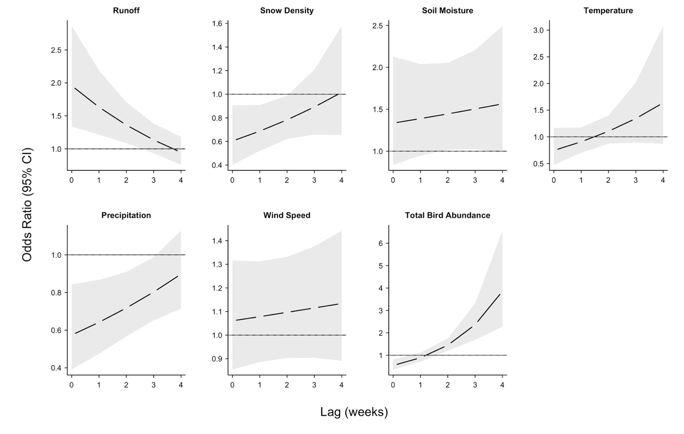
Figure S1. Cumulative odds ratios for the association between meteorological conditions and
wild-bird abundance on odds of an HPAI spillover event. Estimates represent odds ratios (95% CI) per 0.5 standard deviation increase in each environmental predictor. Solid lines represent the odds ratio in each lag week. Shaded areas show the respective 95% confidence intervals.

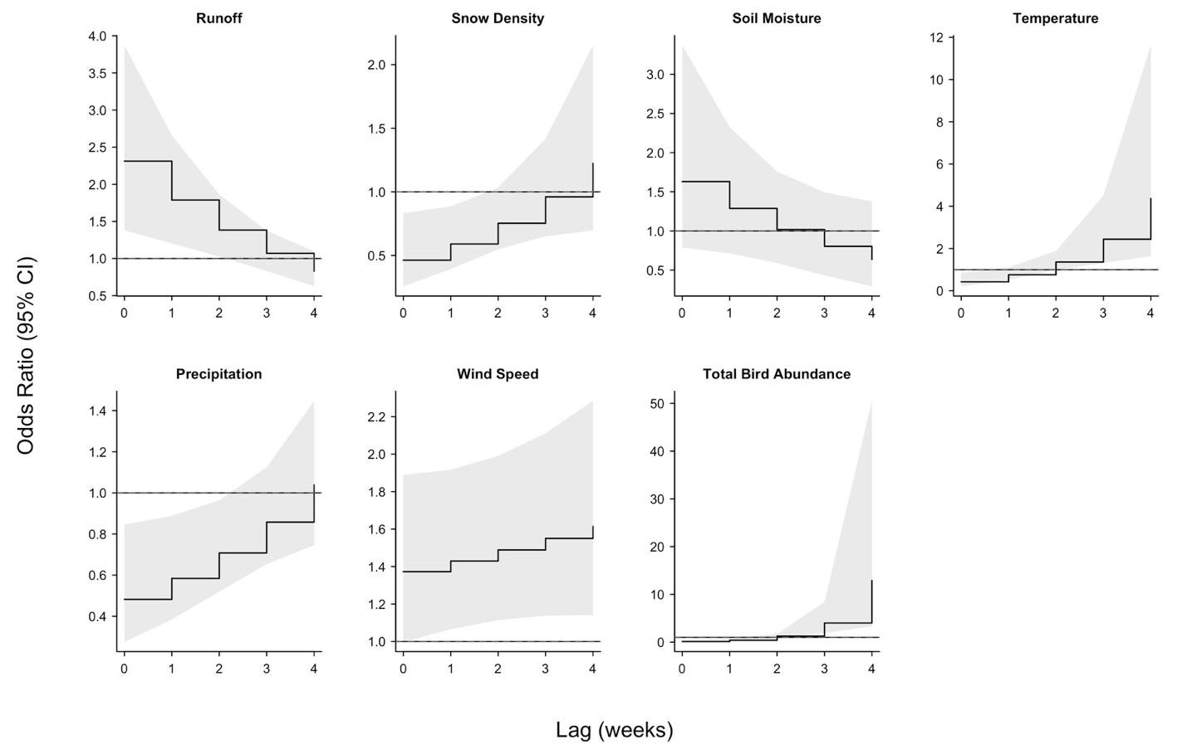

Figure S2. Lag-specific odds ratios for the association between meteorological conditions and
wild-bird abundance on odds of an HPAI spillover event, excluding cases in the winter and summer (defined by the meteorological seasons). Estimates represent odds ratios (95% CI) per 0.5 standard deviation increase in each environmental predictor. Solid lines represent the odds ratio in each lag week. Shaded areas show the respective 95% confidence intervals.

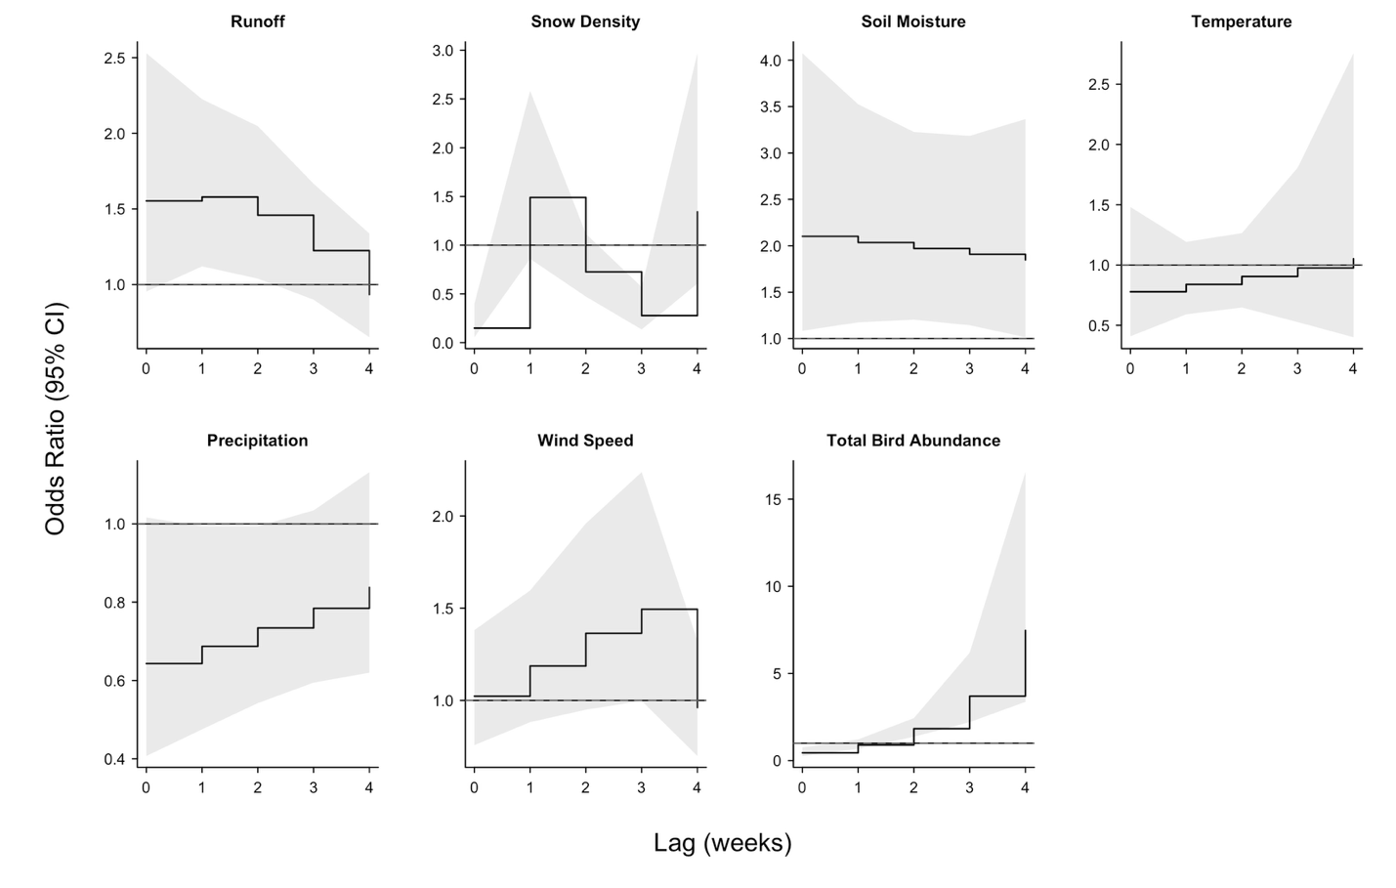

Figure S3. Lag-specific odds ratios for the association between meteorological conditions and
wild-bird abundance on odds of an HPAI spillover event. Estimates are produced from the case-crossover model with flexible degrees of freedom and polynomial splines. Estimates represent odds ratios (95% CI) per 0.5 standard deviation increase in each environmental predictor. Solid lines represent the odds ratio in each lag week. Shaded areas show the respective 95% confidence intervals.

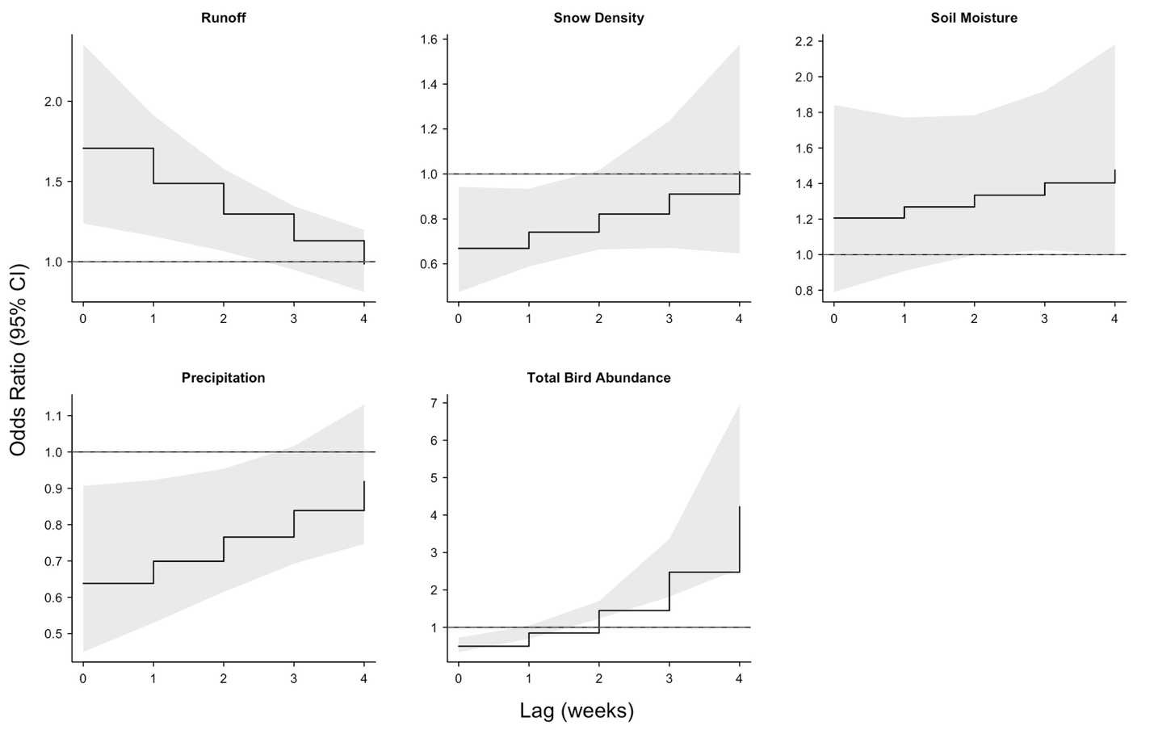
Figure S4. Lag-specific odds ratios from the reduced case-crossover model examining meteorological conditions and wild-bird abundance in relation to HPAI spillover risk. The reduced model excludes temperature and wind speed, which showed minimal effects in a penalized conditional logistic regression with a LASSO penalty. Estimates represent odds ratios (95% CI) per 0.5 standard deviation increase in each environmental predictor. Solid lines represent the odds ratio in each lag week. Shaded areas show the respective 95% confidence intervals.

