<https://www.bilibili.com/video/BV1Z5411A7cj?from=search&seid=11720283781292436368>

## 前期准备

查看ip

iptables –F

iptables-save

设置主机名

vi /etc/hosts

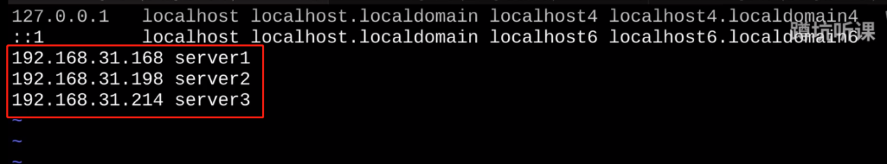





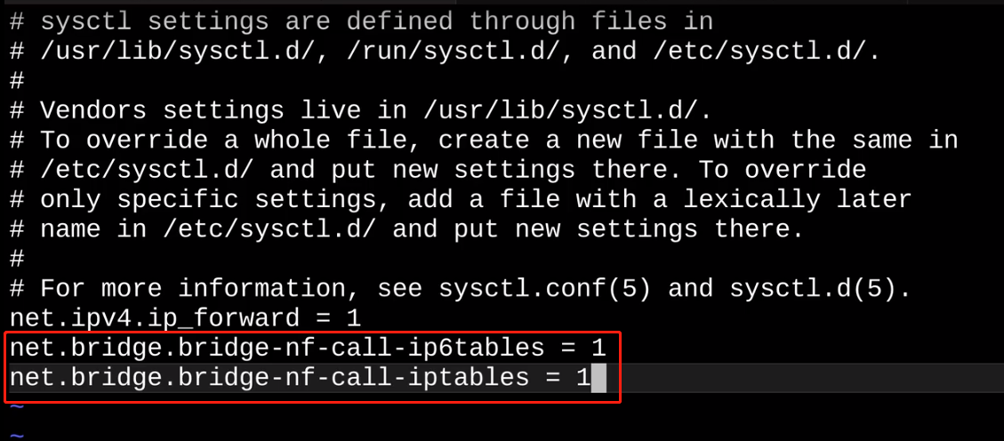



临时关闭分区

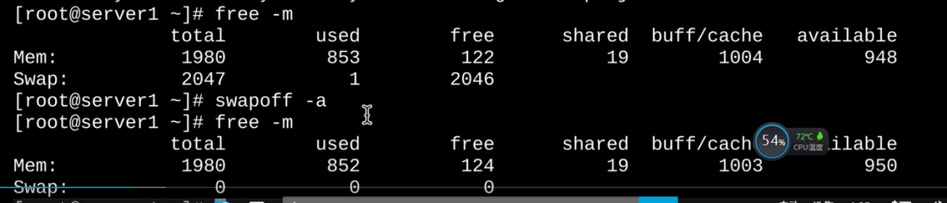



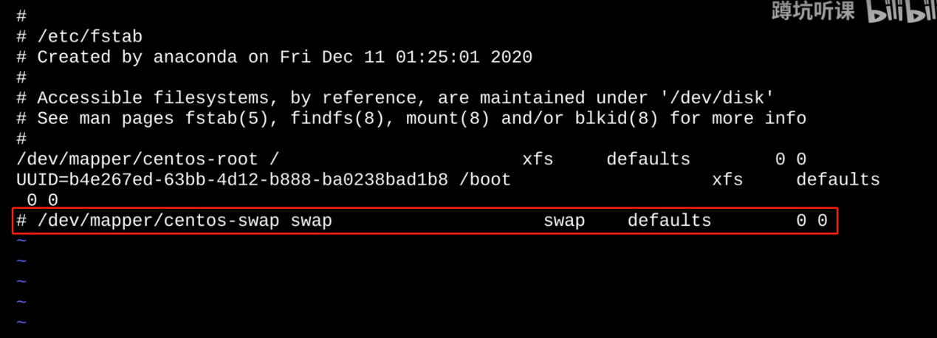

vi /etc/sysctl.conf

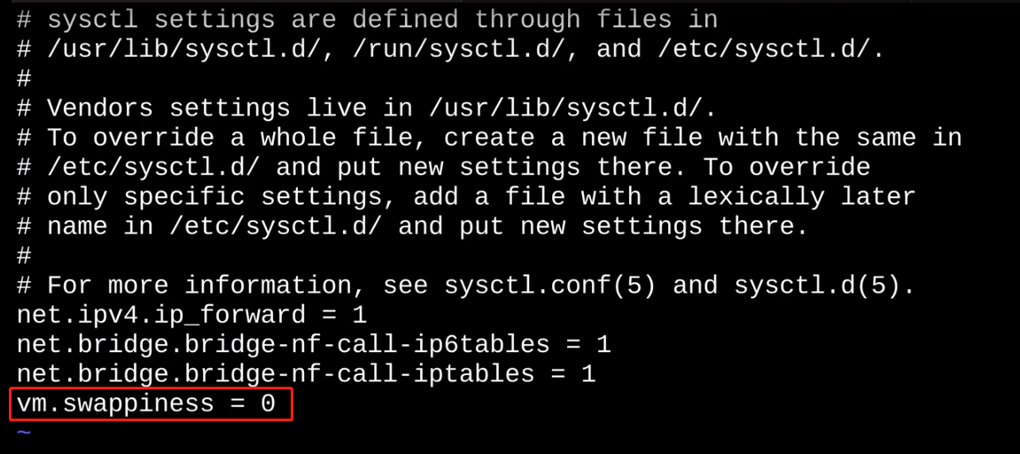

sysctl -p



vi /etc/selinux/config

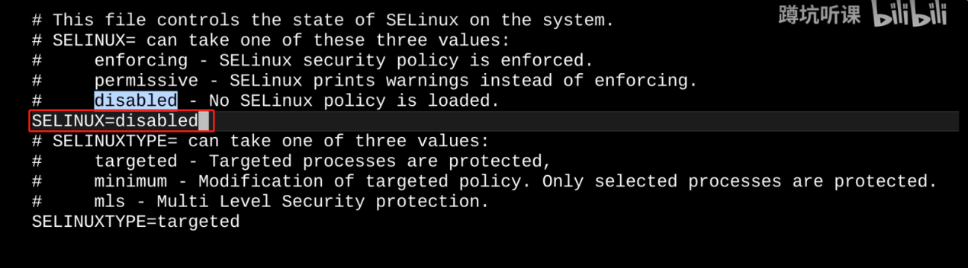

setenforce 0

getenforce :Permissive

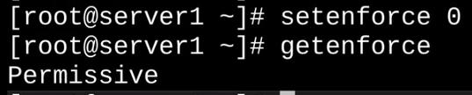

## 安装



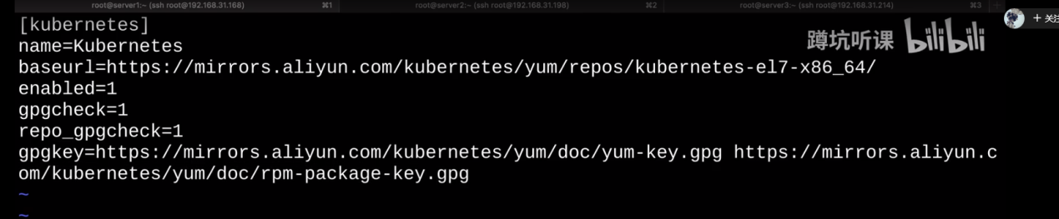



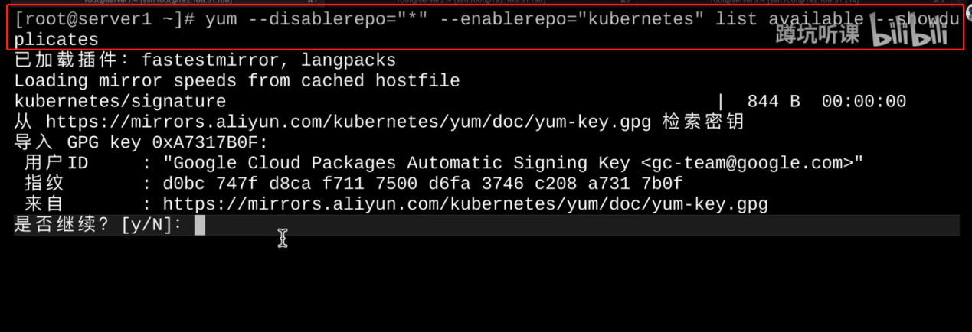



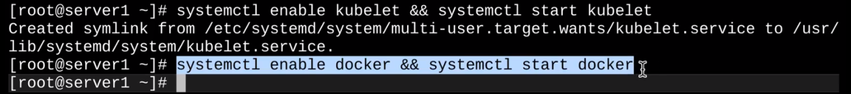

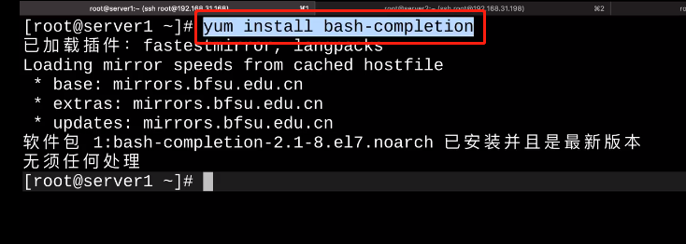

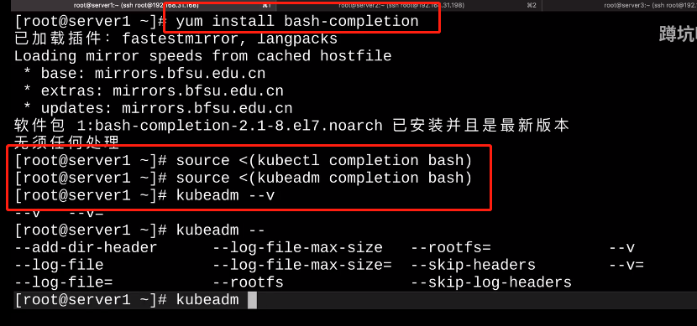



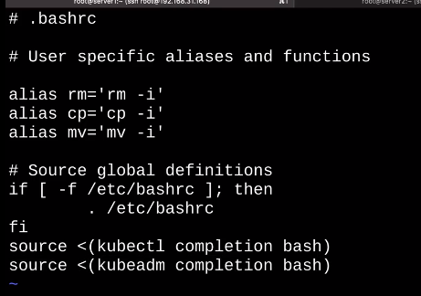

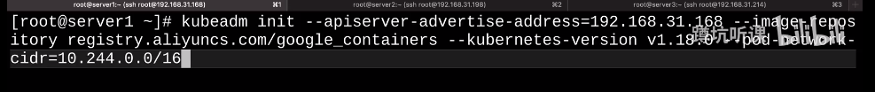

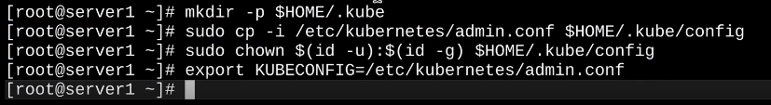

28:44

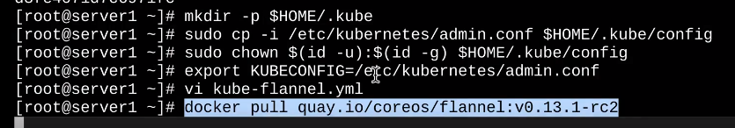

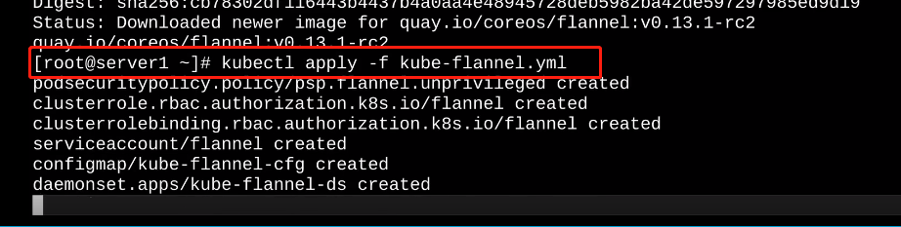

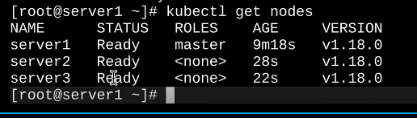

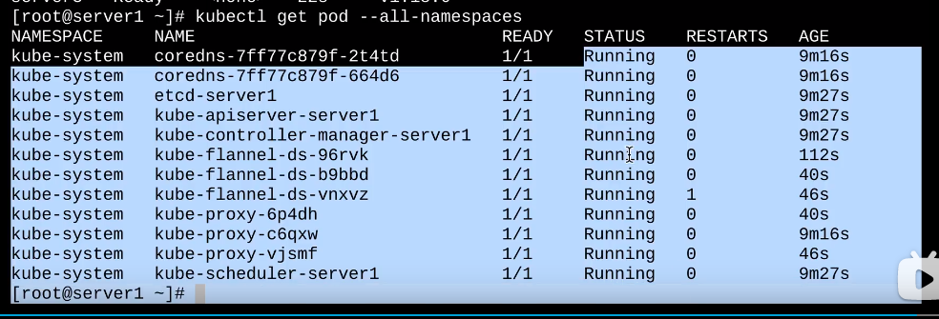

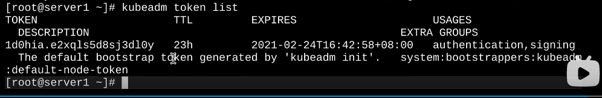

## 2概念

<https://www.bilibili.com/video/BV1Z5411A7cj?p=2>

还有个k3s

Cluster

Master：多master

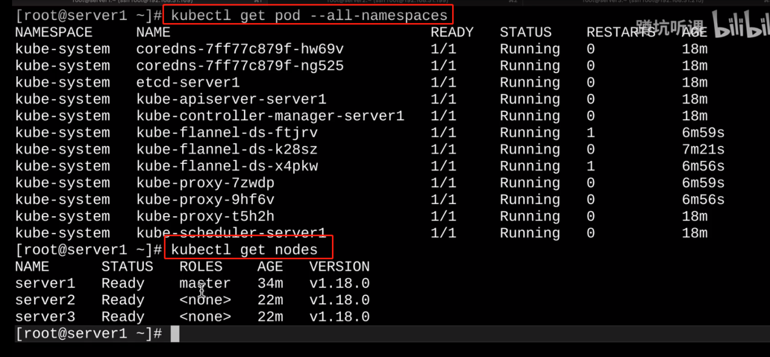

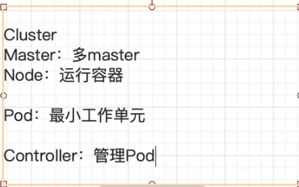

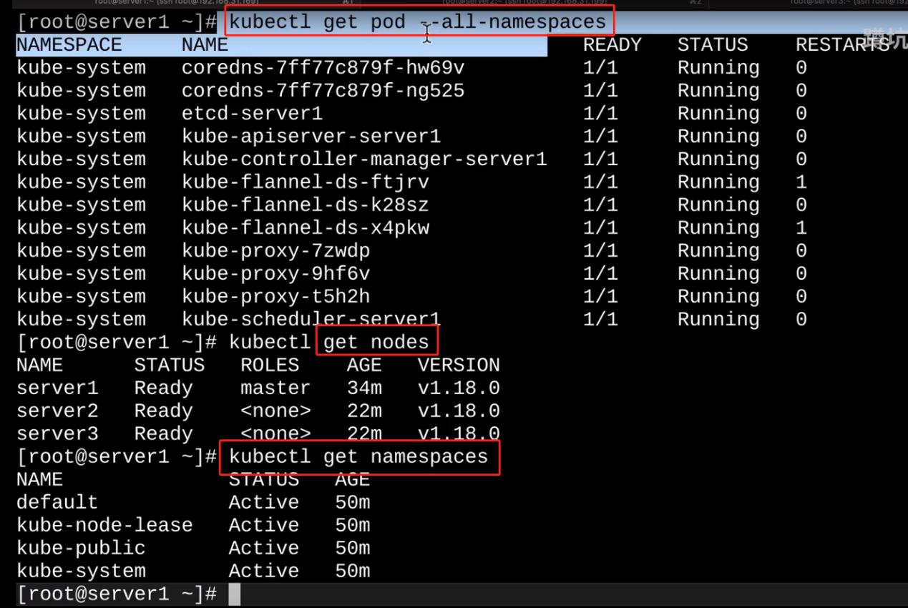

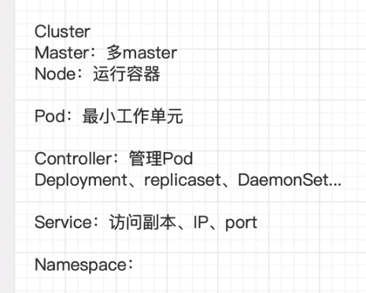



## 3

<https://www.bilibili.com/video/BV1Z5411A7cj?p=3&spm_id_from=pageDriver>