Vehicle Distribution Analysis Report
1. Analysis Approach:
This report analyzes vehicle distribution across different regions and times.
Data processing includes time extraction, regional statistics, and heatmap generation.

2. Data Processing Steps
1. Loaded raw data (2534 records)
2. Extracted hour field (0-23)
3. Calculated regional-time distribution matrix
4. Generated heatmap visualization

3. Key Findings
1. Swan Lake region has highest vehicle count during noon (11-14)
2. Region 4 has high traffic in afternoon (15-17)
3. Legend region has dispersed traffic
4. Region 5 appears mainly during noon

4. Conclusions & Recommendations
1. Strengthen traffic management at Swan Lake during peak hours (11-14)
2. Monitor traffic flow at Region 4 in afternoon
3. No special attention needed for Legend region
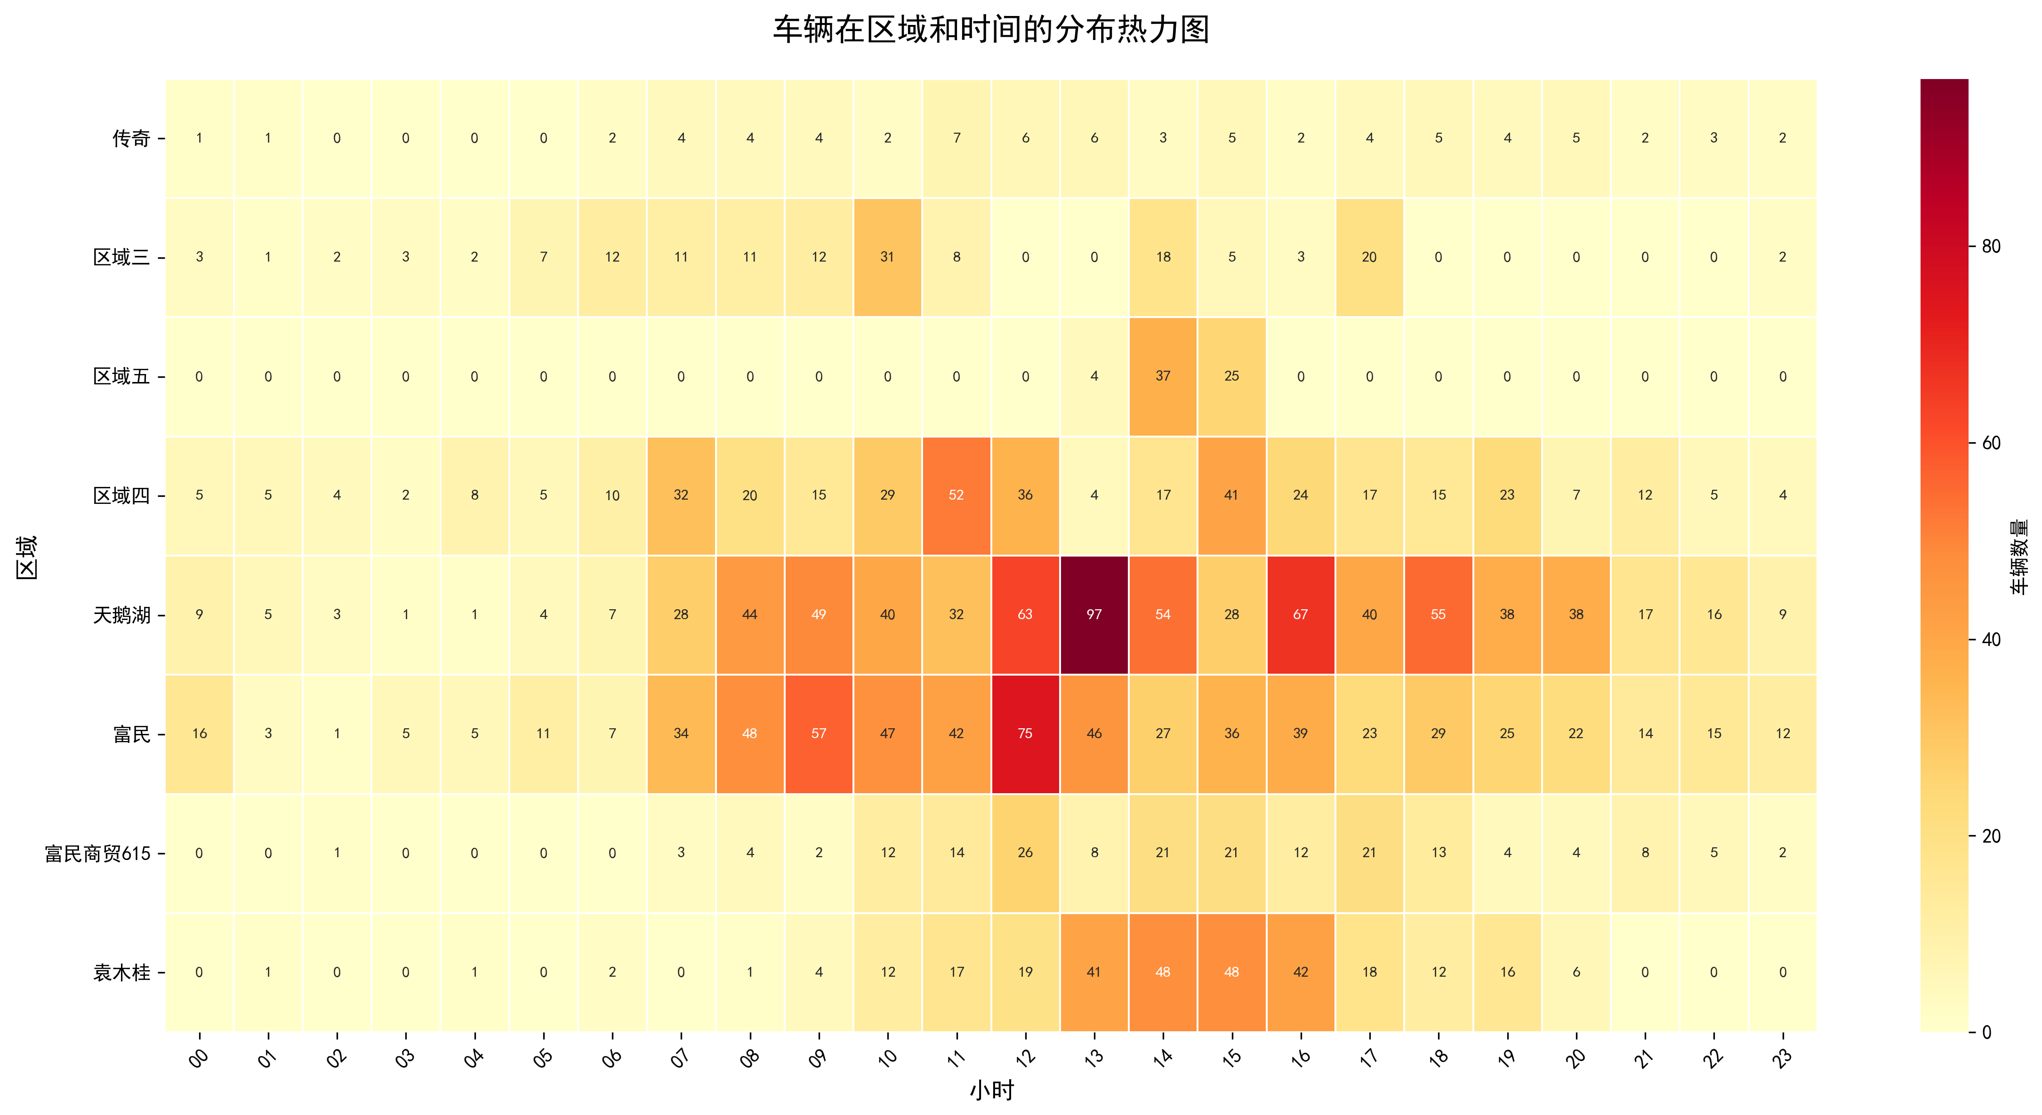
Figure 1: Vehicle distribution heatmap showing traffic patterns

