AN ACCELEROMETER BASED

APPROACH TO MEASURING DISPLACEMENT

OF A VEHICLE BODY

by

Lance D Slifka

Submitted to the Horace Rackham School

Of Graduate Studies of the University of Michigan

In partial fulfillment of the requirements for the degree of

Master of Science in Engineering

April 2004

University of Michigan – Dearborn

Department of Electrical and Computer Engineering

AN ACCELEROMETER BASED

APPROACH TO MEASURING DISPLACEMENT

OF A VEHICLE BODY

by

Lance D. Slifka

Approved as to the style and content by:

__________________________________

__________________________________

__________________________________

ABSTRACT

This thesis presents methods of double integrating acceleration data to find position data for the application of a vehicle road test. The acceleration of a body will be measured with an accelerometer, which is a more convenient to make measurements than the devices used to directly measure position. When performing the double integration, two problems arise:

- The drift associated with real accelerometers.
- The initial conditions (initial position and initial velocity) of the system are unknown.

Both of these problems can cause major integration errors. Therefore, the designed double integration process must overcome these problems and provide an accurate measurement reading.
The principle contributions of this thesis are the development of the double integration process and a thorough evaluation of this process tested on a physical system.

TABLE OF CONTENTS

ABSTRACT iii

CHAPTERS

Chapter 1: Introduction 1
  - Background 1
  - Problem Statement 2
  - Overview of Solution 3
  - Previous Work 4
  - Thesis Organization 4

Chapter 2: Digital Integration 6
2.1 Principle 6
2.2 Analog Integration 7
2.3 Digital Integration Methods 8
2.4 Effect of Sampling Rate on Integration 10
2.5 Choice of Integration Technique 11
2.6 Integration as a Low-pass Filter 11

Chapter 3: Double Integration Process 13
3.1 Block Diagram of System 13
3.2 Accelerometer Drift 13
3.3 Initial Conditions 15
3.4 Summary 18

Chapter 4: Digital Filtering for Double Integration 19
4.1 Digital Filtering 19
4.2 FIR Filtering 19
4.3 IIR Filtering 21
4.4 FFT Filtering 23
4.5 Concluding Remarks 27

Chapter 5: Instrumentation and Setup 28
5.1 Diagram of Setup 28
5.2 Equipment Used 29
5.3 Single Point Setup 30
5.4 Two-Point Measurement Setup 32

Chapter 6: Results of Experiment 34
6.1 Analysis of Errors 34
6.2 Single Point Experimental Results 36
6.2.1 Single Frequency 36
6.2.2 Change in Amplitude 38
6.2.3 Random Input 39
6.2.4 Time- limited Signals 40
6.3 Flexible Body Differential Position Measurement Results 42
6.3.1 Single Frequency Displacement 43
6.3.2 Random Input 44

Chapter 7: Conclusions 46
7.1 Conclusion 46
7.2 Author’s Contribution 46
7.3 Future Work 47

BIBLIOGRAPHY 49

APPENDICES 51
Appendix A Mathematical Results 51
A.1 Analysis of Double Integration with Acc. Drift 51
A.2 Double Integration with Initial Conditions 52
A.3 Double Integration with Combined Effect 53
A.4 Frequency Response of Double Integrator 54
Appendix B Sample Program 56
Appendix C Application: Roof Deflection 60

CHAPTER 1

Introduction

  - Background
The current practice of measuring the displacement of a vehicle body often uses linear variable differential transformers (LVDT) under stationary conditions. This kind of direct measurement technique has limitations in that it is very difficult to be used on a road test if not impossible. Another way to directly measure displacement is with a laser displacement gauge, which can accurately measure very small displacements. However, the equipment is very expensive and not suitable for a road test either. It requires a fixed point of reference to function properly, meaning that the laser head making the measurements must be positioned within a certain distance away from the object.
Therefore, there is a need for a reliable measurement technique that can be used on a road test. One potential technique, which is the topic of this thesis, is to use an accelerometer to measure acceleration, which can then be converted into displacement. In theory, if one wanted to measure a vibration in an experiment, either position, velocity, or acceleration can be used. The three quantities are interrelated through integrals and derivatives. This indirect method of measuring displacement would solve the need for a fixed reference. Acceleration based displacement methods are categorized as inertial based measurement techniques in contrast to the direct measurement methods, which are grouped into reference point techniques. This thesis addresses the measurement procedure and performing error assessment.
It is advantageous to measure displacement for the study of structural integrity. For an elastic structure, the displacement is proportional to the stress, which is required to calculate the damage to the structure. Therefore, it is of interest to find position versus time and analyze the peaks and the troughs (or the RMS value) rather than analyzing the spectrum of the vibration (Ribeiro, 554).
There is yet another advantage to use accelerometers to make measurements. They are physically small and can be easily attached to a body without loading it down. Accelerometers also have a wide frequency and dynamic range. Acceleration (as opposed to velocity and position) is the most popular measurement in the study of vibrations because of its ability to pick up high frequency content and higher sensitivity. Also, accelerometers are affordable and readily available.

1.2 Problem Statement
The goal of this project is to develop a reliable process from which displacement data can be found from acceleration data via a double integration. Ultimately, the intent is to develop a novel and practical vehicle level test to measure displacement accurately with accelerometers. Integration errors must be minimized so the calculated displacement is very close to the actual displacement. An experiment was designed to confirm this is possible. It is of primary importance for this process to work well on low frequency random acceleration data, as this is the type of data generated by a vehicle on the road. However, because of the low-pass filtering effect of the integrator, the displacement signal emphasizes the low frequency data more than the acceleration signal does.
Performing discrete integration on sampled data is a rather simple task. However, there are a number of problems that need to be addressed when performing a double integration. First, there is the problem of unknown initial conditions. Integration requires a known initial condition, whether it is initial velocity or position. There also is the problem of drift in an accelerometer. Both can lead to serious integration errors if not corrected.

1.3 Overview of Solution
To determine whether the displacement signal derived from the acceleration signal is accurate, it needs to be compared to the actual displacement. The position from double integration can be compared to a directly measured position. This direct measurement needs to be very accurate to be used as a reference point. A laser displacement gauge was used for this purpose.
After data collection, analysis was performed to make sure the error was within a desired limit. The desired limit for this project was established to be within 10% of the value of the measured position by the error definitions provided in chapter 6. If suitable results were obtained, the experiment would then be repeated and the vibration pattern would be varied to verify that consistent results are obtained given a variety of vibration patterns.

1.4 Previous Work
Surprisingly, not much work has been previously published on this topic. J.G.T. Ribeiro, J.T.P. Castro, and J.L.F. Freire, from The Catholic University of Rio de Janeiro, have likely made the most significant contribution to this topic. In their papers, they develop a process for measuring displacement with the use of accelerometers. Their work addressed structural integrity studies. The techniques discussed in their papers were applied to this project, although they needed to be modified for the vehicle test application.

1.5 Thesis Organization
The process of converting an acceleration measurement into a displacement measurement is accomplished using double integration. The first integration is performed on an acceleration signal to get a velocity signal. Subsequently, a second integration is performed on the velocity signal to get the displacement. When performing the integration, there are many issues to consider, which will be discussed in detail in chapter 2. Issues using digital integration will also be explored including different numerical techniques for digital integration.
Chapter 3 summarizes the double integration process and illustrates the process on numerically generated data to confirm that the process works in a controlled situation before it is used in an actual experiment.
The topic of chapter 4 is digital filtering. In the double integration process, digital filtering is used extensively. Because the choice of filter design is critical for minimizing errors, care must be taken when selecting an appropriate filter. Different filter types will be evaluated and one will be chosen for processing new data.
Another consideration for this project is the method of collecting data (for acceleration and position), that is given in chapter 5. This will include a list of equipment used and a description of the experimental setup. A number of different setups were used to evaluate the performance of the double integration process. This experiment was set up and performed at an NVH (Noise, Vibration, and Harshness) laboratory at Ford Motor Company as part of research work that became the basis of this thesis.
Chapter 6 describes error analysis techniques and methods. This chapter will include a tabulation of the results of the experiments.
Chapter 7, the final chapter, discusses the accuracy of the results, lists topics for further exploration, and contributions of the research.

CHAPTER 2

Digital Integration

2.1 Principle
Given a position versus time of an object, x(t), the velocity, v(t), can be found by taking the first derivative.
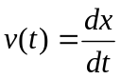
Acceleration, a(t), can be found by taking the second derivative of position or first derivative of velocity.
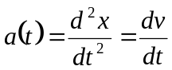
However, it is of interest to reverse this process and find the position signal given an acceleration signal. To do that, integration must be performed twice on the acceleration signal.
In principle, using double integration on an acceleration signal to get a position signal, the initial position and initial velocity must be known. After the first integration, the initial velocity should be added to the result, as the initial position should be added after the second integration. These operations are illustrated in the following equations:
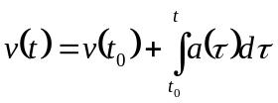,
where t₀ is the initial time and v(t₀) is the initial velocity, which is a constant. To get the position signal from velocity, a similar formula is used:
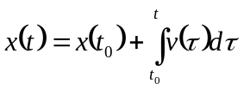
Therefore, for a double integration to be performed on acceleration, the two initial conditions (velocity and position) must be known to avoid integration errors. However, the only way to get these initial conditions is through direct measurement, which is often impractical or unobtainable. An important part of this project is to develop an approach that doesn’t require knowledge of initial conditions.

  - Analog Integration
In principle, the process of double integration can be done electronically with a simple RC opAmp circuit, such as the one shown in the figure below (Ribeiro).
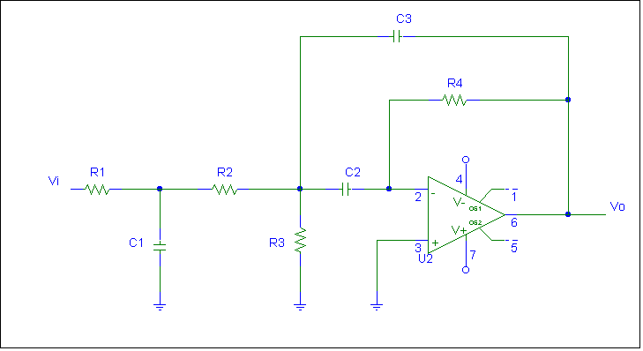
Fig. 2.1: Double Integrator circuit used to find displacement from acceleration data
This circuit takes the acceleration signal (from an accelerometer) for its input and outputs the displacement signal. Ribiero did a study using analog circuitry to perform the double integration and found that the errors were unacceptable for the following reasons:
- The circuit’s transient response was found to have errors of more than 200% in some cases. This type of error occurred whenever the measured displacement had a sudden amplitude change caused by external forces or shocks.
- Error was caused by the systems non-linear phase whenever the displacement included more than a single frequency. Distortion will result for frequency components in that non-linear range, because different frequencies have different delays from the integrator.
- It cannot be used to integrate very low frequencies because of the integrator’s frequency response.
The author concludes that the analog double integrator is reliable only to measure sinusoidal steady state displacements. Otherwise, another type of analysis is highly recommended. For these reasons, digital integration is much better for obtaining a displacement signal from acceleration.

  - Digital Integration Methods
There are a number of discrete integration algorithms available to perform integration numerically. The acceleration signal is sampled, making it a discrete function of time having a sampling frequency, f_{s}, associated with it. The simplest way to perform numerical integration is to use the rectangular integration method. This method uses an accumulator to sum all past sampled inputs and the current input sample and divide by the sampling rate. Rectangular integration is represented by the following difference equation:
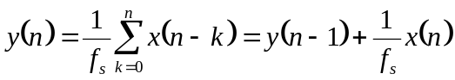,
where x is the integrand, y is the output of the integrator, and f_{s} is the sampling frequency.
Another numerical integration method uses the trapezoidal rule. The results are more accurate with this method than with the rectangular method. The difference equation for trapezoidal integration is:
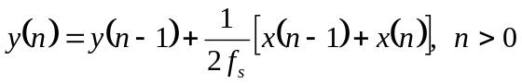

Trapezoidal integration acts as a first order hold on the system, whereas rectangular integration acts as a zero order hold. In figure 2.2 below, a 1Hz sine wave is integrated using both methods, and clearly the trapezoidal method is more accurate in approximating the area under the curve.

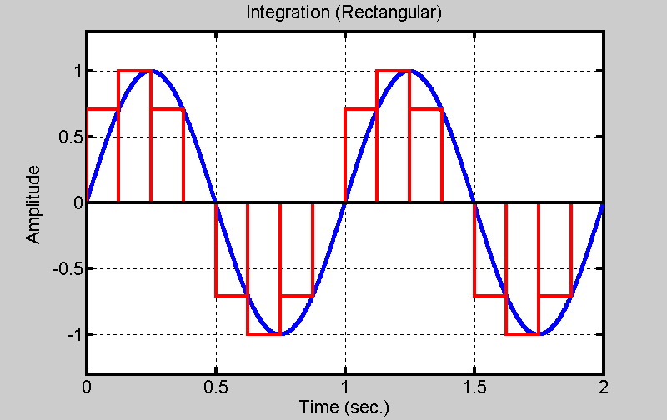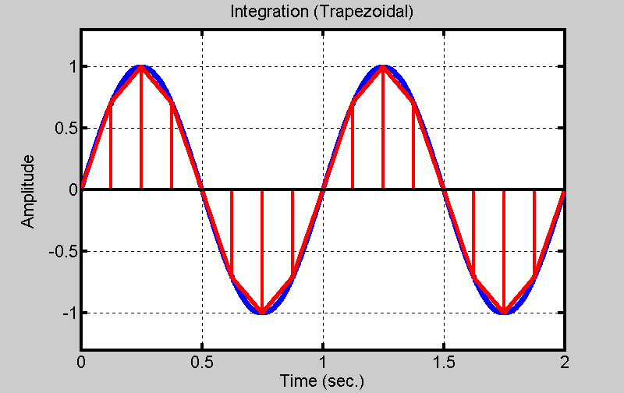

Figure 2.2: Integration using rectangular and trapezoidal methods

There is another method of integrating that uses Simpson’s rule. It is defined by the following difference equation:
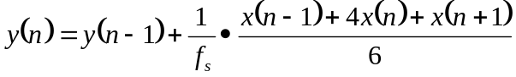
Unlike the other methods, this one requires a future sample of the integrand, x, to get the current sample of the integrated signal, y, so it can’t be performed in real time.

  - Effect of Sampling Rate on Integration
The choice of sampling rate, f_{s}, is also a critical factor in integration. The higher the sampling rate, the more accurate the integration will be, though a very high sampling rate can cause difficulties with digital filtering later. From calculus, the limit as the sampling rate approaches infinity results in the Riemann integral. Figure 2.3 illustrates the sine wave sampled at two different rates. It is obvious that the integral of the signal sampled at the higher rate will be more accurate because it is a better approximation of the original signal.
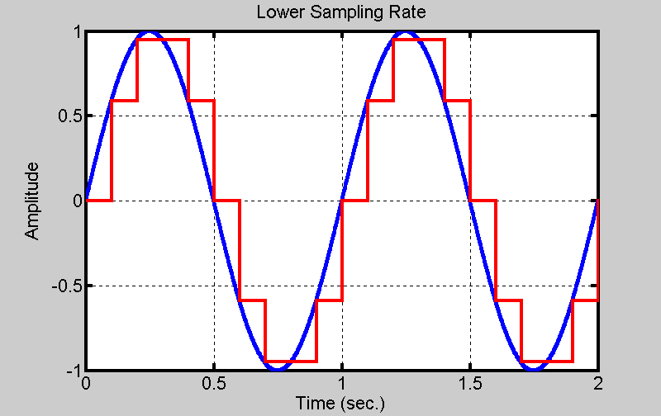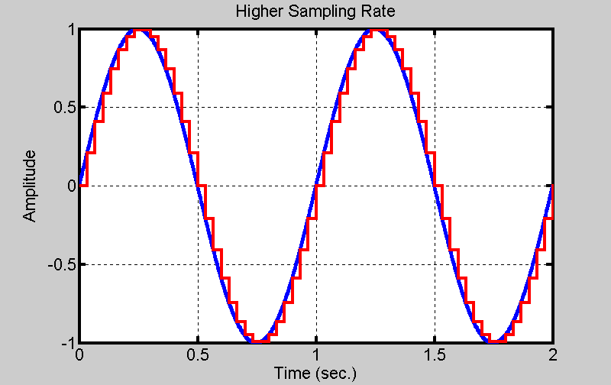

Figure 2.3: Discrete Integration with two different sampling rates.
When sampling, the Nyquist rate must also be considered. When the signal content is contained in a certain bandwidth, the signal must be sampled at a frequency at least twice as high of that bandwidth for perfect reconstruction. Likely, the signal will have to be sampled far beyond the Nyquist rate for an accurate integration.
  - Choice of Integration Technique
The decision was made to use the trapezoidal method of integration to perform the numerical analysis. Simpson’s rule was attempted, but resulted in too many integration errors, possibly because of a large difference in successive sample values. Also, MATLAB, which is the technical computing software that was used to analyze data, only employs trapezoidal integration for numerical analysis working with experimental data. To test Simpson’s rule, the difference equation had to be written as a MATLAB script.

  - Integration as a Low-pass Filter
It is a characteristic of mechanical systems that displacement occurs predominantly at lower frequencies. When integration is performed on a signal, the signal is simply divided by a constant proportional to frequency (ignoring any phase adjustments). When the frequency of the integrand is higher, this constant will be higher, making the amplitude of the output of the integrator smaller. Therefore, the frequency response of the integrator is like that of a low-pass filter. The figure below shows an acceleration signal on the left that contains higher frequency content, which makes the signal appear noisy.
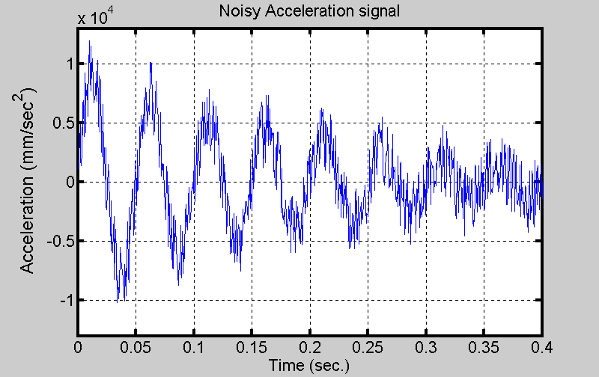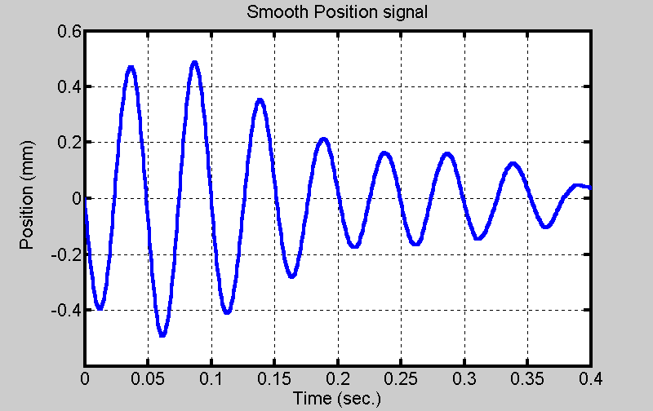
Fig. 2.4 Illustration of Integrator’s “smoothing” effect
The acceleration data was integrated twice to get the position on the right. The position data is much smoother because the high frequency content in the acceleration signal is filtered out in the double integration process. Also, it is 180 degrees out of phase with acceleration, as expected. Each integration operation shifts the signal by -90 degrees. For more information about the frequency response of a double integrator, see appendix A.4.

CHAPTER 3

Double Integration Process

  - Block Diagram of Process
A block diagram of the double integration process is shown in figure 3.1:
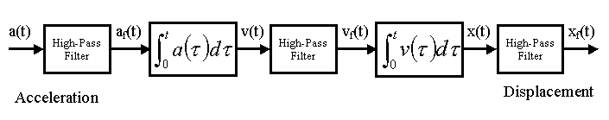
Fig. 3.1 Block Diagram of Double Integration Process
Included with two stages of integration are three stages of high-pass filtering. All signals involved in this process have been digitized so they can be analyzed using MATLAB. The reason for high-pass filtering will be discussed in this chapter.
  - Accelerometer Drift
To measure acceleration, accelerometers are used to convert acceleration to an electrical signal. Unfortunately, accelerometers have an unwanted phenomenon called drift associated with them caused by a small DC bias in the acceleration signal. Ideally, there should be no DC bias from the accelerometer for the measurement of a vibration. A vibration occurs around a fixed point and has a zero mean over time. The presence of drift can lead to large integration errors. If the acceleration signal from a real accelerometer was integrated without any filtering performed, the output could become unbounded over time. The figures below illustrate what often happens to an acceleration signal after a double integration. Figure 3.2 is an example of a somewhat exaggerated acceleration signal that has a slight negative DC bias. The signal is not real acceleration data, but randomly generated to illustrate the problem of drift.
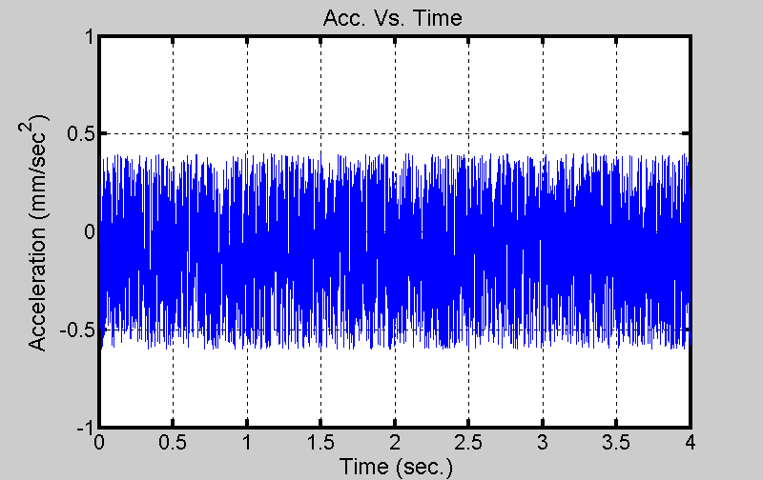
Fig. 3.2 Example of an acceleration signal
Figure 3.3 plots the velocity signal obtained after the first integration and the position signal obtained after the second integration.
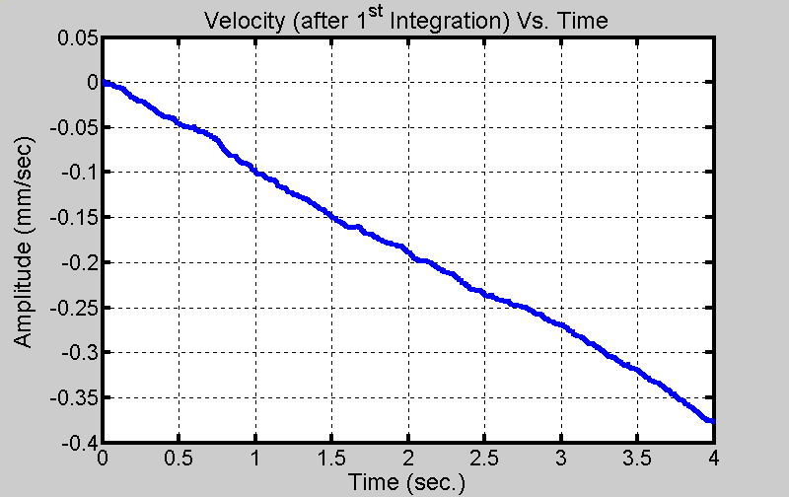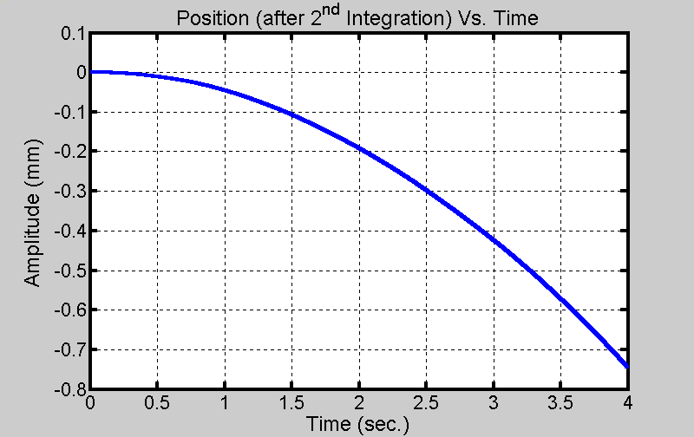
Fig. 3.3 Display of Integration Errors Due to Drift
The left part of the figure shows the result of the first integration. The negative DC bias can be thought of as a negative step. Integrating a step results in a ramp, as shown in the velocity plot. When this ramped velocity signal is integrated, the position changes in a quadratic manner. The displacement graph suggests that the object is moving away from a fixed point when in fact, the vibration is around a fixed point and the object is not moving over time. For a more complete discussion on accelerometer drift, see Appendix A.1.
To solve the problem of drift, a high-pass filter may be used to remove the DC component of the acceleration signal. The frequency response of the filter must have a very low cutoff frequency compared to the bandwidth of the signal. By filtering before integrating, drift errors are eliminated.
  - Initial Conditions
Another problem with the double integration of an acceleration signal is the lack of initial conditions. For proper integration, both initial velocity and initial position must be known from a direct measurement. However, an important objective of this project is to eliminate the need for initial conditions. To illustrate the effect of missing initial conditions, consider the following acceleration signal (with initial conditions given but not used):
Now, a double integration will be performed on the acceleration, a(t), to get both velocity, v(t) (after the first integration), and the position, x(t).
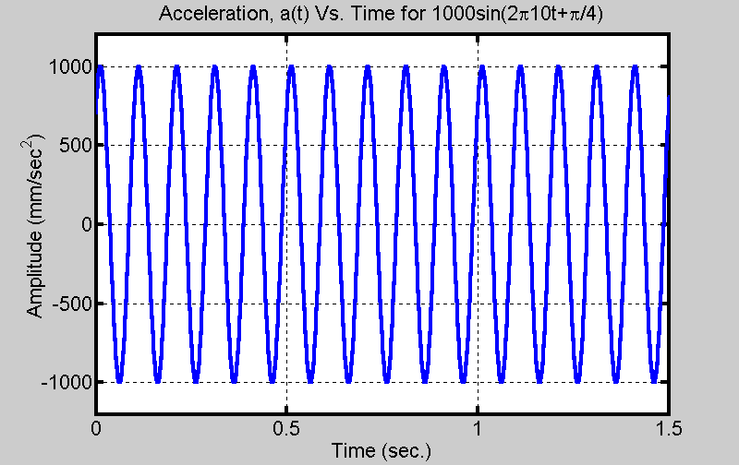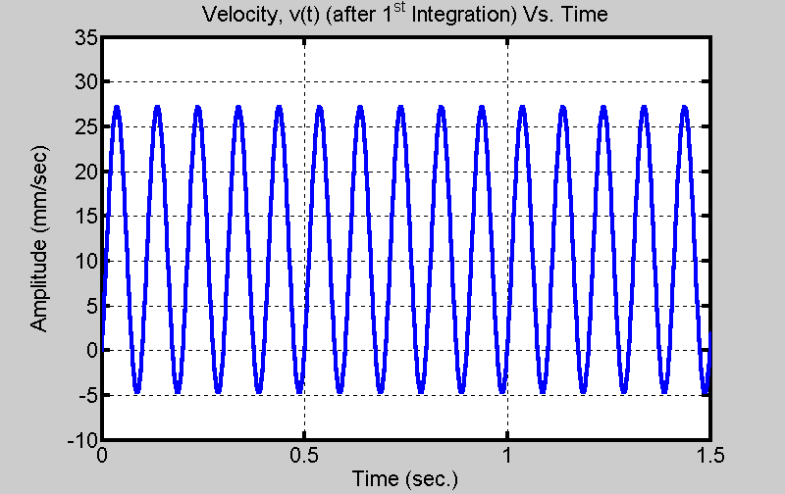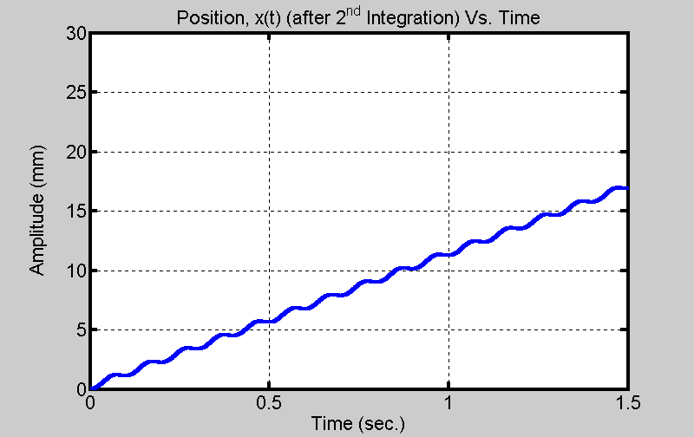
Fig. 3.4 Double Integration not using Initial Conditions
Notice that the middle plot of velocity contains a DC value of about 11.2540. Had the initial velocity value, v(0), been added in, that same amount would’ve been subtracted and the plot would be centered around zero, as it should. Because the initial value wasn’t used and the function was integrated for the second time, the output increases linearly. This example also illustrates another important point: where the integration begins makes a difference in the result. Consider a cosine function for acceleration that has no phase shift (meaning the integration would start at the function’s maximum positive value). If it is integrated for an integer number of periods, then the velocity function will have no DC component and therefore, there would be no need to add an initial condition. This is what happens when there is a zero initial condition for velocity.
Figure 3.5 shows the result of integrating using initial conditions. The position signal is sinusoidal and has the same frequency as the acceleration signal. This is the correct result because integrating a sinusoid twice results in another sinusoid of the same frequency, but different amplitude and phase. The plots in figure 3.5 have no obvious integration errors.
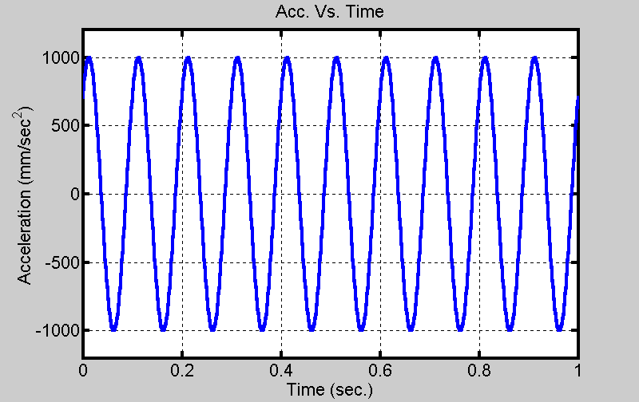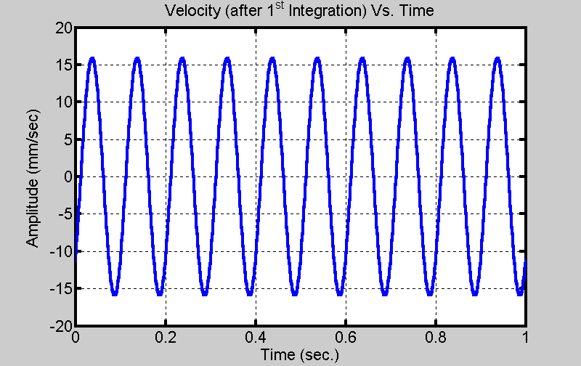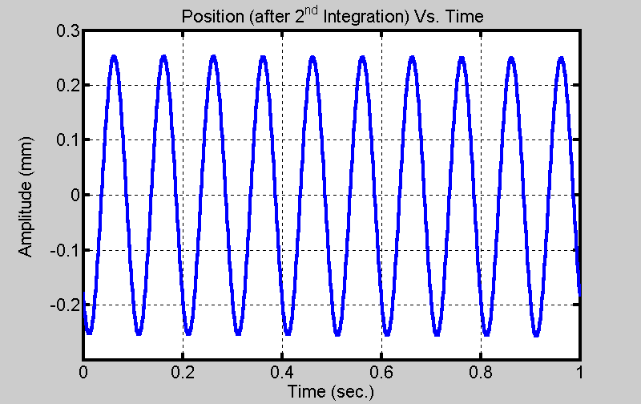
Fig. 3.5 Double Integration with Initial Conditions
Another important effect of the double integration is also illustrated here. That is, the position signal is 180 degrees out of phase with the acceleration signal. The double integration of a single frequency introduces a sign change. The integration works properly with known initial conditions. However, it would be impossible to perform straight integration like this (with no filtering) in an experimental situation because of the lack of initial conditions and offset error. Therefore, it is important to develop a method of double integrating without them.
One solution to the problem of initial conditions is to use filtering. After the acceleration signal is integrated, it will likely have a DC component. A high pass filter can be used to remove that DC component of the signal. Likewise, after the velocity signal is integrated to get position, the position signal can be high-pass filtered as well. Fig. 3.6 below illustrates double integration with filtering to get better results by eliminating integration errors caused by a lack of initial conditions.
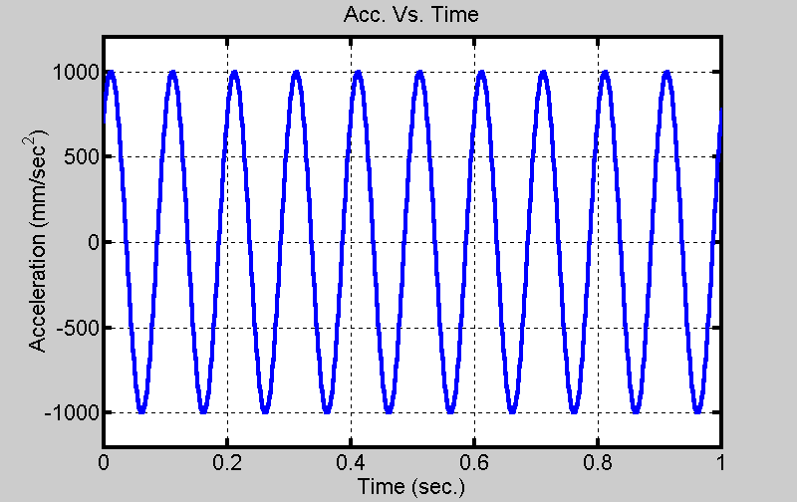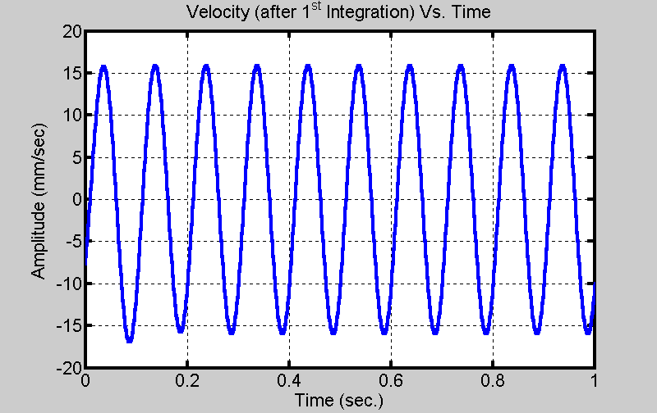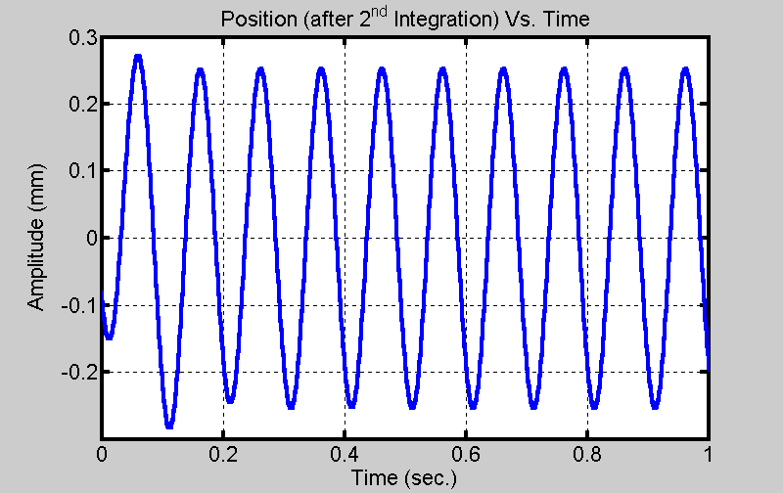
Fig. 3.6 Double Integration using Filtering
The results show that filtering can be very useful in making the double integration process work. However, there are some undesirable effects caused by filtering. The plot of position above contains some transient effects from filtering. There are a number of filters that can be used and are discussed in more detail in the next chapter. More information on integration errors due to unknown initial conditions is given in appendix A.2.
3.4 Summary
The suggested approach uses double integration to derive a position signal from an acceleration signal. The process consists of five steps, which are summarized below:
Step 1: High Pass Filter #1 removes accelerometer drift
Step 2: First integration on acceleration finds velocity
Step 3: High Pass Filter #2 removes DC component from velocity signal to eliminate need for an initial velocity value.
Step 4: Second integration on velocity computes position
Step 5: High Pass Filter #3 removes low frequency content from position signal to eliminate need for an initial position measurement.
This suggested process corrects the problem of integration errors from the combined effects of accelerometer drift and initial conditions. For more information on the combined effects, see appendix A.3. Tests are described in a later chapter to evaluate the performance of the double integration approach in a real world application.

CHAPTER 4

Digital Filtering for Double Integration

  - Digital Filtering
Chapter 3 discussed the need for digital filtering when performing a double integration. Filtering is a frequency selective process that attenuates certain bands of frequencies while passing others. The double integration process uses three high-pass filters. These filters will pass the high frequency content of a signal while rejecting the low. The specifications of a filter are its cutoff frequency, pass-band attenuation, and stop-band attenuation. It is convenient if the three filters are identical to each other to simplify the design. This is applicable as long as the filter doesn’t attenuate frequencies in the signal band. Important aspects of filter design that must be considered for this project are the frequency response of the filter, filter order, and delay. This chapter discusses the different filter types and what effects they have on the double integration process.
4.2 FIR Filtering
FIR (finite impulse response) filtering is described by the following non-recursive difference equation:
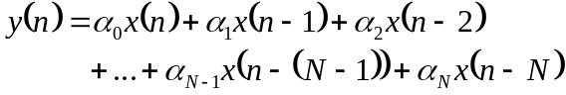,
where y is the output and x is the input. This means that the present output is simply a linear combination of the present input and past N input values, where N is the order of the filter. This type of filtering is useful for the double integration process and is recommended by Ribeiro. It is advantageous to use the FIR filter because its phase response is linear, which is desired because different frequencies passing through the filter will have the same time delay. Also, because the difference equation corresponding to the FIR filter is causal, it can be used in real time calculations. Its disadvantage is that the order can be very high, which can lead to excessive computations. Also, the FIR filter has an undesired transient time associated with it.
For application to a vehicle road test, there is an interest in processing low frequency signals. So the filter must have a low cutoff frequency with a sharp transition band, making the order of the filter high. As a result, there can be a large delay from the input to the output. Figure 4.1 shows the frequency response of an FIR filter of 600th order with a low cutoff frequency. The sampling frequency is 1kHz and the digital cutoff frequency of the filter is 0.01π, which corresponds to an analog frequency of 5Hz.
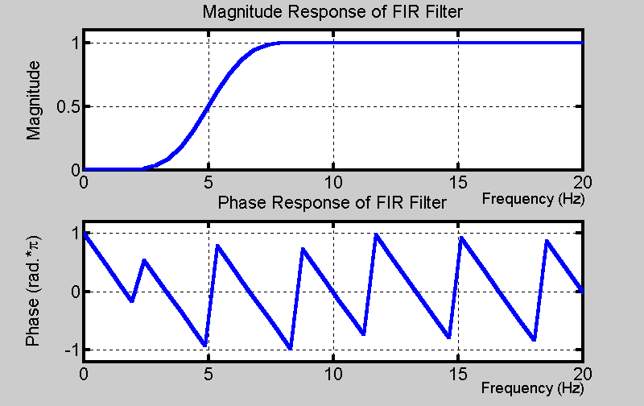
Fig. 4.1 Frequency Response of FIR filter
The delay of the filter is the negative of the derivative of the phase with respect to digital frequency. For this filter, the delay is equal to 300 samples (or 0.3 seconds). The delay in samples is equal to the order of the filter divided by 2 (N/2). That means each stage of filtering will cause a 0.3s delay, which could accumulate to 0.9s for three stages of filtering. Fig. 4.2 below illustrates a double integration with two stages of filtering (with no accelerometer drift to filter).
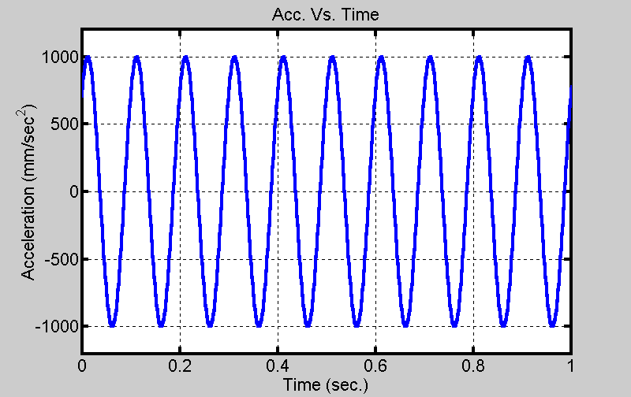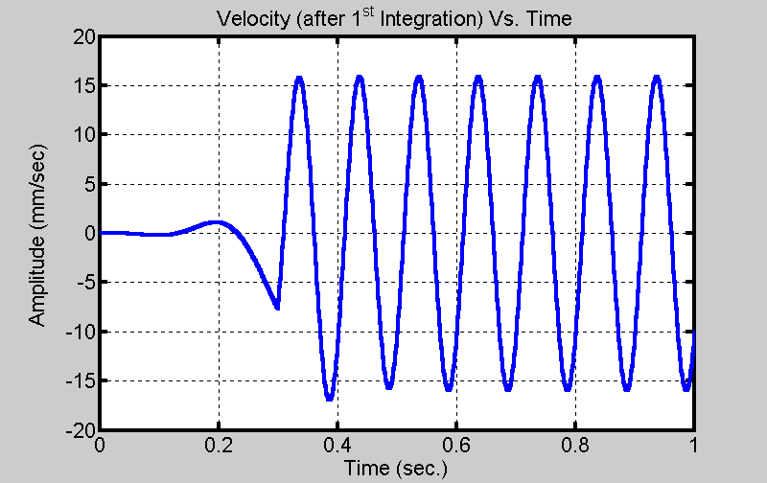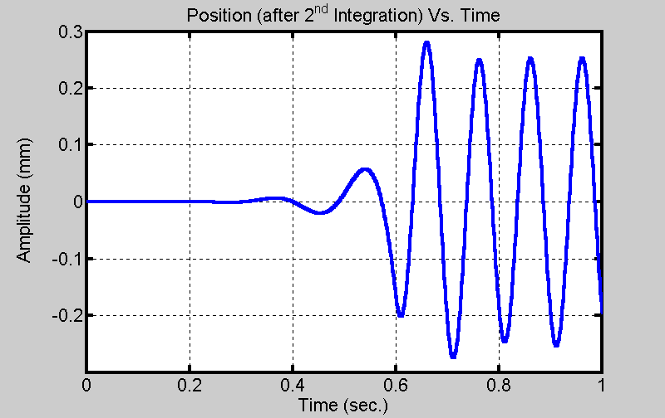
Fig. 4.2 Illustration of delay associated with FIR filtering
By the time the position signal is found, a significant amount of data can be lost. For the example above, only a second of acceleration data was considered. There is only 0.4 seconds of usable position data. The plots of velocity and acceleration can be shifted as in figure 3.6 to start at the zero point. However, for the position data to be valid after 0.4 seconds, acceleration data must be available after 1 second. The obvious solution to this problem is to take data for a longer time interval. However, there could be a problem if the acceleration signal is very localized, as in the case of a shock measurement.
4.3 IIR Filtering
IIR (Infinite Impulse Response) filtering, an alternative approach, uses a recursive difference equation to represent the filter.
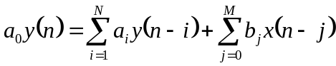
Here, y is the output and x is the input. The output is written as a combination of present and past inputs and past outputs.
This type of filter has an advantage over FIR filters with respect to filter order. An IIR filter that meets the same magnitude response specifications will have a much lower order than its FIR counterpart. Therefore, computations can be done faster with an IIR filter. However, its phase response isn’t linear like the FIR’s response. The physical meaning of this is if a signal is passed through this filter, then different frequency components of this signal will be delayed by different lengths of time, causing distortion. Figure 4.3 shows an example magnitude and phase response for a typical 8th order IIR filter.
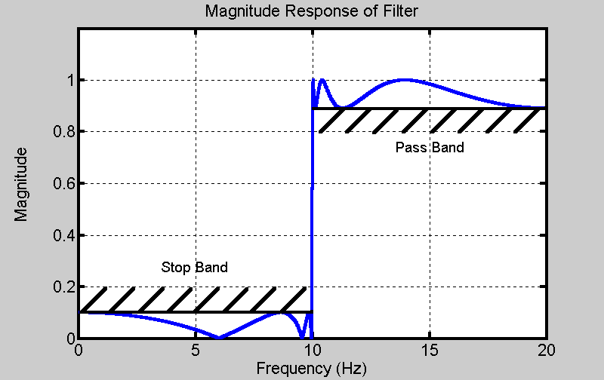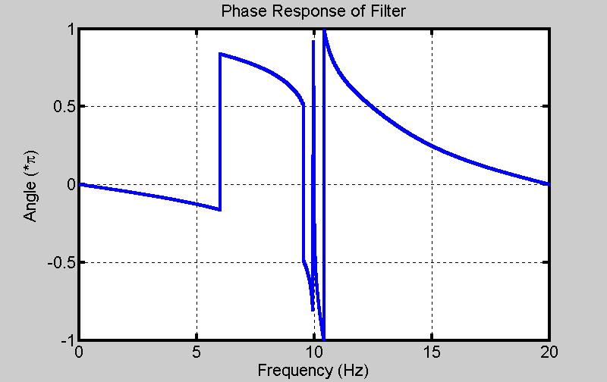
Fig. 4.3 Frequency Response of an IIR Filter
There is a way to overcome the problem of having a non-linear phase with the IIR filter. Mathematical techniques exist that adjust the pole locations of the filter without changing the magnitude response, but make the phase response linear. However, there is a much easier way to linearize the phase. Filter the signal, time reverse the signal, and filter it again with the same filter. The second time through the filter corrects the phase response. However, the magnitude response of the filter has changed, so the order of the filter is effectively doubled. Conveniently, there is a command available in MATLAB (filtfilt) that performs this filtering operation. The drawback to performing this operation is that the filtering can’t be done in real time.
Figure 4.4 demonstrates the double integration process using IIR filters in the system. The given acceleration signal is plotted on the left and velocity is in the middle.
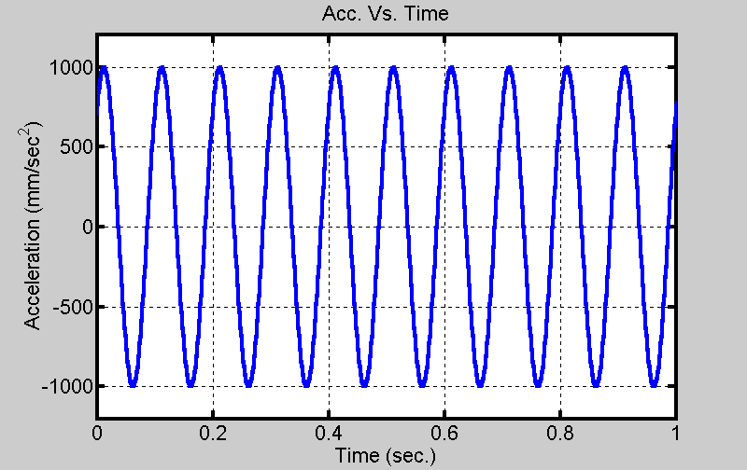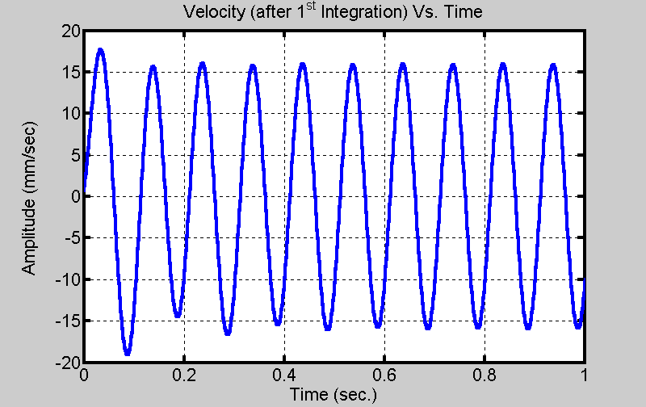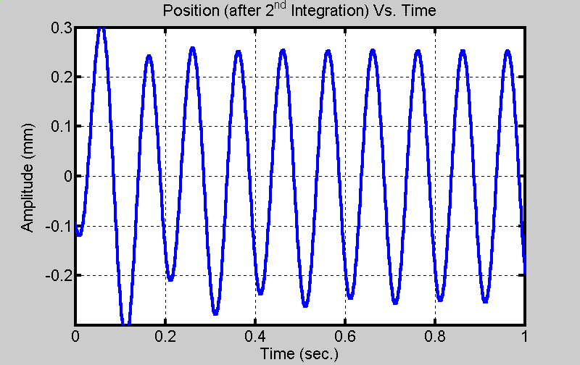
Fig. 4.4 Double Integration Performed with IIR Filtering
Looking at the plot of position on the right, there is a noticeable transient that decays within the first quarter of a second.
4.4 FFT Filtering
Ribeiro suggests a different filtering process rather the conventional methods of using FIR or IIR filters. This technique uses the FFT (Fast Fourier Transform) to remove low frequency content near DC. The FFT of a signal is taken, the lower frequency component coefficients are modified, and the inverse FFT is obtained to get the filtered signal. Ribeiro suggests setting the lower frequency coefficients (below about 0.7Hz, which is the cutoff frequency of the filter) to a value equal to the cutoff frequency coefficient to attenuate the DC component. The lower frequency coefficients are located at the beginning and end of the FFT sequence. The coefficients at the end of the FFT sequence must be changed to equal the conjugate of the ones at the beginning, because the FFT sequence must be conjugate symmetric for the signal of interest to remain real. Here is an example of how the method would work for an FFT of size 2048.
X=fft(x); x is time domain signal to be filtered
Xf=X; Xf represents the filtered signal
Xf(1)=Xf(3); X(3) is the cutoff frequency coefficient
Xf(2)=Xf(3);
Xf(2047)=conj(Xf(2));
xf=IFFT(Xf)

The equations above were taken directly from Ribeiro’s paper. The third element of the FFT corresponds to a frequency of about 0.7Hz. The size of the FFT is often set to a power of 2, such as 2048, because it is more efficient computationally. The method was tested on the same single frequency signal used so far. The results are shown in figure 4.5 below:
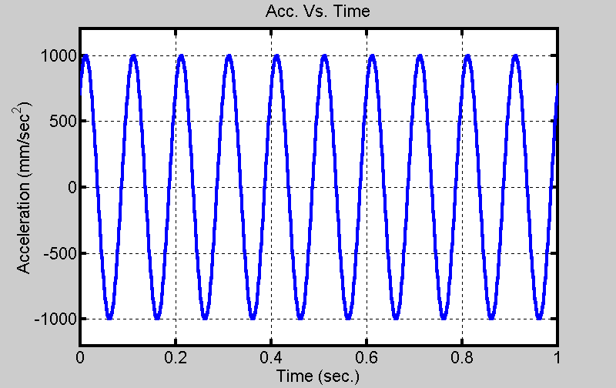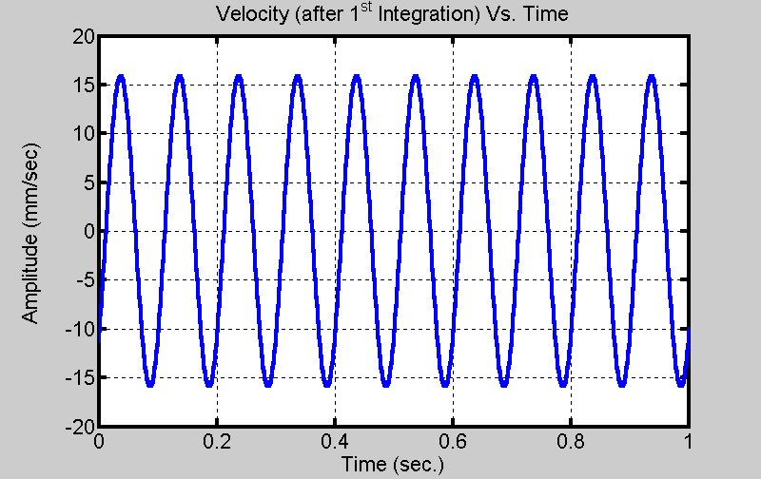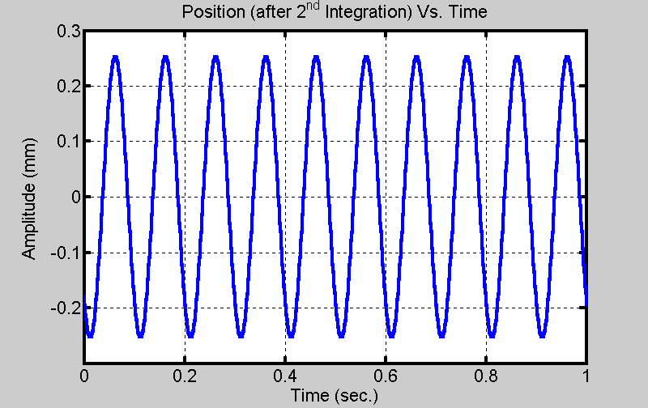
Fig. 4.5 Double Integration with no initial conditions; FFT filtering
For the single frequency signal, the double integration process with FFT filtering works very well. It overcomes the problem of a possible lengthy transient response that is associated with FIR filtering, and the result is very accurate from the start of the time interval of interest. The difference of the values of the velocity and position plots at t=0 and the actual initial condition values is negligible. This implies that initial velocity and position can be calculated accurately without direct measurement.
Unfortunately, the method seems to only work well for a single frequency signal. When a random signal is used, the low cutoff frequency (around 0.7Hz) doesn’t remove the low frequency signals that result from accelerometer drift. Therefore, the double integrated signal has a significant amount of low frequency energy added to it. The left side of Figure 4.6 below shows a plot of acceleration. The right side of the figure shows the plot of the actual position (in red) superimposed with position found by way of the double integration. The green line is a plot of a low frequency sine wave to illustrate how the double integrated data oscillates.
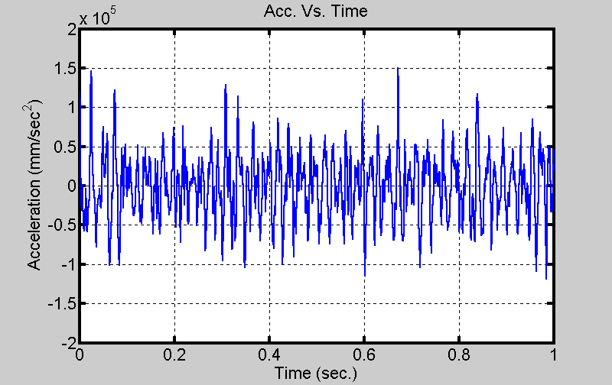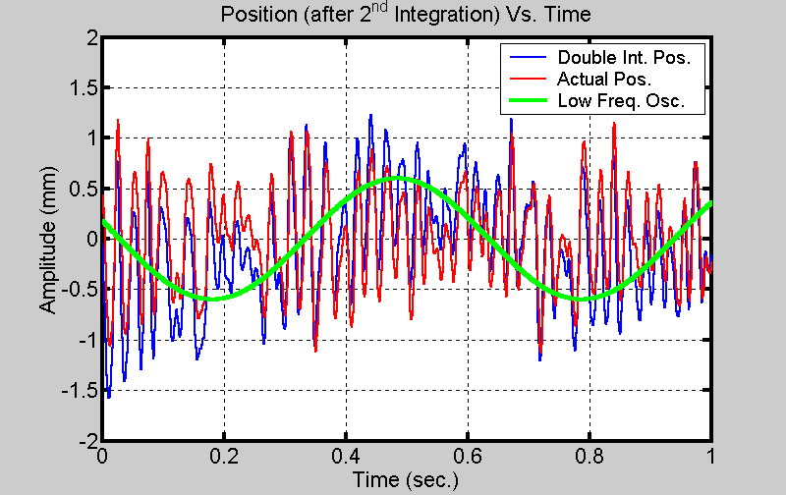
Figure 4.6 Faulty Double Integration using FFT Filtering
The method was modified by increasing the cutoff frequency above 0.7Hz. Some of these lower frequencies aren’t physically present in the system and need to be removed. The cutoff frequency can be increased to remove these frequencies, but must not be high enough to cut into the signal band. The modification to Ribeiro’s method greatly improves the results, which are plotted in figure 4.7.
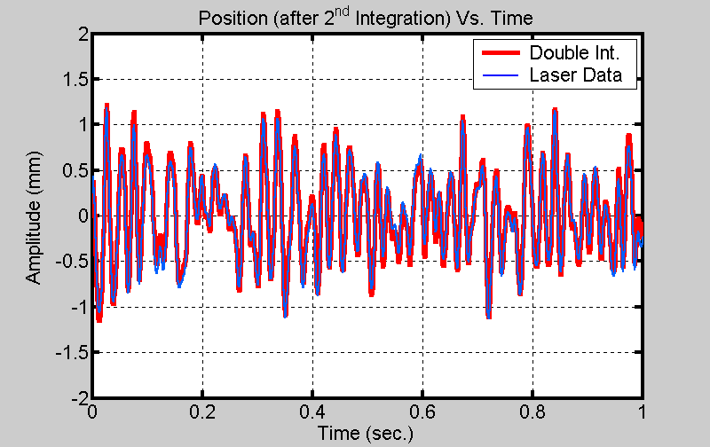
Fig. 4.7 Double Integration using Modified FFT Filtering
Clearly, this modified approach to FFT filtering is an improvement over the suggested approach. The low frequency oscillation is not present. The two position signals closely match.
In conclusion, the FFT is an effective filtering method. However, there is a limit as to how low the cutoff frequency can go. Ribeiro’s suggested cutoff frequency of 0.7Hz doesn’t work well for the particular application of a vehicle test. It’s too low to overcome the problems of drift and unknown initial conditions because the result contains spurious low frequency energy that isn’t actually present in the system. The possibility exists that the need to change the cutoff frequency is dependent on the accelerometer used, since different devices will have different drifts. Three modifications were made to Ribeiro’s algorithm, namely:
- The cutoff frequency was made higher than 0.7 Hz. A cutoff frequency of 2-2.5 Hz was sufficient to remove the low frequency oscillation.
- When taking the inverse FFT (IFFT) to get the time-domain filtered signal, only the real part of this IFFT should be retained because the quantity measured is a real signal. After the FFT coefficients are modified and the IFFT operation is performed, the time domain signal will be complex. The imaginary part of the data (from rounding errors) is small enough to be neglected, but must still be discarded.
- Instead of setting the low frequency FFT coefficients (the ones below the cutoff frequency) to a constant equal to the value of the coefficient closest to the cutoff frequency (which could amplify the low frequency content), they should be zeroed. Otherwise, those lower frequencies could be the cause of integration errors, as integration amplifies these frequencies selectively.
So the FFT filtering algorithm can be re-written as:
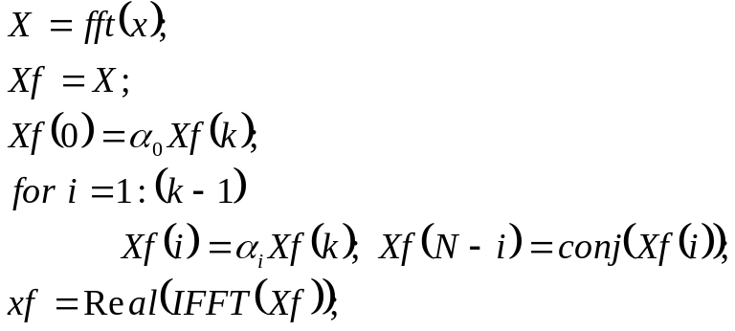
where N is the size of the FFT, k is the index number of the FFT coefficient representing the cutoff frequency, and the α_{i}’s are filtering coefficients specified by the user. Many of the analyses done for this project used a value close to zero for frequencies in the stop band. For designing a filter the user needs to specify the size of the FFT, the cutoff frequency, and the filtering coefficients.
4.4 Concluding Remarks
All three of the filters above are acceptable for this application. There are advantages and disadvantages associated with each. The FIR can be used in real time and has a linear phase, but has a high order and long delay time. The IIR has a lower order and is faster and has a short time delay, but can’t be done in real time. The FFT can’t be used in real time either, but minimizes starting transients and is fast computationally. For the application of a vehicle road test, it is not necessary to perform real time digital filtering.
Between filtering and integrating, a delicate balance needs to be achieved. For filtering, a lower sampling rate would be useful to make the filter specifications easier to meet. However, if the sampling rate gets too low, the accuracy of the integration decreases.

CHAPTER 5

Instrumentation and Setup

5.1 Diagram of Setup
In the mathematical preliminaries covered in the previous chapters, an approach was developed to perform double integration on acceleration data to obtain position data. This chapter discusses how that process was tested experimentally to confirm that it worked. Testing was performed in a laboratory at Ford Motor Company as part of a research project. The following diagram illustrates the test setup:
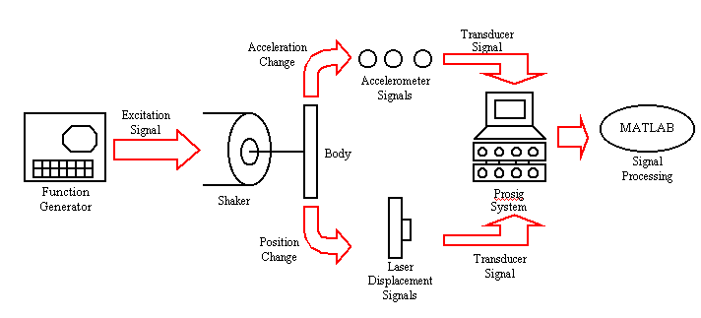
Fig. 5.1 Diagram of Experimental Setup
A shaker was used to provide excitation to a body that can be sinusoidal or random, depending on the control signal from the function generator. When the body is in motion, an accelerometer is attached (using an adhesive) to the body to measure acceleration. A laser position gauge is used to record the position of the body as a function of time. Both the accelerometer and laser output analog voltage signals that need to be digitized using analog to digital (A/D) conversion. The Prosig unit is a data acquisition device that performs such an operation. All of the acceleration and position data are stored in text files where they can later be analyzed by MATLAB or similar software.
To evaluate the process, the acceleration data is first double integrated to find position data. Then that position data is compared to the position data obtained from the laser position gauge that acts as a reference with the objective that the two sets of position data match closely. The results will be discussed in chapter 6.
5.2 Equipment Used
- Bruel & Kjaer Mini Shaker Type 4810
The shaker takes an electrical signal and converts it to a mechanical displacement. A variety of electrical signals can be used, but it is important to note that the shaker will have a larger displacement for lower frequencies than higher frequencies. For example, if it is desired to have the range of displacement constant while increasing the frequency, then the amplitude of the input will have to be increased. The shaker has an allowable range of ±3mm.
- Keyence Laser Displacement Meter (LC2400A and LC2100)
The laser displacement meter contains two components, the control box and the laser head. The laser will be directed at a flat surface. It is important that the laser is properly aligned and a reflective surface is used for measurements. For accurate measurements, the laser heads must remain securely in place. For data acquisition, an analog signal is available from the back of the control box. The signal from the unit is 500mV/mm and the allowable displacement range is ±8mm.
- Bruel & Kjaer Power Amplifier Type 2706
This piece of equipment is used to amplify an incoming electrical signal to drive the shaker.
- PCB Piezotronics Accelerometers
These devices generate an electrical signal when undergoing acceleration. Two different accelerometers were used.
- S/N 4973 has a sensitivity of 10.701 mV/(m/s²)
- S/N 4864 has a sensitivity of 10.762 mV/(m/s²)
For measuring an acceleration of a vibration around a fixed point, the signal should have a zero mean value. The accelerometers, however, have a small DC bias, which requires high-pass filtering to remove.
- Prosig P5600
The Prosig P5600 is used for data acquisition. It accepts analog inputs on 16 different channels through BNC connections. The unit is connected to a laptop computer, which contains software for interfacing with the unit. Following acquisition, the results can be accessed with a laptop computer.
5.3 Single Point Setup
The setup for the first tests measures the displacement of a single point on a body. The system was mounted on a lab tabletop, with the equipment firmly secured to limit the interference from outside sources. Before the tests were performed, all equipment was properly calibrated. These are pictures of the setup:

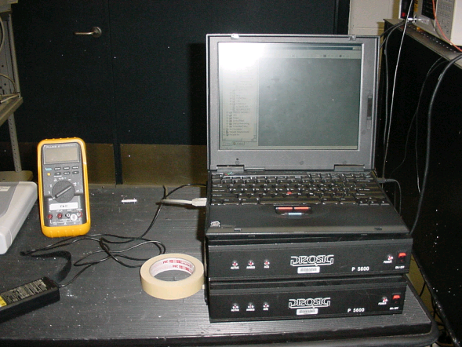Fig. 5.2 This is the Prosig unit and laptop. The cables containing the position and acceleration signals are connected to the back of the unit. The laptop contains an interfacing program to control the data acquisition.

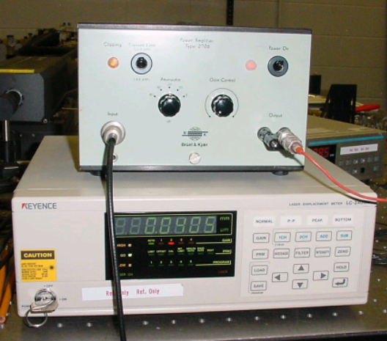
Fig. 5.3 This is the laser position gauge control box (bottom). The output signal is connected of the Prosig unit. A laser head is also connected to the back of the unit. The power amplifier (top) takes its input from the laptop computer to drive the shaker.
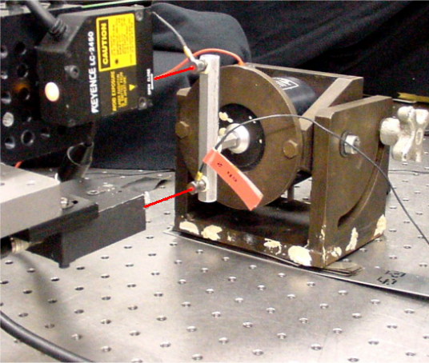
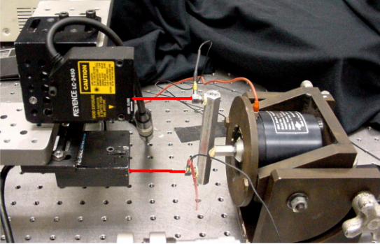
Fig. 5.4 Here is the set up on the lab tabletop. The two laser heads are pointed at an object that is given a displacement by way of the shaker. The object shown is a rigid body. The accelerometers are mounted to the object. The signal outputs from the accelerometers are connected to the Prosig unit. For this test, the displacement of two points is measured but the double integration is done independently on each.

For some parts of the experiment, it will be useful to provide the body with a random displacement. A bandwidth limited random signal is easily generated numerically within the Prosig’s analysis software. The random excitation signal is stored as a sound (.wav) file and generated by the laptop computer via the headphone jack, which is connected to the amplifier to drive the shaker. The body moves in response to this signal.
5.4 Double Point Measurement Setup
In the second phase of the project, the setup is changed to measure displacement and acceleration on two points of a flexible body. The objective here is to find the differential displacement between two points. For this setup, two laser heads are attached to the laser position gauge and the laser is pointed at two different points on the body. Two accelerometers are attached to these points as shown below.
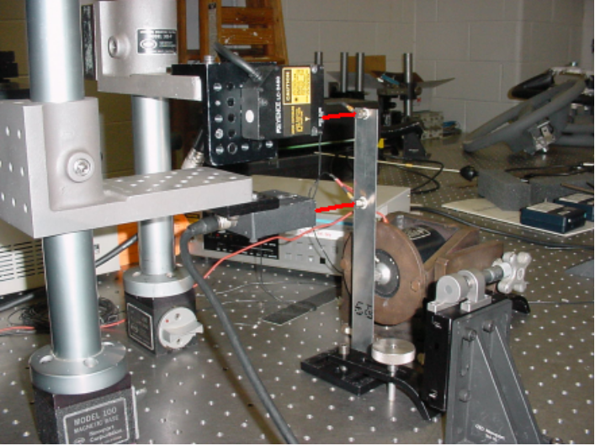
Fig. 5.5 Picture of Setup for 2 Point Measurement
The laser heads acquire two sets of position data and differential position will be calculated by subtraction. Simultaneously, two sets of acceleration data will be acquired and double integrated to get position data. Then one set will be subtracted from the other to get differential position and be compared to the other set of position data from the laser gauge.
When the flexible object undergoing a position change is excited, it will bend. Figure 5.6 below shows the placement of the accelerometers relative to the contact point of the shaker onto the test object.
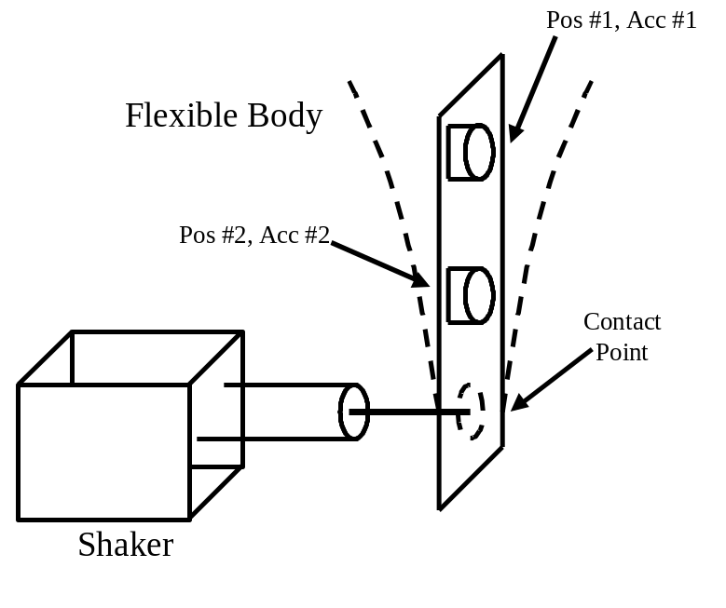
Fig. 5.6 Illustration of Flexible Deformation
The point where accelerometer #1 is placed undergoes a larger displacement than the point where accelerometer #2 is placed because its position is farther from the contact point.

CHAPTER 6

Experimental Results

  - Analysis of Error
The purpose of the experiment was to calculate the displacement of a body using accelerometer data and compare it to another position signal obtained through a direct measurement. It is important to compare the two signals and quantify the accuracy of the process. It is assumed that the position measured directly by the laser gauge is the actual position change to verify that the double integrated position signals closely match the actual change in position (the reference signal).
All the measurements were taken using the Prosig data acquisition system and stored as text files. Although not the most efficient way to store data, it is the easiest to use, as there is no need to decode the numbers. These data files are easily imported into MATLAB for analysis.
6.1.1 Standard Error
Standard error can be used as an indicator of how accurate the double integration process is. It is given by the following equation.
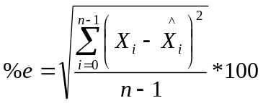
where n is the number of data points, X_{i} is the double integrated position data, and 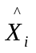is the laser position data. This is a better method for measuring error than simply finding the percent error for each data point, which would be large when near zero crossings, where it is difficult to make accurate measurements.
When measuring standard error, the two position signals must be well matched in time. During a filtering stage of the double integration, a time delay can occur. When this happens, the signal must be time corrected so it is synchronized with the reference signal. It is desired to have a standard error of less than 10% to consider the process accurate. This was the requirement of the sponsor of this project.
6.1.2 Peak Error
There is another method of measuring error that is also useful. Sometimes, it is important to find the peaks and valleys in the displacement waveform. For example, when measuring the stress on a body because displacement is proportional to stress. When standard error was calculated, all data points were used. For the peak error, only the error at peaks will be measured that only include peak points higher than a certain threshold. In the experiments performed, usually a threshold of 50% of the maximum peak was used. For experiments at a single frequency, the setting of this threshold isn’t critical since all peaks have about the same amplitude. For random signals, the threshold must be set so a considerable number of peaks are found to calculate the error.
Two calculations were made for peak error. The maximum peak error is the largest recorded error between two peaks and an average of the error between all peaks. Again, these errors should be less than 10% for the double integration process to be considered sufficiently accurate.
  - Single Point Experimental Results
The purpose of this experiment was to verify that the double integration process works on a single point of a body. A number of different input signals were used to verity that the approach works in a variety of situations. These include:
- Single Frequency (varied), constant amplitude
- Single Frequency (fixed), varied amplitude
- Band-limited Random Input (Lower frequency content)
- Time limited input (Shock Measurements)
    - Single Frequency
The first test was with the use of a single frequency displacement. Because the acceleration signal is a pure single frequency, the position signal should be of the same frequency. Frequencies ranging from 20Hz to 150Hz were used. Figure 6.1 below shows an example of a 50Hz single frequency displacement. A plot of the measured acceleration is on the left, while a superimposed plot of the calculated (via double integration) position and measured position is on the right.
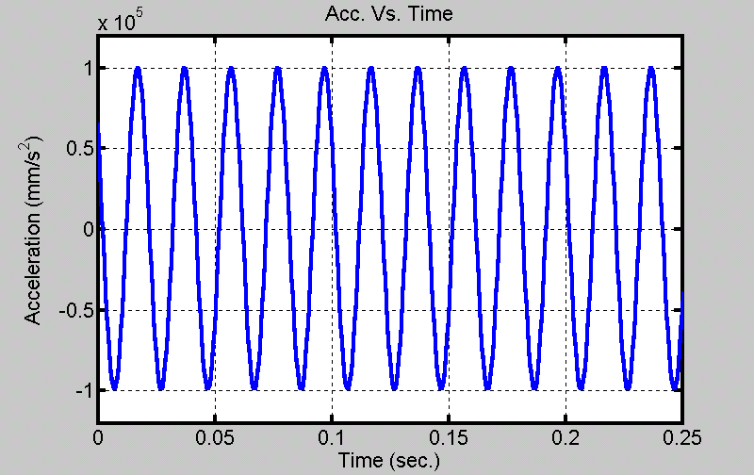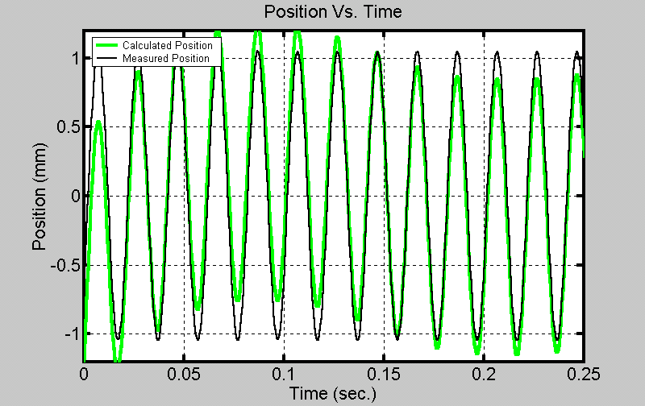
Fig. 6.1 50 Hz Single Frequency Displacement
The results for the single frequency test are shown in the table below.
Frequency, Hz | Filtering Method | Standard Error | Average Peak Error | Maximum Peak Error
20 | FIR | 6.0442 % | 5.2869 % | 5.8033 %
20 | IIR | 6.7719 % | 6.2629 % | 6.8162 %
20 | FFT | 5.7760 % | 5.3513 % | 6.7009 %
50 | FIR | 6.3883 % | 4.6149 % | 5.4385 %
50 | IIR | 7.8649 % | 4.6180 % | 6.1186 %
50 | FFT | 7.1702 % | 4.5602 % | 8.2269 %
75 | FIR | 7.3869 % | 4.5518 % | 7.7939 %
75 | IIR | 7.3731 % | 4.5655 % | 7.6226 %
75 | FFT | 6.9853 % | 4.5558 % | 7.8382 %
100 | FIR | 9.6315 % | 5.8233 % | 10.2217 %
100 | IIR | 12.4791% | 5.8533 % | 9.2978 %
100 | FFT | 9.5380 % | 5.8263 % | 10.8069 %
125 | FIR | 12.0538 % | 6.8958 % | 13.5988 %
125 | IIR | 12.9447 % | 6.9224 % | 11.9304 %
125 | FFT | 10.0618 % | 6.9051 % | 14.6324 %
150 | FIR | 12.7335 % | 6.4213 % | 22.0975 %
150 | IIR | 13.0318 % | 10.3174 % | 18.3353 %
150 | FFT | 21.5673 % | 19.0846 % | 33.1266 %
Table 6.1 Single Frequency Test Results

For this test, the amplitude of the displacement was the same (about 1.25mm) for all the different frequencies. This is to ensure that an amplitude difference won’t effect the error, because the purpose of this test was to find the effect of frequency on the error.
For frequencies below 100Hz, there doesn’t seem to be a noticeable trend. However, at higher frequencies, the error appears to increase with frequency. All three of these filtering methods seem to fail at higher frequencies, which suggests the error is not due to the filtering stages. Also, the higher frequencies are attenuated less by the high-pass filter’s magnitude response. The source of the error could be the integration stage itself. The sampling rate was constant (2kHz) throughout the experiment and a higher frequency displacement would likely be less accurate because of integration errors. However, this isn’t likely to cause the abrupt increase in error as seen in the results above. The equipment used could be a factor in the cause of error.
There doesn’t seem to be any clear choice as to which filtering technique is more accurate. All three methods have a problem of a transient time that causes large errors at the start of the signal.
6.2.2 Effect of Amplitude Change on Results
The next experiment explores how the amplitude affects the accuracy of the results. For conventional filtering techniques like FIR and IIR filtering, it was found that the accuracy of the double integration greatly declined as the movement amplitude in the body was decreased. This decline in accuracy is probably not caused by the A/D converter because as the amplitude of the signal gets smaller, it is amplified to use more of the converter’s range, which preserves measurement precision. The error is more likely to come from the laser displacement gauge and accelerometers. For low amplitude signals, the output voltages of these devices will lose precision. For this experiment, the frequency of the input was held to a constant 50Hz while the amplitude of the displacement was made (using the laser displacement gauge to make adjustments) to range from 2.00mm all the way down to 0.05mm. The results are summarized in the table below.
Amplitude | Standard Error | Average Peak Error | Maximum Peak Error
2.00 mm | 10.4813 % | 5.4713 % | 7.2473 %
1.75 mm | 10.5465 % | 4.5403 % | 6.9542 %
1.50 mm | 8.3484 % | 4.7963 % | 6.1998 %
1.25 mm | 7.7052 % | 5.1866 % | 7.3518 %
1.00 mm | 9.5677 % | 4.4662 % | 6.2024 %
0.75 mm | 7.3607 % | 3.2706 % | 6.8371 %
0.50 mm | 13.5243 % | 10.9208 % | 13.3050 %
0.25 mm | 13.9662 % | 10.0505 % | 13.4414 %
0.15 mm | 18.4785 % | 15.7617 % | 21.6789 %
0.05 mm | 24.9767 % | 23.4974 % | 32.5738 %
Table 6.2 Results of Changing Amplitude on Error
The results for a large displacement are very good, but it is obvious that there is a trend. The amplitude of the displacement is inversely proportional to error between the measured position and calculated position. Therefore, there is a limit to the accuracy of the double integration process for very low amplitude signals. Once the amplitude of the displacement drops below 0.25mm error exceeds 10%.
    - Random Input
The double integration process worked well on single frequency data. However, in a road test, the signal will be low frequency random data. Therefore, it is necessary to test the process with this type of displacement. So, the body is given a band-limited random displacement using the procedure described in chapter 5. For this experiment, the bandwidth of the excitation signal is going to be varied to see how that effects the accuracy of the double integration process.
As the bandwidth of the excitation is increased, the displacement present in the system will emphasize the lower frequencies while rejecting the higher frequencies. These higher frequencies can be observed in the acceleration signal. This demonstrates the difficulty of creating a displacement of uniform bandwidth, because of the nature of the mechanical system and noting that a double integration is essentially a low-pass filter.
The experiment was performed for a number of different frequency bands. An example double integration is shown in the figure below. The plot on the right of position shows that the calculated position follows the actual position very well.
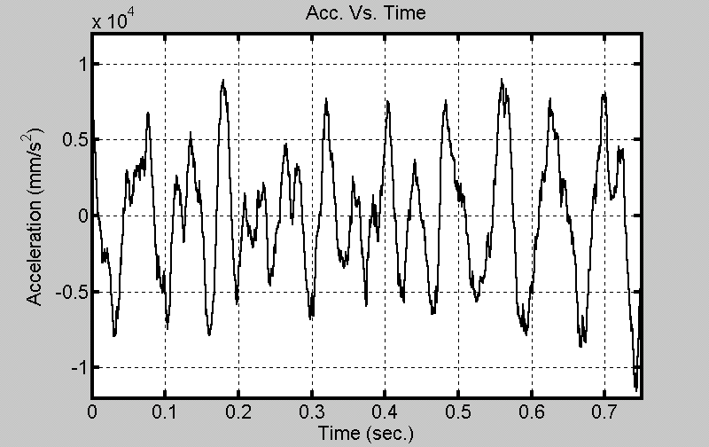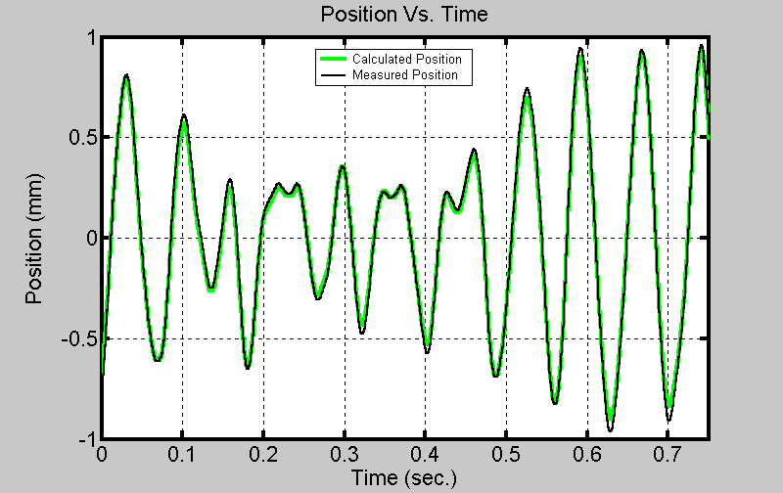
Fig. 6.2 Results from Band-limited Random Displacement
Table 6.4 below summarizes the results of the experiment. As the bandwidth of the excitation signal is varied, there is no noticeable trend in the error and the results are well within the allowable error.
Bandwidth  f_{c}=30 Hz | Standard Error | Average Peak | Maximum Peak
5 | 6.3570 % | 4.3900 % | 13.4798 %
10 | 6.9356 % | 4.5744 % | 11.0763 %
20 | 6.6061 % | 4.6205 % | 8.6914 %
30 | 6.6082 % | 4.6591 % | 9.8483 %
40 | 6.8960 % | 4.3289 % | 10.1590 %
Table 6.3 Results from Random Displacements
    - Time Limited Signals
It has been shown in the previous sections that the double integration procedure works well for measuring the displacement from continuous vibrations. When the test was performed in the laboratory, the body was already in motion before data was collected. However, this does not prove whether the process would work on a very localized vibration. The process has to work reliably for a displacement that is very brief in time and high in amplitude, like a shock measurement. Therefore, another test was designed to evaluate how well the double integration process works in this situation. The data collection process was started before the body was given an excitation. The excitation takes the form of a band-limited random impulse type signal. The width of the pulse was varied to see if there is a relation between the length of time of the pulse and accuracy of the results. The figure below shows the acceleration signal on the left and the resulting position signal from double integration (superimposed with a plot of data taken from direct measurement) on the right.
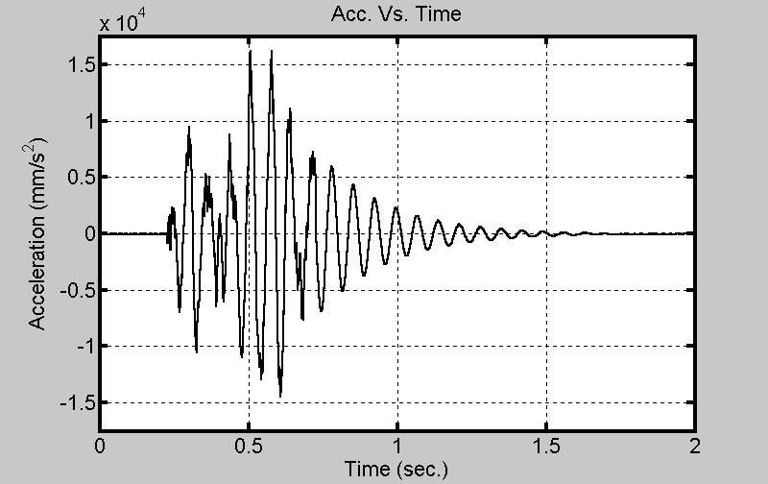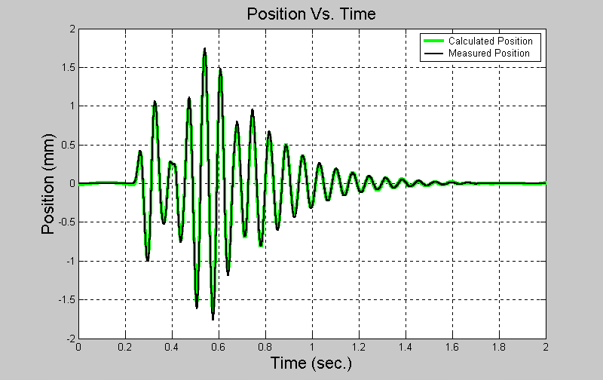
Fig. 6.3 Plot of Acceleration and Position for shock measurement
The figure above displays the case where the width of the pulse is half a second. On the plot for acceleration, the excitation starts around 0.25s and ends around 0.75s. After it ends, the higher frequency content of the signal disappears and the plot looks smoother while the ringing slowly dampens for another second. The plot on the right shows how the calculated position approximates the measured position well. The table below summarizes the results of this test.
Length of Pulse | Standard Error
0.25s | 7.0644 %
0.50s | 5.8584 %
0.75s | 8.0952 %
1.00s | 8.6005 %
Table 6.4 Results from Shock Measurements
There doesn’t seem to be a noticeable trend as the length of the pulse is varied, but the results do show that the method is acceptable for these types of signals.

6. 3 Flexible Body Differential Position Measurements
For the next phase of the experiment, a different type of body was used to test the double integration procedure. This body was flexible and data was taken from two points on the body. The purpose of the experiment was to find the differential position between two points (Fig. 5.6). One set of position data will be subtracted from the other to get the differential position data. These sets of position data will be found from the laser position gauge, which would then be set to gather data from two channels. This position data will be compared to position data calculated from the double integrated acceleration data. Two accelerometers are used on the two points of interest on the body. There is more than one way to do the double integration for this. Subtracting the first acceleration signal from the other and integrating this result is one method. Alternatively, one could double integrate both acceleration signals and then subtract one result from the other. In theory, the same result is obtained in either case. However, here it is preferable to perform the subtraction before the integration. The process is only applied once instead of twice, so error is minimized.
The organization of this experiment isn’t as neat and precise as the previous single point experiment. Previously (section 6.2.1), the amplitude of the position change was made constant by careful adjustment and the use of the laser displacement meter to check the amplitude. Doing this ensured that amplitude changes wouldn’t affect the results, as it was of interest to find the errors due to changes in frequency. The new procedure won’t be so simple, because the amount of deflection at each point changes with frequency, the nature of which is determined by the properties of the material used.
    - Single Frequency Displacement
For a single frequency displacement, the contact point on the body (as shown in Fig. 5.6), moves in a sinusoidal motion. However, the displacement and acceleration of the two points being measured won’t necessarily move in a purely sinusoidal motion. They will have the same fundamental frequency, but harmonics will be generated so that the waveform will have a distorted appearance. This is illustrated in figure 6.4 below. On the left is the plot of the measured position of the two points. The two points are out of phase with each other. If the body had been rigid, the two points would be in phase with each other.
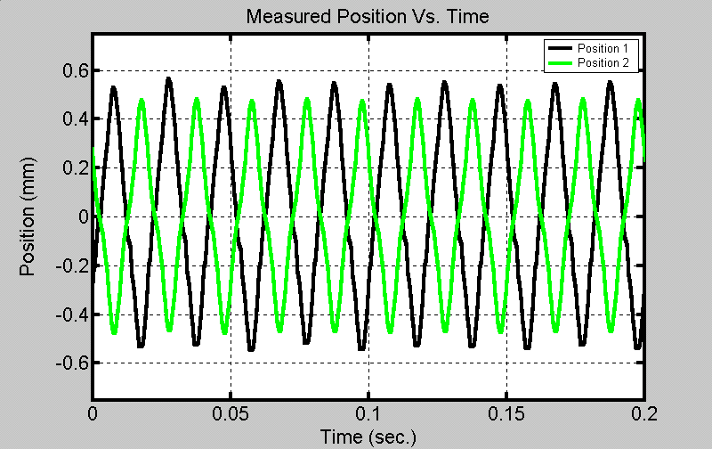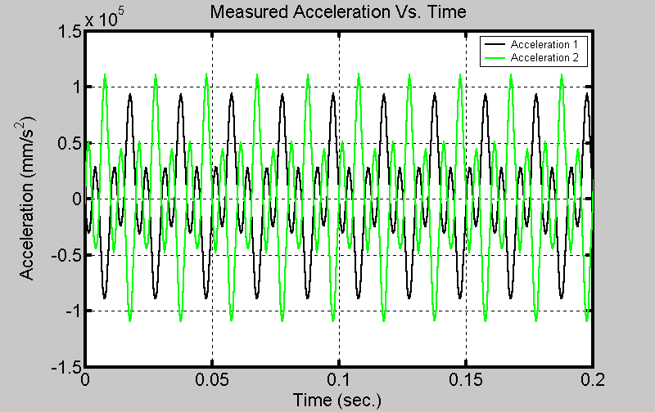
Fig. 6.4 Plots of Measured Accelerations and Positions from Two Points on Body
Figure 6.5 below shows a plot of differential acceleration on the left. This is a subtraction of the acceleration of the point at the top of the body from the point lower on the body. On the right side, the results of the double integration for a 50Hz signal are displayed. The calculated differential position matches the measured differential position very well.
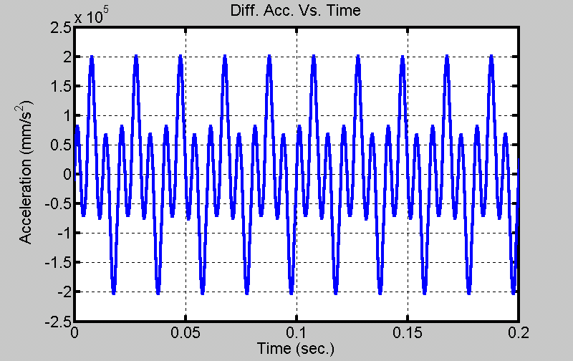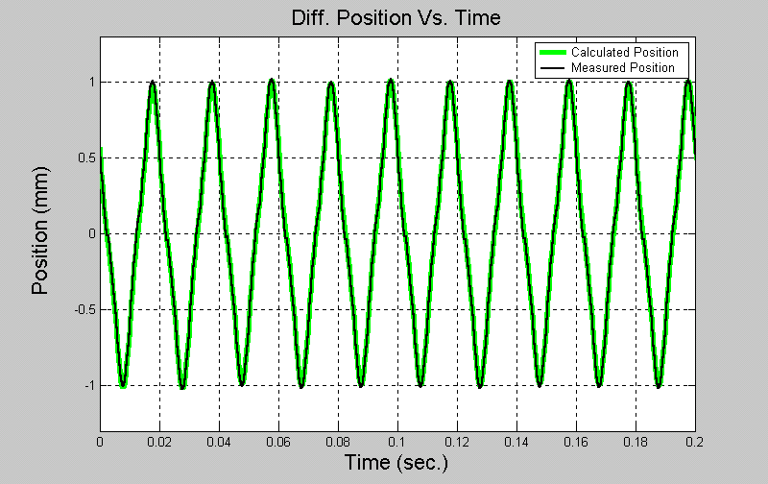
Fig. 6.5 Double Integration Results for 50 Hz Single Frequency
Table 6.6 summarizes the results for the single frequency case. There are very large errors for the 20Hz and 200Hz case. These large errors are due to the small amplitude of the differential position. For the 50Hz case, the differential position was large, making the error small. For the results of this experiment to be accurate, a large displacement on a single point isn’t sufficient, but rather the differential position must be large.
Frequency | Standard Error | Average Peak Error | Maximum Peak Error
20 | 21.3638 % | 18.3697 % | 27.5729 %
50 | 3.7888 % | 1.7914 % | 2.9994 %
100 | 8.5555 % | 4.4165 % | 6.2536 %
200 | 18.2031 % | 15.1745 % | 20.8240 %
Table 6.5 Results from Single Frequency Displacement
    - Random Input
The flexible body was also tested with a random displacement signal. For the excitation signal here, a much wider bandwidth was used. This wider band is easily captured by the acceleration measurement, but as before, the double integration favors the lower frequency content in the signal, and the position appears to be a smooth low frequency signal. Figure 6.6 is a good demonstration of this filtering process. The calculated position on the right figure matches the measured position.
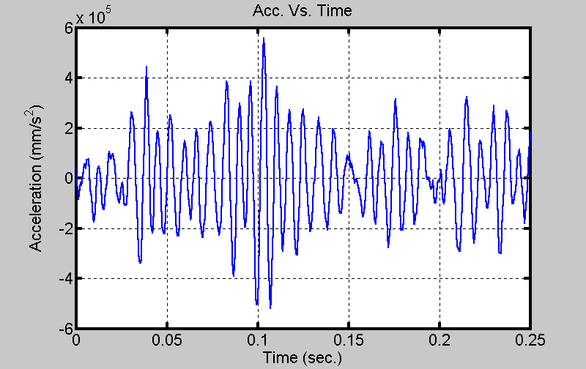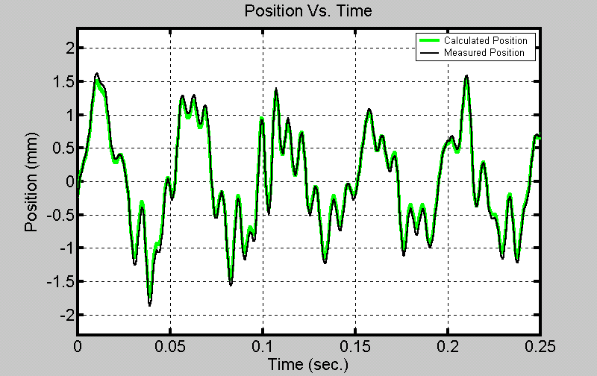

Fig. 6.6 Results of Random Displacement
Table 6.6 summarizes the results for a random displacement. Most errors are a fraction of a percent, proving that the double integration process is accurate.
Frequency Band | Standard Error | Average Peak Error | Maximum Peak Error
20-220 Hz | 9.2369 % | 4.6641 % | 9.2511 %
50-250 Hz | 9.2737 % | 5.8794 % | 8.6637 %
100-300 Hz | 9.3262 % | 4.7314 % | 8.0823 %
100-200 Hz | 8.9255 % | 5.1266 % | 10.1210 %
150-250 Hz | 10.1275 % | 5.4202 % | 9.9638 %
200-300 Hz | 10.1950 % | 5.1760 % | 8.4120 %
Table 6.6 Summary of Results for Random Displacement

Chapter 7 Conclusion

7.1 Conclusion
The work was successfully completed in that a process to double integrate acceleration data to get position data was developed and tested. It was evaluated under different conditions in an attempt to ensure accuracy in every conceivable situation. Different types of acceleration signals were used, including sinusoidal and random. Also, rigid and flexible types of bodies were evaluated under all situations and the technique met the requirement of having an error less than 10%.
The sources of error of the process were discussed and it was found that significant sources of error originated from the filtering stage itself. With an ideal filter, there would be no such errors. Of the three filtering methods that were considered, the FFT filtering method conceptually comes closest to approximating an ideal filter, because of it’s abrupt cutoff frequency. However, there are still errors associated with that filter that are similar in size to the other two filters’ errors. The choice of cutoff frequency was critical in the design of the high-pass filters. If it were made too high, then frequencies of interest would be attenuated. If it is too low, there would be excessive errors due to the presence of spurious low frequencies. A good approach is to make the cutoff frequency half of the lower frequency limit of the signal band. There is a small source of error from the integration itself, but with a sufficiently high sampling rate, it is not significant.

7.2 Author’s Contribution
There hasn’t been a significant amount of previous work done exploring the topic of this thesis. One possible reason for this is that in the study of vibrations, acceleration is more popular as a measurement, as it is better for the purposes of spectrum analysis. In many applications, position isn’t considered to be a useful measurement. Another possible reason for the lack of previous work done on this topic is that considerable processing power is needed to perform calculations. Recent advances in computer technology greatly minimize processing time but many of the textbooks on vibrations still discuss analog integration.
The author’s contribution to this topic expands on previous studies. For example, Ribeiro suggested FFT filtering for double integration. However, the algorithm needed to be enhanced to provide a more accurate modified FFT filter for certain applications. Another contribution made by the author was a thorough evaluation of the double integration process and a presentation of results. The previous papers on this topic were more conceptual and didn’t include numerical results or present applications. This thesis presents one application, displacement measurements of an actual vehicle body.

7.3 Future Work
The work of this thesis raised some interesting questions that could be the basis for future work on this topic. For example, it was demonstrated that with a good filtering technique, the position signal found via double integration could be accurate from the start of the waveform, minimizing transients. Perhaps a technique could be developed to find accurate values for the initial conditions, position and velocity, without a direct measurement. Interestingly, because these quantities were unknown the double integration approach was developed.
Another interesting project might be to perform a single integration on acceleration data to get velocity data. Then this data can be compared to velocity data obtained by direct measurement. One would expect this comparison to be more accurate than the double integration. There would be one less stage of integration and filtering so errors should be smaller.
Future work could also evaluate more applications.

BIBLIOGRAPHY

- Harris, Cyril M. Shock and Vibration Handbook. pp. 12.33-12.36. 4th Ed. McGraw-Hill. New York. 1996.

- Steidel, Robert F. An Introduction to Mechanical Vibrations. Pp. 104-107. 3rd Ed. John Wiley & Sons. New York. 1989.

- Rao, Singiresu S., Mechanical Vibrations. p. 152. Addison-Wesley Pub. Co. Reading, MA. 1986.

- Broch, Jens Trampe. Mechanical Vibration and Shock Measurements. 2nd Ed. Brüel & Kjær. 1984.

- Rong, Taiping; Shen, Chenghu; Yuan, Zhongping; Xu, Songmei; Principle of Measureing the Displacement with Accelerometer and the Error Analysis. Huazhong Ligong Daxue Xuebao/Journal Huazhong (Central China) University of Science and Technology, v 28. n5 May 2000 p. 58-60.

- Ribeiro, J.G.;, Freire, J.L.; de Castro, J.T. Some Comments on Digital Integration to Measure Displacements using Accelerometers. Shock and Vibration Digest, v 32 n1, Jan. 2000 p.52

- Ribeiro, J.G.;, Freire, J.L.; de Castro, J.T. New Improvements in the Digital Double Integration Filtering Method to Measure Displacements using Accelerometers. Proceedings of the International Modal Analysis Conference – IMAC, v 1 2001, p 538-542.

- Oppenheim, Alan V., Schafer, Ronald W. Discrete-Time Signal Processing. 2nd Ed. Prentice Hall. Upper Saddle River, NJ 1999.

- Dynamic Signal Analysis Application Notes. Hewlett Packard. July 1982.

- Mitra, Sanjit K. Digital Signal Processing: A Computer Based Approach. 2nd Ed. McGraw-Hill. Boston 2001.

APPENDIX A

Mathematical Results

A.1 Analysis of Double Integration with Accelerometer Drift
Suppose that the acceleration signal is composed of both a time-varying component and a constant.
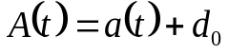

In this equation, a(t) is a zero mean acceleration signal, while d₀ is an unwanted constant. This d₀ represents the drift present in real accelerometers. To find velocity, both parts will be integrated separately. Assuming zero initial conditions, the composite velocity signal will be:
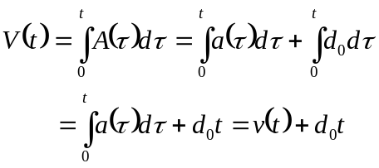

V(t) is the composite velocity signal. The v(t) component of the signal is the desired velocity that will have a zero mean and will be bounded. However, the other component of the signal, d₀t, is a ramp with a slope of d₀. If this composite velocity signal is then integrated to get position, X(t), as in a similar manner above:
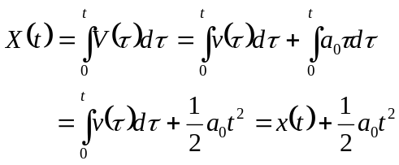,

where x(t) is the desired component of the position signal and the exponential term is the unwanted component. These equations demonstrate the effect that the unwanted DC component in the acceleration signal can have on the double integrated position signal.
A.2 Double Integration with Initial Conditions
Suppose that the acceleration signal, a(t) is being double integrated with initial conditions. The initial velocity (velocity at time, t=0) is denoted by v₀, while initial position (velocity at time, t=0) is denoted by x₀. First, integrate the acceleration signal to get velocity.
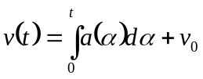
Integrating the velocity signal gives position:
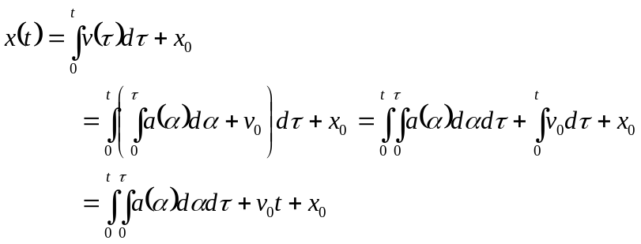
Time varying part
ramp
constant

The position signal contains an unwanted ramp and constant added to a zero mean time varying component. These effects occur when performing digital integration without knowing the initial conditions.
A.3 Double Integration with Combined Effects of Accelerometer Drift and Initial Conditions
Consider now, an acceleration signal that consists of a drift component. This signal can be double integrated with unknown initial conditions to understand the combined effect it will have. Like in A.1, the acceleration, A(t), is equal to
and initial conditions are v₀ for velocity and x₀ for position as in A.2. Now, perform the first integration on acceleration to get velocity.
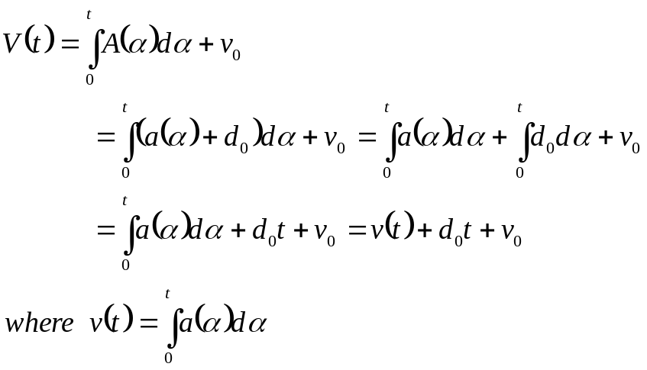
This velocity signal, V(t), is composed of three parts. The first part, v(t), is a zero mean, time varying signal that is bounded. The second part, d₀t, is a ramp with a slope of d₀ and is caused by the accelerometer drift. The third part is the velocity initial condition and represents and integration error from not knowing that initial condition.
Now, to find position, integrate V(t). Remember that when integrating velocity, the initial position term is added.
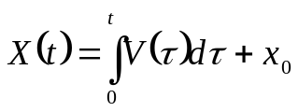
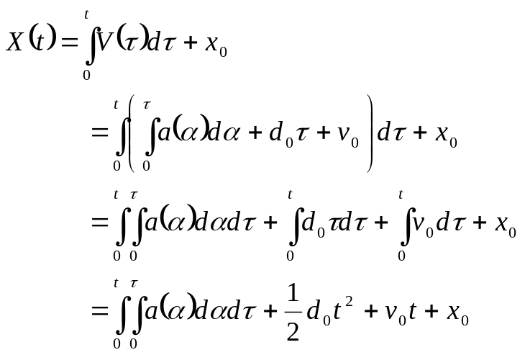
This combines the result from the two previous sections. The exponential term in the equation above dominates the other terms and the output becomes unbounded over time.
A.4 Frequency Response of Double Integrator
For a single frequency input to an integrator, the output will be a single frequency of the same frequency as the input. The output will have different amplitudes depending on the magnitude responses and a phase response of –90 degrees. For an acceleration input,
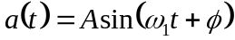,
the velocity output (assuming no initial conditions) is
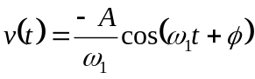.
This is -90° out of phase with the input. Now, by integrating this (and, again, assuming no initial conditions), the position output is
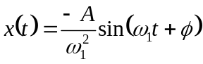,
which is 180° out of phase with a(t).
Now, if the frequency of the input acceleration, ω₁ is increased, the amplitude of the output of the double integrator, position, is decreased. If the frequency is decreased then the output amplitude is increased. This inverse relationship is important. It illustrates how the integrator acts as a low-pass filter. It also shows that the acceleration function will have a much larger amplitude than position, except for when frequency gets so low (less than 1rad/s).

APPENDIX B

Sample Program
sin50_0917_Mfile

fs=2000;
Ts=1/fs;

t=[0:Ts:(20-Ts)]';
acc=-1*acc; %Acceleration and Position are 180 degrees out of phase

figure(1)
%subplot(2,1,1),plot(t,pos),xlabel('Time'),ylabel('Amplitude');
%title('Position'), axis([0 0.5 -1.2 1.2]);
%subplot(2,1,2),plot(t,acc,'g'),xlabel('Time'),ylabel('Amplitude');
%title('Acceleration'), axis([0 0.5 -3e4 3e4]);
plot(t,acc), xlabel('Time (sec.)','FontSize',16),ylabel('Acceleration (mm/s^2)','FontSize',16)
title('Acc. Vs. Time','FontSize',16),grid on, axis([0 0.25 -1.2e5 1.2e5]);

%Filter the Acceleration Signal
Acc_Spect=fft(acc,length(t));
x=length(Acc_Spect);
%Set the First 15 values constant
Acc_Spect(1)=0.0775*Acc_Spect(26);
for i=2:25
Acc_Spect(i)=0.0775*Acc_Spect(26);
Acc_Spect(x-(i-2))=conj(Acc_Spect(i));
end
acc=real(ifft(Acc_Spect));
figure(2)
w=[0:2*pi/(x):2*pi-2*pi/(x)]';
plot(w,abs(Acc_Spect));

%Perform 1st Integration
vel=Ts*cumtrapz(acc);
vel_0=-1*mean(vel);
Vel_Spect=fft(vel,length(t));
x=length(Vel_Spect);
%Set the First 46 values constant
Vel_Spect(1)=0.0775*Vel_Spect(46);
for i=2:45
Vel_Spect(i)=0.0775*Vel_Spect(45);
Vel_Spect(x-(i-2))=conj(Vel_Spect(i));
end
vel=real(ifft(Vel_Spect));
figure(3)
plot(t,vel), grid on;
xlabel('Time (sec.)'),ylabel('Amplitude (mm/sec)'),title('Velocity (after 1^s^t Integration) Vs. Time')

% %Perform 2nd Integration to get Position
pos_ii=Ts*cumtrapz(vel);
Pos_Spect=fft(pos_ii,length(t));
x=length(Pos_Spect);
%Set the First 66 values constant
Pos_Spect(1)=0.0775*Pos_Spect(66);
for i=2:65
Pos_Spect(i)=0.0775*Pos_Spect(66);
Pos_Spect(x-(i-2))=conj(Pos_Spect(i));
end
pos_ii=real(ifft(Pos_Spect));
figure(4)
plot(t, pos_ii,'g'), hold on, plot(t,pos,'k'), grid on
xlabel('Time (sec.)','FontSize',16),ylabel('Position (mm)','FontSize',16)
title('Position Vs. Time','FontSize',16), axis([0 0.25 -1.2 1.2]);
legend('Calculated Position','Measured Position')

%Cutoff first and last 600 samples
new_end=length(t)-600;
pos_ii=pos_ii(1:new_end);
pos=pos(1:new_end);
%Error Analysis
error_1=sqrt((sum((pos_ii-pos).^2))/length(pos));
RMSlaser1=sqrt(mean(pos.^2));
P_error1=(error_1/RMSlaser1)*100

%Error Analysis 2 - Using Maximum Peak Error
%Consider only 8 to 10 seconds of data
ind1=find(t==8.000); ind2=find(t==12.000);
time2=t(ind1:ind2);
pos1=pos(ind1:ind2);
iipos1=pos_ii(ind1:ind2);

%Make a clipped signal
max_peak1=max(pos1);
cut_off1=0.75*max_peak1;

for i=1:length(time2)
if(pos1(i)<cut_off1&pos1(i)>-cut_off1)
pos1(i)=0;
else
pos1(i)=pos1(i);
end
end

%Find indices of zero to nonzero or Nz to z transitions
count=0;
for i=1:(length(time2)-1)
temp=[pos1(i) pos1(i+1)];
if((temp(1)==0&temp(2)~=0)|(temp(1)~=0&temp(2)==0))
count=count+1;
ind(count)=i;
end
end

%Find the indices of the peaks
%Make sure it is of even length
if(rem(count,2)~=0)
count=count-1;
% ind=ind(1:(length(ind)-1));
if (pos1(1)==0)
ind=ind(1:count);
else
ind=ind(2:count+1);
end
else
if (pos1(1)~=0)
length_ind=length(ind);
ind=ind(2:length_ind-1);
count=count-2;
else
ind=ind;
end
end

pos1Mag=abs(pos1);
j=0;
for i=1:2:count
j=j+1;
pk(j)=max(pos1Mag(ind(i):ind(i+1)));
tempind=find(pos1Mag(ind(i):ind(i+1))==pk(j));
if(length(tempind) > 1)
tempind=tempind(1);
end
ind2(j)=ind(i)+tempind-1;
end

%Find average peak error
for i=1:count/2
pe(i)=(abs(pos1(ind2(i))-iipos1(ind2(i)))/abs(pos1(ind2(i))))*100;
end
Avg_Peak_Error_Pos1=mean(pe)
Max_Peak_Error_Pos1=max(pe)

figure(7)
plot(time2,pos1)
hold on
plot(time2,iipos1, 'r')

APPENDIX C

Application: Roof Deflection

The double integration approach to measuring displacement was applied to an actual vehicle body. The test involved measuring the deflection of a vehicle’s roof when the driver side door was slammed. This test was performed under various conditions. For example, the deflection of the roof was measured when all the windows were up. Another situation included when all the windows were down. Before the test was performed, a laser vibrometry scan of the vehicle roof was performed. Velocity was measured over the entire roof for the frequency of 24Hz. Towards the middle of the roof, there’s a “hotspot” where the maximum deflection occurs.
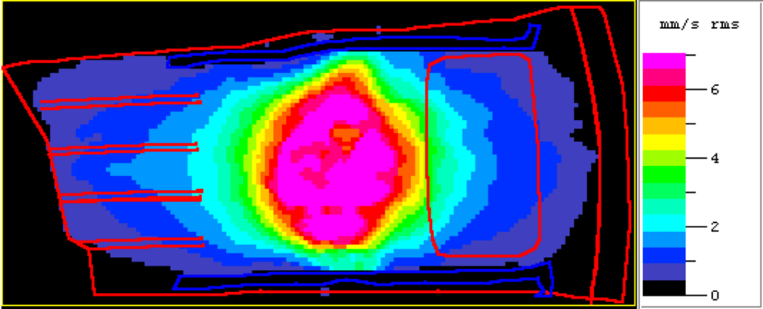
24 Hz.
Fig. C.1 Laser vibrometry scan of vehicle roof
It is at this 24Hz hotspot that the accelerometer was placed and data was collected. Then the data was double integrated to get displacement. Acceleration data was also recorded from two other locations as shown in figure C.2 for frequencies of 39.5Hz and 49Hz.
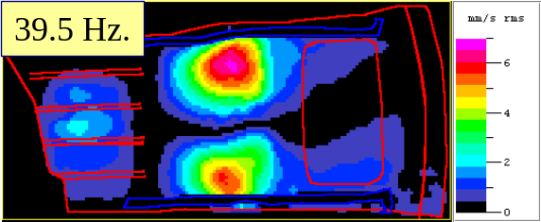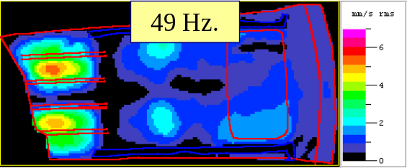
Figure C.2 Laser Vibrometry Scan of Vehicle Roof

On the left, figure C.3 shows a plot of the acceleration data taken from the 24Hz hotspot. On the right, a plot of the spectrum of the acceleration signal is displayed to show that a spike occurs at 24Hz.
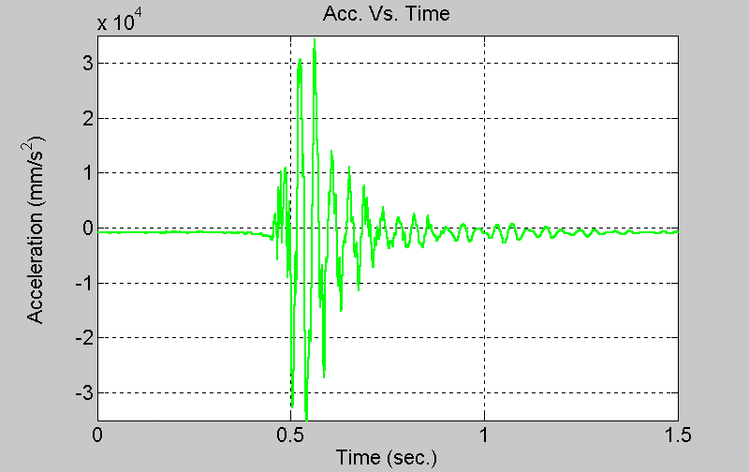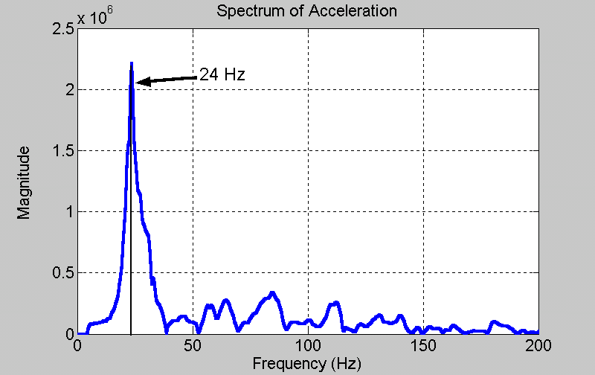
Figure C.3 Acceleration of vehicle roof
That data was integrated once to get velocity, which is shown on the left side in figure C.4. That data was integrated to get displacement, which is on the right side of the figure. This reveals a maximum displacement of almost 2mm.
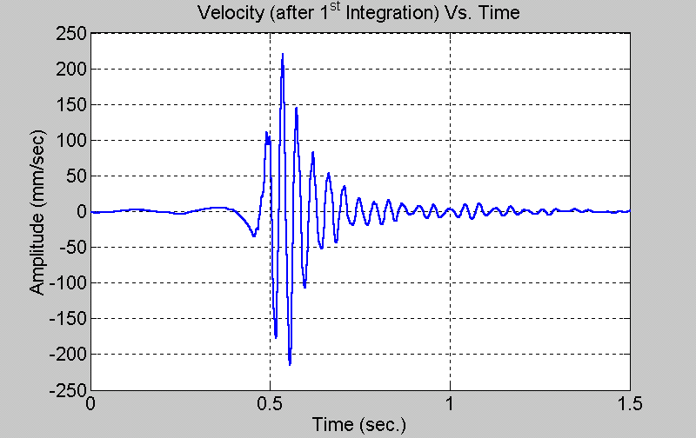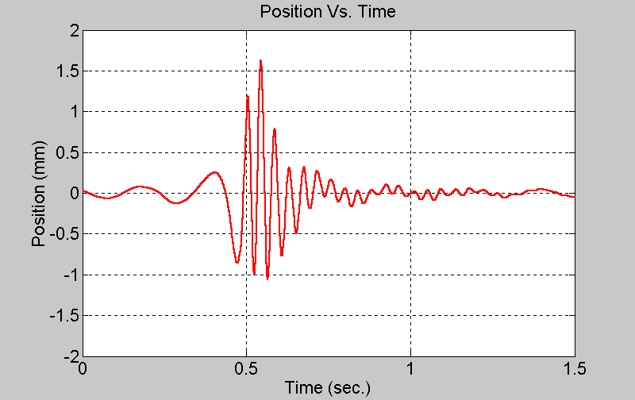
Figure C.4 Velocity/Displacement of vehicle roof

