Lab 2: FPGA-based Mental Binary Math Game with Game Access Control

USER MANUAL

Mubashar Khan

ECE5440

# Introduction

The Mental Binary Math Game is a 2-player mental math game that tests the player’s understanding of binary and hexadecimal numbers. Players must be able to convert between binary and hexadecimal and add in binary to play this game.

The board has three main components that the players will be interacting with. There are three sections of four switches, four buttons and three 7-segment displays. Players must enter a predefined password in order to gain access to the game. Once the correct password has been entered, a green LED will turn on to let players know they can now access the game. The password can be entered using the switches and button marked with green. Player 1 will place inputs using the Player 1 switches and Player 1 button marked in red. Player 2 will place inputs using the Player 2 switches and Player 2 button marked in blue. Figure 1 shows these areas marked. The button marked in brown is the reset button. This will allow players to reset the game and log players out. From left to right, the first display will show Player 1’s input as a hexadecimal number. The second display will show Player 2’s input as a hexadecimal number. The third display will show the sum of Player 1’s and Player 2’s inputs as a hexadecimal number.

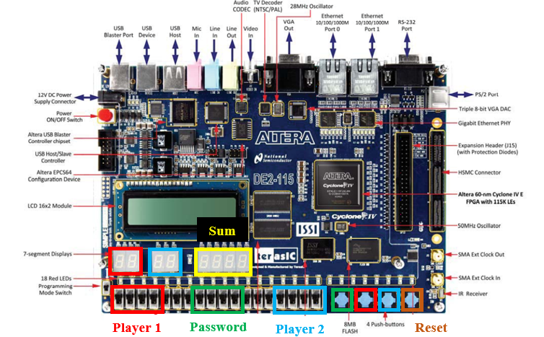

**Figure 1.** DE2-115 FBGA Board. The red box shows the 4 switches that will be used for Player 1’s input and the corresponding display. The blue box shows the 4 switches that will be used for Player 2’s input and the corresponding display. The yellow box shows the display where the sum will appear.

# Instructions for game operation

This is a turn-based game. To begin, one player must enter the password using the green switches displayed in figure 1. The password is a 4-digit number. For this game, the password is 2949. Using the switches, players can enter 1 digit at a time as a binary 4-bit number. Once a player uses the switches to enter a 4-bit value, the player must press the green button to enter the next digit. Repeat this process for all 4 digits and the Red LED will turn Green once players enter the password correctly.

Player 1 will pick a number between 0000 and 1111 in binary and input that into the board using the switches designated for Player 1. The board will convert the binary input into a hexadecimal number that will appear on Player 1’s 7-segment display. Player 2 should look at this hexadecimal number and then using the Player 2 switches, input the binary number that they think will add with Player 1’s number to get to 1111 in binary (F in hexadecimal). Difficulty can be increased by implementing a time limit on Player 2’s turn. We recommend 5 seconds.

**Password Entry Example:**

The password is 2949. Each digit of this password must be entered individually. 2 is 0010 in binary. We enter that value using the green switches and then we press the green button. The next number 9 is 1001 in binary. Again, we enter this value using the green switches and the press the green button. The next value is 4 which is 0100 in binary. We enter the value using the green switches and then press the green button. The last digit in our 4-number password is 9, which is 1001 in binary. We enter this number using the green switch and green button. The red LED will turn off and the green LED will turn on.

**Example 1: Failed Round**

Player 1 decides they want to input 1010 in binary. They type it in, and the Red display shows the letter A in hexadecimal.

Now it’s Player 2’s turn. They see the letter A and mentally convert that to binary. Player 2 thinks that A is equal to 1001 in binary, so Player 2 inputs 0110 using the Player 2 switches. The second display shows the number 6.

The sum displayed is 0. 1010 + 0110 = 10000, however, because the 7-segment display only works for 4-bit numbers for this game, the most significant digit is cut off. This is not F (1111 in binary) and so Player 2 does not get a point this round.

Now Player 1 and Player 2 switch places. Player 2 is now Player 1 and Player 1 is now Player 2.

**Example 2: Successful Round**

Player 1 decides to enter 1101 into the Player 1 switches. The display shows d.

Player 2 see’s the d on Player 1’s display and knows that is 1101 in binary. Player 2 enters 0010 into the board using his switches. Player 2’s display shows 2.

The sum displayed is F. That is binary 1111 and so Player 2 gets a point.

Player 1 and Player 2 switch places to start another round.