Mubashar Khan

1512949

Applied Graph Theory Homework 3

1.

Ch 5, Q1.

Because each village is an enemy of the other two villages, there are only negative bonds between villages. This network of 90 people is not balanced because each village is a mutual enemy of the other two villages. In a balanced scenario, there would be forces motivating two of the three villages to “team up” against the third forming a positive bond.

Ch 5, Q4.

The network is structurally balanced. This is because at the 25th mile mark, that individual is friends with 80% of the famers along that 50-mile river. Each farmer within 20 miles of that farmer will have a strong bond to those individuals closer towards the center. As we move away from the center, we see the weak structural balance property.

2.

Ch 6, Q3.

For this question, there are 2 pure Nash Equilibria. They are at (2,4) and (3,2). The reasoning for this is:

* If Player B chose L, Player A would choose D as their best response. If Player B chose R, Player A would choose U as their best response.
* If Player A chose U, Player B could choose either L or R as their best response. Because the payoff is the same, it makes no difference to Player B whether they choose L or R. If Player A chose D, Player B would choose L as their best response.

Here we find that 2 equilibria exist. Depending on which Player makes the first move, the players will go to one of these two equilibria and stay there. If Player A chooses first, then both players will go to (3,2). If Player B chooses first, then they will both go to (2,4).

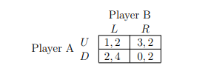

Ch 6, Q5.

As done for question 3, we begin by analyzing all possible combination of strategies.

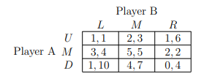

* If Player B chose L, Player A would choose M as their best response. If Player B chose M, Player A would choose M as their best response. If Player B chose R, Player A would choose M as their best response.
* If Player A chose U, Player B would choose R as their best response. If player A chose M, Player B would choose M as their best response. If player A chose D, Player B would choose L as their best response.

Here we find that (5,5) is the pure strategy Nash Equilibria. Player A has a dominant strategy of choosing M in response to anything that Player B chooses. As a result, the best response for B is to pick M as well.

Ch 6, Q7.

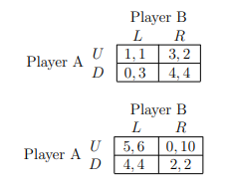

Game 1

Game 2

Game 1:

* If Player B chose L, Player A would choose U. If Player B chose R, Player A would choose D.
* If Player A chose U, Player B would choose R. If Player A chose D, Player B would choose R.

Here Player B has a dominant strategy to choose R. The best response for Player A is to choose D. Thus, the Nash Equilibria is (4,4).

Game 2:

* If Player B chose L, Player A would choose U. If Player B chose R, Player A would choose D.
* If Player A chose U, Player B would choose R. If Player A chose D, Player B would choose L.

In game 2, we do not have a pure strategy Nash Equilibrium. There is no point where one player will not gain a benefit from changing their strategy. This means we must find the mixed strategy equilibrium using the mixed strategy algorithm.

p(6) + (1-p)(4) = p(10) + (1-p)(2)

p = 1/3

q(5) + (1-q)(0) = q(4) + (1-q)(2)

q = 2/3

<p = 1/3, q = 2/3>

This means that the mixed strategy Nash Equilibrium in this game is for Player A to play U with a probability of 1/3 and down with a probability of 2/3 and for Player 2 to play L with a probability of 2/3 and R with a probability of 1/3.

Ch 6, Q11.

An action is strictly dominated if and only if it is never a best response.

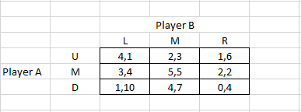

By examining all possible strategies that could be used by both players, we find that there is no row or column which is never a best response to a player’s choice. Here the Nash Equilibrium is at (5,5) and the payoff matrix does not have any strictly dominated strategies.

3.