Flyweight ID

Student:

Izabela Kuźniar

Teacher:

Andrea Corradini

Course:

Software Design Patterns

# Name and category

Flyweight is a structural pattern.

# Intent:

Not really used in the application layer, unless there is a need to manage the resources.

# Motivation:

Flyweight lets us fit more objects into the available amount of RAM by sharing common parts of state between multiple objects instead of keeping all of data in each object.

# Structure as a UML class diagram

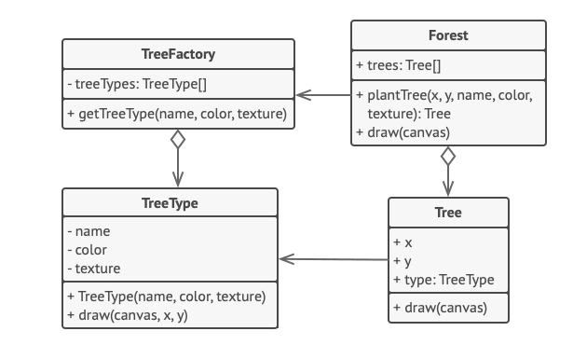

# Implementation:

Objects needs to contain duplicated data across many of them but also contain a unique data.

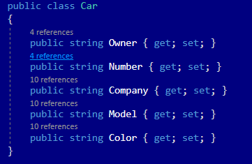

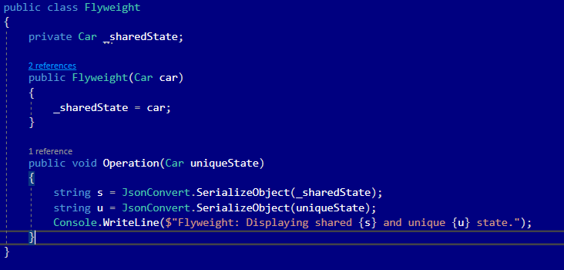

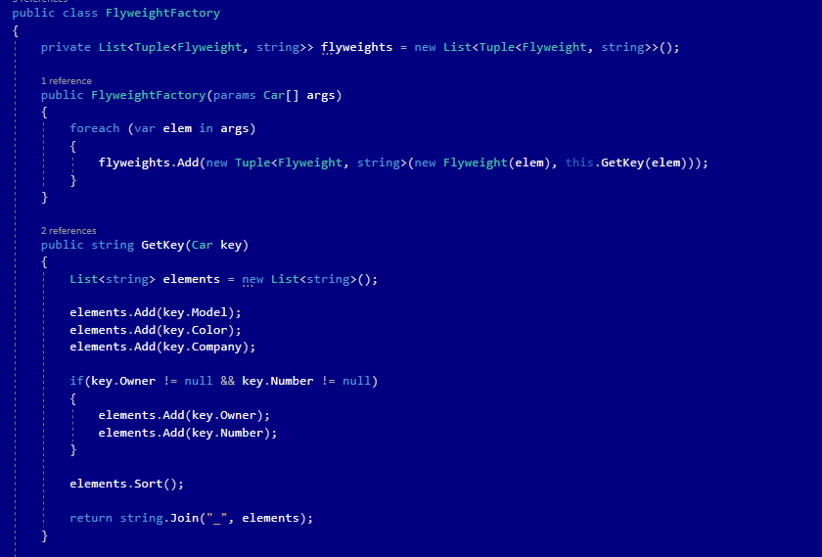

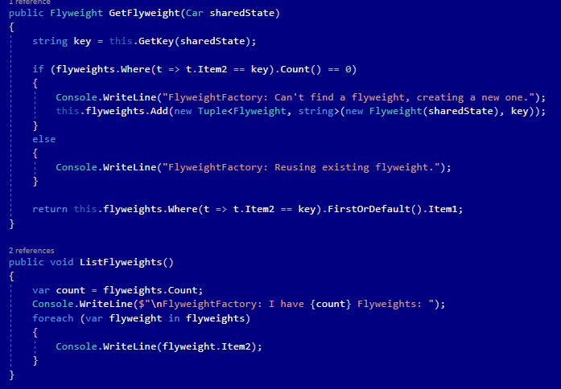

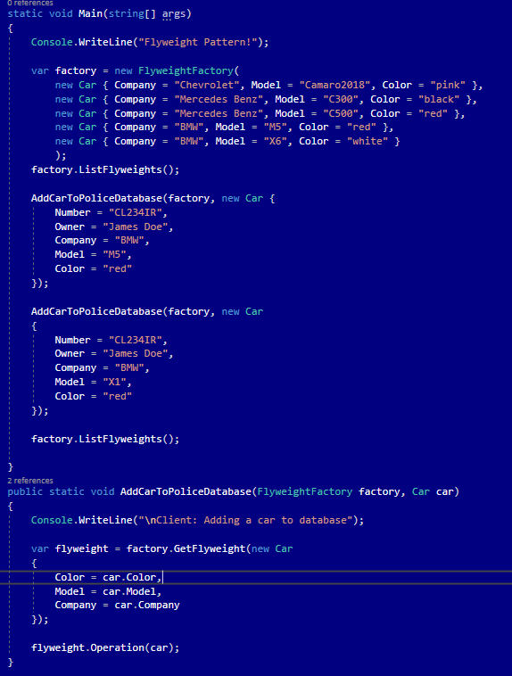

# Consequences:

Benefits:

* Ability to save a lot of RAM, assuming that program has loads of similar objects.

Drawbacks:

* Trading RAM over CPU cycles when some of the context data needs to be recalculated each time somebody calls this method.
* Code becomes super complicated.

# Known uses

* Integer is a wrapper and it could be used as flyweight

# Related patterns

1. Shared leaf nodes of Composite tree can be implemented as Flyweight to save some RAM.
2. Façade shows how to make a single object that represents an entire subsystem, whereas Flyweight shows how to make lots of little objects.
3. Flyweight would resemble Singleton if managed to reduce all shared states of the objects to just one flyweight object.