|  |  |
| --- | --- |
| Student ID | IT23258426 |
| Batch | WD_02.01 |
| **Marking Guide** | |
| App Logo and Launch Screen (1 mark) |  |
| User Onboarding Screens (2 marks) |  |
| Main Interface Design (3 marks) |  |
| Prototype Interaction (2 marks) |  |
| Design Aesthetics and Usability (2 marks) |  |
| **Total Marks(10 marks)** |  |
| Evaluator |  |

**Description:**

My Class is a user-friendly nursery management mobile app designed to streamline administrative tasks, enhance teacher-student interactions, and make learning more engaging. Whether you’re an Admin, Teacher, or Student, this app provides essential tools to manage daily activities efficiently.

Key Features:

For Admins:

* Add and manage teachers & students
* View student reports
* Oversee nursery operations

For Teachers:

* Add students and mark attendance
* Create student reports & learning activities
* Update personal profiles

For Students:

* View progress reports
* Participate in fun learning activities

With an intuitive design, real-time updates, and a seamless experience, My Class makes nursery management effortless and learning exciting!

**Screenshots:**

**App Logo**



**Launch Screen**

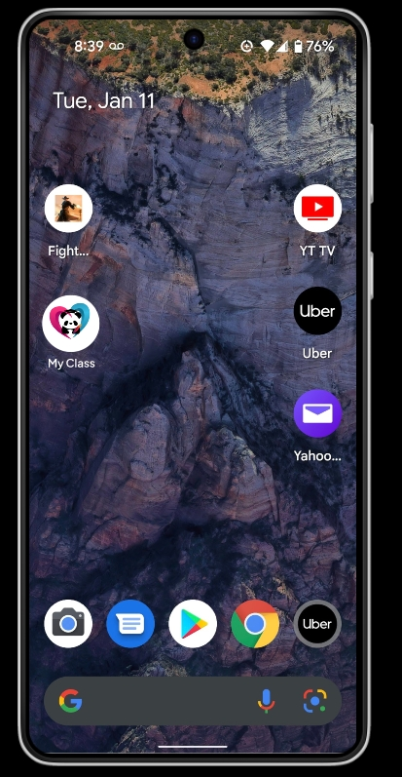

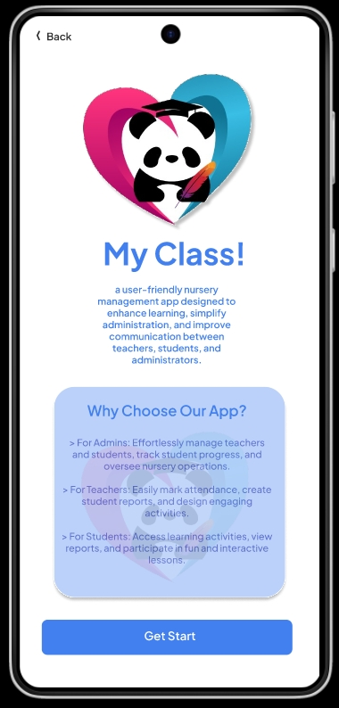

**Onboarding Screen**

