

BUPT Compilers Project1 2025Fall

Name:
1 概述
我将为简易编程语言BPL实现一个编译器。BPL风格类似C语言，但剔除了宏、指针等复杂特性。该编译器具备为BPL代码生成抽象语法树（AST）的能力，并能处理词法与语法错误，同时支持单行和多行注释的识别。
2 AST
2.1 AST构建
用于表示抽象语法树（AST）的数据结构：
typedef struct Head {
char *type;
size_t line_no;
char *property;
struct Head *child, *sibling;
} *Node, *Tree;
用于生成抽象语法树（AST）的函数：
Node new_node(const char *type, size_t line_no, const char *property, Node child, Node sibling);
void print_tree(FILE *restrict stream, Tree tree, size_t indent);
void empty_tree(Tree tree);
create_node函数用于创建新节点，其中type表示节点类型，line_no记录节点在源代码中的行号，property存储节点属性，child指向其首个子节点，sibling指向下一个兄弟节点；print_tree函数通过深度优先遍历将抽象语法树输出至指定流，参数stream定义输出流目标，tree指定待打印的语法树，indent控制缩进空格数；delete_tree函数采用递归方式释放为抽象语法树分配的内存，参数tree为待释放的语法树。
2.2 代码
tree.h文件的实现代码如下：
#ifndef TREE_H_
#define TREE_H_

#ifdef __cplusplus
extern "C" {
#endif

#include <stddef.h>
#include <stdio.h>

typedef struct Head {
char *type;
size_t line_no;
char *property;
struct Head *child, *sibling;
} *Node, *Tree;

Node new_node(const char *type, size_t line_no, const char *property, Node child, Node sibling);
void print_tree(FILE *restrict stream, Tree tree, size_t indent);
void empty_tree(Tree tree);

#ifdef __cplusplus
}
#endif

#endif
tree.c文件的实现代码如下：
#include "tree.h"
#include <stdlib.h>
#include <string.h>
#define INDENT " "

Node new_node(const char *type, size_t line_no, const char *property, Node child, Node sibling) {
Node retval = calloc(1, sizeof(struct Head));
retval->line_no = line_no;
if (type) {
retval->type = strdup(type);
}
if (property) {
retval->property = strdup(property);
}
if (child) {
retval->child = child;
}
if (sibling) {
retval->sibling = sibling;
}
return retval;
}

void print_tree(FILE *restrict stream, Tree tree, size_t indent) {
if (!tree) {
return;
}
if (!tree->type) {
print_tree(stream, tree->sibling, indent);
return;
}
for (int i = 0; i < indent; i++) {
fprintf(stream, INDENT);
}
printf("%s", tree->type);
if (tree->child) {
fprintf(stream, " (%lu)", tree->line_no);
}
else if (tree->property) {
fprintf(stream, ": %s", tree->property);
}
putc('\n', stream);
print_tree(stream, tree->child, indent + 1);
print_tree(stream, tree->sibling, indent);
}

void empty_tree(Tree tree) {
if (!tree) {
return;
}
empty_tree(tree->child);
empty_tree(tree->sibling);
if (tree->type) {
free(tree->type);
}
if (tree->property) {
free(tree->property);
}
if (tree->child) {
free(tree->child);
}
if (tree->sibling) {
free(tree->sibling);
}
}

#ifdef TREE_C_
#include <mcheck.h>
int main(int argc, char **argv, char **env) {
mtrace();
Tree tree = new_node(
"Program", 1, NULL,
new_node(
"ExtDefList", 1, NULL,
new_node(
"ExtDef", 1, NULL,
new_node(
"Specifier", 1, NULL,
new_node(
"TYPE", 1, "int", NULL, NULL),
new_node(
"FunDec", 1, NULL,
new_node(
"ID", 1, "test_1_r01", NULL,
new_node(
"LP", 1, NULL, NULL,
new_node(
"RP", 1, NULL, NULL,
new_node(
"SEMI", 1, NULL, NULL, NULL
)
))),
NULL)),
NULL),
NULL),
NULL);
print_tree(stdout, tree, 0);
empty_tree(tree);
free(tree);
muntrace();
return 0;
}
#endif
3 词法分析
我使用flex为BPL生成了一个词法分析器。该分析器能够识别词素并为语法分析器生成对应的词法单元。这些词法单元将作为节点传递给语法分析器。
lex.l文件的实现代码如下：
%{
#include <stdlib.h>
#include "syntax.tab.h"
#include "tree.h"
#include "error.h"
#define BUFLEN (4096)
size_t line = 1;
char buffer[BUFLEN];
char *parse_int(char *raw);
#define CONCAT(STR1, STR2) strncat(strncpy(buffer, STR1, BUFLEN - 1), STR2, BUFLEN - 1 - strlen(buffer))
%}
%option noyywrap
literal_int [0-9]+|0x[0-9a-fA-F]+
literal_float [0-9]+"."[0-9]+
identifier [a-zA-Z_][a-zA-Z0-9_]*
literal_char \'.\'|\'\\x[0-9a-fA-F]{2}\'
%%

"//".*$ { /* ignore comments */ }
"/*"([^*]|[*][^/]|[*][*]+[^*/])*"*/" { for (size_t i = 0; i < strlen(yytext); i++) if (yytext[i] == '\n') line++; }
[ \t\r]+ { /* ignore whitespace */ }
"\n" { line++; }
"int" { yylval.node = new_node("TYPE", line, yytext, NULL, NULL); return TYPE; }
"float" { yylval.node = new_node("TYPE", line, yytext, NULL, NULL); return TYPE; }
"char" { yylval.node = new_node("TYPE", line, yytext, NULL, NULL); return TYPE; }
"struct" { yylval.node = new_node("STRUCT", line, NULL, NULL, NULL); return STRUCT; }
"if" { yylval.node = new_node("IF", line, NULL, NULL, NULL); return IF; }
"else" { yylval.node = new_node("ELSE", line, NULL, NULL, NULL); return ELSE; }
"while" { yylval.node = new_node("WHILE", line, NULL, NULL, NULL); return WHILE; }
"return" { yylval.node = new_node("RETURN", line, NULL, NULL, NULL); return RETURN; }
"." { yylval.node = new_node("DOT", line, NULL, NULL, NULL); return DOT; }
";" { yylval.node = new_node("SEMI", line, NULL, NULL, NULL); return SEMI; }
"," { yylval.node = new_node("COMMA", line, NULL, NULL, NULL); return COMMA; }
"=" { yylval.node = new_node("ASSIGN", line, NULL, NULL, NULL); return ASSIGN; }
"<" { yylval.node = new_node("LT", line, NULL, NULL, NULL); return LT; }
">" { yylval.node = new_node("GT", line, NULL, NULL, NULL); return GT; }
"<=" { yylval.node = new_node("LE", line, NULL, NULL, NULL); return LE; }
">=" { yylval.node = new_node("GE", line, NULL, NULL, NULL); return GE; }
"!=" { yylval.node = new_node("NE", line, NULL, NULL, NULL); return NE; }
"==" { yylval.node = new_node("EQ", line, NULL, NULL, NULL); return EQ; }
"+" { yylval.node = new_node("PLUS", line, NULL, NULL, NULL); return PLUS; }
"-" { yylval.node = new_node("MINUS", line, NULL, NULL, NULL); return MINUS; }
"*" { yylval.node = new_node("MUL", line, NULL, NULL, NULL); return MUL; }
"/" { yylval.node = new_node("DIV", line, NULL, NULL, NULL); return DIV; }
"&&" { yylval.node = new_node("AND", line, NULL, NULL, NULL); return AND; }
"||" { yylval.node = new_node("OR", line, NULL, NULL, NULL); return OR; }
"!" { yylval.node = new_node("NOT", line, NULL, NULL, NULL); return NOT; }
"(" { yylval.node = new_node("LP", line, NULL, NULL, NULL); return LP; }
")" { yylval.node = new_node("RP", line, NULL, NULL, NULL); return RP; }
"[" { yylval.node = new_node("LB", line, NULL, NULL, NULL); return LB; }
"]" { yylval.node = new_node("RB", line, NULL, NULL, NULL); return RB; }
"{" { yylval.node = new_node("LC", line, NULL, NULL, NULL); return LC; }
"}" { yylval.node = new_node("RC", line, NULL, NULL, NULL); return RC; }
{identifier} { yylval.node = new_node("ID", line, yytext, NULL, NULL); return ID; }
{literal_char} { yylval.node = new_node("CHAR", line, yytext, NULL, NULL); return CHAR; }
{literal_int} { yylval.node = new_node("INT", line, parse_int(yytext), NULL, NULL); return INT;}
{literal_float} { yylval.node = new_node("FLOAT", line, yytext, NULL, NULL); return FLOAT; }
'\\x.*' { yylval.node = new_node("ILLEGAL", line, CONCAT("illegal char ", yytext), NULL, NULL); return ILLEGAL; }
0x([0-9a-fA-F]|[g-zG-Z])+ { yylval.node = new_node("ILLEGAL", line, CONCAT("illegal hex ", yytext), NULL, NULL); return ILLEGAL; }
[0-9]{identifier} { yylval.node = new_node("ILLEGAL", line, CONCAT("illegal identifier ", yytext), NULL, NULL); return ILLEGAL; }
. { yylval.node = new_node("ILLEGAL", line, CONCAT("illegal symbol ", yytext), NULL, NULL); return ILLEGAL; }
%%

char *parse_int(char *raw) {
if (raw[1] == 'x') {
int val = 0;
char *ptr;
for (ptr = raw + 2; *ptr; ptr++) {
val *= 16;
if (*ptr <= '9') {
val += *ptr - '0';
}
else if (*ptr <= 'Z') {
val += *ptr - 'A' + 10;
}
else {
val += *ptr - 'a' + 10;
}
}
buffer[BUFLEN - 1] = 0;
for (ptr = buffer + BUFLEN - 2; val; ptr--) {
*ptr = val % 10 + '0';
val /= 10;
}
return ++ptr;
}
else {
return raw;
}
}

4 语法分析
我使用bison为BPL生成了一个语法分析器。该分析器能够根据给定规则为BPL程序生成抽象语法树，并具备从语法错误中恢复的能力。
syntax.y文件的实现代码如下：
%{
#include <stdio.h>
#include <string.h>
#include "lex.yy.c"
#include "tree.h"
#include "errlist.h"
int exit_code = 0;
Tree result = NULL;
void yyerror(const char *s);
void log_err(char type, size_t line_no, const char *msg);
%}
%union {
struct Head *node;
}
%token <node> ID INT FLOAT CHAR STRUCT RETURN IF ELSE WHILE PLUS MINUS MUL DIV
AND OR LT LE GT GE NE EQ NOT ASSIGN TYPE LP RP LB RB LC RC SEMI COMMA DOT
ILLEGAL
%type <node> Program ExtDefList ExtDef ExtDecList Specifier StructSpecifier
VarDec FunDec VarList ParamDec CompSt StmtList Stmt DefList Def DecList Dec
Exp Args
%right ELSE
%left ASSIGN
%left AND OR
%left LT LE GT GE NE EQ
%left PLUS MINUS
%left MUL DIV
%right NOT
%left LP RP LB RB DOT
%%

/* high-level definition */
Program: ExtDefList {
$$ = new_node("Program", $1->line_no, NULL, $1, NULL);
result = $$;
}
ExtDefList: ExtDef ExtDefList {
$1->sibling = $2;
$$ = new_node("ExtDefList", $1->line_no, NULL, $1, NULL);
}
| /*empty*/ {
$$ = new_node(NULL, 0, NULL, NULL, NULL);
}
ExtDef: Specifier ExtDecList SEMI {
$1->sibling = $2;
$2->sibling = $3;
$$ = new_node("ExtDef", $1->line_no, NULL, $1, NULL);
}
| Specifier SEMI {
$1->sibling = $2;
$$ = new_node("ExtDef", $1->line_no, NULL, $1, NULL);
}
| Specifier FunDec CompSt {
$1->sibling = $2;
$2->sibling = $3;
$$ = new_node("ExtDef", $1->line_no, NULL, $1, NULL);
}
| Specifier ExtDecList error {
log_err(MISSING_SEMI, $2->line_no, "missing semicolon ';'");
}
| Specifier error {
log_err(MISSING_SEMI, $1->line_no, "missing semicolon ';'");
}
ExtDecList: VarDec COMMA ExtDecList {
$1->sibling = $2;
$2->sibling = $3;
$$ = new_node("ExtDecList", $1->line_no, NULL, $1, NULL);
}
| VarDec {
$$ = new_node("ExtDecList", $1->line_no, NULL, $1, NULL);
}

/* specifier */
Specifier: TYPE {
$$ = new_node("Specifier", $1->line_no, NULL, $1, NULL);
}
| StructSpecifier {
$$ = new_node("Specifier", $1->line_no, NULL, $1, NULL);
}
StructSpecifier: STRUCT ID LC DefList RC {
$1->sibling = $2;
$2->sibling = $3;
$3->sibling = $4;
$4->sibling = $5;
$$ = new_node("StructSpecifier", $1->line_no, NULL, $1, NULL);
}
| STRUCT ID {
$1->sibling = $2;
$$ = new_node("StructSpecifier", $1->line_no, NULL, $1, NULL);
}

/* declarator */
VarDec: ID {
$$ = new_node("VarDec", $1->line_no, NULL, $1, NULL);
}
| VarDec LB INT RB {
$1->sibling = $2;
$2->sibling = $3;
$3->sibling = $4;
$$ = new_node("VarDec", $1->line_no, NULL, $1, NULL);
}
FunDec: ID LP VarList RP {
$1->sibling = $2;
$2->sibling = $3;
$3->sibling = $4;
$$ = new_node("FunDec", $1->line_no, NULL, $1, NULL);
}
| ID LP RP {
$1->sibling = $2;
$2->sibling = $3;
$$ = new_node("FunDec", $1->line_no, NULL, $1, NULL);
}
| ID LP VarList error {
log_err(MISSING_CLOSING, $3->line_no, "missing closing symbol ')'");
}
| ID LP error {
log_err(MISSING_CLOSING, $2->line_no, "missing closing symbol ')'");
}
VarList: ParamDec COMMA VarList {
$1->sibling = $2;
$2->sibling = $3;
$$ = new_node("VarList", $1->line_no, NULL, $1, NULL);
}
| ParamDec {
$$ = new_node("VarList", $1->line_no, NULL, $1, NULL);
}
ParamDec: Specifier VarDec {
$1->sibling = $2;
$$ = new_node("ParamDec", $1->line_no, NULL, $1, NULL);
}

/* statement */
CompSt: LC DefList StmtList RC {
$1->sibling = $2;
$2->sibling = $3;
$3->sibling = $4;
$$ = new_node("CompSt", $1->line_no, NULL, $1, NULL);
}
StmtList: Stmt StmtList {
$1->sibling = $2;
$$ = new_node("StmtList", $1->line_no, NULL, $1, NULL);
}
| /*empty*/ {
$$ = new_node(NULL, 0, NULL, NULL, NULL);
}
| Stmt Def DefList StmtList error {
log_err(DEF_AFTER_STMT, $2->line_no, "def after stmt");
}
Stmt: Exp SEMI {
$1->sibling = $2;
$$ = new_node("Stmt", $1->line_no, NULL, $1, NULL);
}
| CompSt {
$$ = new_node("Stmt", $1->line_no, NULL, $1, NULL);
}
| RETURN Exp SEMI {
$1->sibling = $2;
$2->sibling = $3;
$$ = new_node("Stmt", $1->line_no, NULL, $1, NULL);
}
| RETURN Exp error {
log_err(MISSING_SEMI, $2->line_no, "missing semicolon ';'");
}
| IF LP Exp RP Stmt %prec ELSE {
$1->sibling = $2;
$2->sibling = $3;
$3->sibling = $4;
$4->sibling = $5;
$$ = new_node("Stmt", $1->line_no, NULL, $1, NULL);
}
| IF LP Exp RP Stmt ELSE Stmt {
$1->sibling = $2;
$2->sibling = $3;
$3->sibling = $4;
$4->sibling = $5;
$5->sibling = $6;
$6->sibling = $7;
$$ = new_node("Stmt", $1->line_no, NULL, $1, NULL);
}
| WHILE LP Exp RP Stmt {
$1->sibling = $2;
$2->sibling = $3;
$3->sibling = $4;
$4->sibling = $5;
$$ = new_node("Stmt", $1->line_no, NULL, $1, NULL);
}
| Exp error {
log_err(MISSING_SEMI, $1->line_no, "missing semicolon ';'");
}

/* local definition */
DefList: Def DefList {
$1->sibling = $2;
$$ = new_node("DefList", $1->line_no, NULL, $1, NULL);
}
| /*empty*/ {
$$ = new_node(NULL, 0, NULL, NULL, NULL);
}
Def: Specifier DecList SEMI {
$1->sibling = $2;
$2->sibling = $3;
$$ = new_node("Def", $1->line_no, NULL, $1, NULL);
}
| Specifier DecList error {
log_err(MISSING_SEMI, $2->line_no, "missing semicolon ';'");
}
DecList: Dec {
$$ = new_node("DecList", $1->line_no, NULL, $1, NULL);
}
| Dec COMMA DecList {
$1->sibling = $2;
$2->sibling = $3;
$$ = new_node("DecList", $1->line_no, NULL, $1, NULL);
}
| ILLEGAL error {
log_err(LEXEME_ERROR, $1->line_no, $1->property);
}
Dec: VarDec {
$$ = new_node("Dec", $1->line_no, NULL, $1, NULL);
}
| VarDec ASSIGN Exp {
$1->sibling = $2;
$2->sibling = $3;
$$ = new_node("Dec", $1->line_no, NULL, $1, NULL);
}

/* Expression */
Exp: Exp ASSIGN Exp {
$1->sibling = $2;
$2->sibling = $3;
$$ = new_node("Exp", $1->line_no, NULL, $1, NULL);
}
| Exp AND Exp {
$1->sibling = $2;
$2->sibling = $3;
$$ = new_node("Exp", $1->line_no, NULL, $1, NULL);
}
| Exp OR Exp {
$1->sibling = $2;
$2->sibling = $3;
$$ = new_node("Exp", $1->line_no, NULL, $1, NULL);
}
| Exp LT Exp {
$1->sibling = $2;
$2->sibling = $3;
$$ = new_node("Exp", $1->line_no, NULL, $1, NULL);
}
| Exp LE Exp {
$1->sibling = $2;
$2->sibling = $3;
$$ = new_node("Exp", $1->line_no, NULL, $1, NULL);
}
| Exp GT Exp {
$1->sibling = $2;
$2->sibling = $3;
$$ = new_node("Exp", $1->line_no, NULL, $1, NULL);
}
| Exp GE Exp {
$1->sibling = $2;
$2->sibling = $3;
$$ = new_node("Exp", $1->line_no, NULL, $1, NULL);
}
| Exp NE Exp {
$1->sibling = $2;
$2->sibling = $3;
$$ = new_node("Exp", $1->line_no, NULL, $1, NULL);
}
| Exp EQ Exp {
$1->sibling = $2;
$2->sibling = $3;
$$ = new_node("Exp", $1->line_no, NULL, $1, NULL);
}
| Exp PLUS Exp {
$1->sibling = $2;
$2->sibling = $3;
$$ = new_node("Exp", $1->line_no, NULL, $1, NULL);
}
| Exp MINUS Exp {
$1->sibling = $2;
$2->sibling = $3;
$$ = new_node("Exp", $1->line_no, NULL, $1, NULL);
}
| Exp MUL Exp {
$1->sibling = $2;
$2->sibling = $3;
$$ = new_node("Exp", $1->line_no, NULL, $1, NULL);
}
| Exp DIV Exp {
$1->sibling = $2;
$2->sibling = $3;
$$ = new_node("Exp", $1->line_no, NULL, $1, NULL);
}
| LP Exp RP {
$1->sibling = $2;
$2->sibling = $3;
$$ = new_node("Exp", $1->line_no, NULL, $1, NULL);
}
| MINUS Exp {
$1->sibling = $2;
$$ = new_node("Exp", $1->line_no, NULL, $1, NULL);
}
| NOT Exp {
$1->sibling = $2;
$$ = new_node("Exp", $1->line_no, NULL, $1, NULL);
}
| ID LP Args RP {
$1->sibling = $2;
$2->sibling = $3;
$3->sibling = $4;
$$ = new_node("Exp", $1->line_no, NULL, $1, NULL);
}
| ID LP RP {
$1->sibling = $2;
$2->sibling = $3;
$$ = new_node("Exp", $1->line_no, NULL, $1, NULL);
}
| ID LP Args error {
log_err(MISSING_CLOSING, $3->line_no, "missing closing symbol ')'");
}
| ID LP error {
log_err(MISSING_CLOSING, $2->line_no, "missing closing symbol ')'");
}
| Exp LB Exp RB {
$1->sibling = $2;
$2->sibling = $3;
$3->sibling = $4;
$$ = new_node("Exp", $1->line_no, NULL, $1, NULL);
}
| Exp DOT ID {
$1->sibling = $2;
$2->sibling = $3;
$$ = new_node("Exp", $1->line_no, NULL, $1, NULL);
}
| ID {
$$ = new_node("Exp", $1->line_no, NULL, $1, NULL);
}
| INT {
$$ = new_node("Exp", $1->line_no, NULL, $1, NULL);
}
| FLOAT {
$$ = new_node("Exp", $1->line_no, NULL, $1, NULL);
}
| CHAR {
$$ = new_node("Exp", $1->line_no, NULL, $1, NULL);
}
| ID ILLEGAL Exp error {
const char *prefix = "illegal symbol ";
const char *sym = $2->property ? $2->property : "";
if (!strncmp(sym, prefix, strlen(prefix))) {
sym += strlen(prefix);
}
char buf[64];
snprintf(buf, sizeof(buf), "illegal operator '%s'", sym);
log_err(ILLEGAL_OP, $2->line_no, buf);
}
| ILLEGAL error {
log_err(LEXEME_ERROR, $1->line_no, $1->property);
}
Args: Exp COMMA Args {
$1->sibling = $2;
$2->sibling = $3;
$$ = new_node("Args", $1->line_no, NULL, $1, NULL);
}
| Exp {
$$ = new_node("Args", $1->line_no, NULL, $1, NULL);
}
%%

void yyerror(const char *s) { /* fprintf(stderr, "%s\n", s); */ }

void log_err(char type, size_t line_no, const char *msg) {
fprintf(stdout, "Error type %c at Line %lu: %s\n", type, line_no, msg);
exit_code = 1;
}

int main(int argc, char **argv) {
if (argc != 2) {
exit(1);
}
FILE *fin = fopen(argv[1], "rb"), *fout = stdout;
if (!fin) {
exit(1);
}
size_t len = strlen(argv[1]);
if (!strcmp(argv[1] + len - 4, ".bpl")) {
strcpy(argv[1] + len - 3, "out");
fout = freopen(argv[1], "wb", stdout);
}
if (!fout) {
exit(1);
}
yyin = fin;
yyparse();
if (!exit_code) {
print_tree(stdout, result, 0);
}
empty_tree(result);
if (result) {
free(result);
result = NULL;
}
return exit_code;
}
5 错误处理
定义了两个常量LEXEME_ERROR与SYNTAX_ERROR，分别用字符'A'和'B'表示错误类别。LEXEME_ERROR标识词法分析阶段遇到的错误（如非法字符或非法十六进制数），SYNTAX_ERROR则标识语法分析阶段的错误（如缺失分号或右花括号）。
具体而言，ILLEGAL_CHARSET（非法字符集）、ILLEGAL_HEX（非法十六进制数）、ILLEGAL_CHAR（非法字符）、ILLEGAL_ID（非法标识符）及ILLEGAL_OP（非法运算符）均属于词法错误，其值统一为 LEXEME_ERROR；而MISSING_SEMI（缺失分号）、MISSING_CLOSING（缺失右括号/右花括号）和DEF_AFTER_STMT（语句后出现定义）属于语法错误，其值统一为SYNTAX_ERROR。
errlist.h文件的实现代码如下：
#ifndef ERRLIST_H_
#define ERRLIST_H_

#define LEXEME_ERROR 'A'
#define SYNTAX_ERROR 'B'

enum Error {
ILLEGAL_CHARSET = LEXEME_ERROR,
ILLEGAL_HEX = LEXEME_ERROR,
ILLEGAL_CHAR = LEXEME_ERROR,
ILLEGAL_ID = LEXEME_ERROR,
ILLEGAL_OP = LEXEME_ERROR,
MISSING_SEMI = SYNTAX_ERROR,
MISSING_CLOSING = SYNTAX_ERROR,
DEF_AFTER_STMT = SYNTAX_ERROR,
};

#endif
6 可选功能
除必需功能外，我还实现了以下可选功能：该语法分析器能够识别单行注释与多行注释。对于单行注释，分析器直接忽略其内容；对于多行注释，则会统计其中的换行符数量，并将该数值累加至行号计数器中。
"//".*$ { /* ignore comments */ }
"/*"([^*]|[*][^/]|[*][*]+[^*/])*"*/" { for (size_t i = 0; i < strlen(yytext); i++) if (yytext[i] == '\n') line++; }
7 运行
7.1 编译构建
所用命令如下：
make bplc
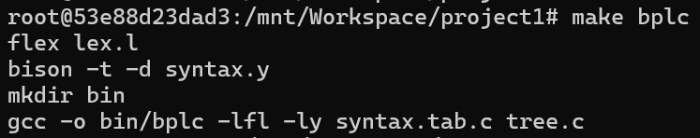
7.2 测试
7.2.1 逐用例测试
测试用例：test/test_1_r01.bpl
所用命令如下：
./bin/bplc ./test/test_1_r01.bpl
可以发现，测试文件夹内已生成输出文件"test_1_r01.out"。
其余测试用例可沿用相同方式生成输出文件。
所用命令如下：
./bin/bplc ./test/test_1_r02.bpl
./bin/bplc ./test/test_1_r03.bpl
./bin/bplc ./test/test_1_r04.bpl
./bin/bplc ./test/test_1_r05.bpl
./bin/bplc ./test/test_1_r06.bpl
./bin/bplc ./test/test_1_r07.bpl
./bin/bplc ./test/test_1_r08.bpl
./bin/bplc ./test/test_1_r09.bpl
./bin/bplc ./test/test_1_r10.bpl
./bin/bplc ./test/test_1_r11.bpl
./bin/bplc ./test/test_1_r12.bpl
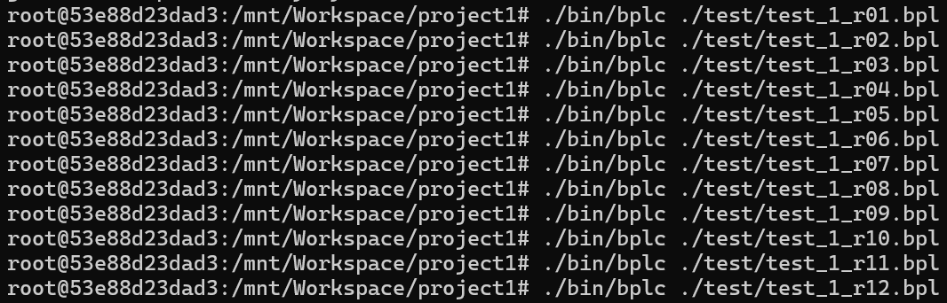
7.2.2 批量测试
我们也可以通过运行test.py一次性完成所有测试用例的验证。
test.py文件的实现代码如下：
import subprocess

for i in range(1,13):
if i<=9:
name = f"0{i}"
else:
name = f"{i}"
file = f"test/test_1_r{name}.bpl"
command = ["./bin/bplc", file]
print(file+" OK.")
subprocess.run(command)
使用命令如下：
python3 test.py
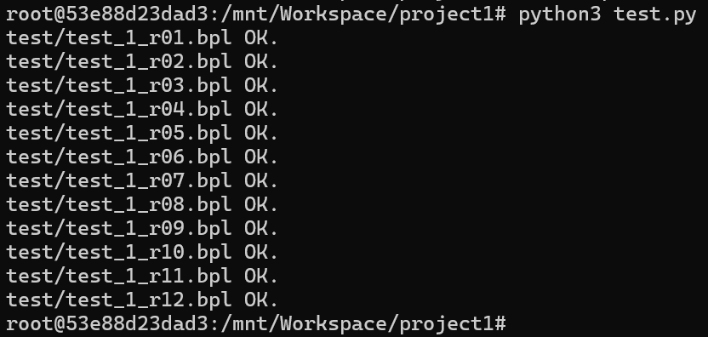
可以看到，测试文件夹内已生成全部输出文件。
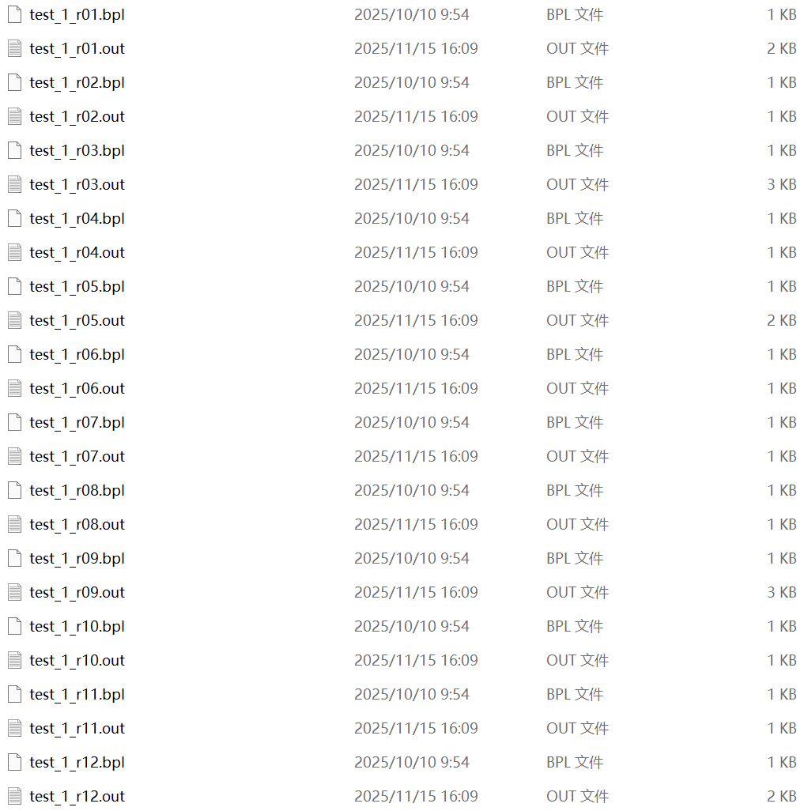
8 结果
8.1 语法有效的BPL程序
对于语法正确的BPL程序，本语法分析器能够输出其语法树结构。
以test_1_r03.bpl为例：
int global;
struct my_struct
{
int code;
char data;
};
int test_1_r03()
{
struct my_struct obj;
obj.code = global;
global = global + 1;
}
本语法分析器可输出其对应的语法树结构如下（test_1_r03.out）：
Program (1)
ExtDefList (1)
ExtDef (1)
Specifier (1)
TYPE: int
ExtDecList (1)
VarDec (1)
ID: global
SEMI
ExtDefList (2)
ExtDef (2)
Specifier (2)
StructSpecifier (2)
STRUCT
ID: my_struct
LC
DefList (4)
Def (4)
Specifier (4)
TYPE: int
DecList (4)
Dec (4)
VarDec (4)
ID: code
SEMI
DefList (5)
Def (5)
Specifier (5)
TYPE: char
DecList (5)
Dec (5)
VarDec (5)
ID: data
SEMI
RC
SEMI
ExtDefList (7)
ExtDef (7)
Specifier (7)
TYPE: int
FunDec (7)
ID: test_1_r03
LP
RP
CompSt (8)
LC
DefList (9)
Def (9)
Specifier (9)
StructSpecifier (9)
STRUCT
ID: my_struct
DecList (9)
Dec (9)
VarDec (9)
ID: obj
SEMI
StmtList (10)
Stmt (10)
Exp (10)
Exp (10)
Exp (10)
ID: obj
DOT
ID: code
ASSIGN
Exp (10)
ID: global
SEMI
StmtList (11)
Stmt (11)
Exp (11)
Exp (11)
ID: global
ASSIGN
Exp (11)
Exp (11)
ID: global
PLUS
Exp (11)
INT: 1
SEMI
RC
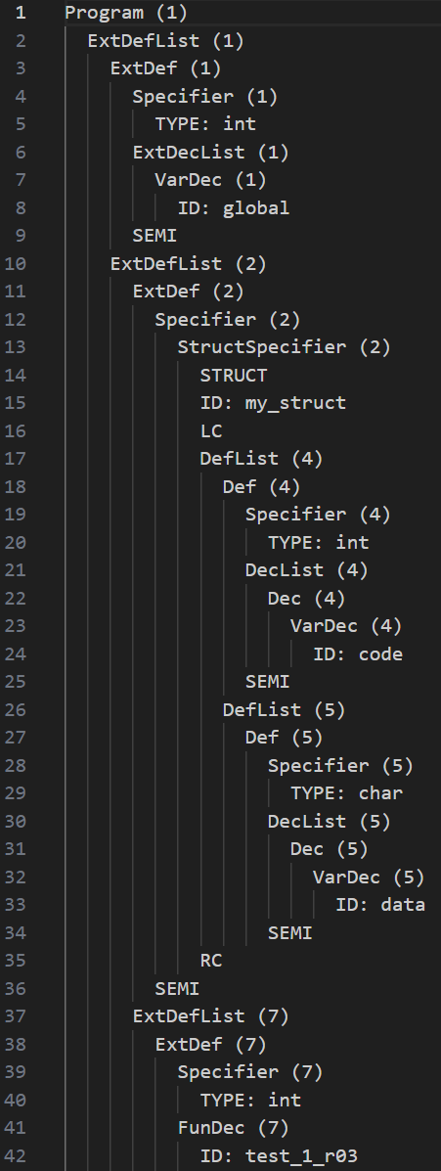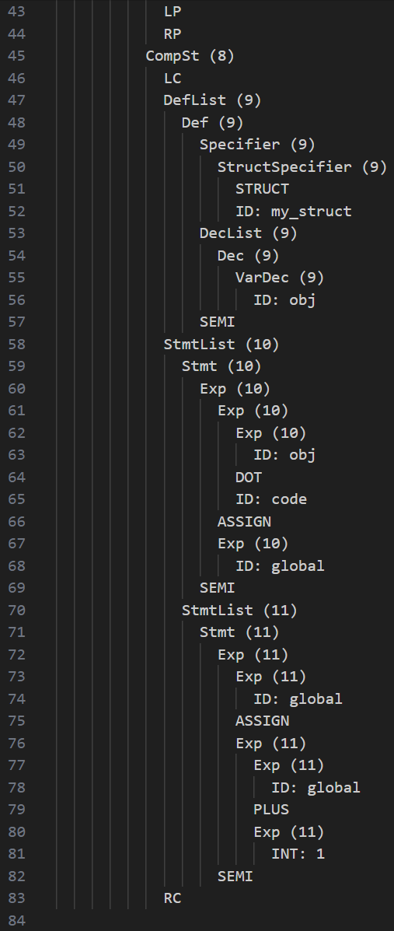
其他测试用例（如 test_1_r01/05/09/12）不再逐一展示。
8.2 语法无效的BPL程序
对于存在语法错误的BPL程序，本语法分析器能够报告所有检测到的错误。
以test_1_r02.bpl为例：
int test_1_r02()
{
int i = 0, j = 1;
float i = $;
if(i < 9.0){
return 1
}
return @;
}
语法分析器成功报告了全部错误：两处词法错误（A类错误）与一处语法错误（B类错误）。(test_1_r02.out)
Error type A at Line 4: illegal symbol $
Error type B at Line 6: missing semicolon ';'
Error type A at Line 8: illegal symbol @
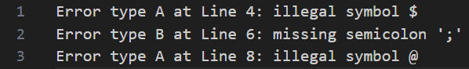
以test_1_r04.bpl为例：
int func_1(int a)
{
return 3 * a;
}
int func_2(int x, int y)
{
return x + y;
}
int test_1_r04(
{
int a, b, c;
c = func_2(func_1(func_1(a+b*func_1(b)), 1.7);
return c;
}
语法分析器检测到两处语法错误（B类错误）并输出报告。（test_1_r04.out）
Error type B at Line 9: missing closing symbol ')'
Error type B at Line 12: missing closing symbol ')'
以test_1_r07.bpl为例：
int test_1_r07()
{
int a, b, c;
a = 1;
b = a && 2;
c = b || 3;
a = c | 4;
b = a & 5;
}
语法分析器识别出两处词法错误（A类错误）并输出报告。（test_1_r07.out）
Error type A at Line 7: illegal operator '|'
Error type A at Line 8: illegal operator '&'
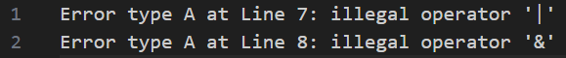
以test_1_r08.bpl为例：
int test_1_r08()
{
int a, bb
if (a > 4)
return bb;
}
语法分析器检测到一处语法错误（B类错误）并生成报错信息。（test_1_r08.out）
Error type B at Line 3: missing semicolon ';'
以test_1_r10.bpl为例：
int test_1_r10()
{
int a, b = 1;
a = 10;
int i = 0;
while (i < a)
{
b = b + i;
i = i + 1;
}
}
语法分析器检测到一处语法错误（B类错误）并已完成报错。（test_1_r10.out）
Error type B at Line 5: def after stmt
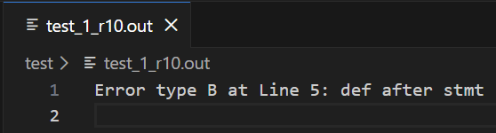
以test_1_r11.bpl为例：
int test_1_o01()
{
int _wrong_hex_int_1 = 0x77G;
int _wrong_hex_int_2 = 0xCS;
int _right_hex_int = 0xdeadbeef;
char _right_hex_char = '\xa0';
char _wrong_hex_char_1 = '\x6u';
char _wrong_hex_char_2 = '\x910';
}
语法分析器成功识别出四处词法错误（A类错误）并输出错误报告。（test_1_r11.out）
Error type A at Line 3: illegal hex 0x77G
Error type A at Line 4: illegal hex 0xCS
Error type A at Line 7: illegal char '\x6u'
Error type A at Line 8: illegal char '\x910'
