Assignment 1
1 Required Exercises
Exercise 1
When a C compiler compiles the following statement, how many tokens will it generate? [5points] int a3 = a * 3;
When compiling the given statement, 7 tokens will be generated. The 1st token is the keyword int, the 2nd token is the identifier a3, the 3rd token is the operator =, the 4th token is the identifier a, the 5th token is the operator *, the 6th token is the integer literal 3, and the 7th token is the delimiter.

Exercise 2
In a string of length 𝑛(𝑛 > 0), how many of the following are there?
在长度为 𝑛 (𝑛 > 0) 的字符串中，以下每项有多少？
1.Prefixes [5 points] 前缀[5分]
2.Proper prefixes [5 points] 真前缀[5分]
3.Prefixes of length 𝑚(0 < 𝑚 ≤ 𝑛) [5 points] 长度为𝑚的前缀(0 < 𝑚 ≤ 𝑛) [5分]
4.Suffixes of length 𝑚(0 < 𝑚 ≤ 𝑛) [5 points] 长度为𝑚的后缀(0 < 𝑚 ≤ 𝑛) [5分]
5.Proper prefixes of length 𝑚(0 < 𝑚 ≤ 𝑛) [10 points] 长度为𝑚的真前缀(0 < 𝑚 ≤ 𝑛) [10分]
6.Substrings [10 points] 子串[10分]
7.Subsequences [10 points] 子序列[10分]
In a string of length n, there are:
1. $n+1$prefixes
2. $n-1$ proper prefixes
3. 1 prefix of length m
4. 1 suffix of length m
5. 1 (if $m≠n$) or 0 (if $m=n$) proper prefix of length m
6.$\frac{n(n+1)}{2}+1$ substrings
7. $2^{n}$ subsequences

Exercise 3
Describe the languages denoted by the following regular expressions:
1. ((𝜖|𝑎)∗𝑏∗)∗ [5 points]
2. (𝑎|𝑏)∗𝑎(𝑎|𝑏)(𝑎|𝑏) [5 points]
3. a∗𝑏𝑎∗𝑏𝑎∗𝑏𝑎∗ [5 points]
1. The language of all strings over the alphabet {a, b}.
2. The language of all strings over the alphabet {a, b} that end with {aaa, aab, aba, abb}.
3. The language of all strings over the alphabet {a, b} where character b appears exactly 3 times.

Exercise 4
Write regular definitions or regular expressions for the following languages.
1. All strings representing valid telephone numbers in Shenzhen. A valid telephone number contains the country code (86), a hyphen, the area code 010, another hyphen, and eight digits where the first one cannot be zero (e.g., 86-010-62282045). [10 points]
2. All strings of a's and b's that start with a and end with b. [10 points]
3. All strings of lowercase letters that contain the five vowels in order. [10 points]
为以下语言编写正规定义或正则表达式。
1.表示深圳有效电话号码的所有字符串。有效的电话号码包含国家代码（86）、一个连字符、区号010、另一个连字符，以及八位数字且第一位数字不能为零（例如：86-010-62282045）。[10分]
2.所有以a开头并以b结尾的a和b的字符串。[10分]
3.所有包含按顺序出现的五个元音字母的小写字母字符串。[10分]
1. $86-010-[1-9]{[0-9]}^{7}$
2. a(a|b)*b
3. Let consonant → (b|c|d|f|g|h|j|k|l|m|n|p|q|r|s|t|v|w|x|y|z)*, the regular expression is
consonant a consonant e consonant i consonant o consonant u consonant.

2 Optional Exercises
Exercise 1
Suppose we have a alphabet ∑ = 𝑎,𝑏,𝑐, write regular definitions to describe all strings over 𝛴 without repeated letters. [Hint: You may draw an NFA for the language and convert the NFA to regular definitions.]
假设我们有一个字母表 ∑ = {𝑎, 𝑏, 𝑐}，请写出正则表达式来描述 ∑ 上所有没有重复字母的字符串。[提示：你可以先画出该语言的 NFA，然后将 NFA 转换为正则表达式。]
The DFA for the language of all strings over Σ without repeated letters is shown in fig. 1
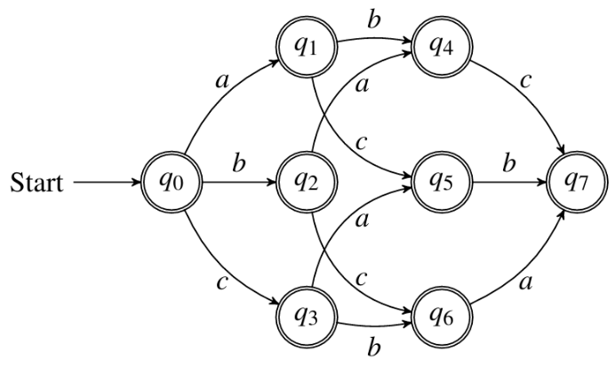
Figure 1: The DFA’s transition diagram
According to the transition diagram, the regular expression for the language of all strings over Σwithout repeated letters is
(ε|a)(ε|b)(ε|c)|
(ε|a)(ε|c)(ε|b)|
(ε|b)(ε|a)(ε|c)|
(ε|b)(ε|c)(ε|a)|
(ε|c)(ε|a)(ε|b)|
(ε|c)(ε|b)(ε|a).

Assignment 2
1 Required Exercises
Exercise 1:
Design NFAs and DFAs to recognize each of the following regular languages. Detailed steps can be omitted.
设计NFA和DFA来识别以下每个正则语言。可以省略详细步骤。
1.$L({(a|b)}^{*}b)$

(1) NFA
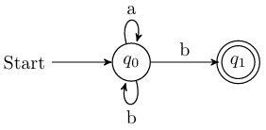
(2) DFA
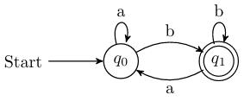

2.$L{(({(ϵ|a)}^{*}b)}^{*})$

(1) NFA
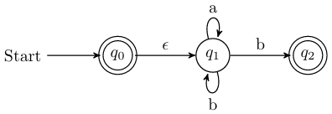
(2) DFA
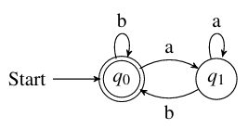

3.$L({\left(a | b\right)}^{*}a\left(a | b\right)\left(a | b\right))$
(1) NFA
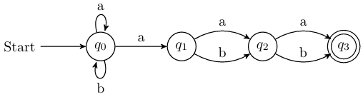
(2) DFA
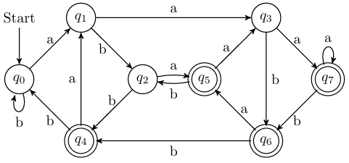

4.$L(a^{*}ba^{*}ba^{*}ba^{*})$
(1) NFA
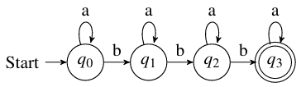
(2) DFA
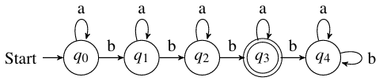

Exercise 2
Convert the following regular expressions to NFAs using the Thompson's Construction Algorithm (Algorithm 3.23 in the dragon book). Please put down the detailed steps.
请使用汤普森构造算法（龙书中的算法3.23）将以下正则表达式转换为NFA。请写出详细的步骤。
1.${({(ϵ|a)}^{*}b)}^{*}$
(1) Construct the NFA for $R_{1}=ε|a$
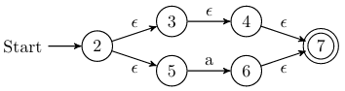
(2) Construct the NFA for $R_{2}={(ε|a)}^{*}=R_{1 }^{*}$
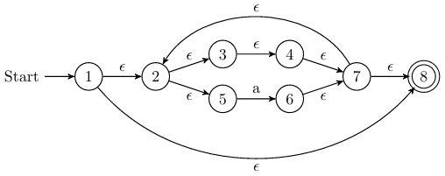
(3) Construct the NFA for $R_{3}={(ε|a)}^{*}b=R_{2}b$
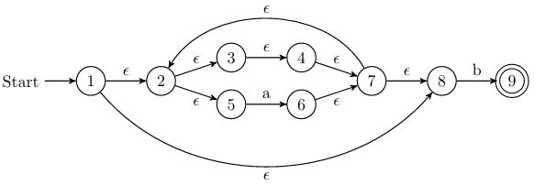
(4) Construct the NFA for ${{((ε|a)}^{*}b)}^{*}=R_{3}^{*}$
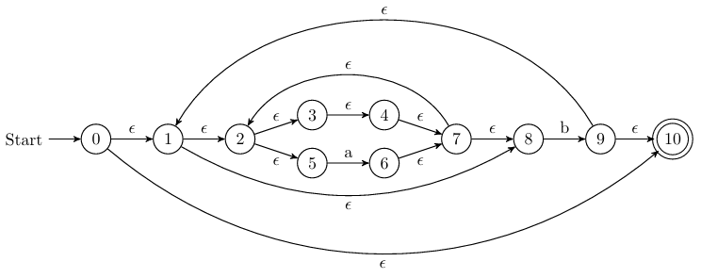

2${.(a|b)}^{*}a(a|b)(a|b)$
(1) Construct the NFA for $R_{1}=a|b.$
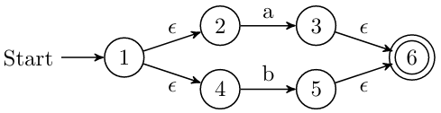
(2) Construct the NFA for $R_{2 }={(a|b)}^{*}=R_{1}^{*}.$
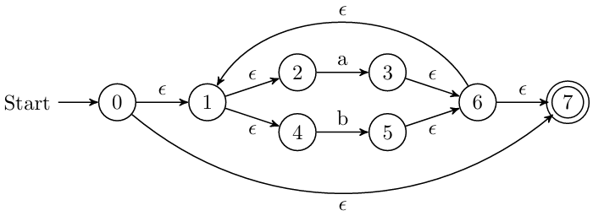
(3) Construct the NFA for $R_{3 }={(a|b)}^{*}a=R_{2}a.$
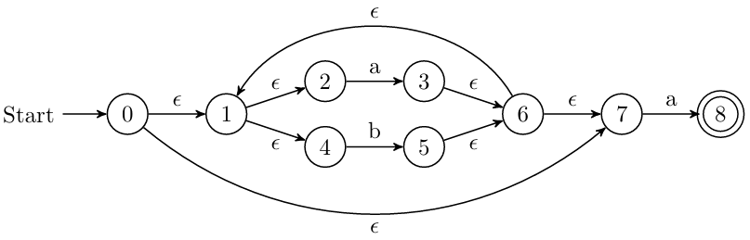
(4) Construct the NFA for $R_{4 }={\left(a | b\right)}^{*}a\left(a | b\right)=R_{3}R_{1}.$
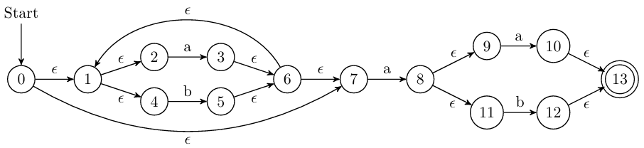
(5) Construct the NFA for ${\left(a | b\right)}^{*}a\left(a | b\right)\left(a | b\right)=R_{4}R_{1}.$
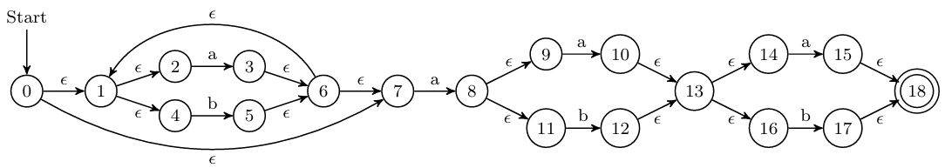

3.$a^{*}ba^{*}ba^{*}ba^{*}$
(1) Construct the NFA for $R_{1}=a^{*}.$
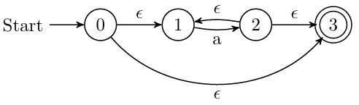
(2) Construct the NFA for $R_{2}=a^{*}b=R_{1}b.$
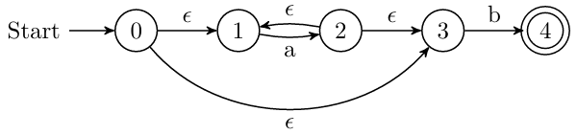
(3) Construct the NFA for $a^{*}ba^{*}ba^{*}ba^{*}=R_{2}R_{2}R_{2}R_{1}$.
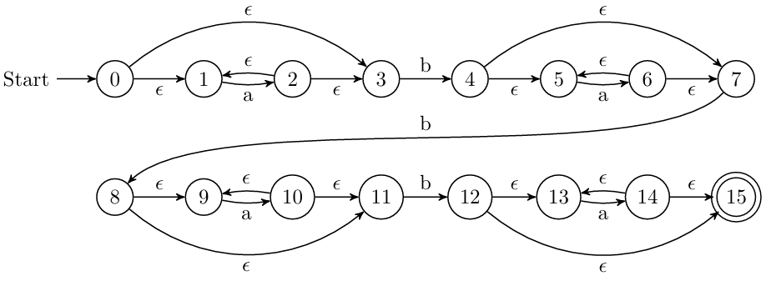

Exercise 3
Convert the NFAs in Exercise2 to DFAs using the Subset Construction Algorithm (Algorithm 3.20 in the dragon book). Please put down the detailed steps. [30points in total; 10 points for each correct conversion]
请使用子集构造算法（龙书中的算法3.20）将练习2中的NFA转换为DFA。请写出详细步骤。[总分30分；每个正确转换得10分]
1.${({(ϵ|a)}^{*}b)}^{*}$
$$A=ε-closure\left(\left\{0\right\}\right)=\left\{0, 1, 2, 3, 4, 5, 7, 8, 10\right\}.$$
$$B=δ_{D}(A, a)=ε-closure\left(\left\{6\right\}\right)=\left\{2, 3, 4, 5, 6, 7, 8\right\}.$$
$$C=δ_{D}(A, b)=ε-closure\left(\left\{9\right\}\right)=\left\{1, 2, 3, 4, 5, 7, 8, 9, 10\right\}.$$
$$D=δ_{D}(B, a)=ε-closure\left(\left\{6\right\}\right)=B.$$
$$E=δ_{D}(B, b)=ε-closure\left(\left\{9\right\}\right)=C.$$
$$F=δ_{D}(C, a)=ε-closure\left(\left\{6\right\}\right)=B.$$
$$G=δ_{D}(C, b)=ε-closure\left(\left\{9\right\}\right)=C.$$
The transition table of the DFA (Starting state is A and finite states are {A, C}):
NFA STATE | DFA STATE | a | b
$$\left\{0, 1, 2, 3, 4, 5, 7, 8, 10\right\}$$ | A | B | C
$$\left\{2, 3, 4, 5, 6, 7, 8\right\}$$ | B | B | C
$$\left\{1, 2, 3, 4, 5, 7, 8, 9, 10\right\}$$ | C | B | C
The transition diagram:
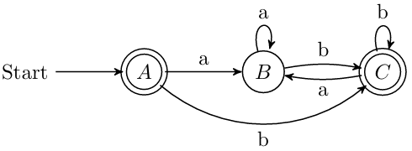

2.${(a|b)}^{*}a(a|b)(a|b)$
$$A=ε-closure\left(\left\{0\right\}\right)=\left\{0, 1, 2, 4, 7\right\}.$$
$$B=δ_{D}(A, a)=ε-closure\left(\left\{3, 8\right\}\right)=\left\{1, 2, 3, 4, 6, 7, 8, 9, 11\right\}.$$
$$C=δ_{D}(A, b)=ε-closure\left(\left\{5\right\}\right)=\left\{1, 2, 4, 5, 6, 7\right\}.$$
$$D=δ_{D}(B, a)=ε-closure\left(\left\{3, 8, 10\right\}\right)=\left\{1, 2, 3, 4, 6, 7, 8, 9, 10, 11, 13, 14, 16\right\}.$$
$$E=δ_{D}\left(B, b\right)=ε-closure\left(\left\{5, 12\right\}\right)=\{1, 2, 4, 5, 6, 7, 12, 13, 14, 16\}.$$
$$F=δ_{D}(C, a)=ε-closure\left(\left\{3, 8\right\}\right)=B.$$
$$G=δ_{D}(C, b)=ε-closure\left(\left\{5\right\}\right)=C.$$
$$H=δ_{D}(D, a)=ε-closure\left(\left\{3, 8, 10, 15\right\}\right)=\left\{1, 2, 3, 4, 6, 7, 8, 9, 10, 11, 13, 14, 15, 16, 18\right\}.$$
$$I=δ_{D}(D,b)=ε-closure\left(\left\{5, 12, 17\right\}\right)=\left\{1, 2, 4, 5, 6, 7, 12, 13, 14, 16, 17, 18\right\}.$$
$$J=δ_{D}(E, a)=ε-closure\left(\left\{3, 8, 15\right\}\right)=\left\{1, 2, 3, 4, 6, 7, 8, 9, 11, 15, 18\right\}.$$
$$K=δ_{D}(E,b)=ε-closure\left(\left\{5, 17\right\}\right)=\left\{1, 2, 4, 5, 6, 7, 17, 18\right\}.$$
$L=δ_{D}\left(H, a\right)=ε-closure\left(\left\{3, 8, 10, 15\right\}\right)=H$.
$M=δ_{D}\left(H, b\right)=ε-closure\left(\left\{5, 12, 17\right\}\right)=I$.
$N=δ_{D}\left(I, a\right)=ε-closure\left(\left\{3, 8, 15\right\}\right)=J$.
$O=δ_{D}\left(I,b\right)=ε-closure\left(\left\{5, 17\right\}\right)=K$.
$P=δ_{D}\left(J, a\right)=ε-closure\left(\left\{3, 8, 10\right\}\right)=D$.
$Q=δ_{D}\left(J, b\right)=ε-closure\left(\left\{5, 12\right\}\right)=E$.
$R=δ_{D}\left(K, a\right)=ε-closure\left(\left\{3, 8\right\}\right)=B$.
$S=δ_{D}\left(K, b\right)=ε-closure\left(\left\{5\right\}\right)=C$.
The transition table of the DFA (Starting state is A and finite states are {H, I, J, K}):
NFA STATE | DFA STATE | a | b
$$\left\{0, 1, 2, 4, 7\right\}$$ | A | B | C
$$\left\{1, 2, 3, 4, 6, 7, 8, 9, 11\right\}$$ | B | D | E
$$\left\{1, 2, 4, 5, 6, 7\right\}$$ | C | B | C
$$\left\{1, 2, 3, 4, 6, 7, 8, 9, 10, 11, 13, 14, 16\right\}$$ | D | H | I
$$\{1, 2, 4, 5, 6, 7, 12, 13, 14, 16\}$$ | E | J | K
$$\left\{1, 2, 3, 4, 6, 7, 8, 9, 10, 11, 13, 14, 15, 16, 18\right\}$$ | H | H | I
$$\left\{1, 2, 4, 5, 6, 7, 12, 13, 14, 16, 17, 18\right\}$$ | I | J | K
$$\left\{1, 2, 3, 4, 6, 7, 8, 9, 11, 15, 18\right\}$$ | J | D | E
$$\left\{1, 2, 4, 5, 6, 7, 17, 18\right\}$$ | K | B | C
The transition diagram:
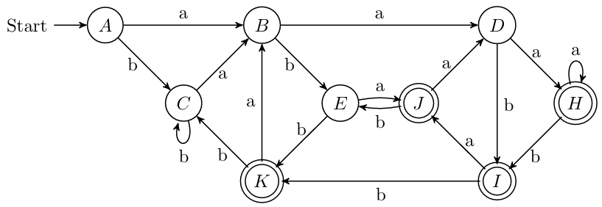

3.$a^{*}ba^{*}ba^{*}ba^{*}$
$$A=ε-closure\left(\left\{0\right\}\right)=\left\{0, 1, 3\right\}.$$
$$B=δ_{D}(A, a)=ε-closure\left(\left\{2\right\}\right)=\left\{1, 2, 3\right\}.$$
$$C=δ_{D}(A, b)=ε-closure\left(\left\{4\right\}\right)=\left\{4, 5, 7\right\}.$$
$$D=δ_{D}(B, a)=ε-closure\left(\left\{2\right\}\right)=B.$$
$$E=δ_{D}\left(B, b\right)=ε-closure\left(\left\{4\right\}\right)=C.$$
$$F=δ_{D}\left(C, a\right)=ε-closure\left(\left\{6\right\}\right)=\{5, 6, 7\}.$$
$$G=δ_{D}\left(C, b\right)=ε-closure\left(\left\{8\right\}\right)=\{8, 9, 11\}.$$
$$H=δ_{D}(F, a)=ε-closure\left(\left\{6\right\}\right)=F.$$
$$I=δ_{D}(F,b)=ε-closure\left(\left\{8\right\}\right)=G.$$
$$J=δ_{D}(G, a)=ε-closure\left(\left\{10\right\}\right)=\left\{9, 10, 11\right\}.$$
$$K=δ_{D}(G,b)=ε-closure\left(\left\{12\right\}\right)=\left\{12, 13, 15\right\}.$$
$L=δ_{D}\left(J, a\right)=ε-closure\left(\left\{10\right\}\right)=J$.
$M=δ_{D}\left(J, b\right)=ε-closure\left(\left\{12\right\}\right)=K$.
$$N=δ_{D}\left(K, a\right)=ε-closure\left(\left\{14\right\}\right)=\left\{13, 14, 15\right\}.$$
$O=δ_{D}\left(K,b\right)=∅$.
$$P=δ_{D}\left(N, a\right)=ε-closure\left(\left\{14\right\}\right)=N.$$
$Q=δ_{D}\left(N, b\right)=∅=O$.
$R=δ_{D}\left(O, a\right)=∅=O$.
$S=δ_{D}\left(O, b\right)=∅=O$.
The transition table of the DFA (Strating state is A and finite states are {K, N}):
NFA STATE | DFA STATE | a | b
$$\left\{0, 1, 3\right\}$$ | A | B | C
$$\left\{1, 2, 3\right\}$$ | B | B | C
$$\left\{4, 5, 7\right\}$$ | C | F | G
$$\{5, 6, 7\}$$ | F | F | G
$$\{8, 9, 11\}$$ | G | J | K
$$\left\{9, 10, 11\right\}$$ | J | J | K
$$\left\{12, 13, 15\right\}$$ | K | N | O
$$\left\{13, 14, 15\right\}$$ | N | N | O
$$∅$$ | O | O | O
The transition diagram:
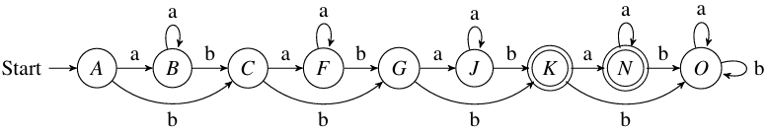

2 Optional Exercises
Exercise 1：Minimize the number of states of the DFAs you have built for regular expressions 2 and 3 in Exercise 2 using the State-Minimization Algorithm (Algorithm 3.39 in the dragon book). Please put down the detailed steps. [10 points for each correct minimization process]
使用状态最小化算法（《龙书》中算法3.39）最小化你在练习2中为正则表达式2和3构建的DFA的状态数。请写下详细步骤。[每个正确的最小化过程10分]
Regular expression 2:
(1) Initial partition: $G_{1}=\left\{A, B, C, D, E\right\}, G_{2}=\left\{H, I, J, K\right\}.$
(2) Handling group $G_{1}:$ b splits it into two groups $G_{3}=\left\{A, B, C\right\}, G_{4}=\left\{D,E\right\}.$
(3) Handling group $G_{3}:$ b splits it into two groups $G_{5}=\left\{A, C\right\}, G_{6}=\left\{B\right\}.$
(4) Handling group $G_{4}:$ a splits it into two groups $G_{7}=\left\{D\right\}, G_{8}=\left\{E\right\}.$
(5) Handling group $G_{2}:$ a splits it into two groups $G_{9}=\left\{H, I\right\},G_{10}=\left\{J,K\right\}.$
(6) Handling group $G_{9}:$ b splits it into two groups $G_{11}=\left\{H\right\}, G_{12}=\left\{I\right\}.$
(7) Handling group $G_{10}:$ b splits it into two groups $G_{13}=\left\{J\right\}, G_{14}=\left\{K\right\}.$
(8) Picking $A, B, D, E, H, I, J, K$ as the representatives to construct the minimum-state DFA.
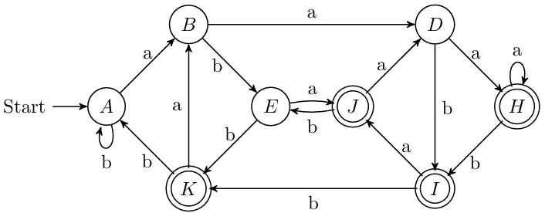

Regular expression 3:
(1) Initial partition: $G_{1}=\left\{A, B, C, F, G, J, O\right\}, G_{2}=\left\{K, N\right\}.$
(2) Handling group $G_{1}:$ b splits it into two groups $G_{3}=\left\{A, B, C, F, O\right\}, G_{4}=\left\{G, J\right\}.$
(3) Handling group $G_{3}:$ b splits it into two groups $G_{5}=\left\{A, B, O\right\}, G_{6}=\left\{C, F\right\}.$
(4) Handling group $G_{5}:$ b splits it into two groups $G_{7}=\left\{A, B\right\}, G_{8}=\left\{O\right\}.$
(5) Picking $A,C, G, K, O$ as the representatives to construct the minimum-state DFA.
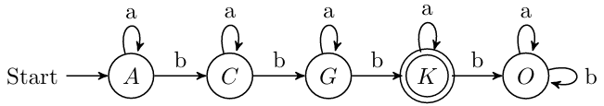

Assignment 3
1 Required Exercises
Exercise 1
Consider the following context-free grammar G:
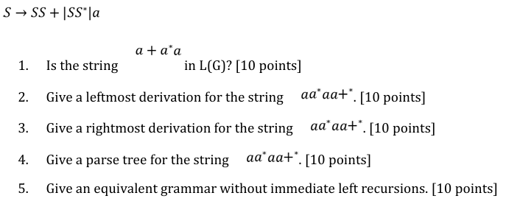
1.字符串a+a*a在L(G)中吗？
2.给出该字符串的最左推导
3.给出该字符串的最右推导
4.为该字符串提供一个解析树
5.给出一个没有直接左递归的等价语法

1. No, it isn’t. (Either a single 'a' alone, or ending with '+' or ending with '*'.)
2.$S\overset{⇒}{lm}SS*\overset{⇒}{lm}SS*S*\overset{⇒}{lm}aS*S*\overset{⇒}{lm}aa*S*\overset{⇒}{lm}aa*SS+*\overset{⇒}{lm}aa*aS+*\overset{⇒}{lm}aa*aa+*$
3.$S\overset{⇒}{rm}SS*\overset{⇒}{rm}SSS+*\overset{⇒}{rm}SSa+*\overset{⇒}{rm}Saa+*\overset{⇒}{rm}SS*aa+*\overset{⇒}{rm}Sa*aa+*\overset{⇒}{rm}aa*aa+*$
4.
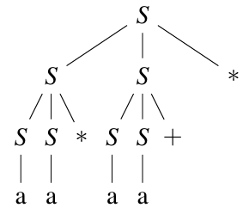
5.$S\underset{→}{ }aS^{'}, S^{'}\underset{→}{ }S+S^{'}\left|S*S^{'}\right|ε.$

Exercise 2
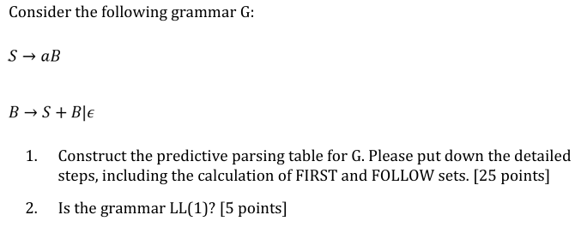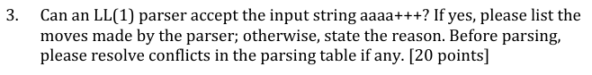
1.为文法G构造预测分析表。请写出详细步骤，包括FIRST和FOLLOW集的计算。
2.这个语法是LL(1)吗？
3.LL(1)解析器能接受输入字符串aaaa+++吗？如果可以，请列出解析器的操作步骤；如果不可以，请说明原因。在解析之前，如果解析表中存在冲突，请先解决冲突。

1. (a) Calculate the FIRST and FOLLOW sets for the grammar.

$$FIRST\left(S\right)=\left\{a\right\}$$
$$FIRST\left(B\right)=\left\{a,ε\right\}$$
$$FIRST\left(aB\right)=\left\{a\right\}$$
$$FIRST\left(S+B\right)=\left\{a\right\}$$
$$FIRST\left(ε\right)=\left\{ε\right\}$$
$$FOLLOW\left(S\right)=\left\{+,\$\right\}$$
$$FOLLOW\left(B\right)=\left\{+,\$\right\}$$

(b) Construct the predictive parsing table for the grammar.
NON-TERMINAL | INPUT SYMBOL
 | a | + | $
S | $$S\underset{→}{ }aB$$
B | $$B\underset{→}{ }S+B$$ | $$B\underset{→}{ }ε$$ | $$B\underset{→}{ }ε$$

2. Yes, it is.
$$FIRST\left(S+B\right)∩FIRST\left(ε\right)=∅$$
$$FIRST\left(S+B\right)∩FOLLOW\left(B\right)=∅$$

3. Yes, it can.
MATCHED | STACK | INPUT | ACTION
 | $$S\$$$ | $$aaaa+++\$$$
 | $$aB\$$$ | $$aaaa+++\$$$ | $$output S\underset{→}{ }aB$$
$$a$$ | $$B\$$$ | $$aaa+++\$$$ | $$match a$$
$$a$$ | $$S+B\$$$ | $$aaa+++\$$$ | $$output B\underset{→}{ }S+B$$
$$a$$ | $$aB+B\$$$ | $$aaa+++\$$$ | $$output S\underset{→}{ }aB$$
$$aa$$ | $$B+B\$$$ | $$aa+++\$$$ | $$match a$$
$$aa$$ | $$S+B+B\$$$ | $$aa+++\$$$ | $$output B\underset{→}{ }S+B$$
$$aa$$ | $$aB+B+B\$$$ | $$aa+++\$$$ | $$output S\underset{→}{ }aB$$
$$aaa$$ | $$B+B+B\$$$ | $$a+++\$$$ | $$match a$$
$$aaa$$ | $$S+B+B+B\$$$ | $$a+++\$$$ | $$output B\underset{→}{ }S+B$$
$$aaa$$ | $$aB+B+B+B\$$$ | $$a+++\$$$ | $$output S\underset{→}{ }aB$$
$$aaaa$$ | $$B+B+B+B\$$$ | $$+++\$$$ | $$match a$$
$$aaaa$$ | $$+B+B+B\$$$ | $$+++\$$$ | $$output B\underset{→}{ }ε$$
$$aaaa+$$ | $$B+B+B\$$$ | $$++\$$$ | $$match+$$
$$aaaa+$$ | $$+B+B\$$$ | $$++\$$$ | $$output B\underset{→}{ }ε$$
$$aaaa++$$ | $$B+B\$$$ | $$+\$$$ | $$match+$$
$$aaaa++$$ | $$+B\$$$ | $$+\$$$ | $$output B\underset{→}{ }ε$$
$$aaaa+++$$ | $$B\$$$ | $$\$$$ | $$match+$$
$$aaaa+++$$ | $$\$$$ | $$\$$$ | $$output B\underset{→}{ }ε$$
Accept. The top of stack is $\$$.

2 Optional Exercises
Exercise 1
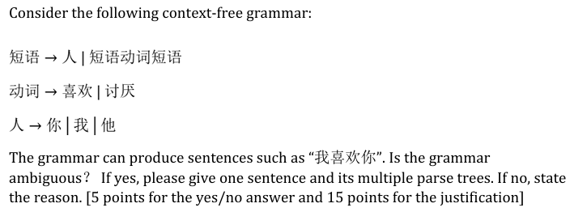
考虑以下无上下文文法。这个语法可以生成诸如“我喜欢你”的句子。这个语法有歧义吗？如果有，请给出一句话及其多种解析树。如果没有，请说明原因。

Yes, it is ambiguous.
e.g. 我喜欢你讨厌他

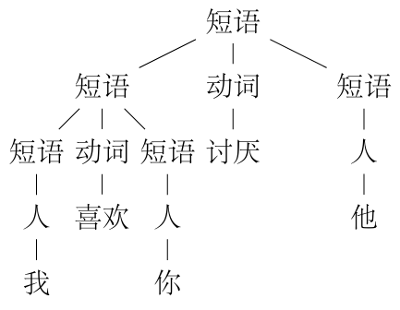
(a) Parse tree 1
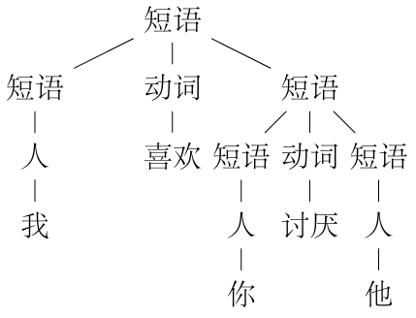
(b) Parse tree 2

Figure: Two parse trees for the ambiguous sentence

Assignment 4
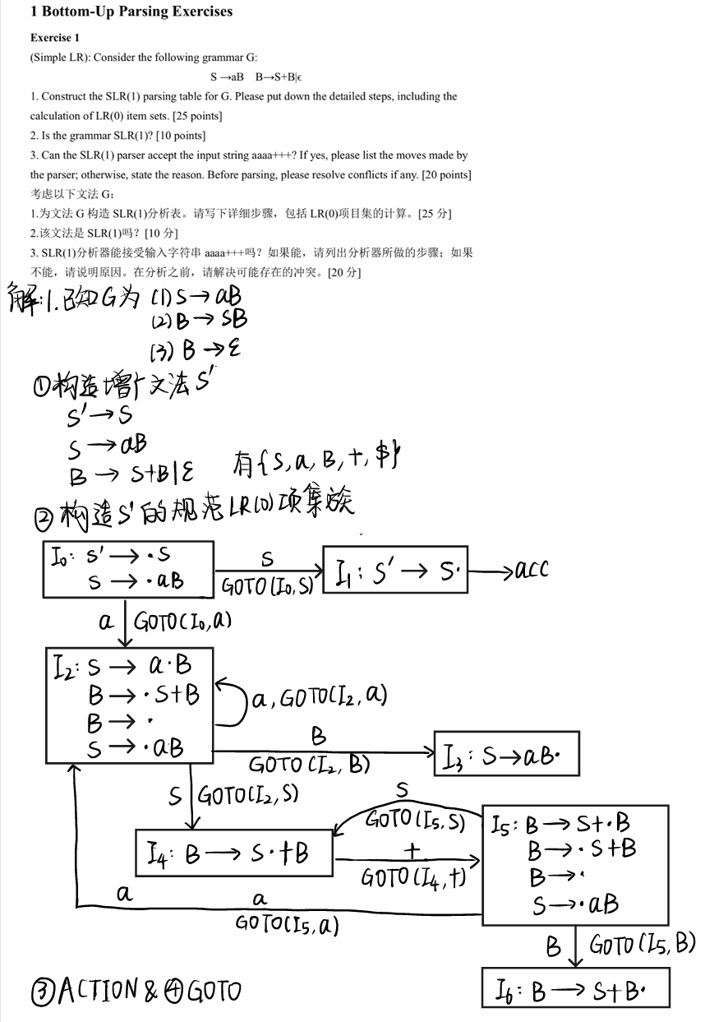

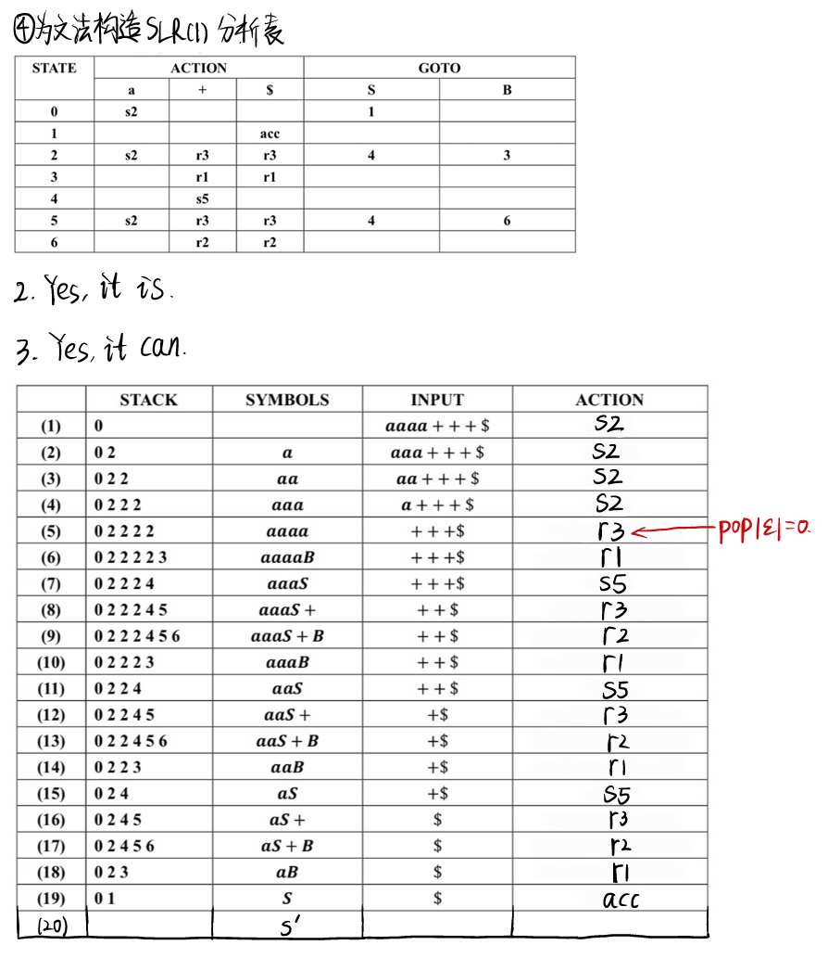

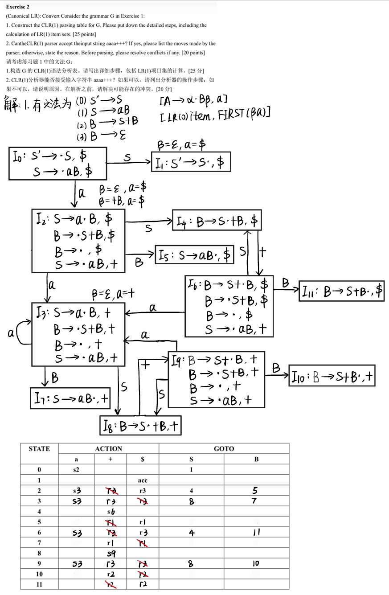
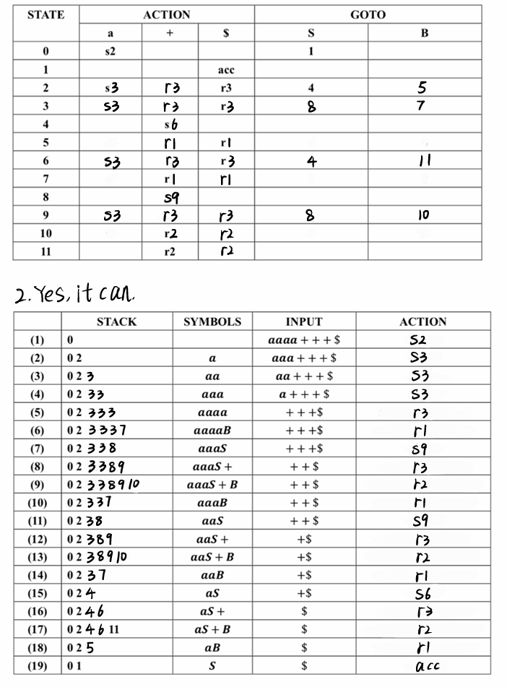

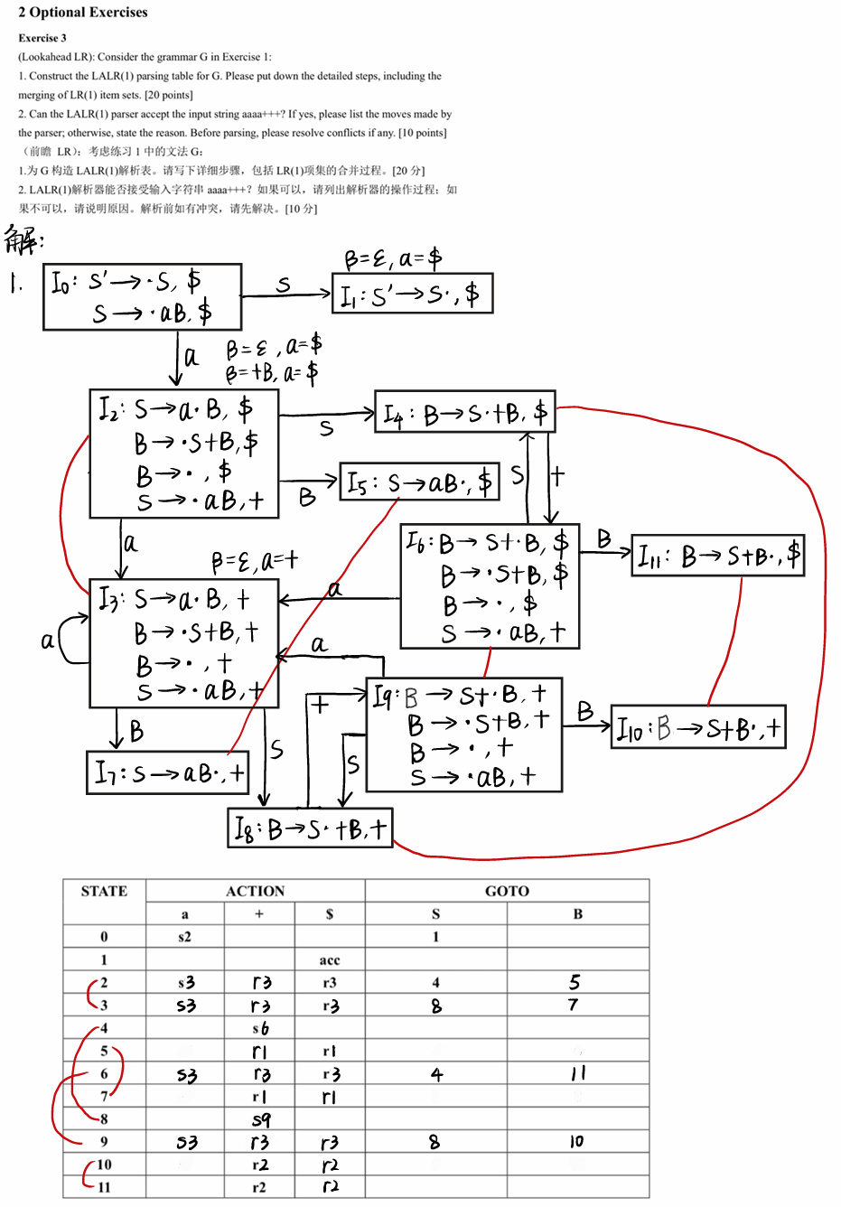

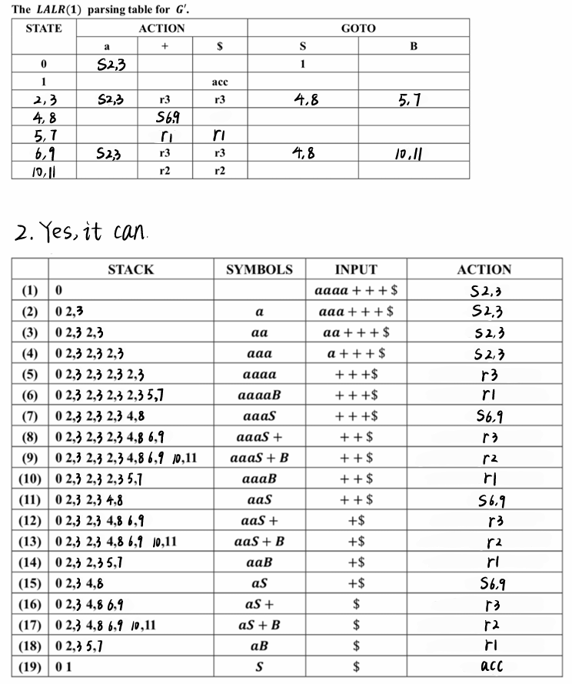

Assignment 5
1 Required Exercises
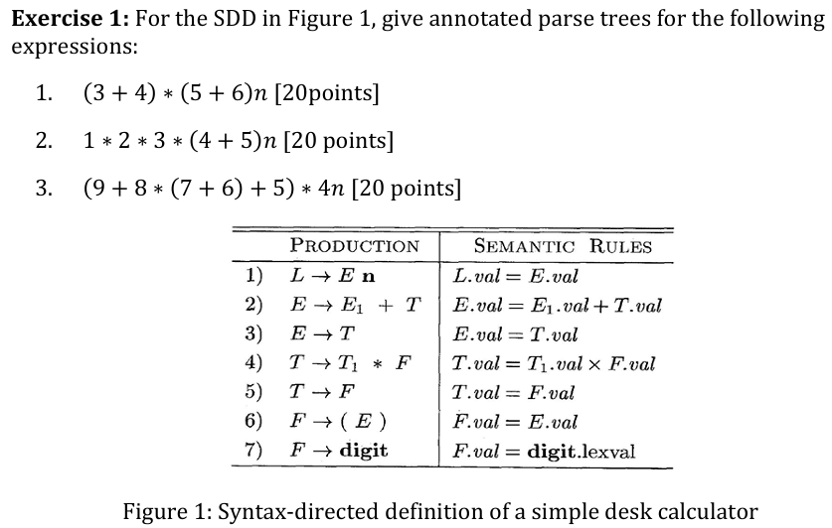
1. $(3+4)*(5+6)n$
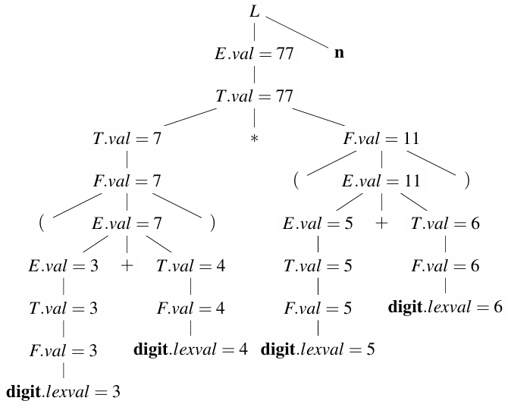

2. $1*2*3*(4+5)n$
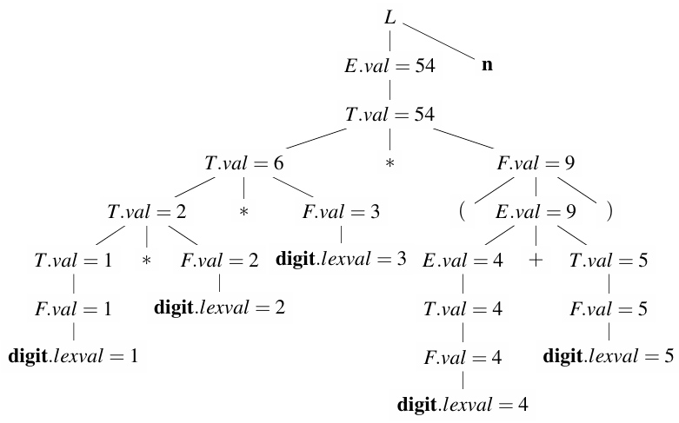

3. $(9+8*\left(7+6\right)+5)*4n$
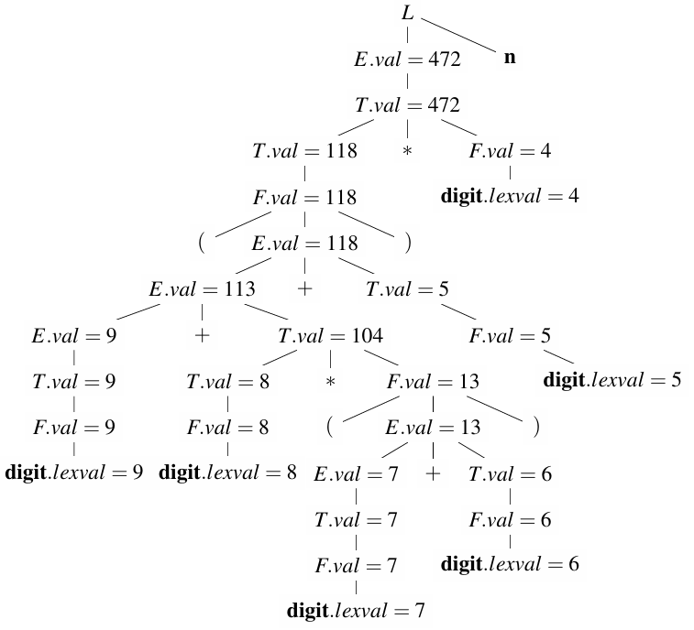

Exercise 2
What are all the topological sorts for the dependency graph of Figure 2? One sort mentioned during lecture is 1,2,3,...,9 (slide #17 of Chapter 4). [20 points]
图2的依赖图的所有拓扑排序有哪些？课堂上提到的一种排序是1,2,3,...,9（第4章第17张幻灯片）。[20分]
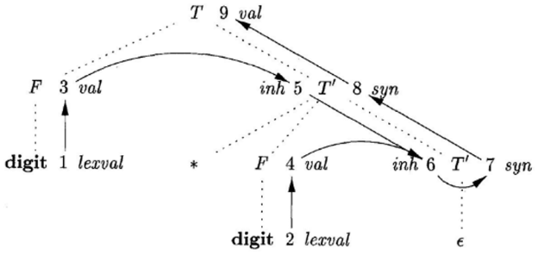
The productions and semantic rules for the grammar involved in figure are as follows
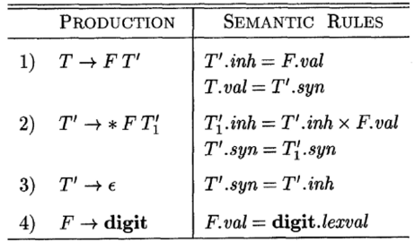
Based on the analysis, we can derive the sequence of attribute computation as follows, where (1, 3) indicates that step 1 must precede step 3.
(1, 3) (2, 4) (3, 5) (5, 6) (4, 6) (6, 7) (7, 8) (8, 9)
There all totally 10 different topological sorts for the dependency graph.
1 | （1, 2, 3, 4, 5, 6, 7, 8, 9）
2 | （1, 2, 3, 5, 4, 6, 7, 8, 9）
3 | （1, 2, 4, 3, 5, 6, 7, 8, 9）
4 | （1, 3, 2, 4, 5, 6, 7, 8, 9）
5 | （1, 3, 2, 5, 4, 6, 7, 8, 9）
6 | （1, 3, 5, 2, 4, 6, 7, 8, 9）
7 | （2, 1, 3, 4, 5, 6, 7, 8, 9）
8 | （2, 1, 3, 5, 4, 6, 7, 8, 9）
9 | （2, 1, 4, 3, 5, 6, 7, 8, 9）
10 | （2, 4, 1, 3, 5, 6, 7, 8, 9）

Exercise 3
Below is a grammar for expressions involving operator + and integer or floating-point operands. Floating-point numbers are distinguished by having a decimal point. Give an SDD to determine the type of each term T and expression E. [20 points]
$$E → E+T | T$$
$$T →num⋅num | num$$
下面是一个涉及运算符+和整数或浮点操作数的表达式语法。浮点数通过有小数点来区分。请给出一个SDD来确定每个项T和表达式E的类型。[20分]

PRODUCTIONS | SEMANTIC RULES
1) $E → E1 +T$ | $$E.type = float if E1.type = float or T.type=float , else int$$
2) $E → T$ | $$E.type = T.type$$
3) $T → num.num$ | $$T.type = float$$
4) $T → num$ | $$T.type = int$$

