Smashing CSS: Errata
Pages 61-62: Figure 2-15 appears at the bottom of page 61 but its caption is at the top of page 62. It should look like this:
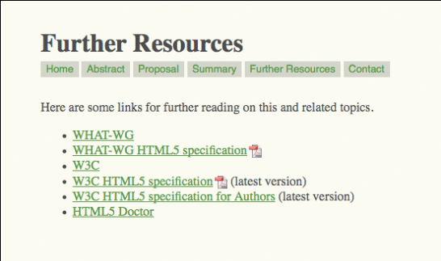
Figure 2-15: PDF icons for links to PDF documents.

Page 65: The very last paragraph speaks of removing top margins from any paragraph that follows an h1, but then the example shows h2 elements. That paragraph should read:

CSS defines a combinator that allows you to select an element based on its previous sibling
element. For example, if you wanted to remove the top margin from any paragraph that
immediately follows an h2 (see Figure 2-21), then it’s a simple matter of saying:

Page 68: last paragraph states "Thus, it's strongly recommended that you use only generated content in the service of what's called progressive enhancement, where you use advanced features to add enhancements that the page can live without." This should read:

Thus, it's strongly recommended that you use generated content only in the service of what's called progressive enhancement, where you use advanced features to add enhancements that the page can live without.

Page 76: States that the slash "/" is only used in line-heights for the font attribute, but it is used again on p. 178 in border-radius. The second line should be deleted from this paragraph on p. 76, as follows:

There’s no space between the font-size and line-height values, just a forward slash.
(In case you’re wondering, this is the only place in the whole of CSS that uses a forward slash.)

Page 80: The CSS mentions #innie, but the HTML is named #wrap. Replace the code sample with the following:
#innie {border-color: #800 #F88 #F88 #800;}
form {border: 3px solid; border-color: #F88 #800 #800 #F88;}
<form>
<div class=”innie”>
(content and form inputs and so on here)
</div>
</form>

Page 83: Last paragraph includes a spelling error: "and then thrww it way off-screen" This sentence should, of course, read:

That’s right: the CSS took that third paragraph, absolutely positioned it, and then threw it
way off -screen.

Page 86: last paragraph, first line: “prnt” should be “print”

Page 92: in the third paragraph, fifth line, the phrase “hand over” appears. This should be “land over”.

Page 177: Last paragraph: Safari/Chrome do support border-radius w/o prefixes.
FIX: true, though other browsers still require prefixes. The paragraph should read:

That’s it! Except that (as of this writing) it won’t work in many browsers, because border-radius isn’t finalized yet. To make sure it works in supporting browsers for the next few years, add vendor prefixes which you can prune out as the need for them diminishes.

Page 188: The caption for Figure 5-41 should read:
Figure 5-41: Diagrams of 50% 50% and 75% 75%.

Page 195: The caption for Figure 5-50 should read:
Figure 5-50: The curve placed into the browser using background positioning on divs.

Page 198, Figure 5-53: both the hovered and unhovered state looks exactly the same. The correct image looks like this:


