UNIVERSITY OF COMPUTING

MINOR PROJECT

Program name :bca

SUBJECT CODE = 23CAP-202

Tic-Tac-Toe

Submitted By: Submitted By:

Uid : 23bca10204 Dr. Shilpi Garg

Name : Abhishek Singh

Section : 23bca-3A

Group : 2

Abstract

**Introduction :**

**Tic-tac-toe is a game played between two players usually with paper and pencil but here, we will create a C++ program that will display the game on the console screen and players can use different keys from the keyboard to play it.**

**Technique :**

• **Function Decomposition**: Code is organized into functions for clarity and modularity (drawBoard, checkWin).

• **Array Usage**: A 2D array represents the game board, simplifying state management.

• **Looping**: for and while loops control game turns and input validation.

• **Conditional Statements**: if statements handle winning conditions and player switching.

**Operating System :**

**Hardware:**

Intel Core i5 (11th or 12th Gen).NVIDIA GeForce GTX 1650 or RTX 3050

8GB or 16GB DDR4 RAM ,12GB SSD or 1TB HDD ,Windows 10 or Windows 11

**Software :**

Visual Studio Code

Summery

**Input :**

**Player Moves**:

The row and column where a player wants to place their mark (usually 'X' or 'O').For example, a player might input "1 2" to place their mark in the first row and second column.

**Game State**:

you might want to input whether the game is ongoing, a draw, or if a player has won. This could be through function calls that check the current board state.

**Process :**

**Initialize Game State:**

**Input**: None (initializes an empty board and sets the first player).

**Output**: Initial game state.

**Draw Board:**

* **Input**: Current game state (board configuration).
* **Output**: Visual representation of the board.

**Check Win:**

* **Input**: Current game state and current player.
* **Output**: Boolean indicating if the player has won.

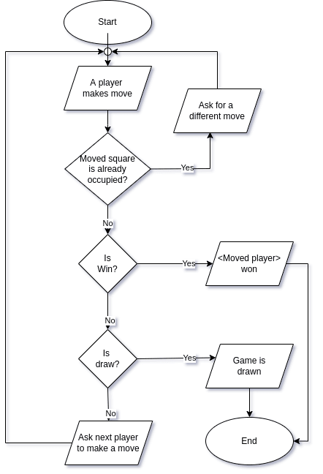

**Output :**

