Introduction
Keloids, as the typical cutaneous pathological scars, serve as the hub connecting soft tissue fibrosis and tumors. On the one hand, the histological features of excessive connective tissue deposition in the reticular dermis confined keloids within fibrotic disease; while on the other hand, their quasi-neoplastic behaviors such as the lifelong aggressive invasion into the adjacent healthy skin beyond initial injury/infection and frequent post-therapeutic recurrence highlight keloids as the most severe type of fibroproliferative conditions¹, with the only differences from cancers in having no atypia or intrinsic metastasis. Specifically, keloid invasion is closely related to local mechanics, as supported by the fundamental explorations in mechanobiological mechanisms (e.g. mechanoresponsive gene of asporin and mechanosignaling of Wnt/β-catenin) and clinical effectiveness of serial tension-releasing mechanotherapeutic strategies (e.g. incision with minimized tension and square-flap surgery). Thus, to trace dynamic changes thereby discovering rules behind keloid local invasion in response to real mechanical scenarios in vivo will benefit both fibrosis and cancer fields.
Until now, the etiology of keloidogensis remains unclear and the therapeutic effects remain limited. Thus, there is a surging demand for ealy diagnoses of its initiation/recurrence and progression, aiming at early, sensitive, accurate, repeatable and traumaless local diagnostic indices. Unfortunately, the available evaluation of keloidgoenesis currently are still confined within unfocused all-inclusive methods, such as 1) static and morphological gradings of keloid size, shape and erythema, as well as 2) the subjective symptom scores in varied scales [e.g. Vancouver scar scale (VSS), Patient and observer scar assessment scale (POSAS), and Japan scar workshop (JSW) scar scale (JSS)], the results of which can only be verified by the post-surgical histological reports and can hardly meet the clinical requirements during the life-long invasion. Specifically, traditional quantitative diagnosis in other disease models focusing on dose-effect relationship and threshold assessments are difficult to implement during keloidogenesis, because the disease grading and staging in keloids are unattainable. Actually, the challenge lies in that the local invasions with minute externalized changes in the surface of skin during keloidogensis can hardly be arrested by traditional assessments such as systemic blood sampling, deep radiological evaluations, rough superficial soft tissue ultrasound examinations, or late histological testings. Thus, a novel diagnostic system form scratch out of the available clinical evidences for ealy diagnostic indices is in thirsty need for intricate quantifications to monitor and analyze the keloid local invasion in a non-invasive, sensitive, dynamic, real-time, customized, and self-verifiable style.
According to the dynamic clinical obervations, we noticed that during the progressive streching-induced growth of keloids, the skin surface texture surrounding the keloids undergoes changes from an indiscintct stage to full emerge, as exemplified in Fig. 1. Brifely, during the continuous invasion of keloids into the adjacent healthy skin under chronic mechanical stimulations, the shape of the single hair follicle changed from round into fusifum. Gradually, these dotted deformed hair follicles presented in a dash-line style while acturally separated from one another. Further, the hair follciles begin to selectively border each other under the help of protrusion of skin textures, untilly finally the skin textures can be differentiated with naked eyes where the long axis of the fusiform is passed through by the skin texture along the direction of mechanical stimulations. If so, for these keloid-specific dynamic evolution of skin textures, it is hypothesized that the intricate skin textures, if dynamically and objectively evaluated, can demonstrate the existence, range, and extent of keloidogenesis, and even predict the direction of keloid invasion, under the help of artificial intelligence (AI).
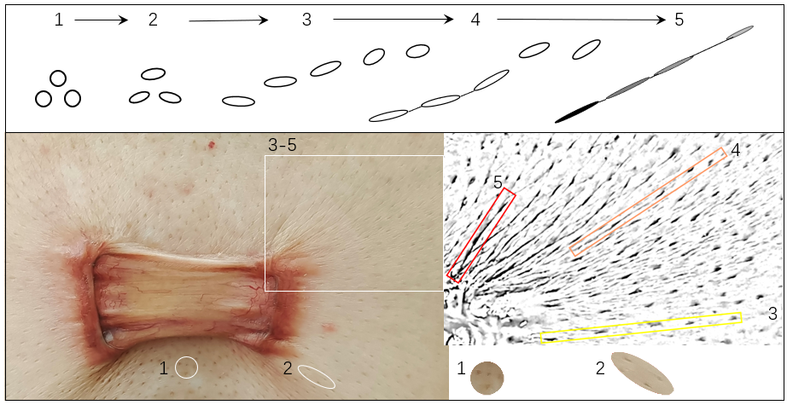
Fig. 1. The captured dynamic formation of skin texture during keloidogenesis
During the continuous invasion of keloid into the adjacent healthy skin, there accompanied dynamic process of the emergence of skin textures around the invasion edge. In responsive to the local mechanical stretching, the shape of the single hair follicle changed from round (1) into fusifum (2). Gruadually, the original regular lattic pattern of dotted hair follicles differentiated into a dash line arrangement (3), though leaving each fusiform separated with eath other. Further, the progressively elongated and flattened fusiform began to border with adjacent neighbors selectively under the help of protrusion of skin textures (4). And finally skin textures fully formed (5) if the continuously deepened and thicked textures can be traced by naked eys when they connect each hair follilcle passing through the long axis of the fursiform along the direction of mechanical stimulations.
In recent years, ‘AI for medicine’ has achieved remarkable results in targeted and precise evaluations. Large foundation model of MedSAM advance medical image segmentation, benefiting local analysis of skin cancers (UWSkinCancerMSBench), local annotation of CT data [AbdomenAtlas-8K: Annotating 8,000 CT Volumes forMulti-Organ Segmentation in Three Weeks, NeurIPS 2023], and local analysis of 3D pathology samples. Large foundation model of Mixture of MOdality Experts(MOME) further shows promising results in local analysis of breast cancer of MRI. Compared with traditional methods, these AI technologies offer non-invasive, objective, and accurate alternatives, which built a base for exploration of the intuitive, easily accessible skin surface features of keloids, and tailored models for keloid invasion assessment.
In this paper, we develop an assessment index to capture the explicit local morphological indicators during keloidogenesis, indicating the existence, range, extent, and even direction of keloid invasion, with artificial intelligence (AI) driven local skin textural structure analysis, and far beyond what could be habitually estimated from the itchiness/pains of the already externalized red invading edge of keloids. First, the keloid images are captured with a high-definition camera for the high-resolusion textures features. Second, the peripheral part of keloid, together with adjacent skin, is segmented from AI foundation model-based segmentation. Third, a novel keloid index (Ke-index) is calculated via Gabor-gradient domain analysis of skin textural structures in segmented area. This Ke-index covers three clinical diagnostic indicators (CDIs), which quantify the presence, severity and direction of keloid invasion. Thus, Ke-index can greatly help clinicians to judge keloid invasion for diagnosis, evaluate its range and extent for therapeutic decision, and further predict invading direction for preventive interventions. The proposed Ke-index with its indicators successfully meets the clinical expectation in evaluating keloidogensis in a non-invasive, sensitive, dynamic, real-time, customized, and self-verifiable way. It can also provide examples for fibrotic and tumor fields in digitalizing their progression as in their priori keloid counterpart.

Results

Association between skin textural structure and keloid invasion:
Out of the first-hand clinical evidences, we discover an association between skin textural structure and keloid invasion, facilitated by experienced clinicans specializing in keloid managements. Clinical information demonstrated by skin textural structures at the periphery of keloid during its local invasion include: (1) the skin textural structure crosses the boundary between the redness of keloid invasive periphery and the adjacent normal skin thereby covering both sites (Fig. 3a), which we named Intertidal Zone (IZ); (2) the originally parallelized-arranged skin texture can be squeezed into concentric circles centripetal towards keloid center or radiantly arranged outward into the adjacent healthy skin (Fig. 3), the latter of which indicating active aggressiveness (Fig. 3b); (3) the radiantly arranged skin texture is frequently seen in the invasive front, which is consistent with direction of the local mechanical stimulation and the typical site-oriented keloid shape (e.g. butterfly in the chest) (Fig. 1b); and (4) as the dynamic and responsive reaction to the chronic local mechanics, the instant skin textural changes in morphology precede the histological structural manifestations, thereby potentially externalizing the missing link between the functional mechanical stimulation and the manifested structural mass formation.

KeTAS:
We developed an AI-driven statistical analysis system for predicting keloid invasion, termed the Keloid Textural Analysis System (KeTAS) (Fig. 2). The system consists of three core modules: an image acquisition module designed to capture high-resolution, detailed skin surface textures; an image segmentation module that distinguishes the intertidal zone from normal skin and the keloid body; and a Gabor-gradient feature analysis module that operates on the segmented intertidal zones to enable accurate, generalizable, and reliable prediction of keloid invasion.
Compared with other AI methods, KeTAS exhibits superior advantages in interpretability, freedom from hallucinations, generalization ability, and robustness. By decomposing the entire analysis into image segmentation and Gabor-gradient feature analysis handled by large segmentation model and feature engineering respectively, our framework effectively harnesses the complementary strengths of both paradigms. This strategy not only obtains strong generalization and robustness while mitigating critical limitations of pure AI methods such as hallucination and poor interpretability, but also obtains highly interpretable and hallucination-free analytical results while overcoming the drawback of pure feature analysis methods which can hardly effectively incorporate knowledge encoded in large annotated datasets.
Notably, KeTAS allows comprehensive assessment of keloid invasion, including its presence, distribution, severity, and direction, which is far more informative than existing conventional clinical evaluation. More importantly, KeTAS makes it possible to quantify the presence, direction, and severity of keloid invasion in a non-invasive, sensitive, dynamic, real-time, personalized, and self-verifiable manner.
Accordingly, KeTAS holds great potential to assist clinicians in identifying keloid invasion for early diagnosis, assessing its spatial range and degree for treatment planning, and further predicting its invasive direction to guide preventive interventions.

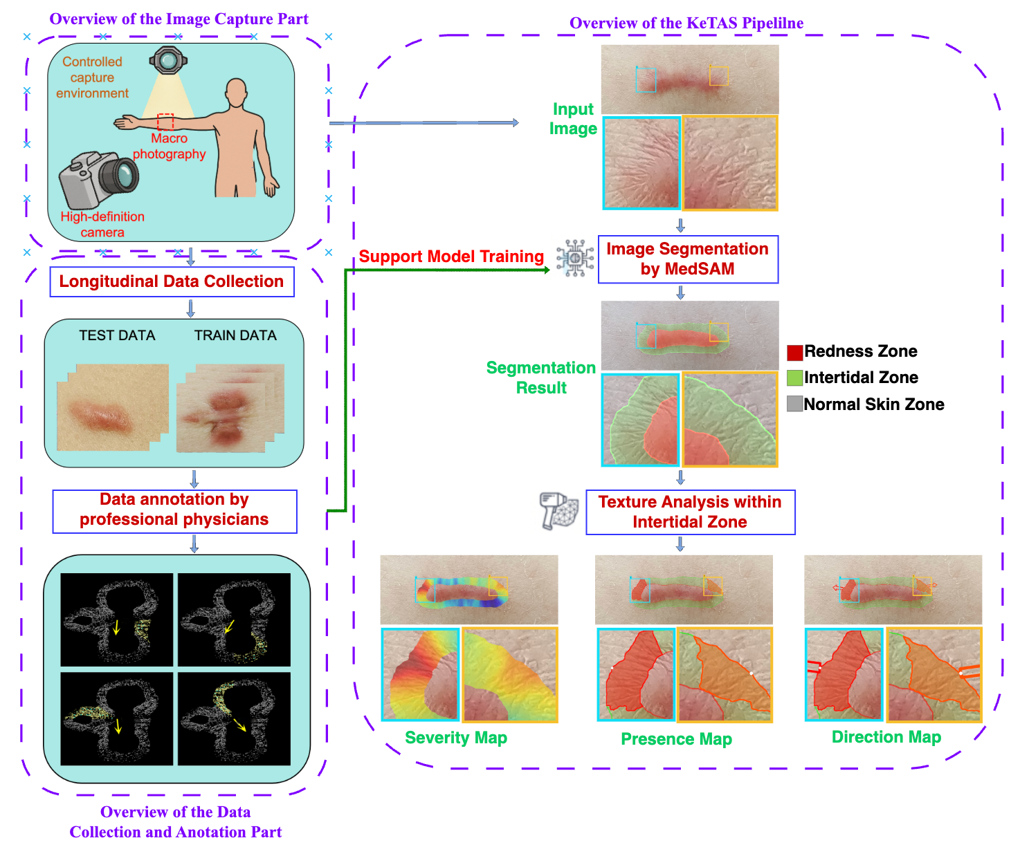
Fig.2. Pipeline of KeTAS
The pipline include data capture, data annotation, and data processing (segmentation with Gabor-gradient domain analysis). The system obtains a novel index of intertidal zones and three indicators of presence, direction, and severity of keloid invasion. 2026

Ke-Index and three indicators:
Using KeTAS, Ke-index is obtained with the following three medical diagnostic indicators:
Indicator 1: The indicator of the presence of keloid invasion (whether the keloid is growing), derived from the presence or absence of IZs.例如xxx示例图，需要跑一下seg，得到0-1 mask map (h,w,1)，每个区域的presence
Indicator 2: The indicator of severity of keloid invasion, derived from the ratio of IZ area to total keloid area (The total keloid area of the entire keloid lesion is also segmented using the KeTAS).例如xxx,八个区域的活跃度

Indicator 3: The indicator of the direction of keloid invasion, derived from texture direction analysis of KeTAS within the segmented IZs.例如xxx
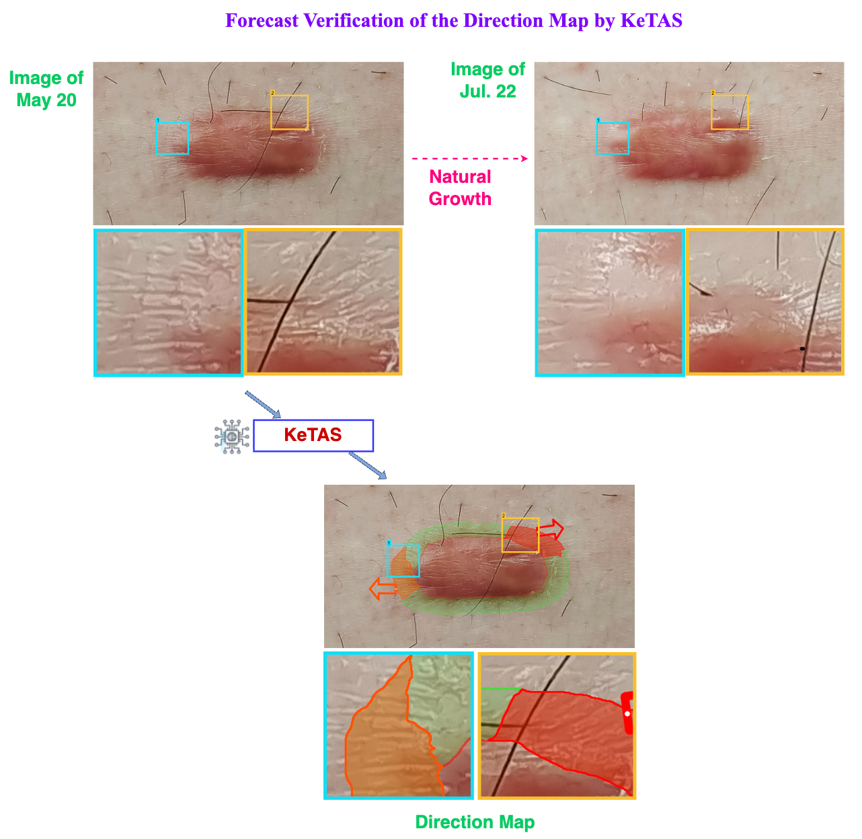
Fig.3. Verification of KeTAS

结合新的图和seg/direction结果描述
Verification: Sensitivity, accuracy, and repeatability of those indicators have been repeatedly verified during the dynamic processes of clinical observations and evaluations. (1) Sensitivity. The dyanamic skin texture highly sensitive and responsive to local motions in an instable way, when repeatedly operated for a long-enough period, can solidify into static skin textures and externally presented as stable signals. Such early signals can be captured by our system when initially appeared, before the traditional and late histological evidences can be manifested meaningful. (2) Validity. The assessments of keloid invasion for each invividual from the perspectives of its existence, severity and dirction have been extended for additional 6 months, aside from the standard obervasion period, which allows for presenting thereby verifying the skin texture assessment of the local invasion in a dynamic way to ensure the accuracy of our evaluations. (3) Repeatibility. For all the patients, whatever therapeutic strategies they prefer and finally choose, pharmaceutical palliative treatment or surgical resection followed by postherapeutic radiation therapy (Figures), the development, invasion or recurrence of keloidogensis was cross-validified accordingly as mentioned in (2) to guarentee the assessment homogeneity among different locations and courses of the disease, as well as different patient individuals, genders, and ages, at the least under the current research capacity. And (4) Reliability. The reliance on specialized imaging hardwares such as camera and lens is low during image acquisition in our system. Additionally, the topical interference during figure recognition is minimal for non-dermatoglyphic confounding variables such as hair strand, skin debris, and topical drug residues. Under such deliberatedly guided superior signal-to-noise ratios, the reliability dermatoglyphic assenssment afterwards can be enhanced accordingly.

Discussion
（Results：1:KeTAS自动进行皮纹—瘢痕疙瘩分析，2:临床发现皮纹—瘢痕疙瘩关联，3:潮间带index和3个指标）
1: Significance of the Combination of AI and Gabor-gradient domain analysis
KeTAS proposes a hybrid strategy combining artificial intelligence (AI) and traditional visual texture analysis in the Gabor-gradient domain, which effectively solves the inherent defects of current mainstream methods【加文献】. Although pure large-model schemes in the field of existing medical diagnosis have made considerable progress, they have problems such as high training difficulty, easy occurrence of "hallucinations" in results, and insufficient reliability. In contrast, traditional visual analysis methods have stronger interpretability and stability but are difficult to fully utilize the knowledge advantages contained in big data and large models, and have limited ability in mining disease-specific features.
This study achieves complementary advantages through task decoupling: for the standard binary classification task of IZ segmentation, which requires a great deal of prior knowledge on keloid morphology, the MedSAM model, which has been fully verified in similar medical segmentation tasks, is adopted and fine-tuned using our manually carefully annotated keloid segmentation data to adapt to the task in this paper; for the non-standard task of texture direction analysis (where it is difficult to obtain large-scale supervised data), a traditional visual analysis method in the Gabor-gradient domain with artificially designed texture direction features is adopted to achieve accurate and hallucination-free result output. This task decoupling strategy not only gives full play to the advantages of pre-trained large models and the value of existing manually annotated keloid data but also effectively avoids the unreliability problems caused by pure large models, providing a better solution for keloid diagnosis.

2: Significance of Objective Quantitative Diagnosis
The diagnosis of keloids has long relied on subjective clinical evaluation; even a few objective indicators are highly dependent on physicians' experience, leading to significant differences in diagnostic results among different medical institutions and physicians, which seriously restricts the standardized development of the field. Our developed KeTAS and standardized analysis method greatly reduce the reliance of diagnosis on subjective judgment, realize consistent diagnosis across institutions and physicians, provide a key technical path for the standardization of keloid diagnosis, and offer strong support for the large-scale promotion, cost control, and efficiency improvement of the diagnosis and treatment of this disease.

3: Significance of the Strong Correlation Between Skin Texture and Keloid Invasion
One of the core findings of this study is the existence of a strong correlation between skin texture morphology and keloid invasion, which has not been reported in the field. This finding not only provides a new quantitative tool for evaluating the degree (intensity and direction) of keloid invasion but also offers important clues for analyzing the pathogenesis of the disease, opening up a new direction for exploring the inherent laws of the occurrence and development of the disease.

4: Significance of Effective Clinical Self-Validation
The results of clinical dynamic self-validation confirm that the newly discovered intertidal zone Ke-index and the three indicators of presence, severity, and direction of keloidogenesis have good effectiveness. This not only verifies the reliability of the technical scheme proposed in this study but also fully confirms the scientificity, accuracy, and efficiency of the entire process, including data collection, processing, analysis, and the calculation of indexs and indicators. Furthermore, it proposes new indicators for predicting the degree and direction of the chronic invasion process of keloids, laying a solid foundation for subsequent clinical transformation.
5. 为什么不看单个更早的单个毛囊而看皮纹(充分性+必要性+最早可识别)
Currently we evaluated the dynamic changes in skin textures during keloidogenesis, rather than the earlier single hair follicles, because (1) During the mechanic-dependent formation of skin textures, it is only after the full emergence of skin textures, can the most impacted and affected hair follicles be decided, with their fusiform shape stabilized and long axis run through the detected skin textures on after another; (2) It is the continuous and fixed skin textures that can be differentiated by naked eyes or pictures taken, while the instable and demarcated hair follicles in lattic or slightly deformed pattern in the entire field served more as interference than contributing factors; (3) It is the full-formed clustered skin textures that help provide collectively the informative patterns through various distribution patterns (Fig. 5). And the longer the keloid course, the thicker, longer, and typical the skin textures will be in facilitating clinical decision-making. For examples, the concentric circle districution of skin textures around keloid edges indicated less invasion than radiant arrangement where the invasion direction was being selected. And it was not until the parallel-patterned skin textures be formed can the true ingrowth of the red keloid be recognized, along the decided invasion direction indicated by the collective paralleled alignment of skin textures.
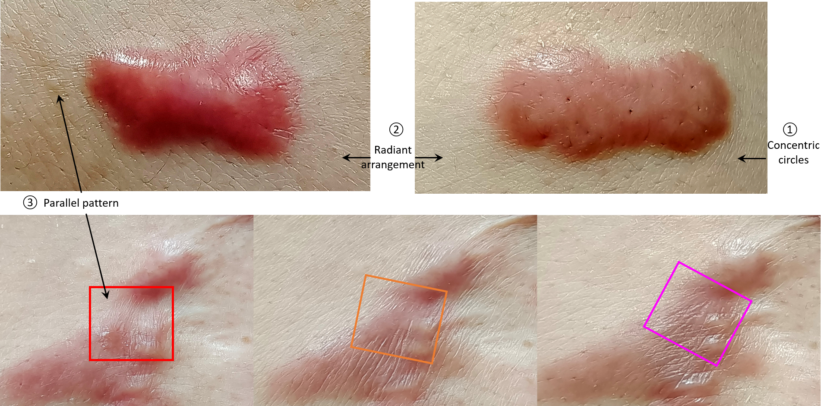
Fig. 5. The recognized clustered skin textures can provide invasion-related inforamtion through their distribution patterns
The recognizable skin textures function as the dynamic and responsive reaction to the chronic mechanical stimulations during local keloid invasion. Thus, the instant skin textural changes precede the histological structural outcomes. Initially, the concentric circle districution of skin textures around keloid edges (①) indicated less invasion than radiant arrangement (②) where the invasion direction was being selected. And it was not until the parallel-patterned skin textures (③) be formed can the true ingrowth of the red keloid be recognized, along the decided invasion direction indicated by the collective paralleled alignment of skin textures. And accordingly, keloid growth is along the directional trail indicated by skin texture, as shown by the gradual changes within red, organ, and pink boxes, towards additional keloid tissue formation, thereby potentially externalizing the missing link between the functional mechanical stimulation and the manifested structural mass formation during keloidogenesis.

Discussion里需要加入的不可或缺的扫雷内容
- 没有金标准下的自验证
Though hardly can dynamic histological verification be feasible as golden standard to match our KeTAS results, the self-verifications, both static and dynamic, are proved credible and effective. Statically, inside the intertidal zone, the three indictors of presence, severity, and direction, separately deducted by KeTAS automatically, can fullfill the loop through cross-validications among the three, with progressive refresh and refinement. Further outside the intertidal zone, our direction index for coming invasion is echoed by the long axis of fusiform-shaped hair follicles in the ajacent healthy skin, although their sensitivity can outweigh specificity as collateral evidences. And dynamically, all the three indicators can have their factual evidences for direct confirmation during the continuous obervations where keloid invasion is truly following what the KeTAS direction indicates earlier. Such an abiding behavior is additionally supported by the visible enlargement and edema of the keloid mass in designated area and direction.
- 为什么能动态观察有足够量的图片而不牺牲患者的利益
Our clinical obervations of the skin textures are available during daily standarized keloid managements (e.g. external phamaceuticals, laser therapy, costosterioid injection, or surgery following by irradiation) according to the preference of the patients and feasibility for the treatments, aiming to benefit the patient to the most. Considering that keloid can resulted from minute folliculitis or after trauma/surgery with frequent post-surgical recurrence, the KeTAS is particularly suitable for those: (1) with their preference for conservative treatments, especially those with family history; (2) with refractory keloids and multiple post-surgical recurrences; and (3) with multiple spreading and progressively new lesions.

6: Future Extended Applications of This Work
The KeTAS proposed in this study provides a feasible scheme for the standardization of keloid skin texture analysis and diagnosis, with significant potential application value—it is expected to become a routine non-invasive, sensitive, dynamic, real-time, personalized, and self-verifiable objective evaluation tool in clinical practices such as keloid diagnosis, treatment, and prevention (corresponding to the positioning of "a non-invasive, sensitive, dynamic, real-time, customized, and self-verifiable way" in the Introduction section), similar to the standardized status of platelet detection in blood tests. Promoting the KeTAS system and the corresponding Ke-index with the three indicators to medical institutions at all levels can realize the unification and standardization of the keloid diagnosis process, provide credible and high-quality diagnostic basis for the majority of patients, build a low-cost and high-efficiency social medical foundation for keloid diagnosis, and help upgrade and improve the medical system in the field of diagnosis and treatment of this disease.
Such a keloid-specific KeTas system by skin textures are endowed with characteristic features. (1) Morphological manifestation of functions. As a mechano-sensitive and -responsive disease, keloid demonstrates stretching-dependent invasion. The mechanic stimulations include mainly contraction of underlying skeletal muscles, meanwhile covering hearbeating and breathing with fixed rhythm and frequency. Such complex functions of movements can hardly be monitored independently, not to say be packaged into a meaningful group. Fortunately, those functional changes can be traced in the superficial skin textures and explicated by our KeTAS system through morphological manifestations. (2) Static manifestation of dyanmic invasion. The quasi-neoplastic continuous invasion is the iconic feature of keloid as benign fibrotic disease. The presence, distribution, severity, and direction of such dynamic processes can be collectively catptured and reflected as perodic pictures in the statical forms of changes in density, depth, thickness and direction of skin textures. (3) Quantifiable manifestation of highly differentiated features. In contrast to the traditional subjective evaluation of keloid severity through qualified or semi-quantified questionnaire, the recognizable and traceble skin textures can provide objective information thorugh our KeTAS system. (4) Early capture of invasion information. Traditional golden standard of keloidogenesis is the histological findings of hyalinized collagen fiber under the microscope by pathologists after surgical excision. Such a lagging histological finding merely for diagnosis is too late meanwhile far from the practical expectations towards traumaless diagnosis, non-invasive intervention, and early prediction before true growth happens, for which KeTAS can provide full solutions.
Besides, our KeTAS provides a paradigm with static skin texture as an early diagnostic system of disease progression integrating the qualitative (to initiate or not), quantitative (the severity) and directional information, meanwhile covering the whole course of the disease and varied therapeutic strategies. Additionally, it is applicable not only in disease diagnosis, but can also guide selecting prophylactic procedures and modifying therapeutic strategies for both doctors and patients. Thanks to the advances in AI, the successful applications of our KeTAS during keloidogensis in the largest and most superfical organ of skin inside human body indicate a promising future for development potentials in other chronic diseases and organs with the striae-like apperances, such as fibrosis or tumors, where keloids serve as a hub connecting through not only the invasion behavior but also morphological indicators.
Indeed, the keloid-specific skin textures provides a typical link between scar mechanobiology as fundamental explorations and scar mechanotherapy as practical applications. Under the dyamic evaluations thorugh skin textures around keloids to the local mechanics, KeTAS can (1) provides sufficient information to diagnosis, therapeutics and prophylasixs for clinical decision-making, which can radically upgrade the theragnostic strategies in patholcial scars; (2) provides a typical demonstration for fibrosis and tumors to learn. Keloids are the typical example of dermal fibrosis demonstrating quasi-neoplasctic featues. As long as the continuous invasion can be monitored and evaluated during keloidogenesis, the KeTAS system can be borrowed into fibrogenesis and tumorigenesis, to ignite more fascinating findings and applications.

- Methods

In this study, we enrolled a total of xxx adult outpatient patients with keloids located on the chest, scapula, or abdomen, who received clinical treatment at Beijing Tsinghua Changgung Hospital from xxxx to xxxx. Standardized macro photography was performed during each follow-up visit to dynamically record the subtle changes in keloid skin texture, with all data strictly processed to avoid privacy disclosure.

Based on clinical observations of the inherent correlation between skin texture structure and keloid invasive progression, we propose a novel Keloid Texture Analysis System (KeTAS) consisting of three core modules: standardized keloid image acquisition, precise keloid region segmentation, and Gabor-gradient domain texture analysis for keloid invasion assessment. (1) The standardized keloid image acquisition ensures clear and high-definition imaging of detailed skin textures. (2) The keloid region segmentation module partitions input keloid images into three anatomically and pathologically distinct regions: the normal skin zone with intact skin tissues free of keloid invasion, the keloid intertidal zone featuring ongoing invasive progression at the lesion boundary, and the keloid body zone with fully invaded and diseased skin tissues. (3) For the critical intertidal zone closely related to keloid invasion, we propose Gabor-gradient domain texture analysis for keloid invasion assessment, and generates three quantitative invasion indicators: a severity map reflecting the degree of keloid invasion, a presence map highlighting high-risk invasive regions, and a direction map characterizing the specific invasive orientation of high-risk invasive regions.
Different from conventional end-to-end large vision model paradigms, our pipeline decouples the analysis into two collaborative stages: deep learning-based keloid region segmentation and Gabor-gradient domain texture analysis based on traditional computer vision techniques. This two-stage design is strategically proposed to address the inherent bottlenecks of end-to-end model implementation in keloid invasive analysis.
Specifically, deep learning models rely heavily on high-quality manual annotations and large-scale labeled datasets, which are feasible for coarse regional segmentation tasks (distinguishing normal skin, intertidal zone, and keloid body). However, fine-grained skin texture features related to keloid invasion are microscopic, ambiguous, and non-intuitive, making manual texture annotation extremely difficult, subjective, and irreproducible. Meanwhile, there are no publicly available annotated datasets for keloid invasive texture analysis, which renders the training of an end-to-end large model infeasible and unreliable.
To tackle this challenge, our decoupled pipeline yields distinct advantages. The segmentation stage leverages human annotations and deep learning to achieve accurate, robust regional partitioning of keloid images, eliminating the interference of irrelevant skin areas. The texture analysis stage gets rid of data-dependent deep learning and adopts customized Gabor-gradient domain vision algorithms, which can stably extract subtle invasive texture features that cannot be captured by manual labeling and end-to-end models. This design effectively avoids the data scarcity and annotation subjectivity bottlenecks of end-to-end learning, ensuring the accuracy, interpretability, and clinical practicability of keloid invasion quantitative analysis. Because the current severity map is normalized independently within each image and the presence map is defined using an image-specific percentile threshold, these outputs primarily describe relative spatial risk within a single image and are not yet an absolute scale for direct comparison across patients, imaging sessions, or devices.
4.1 Keloid image capture
In the image acquisition stage, we center the target keloid in the image and capture images using a high-definition macro camera. This ensures that the captured images can obtain clear textural details of the keloid and its surrounding regions, facilitating subsequent processing and analysis.

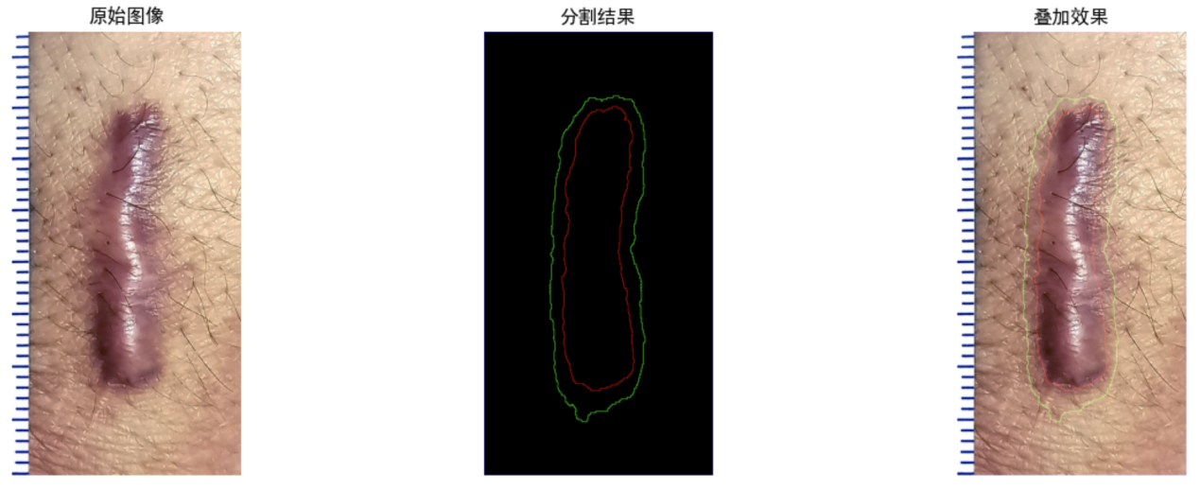
Figure 5. Example results of segmentation using the trained U-Net model.
The region beyond the green curve is normal skin zone, the region between the green and red curve is intertidal zone, and the region within the red curve is keloid body zone.
4.2 Keloid region segmentation
We segment keloid images into three types of regions: normal skin zone, intertidal zone, and keloid body zone. The normal skin zone refers to the skin area that has not been eroded or affected by keloids; the keloid body zone is the area where the skin has been completely infiltrated by keloids; the intertidal zone, proposed in this paper, is the junction area between the normal skin zone and the keloid body zone. According to this definition, for the keloid images captured in Section 4.1, we manually annotated these three types of zones with the assistance of clinicians to construct annotated images containing segmentation labels of the three zones, which can provide supervision for model training (see Fig. XX for an example).
To achieve automatic segmentation of these three zones, we use a custom convolutional U-Net as the basic architecture. RGB images are resized to 256 × 256 pixels before being passed to the network. The encoder contains five double-convolution stages with channel dimensions of 64, 128, 256, 512, and 1024. Each double-convolution stage consists of two 3 × 3 convolutions with padding, batch normalization, and rectified linear-unit activation, and max pooling is used for downsampling. The decoder uses transposed convolutions for upsampling and skip connections to fuse the corresponding encoder features. A final 1 × 1 convolution outputs three-channel pixel logits for the normal skin zone, intertidal zone, and keloid body zone.
In model implementation details, we adopt a data augmentation mechanism: tone adjustments (including brightness, contrast, saturation, and hue) are performed on the original images to enhance the model's robustness to different lighting conditions and white balance. CrossEntropyLoss is used as the loss function for this multi-class segmentation task. The Adam optimizer is adopted with a learning rate set to 0.001 and a batch size of 8, balancing memory usage and gradient stability. Training is conducted for a maximum of 100 epochs. An early stopping mechanism is also employed during the training process to monitor the validation loss, with patience set to 20. The training automatically stops if the validation loss does not improve for 20 consecutive epochs, so as to prevent overfitting and save computing resources. Before texture analysis, the predicted intertidal-zone mask is processed using a 5 × 5 morphological closing operation, dilation with a scale proportional to image height (h/30), erosion with a scale proportional to image height (h/80), and retention of at most the eight largest connected components. Subsequent texture calculations use this post-processed mask rather than the raw class-1 prediction.
4.3 Gabor-gradient domain skin texture analysis for keloid invasive direction
Our clinical practice observes that subtle skin texture alterations in the keloid intertidal zone can effectively reflect the latent growth trends and invasive orientations of keloid lesions. Accordingly, after obtaining precise regional segmentation results in Section 4.2, we target the intertidal zone for dedicated skin texture analysis to quantify keloid invasive areas and their corresponding propagation directions. To achieve fine-grained and reliable invasion evaluation, we develop a novel Gabor-gradient domain texture analysis method. Specifically, our method first performs pixel-level texture feature extraction and pixel-level invasive direction estimation within the Gabor-gradient feature domain. Based on dense per-pixel texture characterization, we further construct three quantitative evaluation indicators, including the severity map, presence map, and direction map, to comprehensively and intuitively quantify the invasive degree, invasive probability region, and invasive direction of keloids.
（1）Pixel-level texture and direction estimation in Gabor-gradient domain
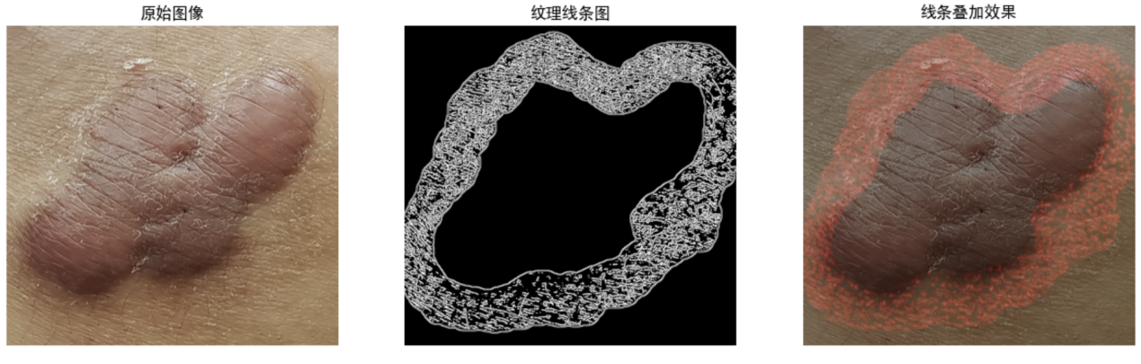
Figure 6. Example results of the extracted texture points within the intertidal zone using the Gabor domain analysis.
1）Gabor domain analysis
To comprehensively extract texture features of different orientations and scales, we design the Gabor filter bank to transfer the input intertidal zone image into the Gabor domain, and the filters in the bank are configured with distinct direction and scale parameters. Specifically, in the direction dimension, there are 4 directions in total (0°, 45°, 90°, 135°), which can cover the main texture directions of the intertidal zone. In the scale dimension, 2 wavelength parameters (10 and 15 pixels) are adopted to capture textures of varying thicknesses. Thus, the Gabor filter bank consists of 8 filters with different direction and scale parameters. The corresponding Gabor feature is expressed as:
$F_{i}=g_{i}(I)$ (1)
The unified parameter configuration for all Gabor filters is as follows: kernel size k= 9×9 pixels, standard deviation =3.0 (which is used to control the filter width), aspect ratio =0.5 (resulting in an elliptical filter), and phase offset =0 (forming a symmetric filter). In the current implementation, each kernel is normalized by dividing its coefficients by 1.5 times the sum of the kernel coefficients.

After obtaining the response of each of the 8 Gabor filters, we linearly superimpose the responses of all 8 filters and perform normalization processing, denoted as NM, to ensure that the output range of the final texture feature map is constrained within [0, 255], i.e.
$FA=NM(\sum_{i}{F_{i}})$ (2)
Subsequently, we binarize the extracted Gabor features. To enhance the robustness of binarization, an adaptive thresholding method is adopted to dynamically calculate the threshold based on local statistics. Specifically, we use the Gaussian Weighted Average method for feature map binarization, with an 11 × 11 local window and subtraction constant C = 2, which introduces a Gaussian distribution-based weight assignment mechanism (i.e., higher weights for central pixels and decreasing weights for edge pixels), i.e.
$FB=GB(FA)$ (3)
To furthermore enhance the texture contour details (such as edge curvature and tiny protrusions) to improve the accuracy of subsequent tasks, we also adopt the Canny operator for edge detection and enhancement, using lower and upper thresholds of 50 and 150, followed by one iteration of dilation with a 3 × 3 kernel, i.e.
F = Dilate(Canny(B; 50, 150), 3 × 3, 1) (4)
The resulting binary texture map F is intersected with the post-processed intertidal-zone mask before subsequent density calculations.
2）Gradient domain analysis
The Gabor feature map has extracted texture information of different directions and widths. To extract texture direction information, we transform it into its gradient domain and estimate the local texture-line orientation from the gradient structure tensor. Specifically, we construct a gradient structure matrix for each point, where it is a 2 × 2 symmetric matrix, and
$$J_{11}(i)=\sum_{j∈Ω(i)}{w(i,j){G_{x}(j)}^{2}}$$
$$J_{22}(i)=\sum_{j∈Ω(i)}{w(i,j){G_{y}(j)}^{2}}$$
J(i) = Σ_{j∈Ω_i} w(i,j) [[G_x(j)^2, G_x(j)G_y(j)], [G_x(j)G_y(j), G_y(j)^2]] (5)
We calculate the x-direction and y-direction gradients of the Gabor feature map using the Scharr operator. To eliminate the influence of noise, all pixel elements in the neighboring region around each point i are considered to build the structure tensor, and the Gaussian weight is defined using the two-dimensional Euclidean distance between pixel coordinates:
w(i,j) = exp(−||x_i − x_j||₂² / (2σ²)) (6)
where σ = max(3, floor(min(H, W)/100)), H and W are the image height and width, respectively, and the height and width of the local window are 6σ + 1.
We adopt the eigenvalue decomposition method to perform eigenvalue decomposition on the gradient structure matrix J of each pixel point i.
J(i) = v(i) · Λ(i) · vᵀ(i) (7)
For the 2×2 gradient structure matrix J(i), v(i) is the 2×2 eigenvector matrix corresponding to point i, and v(i) = [v₁(i) v₂(i)]. Λ(i) is the 2×2 diagonal matrix corresponding to point i, and Λ(i) = [[λ₁(i), 0], [0, λ₂(i)]] (the diagonal elements are the eigenvalues λ₁(i) and λ₂(i)). vᵀ(i) is the transpose of the eigenvector matrix v(i). λ₁(i) is the maximum eigenvalue of J(i), λ₂(i) is the secondary eigenvalue of J(i), i.e. λ₁(i) ≥ λ₂(i). Their corresponding eigenvectors are v₁(i) and v₂(i), respectively. The eigenvector v₁(i) corresponding to the maximum eigenvalue λ₁(i) represents the direction of the strongest local intensity change, which is normal to a line-like texture. Therefore, v₁(i) is rotated by 90° to obtain the local texture direction: θ_texture(i) = [atan2(v₁y(i), v₁x(i)) + π/2] mod π. The resulting direction is an undirected texture axis with 180° periodicity.
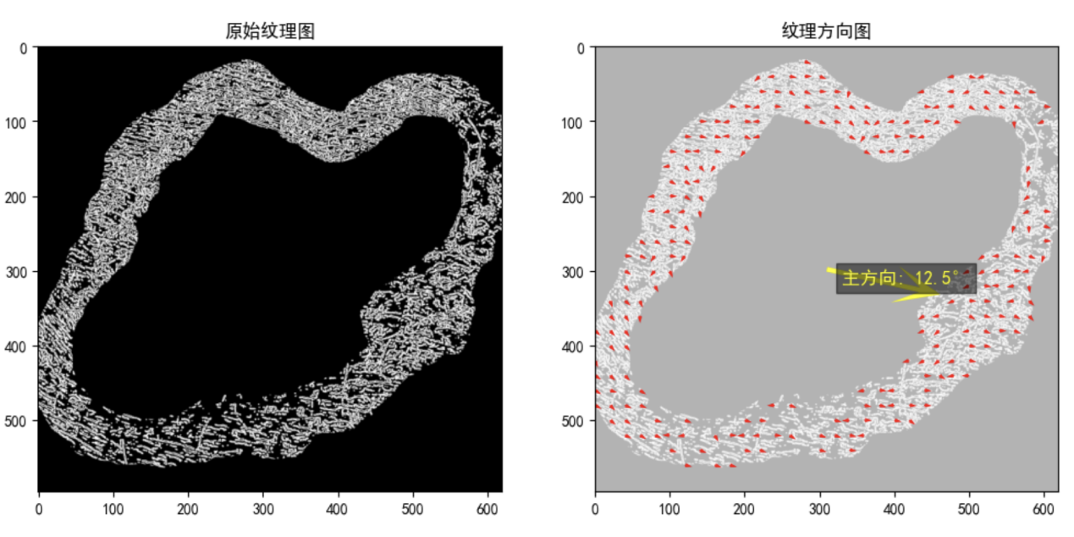
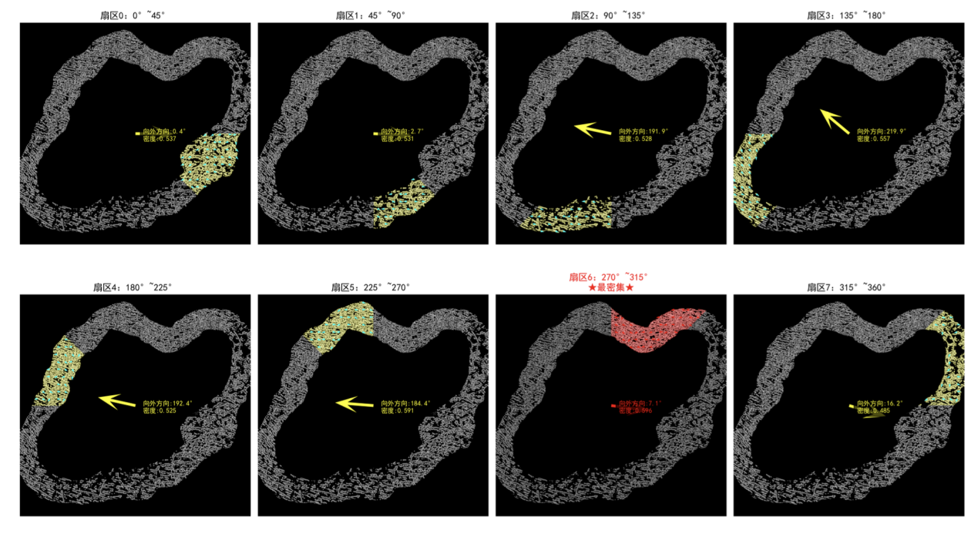
Figure 7. Example results of the estimated texture direction using the gradient domain analysis of the Gabor feature map. We divide the intertidal zone into eight sectors (marked in yellow and red). For each sector, we calculate the region average direction and the region direction consistency. According to the texture density and region direction consistency of each sector, we select the most salient sector (marked in red) and use its region average direction as the main direction of the whole intertidal zone.
（2）Indicators computation
Based on the pixel-level texture and directional features estimated in the Gabor-gradient domain, we first calculate the invasive severity score for each pixel to generate the severity map. Guided by the severity map, we further localize high-risk regions with prominent invasive potential and visualize them as the presence map. For the identified high-risk regions extracted from the presence map, we statistically aggregate pixel-level texture and directional information to estimate the dominant invasive orientation of each region, forming the final direction map. Collectively, the three complementary indicators quantitatively characterize keloid invasion in a hierarchical manner: the severity map reflects the degree of invasion of pixels in the intertidal zone, the presence map pinpoints the spatial high-risk regions of invasive lesions in the intertidal zone, and the direction map reveals the propagation orientation of high-risk regions. In the current implementation, the severity and presence outputs are normalized and thresholded within each image; therefore, they describe relative within-image patterns rather than an absolute invasion scale.

- Computation of Severity Map

The severity map is exclusively calculated within the segmented intertidal zone to quantitatively evaluate the local invasive intensity of keloids. In this work, the invasive severity at each pixel is jointly determined by two critical texture priors: local texture density and orientation consistency. The pixel surrounded by pixels with denser invasive textures and more consistent directional distributions is assigned higher invasion severity score, indicating more active keloid invasive behaviors.
First, we compute the local texture density map. Given the binarized texture map F obtained from the preceding Gabor-gradient feature analysis, we define a circular neighborhood with a binary disk kernel K_r. Unless a fixed radius is specified, the default radius is dynamically scaled according to the image short side as r = clip(round(80 × min(H,W)/920), 12, 96). A two-dimensional convolution operation is performed to statistically count valid texture pixels within each local region. The texture density map is formulated as:
D_s = N_F / (N_M + ε), (8)
where N_F is the number of identified texture pixels within the disk neighborhood and is obtained by
N_F = conv(F, K_r), (9)
N_M represents the total number of valid pixels belonging to the post-processed intertidal-zone mask within the same disk neighborhood and is obtained by
N_M = conv(Mask, K_r). (10)

Second, we quantify the orientation consistency to characterize the uniformity of local orientations. Let θ_k be each finite texture-direction estimate within the valid intertidal-zone neighborhood defined by K_r, as calculated via the Gabor-gradient feature responses by Eqs. (5)-(7). To eliminate the inherent 180° directional periodicity of texture orientation, we convert the angle from degrees to radians and double the angular value:
$α_{k}=2π/180°·θ_{k}$ (11)
where $α_{k}$ is the doubled radian value of $θ_{k}$. Then we calculate the cosine and sine values of all $α_{k}$,
$$cos2=cos⁡(α_{k})$$
$sin2=sin⁡(α_{k})$ (12)
Next, the average cosine and sine responses within the local disk kernel K_r are obtained via normalized convolution,
cos2_mean=conv(cos2,K)/N
sin2_mean=conv(sin2,K)/N (13)
where N_M indicates the number of valid intertidal-zone pixels in the corresponding neighborhood defined by K_r. We then compute the consistency map as
$D_{c}=\sqrt{{{cos2}_{mean}}^{2}+{{sin2}_{mean}}^{2}}$ (14)
Finally, the pixel-level invasion severity score is generated by weighted fusion of the texture density map D_s and orientation consistency map D_c. The default density weight d_w and consistency weight c_w are empirically set to 0.7 and 0.3, respectively. In the Web demonstration interface, user-specified weights are normalized to sum to 1 before calculation:
S_raw = d_w' D_s + c_w' D_c, d_w' = d_w/(d_w+c_w), c_w' = c_w/(d_w+c_w) (15)
The raw severity score is subsequently normalized independently within the valid mask of each image as S(x) = [S_raw(x) − S_min]/[S_max − S_min + ε]. The final output constitutes the normalized severity map S, where higher pixel values correspond to relatively higher texture-based severity within the same image. Because S_min and S_max are calculated separately for every image, equal normalized values in different images do not necessarily indicate equal absolute texture density or biological invasion intensity.
- Computation of Presence Map
The presence map is derived from the pixel-wise severity map $$S$$, aiming to automatically localize the most dominant and high-risk invasive regions within the intertidal zone. Instead of retaining all low-confidence invasive pixels, we screen out the top-ranked invasive areas and preserve only large-scale, clinically meaningful lesion regions to eliminate trivial noise interference.
Two hyperparameters are predefined in this stage: the within-image severity percentile and the top region number TR. Under the default Web-demo settings, the threshold is the 80th percentile of valid intertidal-zone severity values, retaining approximately the highest-scoring 20% of pixels, and TR = 2. The interface allows TR to vary from 1 to 5.
The computation pipeline starts with the generation of a rough presence map. We determine the threshold q_0.80 corresponding to the 80th percentile of severity scores within the valid intertidal-zone mask. Pixels with severity values equal to or exceeding q_0.80 are regarded as candidate high-risk pixels to produce the rough presence map:
P_rough(x) = 1[S(x) ≥ q_0.80] · Mask(x), (16)
where 1[·] denotes the indicator function.
To further screen the most credible and dominant high-risk regions from the rough presence map, we adopt an iterative region-selection strategy to select up to TR connected regions with the highest mean severity. The default candidate-box side length is 80 pixels; when dynamic scaling is enabled, it is calculated as clip(round(80 × min(H,W)/920), 32, 240). Candidate boxes must satisfy a minimum intertidal-zone overlap ratio and avoid previously forbidden regions. For each admissible box, the average regional severity S_mean and intertidal-zone overlap ratio R_overlay are calculated for box evaluation:
S_mean(b) = Σ_{x∈b} S(x)Mask(x) / [Σ_{x∈b} Mask(x) + ε], (17)
The average severity S_mean quantifies the mean normalized severity over valid intertidal-zone pixels inside each candidate box and is the primary ranking criterion among boxes that satisfy the overlap constraint.
R_overlay(b) = Σ_{x∈b} Mask(x) / |b|, (18)
The overlap ratio R_overlay characterizes the effective occupation ratio of intertidal-zone pixels inside each box. It is used as a minimum eligibility constraint and as a secondary criterion for otherwise comparable candidates.
Among the candidate boxes satisfying the minimum overlap constraint, boxes are ranked primarily by mean severity, with overlap ratio used as a secondary ordering criterion. The optimal seed box for the current iteration is determined as:
b_i = argmax_{b: R_overlay(b)≥τ, b∩Forbidden=∅} (S_mean(b), R_overlay(b)). (19)
Within the intersection of the selected box b_i and the valid intertidal-zone mask, the pixel with the largest severity value is used as a seed point x_i. In the full-image rough high-risk map, the single 8-connected component containing x_i is then extracted.
C_i = CC₈(P_rough, x_i). (20)
The selected component is processed using a morphological closing operation with a 7 × 7 elliptical structuring element. Its external contour is filled, and the result is intersected with the valid intertidal-zone mask to obtain the target region R_i:
R_i = Mask ∩ Fill(ExternalContour(Close(C_i, E_7×7))).
Subsequent iterations prohibit candidate-box overlap and apply a forbidden-area mask to previously selected regions; the original severity map and segmentation mask are not directly cleared. (21)

By repeating the above procedure iteratively, we finally obtain up to TR non-overlapping dominant high-risk regions R_1, R_2, ..., R_TR. The aggregation of all screened regions constitutes the final presence map, which highlights the primary relative high-risk areas within the current image.

- Computation of Direction Map
The direction map is designed to characterize the dominant texture orientation for each high-risk region R_i extracted from the presence map. Two related direction visualizations are generated: a region-average direction calculated from all finite orientation estimates within R_i, and a local direction calculated within an independently adjustable circular neighborhood around the arrow origin, with a default radius of 40 pixels. To obtain robust region-level orientations and eliminate the inherent 180° periodicity of the texture axis, we perform vector-based double-angle averaging.
Let θ_k denote the texture direction angle of each valid orientation estimate belonging to the selected regional scope. To resolve the ambiguity caused by 180° periodicity, we first double the angular value:
φ_k = 2θ_k. (22)
We then calculate the mean cosine and sine values of the doubled angles in the selected region to achieve stable angular averaging:
$$cosᾱ=\frac{1}{N}\sum_{k=1}^{N}{cos⁡(α_{k})}$$
C = (1/N)Σ_k cos(φ_k), Q = (1/N)Σ_k sin(φ_k). (23)
where N is the total number of valid orientation estimates in the selected region. The undirected regional texture-axis angle is recovered as
θ_axis = [0.5 atan2(Q, C)] mod π. (24)
Because θ_axis and θ_axis + π represent the same texture axis, texture alone does not identify a unique propagation direction. The arrow origin is selected as the highest-severity point within R_i that also lies in a 10-pixel inner band adjacent to the outer boundary of the valid analysis mask; if this intersection is empty, the highest-severity point within R_i is used. The implementation then uses the outward vector from the keloid-body center to the arrow origin to select between the two opposite directions of the texture axis:
θ_arrow = θ_axis if u_axis · u_out ≥ 0; otherwise θ_axis + π. (25)
By calculating the averaged orientation for every screened high-risk region and orienting the undirected texture axis using the outward spatial prior, we generate the complete direction map. The arrows should therefore be interpreted as outward-oriented candidate invasion directions obtained from the texture axis together with the relative position of the keloid body, rather than as unique directions inferred from texture alone. Arrow length is scaled according to the image short side, and arrow thickness is determined jointly by regional texture density and orientation consistency. Longitudinal follow-up is required to verify agreement between these candidate directions and subsequent lesion growth.

References

. Huang, C. et al. Fibroproliferative conditions: the 3R approach bridging fibrosis and tumors. Trends. Mol. Med. S1471-4914(25)00060-7 (2025).
. Huang, C. et al. Keloidal pathophysiology: Current notions. Scars. Burn. Heal. 7, 2059513120980320 (2021).
. Liu, L. et al. Asporin inhibits collagen matrix-mediated intercellular mechanocommunications between fibroblasts during keloid progression. FASEB. J. 35, e21705 (2021).
. Huang, C. et al. Fibroproliferative disorders and their mechanobiology. Connect. Tissue. Res. 53, 187-196 (2012).
. Huang, C. et al. Mechanotherapy: revisiting physical therapy and recruiting mechanobiology for a new era in medicine. Trends. Mol. Med. 19, 555-564 (2013).
. Huang, C., Quong, W.L., Kamii, Y., Ogawa, R. Ideal ssurgical incision lines minimizing tension: a proposal based on observations of hypertrophic scars and keloids. Plast. Reconstr. Surg. Glob. Open. 13, e7344 (2025).
. Huang C., Ogawa, R. Chapter 36. The Square Flap Method. In: Color Atlas of Burn Reconstructive Surgery. Springer, 2025.
. Carrière, M.E. et al, Scar Assessment Scales. In: Textbook on Scar Management: State of the Art Management and Emerging Technologies [Internet]. Cham (CH): Springer; 2020. Chapter 14.
. Ogawa, R. et al. Japan scar workshop (JSW) scar scale (JSS) for assessing keloids and hypertrophic scars. In Textbook on Scar Management: State of the Art Management and Emerging Technologies [Internet]. Cham (CH): Springer; 2020. Chapter 15.
. Song, A. H. et al. Analysis of 3D pathology samples using weakly supervised AI. Cell. 187, 2502-2520.e17 (2024).
Luo, L. et al. A large model for non-invasive and personalized management of breast cancer from multiparametric MRI. Nat. Commun. 16, 3647 (2025)

