Programming Assignment HW4
Name: Amna Malik ID: R11827604
Problem-1
(Your Codes)
RoomDimension.java
package q1;
/**
* The RoomDimension class stores the length and width of a room.
* It can calculate and return the area of the room in square feet.
*/
public class RoomDimension {
// Stores the length of the room.
private double length;
// Stores the width of the room.
private double width;
/**
* Constructs a RoomDimension object with the given length and width.
*
* @param len the length of the room
* @param w the width of the room
*/
public RoomDimension(double len, double w) {
length = len;
width = w;
}
/**
* Calculates and returns the area of the room.
*
* @return the area of the room in square feet
*/
public double getArea() {
return length * width;
}
/**
* Returns a string representation of the room dimensions.
*
* @return a string containing the room length and width
*/
@Override
public String toString() {
return "Length: " + length + " ft, Width: " + width + " ft";
}
}

RoomCarpet.java
package q1;
/**
* The RoomCarpet class stores information about carpeting for a room.
* It contains a RoomDimension object and the carpet cost per square foot.
* It can calculate the total cost of carpeting the room.
*/
public class RoomCarpet {
// Stores the dimensions of the room.
private RoomDimension size;
// Stores the carpet cost per square foot.
private double carpetCost;
/**
* Constructs a RoomCarpet object with room dimensions and carpet cost.
*
* @param dim the RoomDimension object for the room
* @param cost the carpet cost per square foot
*/
public RoomCarpet(RoomDimension dim, double cost) {
size = dim;
carpetCost = cost;
}
/**
* Calculates and returns the total carpet cost for the room.
*
* @return the total cost of the carpet
*/
public double getTotalCost() {
return size.getArea() * carpetCost;
}
/**
* Returns a string representation of the carpet information.
*
* @return a string containing room details, carpet cost, and total cost
*/
@Override
public String toString() {
return size.toString()
+ "\nCarpet Cost per Square Foot: $" + carpetCost
+ "\nCarpet Cost per Square Foot: $" + String.format("%.2f", carpetCost);}
}

Question1Demo.java
import q1.RoomCarpet;
import q1.RoomDimension;
import java.util.Scanner;
/**
* The Question1Demo class is the driver program for the carpet cost application.
* It asks the user for room dimensions and carpet price, then displays total cost.
*/
public class Question1Demo {
/**
* The main method gets user input, creates objects, and displays results.
*
* @param args command-line arguments
*/
public static void main(String[] args) {
Scanner keyboard = new Scanner(System.in);
double length;
double width;
double costPerSquareFoot;
System.out.print("Enter the length of the room in feet: ");
length = keyboard.nextDouble();
System.out.print("Enter the width of the room in feet: ");
width = keyboard.nextDouble();
System.out.print("Enter the carpet cost per square foot: ");
costPerSquareFoot = keyboard.nextDouble();
RoomDimension room = new RoomDimension(length, width);
RoomCarpet carpet = new RoomCarpet(room, costPerSquareFoot);
System.out.println("\nRoom Carpet Information");
System.out.println("-----------------------");
System.out.println(carpet);
keyboard.close();
}
}

(Output- screenshots)
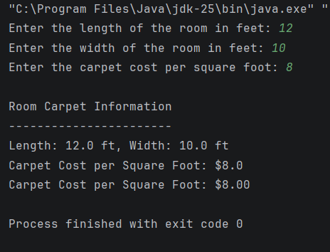

Problem-2
(Your Codes)
Month.java
package q2;
/**
* The Month class stores the number of a month and provides
* methods to get the month name and compare months.
*/
public class Month {
// Stores the number of the month.
private int monthNumber;
/**
* No-arg constructor sets monthNumber to 1.
*/
public Month() {
monthNumber = 1;
}
/**
* Constructor that accepts a month number.
* If invalid, sets to 1.
*
* @param month the month number
*/
public Month(int month) {
if (month >= 1 && month <= 12) {
monthNumber = month;
} else {
monthNumber = 1;
}
}
/**
* Constructor that accepts a month name.
*
* @param name the month name
*/
public Month(String name) {
setMonthFromName(name);
}
/**
* Sets the month number.
*
* @param month the month number
*/
public void setMonthNumber(int month) {
if (month >= 1 && month <= 12) {
monthNumber = month;
} else {
monthNumber = 1;
}
}
/**
* Returns the month number.
*
* @return month number
*/
public int getMonthNumber() {
return monthNumber;
}
/**
* Returns the name of the month.
*
* @return month name
*/
public String getMonthName() {
String[] months = {
"January", "February", "March", "April",
"May", "June", "July", "August",
"September", "October", "November", "December"
};
return months[monthNumber - 1];
}
/**
* Returns the month name.
*
* @return month name
*/
@Override
public String toString() {
return getMonthName();
}
/**
* Checks if months are equal.
*
* @param other another Month object
* @return true if equal
*/
public boolean equals(Month other) {
return this.monthNumber == other.monthNumber;
}
/**
* Checks if this month is greater.
*
* @param other another Month object
* @return true if greater
*/
public boolean greaterThan(Month other) {
return this.monthNumber > other.monthNumber;
}
/**
* Checks if this month is less.
*
* @param other another Month object
* @return true if less
*/
public boolean lessThan(Month other) {
return this.monthNumber < other.monthNumber;
}
/**
* Converts a month name to its number.
*
* @param name the month name
*/
private void setMonthFromName(String name) {
String[] months = {
"January", "February", "March", "April",
"May", "June", "July", "August",
"September", "October", "November", "December"
};
for (int i = 0; i < months.length; i++) {
if (months[i].equalsIgnoreCase(name)) {
monthNumber = i + 1;
return;
}
}
monthNumber = 1;
}
}

Question2Demo.java
package q2;
/**
* Demonstrates the Month class.
*/
public class Question2Demo {
/**
* Main method to test Month class.
*
* @param args command-line arguments
*/
public static void main(String[] args) {
Month m1 = new Month(1); // January
Month m2 = new Month(7); // July
Month m3 = new Month("March"); // March
System.out.println("Month 1: " + m1 + " (" + m1.getMonthNumber() + ")");
System.out.println("Month 2: " + m2 + " (" + m2.getMonthNumber() + ")");
System.out.println("Month 3: " + m3 + " (" + m3.getMonthNumber() + ")");
System.out.println("\nComparisons:");
System.out.println("m1 equals m3: " + m1.equals(m3));
System.out.println("m2 greater than m3: " + m2.greaterThan(m3));
System.out.println("m1 less than m2: " + m1.lessThan(m2));
}
}
(Output- screenshots)
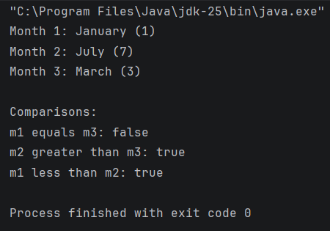
Problem-4
(Your Codes)
Date.java
package q3;
import q2.Month;
/**
* The Date class represents an immutable date.
* It stores a month, day, and year and validates input values.
*/
public final class Date {
// Stores the month using the Month class.
private final Month month;
// Stores the day of the month.
private final int day;
// Stores the year.
private final int year;
/**
* Constructor that accepts month, day, and year.
* Validates all values.
*
* @param m the month (1-12)
* @param d the day
* @param y the year
*/
public Date(int m, int d, int y) {
// Validate month
if (m < 1 || m > 12) {
m = 1;
}
this.month = new Month(m);
// Validate year (cannot be 0)
if (y == 0) {
y = 1;
}
this.year = y;
// Validate day based on month
int maxDays = getDaysInMonth(m);
if (d < 1 || d > maxDays) {
d = 1;
}
this.day = d;
}
/**
* Copy constructor.
*
* @param other another Date object
*/
public Date(Date other) {
this.month = new Month(other.month.getMonthNumber());
this.day = other.day;
this.year = other.year;
}
/**
* Returns the number of days in a given month.
*
* @param m the month number
* @return number of days
*/
private int getDaysInMonth(int m) {
switch (m) {
case 2:
return 28;
case 4: case 6: case 9: case 11:
return 30;
default:
return 31;
}
}
/**
* Returns the date as a formatted string.
*
* @return formatted date string
*/
@Override
public String toString() {
return month.getMonthName() + " " + day + ", " + year;
}
}
Question3Demo.java
package q3;
import java.util.Scanner;
/**
* Demonstrates the Date class using user input.
*/
public class Question3Demo {
/**
* Main method asks user for a date and displays it.
*
* @param args command-line arguments
*/
public static void main(String[] args) {
Scanner keyboard = new Scanner(System.in);
System.out.print("Enter month (1-12): ");
int month = keyboard.nextInt();
System.out.print("Enter day: ");
int day = keyboard.nextInt();
System.out.print("Enter year: ");
int year = keyboard.nextInt();
Date date = new Date(month, day, year);
System.out.println("\nFormatted Date:");
System.out.println(date);
keyboard.close();
}
}
(Output- screenshots)
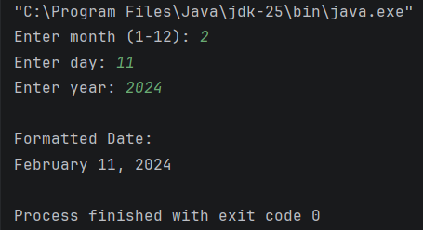

Problem-4
(UML)
