Data Science Term Project Final Report
Used Car Fair Price Prediction and Deal Detection
Final English Report with Presentation Feedback Reflected
Item | Description
Team | Team 2
Members | Jeong Moonsok (정문석), Lee Jaeseo (이재서), Lim Junseo (임준서)
Course | Data Science
Submission | Final Report
GitHub Repository | https://github.com/moonsokC/DataScience_project

This final report reflects the presentation feedback by adding an XGBoost experiment, clarifying the rationale for Ridge Regression, and including team contribution and individual learning notes.

Contents
1. Project Objective
2. Dataset and Sampling
3. Data Inspection
4. Data Preprocessing and Feature Engineering
5. Modeling Strategy and Ridge Regression Rationale
6. Evaluation Metrics
7. Presentation-Stage Results: Random Forest
8. Feedback-Applied Additional Experiment: XGBoost
9. Deal Detection Result
10. Error Analysis and Interpretation
11. Open-Source SW Contribution
12. Limitations and Future Work
13. Team Contribution and Individual Learning Notes
14. Conclusion
References
Appendix: Library and Function Explanation

1. Project Objective
The objective of this project is to predict fair market prices for used cars using Craigslist vehicle listing data and to identify potentially overpriced or underpriced listings by comparing the actual listed price with the model-predicted fair price. Used car prices are affected by many factors, including vehicle year, mileage, manufacturer, condition, fuel type, transmission, drive type, vehicle type, and region. Because ordinary buyers often do not have enough information to judge whether a listed price is reasonable, a data-driven fair price estimation system can support more rational purchase decisions.
This project is defined as a supervised regression problem. The target attribute is `price`, which is the listed price of each used car. The model predicts a continuous numerical value. The `price_gap` used in the deal detection stage is not the target variable; it is a post-analysis metric calculated after prediction.
According to the updated instruction from the professor, this project focuses on one learning type: regression. Underpriced and overpriced detection is therefore not implemented as a separate classification model. Instead, it is a rule-based post-analysis based on the regression output.
Item | Definition
Target attribute | `price`
Problem type | Supervised regression
Predicted output | Predicted fair price of a used car
Price Gap | Actual Price - Predicted Price
Positive Gap | Actual price is higher than predicted fair price: potentially overpriced
Negative Gap | Actual price is lower than predicted fair price: potentially underpriced or a bargain

2. Dataset and Sampling
The dataset used in this project is the Craigslist vehicles listing dataset from Kaggle. The original `vehicles.csv` file contains 426,880 records and 26 columns, including price, manufacturer, model, year, odometer, vehicle condition, fuel type, transmission, drive type, vehicle type, and location-related information.
Because the original dataset is large, repeatedly training models on the full file would require unnecessary computation. Therefore, we first created a reproducible random sample of 20,000 records using random seed 42. Importantly, no cleaning was performed before sampling. This preserved missing values and outliers so that dirty data could be handled in the preprocessing stage rather than being removed before inspection.
The sampled dataset satisfies the project requirements because it contains more than 1,000 records, more than 10 features, a reasonable amount of dirty data, and a mixture of numerical and categorical variables.
Dataset Stage | Rows | Columns | Description
Raw dataset | 426,880 | 26 | Kaggle Craigslist vehicles dataset
Random sample | 20,000 | 26 | Random seed 42; no cleaning before sampling
Cleaned modeling dataset | 16,921 | 25 | After dirty data handling and feature engineering

3. Data Inspection
After sampling, we inspected the dataset shape, data types, missing values, target distribution, categorical cardinality, and numerical outliers. The sampled dataset contained 7 numerical columns and 19 categorical columns. The total number of missing values was 76,335. Columns such as `county`, `size`, `cylinders`, `condition`, `VIN`, `drive`, `paint_color`, and `type` contained many missing values, confirming that the dataset includes messy real-world data.
Column | Missing Count | Missing Ratio
county | 20,000 | 100.00%
size | 14,268 | 71.34%
cylinders | 8,231 | 41.16%
condition | 7,669 | 38.35%
VIN | 7,473 | 37.37%
drive | 6,239 | 31.20%
paint_color | 5,942 | 29.71%
type | 3,954 | 19.77%
manufacturer | 877 | 4.39%

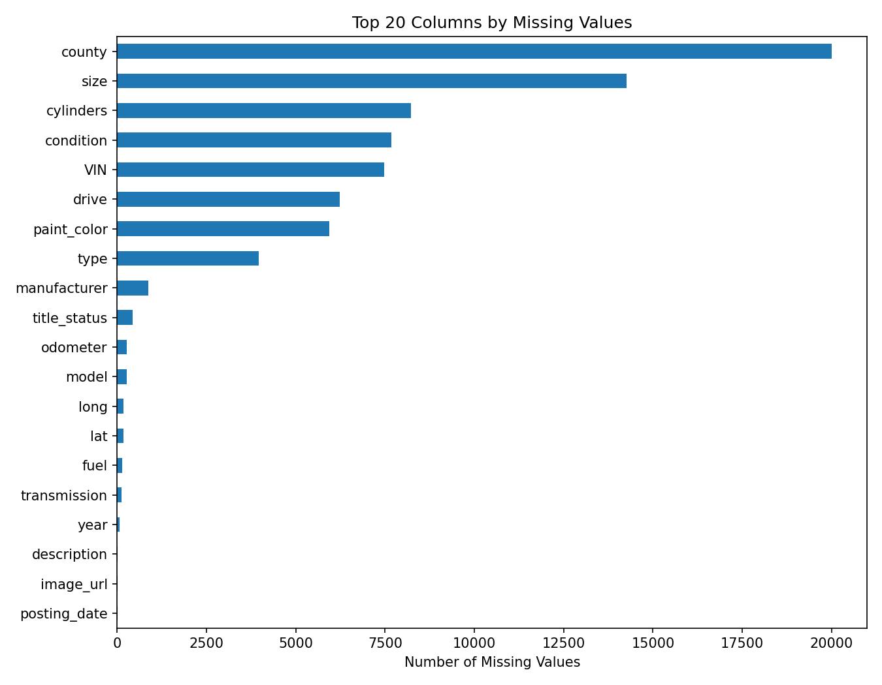
Figure 1. Top missing-value columns in the sampled dataset
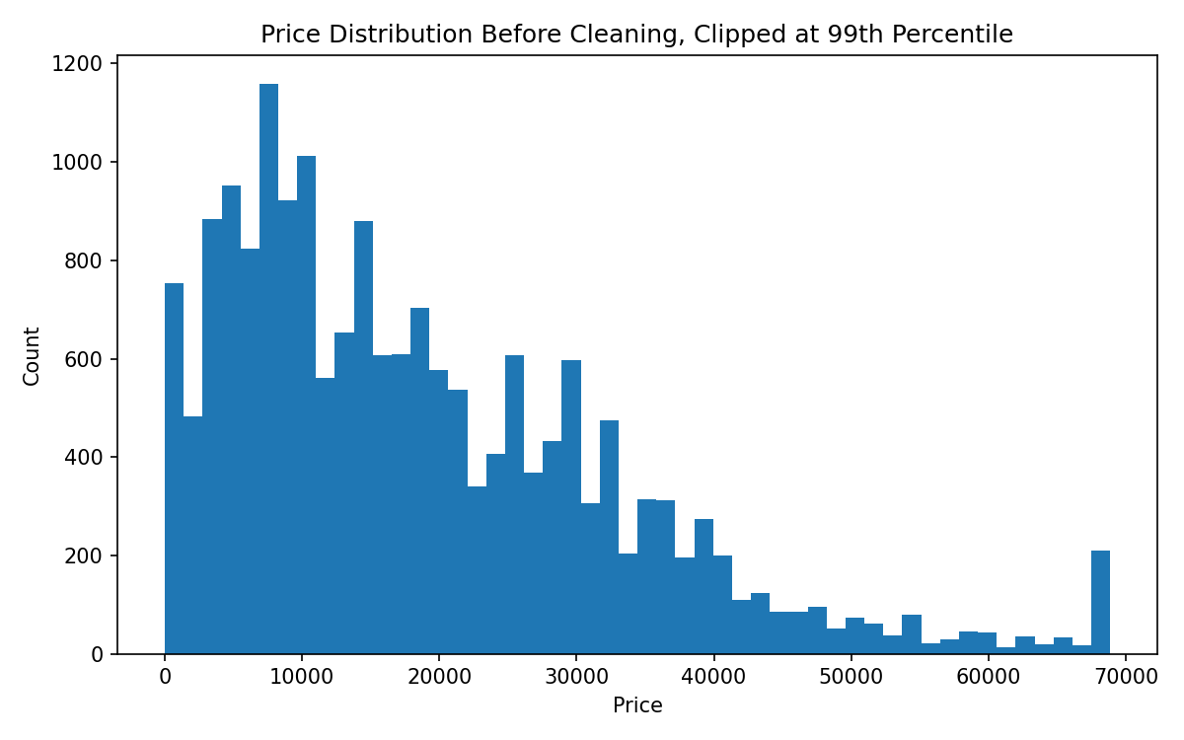
Figure 2. Price distribution before cleaning
The original price distribution included zero or extremely low prices as well as very high listings. Some of these values may represent typos, down payments, promotional listings, or deposits rather than realistic vehicle prices. Such values can distort regression training and especially MAPE, because percentage-based errors become unstable for very low actual prices.

4. Data Preprocessing and Feature Engineering
The preprocessing stage was implemented as a reproducible function. It included target filtering, invalid value removal, feature dropping, missing-value handling, feature engineering, and rare-category grouping.
At first, we used a minimum price threshold of $500. However, very low-priced listings strongly distorted MAPE and deal detection examples. In the final experiment, listings under $2,000 were excluded. Even after applying this threshold, 16,921 records remained, which still satisfies the dataset size requirement.
Preprocessing Item | Method
Price filtering | Minimum price threshold of $2,000; upper bound based on the 99th percentile ($68,873.12)
Year filtering | Removed vehicles before 1980 and abnormal model years
Odometer filtering | Removed negative values and values over 500,000 miles
Dropped columns | `id`, `url`, `region_url`, `VIN`, `image_url`, `county`, `description`, `posting_date`
Missing numerical values | Median imputation inside the model pipeline
Missing categorical values | Replaced with `Unknown`
Rare categories | Low-frequency categories grouped into `Other`

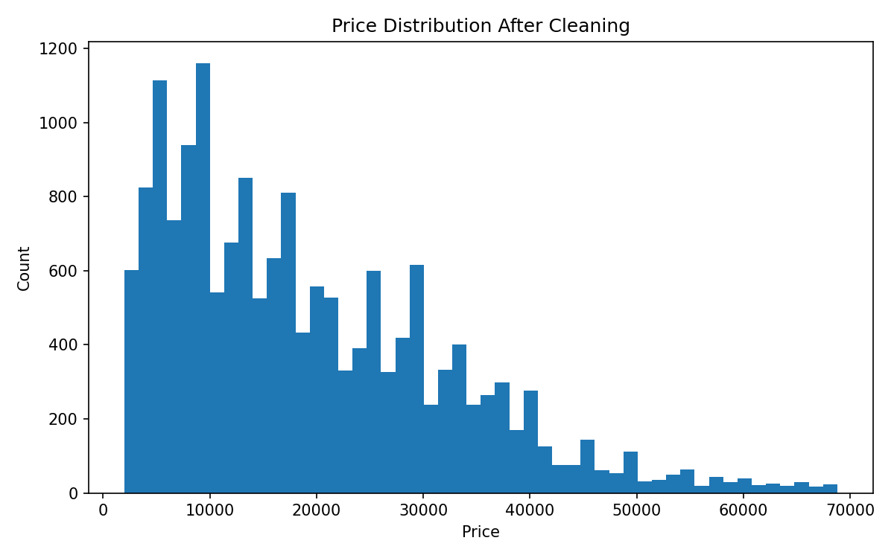
Figure 3. Price distribution after cleaning
Feature engineering was used to represent vehicle aging, usage intensity, seller information richness, and listing timing, which are not fully captured by raw columns alone.
Engineered Feature | Meaning
car_age | posting_year - vehicle year; represents vehicle age
odometer_per_year | odometer divided by car_age; represents average annual mileage
is_high_mileage | Binary feature indicating whether the vehicle has high mileage
posting_month | Listing month; may reflect seasonal or market timing effects
description_length | Length of the listing description; proxy for seller-provided information
manufacturer_frequency | Frequency of each manufacturer in the dataset

5. Modeling Strategy and Ridge Regression Rationale
The project compared several regression models. The purpose was not only to find a high-performing model, but also to assign a clear methodological role to each model.
Model | Role in Experiment | Reason
DummyRegressor | Baseline | Simple benchmark that predicts the central tendency of the target
Ridge Regression | Regularized linear baseline | Stable linear comparison model for a high-dimensional one-hot encoded feature space
Random Forest Regressor | Nonlinear ensemble model | Captures nonlinear relationships and interactions among vehicle features
XGBoost Regressor | Feedback-applied boosted-tree model | Added after presentation feedback to test gradient boosting performance

5.1 Why Ridge Regression Was Used
After the presentation, the professor asked why Ridge Regression was included. In this final report, we clarify its role. Ridge Regression was not included because we expected it to be the final best model. It was included as a regularized linear baseline.
After categorical variables such as manufacturer, model, condition, fuel, transmission, drive, type, state, and region are transformed by OneHotEncoder, the feature space becomes high-dimensional and sparse. Some encoded features can also be correlated. In this situation, ordinary Linear Regression can become unstable because coefficients may become too large. Ridge Regression addresses this issue by applying L2 regularization, which penalizes large coefficients and stabilizes the linear model.
The Ridge objective can be expressed as:
Loss = MSE + alpha * sum(beta_j^2)
Therefore, Ridge Regression was used to answer the following methodological question: Is a regularized linear model sufficient for used-car price prediction, or do nonlinear ensemble models provide a clear advantage? In our experiment, Ridge Regression performed much better than DummyRegressor, which showed that the features contained useful predictive information. However, Ridge performed worse than Random Forest and XGBoost, suggesting that the relationship between vehicle features and price is not purely linear and that nonlinear interactions are important.

5.2 Pipeline Design
Numerical features were processed with median imputation followed by StandardScaler or RobustScaler. Categorical features were processed by replacing missing values with `Unknown` and then applying OneHotEncoder. Imputation, scaling, and encoding were performed inside scikit-learn Pipeline and ColumnTransformer objects so that the same preprocessing logic would be applied consistently during cross-validation and holdout testing.

6. Evaluation Metrics
The data was split into training and holdout test sets. Within the training set, we used 5-fold cross-validation. Final performance was evaluated on the holdout test set using MAE, RMSE, R², and MAPE.
Metric | Meaning | Reason for Use
MAE | Mean Absolute Error | Easy to interpret as the average dollar error
RMSE | Root Mean Squared Error | Penalizes large prediction errors more strongly
R² | Coefficient of determination | Measures the proportion of price variation explained by the model
MAPE | Mean Absolute Percentage Error | Shows relative error, but is sensitive to low-priced listings

7. Presentation-Stage Results: Random Forest
In the presentation-stage experiment, we compared DummyRegressor, Ridge Regression, and Random Forest Regressor. Among these models, StandardScaler + RandomForestRegressor achieved the best performance and was selected as the presentation-stage best model.
Random Forest achieved a Test R² of 0.8339, a Test MAE of about $3,689, and a Test RMSE of about $5,468. It outperformed Ridge Regression in MAE, RMSE, and R², indicating that a nonlinear ensemble model is more suitable than a linear baseline for this used-car price prediction task.
Experiment | Scaler | Test MAE | Test RMSE | Test R² | Test MAPE
DummyRegressor | standard | $10,687.16 | $13,949.70 | -0.0812 | 83.78%
Ridge Regression | standard | $5,161.66 | $7,164.10 | 0.7148 | 44.49%
Random Forest | standard | $3,688.99 | $5,467.53 | 0.8339 | 27.88%
Random Forest | robust | $3,690.01 | $5,473.11 | 0.8336 | 27.90%

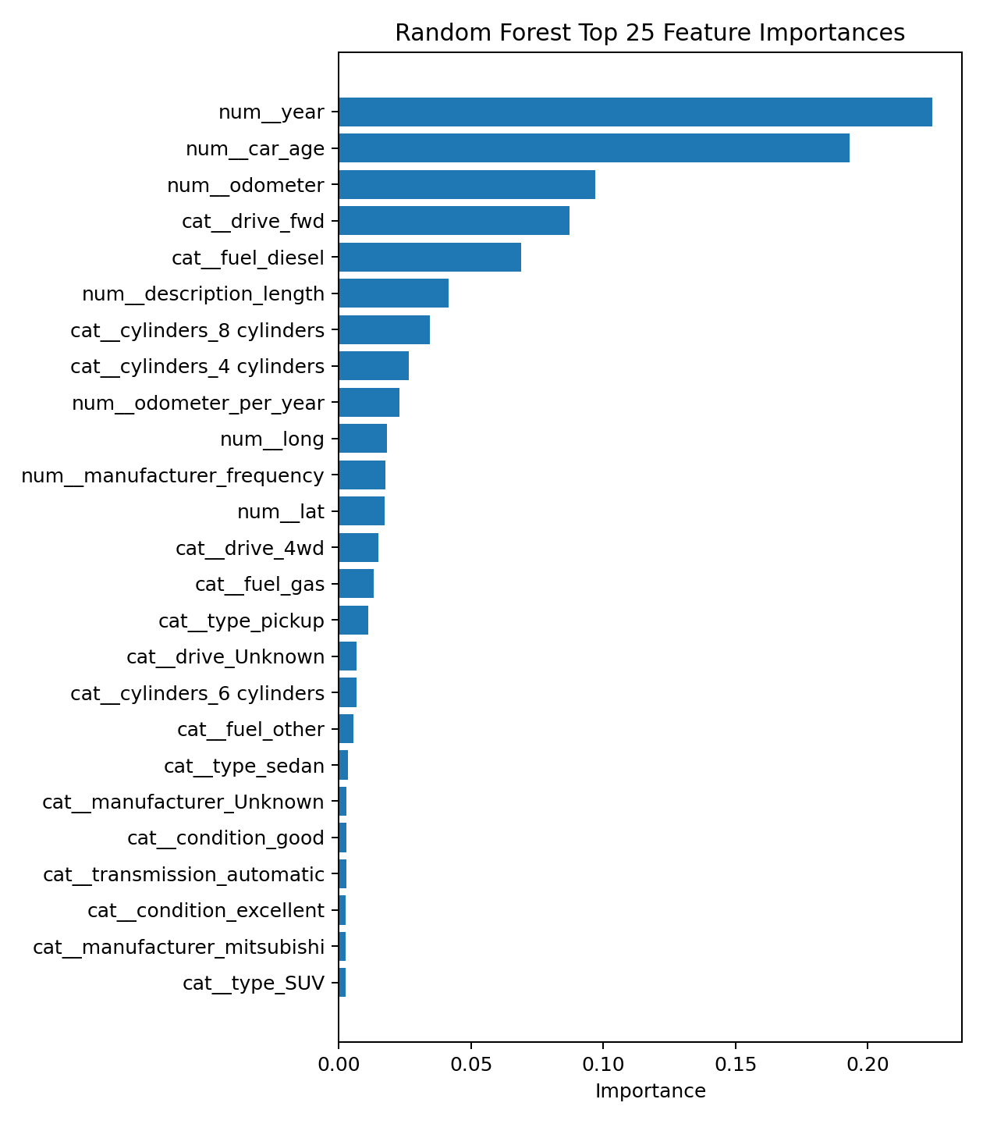
Figure 4. Random Forest feature importance
The Random Forest feature importance result showed that year, car_age, and odometer were the most important features. This is consistent with real-world used-car pricing logic because vehicle age and usage intensity strongly affect price. Structural features such as drive type, fuel type, cylinders, and vehicle type also contributed to prediction.

8. Feedback-Applied Additional Experiment: XGBoost
After the presentation, we received feedback that teams that had not used XGBoost should add an XGBoost experiment and include the result in the final report. We therefore performed an additional XGBoost Regressor experiment using the same cleaned modeling dataset. The target remained `price`, so the task remained supervised regression.
For a fair comparison with the previous pipeline, the main XGBoost experiment used StandardScaler for numerical features and OneHotEncoder for categorical features. The XGBoost parameters were set to n_estimators=400, max_depth=5, learning_rate=0.06, subsample=0.85, colsample_bytree=0.85, reg_lambda=1.0, and tree_method=hist.
XGBoost + OneHotEncoder achieved a Test MAE of $3,590.57, a Test RMSE of $5,233.80, a Test R² of 0.8478, and a Test MAPE of 26.39%. Compared with the previous Random Forest model, XGBoost improved all main evaluation metrics. Therefore, after applying the presentation feedback, XGBoost is presented as the strongest final model in this report.
Model | Encoder | Test MAE | Test RMSE | Test R² | Test MAPE
XGBoost | OneHotEncoder | $3,590.57 | $5,233.80 | 0.8478 | 26.39%
Random Forest | OneHotEncoder | $3,688.99 | $5,467.53 | 0.8339 | 27.88%
Ridge Regression | OneHotEncoder | $5,161.66 | $7,164.10 | 0.7148 | 44.49%
DummyRegressor | OneHotEncoder | $10,687.16 | $13,949.70 | -0.0812 | 83.78%

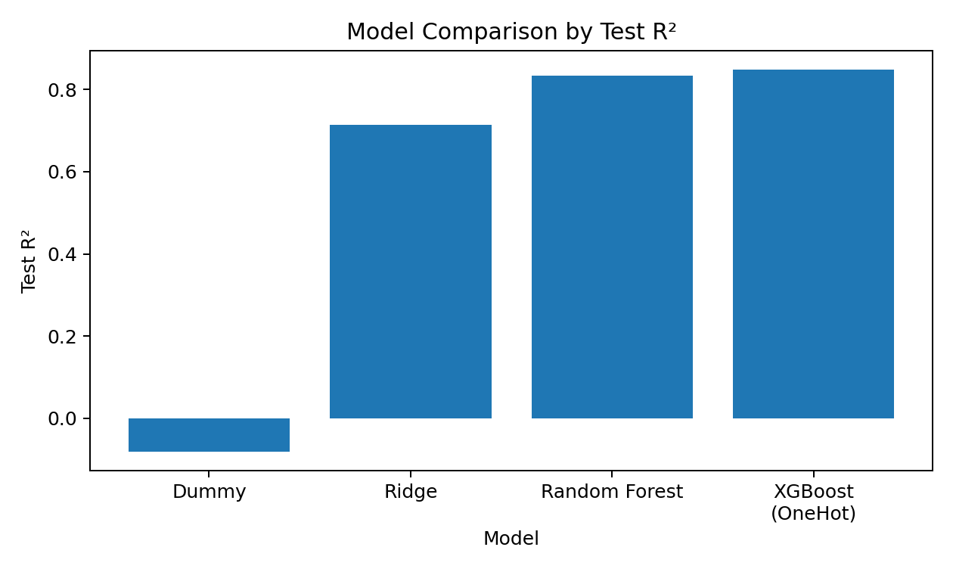
Figure 5. Model comparison by Test R²
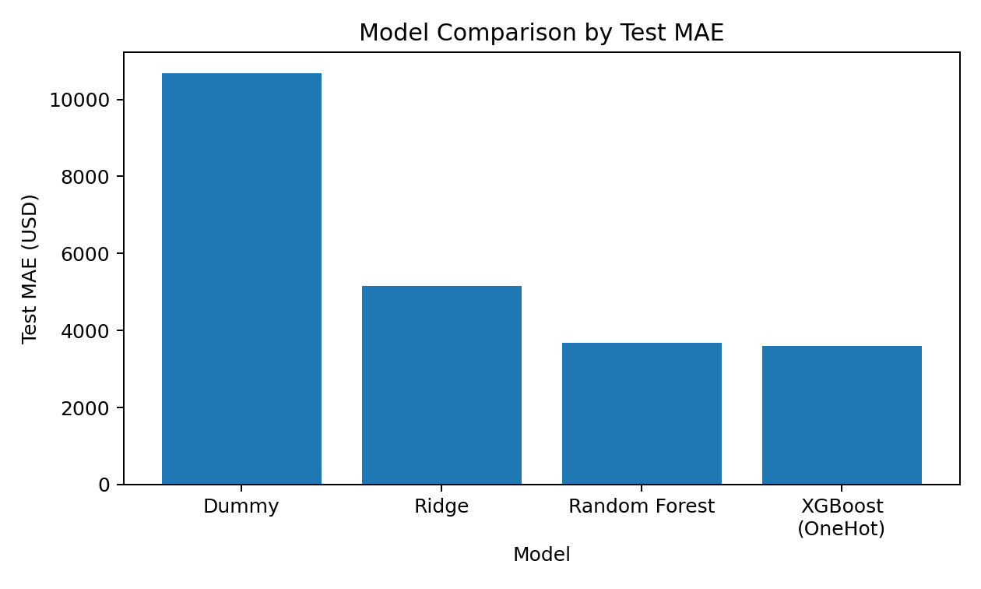
Figure 6. Model comparison by Test MAE
We also tested a tree-optimized XGBoost version with OrdinalEncoder. This version achieved a Test R² of 0.8584 and a Test MAE of $3,486.65, which was the highest numerical performance. However, because nominal categorical variables can receive artificial ordering under ordinal encoding, the main comparison in this report focuses on the OneHotEncoder result, which is consistent with the previous preprocessing pipeline.
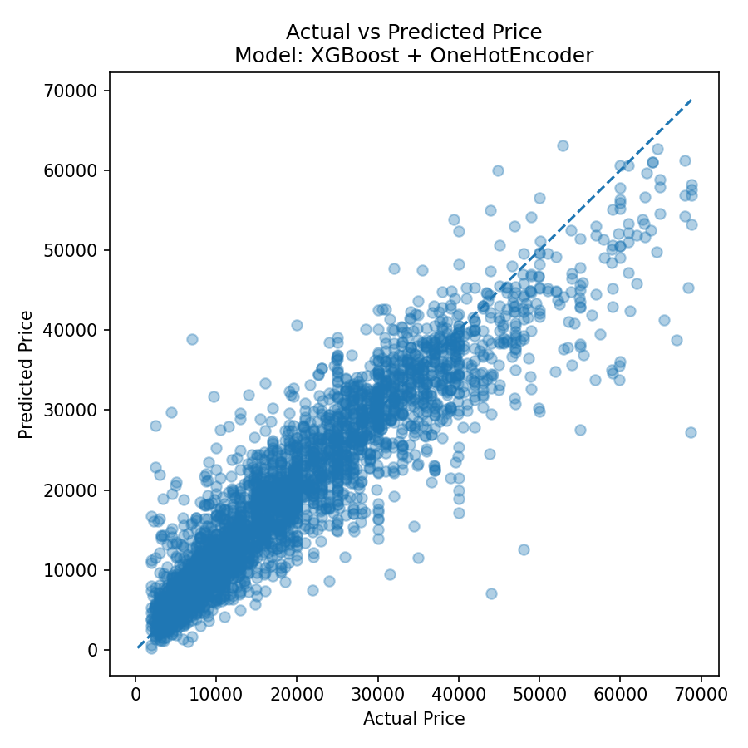
Figure 7. XGBoost actual vs. predicted price
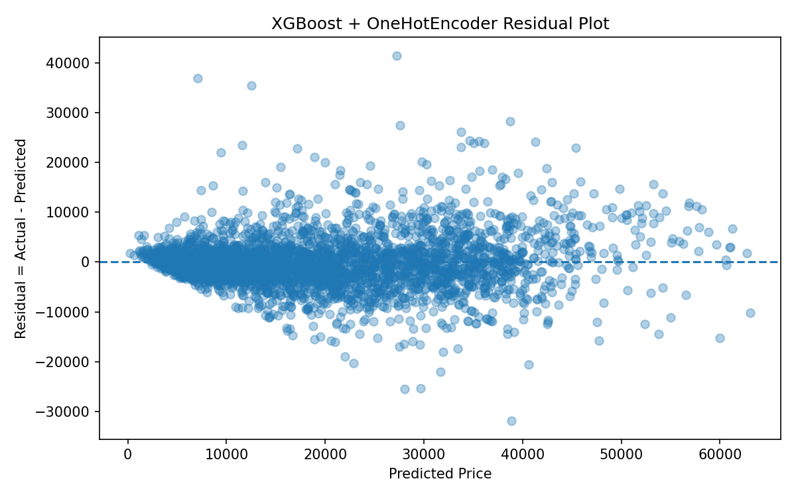
Figure 8. XGBoost residual plot
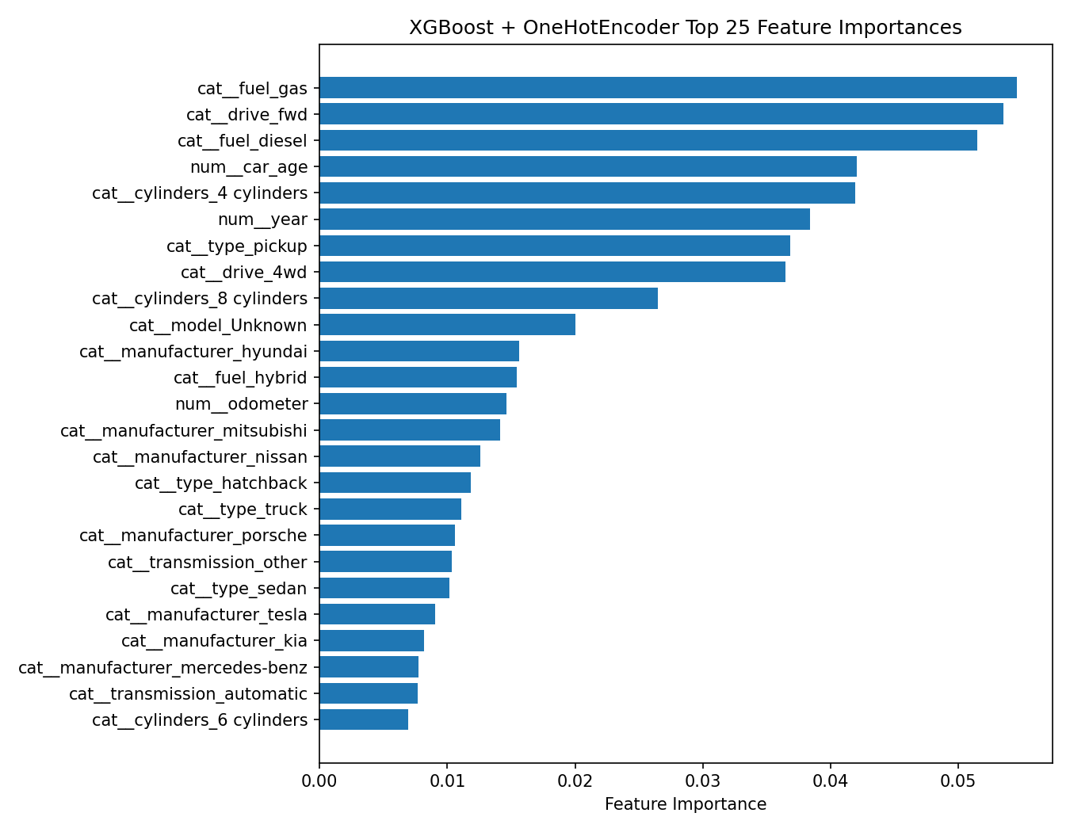
Figure 9. XGBoost feature importance

9. Deal Detection Result
Using the predicted prices from the final regression model, we calculated the price gap as follows: price_gap = actual_price - predicted_price. If the value is positive, the actual listing price is higher than the model-predicted fair price, so the listing may be overpriced. If the value is negative, the actual listing price is lower than the predicted fair price, so the listing may be underpriced or a potential bargain.
The following table shows underpriced candidate examples based on the XGBoost result. These examples should be interpreted as model-based candidates only. Actual purchase decisions require additional verification such as accident history, maintenance records, options, and physical vehicle condition.
Vehicle | Odometer | Condition | State | Actual | Predicted | Gap
CHEVROLET Silverado (2021) | 6,711 | Unknown | CA | $7,000.00 | $38,876.79 | -$31,876.79
FIAT Other (2017) | 19,476 | excellent | CA | $9,695.00 | $31,668.19 | -$21,973.19
AUDI Other (2015) | 96,200 | like new | CA | $19,999.00 | $40,631.48 | -$20,632.48

The following table shows overpriced candidate examples. A positive gap means that the actual listed price is higher than the predicted fair price.
Vehicle | Odometer | Condition | State | Actual | Predicted | Gap
AUDI Other (2011) | 55,293 | Unknown | CA | $68,750.00 | $27,265.32 | $41,484.68
JEEP Other (1986) | 350,000 | excellent | CA | $44,000.00 | $7,087.52 | $36,912.48
UNKNOWN Other (2000) | 177,581 | good | CA | $48,000.00 | $12,535.57 | $35,464.43

Deal detection is not a separate classification model. It is a post-analysis that uses regression output. Therefore, labels such as bargain or overpriced should be understood as candidate flags rather than final purchase recommendations.

10. Error Analysis and Interpretation
In the actual-vs-predicted plot, most points are distributed near the diagonal line, indicating that the model learned the overall relationship between listing features and price. However, the residual variance tends to increase for higher-priced vehicles. This may be because high-priced vehicles are more affected by missing hidden variables such as trim level, accident history, rare options, vehicle condition, and local demand.
The residual plot is generally centered around zero, which suggests that there is no strong systematic bias. However, prediction uncertainty is not equal across all price ranges, and high-priced vehicles show larger error variance.
MAPE is very sensitive to low-priced listings. For example, if a vehicle with a low actual price has an error of several thousand dollars, the percentage error can become very large. For this reason, we interpret MAE, RMSE, and R² as the main metrics, and use MAPE as a supplementary metric.

11. Open-Source SW Contribution
The project code and outputs were organized in a GitHub repository:
GitHub: https://github.com/moonsokC/DataScience_project
To satisfy the open-source software contribution requirement, we implemented preprocessing, scaling/encoding, model training/testing, parameter comparison, and evaluation inside a reusable top-level function for a cleaned dataset.
The main function, `run_used_car_regression_experiments()`, accepts parameters such as scalers, models, cv, test_size, and random_state. It automatically executes experiment combinations and returns a leaderboard, best_model, cv_results, test_metrics, and feature_importance. The function was documented in a style similar to Pandas and Scikit-learn documentation.
File / Folder | Description
src/used_car_project_pipeline.py | Functions for data loading, inspection, cleaning, feature engineering, regression experiments, and output saving
scripts/create_random_sample.py | Creates a reproducible random sample of 20,000 records from the original vehicles.csv
scripts/run_xgboost_experiment.py | Runs the feedback-applied XGBoost additional experiment
outputs_minprice_2000/ | Presentation-stage Random Forest results
outputs_xgboost/ | Additional XGBoost experiment results
docs/function_specification.md | User manual and specification for the main top-level function

12. Limitations and Future Work
Limitation | Explanation
Listing price vs. transaction price | The target `price` is the seller listing price, not the final transaction price. Negotiated prices may differ.
Missing hidden variables | Important variables such as accident history, maintenance records, ownership count, trim level, options, and exterior/interior condition are unavailable.
Regional market differences | Vehicle demand, climate, income levels, and preferred vehicle types can differ by state or region. Localized models may improve accuracy.
Noisy listings | Craigslist listings may include typos, down payments, promotional listings, or deposits.
Interpretation of deal detection | Price gap is a candidate detection metric and cannot fully replace expert inspection or domain knowledge.

Future work could include linking the model to actual transaction datasets, adding accident and maintenance records, building region-specific or state-level models, incorporating image-based deep learning features, and expanding XGBoost/LGBM hyperparameter tuning.

13. Team Contribution and Individual Learning Notes

13.1 Team Contribution
All team members participated in topic selection, result interpretation, presentation preparation, and final report review. The detailed contribution distribution is summarized below.
Member | Main Contribution | Contribution
Jeong Moonsok (정문석) | Project topic design, proposal writing, random sampling, preprocessing pipeline, model comparison, GitHub organization, and final report writing | 34%
Lee Jaeseo (이재서) | Data inspection, dirty data analysis, visualization, presentation slide preparation, result interpretation, and limitation analysis | 33%
Lim Junseo (임준서) | Feature engineering, model implementation support, evaluation metric analysis, deal detection examples, and presentation/Q&A preparation | 33%

13.2 Individual Learning Notes
Jeong Moonsok: Through this project, I learned that model performance depends not only on algorithm choice but also on preprocessing decisions. In particular, the lower price threshold, outlier filtering, and feature engineering significantly affected MAPE and deal detection results. The feedback about Ridge Regression also helped me understand that each model must have a clear role in an experiment rather than being included only because it is available in a library.
Lee Jaeseo: I learned that real-world datasets are much messier than classroom examples. The Craigslist dataset included missing values, unrealistic prices, high-cardinality categorical variables, and noisy listing text. Therefore, data inspection and cleaning were essential before modeling. I also learned that plots such as price distributions, actual-vs-predicted plots, residual plots, and feature importance graphs are important tools for understanding model behavior and limitations.
Lim Junseo: I learned that Ridge Regression, Random Forest, and XGBoost capture different types of relationships. Ridge was useful as a stable linear baseline, while tree-based ensemble models performed better because used-car prices depend on nonlinear relationships and interactions among year, mileage, vehicle type, fuel type, and drive type. I also learned that evaluation should not rely on only one metric; R², MAE, RMSE, and MAPE each show different aspects of model performance.

14. Conclusion
This project built an end-to-end regression pipeline to predict fair prices for used cars using Craigslist listing data and to identify underpriced or overpriced listings through price gap analysis. Starting from a 20,000-record random sample, we performed dirty data handling, feature engineering, scaling, encoding, model training, 5-fold cross-validation, holdout evaluation, result interpretation, and GitHub-based documentation.
In the presentation-stage experiment, Random Forest Regressor achieved the best performance among DummyRegressor, Ridge Regression, and Random Forest, with a Test R² of 0.8339 and a Test MAE of about $3,689. After applying presentation feedback, we additionally tested XGBoost Regressor. XGBoost + OneHotEncoder achieved a Test R² of 0.8478 and a Test MAE of about $3,591, improving upon Random Forest. Therefore, in the final report, XGBoost is presented as the strongest feedback-applied model.
Overall, the results show that nonlinear tree-based ensemble models are more suitable than simple linear models for used-car price prediction. The project also confirmed that features such as vehicle year, vehicle age, odometer, fuel type, drive type, and vehicle type play important roles in predicting used-car prices.

References
- Term Project Specification, Data Science, Ok-Ran Jeong & Woong-Kee Loh.
- Kaggle Dataset: Used Cars Dataset: Vehicles Listings from Craigslist.org, https://www.kaggle.com/datasets/austinreese/craigslist-carstrucks-data
- Pandas Documentation, https://pandas.pydata.org/docs/
- Scikit-learn Documentation, https://scikit-learn.org/stable/
- XGBoost Documentation, https://xgboost.readthedocs.io/
- GitHub Repository: https://github.com/moonsokC/DataScience_project

Appendix: Library and Function Explanation
To meet the final submission requirement, the following table summarizes major libraries, classes, functions, and parameters that require explanation because they were central to the project implementation.
Library / Function | Purpose | Important Parameters
pandas.read_csv | Loads CSV dataset files | filepath, low_memory
train_test_split | Splits data into training and holdout test sets | test_size=0.2, random_state=42
KFold | Creates 5-fold cross-validation splits | n_splits=5, shuffle=True, random_state=42
ColumnTransformer | Applies separate preprocessing to numerical and categorical features | transformers
Pipeline | Connects preprocessing and model into one workflow | steps
SimpleImputer | Replaces missing values | strategy="median" or constant="Unknown"
StandardScaler | Standardizes numerical features | mean=0, standard deviation=1
RobustScaler | Scales numerical features using statistics less sensitive to outliers | median and IQR
OneHotEncoder | Converts categorical variables into binary dummy columns | handle_unknown="ignore"
Ridge | L2-regularized linear regression | alpha
RandomForestRegressor | Bagging-based tree ensemble model | n_estimators, max_depth, random_state
XGBRegressor | Gradient boosting tree model used in the additional feedback experiment | n_estimators, max_depth, learning_rate, subsample, colsample_bytree, reg_lambda
cross_validate | Runs cross-validation and returns metric values | scoring, cv, n_jobs
joblib.dump | Saves trained model pipeline | filename

Appendix: Main Top-Level Function
The following function was implemented to automatically perform preprocessing combinations, model combinations, cross-validation, holdout test evaluation, and best model selection on the cleaned dataset.
run_used_car_regression_experiments(
data,
target="price",
scalers=("standard", "robust"),
models=("dummy", "ridge", "random_forest"),
cv=5,
test_size=0.2,
random_state=42
)
`scripts/run_xgboost_experiment.py` was additionally written after the presentation feedback. It loads the same cleaned dataset, tests XGBoost + OneHotEncoder and XGBoost + OrdinalEncoder, and saves the leaderboard, predictions, feature importance, actual-vs-predicted plot, and residual plot.

