Step: 1

Need to go to the project properties

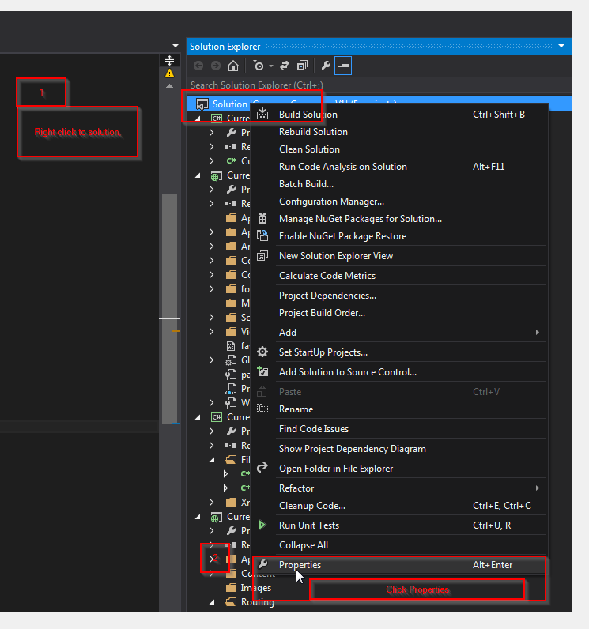

Step 2:

Setting multiple project start up

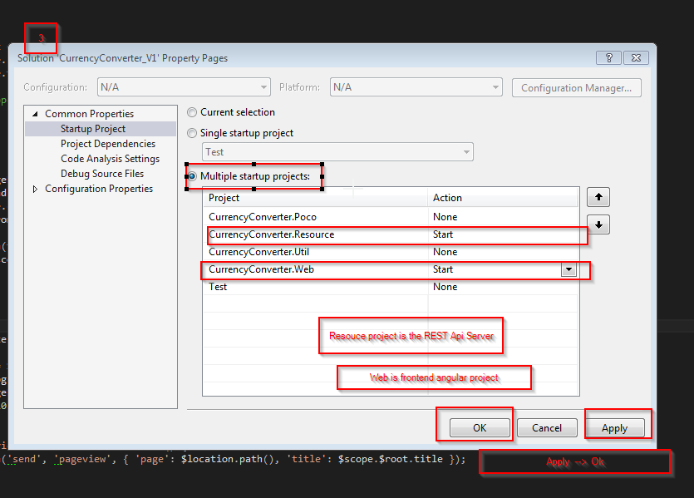

Step 3:

Configure RateMapping.xml file path

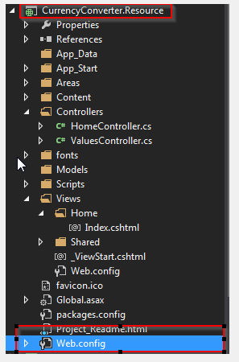

Set the vale to actual path of RateMapping.xml

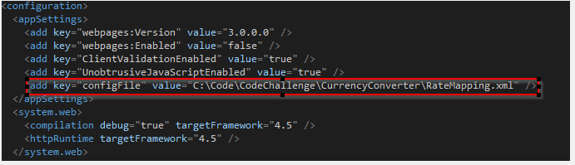

Step: 4

Run the project

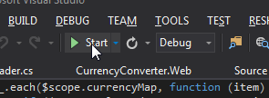

Result:

Two website will start

1. Resource (REST API)

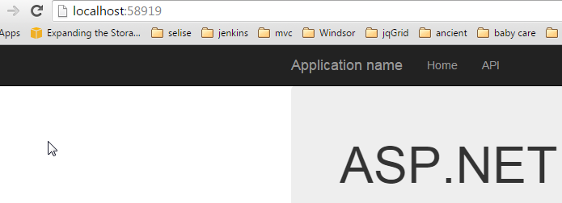

1. Angular App

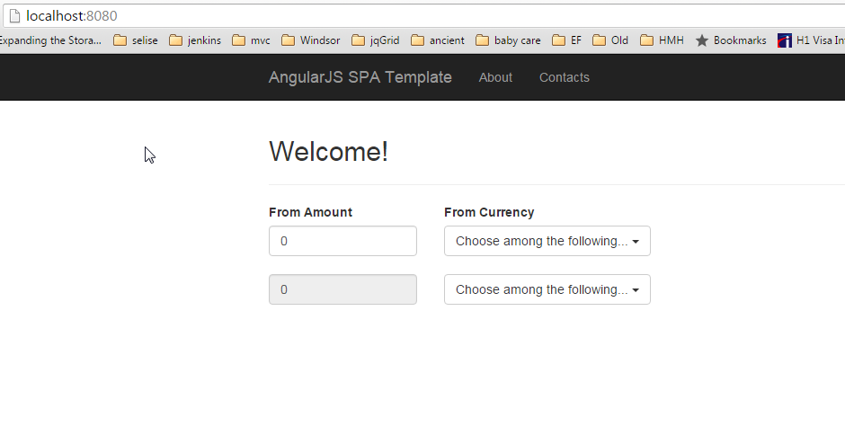

Note: Port 58919 and 8080 has to be free to run this application.