# USER tutorial

## Premise

This tutorial teaches how to use the user webApp developed by spring boot

## Start the web application

Open a command line session 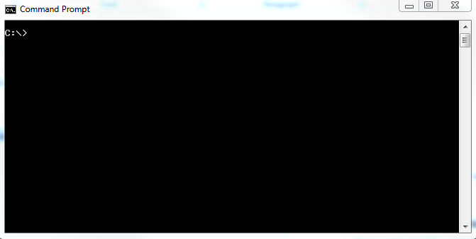

Unzip the file and navigate inside

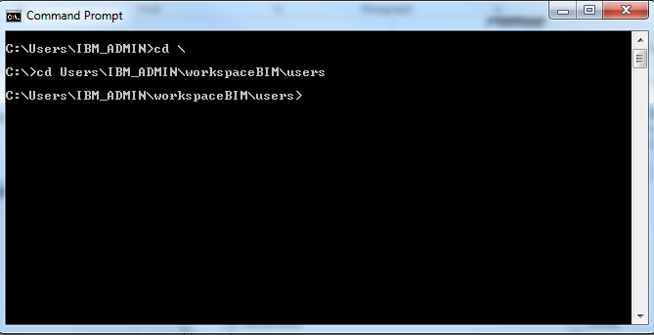

For start the embeded server type

java -jar users-0.0.1-SNAPSHOT.jar

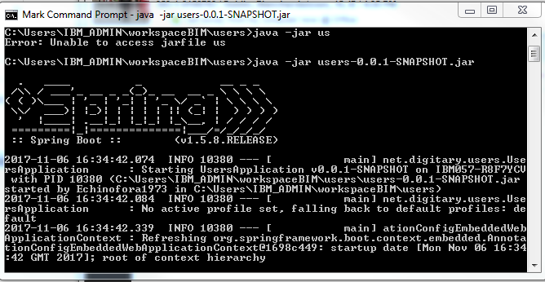

After the server is started open your prefered web browser and type <http://localhost:8080/appCrudUser> the browser will load the following page

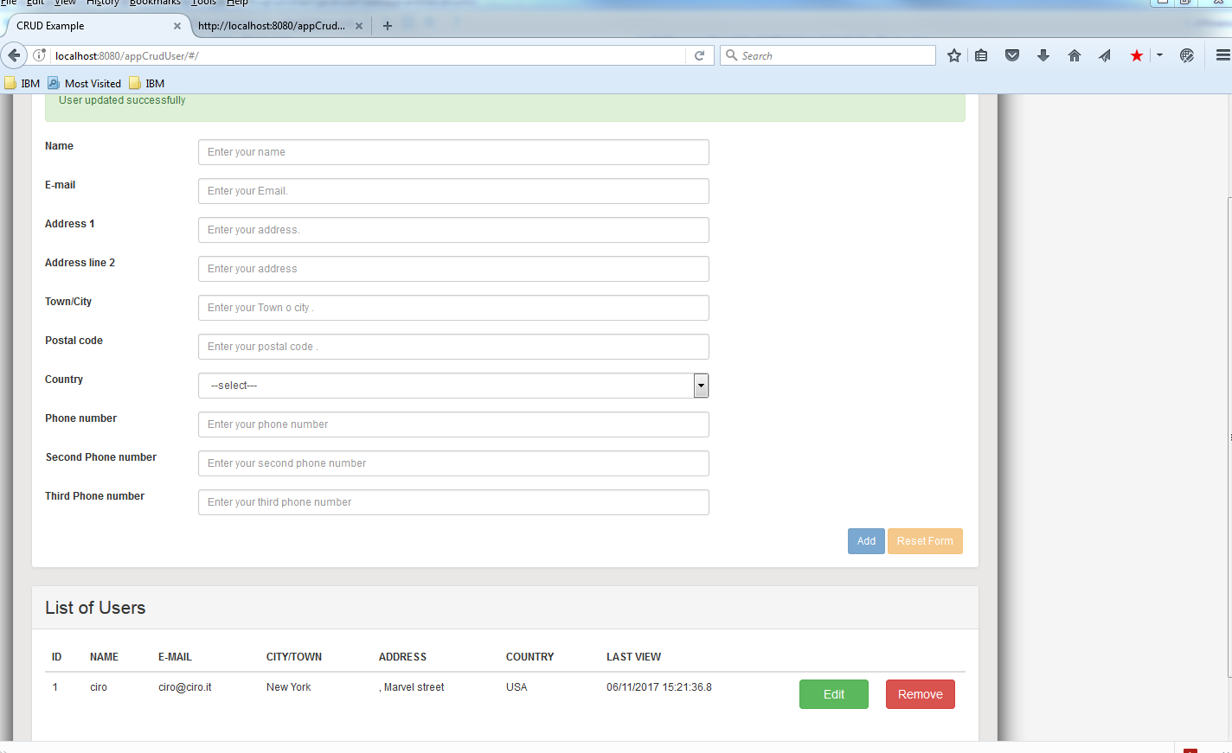

## Using the web app

### Insert new User

In the form it is possible di insert and update the user data, filling the following field

* Name (mandatory)
* Email (mandatory)
* Address 1 (mandatory)
* Address line 2 (optional )
* Town/City (mandatory)
* Postal Code (optional)
* Country (mandatory)
* Telephone number1 (optional)
* Telephone number2 (optional)
* Telephone number3 (optional)

Full the form and push the add button, the new user will be unsert in the table and updated the table in the bottom .

### Update user

Select the user pushing edit button from the table in the bottom

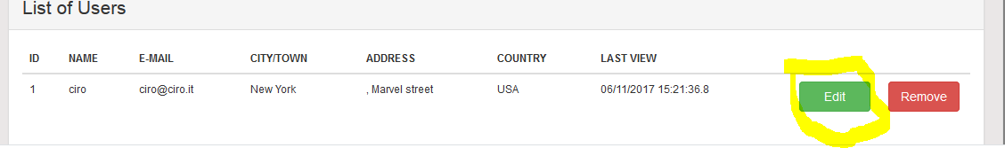

And the will be loaded in the form above and submit button will renamed update

The process is similar to insert mode push update button and the selected user will be update in the db and in the List of users.

### Delete user

Click on the delete in the user record and the user will be deleted from db and from web table

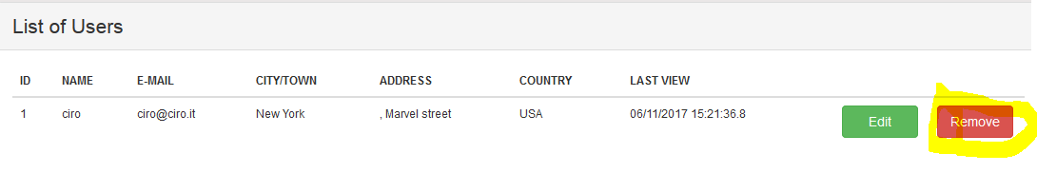

## Use the web service rest

The server makes available the use of webServices restul in order to execute the operation outside the web interface

For the example we will use PostMan(Extension of Chrome)

### Select all users

For select all users in the user table write in postman url box <http://localhost:8080/appCrudUser/api/users> setting the http method in GET

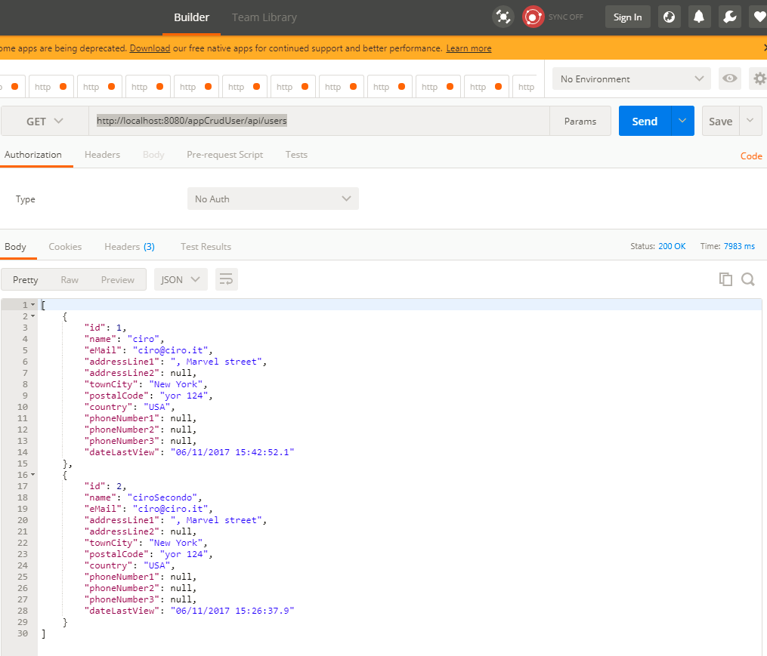

It will return the users in a json Array

[

{

"id": 1,

"name": "ciro",

"eMail": "ciro@ciro.it",

"addressLine1": ", Marvel street",

"addressLine2": null,

"townCity": "New York",

"postalCode": "yor 124",

"country": "USA",

"phoneNumber1": null,

"phoneNumber2": null,

"phoneNumber3": null,

"dateLastView": "06/11/2017 15:42:52.1"

},

{

"id": 2,

"name": "ciroSecondo",

"eMail": "ciro@ciro.it",

"addressLine1": ", Marvel street",

"addressLine2": null,

"townCity": "New York",

"postalCode": "yor 124",

"country": "USA",

"phoneNumber1": null,

"phoneNumber2": null,

"phoneNumber3": null,

"dateLastView": "06/11/2017 15:26:37.9"

}

]

### Select single user

For select all users in the user table write in postman url box <http://localhost:8080/appCrudUser/api/users/1> adding the number id in the url and setting the http method in GET

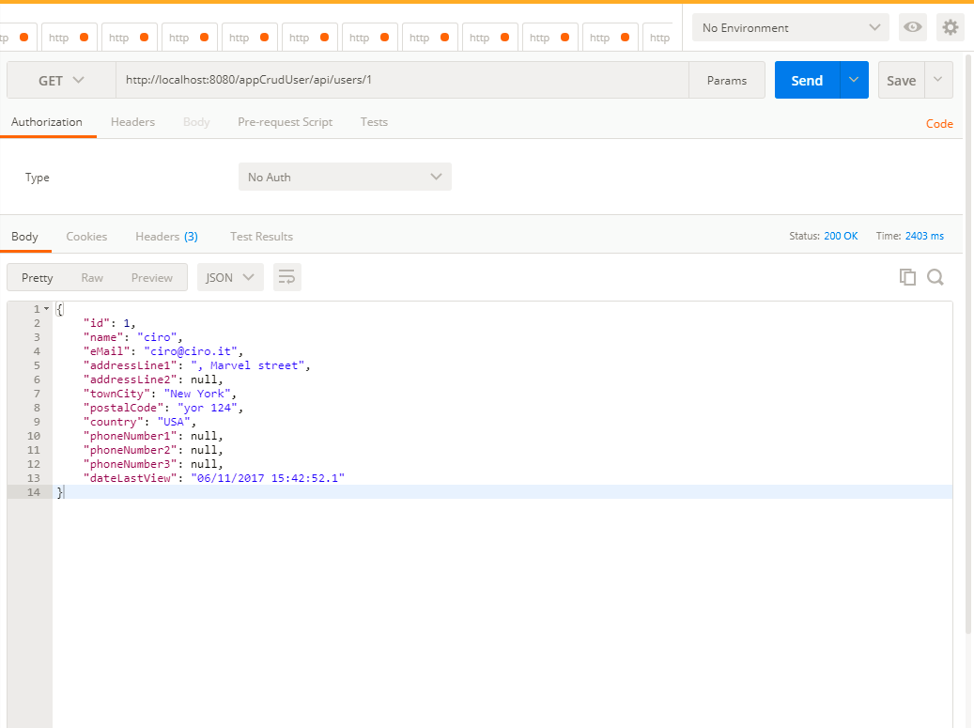

It will return the users in a json object

### Insert new User

To insert a new user we need to add a json text in text box body in chrome write the following url

<http://localhost:8080/appCrudUser/api/users> and setting a post the http method

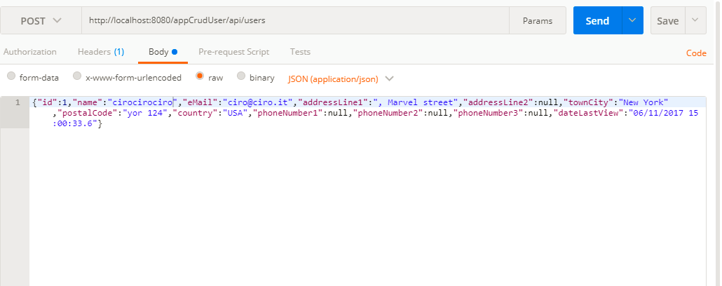

{"id":1,"name":"cirocirociro","eMail":"ciro@ciro.it","addressLine1":", Marvel street","addressLine2":null,"townCity":"New York","postalCode":"yor 124","country":"USA","phoneNumber1":null,"phoneNumber2":null,"phoneNumber3":null,"dateLastView":"06/11/2017 15:00:33.6"}

The server will return the code status 201 (created).

In case the user name is already inserted the server will send status code 409(conflict) and a json object where there are the error informations.

{

"code": 409,

"errorMessage": "Unable to create. A User with name cirocirociro already exist.",

"path": "/api/users",

"timeStamp": "06/11/2017 18:16:29.3"

}

### Update user

Similar to the insert service, we need to add a Json text in the text box body and setting the http method in put and writing the follow url <http://localhost:8080/appCrudUser/api/users/3>

The server will execute the update and send to the client the status code 200

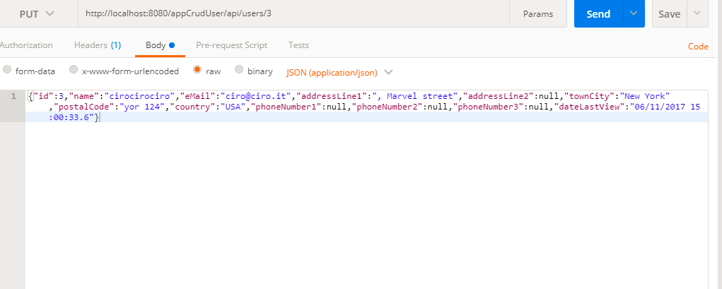

In case will try to update a inexistent user the server will send the following json object

{

"code": 404,

"errorMessage": "Unable to update. User with id 4 not found.",

"path": "/api/users/4",

"timeStamp": "06/11/2017 18:22:00.0"}

## Delete the user

For deleting the user we need to set the method on delete and write the following url in the url box

<http://localhost:8080/appCrudUser/api/users/3> the id in the end of the url

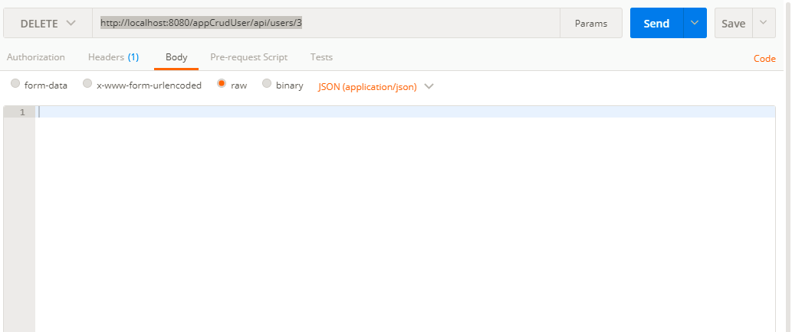if the user is deleted the server will return the status code 204(NO_CONTENT) .

If the user was’nt not in the db table the server will send the following Json Object

{

"code": 404,

"errorMessage": "Unable to delete. User with id 3 not found.",

"path": "/api/users3",

"timeStamp": "06/11/2017 18:31:41.7"

}