**Banking Management System**

**(BMS)**

**Session 2023 - 2027**

**Submitted by:**

Munees Tariq 2023-CS-32

**Supervised by:**

Dr Muhammad Awais Hassan

**Course:**

CSC-102 Programming Fundamentals

Department of Computer Science

**University of Engineering and Technology**

**Lahore Pakistan**

Table of Contents

❖ About Banking Management System (BMS): 4

I. Secure and Convenient Banking: 4

II. What it does: 4

❖ User Types In BMS: 4

i. Manager: 4

ii. Client: 4

• Manager’s Functions: 5

• Client’s Functions: 6

❖ Images From The Application 6

1. Manager’s Login Page: 6

2. Current Manager Menu: 7

3. Client’s Login Page: 7

4. Current Client Menus: 8

**Table of Figures**

Figure 1 6

Figure 2 7

Figure 3 7

Figure 4 8

### About Banking Management System (BMS):

## Secure and Convenient Banking:

The Banking Management System is a user-friendly software application designed to secure and simplify the operations of a bank. This system is aimed at improving the overall banking experience by providing a secure and convenient platform for both customers and bank manager.

## What it does:

It allows the manager of the bank to create new accounts, delete existing records, or to view the records efficiently. Customers can access their accounts, check balances, and perform transactions.

### User Types In BMS:

The banking management system provides different access for different users. There are two types of user. Manager who have the authority over the whole system. Client who can access his personal account and perform transactions.

## Manager:

The manager can add new accounts for new clients , remove existing accounts that are no longer in use, view the records of the users for some purpose. Other Functions are discussed in details in the Manger Functions Table

## Client:

The client can access his account and view his balance, transfer money to another account, deposit money in his account, withdraw money from his account. . Other Functions are discussed in details in the Client Functions Table

* + - **Functional Requirements Of BMS:**

Some of the functions that can be performed by the Manager and Client in my Banking management system are under:

## Manager’s Functions:

|  |  |  |
| --- | --- | --- |
| **User Type** | **Functions** | **Action Performed** |
| **Admin/Manager** | Add New User | Used to create new user account in the application |
| View Records | Used to view the records of existing clients in the application |
| Delete User | Used to delete the record of an existing client |
| Set Interest Rate | Used to set the interest rate |
| View Transactions | Used to view transactions of the clients |
| Update Information | Allows to edit information for client |
| Reset Passwords | Used to reset the passwords |
| Give Loan | Allows to give loan to specific client |
| Loan Calculator | Used to calculate the loan |
| Interest Calculator | Used to calculate the interest on money |

## Client’s Functions:

|  |  |  |
| --- | --- | --- |
| **Client/User** | Deposit Money | Allows to deposit money into the account |
| Withdraw Money | Allows to withdraw money from the account |
| Transfer Money | Allows to transfer money to another account |
| Apply for Loan | Used to apply for loan |
| Request For Account removal | Allow user to apply to remove his account |
| View Transaction History | Allows the user to see his transactions |
| Block Transactions | Used to limit transactions |
| Modify Information | Allows to edit basic information |
| Apply for Change of Password | Used to Change Password |
| Freeze/Unfreeze Cards | Used to Freeze/Unfreeze the card |

### Images From The Application

## Manager’s Login Page:

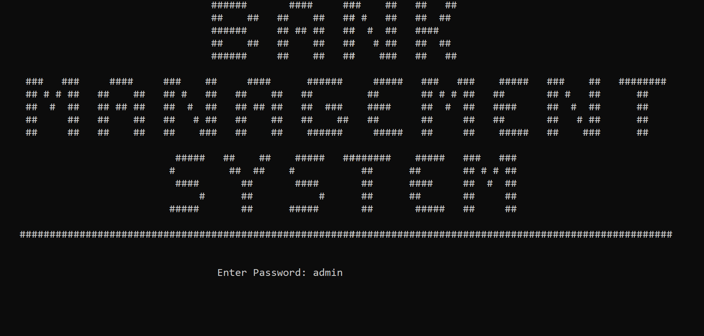

Figure 1

## Current Manager Menu:

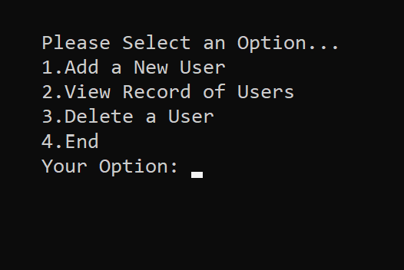

Figure 2

## Client’s Login Page:

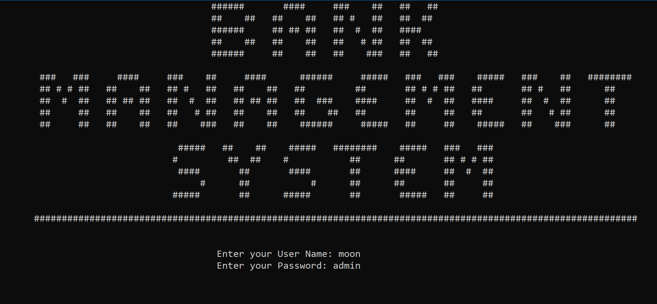

Figure 3

## Current Client Menus:

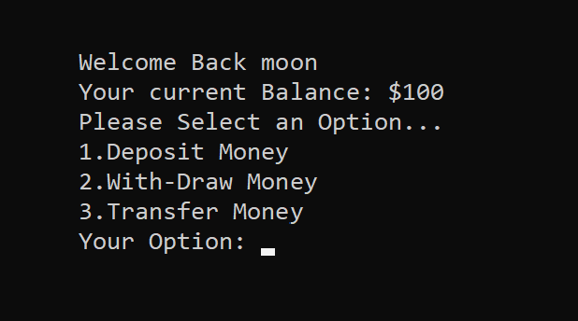

Figure 4