**School Management System**



**Session 2023 - 2027**

**Submitted by:**

Munees Tariq **2023-CS-32**

Sheharyar Zahid **2023-CS-30**

Muhammad Mahad **2023-CS-36**

Muhammad Uzair **2023-CS-22**

Muhammad Asad **2023-CS-14**

**Course:**

**Advanced Database Mangement**

Department of Computer Science

**University of Engineering and Technology**

**Lahore Pakistan**

**Table of Contents**

[1. Introduction 4](#_Toc9581)

[1.1 Project Overview 4](#_Toc29033)

[1.2 Objectives 4](#_Toc9255)

[1.3 Scope 4](#_Toc30794)

[2. System Analysis 4](#_Toc25981)

[2.1 Existing System and Its Limitations 4](#_Toc5374)

[2.2 Proposed System 4](#_Toc17754)

[2.3 Functional Requirements 5](#_Toc15113)

[2.4 Non-Functional Requirements 5](#_Toc22177)

[3. System Design 5](#_Toc13537)

[3.1 Database Design 5](#_Toc28027)

[3.3 User Interface Design 6](#_Toc22090)

[4. Implementation 8](#_Toc32244)

[4.1 Technologies Used 8](#_Toc21219)

[4.2 Modules and Features 8](#_Toc22978)

[5. Conclusion & Future Enhancements 8](#_Toc14285)

[5.1 Summary 8](#_Toc31395)

[5.2 Limitations 8](#_Toc15469)

[5.3 Future Enhancements 8](#_Toc15908)

[6. References 9](#_Toc26309)

## ****1. Introduction****

### ****1.1 Project Overview****

The School Management System is a comprehensive software solution designed to streamline school operations. It enables efficient management of students, teachers, and classes while automating tasks such as attendance tracking and student evaluation. This system enhances administrative efficiency and ensures smooth day-to-day operations within an educational institution.

### ****1.2 Objectives****

* Automate student and staff management
* Maintain attendance and fee records
* Generate reports for administration
* Improve efficiency in school operations

### ****1.3 Scope****

* Managing student, teacher, and staff records
* Attendance tracking
* Fee management system
* Reporting and analytics
* User authentication and role-based access control

## ****2. System Analysis****

### ****2.1 Existing System and Its Limitations****

Traditional school management relies on manual record-keeping or outdated software, leading to inefficiencies. Attendance tracking, student evaluation, and teacher management require significant time and effort. Data retrieval is slow, error-prone, and lacks automation, making it difficult to generate reports quickly. Existing systems often lack integration, requiring multiple platforms for different tasks, increasing administrative workload

### ****2.2 Proposed System****

### The new system automates student, teacher, and class management, ensuring accurate records, quick access, and reduced errors. It streamlines attendance tracking and student evaluation, improving efficiency and minimizing paperwork with an all-in-one platform.

### ****2.3 Functional Requirements****

* **Student Registration** – Add, update, and manage student records.
* **Teacher Management** – Register and manage teacher details.
* **Class Management** – Assign students and teachers to classes.
* **Attendance Management** – Mark and track student and teacher attendance.
* **Fee Payment & Management** – Record and manage fee transactions.
* **Exam & Result Processing** – Evaluate student performance and generate results.

### ****2.4 Non-Functional Requirements****

* **User-friendly Interface** – Easy navigation and intuitive design.
* **Performance** – Fast loading times and quick data retrieval.
* **Scalability** – Support for future growth and additional features.
* **Bug-Free** – Minimal errors and issues for smooth operation.
* **Maintainability** – Easy to update and maintain the system.

## ****3. System Design****

### ****3.1 Database Design****

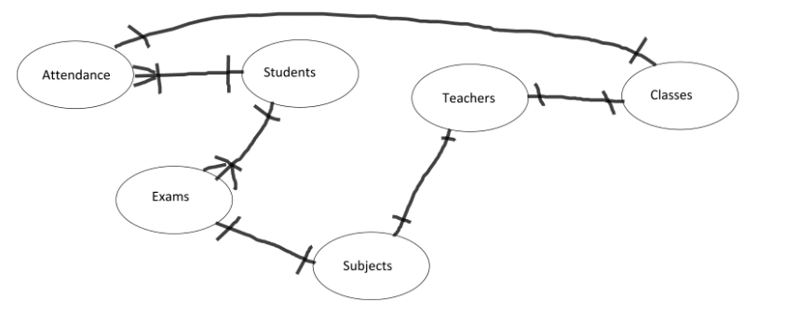

### ****3.3 User Interface Design****

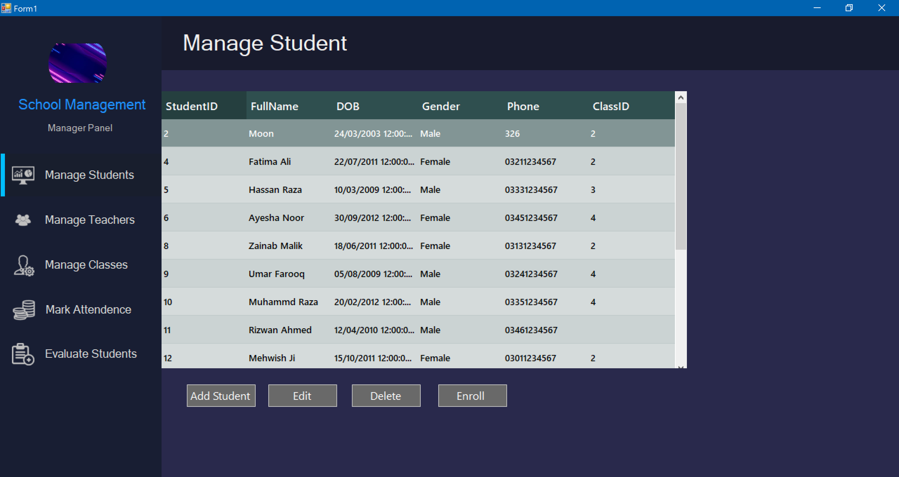

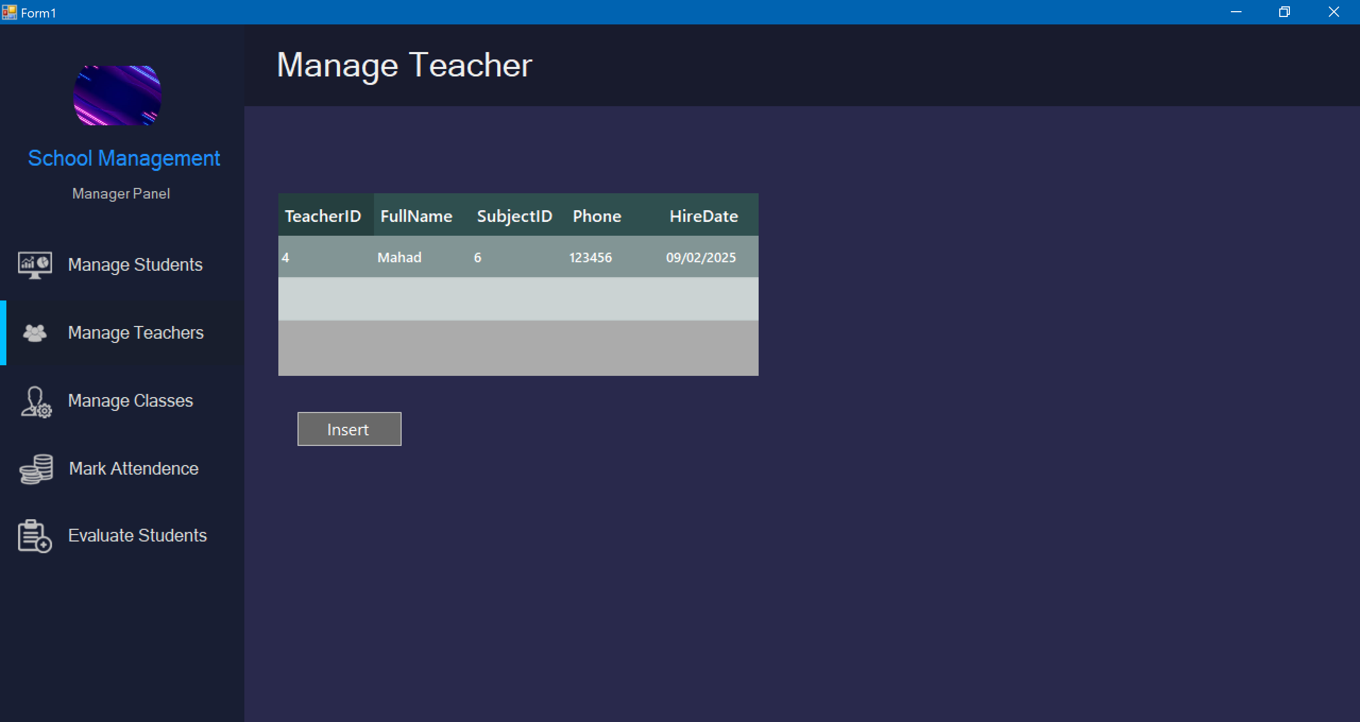

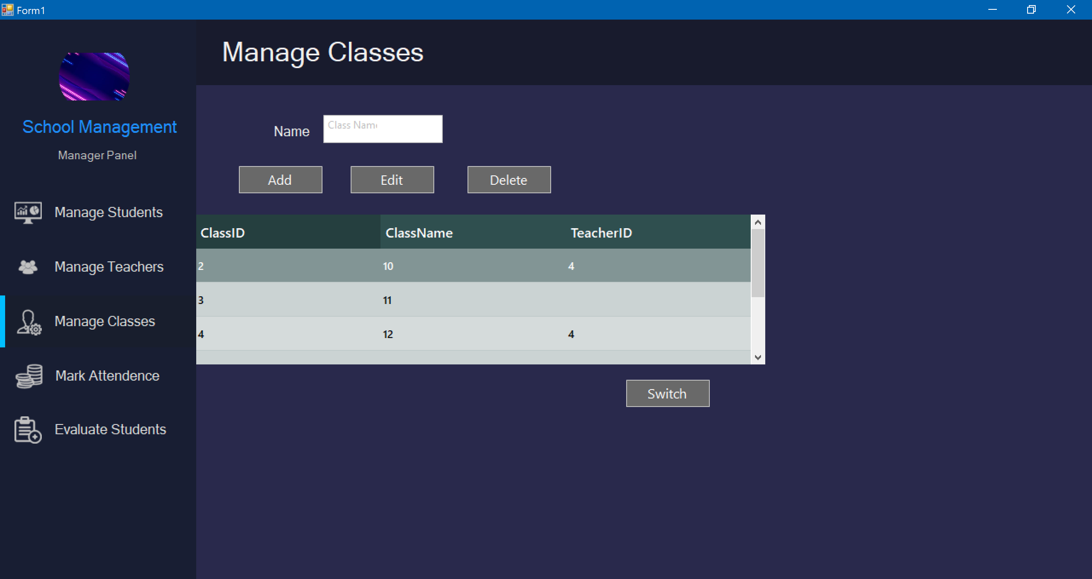

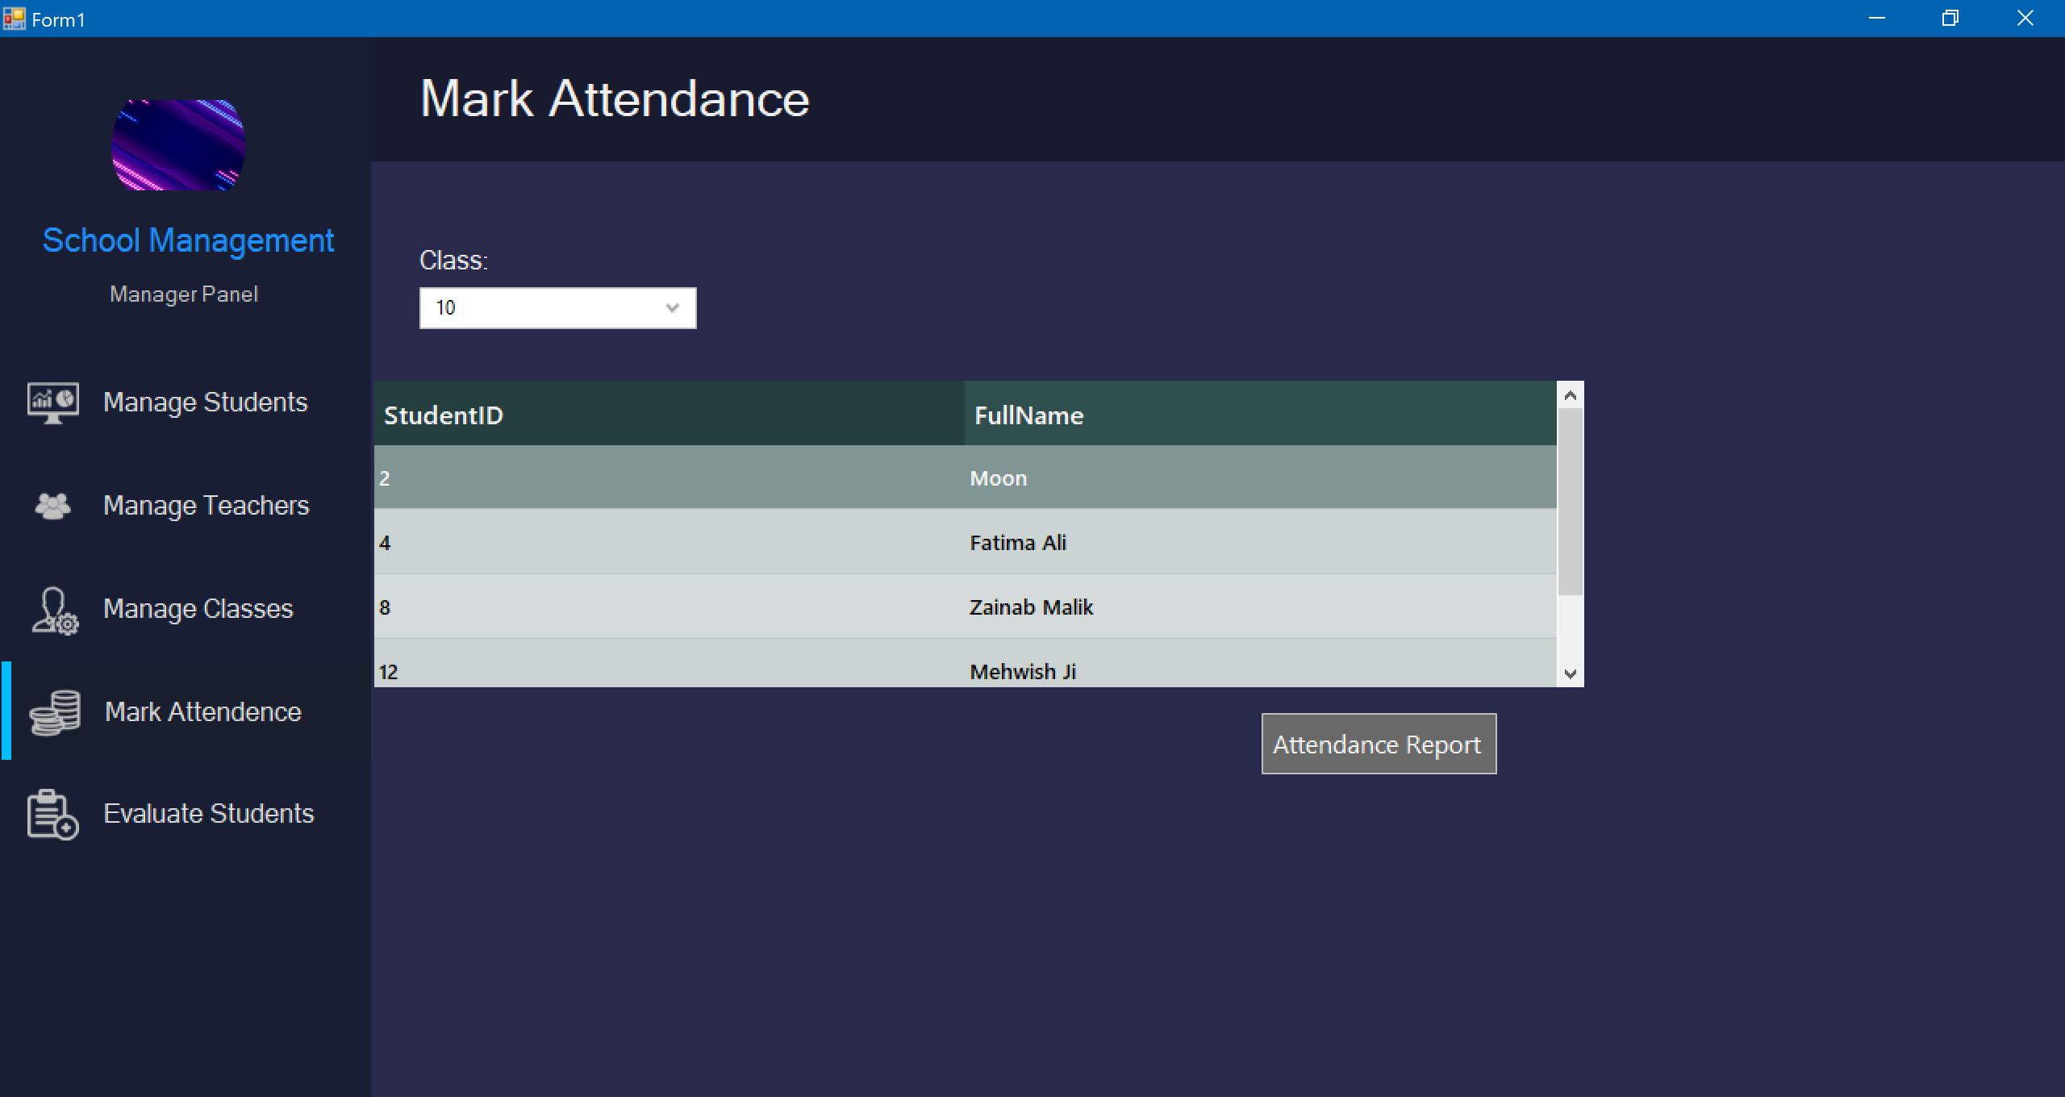

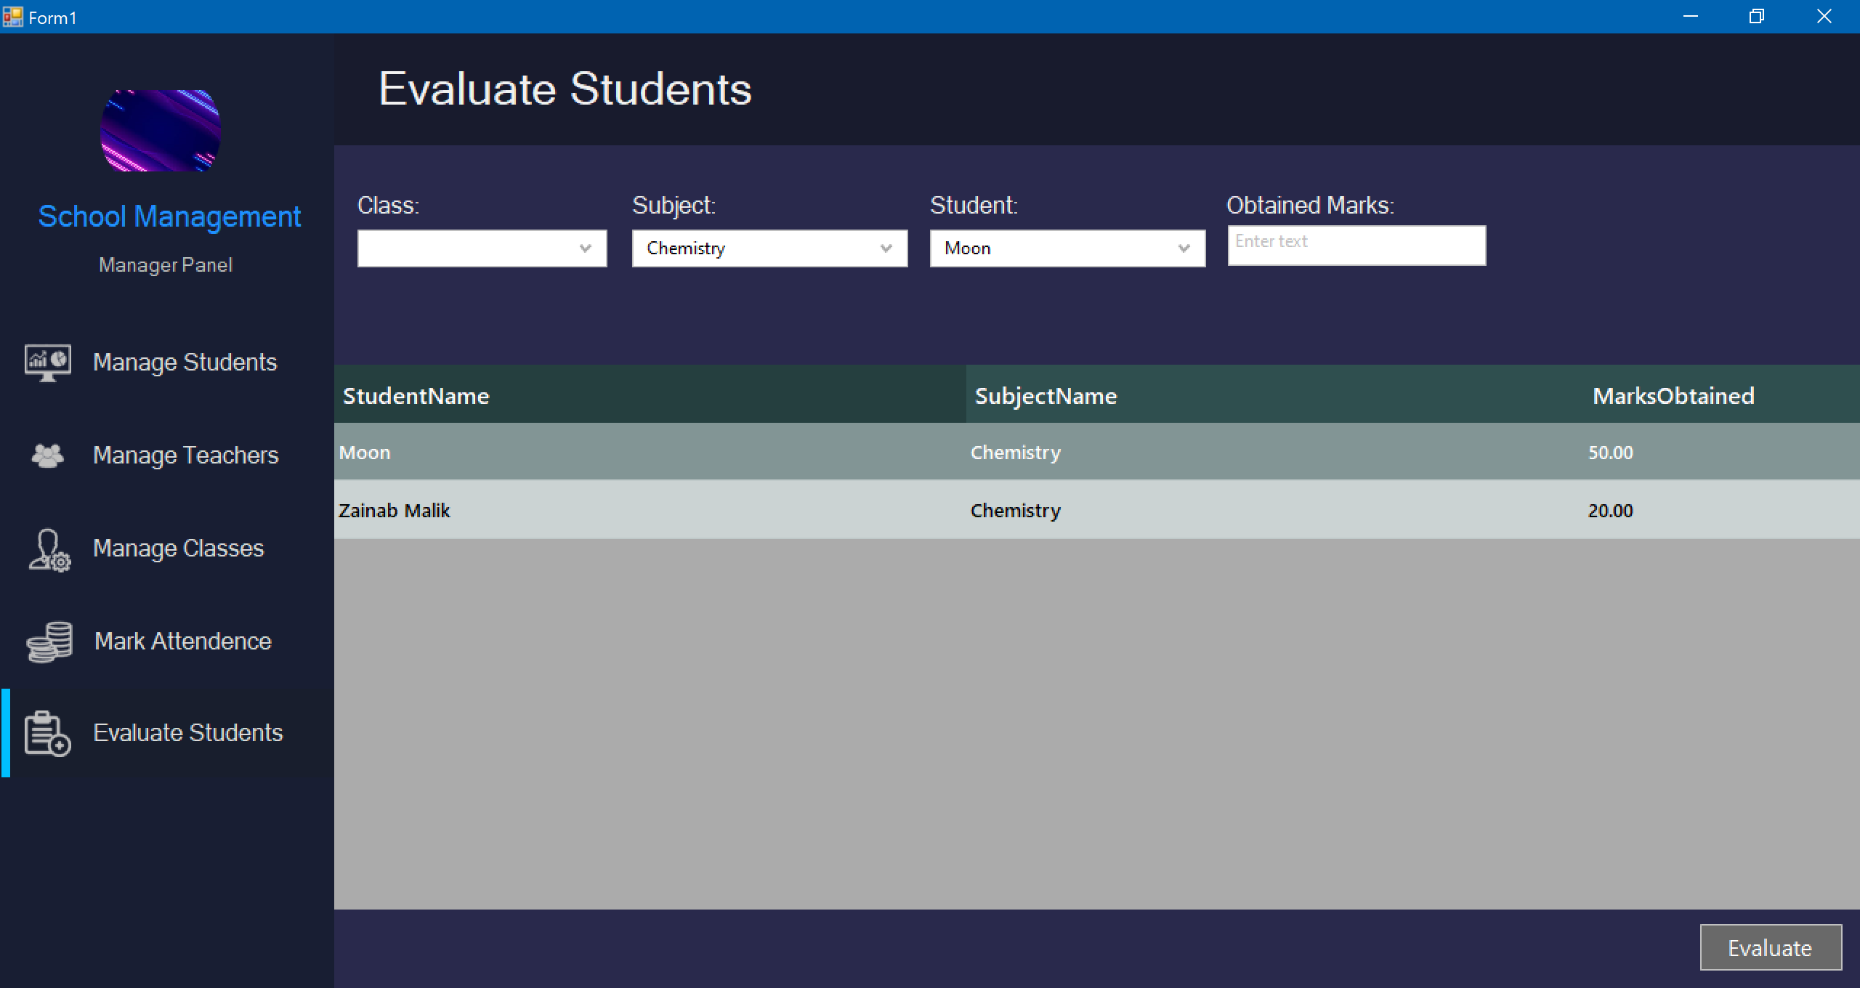

## ****4. Implementation****

### ****4.1 Technologies Used****

* **Programming Language:** C# (Windows Forms)
* **Database:** SQL Server
* **Framework:** .NET Framework

### ****4.2 Modules and Features****

* **Student Management** – Allows registration, updating, and viewing of student records, including personal details, enrollment status, and academic history.
* **Teacher Management** – Manages teacher information, including registration, assignment of subjects, and scheduling.
* **Class Management** – Organizes classes, assigns students and teachers, and manages class schedules.
* **Attendance Management** – Tracks and records student and teacher attendance, with the ability to generate reports and send notifications.
* **Exam & Result Processing** – Allows exam scheduling, result entry, and automatic generation of student performance repor

## ****5. Conclusion & Future Enhancements****

### ****5.1 Summary****

The project successfully addresses key school management tasks, such as student registration, attendance tracking, and exam processing, through automation and centralization. It streamlines administrative processes, reduces errors, and improves efficiency, fully meeting the project’s objectives.

### ****5.2 Limitations****

### The current system may require manual data input for some processes and lacks integration with external platforms, such as online payment systems or mobile app support.and isn’t yet reponsive

### ****5.3 Future Enhancements****

## Future improvements could include mobile app support for better accessibility, integration of online payment systems, and adding advanced reporting features for more detailed insights.

## ****6. References****

* W3Schools ([https://www.w3schools.com](https://www.w3schools.com" \t "_new)) – For SQL tutorials and resources
* Microsoft Documentation ([https://docs.microsoft.com](https://docs.microsoft.com" \t "_new)) – For C# Windows Forms and SQL Server integration.
* Stack Overflow ([https://stackoverflow.com](https://stackoverflow.com" \t "_new)) – For community-driven solutions and troubleshooting.
* GitHub ([https://github.com](https://github.com" \t "_new)) – For accessing open-source code and libraries related to school management systems.