Everything started in main file but it was moved to a bunch of separate files. Now the main file looks like this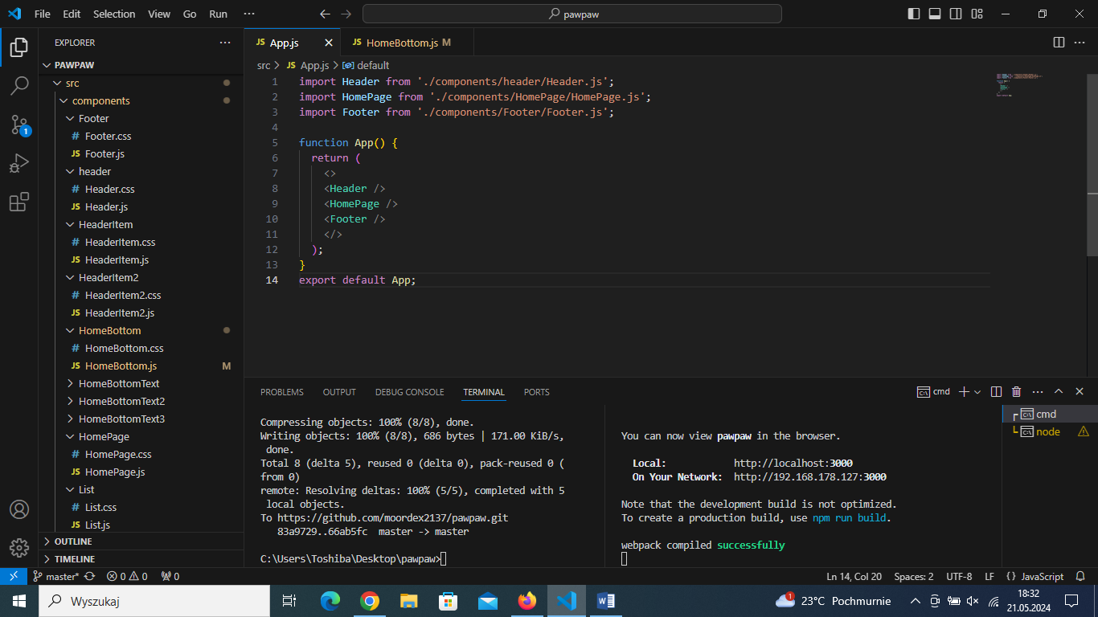

We learned how to use React, how to import things and how to keep code clean.

The hardest thing to do in our opinion was this part of the site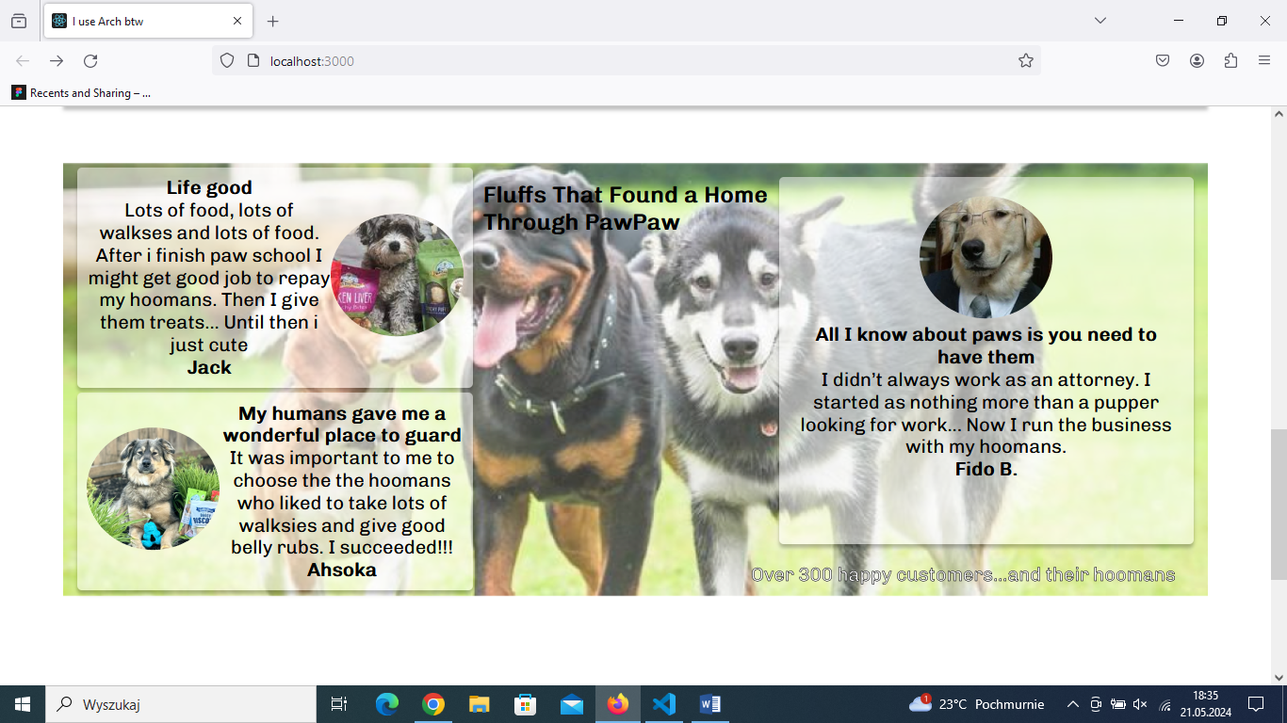

It took a long time and a lot of components (pic below) to finally make it.

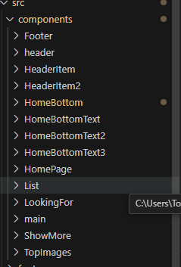

The easiest part was the footer

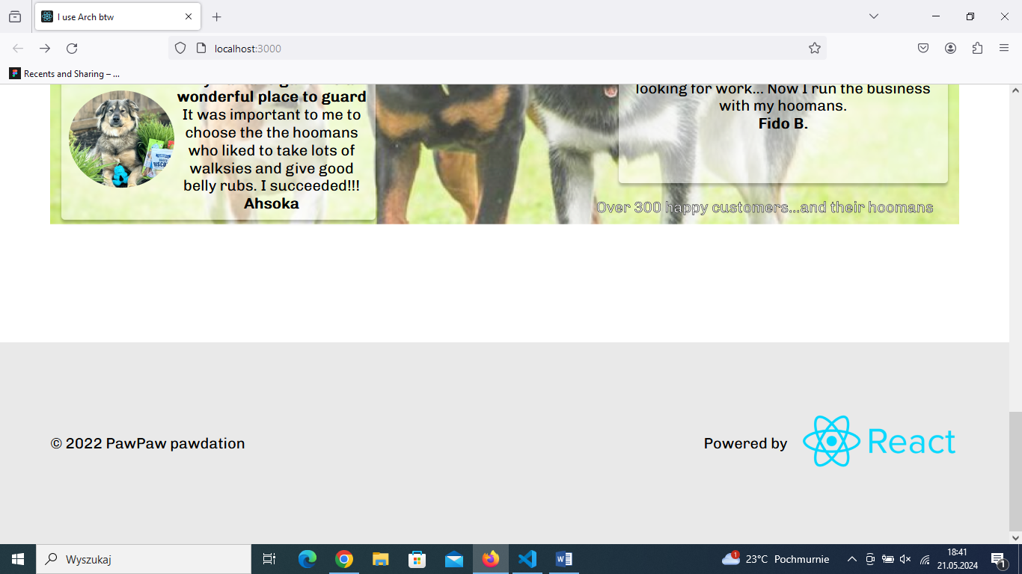

And we really liked the part when we needed to make something in a separate function to use it multiple Times

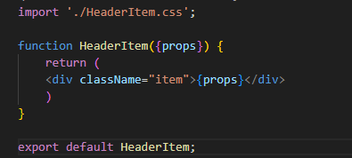

Also using Git feels very nice.