**3b/4a**) A and b matrices match, solved, the temperature profile is:

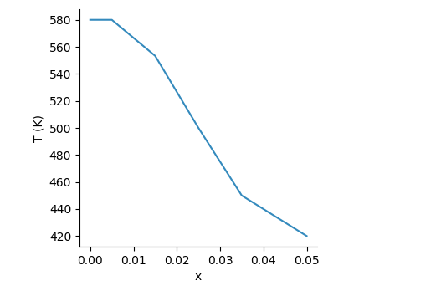

**4b)** More smooth as expected

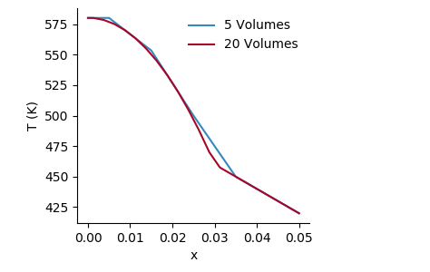

**5a,b)**

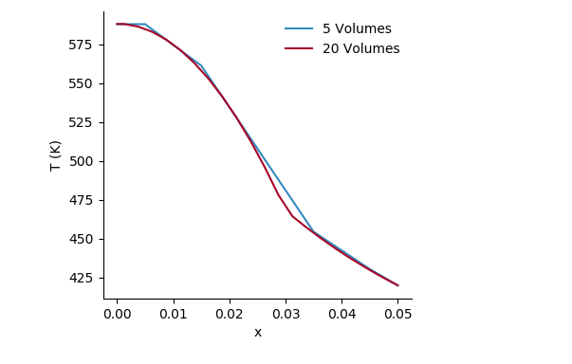

**5c)** about 100 control volumes is grid independent

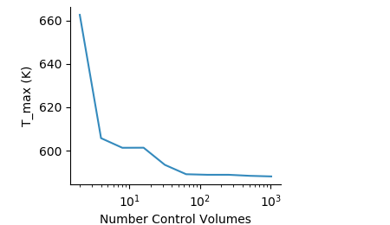

**Solver Source Code: Julia**

using PyPlot

#-------- Input Parameters --------#

function runsolver(N_cv)

aw = zeros(N_cv+2)

ap = zeros(aw)

ae = zeros(aw)

b = zeros(aw)

k = zeros(aw)

kw_h = zeros(aw) #harmonic mean

ke_h = zeros(aw)

Sc = zeros(N_cv) #constant source term

Sp = zeros(N_cv) #slope of source term, multiplied by temp

h = 1000

Tinf = 300

boundary = 0.03

cv_x = collect(linspace(0,0.05,N_cv+1))

cv_dx = cv_x[2:end] - cv_x[1:end-1]

node_x = [0;(cv_x[2:end]+cv_x[1:end-1])/2;cv_x[end]]

node_dx = node_x[2:end] - node_x[1:end-1]

for i = 1:length(k)

if node_x[i]<boundary

k[i] = 15

else

k[i] = 137*exp(25*node_x[i]-2)

end

end

for i = 1:length(Sc)

if cv_x[i]<boundary

Sc[i] = 4E6

Sp[i] = 0

else

Sc[i] = 0

Sp[i] = 0

end

end

#-------- Apply harmonic mean --------#

node_dx_minus = cv_x-node_x[1:end-1]

node_dx_plus = node_x[2:end]-cv_x

for i = 1:length(kw_h)-1

ke_h[i] = node_dx[i]*k[i+1]*k[i]/(k[i+1]*node_dx_minus[i]+k[i]*node_dx_plus[i])

kw_h[i+1] = node_dx[i]*k[i]*k[i+1]/(k[i]*node_dx_plus[i]+k[i+1]*node_dx_minus[i])

end

#-------- Assemble the coefficients --------#

# Apply Left BC

aw[1] = 0

ae[1] = ke_h[1]/node_dx[1]

ap[1] = ke_h[1]/node_dx[1]

b[1] = 0

# Apply Interior Points

for i = 2:N_cv+1

aw[i] = kw_h[i]/node_dx[i-1]

ae[i] = ke_h[i]/node_dx[i]

ap[i] = aw[i]+ae[i]-Sp[i-1]*cv_dx[i-1]

b[i] = Sc[i-1]*cv_dx[i-1]

end

# Apply Right BC

aw[end] = kw_h[end]/node_dx[end]

ae[end] = 0

ap[end] = kw_h[end]/node_dx[end]+h

b[end] = h*Tinf

#-------- Assemble the A_matrix --------#

A = zeros(N_cv+2,N_cv+2)

# First Row

A[1,1] = ap[1]

A[1,2] = -ae[1]

# Interior Rows

for i = 2:N_cv+1 #loop through the interior rows

A[i,i-1] = -aw[i]

A[i,i] = ap[i]

A[i,i+1] = -ae[i]

end

# Last Row

A[end,end-1] = -aw[end]

A[end,end] = ap[end]

#-------- Solve the System --------#

T = A\b

return T,node_x

end

rc("figure", figsize=(4.5, 2.6))

rc("font", size=10.0)

rc("lines", linewidth=1.5)

rc("lines", markersize=3.0)

rc("legend", frameon=false)

rc("axes.spines", right=false, top=false)

rc("figure.subplot", left=0.18, bottom=0.18, top=0.97, right=0.72)

rc("axes", color_cycle=["348ABD", "A60628", "009E73", "7A68A6", "D55E00", "CC79A7"])

# PyPlot.close("all")

# PyPlot.figure("5")

# N_cv = [5,20]#linspace(5,100,7)

# N_cv = round.(Int,N_cv)

# for i = 1:length(N_cv)

# T,node_x = runsolver(N_cv[i])

# PyPlot.plot(node_x,T,label = "$(N_cv[i]) Volumes")

# PyPlot.pause(0.01)

# end

# PyPlot.xlabel("x")

# PyPlot.ylabel("T (K)")

# PyPlot.legend(loc = "best")

PyPlot.figure("5c")

N_cv = zeros(10)

for i = 1:length(N_cv)

N_cv[i] = 2^i

end

N_cv2 = round.(Int,N_cv)

T2 = zeros(length(N_cv))

for i = 1:length(N_cv)

# i = 1

T,node_x = runsolver(N_cv2[i])

T2[i] = T[1]

println(i)

end

PyPlot.semilogx(N_cv,T2)

PyPlot.xlabel("Number Control Volumes")

PyPlot.ylabel("T_max (K)")