**2)** N_Nodes 320

delta_t = dxdt*rod_L/N_node = 3.125E-5

where dxdt = 1

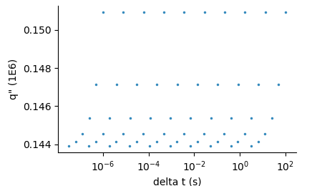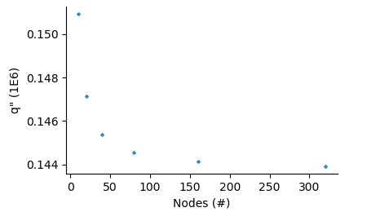

**3)**

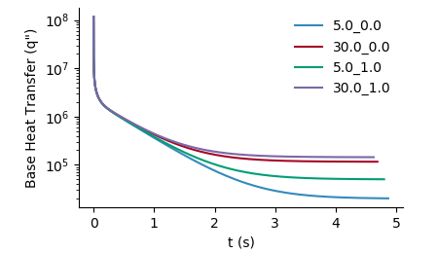

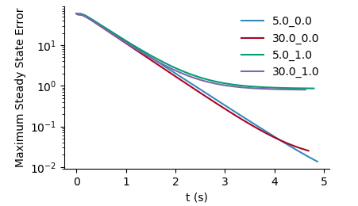4) Maximum steady state error as compared to the analytical only went down to 10^-2.

Legend: h_epsilon

