Efficiency of Quadratic Probing and Separate Chaining

Christopher Moore
College of Charleston
66 George Street
Charleston, SC 29424
(843) 805-5507
moorect@g.cofc.edu

ABSTRACT
In this paper, I compare the efficiency of a quadratic probing hash table versus a separate chaining hash table by examining the collision resolution between the two.
Categories and Subject Descriptors
D.3.3 [Software and its engineering]: Software verification and validation - Empirical software validation.
General Terms
Algorithms, Measurement, Documentation, Performance, Design, Experimentation, Languages, Theory, Verification.
Keywords
Insertion Efficiency, Quadratic Probing, Separate Chaining, Hash Tables.

INTRODUCTION
There are many implementations of hash tables and this project will attempt to discover which implementation is more efficient for insertion: quadratic probing or separate chaining. My hypothesis is that a quadratic probing hash table inserts more efficiently than a separate chaining hash table due to the lack of traversing along a linked list of elements as we see in a separate chaining implementation.

METHODS
This project will modify existing code provided by Mark Allen Weiss of two hash tables which resolve collisions differently: one implements quadratic probing and the other implements separate chaining. The modifications to the code result in the processing of duplicate elements which are inserted into the tables, the use of counters to keep track of how many times each table performs a probe, and the use of time stamps to measure the run-time of each implementation.

2.1 Probe Measurements
A probe is measured in a quadratic probing implementation whenever an element is inserted into the table without a collision or each and every time a collision occurs which forces the program to calculate a new possible entry point to try to insert the element. A probe is measured in a separate chaining implementation whenever an element is inserted into the table without a collision or, in the case of a collision, one probe is counted for each and every time the program must traverse across an element in the linked list while attempting to insert the element.

2.2 Time Measurements
The time was measured in both implementations using the same computer and included the time to read each word from the text file, convert that word into a simple object, and insert that object into the appropriate table.

2.3 Data Used

Ten text files of varying size were used to insert the words as string elements into both tables. (A special case of Dictionary.txt was added to provide a comparison where the elements were completely unique.) The program's output was the total number of probes counted in each table along with the total number of words in the text file.

Table 1. Word count and file size of the text files used in project
Name of data file | Word count | Size of data file
Hare.txt | 414 | 3 KB
Puss.txt | 1,138 | 7 KB
Beer.txt | 1,742 | 10 KB
Barney.txt | 11,676 | 67 KB
Darkness.txt | 39,699 | 213 KB
Humor.txt | 40,036 | 260 KB
Aesop.txt | 40,861 | 224 KB
Gulliver.txt | 104,110 | 692 KB
*Dictionary.txt | 109,582 | 1,128 KB
Bible.txt | 840,245 | 4,295 KB
Big.txt | 1,079,293 | 6,315 KB

RESULTS

Probe Count Comparison
The results of this project show that the hash table which implements separate chaining performs anywhere from 23% to 499% more probes than the table which implements quadratic probing.

Permission to make digital or hard copies of all or part of this work for personal or classroom use is granted without fee provided that copies are not made or distributed for profit or commercial advantage and that copies bear this notice and the full citation on the first page. To copy otherwise, or republish, to post on servers or to redistribute to lists, requires prior specific permission and/or a fee.
Conference’10, Month 1–2, 2010, City, State, Country.
Copyright 2010 ACM 1-58113-000-0/00/0010 …$15.00.

Table 2. Number of probes performed by quadratic probing (QPHT) and separate chaining (SCHT) implementation
Name of data file | QPHT Probes | SCHT Probes
Hare.txt | 1,041 | 1,284
Puss.txt | 2,489 | 5,026
Beer.txt | 3,338 | 10,212
Barney.txt | 19,592 | 53,707
Darkness.txt | 67,059 | 199,449
Humor.txt | 72,172 | 208,455
Aesop.txt | 66,838 | 203,639
Gulliver.txt | 145,202 | 448,127
*Dictionary.txt | 318,335 | 330,271
Bible.txt | 1,039,714 | 4,310,046
Big.txt | 1,421,515 | 7,091,305

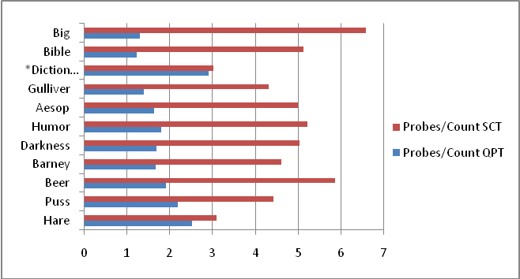
Figure 1. Average number of probes per word
The results also revealed a pattern. With the exception of Dictionary.txt, as the word count of the text file increased (likely the number of duplicate elements increased as well) the quadratic probing implementation performed less probes as the separate chaining implementation performed more probes.
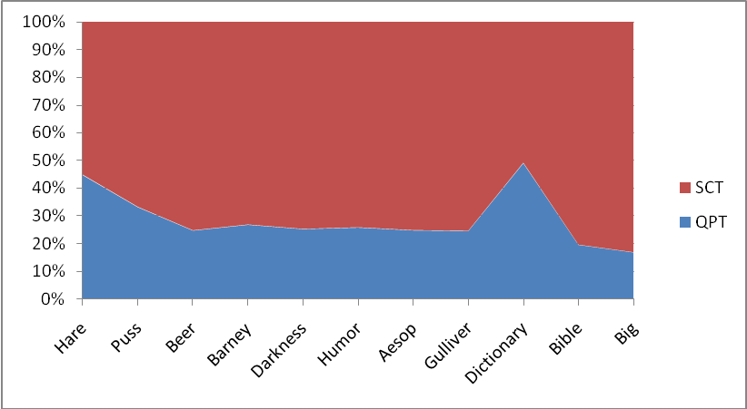
Figure 2. Separate chaining implementation performed an average of 3 times more probes than quadratic probing

Time Comparison
The results of the run-time comparison follow closely with what was observed with the probe count comparison. Excluding Dictionary.txt, the separate chaining implementation requires anywhere from 20% to 422% more time than the table which implements quadratic probing.
Table 3. Seconds required to insert data using quadratic probing and separate chaining implementation
Name of data file | QPHT Time (sec) | SCHT Time (sec)
Hare.txt | 0.005 | 0.006
Puss.txt | 0.009 | 0.011
Beer.txt | 0.011 | 0.014
Barney.txt | 0.024 | 0.029
Darkness.txt | 0.052 | 0.088
Humor.txt | 0.055 | 0.090
Aesop.txt | 0.054 | 0.089
Gulliver.txt | 0.121 | 0.243
*Dictionary.txt | 0.217 | 0.282
Bible.txt | 0.773 | 2.052
Big.txt | 1.112 | 4.699

As expected, the run-time for both tables increases as the word count increases, however once the word count exceeds approximately 150,000, the time required for the separate chaining implementation climbs at a significantly higher rate.
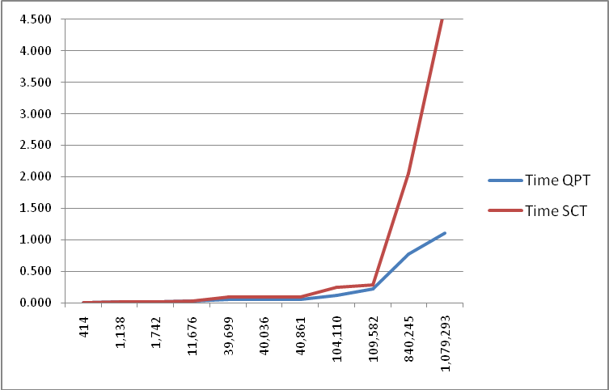
Figure 3. Run-time in seconds compared with the word count of the text file
Although the results reveal a seemingly insignificant maximum difference of about 3.5 seconds, the rate at which the separate chaining implementation climbs along the graph reveals that data sets of considerable size could require impractical amounts of time to process.

CONCLUSION
According to the results of this project, my hypothesis has been verified: quadratic probing is more efficient than separate chaining. The author's quadratic probing implementation resizes and rehashes once the load level reaches 50% which may prove to be more costly and less efficient depending on the application. The author's separate chaining implementation resizes and rehashes only when the number of uniquely inserted elements becomes larger than the size of the array which may be a more efficient solution depending on the data and the needs of the user. In the case of many possible duplicate items (such as these text files disregarding Dictionary.txt) however, it seems clear that the quadratic probing implementation is a more efficient choice which sacrifices storage space for efficiency. Separate chaining might very well outperform quadratic probing in a more restricted case where the elements to be inserted are entirely or nearly all unique (demonstrated by the Dictionary.txt data file) thereby resulting in less collision resolution. Another possible case would be with an enormous amount of data where it would be impractical to use a space-wasting implementation such as quadratic probing which must reserve storage space equal to two times the number of elements.

REFERENCES
- Weiss, Mark Allen. Data Structures and Algorithm Analysis in Java. Boston: Pearson Education, Inc. 2012.
- Scott, Jason. "The Textfile Directory." 27 March 2013. http://textfiles.com/.
- IFB Web. "Download, Format and Print the King James Bible (1611 Authorized Version)." 27 March 2013. http://printkjv.ifbweb.com/

