
IOT-ENABLED REAL-TIME PATIENT MONITORING AND ALERT SYSTEM FOR INTRAOPERATIVE AND POSTOPERATIVE CARE
A Midterm Research and Software Project Proposal
Course Code: 4-SRC-10-804
Title: Scientific Research and Communication
Team Name: Alisher
Team Members:
ID | Full Name | Role
230271 | Babadjanov Alisher | Sole researcher and developer (IoT, backend, frontend, evaluation)

Degree Program: BS in Computer Science
Supervisor: Dr. Eugene Castro
Date: 20 October 2026

EXECUTIVE SUMMARY
Continuous monitoring of vital signs is central to patient safety during and after surgery, yet the data often remain in bedside devices and are not available to medical staff in one remote interface. Network delays or interruptions can further reduce the timeliness of the data, and large streams of readings are difficult to interpret without automated alerts. This proposal addresses these three problems from a computing perspective.
It asks (RQ1) how an IoT system can collect and display patient vital signs in near real time, (RQ2) to what extent reliable data handling can maintain timely monitoring during interruptions, and (RQ3) how visualization and threshold alerts can improve the identification of abnormal readings.
The proposed solution is a layered IoT platform. ESP32-based sensor nodes (heart rate, SpO₂, body temperature) publish readings over MQTT to a broker; a backend service validates and stores the stream in a PostgreSQL/TimescaleDB database, detects delayed or missing updates and evaluates configurable thresholds; a web dashboard presents live and historical data and raises alerts.
By the end of the semester the Minimum Viable Product (MVP) will be a working end-to-end prototype, evaluated with sensor and simulated data against measurable targets: end-to-end latency of at most 2 s (95th percentile), detection of missing data within 5 s, no data loss during outages of up to 60 s, and alerts within 1 s of a threshold crossing. The system is a research prototype, not a certified medical device.

Table of Contents

EXECUTIVE SUMMARY 2
INTRODUCTION AND BACKGROUND 4
Background 4
Problem Context & Technical Motivation 4
Project Scope & Boundaries 4
PROBLEM STATEMENT, RESEARCH QUESTIONS, AND OBJECTIVES 5
Investigation / Contextual Synthesis 5
Problem Statement 5
Research Questions (RQs) 6
Research Objectives 6
LITERATURE REVIEW & RELATED WORK 7
Overview of Existing Solutions & Studies 7
Comparative Analysis Matrix 8
Theoretical & Technical Justification 9
SYSTEM METHODOLOGY & TECHNICAL DESIGN 10
Software Development Methodology 10
System Architecture Modeling & Component Flow 11
Core Technical Implementation (Option A: Database & Web/IoT Platform) 12
Evaluation Plan 14
Ethics, Security and Limitations 15
PROJECT TIMELINE & MVP SCOPE 15
MVP Definition & Target Capabilities 15
Implementation Roadmap (Milestones) 17
REFERENCES 17

INTRODUCTION AND BACKGROUND

Background
Continuous measurement of vital signs such as heart rate, peripheral oxygen saturation (SpO₂) and body temperature is a routine part of patient care during surgery (the intraoperative phase) and during recovery (the postoperative phase). Deviations from safe ranges must be noticed quickly by medical staff, who are often responsible for several patients at once and are not always at the bedside.
In parallel, the Internet of Things (IoT) has become a key enabling technology for healthcare. The Internet of Medical Things (IoMT) is described in recent edited volumes that cover remote healthcare systems and applications [1], IoT- and ICT-based architectures for patient care [2], biomedical sensors and signal processing [3], the secure exchange of real-time health data [4] and the growing role of wearable and connected devices [5]. Reviews of biomedical IoT discuss its enabling technologies, architectural elements, challenges and future directions [6], and the integration of biosensors with multi-hop IoT systems through cloud connectivity for real-time remote monitoring [7].
The underlying technologies (low-cost microcontrollers, wireless networking, lightweight messaging protocols and time-series databases) are mature and inexpensive enough to build a working prototype within a single semester. Much of the available material is presented as concepts, architectures and application overviews; what a Computer Science project can add is a concrete, open and measurable implementation that shows how quickly data reach medical staff, what happens when the network misbehaves, and how reliably abnormal values are flagged.

Problem Context & Technical Motivation
Three gaps motivate this project:
- Fragmented access to data. Continuous vital-sign data may not be available to medical staff in one remote interface. A unified sensor-to-dashboard pipeline is needed.
- Fragile transmission. Network delays or interruptions can reduce the timeliness of monitoring data, and a silent loss of data can be as dangerous as an abnormal reading. The pipeline must detect and survive such conditions.
- Information overload. Large data streams are difficult to interpret quickly without automated alerts. Visualization and threshold-based alerting must support, not replace, staff attention.
From a Computer Science perspective these are classical problems of distributed and real-time systems: publish/subscribe messaging, delivery guarantees and latency [8], [9], fault tolerance and store-and-forward buffering, event detection over streaming data, and time-series storage and visualization. They cannot be solved by a single device or by a purely clinical approach, so a software and engineering solution is required.

Project Scope & Boundaries
In-Scope (delivered in the MVP):
- ESP32-based sensor nodes measuring heart rate, SpO₂ and body temperature (1 Hz sampling), plus a simulator that generates synthetic streams for at least 10 virtual patients.
- Secure transmission of readings over MQTT (QoS 1) with edge buffering and heartbeat messages.
- Backend service for validation, storage, detection of delayed or missing updates and threshold evaluation.
- Relational/time-series database (PostgreSQL with TimescaleDB) with a documented schema.
- Web dashboard with live charts, at least 24 hours of history, device connection status and configurable per-patient thresholds.
- Quantitative evaluation of latency, delivery reliability, outage recovery and alert performance.
Out-of-Scope (will not be done this semester):
- Clinical validation, regulatory certification or use on real patients; the system is a research prototype and not a medical device.
- Machine-learning diagnosis or prediction; alerts are rule-based (threshold) only.
- Integration with hospital information systems (HIS/EHR) and clinical-grade sensors such as invasive blood-pressure or ECG equipment.
- Advanced security mechanisms such as blockchain-based data sharing [4]; only TLS transport security and user authentication are implemented.
- SMS, e-mail or push notifications and native mobile applications; alerts are shown in the responsive web dashboard.

PROBLEM STATEMENT, RESEARCH QUESTIONS, AND OBJECTIVES

Investigation / Contextual Synthesis
Three preliminary explorations shaped the project. First, a literature scan of IoMT books and recent ESP32/MQTT prototype studies (Section 4). Second, a stakeholder and business-model analysis (Business Model Canvas), which identified hospitals and surgical centers as the main customer segment, anesthesiologists, surgeons and nursing staff as end users, and hospital IT departments as secondary stakeholders. Third, a browser-based interactive simulation of the monitoring workflow (patients, manual and simulated readings, per-patient thresholds, alerts and a missing-data watchdog), used to explore alert rules and dashboard requirements before implementation. Together they showed that the stakeholders’ main concerns are timely visibility of data, trustworthy delivery of that data and a manageable number of alerts. These concerns are formalized as the three research problems below.

Problem Statement
The three research problems submitted earlier are retained and developed here. The core problem is that the pipeline carrying vital signs from the patient to medical staff is not yet unified, fault-tolerant and self-explanatory. Data are not always available in a single remote interface (RP1), network delays and interruptions can silently reduce the timeliness of the data (RP2), and the volume of continuous data is hard to interpret quickly without automated alerting (RP3). Anaesthetists, surgical and recovery-ward nurses are directly affected, and ultimately patients, whose safety depends on early detection of abnormal readings. The missing capability is an open, measurable IoT pipeline from sensor to alert that is evaluated against explicit latency, reliability and detection targets.
TABLE I. RESEARCH PROBLEMS ADDRESSED BY THE PROJECT
ID | Problem statement | Brief context / justification
RP1 | Continuous vital-sign data may not be available to medical staff in one remote interface. | IoT sensors and a central dashboard are needed for near-real-time monitoring.
RP2 | Network delays or interruptions can reduce the timeliness of patient monitoring data. | The system should transmit data continuously and detect delayed or missing updates.
RP3 | Large data streams may be difficult to interpret quickly without automated alerts. | A dashboard should visualize data and alert staff when values cross set thresholds.

Research Questions (RQs)
- RQ1: How can an IoT system collect and display patient vital signs in near real time?
- RQ2: To what extent can reliable data handling maintain timely monitoring during interruptions?
- RQ3: How can visualization and threshold alerts improve identification of abnormal readings?

Research Objectives
General Objective
To design, develop, implement, and evaluate an IoT system for real-time remote patient monitoring during intraoperative and postoperative care, including data transmission and alerts.
Specific Objectives
- Objective 1 (corresponds to RQ1): To design and implement, by Week 8, an IoT architecture (ESP32 sensor nodes → MQTT broker → backend → database → web dashboard) that delivers heart-rate, SpO₂ and temperature readings sampled at 1 Hz to the dashboard with an end-to-end latency of at most 2 s at the 95th percentile for at least 10 concurrent monitored (real or virtual) patients.
- Objective 2 (corresponds to RQ2): To develop and test, by Week 10, a data-transmission mechanism (QoS 1 delivery, edge buffering and heartbeat watchdog) that detects delayed or missing updates within 5 s and recovers without data loss after network outages of up to 60 s, verified in at least 20 fault-injection trials.
- Objective 3 (corresponds to RQ3): To implement, by Week 10, a dashboard with live charts, at least 24 hours of history and configurable per-patient thresholds that raises an alert within 1 s of a threshold crossing, and to evaluate by Week 13 that at least 95% of injected abnormal events in simulated data are flagged, reporting the false-alert rate.
TABLE II. TRACEABILITY: PROBLEM → QUESTION → OBJECTIVE → EVIDENCE
RP | Research question | Objective | Evidence used to answer the RQ
RP1 | RQ1: near-real-time collection and display | Objective 1: architecture, latency ≤ 2 s (p95) | End-to-end latency measurements (sensor timestamp → dashboard render) for 1, 5 and 10+ patients
RP2 | RQ2: reliable handling during interruptions | Objective 2: detection ≤ 5 s, no loss up to 60 s | Fault-injection trials: detection time, delivery ratio and number of lost or duplicated readings
RP3 | RQ3: visualization and threshold alerts | Objective 3: alert ≤ 1 s, ≥ 95% detection | Injected abnormal events: detection rate, alert latency, false-alert rate

LITERATURE REVIEW & RELATED WORK

Overview of Existing Solutions & Studies
The review draws on five Springer volumes on IoT in healthcare [1]–[5], two review articles on biomedical IoT [6], [7], a networking textbook [8], the MQTT specification [9], two books on artificial intelligence in healthcare [10], [11] and two recent prototype studies of ESP32-based monitoring systems [12], [13]. The sources are grouped into five themes.
IoMT systems and applications. Hemanth et al. [1] collect work on remote healthcare systems and applications of the Internet of Medical Things, and the volume on IoT and ICT for healthcare applications [2] presents applications and architectures that use IoT and ICT to improve health services. A recent volume on the Medical Internet of Things [5] focuses on wearable technologies and connected devices, and discusses both the opportunities they create and the technological advances still needed. Aledhari et al. [6] review enabling technologies, architectural elements, challenges and future directions of biomedical IoT, and Uddin and Koo [7] review biosensors integrated with multi-hop IoT systems via cloud connectivity for real-time remote patient monitoring. These works show that remote monitoring is a central IoMT use case and provide reference architectures, but they are surveys rather than a single reproducible, measured implementation.
Sensing and data handling. The volume on IoT for healthcare technologies [3] covers three trends: advanced medical imaging and signal processing, biomedical sensors, and biotechnological and healthcare advances. It informs the choice of sensors and the treatment of physiological signals, while network reliability and alert design are outside its main focus.
Security, privacy and AI. Blockchain-based approaches to secure IoMT data are discussed in [4]. The books on AI in healthcare [10], [11] cover data, ethics, remote monitoring and the security, privacy and information-sharing aspects of health data. They justify keeping the data handling of the MVP simple and secure, and they position machine-learning analytics as a possible future extension rather than part of this semester’s scope.
Networking foundations. Kurose and Ross [8] provide the theoretical basis for delay, loss, transport and application-layer protocols and for network security, which underpins the latency and reliability analysis in RQ1 and RQ2. The MQTT specification [9] defines the publish/subscribe protocol, its quality-of-service levels and the Last Will mechanism used in the proposed design.
Prototype studies. Naeem et al. [12] present an ESP32-based monitoring system for hospitalized high-risk COVID-19 patients in which vital signs are sent through a gateway to an IoT server and SMS alerts are issued when readings pass predetermined thresholds; their main contribution is the gateway algorithm. Krishnapriya and Prema [13] build a low-cost system with an ESP32 board and a MAX30102 sensor that sends heart rate and SpO₂ to a cloud IoT platform; a pilot with volunteers compared against a medical-grade pulse oximeter reports an average capture-to-display latency of 1–2 s, and the authors acknowledge that Wi-Fi links can be unreliable. These studies confirm that the chosen hardware class and a 1–2 s latency are realistic, and they expose the open issue addressed in RQ2: behaviour under unreliable networks is discussed but not quantified.
This review is based on the scope and content descriptions of the books and on the full text of the two prototype studies, and it will be extended with further recent journal and conference papers on IoT-based patient monitoring during the project.

Comparative Analysis Matrix
TABLE III. COMPARISON OF RELATED SOURCES AND THIS PROJECT
Existing solution / study | Methodology / technology used | Strengths | Limitations / gaps | How our project differs
Hemanth et al. [1] | Edited volume on IoMT remote healthcare systems and applications | Broad view of remote healthcare systems; many application examples | Overview level; no single end-to-end implementation evaluated against latency and loss targets | Builds and measures one concrete pipeline for intra-/postoperative monitoring
IoT and ICT for Healthcare Applications [2] | IoT/ICT applications and architectures for health care | Reference architectures and applications | Architectural focus; limited quantitative treatment of network interruptions | Quantifies behaviour under injected delays and outages (RQ2)
Chakraborty et al. [3] | IoT for biomedical sensing and signal processing | Sensor and signal-processing background | Network reliability and alerting are not the main focus | Adds transport reliability, watchdog and alert logic on top of simple sensing
Blockchain for Secure Healthcare Using IoMT [4] | Blockchain-based protection of IoMT data | Strong treatment of data security and trust | Security-centred; real-time performance overhead is a concern for time-critical alerts | Uses lightweight TLS and authentication; security extensions listed as future work
Advancing Healthcare with the Medical IoT [5] | Wearables and connected devices in care | Most recent view of connected-device opportunities and open needs | Application emphasis; not a software design for monitoring pipelines | Provides a reproducible software design and open evaluation
Aledhari et al. [6]; Uddin and Koo [7] | Review articles on biomedical IoT architectures and cloud-connected biosensors | Broad coverage of technologies, architectures and challenges | Surveys; no implementation or measurements of their own | Applies the reviewed architecture to a concrete prototype with measured targets
Naeem et al. [12] | Two ESP32 controllers + gateway; MQTT to IoT server; SMS alerts on thresholds | Real-time reports and high-risk alerts for hospitalized patients; remote access | Focus on gateway algorithm and alerting; the abstract reports no latency or outage-recovery targets | Defines latency, outage and alert targets and verifies them by fault injection
Krishnapriya and Prema [13] | ESP32 + MAX30102; cloud IoT platform; buzzer and display; pilot vs. medical-grade oximeter | Low cost; 1–2 s average latency; accurate HR and SpO₂ in pilot | HR and SpO₂ only; pilot-level validation; Wi-Fi reliability acknowledged as a limitation | Adds temperature, multi-patient dashboard, edge buffering, watchdog and quantified outage tests
Mahajan [10]; Bohr and Memarzadeh [11] | AI, machine learning and data in healthcare; remote monitoring; privacy and security | Clinical context, ethics, data and privacy considerations | AI-oriented; do not specify an IoT messaging architecture | Rule-based thresholds in the MVP, with AI-based analytics left as future work
Kurose and Ross [8]; MQTT specification [9] | Network layering, transport and application protocols; MQTT publish/subscribe with QoS | Solid theory for delay, loss and delivery guarantees | General-purpose; not tied to healthcare monitoring requirements | Applies these principles to a medical-monitoring scenario with measured targets

Theoretical & Technical Justification
Messaging protocol. MQTT is a lightweight publish/subscribe protocol designed for constrained devices and unreliable networks. It offers three quality-of-service levels, retained messages and a Last Will mechanism for signalling abnormal disconnection [9]. QoS 1 (at-least-once) is chosen because losing a reading is worse than receiving a duplicate, which can be removed by the primary key (session, timestamp) in the database. The prototype studies [12], [13] show that ESP32 devices with MQTT or cloud IoT platforms are an accepted pattern for this class of system.
Latency and reliability model. End-to-end latency is the sum of processing, queuing, transmission and propagation delays at each hop [8]. Measuring timestamps at the sensor, at the broker and at the dashboard allows the contribution of each stage to be analysed, and fault injection (added delay, packet loss, forced disconnection) tests the behaviour that RQ2 asks about. The reported 1–2 s capture-to-display latency of a comparable low-cost system [13] supports the 2 s target of Objective 1.
Rule-based alerting. Threshold rules are transparent, deterministic and easy to validate with injected events, and patient-specific thresholds are a recognised improvement over fixed vendor thresholds [13]. AI-based analytics [10], [11] could reduce false alarms in the future, but would require clinical datasets and validation that are outside the scope of this semester.
Storage. PostgreSQL with the TimescaleDB extension combines a standard relational model (patients, devices, thresholds, alerts) with efficient time-series storage for readings, so a single database serves both the configuration data and the high-frequency stream.

SYSTEM METHODOLOGY & TECHNICAL DESIGN

Software Development Methodology
To ensure a systematic, rigorous, and controlled approach to building our system, Team Alisher will utilize the Agile Scrum framework with two-week sprints throughout this semester, as shown in Fig. 1.
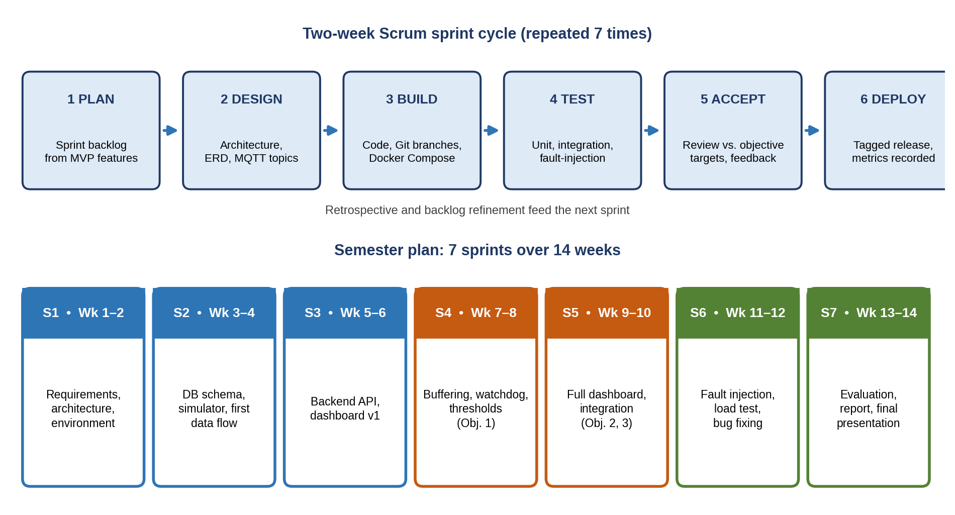
Fig. 1. Scrum sprint cycle and the 7-sprint semester plan.
Given that our project falls under the Database & Web/IoT Platform domain, this methodology was selected because the requirements for alert rules, dashboard views and fault scenarios will be refined as measurements accumulate. Short sprints deliver a working end-to-end increment (sensor → dashboard) early, and every sprint produces data that feed the evaluation of RQ1–RQ3. The team has one member, who acts as product owner, scrum master and developer, so the roles are combined while the backlog, sprint planning, review and retrospective are kept as lightweight practices. Table IV describes how each phase of the cycle is used in the research.
TABLE IV. USE OF EACH SPRINT PHASE IN THE RESEARCH
Phase | Application in this project
1. Plan | Select backlog items from the MVP features F1–F7 for the sprint, estimate effort and link each item to the research question or objective it supports.
2. Design | Update the architecture and ERD, define MQTT topics and message formats, REST/WebSocket endpoints and the structure of the evaluation experiments.
3. Build | Implement firmware/simulator, backend, database migrations and dashboard on short-lived Git feature branches; the stack is described in a Docker Compose file so that the environment is reproducible.
4. Test | Unit tests for validation and alert rules, integration tests for the MQTT-to-database path and fault-injection tests (delay, loss, disconnection); latency and delivery metrics are logged for the evaluation.
5. Accept | Sprint review against the acceptance criteria derived from the objectives (for example latency ≤ 2 s at p95), followed by supervisor feedback and a short retrospective.
6. Deploy | Tag a release in Git, update the demonstration environment (“docker compose up”) and record results, so that every sprint ends with a runnable prototype.
Version control uses Git with a protected main branch; every merge runs the automated tests in a continuous-integration pipeline, and commit messages reference the backlog item they implement.

System Architecture Modeling & Component Flow
To establish the structural framework of our application, our system follows a four-layer IoT architecture (perception, transport, processing and storage, application), organized as a multi-tier client–server system with publish/subscribe messaging. As illustrated in Fig. 2, the system is designed around modular layers that separate user presentation, core processing logic, and data persistence; the underlying principles are modularity and separation of concerns.
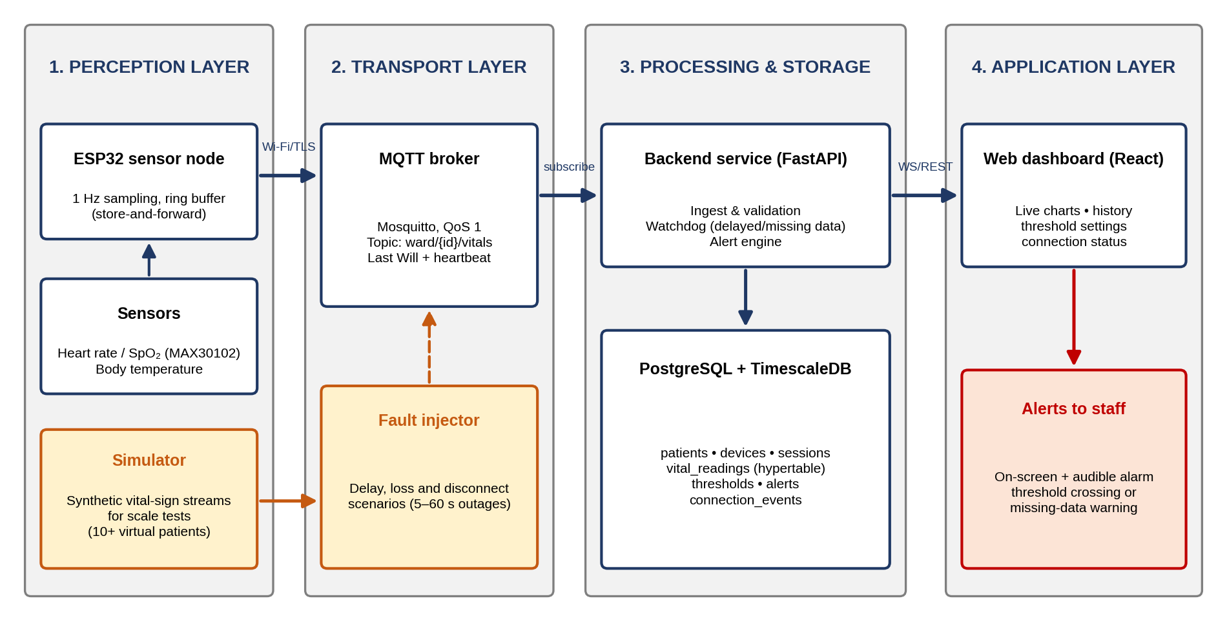
Fig. 2. Layered system architecture of the proposed IoT monitoring platform.
Component layer responsibilities:
- Presentation / Input layer: the ESP32 sensor nodes and the simulator provide the input data, and the web dashboard (React) handles user interaction, threshold configuration, alert display and rendering of live and historical charts.
- Business logic / Processing layer: the backend service (FastAPI) subscribes to the broker, validates and de-duplicates readings, runs the watchdog for delayed or missing data and the threshold-based alert engine, and exposes REST and WebSocket endpoints.
- Data / Storage layer: PostgreSQL with TimescaleDB stores configuration data, readings as a time-partitioned hypertable, alerts and connection events, and supports history queries.
Data flow summary: data originate from the sensors (or the simulator) on the ESP32 node, flow through the MQTT broker, the backend validation and alert engine and the database, and terminate at the web dashboard and the alert panel, ensuring a seamless end-to-end execution path for the MVP. A fault injector acts as a network proxy between publishers and broker to emulate delays, loss and disconnections during evaluation.
TABLE V. RESPONSIBILITIES OF EACH LAYER AND MODULE
Layer | Component | Responsibility
Perception | ESP32 sensor node; MAX30102 (heart rate, SpO₂); temperature sensor | Samples vital signs at 1 Hz, adds a timestamp and sequence number, keeps a ring buffer of unsent readings and publishes JSON messages
Perception (test) | Simulator | Generates physiologically plausible synthetic streams, including abnormal events with known timestamps, for at least 10 virtual patients
Transport | Mosquitto MQTT broker (TLS, QoS 1) | Routes messages by topic ward/{patient}/vitals, delivers the Last Will message and heartbeat of each device
Transport (test) | Fault injector | Adds delay, packet loss and forced disconnection of 5–60 s to evaluate RQ2
Processing | Backend service (FastAPI) | Subscribes to topics, validates and de-duplicates readings, writes to the database, runs the watchdog and the threshold-based alert engine, serves REST and WebSocket endpoints
Storage | PostgreSQL + TimescaleDB | Stores configuration data, readings as a time-partitioned hypertable, alerts and connection events
Application | Web dashboard (React) | Shows live charts, 24-hour history, device status, alert panel and threshold settings; authenticates users
Application | Alert channel | On-screen and audible alarms for threshold crossings and for missing-data warnings

Core Technical Implementation (Option A: Database & Web/IoT Platform)
Database Schema & Data Dictionary
To manage persistent data storage and state management for our MVP, our system utilizes a relational PostgreSQL database with the TimescaleDB extension. This database was selected because it offers ACID guarantees and a mature relational model for patients, devices, thresholds and alerts, plus automatic time partitioning, compression and continuous queries for the high-frequency vital_readings table. Compared with a pure NoSQL store it allows joins and constraints (for example thresholds that reference patients), and compared with a dedicated time-series engine it avoids operating two databases.
Entity-Relationship design: as illustrated in Fig. 3, the database architecture consists of the primary entities patients, devices, monitoring_sessions, vital_readings, thresholds, alerts and users, linked via relational foreign keys.
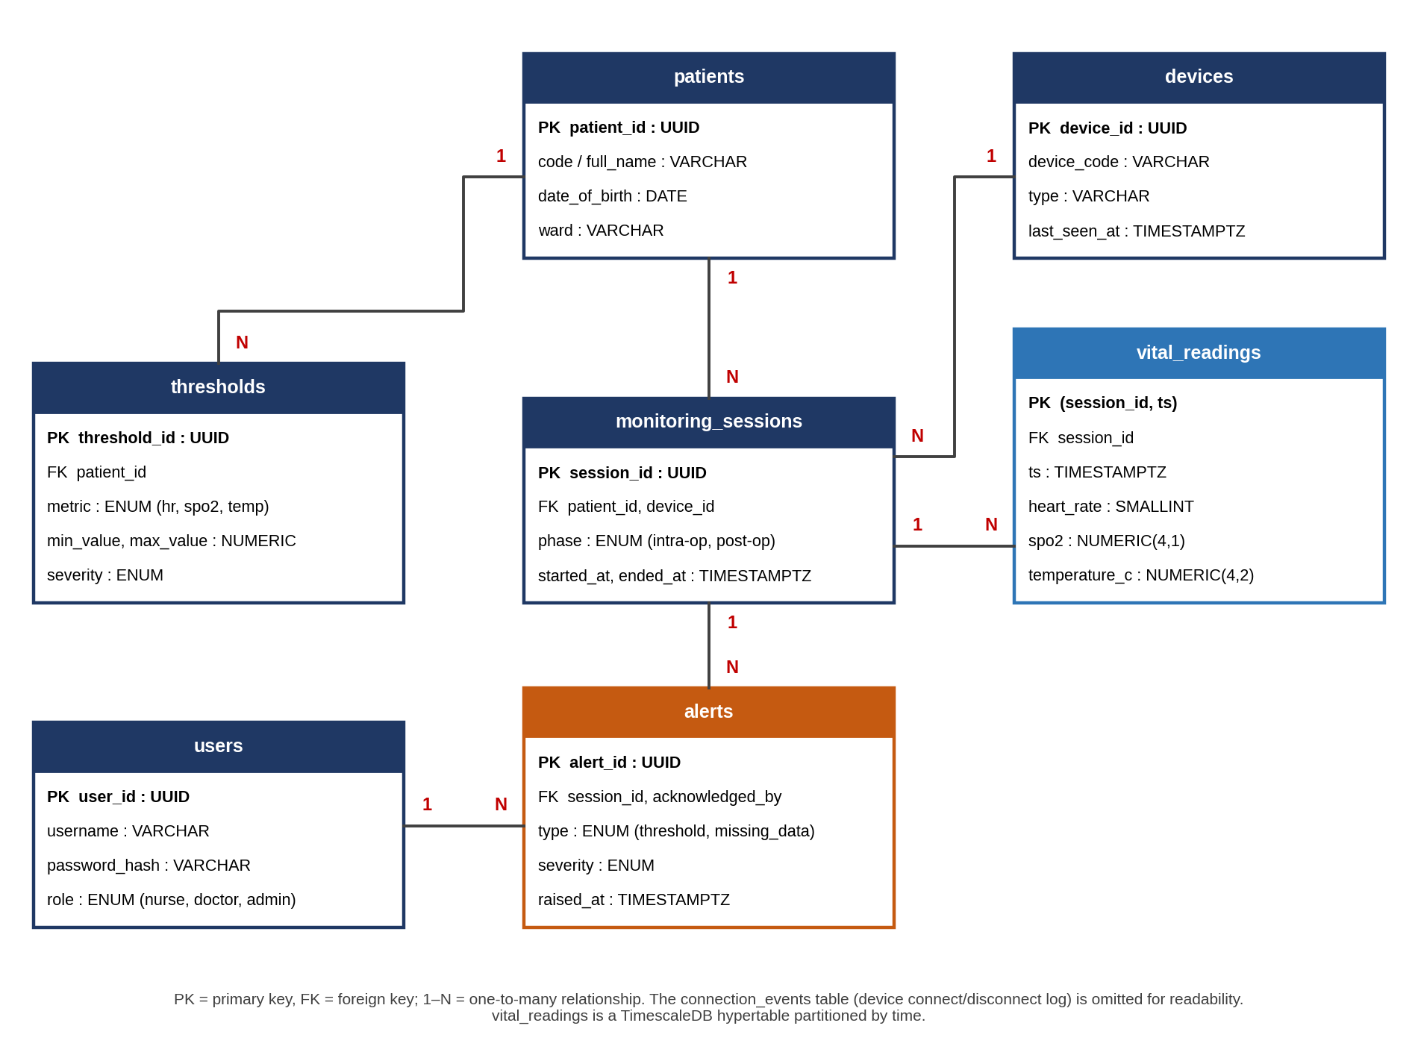
Fig. 3. Entity-Relationship Diagram (ERD) of the monitoring database.
Data dictionary: the structure of our core database schema is detailed in Table VI.
TABLE VI. DATA DICTIONARY
Field name | Data type | Constraints | Description
patients
patient_id | UUID | PRIMARY KEY | Unique identifier of the patient (pseudonymised code, no real personal data in the MVP)
code | VARCHAR(32) | UNIQUE, NOT NULL | Pseudonymous patient code shown on the dashboard
ward | VARCHAR(64) |  | Ward or operating-room identifier
devices
device_id | UUID | PRIMARY KEY | Unique identifier of a sensor node or simulator
device_code | VARCHAR(32) | UNIQUE, NOT NULL | Human-readable device name used in MQTT topics
last_seen_at | TIMESTAMPTZ |  | Time of the last message or heartbeat; used by the watchdog
monitoring_sessions
session_id | UUID | PRIMARY KEY | One continuous monitoring period of a patient
patient_id, device_id | UUID | FOREIGN KEY, NOT NULL | Patient and device involved in the session
phase | ENUM | NOT NULL | intra-op or post-op
started_at, ended_at | TIMESTAMPTZ | started_at NOT NULL | Start and end of the session
vital_readings
session_id | UUID | FOREIGN KEY, part of PK | Session the reading belongs to
ts | TIMESTAMPTZ | part of PK | Measurement time at the sensor (partitioning key of the hypertable)
heart_rate | SMALLINT | CHECK 0–300 | Heart rate in beats per minute
spo2 | NUMERIC(4,1) | CHECK 0–100 | Oxygen saturation in percent
temperature_c | NUMERIC(4,2) | CHECK 25–45 | Body temperature in °C
thresholds
threshold_id | UUID | PRIMARY KEY | Unique identifier of a rule
patient_id | UUID | FOREIGN KEY | Patient the rule applies to
metric | ENUM | NOT NULL | hr, spo2 or temp
min_value, max_value | NUMERIC | min ≤ max | Allowed range; a reading outside it triggers an alert
severity | ENUM | NOT NULL | warning or critical
alerts
alert_id | UUID | PRIMARY KEY | Unique identifier of an alert
session_id | UUID | FOREIGN KEY | Session in which the alert was raised
type | ENUM | NOT NULL | threshold or missing_data
raised_at | TIMESTAMPTZ | NOT NULL | Time the alert was generated (used to measure alert latency)
acknowledged_by | UUID | FOREIGN KEY (users) | Staff member who acknowledged the alert
users
user_id, username | UUID, VARCHAR | PRIMARY KEY, UNIQUE | Dashboard account
password_hash, role | VARCHAR, ENUM | NOT NULL | Salted password hash; role is nurse, doctor or admin

Evaluation Plan
The evaluation answers the research questions with measurements collected automatically during test runs. Sensor and simulator messages carry the measurement timestamp, the broker and backend log their receive times, and the dashboard logs the render time, so the delay of each stage can be reported.
TABLE VII. EVALUATION METRICS AND TARGETS
Metric | Definition | Target | Method
End-to-end latency (RQ1) | Time from sensor timestamp to dashboard render | ≤ 2 s at p95, 10+ patients | Timestamp logging; runs with 1, 5 and 10+ patients
Delivery ratio (RQ2) | Readings stored / readings sent | 100% after outages ≤ 60 s | Sequence-number check after reconnection
Detection time (RQ2) | Time from last valid update to missing-data alert | ≤ 5 s | At least 20 fault-injection trials
Alert latency (RQ3) | Time from the threshold-crossing reading to the alert on screen | ≤ 1 s | Injected abnormal events
Event detection rate (RQ3) | Injected abnormal events flagged / injected events | ≥ 95% | Simulated streams with known events
False-alert rate (RQ3) | Alerts without an injected event / total alerts | Reported, not constrained | Normal-range streams over 24 h

Ethics, Security and Limitations
No real patient data are used: the evaluation uses simulated streams and measurements from the developer or volunteers who give consent, and patients are identified by pseudonymous codes. Communication uses TLS and the dashboard requires authentication with role-based access. The MVP is a research prototype that must not be used for clinical decisions. Its main limitations are the use of low-cost sensors with limited accuracy, a single Wi-Fi network in the test setup and the absence of clinical validation.

PROJECT TIMELINE & MVP SCOPE

MVP Definition & Target Capabilities
To ensure successful delivery by the end of the semester, Team Alisher has scoped our project around a Minimum Viable Product (MVP) focused exclusively on solving our core problem statement. The MVP will deliver a working end-to-end prototype that validates our primary research objectives.
In-scope features (this semester):
- F1 – Sensor data acquisition: ESP32 node (or simulator) publishing heart rate, SpO₂ and temperature at 1 Hz over MQTT with TLS.
- F2 – Core processing pipeline: backend ingestion with validation, de-duplication and storage in PostgreSQL/TimescaleDB.
- F3 – Result dashboard: live charts for several patients and a device status indicator (online, delayed, offline).
- F4 – Reliability layer: edge buffering and watchdog that detect delayed or missing data within 5 s and back-fill after reconnection.
- F5 – Alerting: configurable per-patient thresholds with on-screen and audible alerts and alert acknowledgement.
- F6 – History: at least 24 hours of data and an alert log.
- F7 – Evaluation tooling: automated test and evaluation scripts (simulator, fault injector, metric collection) that reproduce the results in Table VII.
Out-of-scope features (future work): to maintain project feasibility within the semester timeline, advanced features such as machine-learning risk prediction, hospital information-system (EHR) integration, SMS or push notifications, blockchain-based data sharing and native mobile applications are formally classified as out-of-scope and deferred to future iterations.
Fig. 4 summarises the MVP concept from sensing to dashboard, and Fig. 5 shows a concept mockup of the user interface that the MVP will provide.
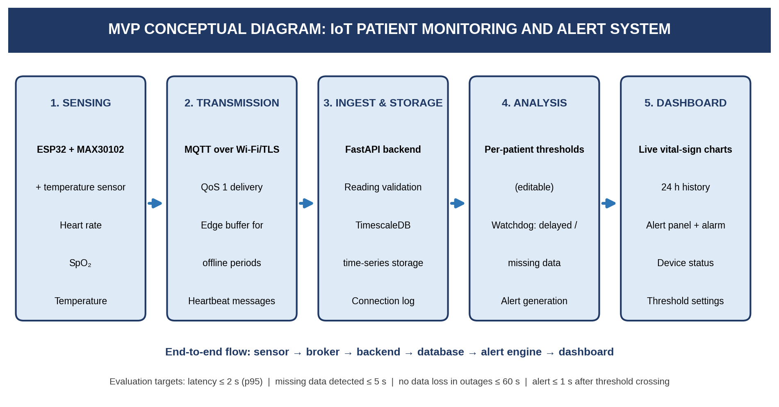
Fig. 4. MVP conceptual diagram.
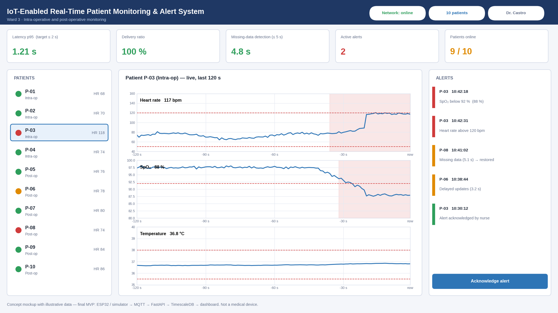
Fig. 5. Concept mockup of the monitoring dashboard (illustrative data).

Implementation Roadmap (Milestones)
To ensure a controlled and timely execution of our research project, Team Alisher has structured our semester implementation into sequential milestone phases (aligned with the sprints in Fig. 1). Task distribution and target deliverables are outlined in the roadmap table:
TABLE VIII. IMPLEMENTATION ROADMAP
Phase / week | Target deliverable / milestone | Responsible member
Weeks 1–3 | Requirements and use cases, final architecture, environment setup (Git repository, Docker Compose with broker and database), sensor bring-up, completed literature review | Babadjanov Alisher (researcher / full-stack developer / QA)
Weeks 4–6 | Core backend API (ingestion, REST, WebSocket), database schema and migrations, sensor firmware and simulator, first end-to-end data flow | Babadjanov Alisher (researcher / full-stack developer / QA)
Weeks 7–8 | Core logic: edge buffering, watchdog and threshold engine. Objective 1 target (Week 8): latency ≤ 2 s (p95) | Babadjanov Alisher (researcher / full-stack developer / QA)
Weeks 9–10 | Integration, dashboard (live, history, thresholds), MVP functional testing and preliminary evaluation. Objectives 2 and 3 implemented (Week 10) | Babadjanov Alisher (researcher / full-stack developer / QA)
Weeks 11–12 | Final system testing: fault-injection campaign, load test with 10+ virtual patients, bug fixing, security checks | Babadjanov Alisher (researcher / full-stack developer / QA)
Week 13 | Research evaluation: collect metrics, analyse results, answer RQ1–RQ3 | Babadjanov Alisher (researcher / full-stack developer / QA)
Week 14 | Final documentation, report, demonstration and final presentation | Babadjanov Alisher (researcher / full-stack developer / QA)

REFERENCES
[1] D. J. Hemanth, J. Anitha, and G. A. Tsihrintzis, Eds., Internet of Medical Things: Remote Healthcare Systems and Applications. Cham, Switzerland: Springer, 2021, doi: 10.1007/978-3-030-63937-2.
[2] IoT and ICT for Healthcare Applications (EAI/Springer Innovations in Communication and Computing). Cham, Switzerland: Springer, 2020, doi: 10.1007/978-3-030-42934-8.
[3] C. Chakraborty, A. Banerjee, M. H. Kolekar, et al., Eds., Internet of Things for Healthcare Technologies (Studies in Big Data, vol. 73). Singapore: Springer, 2020, doi: 10.1007/978-981-15-4112-4.
[4] Blockchain for Secure Healthcare Using Internet of Medical Things (IoMT). Cham, Switzerland: Springer, 2023, doi: 10.1007/978-3-031-18896-1.
[5] Advancing Healthcare with the Medical Internet of Things: Revolutionizing Patient Care through Connected Devices (Health Informatics). Cham, Switzerland: Springer, 2026, doi: 10.1007/978-3-032-23933-4.
[6] M. Aledhari, R. Razzak, B. Qolomany, A. Al-Fuqaha, and F. Saeed, “Biomedical IoT: Enabling technologies, architectural elements, challenges, and future directions,” IEEE Access, vol. 10, pp. 31306–31339, 2022, doi: 10.1109/ACCESS.2022.3159235.
[7] R. Uddin and I. Koo, “Real-time remote patient monitoring: A review of biosensors integrated with multi-hop IoT systems via cloud connectivity,” Appl. Sci., vol. 14, no. 5, Art. no. 1876, 2024, doi: 10.3390/app14051876.
[8] J. F. Kurose and K. W. Ross, Computer Networking: A Top-Down Approach, 8th ed., Global ed. Harlow, U.K.: Pearson Education, 2022, ISBN 978-1-292-40546-9.
[9] OASIS, “MQTT Version 5.0,” OASIS Standard, Mar. 2020. [Online]. Available: https://docs.oasis-open.org/mqtt/mqtt/v5.0/mqtt-v5.0.html
[10] P. Mahajan, Artificial Intelligence in Healthcare: AI, Machine Learning, and Deep and Intelligent Medicine Simplified for Everyone, 3rd ed. (Academic Edition). Albuquerque, NM, USA: MedMantra, 2022, ISBN 978-1-954612-02-0.
[11] A. Bohr and K. Memarzadeh, Eds., Artificial Intelligence in Healthcare. London, U.K.: Academic Press, 2020, ISBN 978-0-12-818438-7.
[12] S. Q. Naeem, A. I. Majeed, and N. N. ALfaisaly, “Design and implementation of monitoring system for lethal events of high-risk COVID-19 patients,” Iraqi J. Elect. Electron. Eng., vol. 21, no. 1, pp. 221–231, 2025, doi: 10.37917/ijeee.21.1.22.
[13] G. Krishnapriya and S. Prema, “Cost-effective IoT-based real-time vital sign monitoring: An affordable telehealth solution,” Telehealth Med. Today, vol. 10, Art. no. 611, 2025, doi: 10.30953/thmt.v10.611.

