WEEK 9 ASSIGNMENT
Scientific Research and Communication | 4-SRC-10-804
Babadjanov Alisher | Student ID: 230271 | Central Asian University
Project: IoT-Enabled Real-Time Patient Monitoring and Alert System for Intraoperative and Postoperative Care

1. One-page IMRaD outline

I. Introduction
Continuous intraoperative and postoperative monitoring requires timely visibility of heart rate, SpO₂ and temperature. Three research problems motivate the project: fragmented access to patient readings (RP1), delayed or missing updates (RP2), and difficulty identifying abnormal values without alerts (RP3). The research questions examine near-real-time display, handling interruptions and alert-supported interpretation. Existing IoMT and ESP32 studies establish feasibility but leave an opportunity to test a reproducible monitoring workflow.

II. Methods
The current MVP is a single-page HTML/CSS/JavaScript web application with virtual sensors rather than physical ESP32/MQTT devices. Its layers cover input and dashboard, reading processing and threshold/watchdog logic, and a pluggable document-oriented storage adapter (shared document storage when supported, otherwise browser localStorage). An iterative Agile process is used. Automated Chromium/Playwright tests are specified for alert display, threshold re-evaluation, acknowledgement, offline detection, reconnection, persistence and virtual-sensor updates.

III. Results
The submitted IEEE manuscript reports the prototype features as implemented: patient management, manual and simulated readings, trend charts, configurable thresholds, alerts, a missing-data watchdog, history and persistence. It gives acceptance targets rather than a complete quantitative results table: alert display ≤100 ms, missing-data detection ≤7 s, and default automatic updates every 120 s. Measured outcomes from the full evaluation are not yet supplied in the manuscript; these must be reported after testing.

IV. Discussion
The browser-based prototype can test the usability and functional logic of remote monitoring without clinical data or physical hardware. However, its timing and reliability results cannot establish MQTT delivery guarantees or clinical performance. The manuscript identifies no authentication, simulated sensors and browser-local persistence as limitations. Future work includes physical devices, MQTT transport, backend services and clinical-grade validation; these are not current MVP capabilities.

V. Conclusion (planned)
Summarize which research questions are supported by measured browser-test evidence, distinguish functional demonstration from clinical validation, and identify remaining work without claiming unmeasured outcomes.

2. Deployment map — current prototype
The deployment below reflects the latest submitted IEEE manuscript, not the earlier proposed ESP32 → MQTT → FastAPI → TimescaleDB stack. The browser hosts the user interface and processing logic. Storage is selected through an adapter.
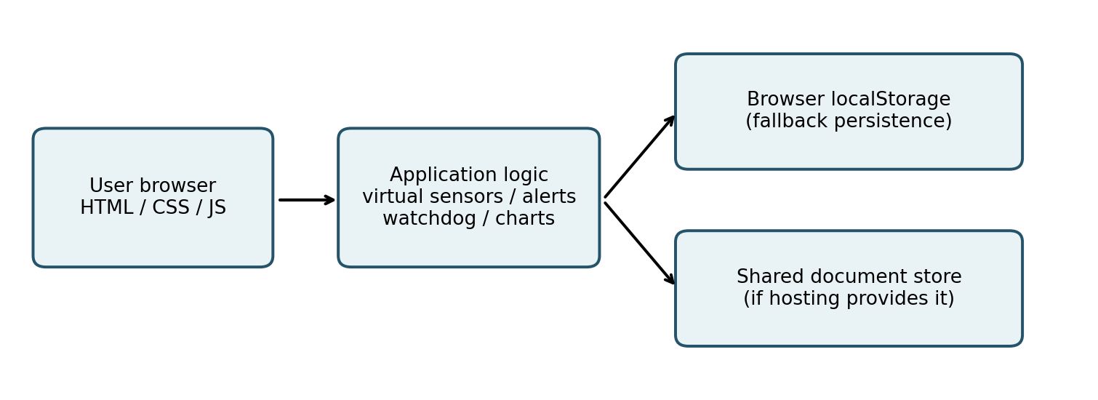
Fig. 1. Deployment map for the current browser-based monitoring prototype.
Deployment notes: open the single-page application in a modern browser; select or detect the available storage adapter; use virtual sensors or manual input; inspect dashboard, alert history and offline status. The IEEE manuscript does not provide a reproducible server URL, build commands, exact package versions or hosting configuration, so these details cannot be asserted.

3. Conceptual class diagram
The IEEE manuscript describes a single-page JavaScript application and document model, not an audited object-oriented source-code class hierarchy. The diagram below is therefore a conceptual decomposition of documented responsibilities, not a claim that these named classes already exist in the code.
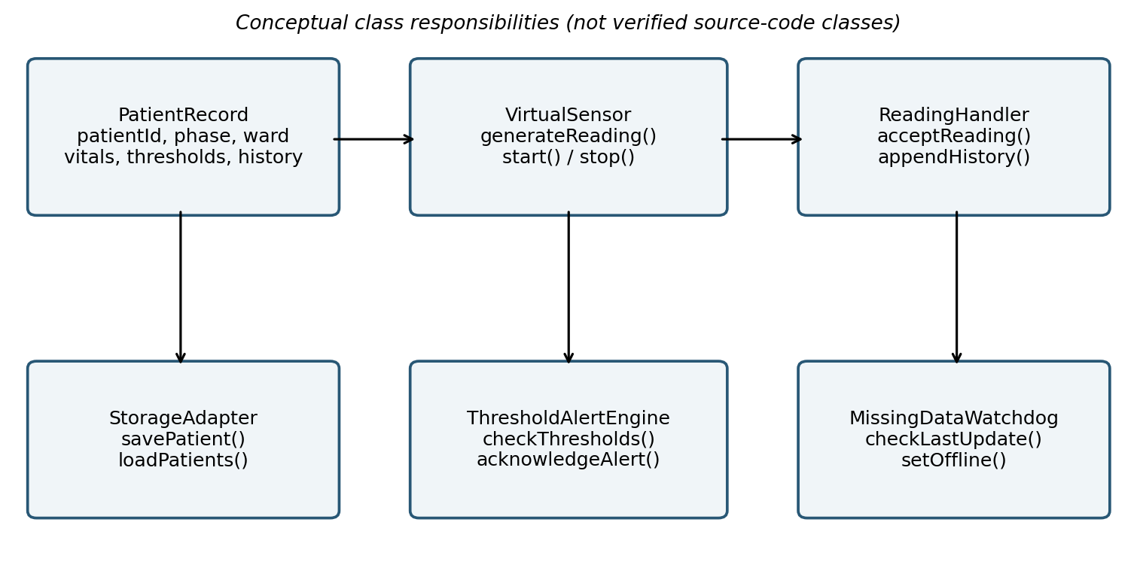
Fig. 2. Conceptual classes/modules and responsibilities derived from the submitted architecture.

4. MVP definition

Three MUST features
• Patient monitoring: manage multiple patient records and display heart rate, SpO₂ and temperature from manual or virtual-sensor readings.
• Alerting: configurable patient-specific thresholds, visible alert banner/log, sound and acknowledgement.
• Continuity: missing-data watchdog, device offline/reconnection state, reading history and persistence across page reloads.

Three measurable metrics
Metric | Measurement | Target in submitted IEEE paper
Alert display latency | Submit an out-of-range manual reading; time until alert appears | ≤ 100 ms
Missing-data detection | Disconnect a device; time until watchdog marks it offline | ≤ 7 s (5 s timeout + 2 s check)
Auto-update interval | Advance virtual time and inspect successive sensor updates | 120 s default
Status: These are acceptance targets from the previously submitted IEEE paper; the Week 9 materials do not establish that all numerical targets have been independently verified.

5. IEEE style and source alignment
IEEE conventions reviewed: numbered Roman-numeral sections, numbered citations [1]–[13], table captions above tables, figure captions below figures, and two-column formatting for the research paper. This assignment is a separate outline-and-diagrams handout; the previously submitted research manuscript already uses the IEEE two-column layout.
Source basis: (1) Week 9 – The IMRAD Modeling for Engineering, Assignment slide; (2) IoT-Enabled Real-Time Patient Monitoring and Alert System for Intraoperative and Postoperative Care, six-page IEEE manuscript; (3) earlier Midterm Proposal and Presentation, consulted to identify architectural changes. No unreported test data have been invented.

