Dtour

Digital Tour Guide

Description:

D our is an easy-to-use web plication that gives the experience of travel back into the hands of its users. D our is a digital tour guide that allows you to gift any travel experience to a friend or everyone with just a click of a button; turning your current adventure into a pinpointed, and returnable personalized digital tour guide. D our helps you share your route(s) with a selected group of friends or with anyone wanting to experience a similar destination.

Mission:

Our mission is to give travel experiences and sites an unprecedented more exposure. Through a customizable mobile application, we will highlight every hotel, restaurant, trail, and or natural experience by tagging all heartfelt landmarks; for all to enjoy. We will do all the work, by providing a digital tour guide, so you can enjoy your D our.

Vision:

Our vision is to make traveling fun and by exposing forgotten routes, businesses, meals, lodging, or simple nature trails, with just a click of a button, we’re making route sharing more possible; turning your current adventure into a pinpointed, and returnable personalized digital tour guide.

**Capabilities:**

Login to mobile application:

1. If someone’s shared a route with you, your profile will ping you with the (person, place, and price) of the trip.
   1. User has the option to accept
      1. Trip (hotel, respective restaurants, and etc.) is booked via online automated travel booking algorithm
   2. User has the option to decline
      1. Trip is archived or
      2. Trip is Canceled
2. If no one has shared a route with you, then move on to searching for a new or revisited adventure.

Choose Destination (International or Domestic)

1. A list of destinations is populated
2. Number of attendants are required (Individual or Family Trip)
3. Price Range is required
   1. Click Search for a listing that match your search criteria
4. Users can scroll through a listing of routes that people have traveled.
   1. Like it
   2. Love it
   3. Book it
   4. Skip it
5. Screen displays with planned route (user can choose to follow the exact route or start from their respective destination to travel to any plotted destination within the map.
6.  If users fail to visit all destinations plotted on the course, then a notification is displayed prompting new course to be created based on their experience.

Once user reaches a destination, they have the option to plot it on their D our

* 1. User has the option to take a picture
  2. If user purchase anything, user has the option to add total price.

Auto Calculation: users can add prices of each place they’ve visited, and throughout the course of their tour D our

1. will update the price and auto calculate their expenses.
   1. At the end of the trip RouteShare will auto calculate the final total and add the destination and price the que as an updated filer option.
   2. Option: Take a picture of the receipt, and RouteShare will extract the Total from the paper and add it to that destination for a final price roll-up.
2. RouteShare request to have access to your build-in navigation
3. RouteShare request to have access to your FB friends
4. RouteShare request to have access to your Instagram
5. RouteShare request to have access to your Twitter
6. RouteShare will have the ability to translate in every language, making it easy for receipts to be read and calculations to be performed.
7. Once a picture is taken RouteShare will ask; “Would you like to post this picture in any of the aforementioned platforms.”
8. RouteShare will have the ability to set reservations; if a restaurant requires, and send you a reminder once you’re nearing the reservation window.
9. RouteShare will have the ability to allow you to order an uber.

Simple Workflow diagram:

Possible Colors:

Backgound color =’Green faded from dark to light’

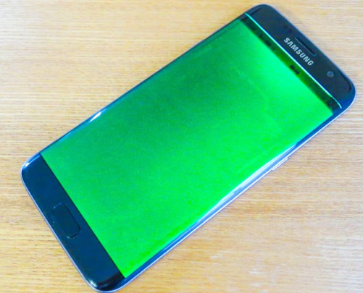

Dtour

USA + 1 (252) 555-555

Text Boxes = White with Black Letters or Transparent with White Letter

Login

Profile picture = User’s face incased in a circle:

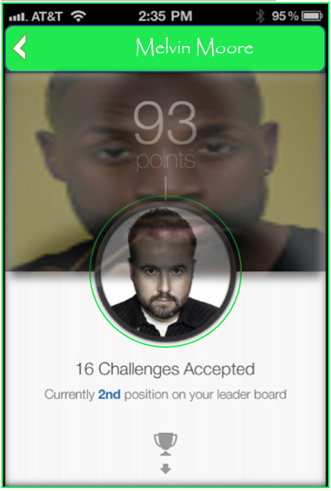

93 Trips taken via *D*tour.

Currently 3 Trips shared with you.

After 6pm the mobile application will transition into an easy to read color scheme. Black background with green letters. 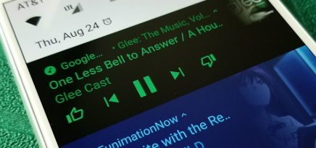

Date and Time stamp will be associated with each entry and depending on country. There a time difference when travailing abroad. There should be an accommodation as it relates to time differences per country. dTour will convert time

**Cons**:

The Name RouteShare has already be patented.

DTours is a similar name, however, the methodology isn’t the same.

**System Design**

Notes:

dTour can be accessed, however all privileges to view shared routes and/or share a route will be disabled until a profile is created.

