Lacuna: Cryptic Binding Pocket Discovery via Conformational Ensemble Analysis
Clayton W. Moore
Molecular & Environmental Plant Sciences, Texas A&M University, College Station, TX, USA

Abstract
We introduce Lacuna, an open-source Python tool for discovering cryptic binding pockets: sites that are absent or too small to detect in a protein's unbound structure and open only during conformational fluctuation. Most binding-site predictors score a single static structure, which is precisely the structure in which a cryptic site is invisible. Lacuna instead generates a conformational ensemble from any input structure, detects pockets independently in every conformer, clusters the detections into persistent sites across the ensemble, and ranks those sites with a model fitted on within-structure pairs. Ensemble generation is pluggable: normal mode analysis by default, with implicit-solvent molecular dynamics, Boltz-2 diffusion sampling, or a user-supplied ensemble as alternatives. On the held-out test fold of CryptoBench, Lacuna recovers 55.6% of cryptic sites in its top five predictions, rising to 66.1% with an optional sequence ranker, and it recovers 73%, 45% and 87% on the PocketMiner set, a curated set of literature apo/holo pairs, and COACH420 respectively. The default backend completes in a median of 2.6 seconds per chain on one CPU core, so ensemble-based pocket finding does not require a simulation budget. Every site carries a continuous crypticity score, and outputs are emitted as docking-ready Boltz YAML constraints, AutoDock Vina boxes and pseudoatom PDB files. Lacuna is MIT licensed and available at https://github.com/mooreneural/lacuna and on PyPI as lacuna-pockets.

1 Introduction
Roughly 70% of disease-relevant human proteins have no obvious binding site in their experimentally determined structures and are classified as undruggable [1]. A substantial fraction of those are not truly featureless: they carry cryptic sites, pockets that are closed in the apo structure and open on ligand binding or thermal fluctuation [2]. K-Ras was considered undruggable for three decades until a cryptic pocket beneath switch-II was identified, which led directly to a clinical programme [3]. The practical question is not whether such sites exist but whether they can be found computationally before a ligand is known.
This is hard for a specific and structural reason. The dominant approach to binding-site prediction scores a single static structure, whether geometrically by identifying concave surface features [4] or by machine learning over surface descriptors [5] or learned residue representations [6]. Applied to an apo structure containing a cryptic site, these methods are being asked to find a cavity that is not there. Methods built specifically for cryptic sites predict per-residue opening propensity from a single structure [7], which sidesteps the geometry problem but returns residue scores rather than a pocket a docking program can accept.
The alternative is to supply the missing conformations. Molecular dynamics followed by pocket detection on the trajectory is the established route [8], and it works, but it places a simulation budget between the user and an answer, which in practice restricts it to targets already considered worth the investment. That cost is why ensemble-based pocket finding has not become routine tooling in the way single-structure detectors have.
Lacuna is built on the observation that the ensemble does not have to be expensive to be useful. A cryptic pocket needs only to open somewhere in a set of plausible conformations for a geometric detector to see it, and the cheapest useful source of such conformations, an elastic network model, costs seconds rather than CPU-days. What matters is then the bookkeeping: detecting pockets per conformer produces a large, redundant set of transient cavities that must be matched across frames into persistent sites and ordered so the interesting one appears near the top.
Our contributions are as follows.
Lacuna makes ensemble-based pocket discovery cheap enough to be routine. The default backend requires no simulation setup, no force field parameterisation and no GPU, and completes in a median of 2.6 seconds per chain on one CPU core (Figure 4). Users who want a more expensive ensemble can substitute one without changing anything downstream.
Ensemble generation is pluggable, including a co-folding backend. Normal mode analysis, implicit-solvent molecular dynamics, Boltz-2 diffusion sampling, and arbitrary user-supplied ensembles all present the same interface, so the sampling method is a parameter rather than a rewrite.
Transient pockets are first-class objects. Detections are clustered across conformers into sites that carry their own statistics: how often the site is open, how much it opens relative to the input structure, and how far its centroid wanders. These ensemble-derived quantities are unavailable to any single-structure detector and are what the ranker relies on most.
Ranking is fitted, not hand-tuned. A linear model over 23 features, trained on within-structure pairs so that it optimises ordering directly, recovers roughly three times as many known sites on CryptoBench as the analytic crypticity rule it replaced.
Output is docking-ready. Each site is emitted as a Boltz YAML constraint, an AutoDock Vina box, and a pseudoatom PDB, so a predicted pocket can be handed directly to a docking or co-folding run.
Lacuna is MIT licensed, distributed on PyPI, archived on Zenodo [9], and covered by 167 tests. This report describes the design and validates the implementation. A separate study uses Lacuna's per-candidate output, alongside three other detectors, to analyse how the field's standard evaluation metric conflates detection with ranking; that analysis is reported elsewhere [10] and is not restated here.
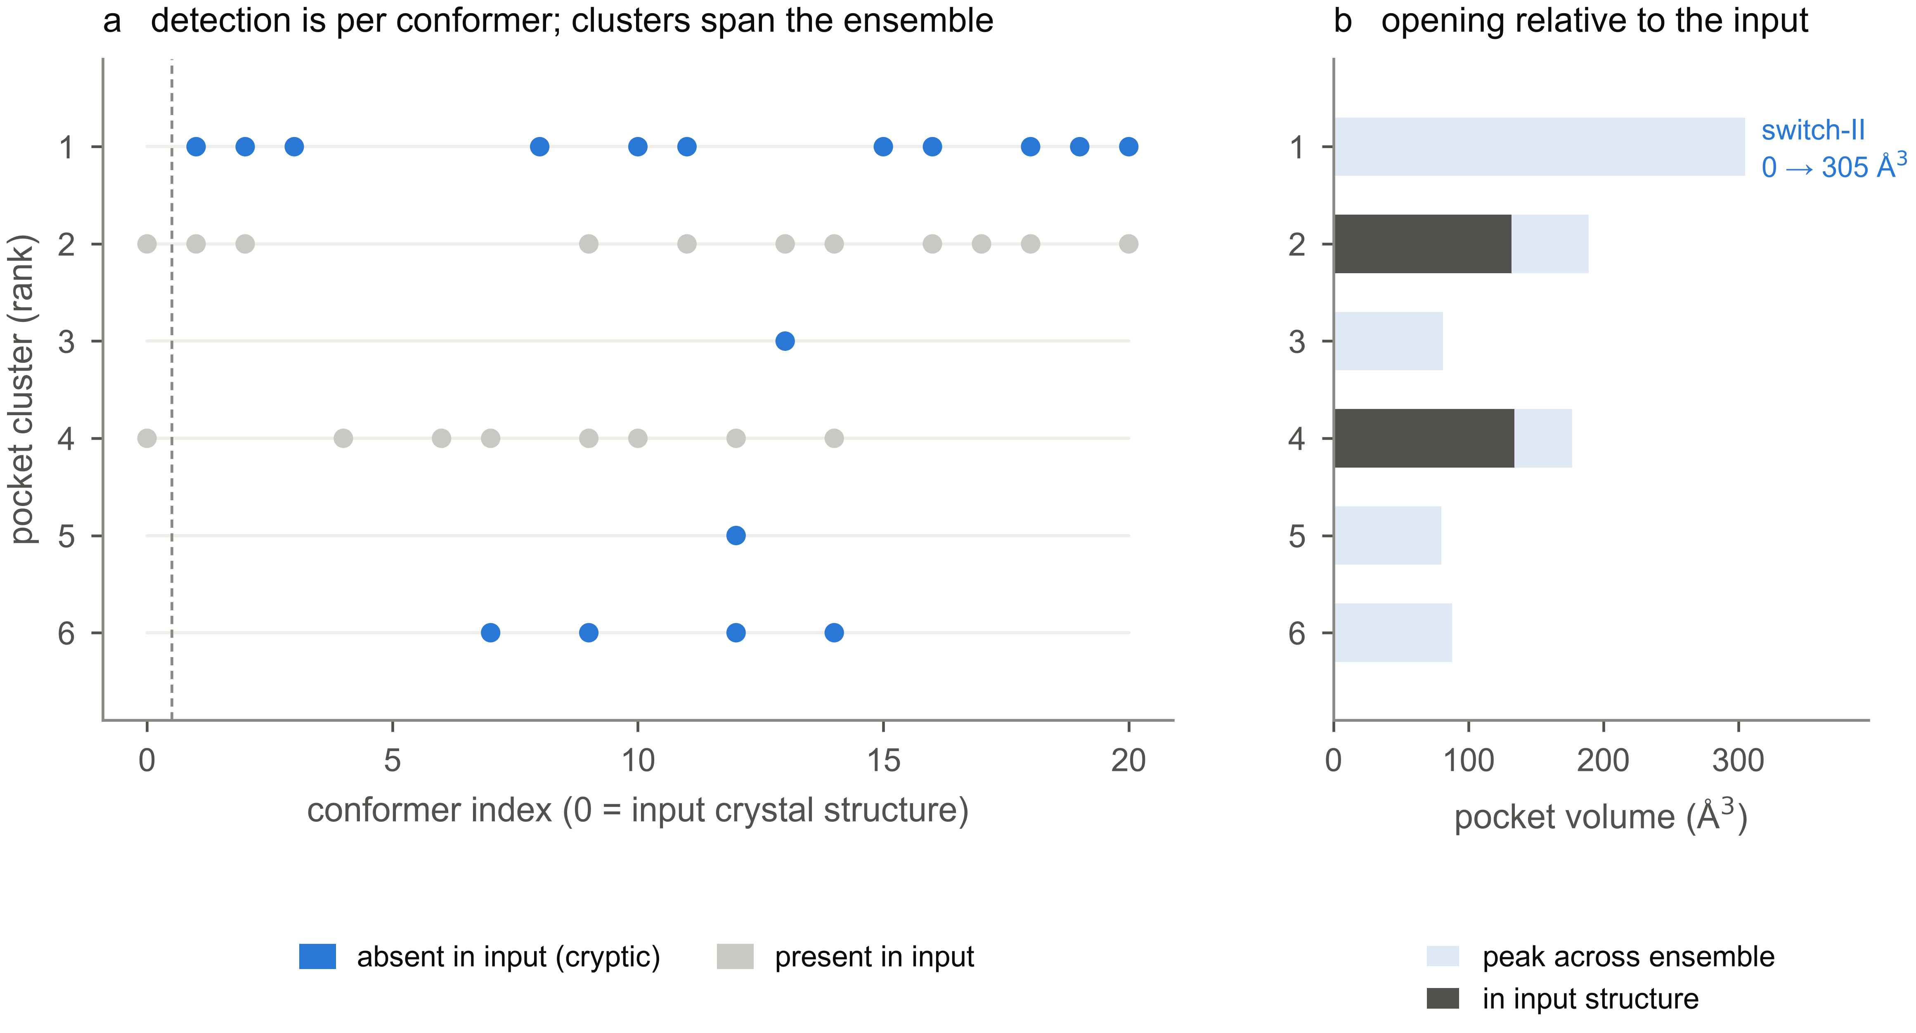
Figure 1: The canonical cryptic pocket, recovered at rank 1 in three seconds. Lacuna run on chain A of apo K-Ras (PDB 4OBE) with default settings: normal mode backend, 20 conformers. (a) Each row is a pocket cluster, each column a conformer, and a mark indicates the cluster was detected in that conformer. Column 0, left of the dashed line, is the input crystal structure itself; columns 1 to 20 are generated conformers. Clusters absent from the input structure are coloured blue. The rank-1 cluster is the switch-II pocket: it is detected in 11 of the 20 generated conformers and in none of the input, which is what makes it cryptic and what makes it invisible to a detector that sees only column 0. (b) Pocket volume in the input structure against the peak volume reached anywhere in the ensemble. The switch-II cluster goes from 0 to 305 Å³. Clusters 2 and 4 are ordinary surface pockets, already open in the input, and the ensemble adds little to them. The rank-1 cluster reaches a Jaccard overlap of 0.33 with the literature-annotated switch-II site and contains 79% of its residues.

2 Design

2.1 Overview
Lacuna is a four-stage pipeline (Figure 2). A structure enters, an ensemble is generated, pockets are detected independently in each conformer, detections are clustered across conformers, and the resulting sites are ranked and written out. Each stage is separable, and the ensemble stage in particular is a plugin point.
Ensemble generation. The default backend is an anisotropic network model [11], an elastic network in which residues are nodes connected by harmonic springs. Displacing the structure along its lowest-frequency normal modes produces conformers that respect the fold's intrinsic flexibility at negligible cost. This is deliberately the cheapest reasonable choice, and it is also the most limited: harmonic modes describe collective breathing well and cannot produce large hinge motions or loop rearrangements. Three alternatives share the same interface. An implicit-solvent molecular dynamics backend samples thermal motion directly. A Boltz-2 backend [16] draws conformers as independent samples from a co-folding model's learned posterior, with the diffusion step scale lowered from its default to increase structural diversity. Finally, --ensemble accepts a multi-model PDB or a directory of structures, so an ensemble produced by any external method can be analysed without Lacuna generating anything; frames are matched to the input by residue numbering and atom name, so a frame missing a loop remains usable.
Pocket detection. Within each conformer, pockets are found by a grid-based alpha-sphere method in the fpocket lineage [4]: candidate spheres are placed where they contact protein atoms without penetrating them, retained within a radius band that admits ligand-sized cavities while rejecting bulk solvent and interstitial voids, and clustered spatially into pockets. Lining residues are assigned by true atomic contact rather than by a radius around the pocket centre, which matters because a centre-and-radius definition inflates the residue set of large pockets and makes any overlap metric computed from it optimistic. Alternative detectors are available: --detector p2rank substitutes P2Rank [5] per conformer, and fusion runs both.
Cross-conformer clustering. This is the step that turns per-frame detections into sites. Pockets from different conformers are matched into clusters by spatial proximity of their centres together with overlap of their lining residue sets, so that the same physical site detected in fifteen conformers becomes one cluster rather than fifteen candidates. Each cluster then carries statistics no single structure can provide: persistence, the fraction of conformers in which the site is open; the volume distribution across the ensemble and its coefficient of variation; the volume in the input structure specifically; and the positional spread of the cluster's centroid between conformers.
Ranking. The default strategy is a linear model over 23 features spanning pocket geometry, druggability in the sense of Halgren's descriptors [12], and the ensemble-derived terms above. It is fitted on within-structure pairs, so it optimises the ordering of candidates inside one protein rather than classifying pockets in isolation, which is the quantity that actually determines whether a user sees the right site. Fitting used only CryptoBench's homology-separated training folds. An optional strategy, learned-plm, refits the same linear form with four additional features summarising a protein language model's per-residue cryptic-site probabilities over the cluster's lining [13]; it requires an optional dependency and is not the default, so that the same command produces the same ranking on every installation. Several analytic strategies remain available for targets that resemble classical case studies more than they resemble CryptoBench.
Crypticity. Independently of rank, every site receives a continuous score between 0 and 1 capturing the conformational-selection signature:
`` opening = (max_volume − input_volume) / max_volume crypticity = opening × peak_open_state_druggability ``
A site absent from the input structure has opening 1.0, so crypticity reduces to its druggability once open. A site already open in the input has low opening and therefore low crypticity regardless of how druggable it is. A site is additionally flagged cryptic when it is present in fewer than 90% of conformers.
Outputs. Sites are written as a ranked JSON report carrying every quantity above, and optionally as Boltz YAML constraint files, AutoDock Vina box configs, and pseudoatom PDB files for visualisation. The docking outputs exist because a predicted pocket that cannot be handed to the next tool in a workflow is of limited use.
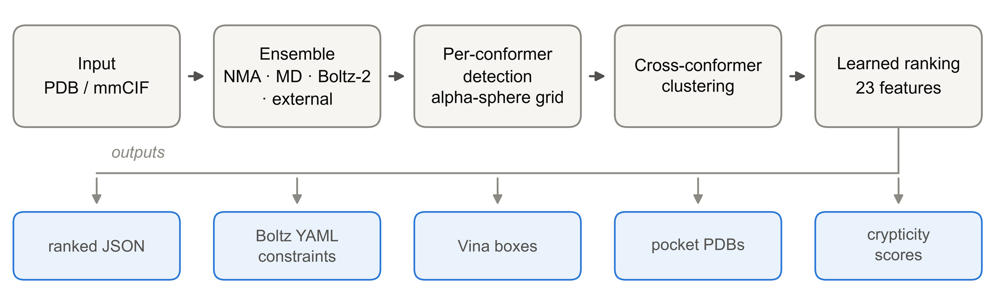
Figure 2: Lacuna's pipeline. Ensemble generation is a plugin point; detection runs independently per conformer; clustering is what converts transient per-frame cavities into persistent sites with ensemble statistics.

2.2 Interface
The command line covers the common case:
``bash pip install lacuna-pockets lacuna discover protein.pdb lacuna discover protein.pdb --backend boltz --conformers 30 lacuna discover protein.pdb --emit-boltz-constraints --emit-vina-boxes ``
Inputs are PDB or mmCIF and may come from the PDB, AlphaFold [14], Boltz or Chai. A --homodimer flag builds the biological assembly from BIOMT or _pdbx_struct_oper_list records, which is required for sites at dimer interfaces. The Python API exposes the same stages individually for users who want to substitute a component. Optional extras (lacuna[openmm], lacuna[boltz], lacuna[plm]) gate the heavier dependencies so that a base install stays small.

3 Validation

3.1 A worked example
Figure 1 shows Lacuna applied to apo K-Ras (PDB 4OBE, chain A) at default settings. The switch-II pocket is returned at rank 1, with a Jaccard overlap of 0.33 against the literature-annotated site and 79% of its annotated residues recovered. The run took 3.1 seconds.
The mechanism is visible in the figure rather than asserted. The switch-II cluster has zero volume in the input crystal structure and reaches 305 Å³ at its widest in the ensemble, and it is detected in 11 of 20 generated conformers. A detector restricted to column 0 has nothing to find. This example is a favourable one, chosen because it is the canonical case; the aggregate behaviour is in the next section.

3.2 Recovery across four datasets
A site counts as recovered when, among the top five ranked clusters, one reaches a Jaccard overlap of at least 0.25 with the known ligand-contact residues, or its centre lies within 4 Å of the site centroid. Jaccard is used rather than plain recall because recall is size-gameable: a sufficiently large pocket engulfs most of a small known site without being localised on it, and we confirmed that a re-ranker can reach 84% on the recall metric purely by ordering pockets on volume. Jaccard penalises that directly.
Figure 3 reports recovery on four datasets. On the held-out CryptoBench test fold [15], the largest and most diverse cryptic-site benchmark, the default ranker recovers 55.6% and the optional sequence ranker 66.1%. Independent validation is consistent: 73% (33/45) on the PocketMiner set [7] and 45% (10/22) on a curated set of apo/holo pairs assembled from the cryptic-pocket literature [2]. The CryptoBench split follows the dataset's own homology-separated folds and the ranker was fitted on training folds only, so the test fold is genuinely unseen.
The fourth dataset is a deliberate negative control. COACH420 contains holo structures whose pocket is already open, which is an easier task and not the one Lacuna is built for. Lacuna scores 86.8% there, but paired on the same 144 structures P2Rank scores 93.8%, a difference of −6.9% (95% CI −12.5 to −1.4) that excludes zero, having tied Lacuna on cryptic sites. Each tool wins where it was designed to win, and the higher absolute number on COACH420 reflects the easier task rather than better performance. Cross-dataset comparison of these figures is not meaningful.
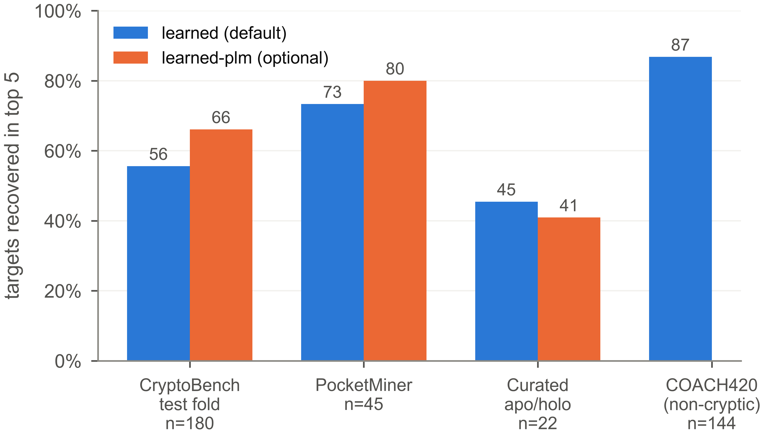
Figure 3: Recovery in the top five predictions across four datasets. A site counts as recovered at Jaccard ≥ 0.25 against known ligand-contact residues, or a centroid within 4 Å. learned is the default ranker and needs only a base install; learned-plm additionally requires a protein language model and was not measured on COACH420. COACH420 holds general, already-open binding sites rather than cryptic ones and is included as a control, not as a headline: the task is easier, and a general-purpose detector beats Lacuna on it.

3.3 Runtime
Figure 4 reports wall-clock time against chain length for the default backend at 20 conformers on a single core. Each structure is a single extracted chain, timed in a separate process so that interpreter warm-up cannot flatter later runs, drawn across the CryptoBench size range rather than cherry-picked.
Across 30 chains spanning 57 to 676 residues, the complete pipeline, ensemble generation through ranking, takes 0.9 to 7.2 seconds, with a median of 2.6. A power-law fit gives an exponent of 0.89, so cost is essentially linear in chain length over this range. The K-Ras example in Figure 1 took 3.1 seconds.
The practical consequence is that ensemble-based pocket discovery on a single protein is an interactive operation rather than a scheduled job, which is the design goal. The heavier backends are correspondingly more expensive: the molecular dynamics and Boltz-2 backends cost minutes to hours per target and are appropriate when the default's harmonic sampling is known to be insufficient.
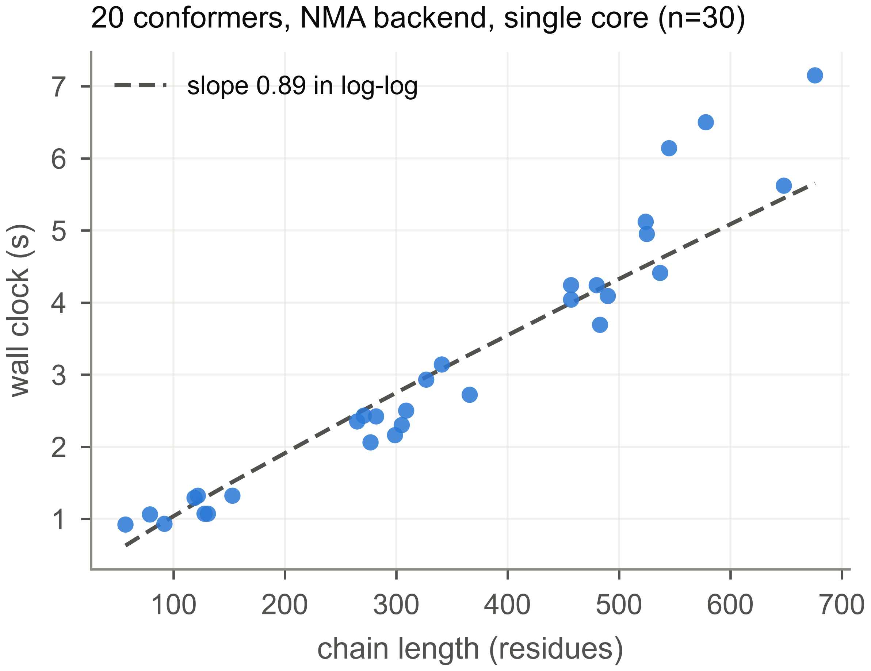
Figure 4: Wall clock against chain length. Default normal mode backend, 20 conformers, single core, single extracted chain per structure, drawn across the CryptoBench size range rather than cherry-picked. The dashed line is a power-law fit in log-log coordinates.

4 Conclusions
Lacuna packages ensemble-based cryptic pocket discovery as a tool that installs with pip and runs in seconds, rather than as a protocol requiring a simulation budget. Its distinguishing choices are that the ensemble backend is a swappable parameter, that detections are clustered across conformers into sites carrying ensemble statistics, and that ranking those sites is a fitted problem rather than a hand-designed rule.

4.1 Limitations
Two limits are worth stating plainly.
The first is ranking. Across the candidate set Lacuna generates, some cluster clears the recovery criterion for 73.7% of CryptoBench test-fold structures, against the 66.1% that reach the top five. The site is often found and then out-ranked. Several attempts to close that gap returned nothing measurable: spatial non-maximum suppression, merging adjacent sub-pockets, hard-negative mining, gradient boosting in place of the linear model, and importing P2Rank's own per-pocket confidence as a ranking feature. The last is the most informative, since if per-point scoring were the missing ingredient then handing the ranker P2Rank's opinion directly should have helped, and it did not.
The second is sampling. Stratifying the test fold by how far the site moves between apo and holo, Lacuna recovers 47% of the most-mobile quartile against P2Rank's 62%. The default elastic network is harmonic and cannot generate large hinge or interface openings. Enhanced-temperature dynamics, metadynamics along an apo-derived collective variable, and scaled-water dynamics were each null against baseline at single-workstation sampling. Catching those events reliably appears to need tens to hundreds of nanoseconds across dozens of replicas per target, which is a cluster-scale cost rather than a missing algorithm. This is the gap the co-folding backend is intended to probe, since a generative model samples conformational diversity without paying for the trajectory between states.

Data and code availability
Source code is at https://github.com/mooreneural/lacuna under the MIT licence, released as v1.0.0 and installable as pip install lacuna-pockets. The exact version described here is archived on Zenodo at doi:10.5281/zenodo.21891171 [9]. All benchmark scripts, including those that produce every number in Figure 3, are in the repository's benchmarks/ directory and download their datasets automatically.

References
1. Dang CV, Reddy EP, Shokat KM, Soucek L. Drugging the 'undruggable' cancer targets. Nature Reviews Cancer 2017. doi:10.1038/nrc.2017.36
2. Cimermancic P, Weinkam P, Rettenmaier TJ, Bichmann L, Heffron GJ, Rakoczy S, et al. CryptoSite: expanding the druggable proteome by characterization and prediction of cryptic binding sites. Journal of Molecular Biology 2016;428(4):709-719. doi:10.1016/j.jmb.2016.01.029
3. Ostrem JM, Peters U, Sos ML, Wells JA, Shokat KM. K-Ras(G12C) inhibitors allosterically control GTP affinity and effector interactions. Nature 2013;503:548-551. doi:10.1038/nature12796
4. Le Guilloux V, Schmidtke P, Tuffery P. Fpocket: an open source platform for ligand pocket detection. BMC Bioinformatics 2009;10:168. doi:10.1186/1471-2105-10-168
5. Krivák R, Hoksza D. P2Rank: machine learning based tool for rapid and accurate prediction of ligand binding sites from protein structure. Journal of Cheminformatics 2018;10:39. doi:10.1186/s13321-018-0285-8
6. Carbery A, Buttenschoen M, Skyner R, von Delft F, Deane CM. Learnt representations of proteins can be used for accurate prediction of small molecule binding sites on experimentally determined and predicted protein structures. Journal of Cheminformatics 2024;16:32. doi:10.1186/s13321-024-00821-4
7. Meller A, Ward M, Borowsky J, Kshirsagar M, Lotthammer JM, Oviedo F, et al. Predicting locations of cryptic pockets from single protein structures using the PocketMiner graph neural network. Nature Communications 2023;14:1177. doi:10.1038/s41467-023-36699-3
8. Schmidtke P, Bidon-Chanal A, Luque FJ, Barril X. MDpocket: open-source cavity detection and characterization on molecular dynamics trajectories. Bioinformatics 2011. doi:10.1093/bioinformatics/btr550
9. Moore CW. Lacuna: cryptic binding pocket discovery via conformational ensemble analysis (v1.0.0). Zenodo, 2026. doi:10.5281/zenodo.21891171
10. Moore CW. Cryptic binding sites are detected but not ranked: coverage, conversion, and detector consensus. Preprint 2026.
11. Atilgan AR, Durell SR, Jernigan RL, Demirel MC, Keskin O, Bahar I. Anisotropy of fluctuation dynamics of proteins with an elastic network model. Biophysical Journal 2001. doi:10.1016/S0006-3495(01)76033-X
12. Halgren TA. Identifying and characterizing binding sites and assessing druggability. Journal of Chemical Information and Modeling 2009. doi:10.1021/ci800324m
13. Lin Z, Akin H, Rao R, Hie B, Zhu Z, Lu W, et al. Evolutionary-scale prediction of atomic-level protein structure with a language model. Science 2023;379(6637):1123-1130. doi:10.1126/science.ade2574
14. Jumper J, Evans R, Pritzel A, Green T, Figurnov M, Ronneberger O, et al. Highly accurate protein structure prediction with AlphaFold. Nature 2021. doi:10.1038/s41586-021-03819-2
15. Škrhák V, Novotný M, Feidakis C, Krivák R, Hoksza D. CryptoBench: cryptic protein-ligand binding sites dataset and benchmark. Bioinformatics 2025;41(1):btae745. doi:10.1093/bioinformatics/btae745
16. Passaro S, Corso G, Wohlwend J, Reveiz M, Thaler S, Somnath VR, et al. Boltz-2: towards accurate and efficient binding affinity prediction. bioRxiv 2025. doi:10.1101/2025.06.14.659707

