

**FACULTY OF SCIENCE AND ENGINEERING**

**SEMESTER 2, 2016**

**IFB299 - Application Design & Development**

**Project: Personal portfolio**

**Due Date: Week 13**

**Submission Method: Blackboard**

**Weight: 30%**

**Student Names:** Matt Lye

**Student Number:** 9191453

Release 1

Artefact 1 – Release and Sprint Planning

**What did you do that made a meaningful contribution to the teamwork in producing the final solution?**

Upon receiving the user stories from the client we all, client and developer held a meeting to decide what user storied needed to be in the first release, this was done by following the INVEST criteria. After establishing what was required in the first release Andy, Laura and I were tasked with creating the first sprint plan.

**Evidence of Work**

Every Monday the team held a meeting at 10am and for the each time a new sprint was needed we would take time aside from the meeting and decide what needed to be in the next sprint and if anything was needed to be pushed back to further releases or sprints. Evidence of this can be seen in the submitted documents and improvements can be seen from sprint to sprint as we got used to the effectiveness of the team as a whole.

**How did it fit in the team work/project work?**

In order to be an effective team it is important for everyone to have an understanding of what needs to be done and in the time period it need to be completed in, this is what the sprint plan represented. This was the main tool our team used to stay on top of the work load and not fall behind.

Artefact 2 – Programming Research

**What did you do that made a meaningful contribution to the teamwork in producing the final solution?**

Due to my lack in knowledge of the chosen programming languages, I decided to sit down and run through the basics of each language. Also running through group member’s already written code to see the coding standard that was expected by the group and clients and to see how all the languages interconnected.

**Evidence of Work**

HTML Tutorials:

* <http://htmldog.com/guides/html/beginner/>
* <http://www.w3schools.com/html/>

CSS Tutorials:

* <http://www.htmldog.com/guides/css/beginner/>
* <http://www.w3schools.com/css/>

Javascript Tutorials:

* <http://www.w3schools.com/js/>

AngularJS:

* <http://www.w3schools.com/angular/>

**How did it fit in the team work/project work?**

In order to be useful to the team beside documentation it was necessary that I understand how to use the language to help with the programming side. This led me to be able to create ideas and concepts of views and functionality and actually put them in to practice for the project.

Artefact 3 - Peer Review Letter

**What did you do that made a meaningful contribution to the teamwork in producing the final solution?**

Laura and I drafted the business letter that was sent to our developer team.

**Evidence of Work**

***Business Letter***

Thank you for your demonstration of all the user stories you have completed so far as well as your presentation of the current state of your projects development.

Your level of preparation was more than adequate and we were highly impressed with your team’s presentation quality and content. Furthermore, the presentation was very thorough explaining the design process and further elaborating on the projects finer details and essential information. Through the presentation of the product your team was able to demonstrate to us a working home page for your application which was very polished and well presented. Additionally, we recognize that there were limitations within what your team could present at this stage due to technical limitations as well as there being a large amount of backend work that had not been fully integrated with the frontend components at this stage.

As a result, your team was able to successfully deliver some of the user stories planned for sprint 1 in their entirety. In addition, the presentation of the application prototypes and wireframes were able to establish a proof of concept and clear direction of where the application is heading. Though some of the other initial features planned for sprint 1 had not been completed it was evident that you had replanned your process in order to complete the construction of your product in time for release 1. At this point in time the product appears to be extremely useful for business value especially within event management.

We’re interested in your decision to use the Play Framework as it has been designed to provide minimal resource consumption as well as being highly-scalable. We noted that you did comment on the fact that the Play Framework was rather “finicky” but you were working around any difficulties as they arise. Furthermore, your choice of SQL for your applications database management is logical and well founded. As well as your use of Materialize CSS has been highly effective in making an appealing and polished GUI.

During the peer review your team was able to deliver a clear and coherent presentation. Anything that wasn’t properly explained was further elaborated on and you were able to answer any of the questions we threw at you. Your use of PowerPoint during the presentation as well as a demonstration of your product showed that you had prepared in advance for the presentation. Also it was encouraging to see all members of your team actively presenting and showing their involvement within the project. While we are happy with the quality and quantity of work presented, we are concerned about the wellbeing of the team, we would like you to use the full two weeks to complete the tasks set as to reduce the amount of long days and late night due to lack of time efficiency.

In conclusion we are eagerly awaiting to see the further implementation of more features in the near future and hopefully a more complete product for the first Release.

Artefact 4 - Preliminary Driver Views

**What did you do that made a meaningful contribution to the teamwork in producing the final solution?**

One user story consisted of a driver view to see the existing jobs that need to be completed and what state they are in with the ability to change the state of a package. This view also covers a part of another user story with a button to be able to print important information about the selected package. As this was a preliminary view it was just the foundation for the final product and was not fully functional.

**Evidence of Work**

***HTML Code***

<div class='row' ng-repeat='order in orders'>

<div class='col-md-8 order-container'>

<span class='float-right'><a href=''><i class="material-icons">delete_forever</i></span></a>

<span class='float-right'><a href=''><i class="material-icons">print</i></span></a> <p<h5 class='card-order-id'><b>Order ID# {{order.id}}</b></h5> &nbsp; &nbsp;&nbsp;&nbsp;&nbsp;&nbsp;&nbsp;&nbsp; <small>Destination: {{order.destination}}</small> </p>

<input class='float-right' type="checkbox" ng-model="myVar" ng-init="myVar = false">

</div>

<div ng-if="myVar">

<div class='col-md-8 div-panel'>

<div class="progress progress-striped">

<div class="progress-bar progress-bar-success" style="width: {{order.progress}}"></div>

</div>

<button class='col-sm-3 status-text-button'>

<p>Order placed</p>

</button>

<button class='col-md-3 status-text-button'>

<p>Driver en-route</p>

</button>

<button class='col-md-3 status-text-button'>

<p>Parcel picked up</p>

</button>

<button class='col-md-3 status-text-button'>

<p>Delivered</p>

</button>

</div>

</div>

</div>

</div>

<br><br>

***Screenshot of Preliminary Driver page***

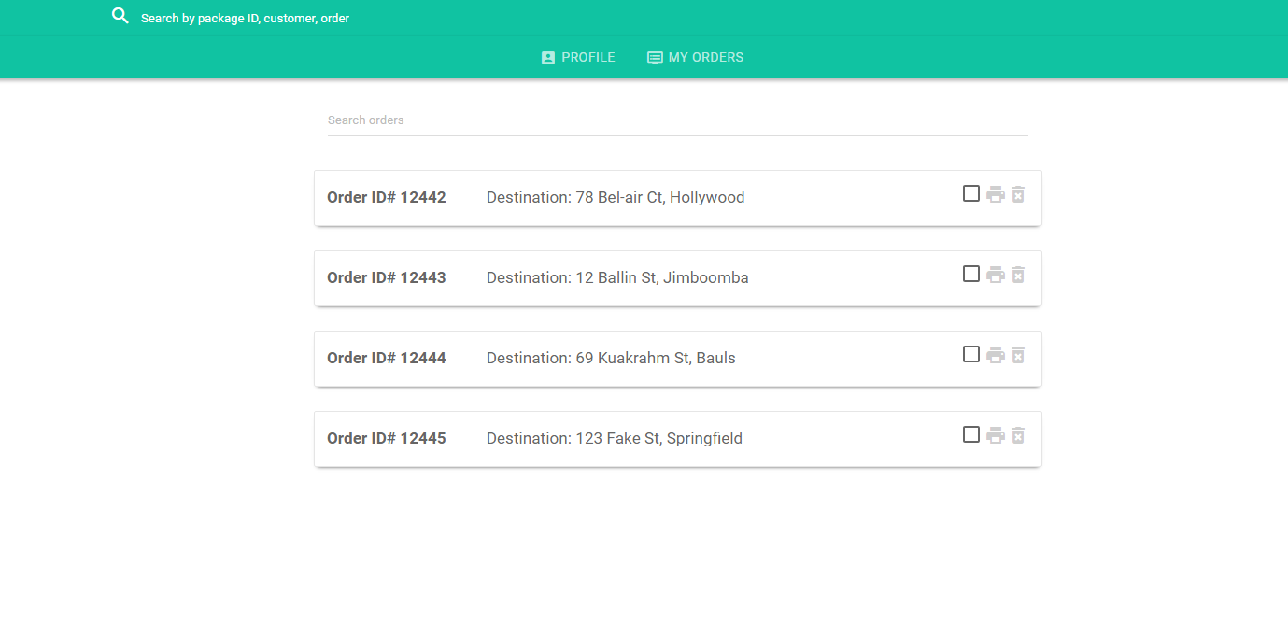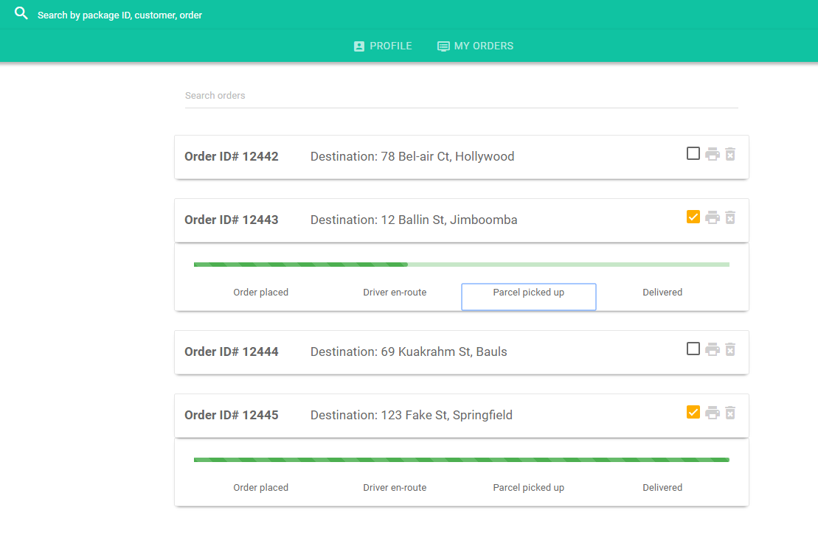

**How did it fit in the team work/project work?**

To further convenience drivers of On the Spot it was necessary for them to have access to all assigned orders and be able change the state easily. This view is an essential part of the web apps usability and the company’s ability to run efficiently.

Artefact 5 - Burn-down chart analysis

**What did you do that made a meaningful contribution to the teamwork in producing the final solution?**

A burn-down chart was maintained throughout the first release so we could see our productivity and if we needed to increase or decrease our workload. Burn-down charts are a great visualisation tool to show clients that work is being done efficiently and no time is being wasted.

**Evidence of Work**

Using the sprint plan and the assigned story point every meeting we had we would go over the story points completed and when they were completed and add the data to a table then visualised it with a graph.

**How did it fit in the team work/project work?**

The burn-down charts was a key instrument for us as a team to keep on track and see how much work was completed week to week. The graph showed us how much of the sprint we completed and helped us make decisions with the client easier to push back certain user stories in favour of more significant tasks.

Release 2

Artefact 1 - Sprint Planning

**What did you do that made a meaningful contribution to the teamwork in producing the final solution?**

Going into release 2 we remained consistent with the first release and the same people worked on the sprint planning as we were happy with the productivity and effectiveness of the team.

**Evidence of Work**

Seeing no need to increase regular meetings, the one 10am meeting on Monday was kept the same and here we discussed the sprints for release 2. Sprint 3 and 4 were also uploaded in the final submission.

**How did it fit in the team work/project work?**

Sprint planning kept our team organised and generally without communication issues. Ultimately helping us to reach the end goal of completing the project,

Artefact 2 - Further Driver View Functionality

**What did you do that made a meaningful contribution to the teamwork in producing the final solution?**

I continued to work on the driver view and the functionality on the page, a user story was to have express and valuable packages for the customer. In order to convey to the driver that a package was either valuable or express I added an icon to display this, this was done by adding a Boolean variable to the new order controller. I also attempted to print labels according to each individual order but could not dynamically name the orders, shortly later I found out that another member had already finished creating a label so stopped trying to fix the issue.

**Evidence of Work**

***HTML Code***

<div ng-if='order.isExpress'>

<span class='float-left' style="display: flex;">

<i class="material-icons express-icon">directions_run</i>

</div>

<div ng-if='order.isFragile'>

<span class='float-left' style="display: flex;">

<i class="material-icons valuable-icon">broken_image</i>

</div>

***Screenshot of Icons***

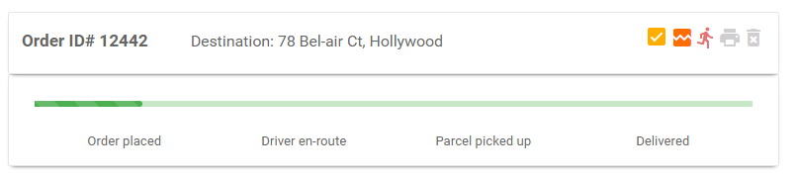

***Javascript Code***

function printContent(el){

var restorepage = document.body.innerHTML;

var printcontent = document.getElementById(el).innerHTML;

document.body.innerHTML = printcontent;

window.print();

document.body.innerHTML = restorepage;

}

***Screenshot of printed label***

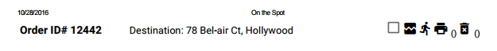

**How did it fit in the team work/project work?**

This functionality easily lets the driver know the importance of a package with a glance due to the icons being bright colours on the contrasted white background.

Artefact 3 – User Testing

**What did you do that made a meaningful contribution to the teamwork in producing the final solution?**

User tests were ran by Laura and myself at different stages of the project I ran mine towards the end of the project. During my user testing I gave each individual a different role such as customer driver and admin, giving each different question and asking them to play around with the functionality of the website.

**Evidence of Work**

***User Test***

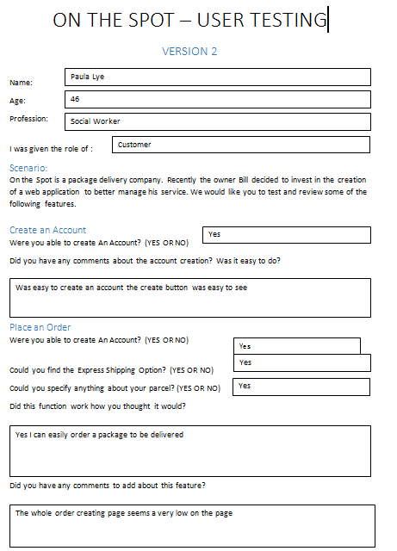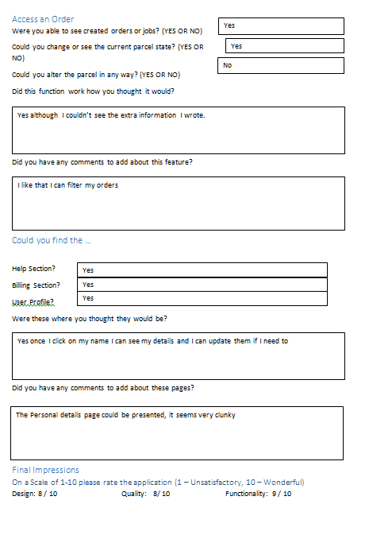

**C:\Users\Matt\AppData\Local\Microsoft\Windows\INetCache\Content.Word\usertest3.png**

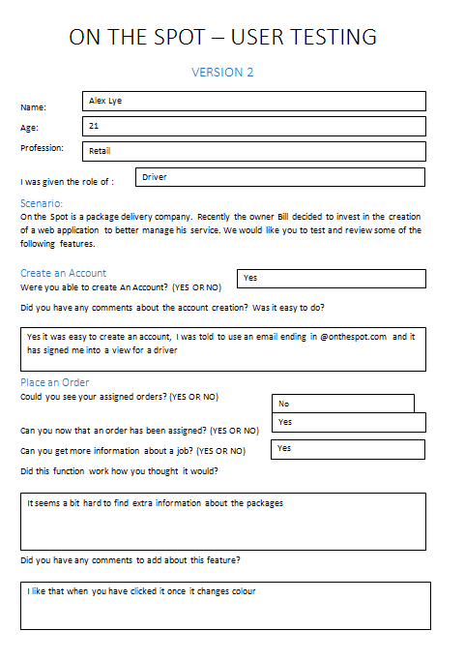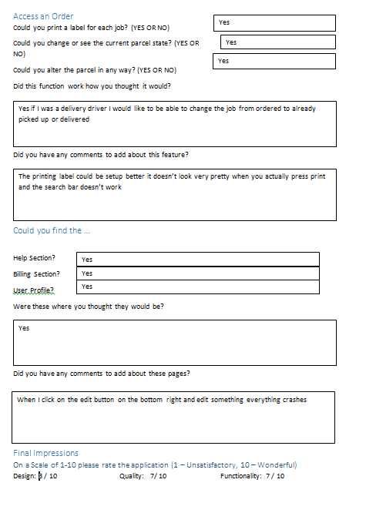

**How did it fit in the team work/project work?**

User testing was very helpful as they gave us small improvements on our web app and one user even found a bug that crashed the website when editing detail. User testing was critical as if it was not done the website overall usability and professionalism would have not been up to the standard of the final design.

Artefact 4 – Peer Review Letter

**What did you do that made a meaningful contribution to the teamwork in producing the final solution?**

Laura and I drafted the second business letter that was sent to our developer team.

**Evidence of Work**

***Business Letter***

Thank you for your team’s informative demonstration regarding the present state of your projects development. The presentation was not only well prepared but allowed us to fully understand the current scope and trajectory of the project and your progress.

Since our last meeting you have finished everything from the previous sprint and are well underway to completing sprint 3. Furthermore, your team has implemented a wide number of features that managed to pass the acceptance criteria such as; implementing the administrator’s functions, updating the login permissions, producing a working user dashboard, as well as many attendee and volunteer functions. Unfortunately, you didn’t fully complete the user story regarding passwords but we are confident you will have this completed before the next time we meet. At this point in time it seems that you’re on track in terms of your sprint plan but there was no visual communication of this fact such as a burndown chart.

At this point in time we are very impressed by the communication and quality of work demonstrated throughout the development period. Your presentation was easy to understand and follow however we would have liked for further elaboration regarding the switch in your systems architecture from the Play framework over to Django. We understand that you encountered difficulties with the Play framework and as a result came to the decision to completely redo your application. Though this was disheartening to hear we congratulate you for being able keep to your project on schedule regardless of these setbacks.

From the demonstration of your product as well as your clear and coherent presentation we are very impressed with your team and their overall performance. The communication among your team as well as us your clients has been very encouraging and we are excited to see the fully completed product as well as what you will produce in Sprint 4.

Artefact 5 - Burn-down chart analysis

**What did you do that made a meaningful contribution to the teamwork in producing the final solution?**

Throughout the whole web app process burn-down charts were always an integral part of our team and all our client meetings.

**Evidence of Work**

All burn-down charts were submitted in the final project folder.

**How did it fit in the team work/project work?**

The consistent visual recognition the burn-down graph gave us each week made the final product feel and be in reach. This was a nice reminder to keep production up and not slack off throughout all of release 2.