An Optimal Handling Bicycle
J. K. Moore, M. Hubbard, and R. A. Hess
Dept. of Mechanical and Aerospace Engineering
University of California, Davis,
Davis, CA 95616, USA
e-mail: jkm@ucdavis.edu, mhubbard@udavis.edu, rahess@ucdavis.edu
Abstract
The handling qualities of single-track vehicles such as bicycles and motorcycles are one of the most important determinants governing the safety of these vehicles. The subject of “handling qualities” had its birth in the assessment of aircraft. In aircraft applications, handling qualities refer to those qualities or characteristics that determine the ease and precision with which a pilot may complete a given task [1]. Substitute “bicycle” or “motorcycle” for “aircraft” and “rider” for “pilot” and a workable definition of single-track vehicle handling qualities is evident [2].
A model of the bicycle rider was presented in Reference [2], and included a frequency-domain based Handling Qualities Metric (HQM) for evaluating bicycle handling qualities. Figure 1 shows the rider model as a five-loop feedback system where the rider “dynamics” are captured by a simple model of the rider’s neuromuscular system and five feedback “gains.” In Figure 1, T_{δ} , ϕ, ψ and y represent rider steer torque input, vehicle roll, vehicle heading, and vehicle lateral deviation, respectively. Reference [2] exercises the model using the dynamics of six bicycles.
A “handling qualities metric” (HQM) was created based upon a similar metric utilized for the evaluation of aircraft handling qualities [3]. Figure 2 from Reference [2] shows the task independent HQMs predicted for the six bicycle models. The indicated “levels” in Figure 2 can be described as Level 1 (desirable), Level 2 (acceptable), and Level 3 (unacceptable) [1]. Note in Figure 2 that bicycles (1) and (2) were predicted to exhibit poorer handling qualities that bicycles (3) through (6). It is interesting to note that bicycles (1) and (2) differed only by the addition of a 5 kg mass on the rear rack of bicycle (1), i.e. a difference in the plant's physical parameters.
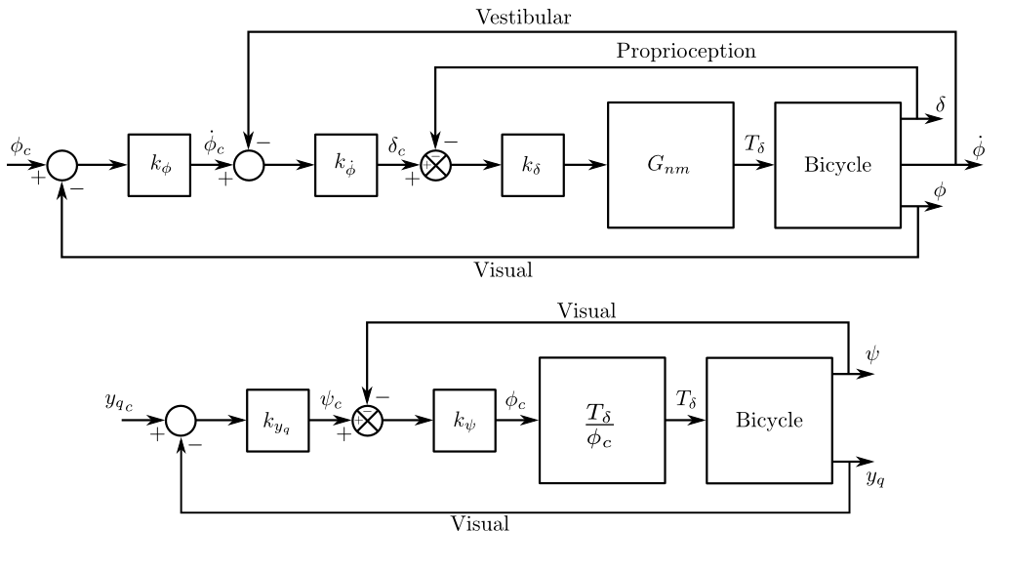Figure 1: The bicycle rider model from Reference [2].
Vehicle speed is also known to strongly affect the plant dynamics [4] and Figure 3 shows how this manifests itself in HQMs for each of the six bicycles. These observations allow us to postulate that there is a set of optimal plant parameters that minimize the peak of the analytically predicted HQM. The research presented will detail a constrained optimization approach that discovers the optimal handling bicycle. The approach makes use of the model and gain selection technique presented in Reference [2] coupled with constraints that bound a solution space of physically realizable bicycles. We will present candidate optimal bicycle designs and compare them to the evolutionarily derived bicycle design that we know today.

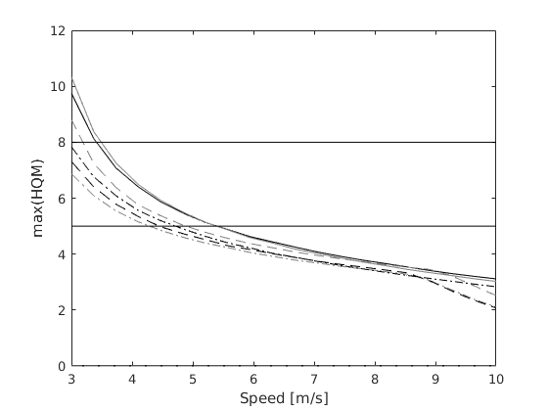Figure 3: The effect on the peak HQM due to vehicle speed.
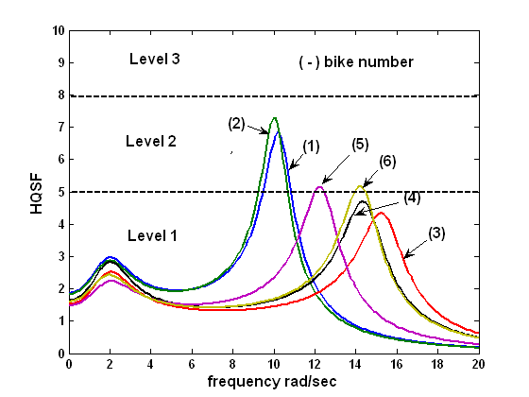Figure 2: An example of handling qualities metrics (HQMs) at 5 m/s for six bicycles from Reference [2].
References
[1] G. E. Cooper, and R. P. Harper, Jr., “The use of pilot rating scales in the evaluation of aircraft handling qualities,” NASAN TN D-5153, April 1969.
[2] R. Hess, J. K. Moore, and M. Hubbard, “Modeling the Manually Controlled Bicycle,” IEEE Transactions on Systems, Man, and Cybernetics, Part A, Systems and Humans, Vol 42, No. 3, May 2012,. pp. 545-557.
[3] R. A. Hess, “Simplified approach for modelling pilot pursuit control behavior in multi-loop flight control tasks,” Proc. Inst. Mech. Eng., Part G., Journal of Aerospace Engineering, Vol. 220, No. 2, April, 2006, pp. 85-102
[4] J. P. Meijaard, Jim M. Papadopoulos, Andy Ruina, and A. L. Schwab. Linearized dynamics equations for the balance and steer of a bicycle: A benchmark and review. Proceedings of the Royal Society A: Mathematical, Physical and Engineering Sciences, 463(2084):1955–1982, August 2007.

