Type of the Paper: Extended Abstract

Instructions for Preparing an Extended Abstract for Bicycle and Motorcycle Dynamics 2023
Author B. One¹, Author C. Two², and Author D. Three^{2,}*
¹Affiliation 1; email One; ORCID One (if applicable)
²Affiliation 2; email Two, ORCID Two (if applicable); email Three, ORCID Three (if applicable)
*corresponding author.

Name of Editor: Firstname Lastname
Submitted: dd/mm/yyyy
Accepted: dd/mm/yyyy
Published: dd/mm/yyyy
Citation:
Abstract:

Authors are requested to upload an extended abstract of two pages (including references and figures) to the Orvium website by the stated date in the call for abstracts. For OpenDocument text or Microsoft Word text documents, upload a single .odt file or .docx file, respectively, named using the following pattern Surname1Surname2Surname3_abstract.odt/docx. Note that .doc files are not permitted, only .docx.

The abstract must be written in English. It must contain the names, affiliations, and e-mail addresses of the authors. Do not edit the headers or footers. The paper size is European A4 (21 x 29.7 cm).The left and right margins are 1.27 cm, the top margin (not including the header) is 2.5 cm, and the bottom margin is 1.9 cm. The title should be in Times New Roman 18 pt, and may extend over more than one line. The author’s name or authors’ names should be in Times New Roman 10 pt and the affiliation should be in 8 pt.

The abstract itself has the section heading Abstract:, bold 11 pt Times New Roman, and the text should be written in Times New Roman 10 pt.

Equations should be numbered continuously according to the format shown in Equation (1):
(1)

where the unknown symbols are explained after the equation.
Table 1. Example of a table with a short caption.
 | x | y | z
x' | α₁ | β₁ | γ₁
y' | α₂ | β₂ | γ₂
z' | α₃ | β₃ | γ₃

Figures, graphs and tables must be included using the same style as in Figure 1 and Table 1. Both figures and tables should be centered on the page. Use of at least 300 dpi resolution for pictures and 600 dpi for line art is required, 1 px wide lines in figures should be avoided as they may become invisible in print.
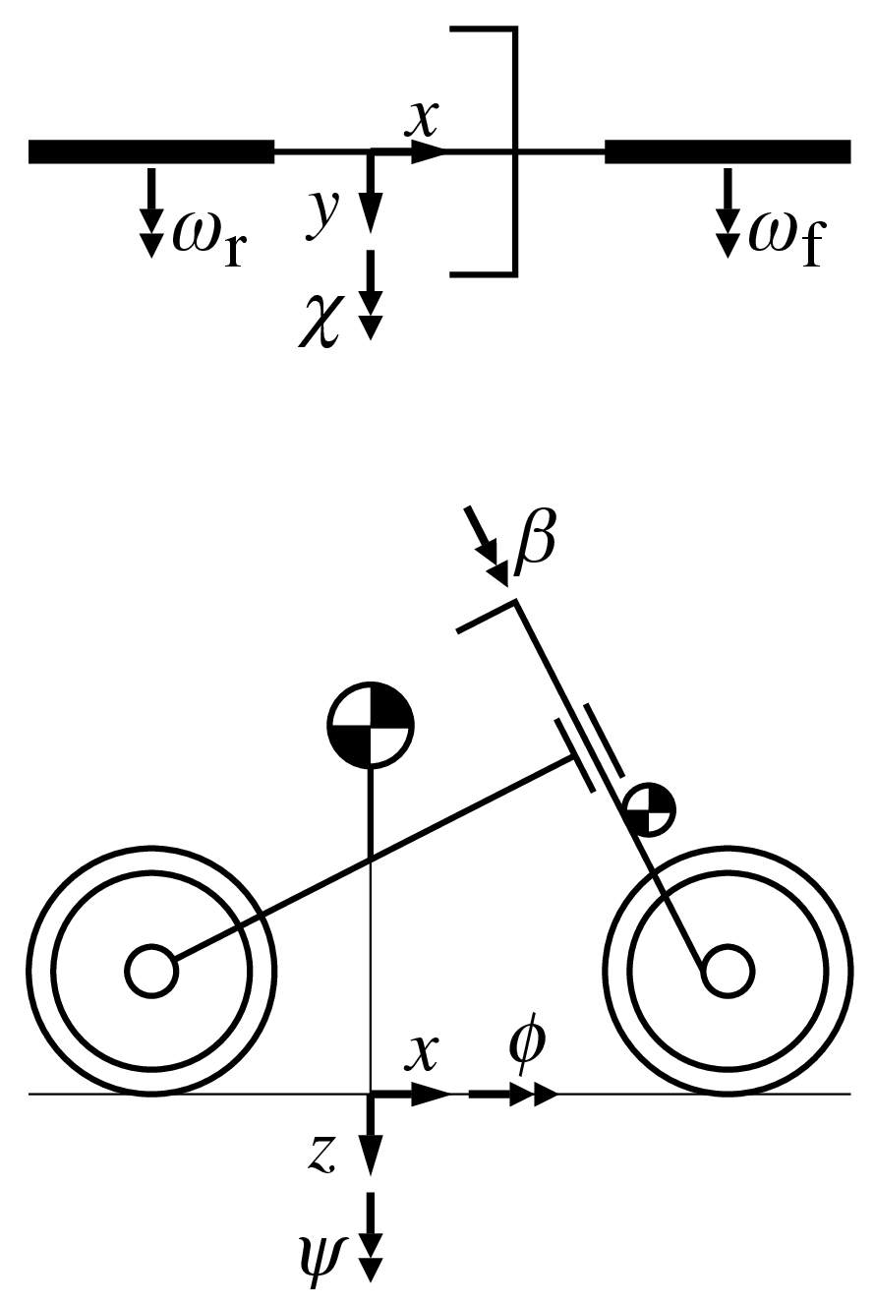
Figure 1. An example of a figure caption. Use 10 pt Times New Roman. Use the same style for the tables.

Bibliographical citations should be written in alphabetical order in the References section at the end of the document and use the APA citation system and the APA format. See the References section below, where (Pacejka, 2002) exemplifies the case of a textbook, (Bertolazzi et al., 2007) is an article in a conference proceedings, and (Sharp, 1971) is an article in a journal.

We very much look forward to welcoming you in Delft! Best wishes and the warmest regards from the Organizing Committee of Bicycle and Motorcycle Dynamics 2023.

References
Bertolazzi, E., Biral, F., Da Lio, M., & Cossalter, V. (2007, June 25–28), The influence of rider’s upper body motions on motorcycle minimum time maneuvering. In C. L. Bottasso, P. Masarati, & L. Trainelli (Eds.), Proceedings, Multibody Dynamics 2007, ECCOMAS Thematic Conference, Politecnico di Milano, Milano, Italy, 15.
Pacejka, H. B., (2002). Tyre and Vehicle Dynamics. Butterworth and Heinemann, Oxford.
Sharp, R. S. (1971). The stability and control of motorcycles. Proceedings of the IMechE, Part C, Journal of Mechanical Engineering Science, 13, 316–329.

