Automated Viral Plaque Counting Using Image Processing Techniques
Michael Moorman^{#1}, Anjuan Dong³
Hood College
Frederick, Maryland USA
¹mem19@hood.edu
³dong@hood.edu

Abstract— The viral plaque assay is an important procedure in virology. One step of this procedure includes the manual counting of viral plaques with the naked eye. This is often a time consuming and laborious process. A method is presented for automating viral plaque counting using image processing techniques and the OpenCV Computer Vision library. The method consumes an image of an entire platter of viral plaque samples and then outputs individual counts of each sample in the platter. The image is captured using a commercial flat bed scanner. Experimental results show that the method is up to 90 percent accurate in comparison to trained human counts. The program produces results for a single image in about one second. Compared to commercial colony counter systems, the proposed method is extremely economical; the only hardware required by the method is a personal computer and a flatbed scanner. Finally, an open source implementation of the program is provided, which includes an optional graphical user interface.

Keywords— Include at least 5 keywords or phrases
- Introduction
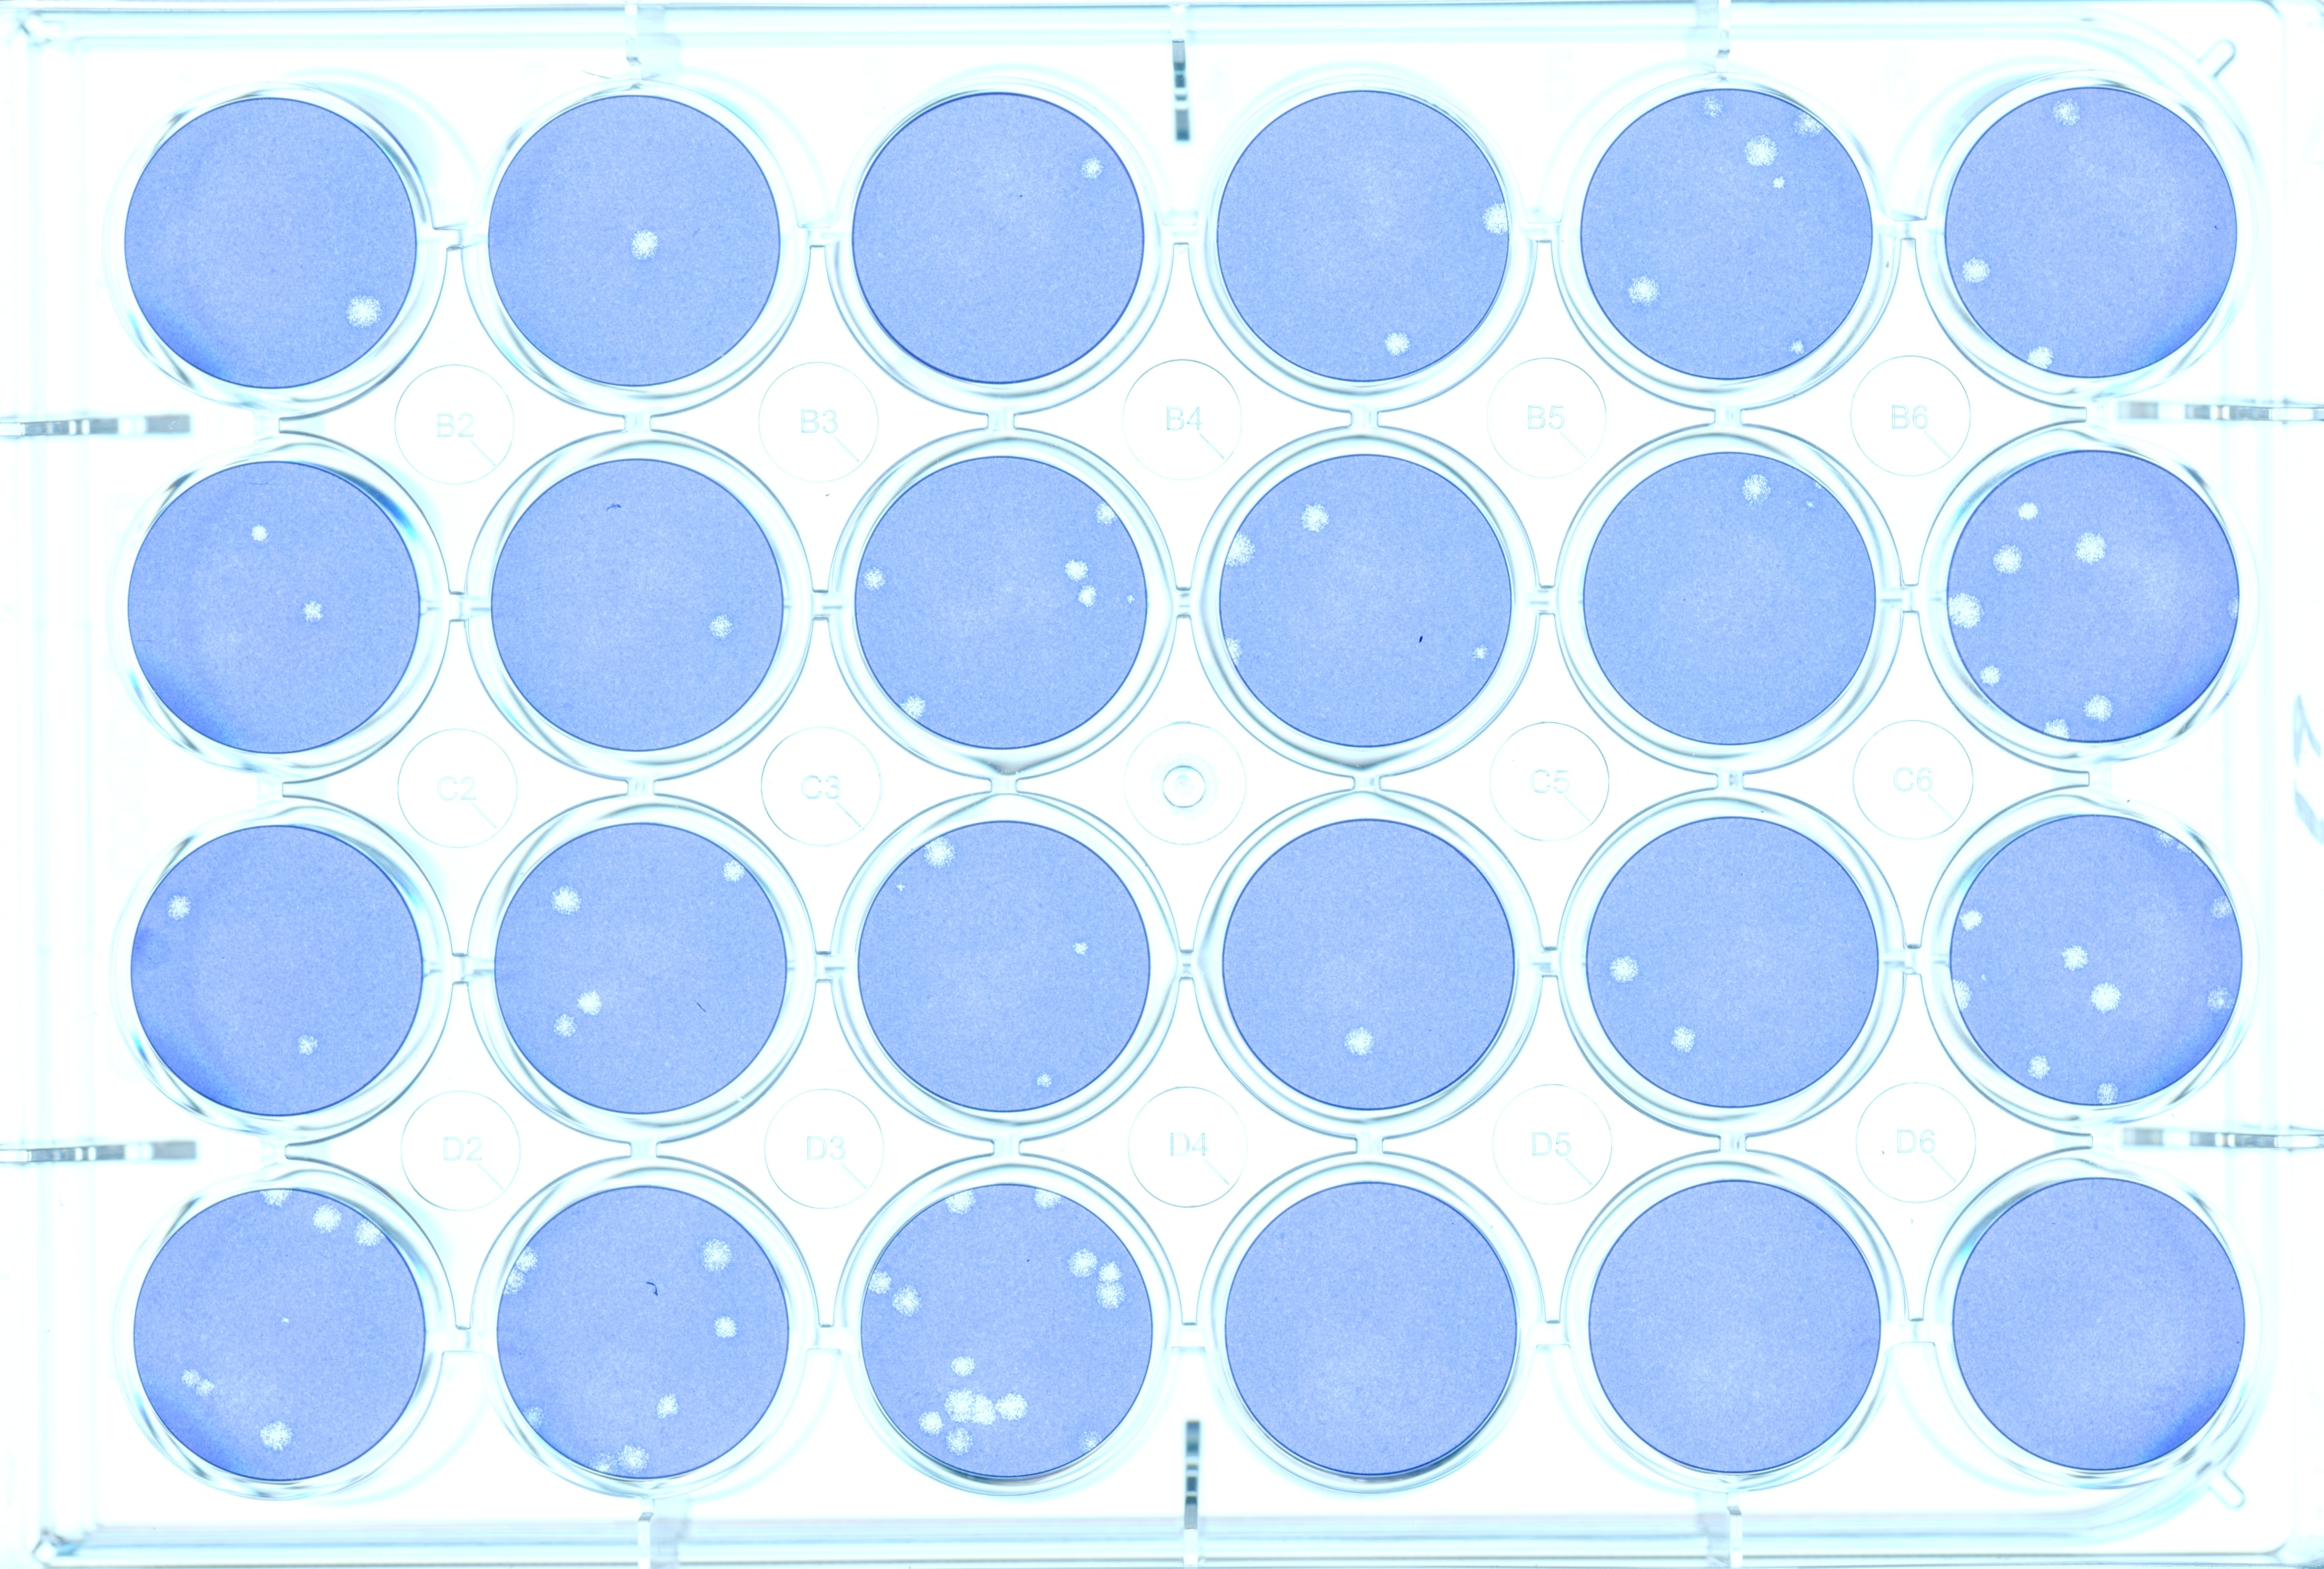
The viral plaque assay is an important and commonly used procedure in biology; however, a stage of the process requires that a person manually count the instances of plaque structures . The work presented here attempts to accurately count mammalian viral plaques using image processing techniques. The image below is a typical example of an input image.

The viral plaque assay remains to be an important procedure in the field of biology. A common example of the procedure begins by preparing several dilutions of a virus stock. Petri dishes are also prepared, arranged in 4x6 platters, containing a thin monolayer of susceptible animal tissue sample. The dishes are then innoculated using the various virus dilutions. After inncoulation, the dishes are topped off with a special agar that limits viral expansion to only neighboring cells. Each sample is allowed to incubate for some amount of time, allowing the virus to attack the cells In the monolayer. Over time, the virus gradually destroys neighboring cells, creating visible structures also known as viral plaques. The visibility of these plaques are sometimes enhanced with the usage of special dyes. Once the plaques have grown large enough to be seen by the naked eye, the titer of the original virus stock is discovered by observing the number of plaque-forming units (PFU) per milliliter present in each plate.
The last stage of this procedure can be particularly laborious . Counts of the number of plaque formations on each plate are manually tallied by hand. In a typical case, a sample can contain over 100 viral plaques. It is easy to see how tallying an entire platter of samples often consumes several minutes of someones time.
Automated counting of viral plaques via image processing techniques has been proposed and investigated many times before, and there are several commercial products on the market that manufacture colony counting systems. [CITE]. There is a lucrative market for automated colony counting, and several companies manufacture colony counting systems. Some of these systems can cost thousands of dollars and are often both closed source and not economically feasible. [CITE] . Other studies have approached automated viral plaque counting before and have tried a number of different approaches. Some of these include use of a Watershed Transform [CITE], Distance transform[CITE], Hough transform[CITE], parameter identification and fuzzy logic. Of these works, However, they did not feature the ability to process an entire platter of samples.
At present time, there is not a low cost and accurate colony counting system available that enjoys wide spread adoption and that is able to accommodate an entire platter of samples. This is a primary motivation for the work presented here. In addition, the performance of some of these works was poor. In the case of [CITE], the system consumed ten seconds of wall clock computational time to analyze a single viral plaque plate.

Accurately counting plaques in these types of images presents several challenges. Perhaps the most difficult challenge that any solution must address is how to deal with the noise in the image. How does one go about discerning the difference between viral plaques and the frequent noisy particles in the agar of the plates? This is particularly problematic when dealing with small plaques, as there signal to noise ratio is very small in that case.

OpenCV is an open source computer vision library available from http://sourceforge.net/projects/opencvlibrary. The library is written in C and C++ and runs under Linux, Windows, and Mac OS X. It provides an application interface (API) that this study uses to implement the proposed method.
- methodology
The proposed method is implemented as a computer program written in C++ and uses the OpenCV [CITE] image processing API to perform image analysis. The user supplies the program with an image of a platter of viral plaques, and also uses three parameters that are supplied by the user. They are defined below

- Plate radius:
-Plate radius: The radius of each plate in the platter, given in pixels.
-Min plaque radius
-Max plaque radius

- Page Layout
Your paper must use a page size corresponding to A4 which is 210mm (8.27") wide and 297mm (11.69") long. The margins must be set as follows:

Your paper must be in two column format with a space of 4.22mm (0.17") between columns.
- Page Style
All paragraphs must be indented. All paragraphs must be justified, i.e. both left-justified and right-justified.
- Text Font of Entire Document
The entire document should be in Times New Roman or Times font. Type 3 fonts must not be used. Other font types may be used if needed for special purposes.
Recommended font sizes are shown in Table 1.
- Title and Author Details
Title must be in 24 pt Regular font. Author name must be in 11 pt Regular font. Author affiliation must be in 10 pt Italic. Email address must be in 9 pt Courier Regular font.

TABLE I
Font Sizes for Papers
Font Size | Appearance (in Time New Roman or Times)
Font Size | Regular | Bold | Italic
8 | table caption (in Small Caps),  figure caption,  reference item |  | reference item (partial)
9 | author email address (in Courier),  cell in a table | abstract body | abstract heading (also in Bold)
10 | level-1 heading (in Small Caps),  paragraph |  | level-2 heading,  level-3 heading,  author affiliation
11 | author name
24 | title

All title and author details must be in single-column format and must be centered.
Every word in a title must be capitalized except for short minor words such as “a”, “an”, “and”, “as”, “at”, “by”, “for”, “from”, “if”, “in”, “into”, “on”, “or”, “of”, “the”, “to”, “with”.
Author details must not show any professional title (e.g. Managing Director), any academic title (e.g. Dr.) or any membership of any professional organization (e.g. Senior Member IEEE).
To avoid confusion, the family name must be written as the last part of each author name (e.g. John A.K. Smith).
Each affiliation must include, at the very least, the name of the company and the name of the country where the author is based (e.g. Causal Productions Pty Ltd, Australia).
Email address is compulsory for the corresponding author.
- Section Headings
No more than 3 levels of headings should be used. All headings must be in 10pt font. Every word in a heading must be capitalized except for short minor words as listed in Section III-B.
- Level-1 Heading: A level-1 heading must be in Small Caps, centered and numbered using uppercase Roman numerals. For example, see heading “III. Page Style” of this document. The two level-1 headings which must not be numbered are “Acknowledgment” and “References”.
- Level-2 Heading: A level-2 heading must be in Italic, left-justified and numbered using an uppercase alphabetic letter followed by a period. For example, see heading “C. Section Headings” above.
- Level-3 Heading: A level-3 heading must be indented, in Italic and numbered with an Arabic numeral followed by a right parenthesis. The level-3 heading must end with a colon. The body of the level-3 section immediately follows the level-3 heading in the same paragraph. For example, this paragraph begins with a level-3 heading.
- Figures and Tables
Figures and tables must be centered in the column. Large figures and tables may span across both columns. Any table or figure that takes up more than 1 column width must be positioned either at the top or at the bottom of the page.
Graphics may be full color. All colors will be retained on the CDROM. Graphics must not use stipple fill patterns because they may not be reproduced properly. Please use only SOLID FILL colors which contrast well both on screen and on a black-and-white hardcopy, as shown in Fig. 1.

Fig. 1 A sample line graph using colors which contrast well both on screen and on a black-and-white hardcopy

Fig. 2 shows an example of a low-resolution image which would not be acceptable, whereas Fig. 3 shows an example of an image with adequate resolution. Check that the resolution is adequate to reveal the important detail in the figure.
Please check all figures in your paper both on screen and on a black-and-white hardcopy. When you check your paper on a black-and-white hardcopy, please ensure that:
- the colors used in each figure contrast well,
- the image used in each figure is clear,
- all text labels in each figure are legible.
- Figure Captions
Figures must be numbered using Arabic numerals. Figure captions must be in 8 pt Regular font. Captions of a single line (e.g. Fig. 2) must be centered whereas multi-line captions must be justified (e.g. Fig. 1). Captions with figure numbers must be placed after their associated figures, as shown in Fig. 1.

Fig. 2 Example of an unacceptable low-resolution image

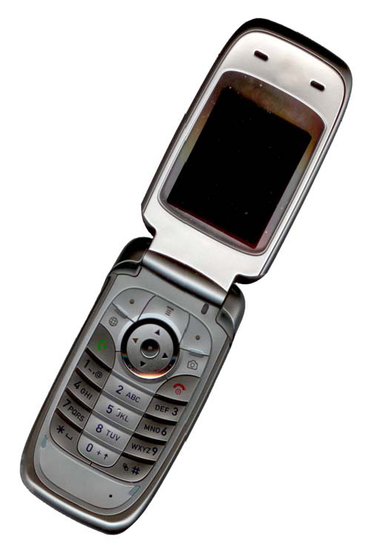
Fig. 3 Example of an image with acceptable resolution

- Table Captions
Tables must be numbered using uppercase Roman numerals. Table captions must be centred and in 8 pt Regular font with Small Caps. Every word in a table caption must be capitalized except for short minor words as listed in Section III-B. Captions with table numbers must be placed before their associated tables, as shown in Table 1.
- Page Numbers, Headers and Footers
Page numbers, headers and footers must not be used.
- Links and Bookmarks
All hypertext links and section bookmarks will be removed from papers during the processing of papers for publication. If you need to refer to an Internet email address or URL in your paper, you must type out the address or URL fully in Regular font.

- References
The heading of the References section must not be numbered. All reference items must be in 8 pt font. Please use Regular and Italic styles to distinguish different fields as shown in the References section. Number the reference items consecutively in square brackets (e.g. [1]).
When referring to a reference item, please simply use the reference number, as in [2]. Do not use “Ref. [3]” or “Reference [3]” except at the beginning of a sentence, e.g. “Reference [3] shows …”. Multiple references are each numbered with separate brackets (e.g. [2], [3], [4]–[6]).
Examples of reference items of different categories shown in the References section include:
- example of a book in [1]
- example of a book in a series in [2]
- example of a journal article in [3]
- example of a conference paper in [4]
- example of a patent in [5]
- example of a website in [6]
- example of a web page in [7]
- example of a databook as a manual in [8]
- example of a datasheet in [9]
- example of a master’s thesis in [10]
- example of a technical report in [11]
- example of a standard in [12]
- Conclusions
The version of this template is V2. Most of the formatting instructions in this document have been compiled by Causal Productions from the IEEE LaTeX style files. Causal Productions offers both A4 templates and US Letter templates for LaTeX and Microsoft Word. The LaTeX templates depend on the official IEEEtran.cls and IEEEtran.bst files, whereas the Microsoft Word templates are self-contained. Causal Productions has used its best efforts to ensure that the templates have the same appearance.
Causal Productions permits the distribution and revision of these templates on the condition that Causal Productions is credited in the revised template as follows: “original version of this template was provided by courtesy of Causal Productions (www.causalproductions.com)”.
Acknowledgment
The heading of the Acknowledgment section and the References section must not be numbered.
Causal Productions wishes to acknowledge Michael Shell and other contributors for developing and maintaining the IEEE LaTeX style files which have been used in the preparation of this template. To see the list of contributors, please refer to the top of file IEEETran.cls in the IEEE LaTeX distribution.
References
- S. M. Metev and V. P. Veiko, Laser Assisted Microtechnology, 2nd ed., R. M. Osgood, Jr., Ed. Berlin, Germany: Springer-Verlag, 1998.
- J. Breckling, Ed., The Analysis of Directional Time Series: Applications to Wind Speed and Direction, ser. Lecture Notes in Statistics. Berlin, Germany: Springer, 1989, vol. 61.
- S. Zhang, C. Zhu, J. K. O. Sin, and P. K. T. Mok, “A novel ultrathin elevated channel low-temperature poly-Si TFT,” IEEE Electron Device Lett., vol. 20, pp. 569–571, Nov. 1999.
- M. Wegmuller, J. P. von der Weid, P. Oberson, and N. Gisin, “High resolution fiber distributed measurements with coherent OFDR,” in Proc. ECOC’00, 2000, paper 11.3.4, p. 109.
- R. E. Sorace, V. S. Reinhardt, and S. A. Vaughn, “High-speed digital-to-RF converter,” U.S. Patent 5 668 842, Sept. 16, 1997.
- (2002) The IEEE website. [Online]. Available: http://www.ieee.org/
- M. Shell. (2002) IEEEtran homepage on CTAN. [Online]. Available: http://www.ctan.org/tex-archive/macros/latex/contrib/supported/IEEEtran/
- FLEXChip Signal Processor (MC68175/D), Motorola, 1996.
- “PDCA12-70 data sheet,” Opto Speed SA, Mezzovico, Switzerland.
- A. Karnik, “Performance of TCP congestion control with rate feedback: TCP/ABR and rate adaptive TCP/IP,” M. Eng. thesis, Indian Institute of Science, Bangalore, India, Jan. 1999.
- J. Padhye, V. Firoiu, and D. Towsley, “A stochastic model of TCP Reno congestion avoidance and control,” Univ. of Massachusetts, Amherst, MA, CMPSCI Tech. Rep. 99-02, 1999.
- Wireless LAN Medium Access Control (MAC) and Physical Layer (PHY) Specification, IEEE Std. 802.11, 1997.

