Automated Viral Plaque Counting Using Image Analysis Techniques
Michael Moorman and Aijuan Dong
Department of Computer Science,
Hood College, Frederick, 21701
Abstract
Manual counting of viral plaques is a tedious and labor intensive process. In this paper, an efficient and economical method is proposed for automating viral plaque counting via image segmentation and various morphological operations. The method first segments a plate image into individual well images. Then, it converts each well image into a binary image and creates a new image by merging the dilated binary image and the complement image of the eroded binary image. At last, the contour hierarchy of the merged image is obtained and the plaque count is calculated by evaluating each outer contour count and its inner contour counts. Experiment results showed that the counting accuracy for the proposed method is up to 90 percent and the average processing time for a single image is about one second. An open source implementation with optional graphical user interface is available for public use.
1. Introduction
Viral plaque assay is an important and commonly used procedure in in assessing the immunogenicity of various vaccine formulations,. The procedure begins by preparing several dilutions of a virus stock. Tissue plates (Figure 1), arranged in rows of wells, are configured with a thin monolayer of susceptible animal tissue sample. The wells are then inoculated using various virus dilutions. Each plate is allowed to incubate for some amount of time, allowing the virus to attack the cells in the monolayer. Over time, the virus gradually destroys neighboring cells, creating visible structures also known as viral plaques. The last stage of this procedure is to count the number of plaque-forming units (PFU) present in each well, which often involves manual counting by lab personnel.
The manual counting of viral plaques is a tedious and labor intensive. It is also subjective, with different technicians frequently reporting different counts for a given sample. The work presented here attempted to automate the counting of mammalian viral plaques using image analysis techniques. The image below (Figure 1) is a typical viral plaque image with white clusters representing viral plaques.

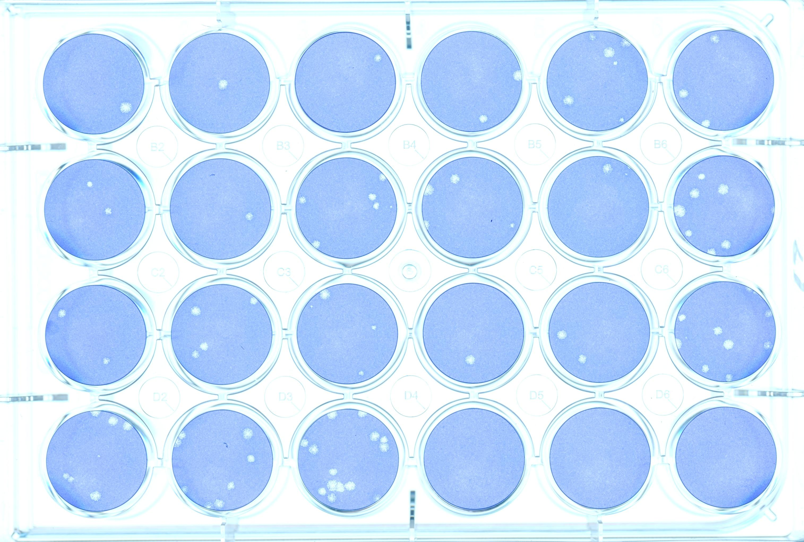
Figure 1: An example viral plaque image
Automated counting of viral plaques via image analysis techniques has been proposed and investigated many times before. There are several commercial products on the market for colony counting. Some examples include the Revolutionary Science IncuCount Automatic Colony Counter priced at $7,845 [1], the UVP Imaging Sys EC3 410 priced at $31,179 [2], and the Flash and Grow Automatic Colony Counter priced at $9,980 [3]. These systems cost thousands of dollars and use propriety software, which make it difficult for wide adoption.
There are a number of other automated viral plaque counting approaches in the literature. In [4], a watershed transform was used to analyze a single well image acquired by an overhead camera. This system was capable of counting to within 93% of manual counting, however mammalian type plaque structures were not tested, and the implementation required up to ten seconds to process a single plate. A similar approach was used in [5], where a distance transform was used instead of watershed. This study implemented a software suite that was capable of counting an entire plate of samples with accuracy within 95% of human counts, but the process requires users to manually identify each area of interest on the plate using a graphical user interface. Another approach [6] used images of stained culture flasks and Hough transform technique. The study produced counts falling well within the distribution of corresponding manual counts, but it requires a special image acquisition apparatus and does not allow for batch processing of an entire plate.
Based on the above discussion, the primary motivation for the work presented here is to create an automated viral counting method that 1) requires minimum human intervention; 2) accurate and fast; and 3) low-cost that can be very easily adopted.
The rest of the paper is organized as follows. In Section 2, the details of the proposed method are presented. Experiment results and discussion are described in Section 3 and the paper concludes in Sections 4.
- Methodology
2.1. Overview
There are two main stages in the proposed viral plaque counting method: image segmentation and viral plaque counting (Figure 2). With image segmentation stage, the whole plate image is segmented into individual well images. These well images are the Regions of Interests (ROIs) in this context. In the viral plaque counting stage, each well image is first converted into a binary image via Otsu thresholding, then a new image is created by merging the dilated binary image and the complement image of the eroded binary image. At last, the contour hierarchy of the merged image is obtained and the plaque count is calculated by evaluating each outer contour count and its inner contour counts.
To make the method adaptable to different viral plaque assay settings, the proposed counting method can be customized with three parameters: well radius, minimum plaque radius, and maximum plaque radius. The well radius is the radius of each well, given in pixels; while the minimum radius and maximum radius are the minimum and maximum radius in pixel of a viral plaque structure, respectively.

Otsu thresholding
Dilation
Aggressive erosion
Calculate centroids
Floodfill from centroids
Recalculate centroids
Draw circles of
size specified by
user parameter
Otsu thresholding
Merge the two
renderings of the welI
Render a dilated
and filtered copy
of a well
Render an eroded
and filtered copy
of a well
Count the number of
plaques using the
resulting contour
hierarchy
Image Segmentation
Viral Plaque Counting

Figure 2: Overview of the counting method
2.2. Image segmentation
Accurately counting viral plaques presents several challenges. Perhaps the most difficult one is how to deal with the noises in the image. One of the noises is unwanted background structures. Image segmentation extracts only interesting parts of the image that lay within each well. Therefore, remove background noises.
Another challenge that segmentation stage faces is the plate orientation. Since images are acquired using a off-the-shelf flatbed scanner, there is no guarantees as to the position of the plate with relation to the scanner surface. Plates may be butted up against the top left corner of the scanner, have a slight offset on one axis, or have any slight orientation about them, etc. A global thresholding method overcomes these challenges by extracting the interesting features of the image (viral plaque wells) without consideration for where they are located on the image. This approach consists a few steps as described below.
1. Grayscale the image.
2. Use Otsu’s thresholding method [7] to transform the image into a binary image (Figure 3(a)).
3. Perform a morphological dilation on the image that is sufficient enough to close viral plaque holes (Figure 3(b)).

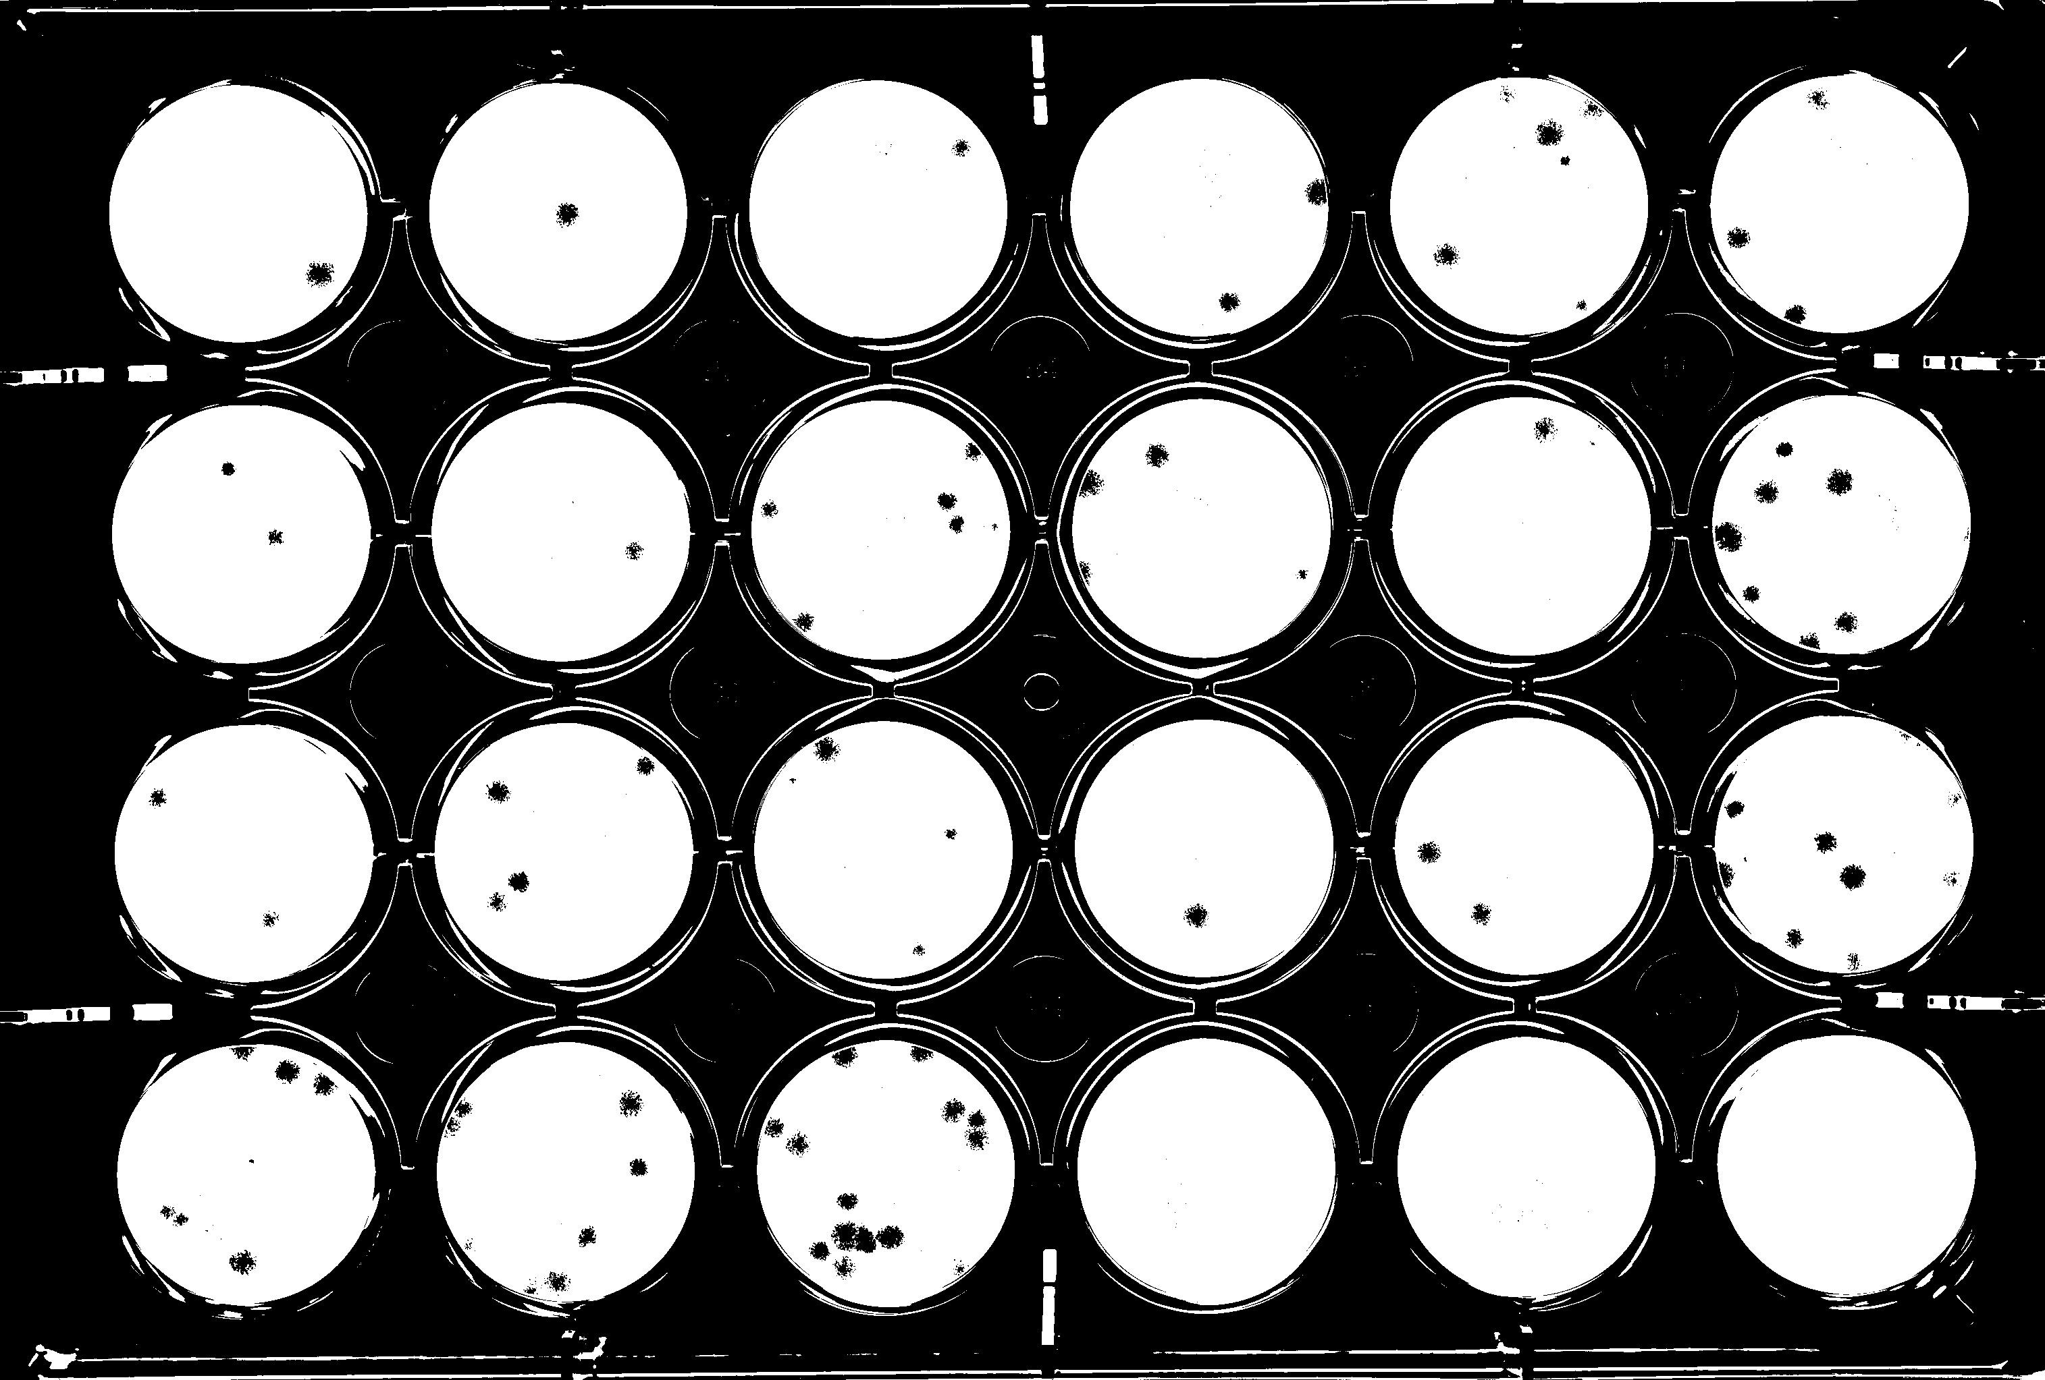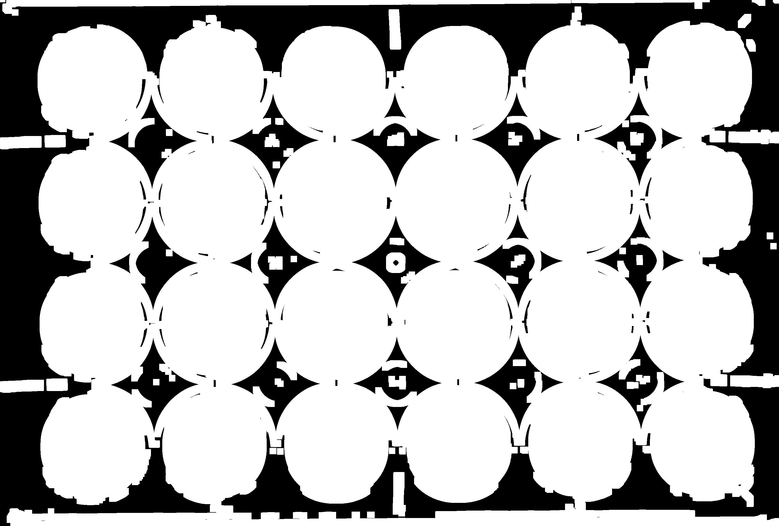
Figure 3(a): Otsu Figure 3(b): Dilation to
thresholding fill holes
4. Aggressively perform several iterations of morphological erosion on the image until the number of artifacts that remain on the image equals the number of wells on the plate (Figure 3(c)).
5. Calculate the center points of each remaining artifact. Use these points as seeds for a floodfill [8] operation that grows the region outward from each of these points on an RGB thresholded rendering of the original image. Aggressively perform several iterations of morphological erosion on the image until the number of artifacts that remain on the image equal the number of wells on the plate. The resulting image is shown in Figure 3(d).
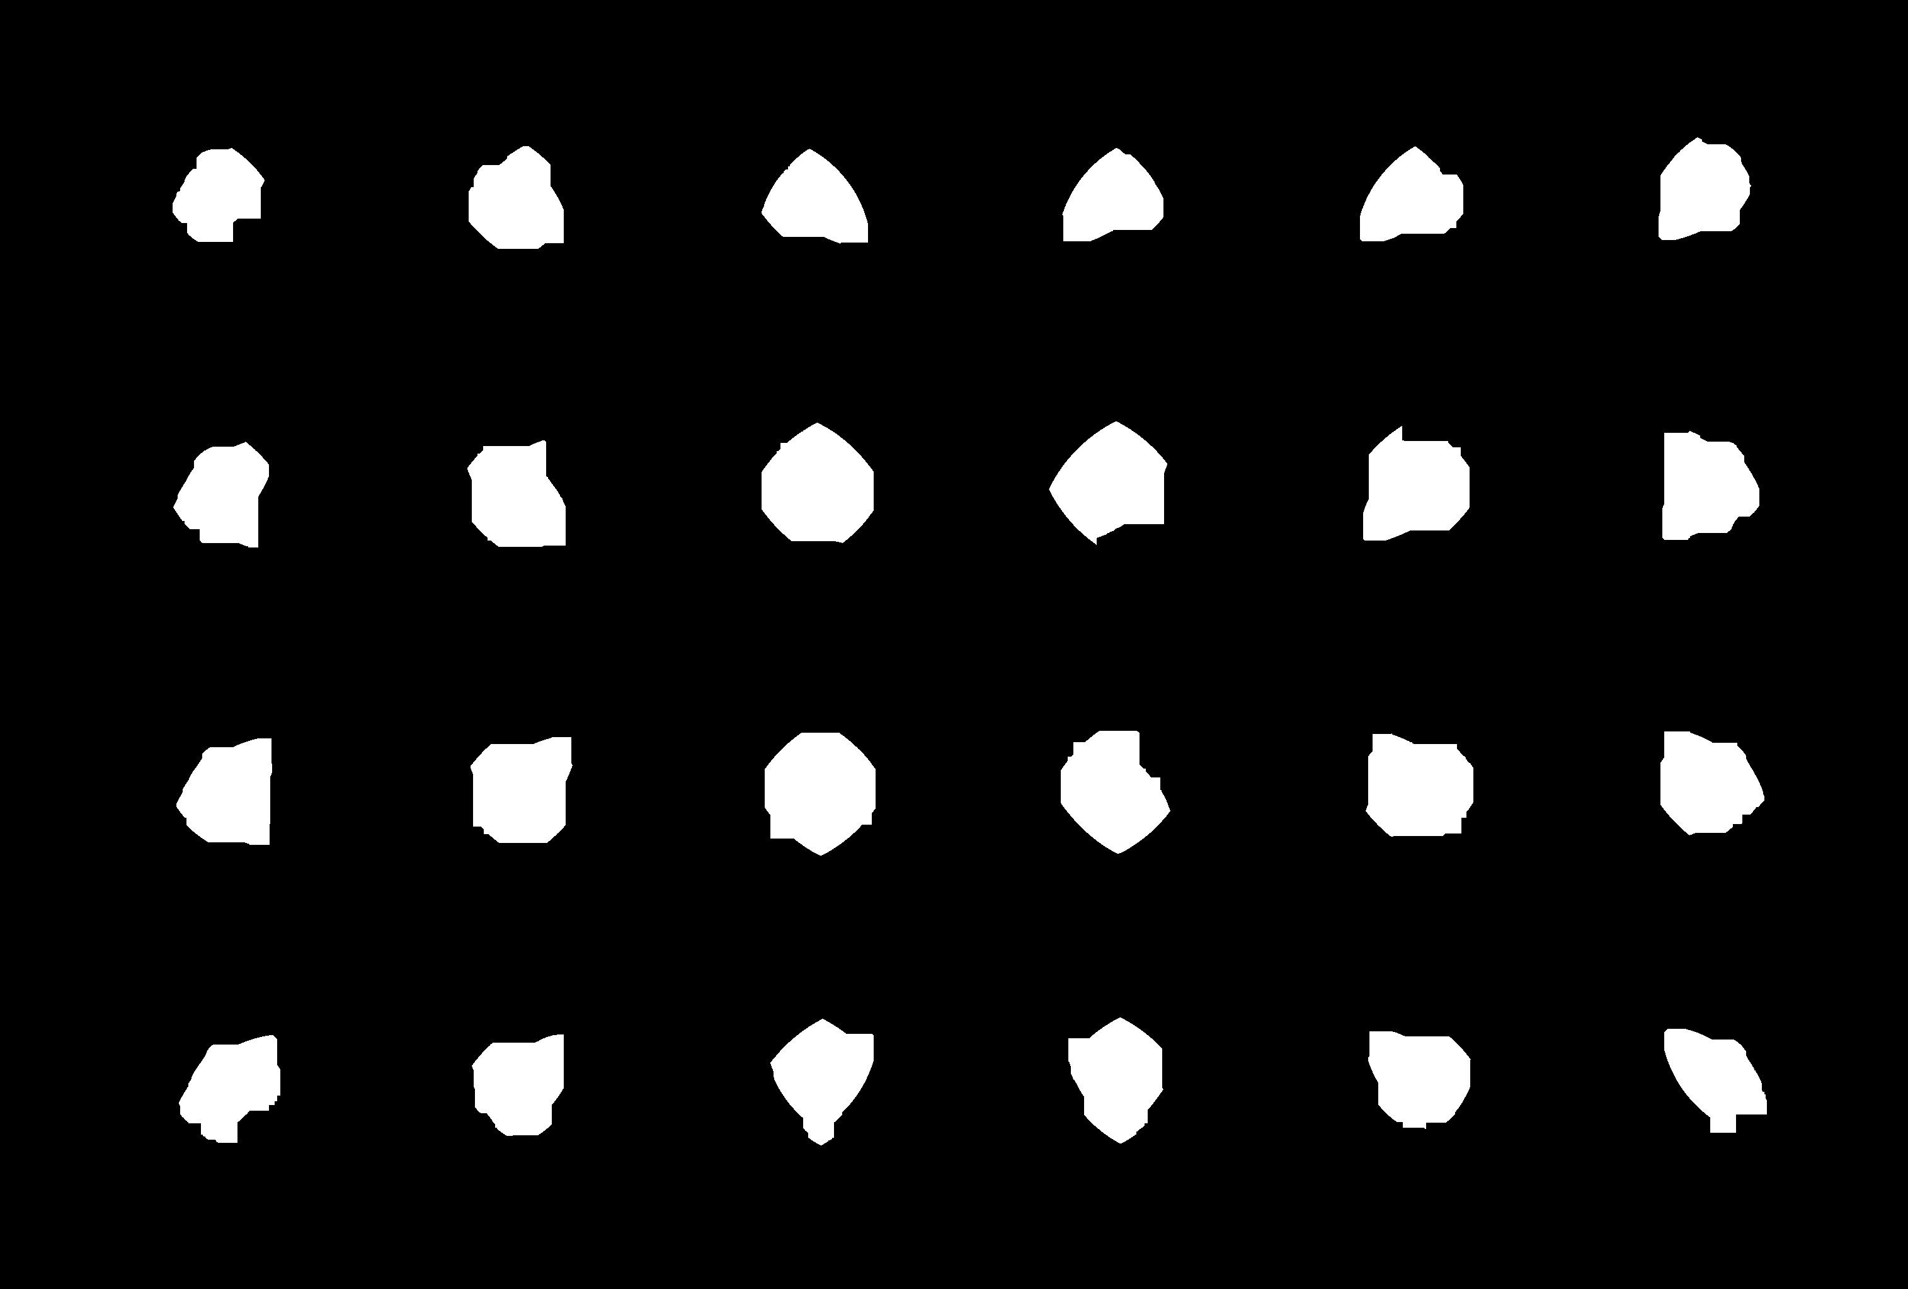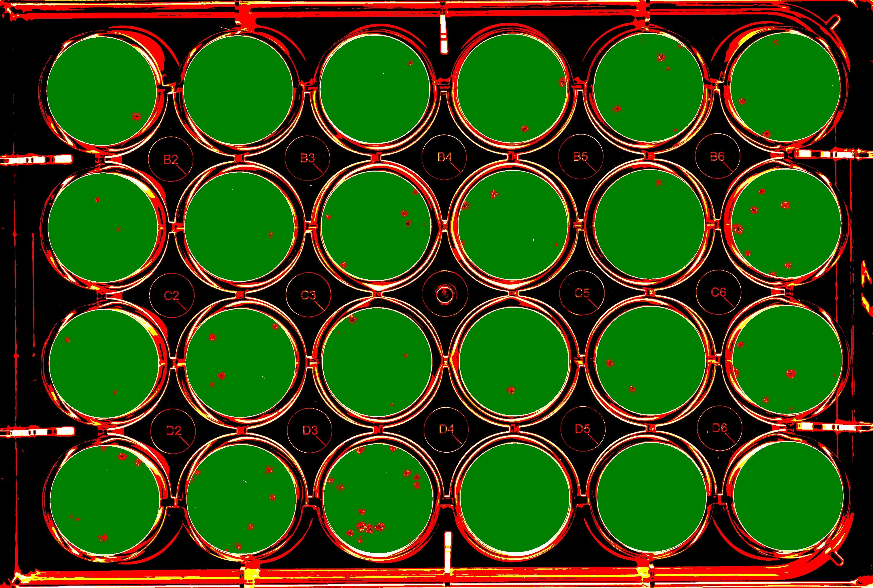
Figure 3(c): Massive Figure 3(d): Flood fill
erosion with erosion
6. Recalculate the centroids of the new artifacts. Draw a circle with centroids as origins and radius specified by the well radius parameter (Figure 3(e)).
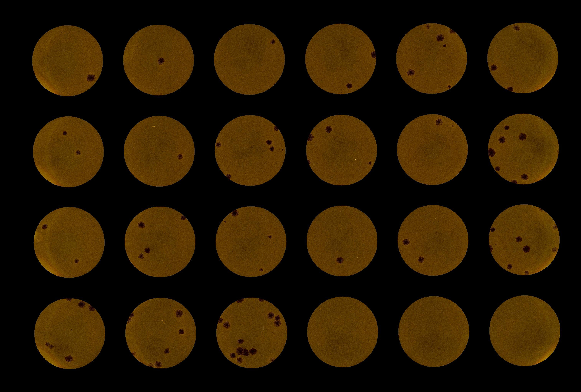
Figure 3(e): Use of well radius parameter
The procedure described above exploits the observation that plate images tend to have similar overall structure. The image artifacts that represent the agar or agar equivalent in the wells are the most predominant features of the images. Thus, the image can be reliably eroded until only these features remain.
Segmentation also exploits the fact that the wells of the tissue plates are machined to be perfectly round. This knowledge combined with the well radius parameter allows the image segmentation procedure to produce clean regions of interest, which is important to the success of the later processing stage.
2.2. Viral plaque counting
The goal of this stage is to produce viral plaque count in each well. The steps involved are summarized below.
1. Let a masked region of interest be Image A. This is a color image containing a single well.
2. Grayscale and then apply Otsu thresholding upon image A, generating Image B.
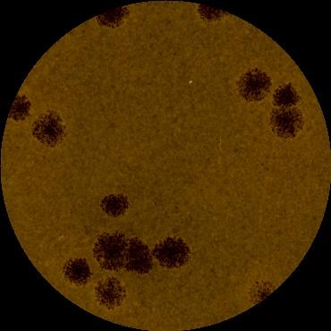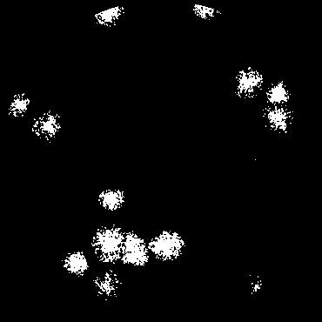
Figure 4(a) Image A Figure 4(b) Image B
3.Let images C and D be new images with dimensions of image B.
4. On Image C, render an eroded image.
Render a morphological open [9] operation on Image C using a 2x2 rectangular shaped kernel. Choose the number of iterations based on a constant derived from the maximum plaque radius parameter.
5. On Image D, render a dilated image.
(a) Find every contour in Image D. If the contour area is smaller than a constant derived from the minimum plaque area, remove it from the image.
(b) Dilate D using a 2x2 rectangular shaped kernel. Choose the number of iterations based on a constant derived from the minimum plaque radius parameter.
(c) Close any internal holes in the contours on Image D.
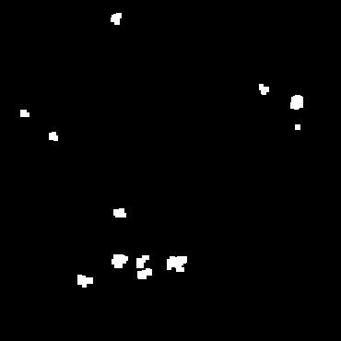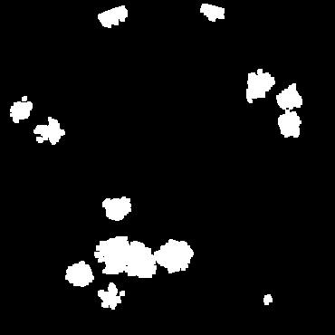
4(c) Image C 4(d) Image D
6. Merge Image D and the complement image of Image C and create a new Image E using a binary image merge of the form
E = ~C & D

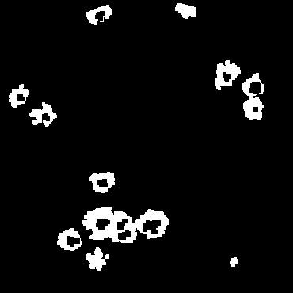
4(e) Image E
- Obtain the hierarchy of contours in E. The total number of contours be determined by the following algorithm:

minP = min plaque area
maxP = max plaque area
totalCounts = 0
for each outer contour C in E
if( area(C) < minP):
continue;
totalCounts += max(1,
innerContourCount(C),
round(area(C)/maxP))

Each outer contour of image E is iterated. If the contour's total area is less than an minP, a value calculated from the minPlaqueRadius parameter, that contour is ignored. Otherwise, the total count for the well is incremented by the greater of the value one, the number of inner contours, or the rounded quotient of the area of the outer contour divided by maxP, a value calculated from the maxPlaqueRadius parameter. This formula is used because it considers both plaque radius parameters when tallying counts. For example, an outer contour with no inner contours that is less than maxP is counted as one, and a contour that is three times larger than maxP and has only two inner contours is counted as three, etc.
The plaque counting method attempts to find a balance between finding faint and sparse plaques and properly separating and detecting dark, prominent plaques. Faint plaques are typically discovered through analysis of the dilated image (Image D). Dilation effectively joins plaque clusters and forms a cohesive, filled areas. The erosion is focused on discerning prominent and connected plaque structures. Without an erosion step, a cluster of viral plaque structures is at risk of being inaccurately tallied as a single plaque. Combining the dilated and eroded versions of a well image takes advantages of both morphological transformations. Small, faint plaques are emphasized and large, clustered plaques are separated. Both transformations scale with the user supplied parameters maxPlaqueRadius and minPlaqueRadius. These two parameters are also used when tallying total plaque counts.
3. Experiments
3.1. Image acquisition
Images were acquired using an Epson Perfection 799 flatbed scanner, configured to capture at 24 bit color mode and 600 dots per inch. In each experiment, the wells were prepared using a .5% Methyl Cellulose overlay in lieu of agar. A .4% solution of Crystal Violet was used as a dye.
The plates used were Costar/Corning 24 well (6x4) Tissue culture plates. Plates in the same study are prepared with same or very similar parameters, including incubation time, inoculation techniques, agar type, tissue mediums, and viruses. After scanning, plate images are grouped by study. This organization scheme makes parameter configuration much easier since the three parameters, i.e. well radius, minimum plaque radius, and maximum plaque radius, are needed on a per study basis.
3.2. Evaluation criteria
To evaluate the performance of the counting method, accuracy measure is used, which is defined for each well as

Truth data contains plaque counts for individual wells in each plate and wa s obtained by manual counts. The proposed counting method is implemented using OpenCV, an open source computer vision library [10].
3.3. Study One
In the first study, African Green Monkey Kidney Cells Cell strain Vero E6 were infected with a Vaccinia Virus Western Reserve strain. Seven plates and therefore seven images were captured. Each plate contained 24 wells, and a total of 168 wells generates 168 plaque counts. Viral plaques for this study were large both large and small in size. The max plaque radius parameter was set to 25 pixels and the min plaque radius was set to 5. The average background noise found in each well is minimal in this study as compared to the other studies. Two typical samples of study one are shown in Figure 5.

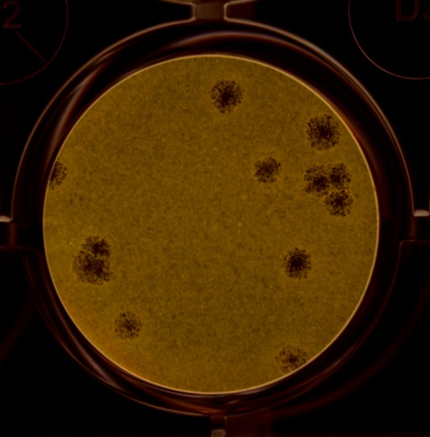
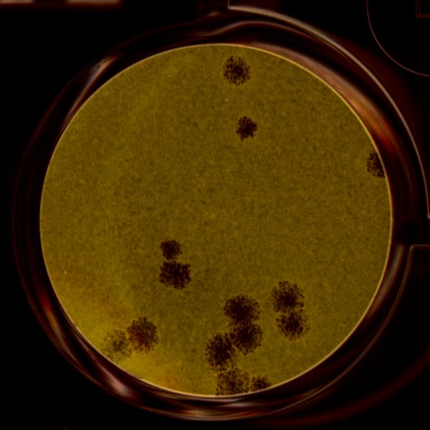
Figure 5: Study one sample images

Table 1 shows the results by plate. “Computed counts” is the sum of computed well counts on one plate, while “Manual counts” is the sum of manual well counts on the same plate.
Table 1: Study One results
Plate No. | Errant computed counts | Manual counts | Accuracy %
1 | 7 | 41 | 83
2 | 3 | 42 | 93
3 | 9 | 81 | 89
4 | 8 | 121 | 93
5 | 6 | 61 | 90
6 | 4 | 48 | 92
Ave. |  |  | 90

Figure 4 shows the comparison between computed counts and manual counts using 50 out of 168 wells.

Figure 6: Computed counts vs Manual counts for 50 of 168 wells
3.4. Study Two
In the second study, African Green Monkey Kidney Cells Cell strain Vero E6 were again infected with Vaccinia Virus Western Reserve strain. The plaques in this study were similar to study one in size and shape, however the average background noise levels in the wells was much higher. Shown in Figure 7 are two typical well images for study two.
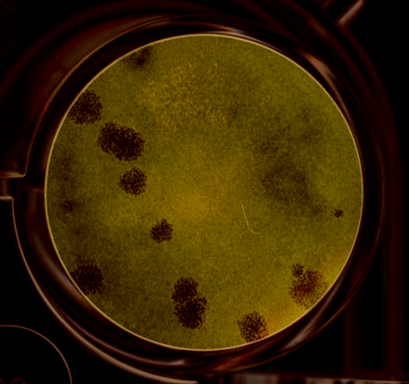
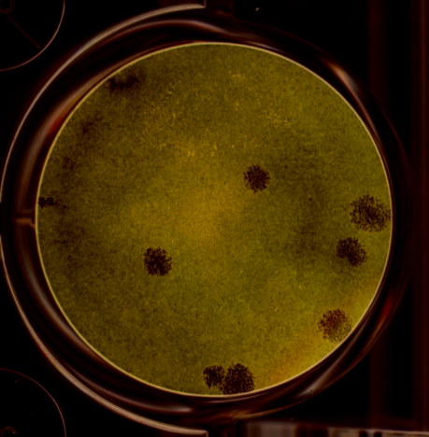
Figure 7: Study two sample images
Five sample images were captured. Each plate contained 24 wells, generating a total of 144 counts. Table 2 shows summarized results for study two and Figure 8 shows the comparison between computed counts and manual counts using 50 out of 144 wells.
Table 2: Study two results
Plate No. | Errant computed counts | Manual counts | Accuracy %
1 | 26 | 105 | 75
2 | 13 | 95 | 86
3 | 13 | 70 | 81
4 | 16 | 78 | 79
5 | 11 | 49 | 78
Ave. |  |  | 80

Figure 8: Study 2 results
3.5. Study Three
In the third study, African Green Monkey Kidney Cells Cell strain Vero E6 were again infected with Monkey Pox Zaire strain. The plaques used in this study are very small compared to the previous two studies, and the structures are very faint.
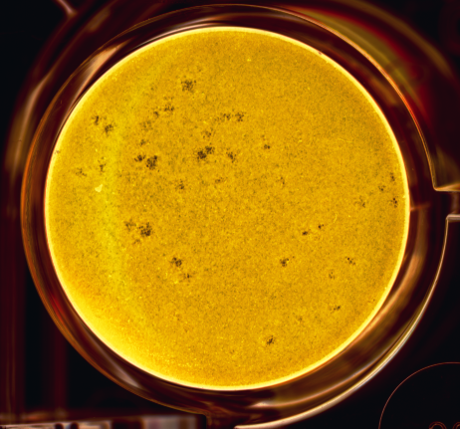
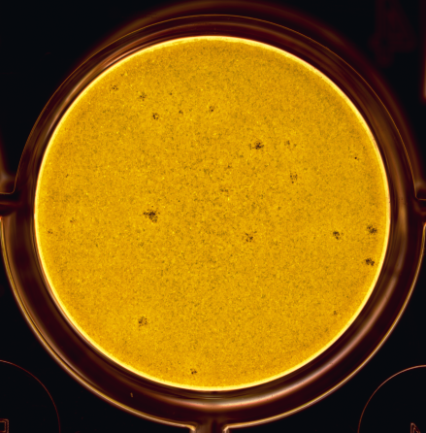
Figure 9: Study three sample images
A minimum plaque radius of 1 and a maximum plaque radius of 5 are used as parameters when processing these images. Three sample images were captured. Each plate contained 18 wells, and a total of 52 data points were compared with corresponding truth data points.
Table 3: Study three results
Plate No. | Errant computed counts | Manual counts | Accuracy %
1 | 47 | 330 | 86
2 | 47 | 210 | 78
3 | 43 | 159 | 73
Ave. |  |  | 80

Figure 9: Study three results
3.5. Study Four
In study four, the execution times for the viral plaque counting implementation was measured. Wall clock time was measured for each plate image used in this paper. An Intel(R) Core(TM) i5 2.80 GHz processor and Windows 7 Professional was used as a platform for the program. Figure 11 shows the execution times for 22 plate images.
Figure 10: Execution times
3.6. Discussions
Given the often noisy nature of the substrate and viral plaques in the well, it is difficult to devise a method that works well for all. Viral plaques can be very small, very large, malformed, or even overlapped on top of one other. The plaque counting method attempts to be simple and accurate for the most commonly occurring instances of viral plaques.
Experimental data shows that the proposed method automatically counts an entire viral plaque plate with an accuracy range of 70 to 90 percent. It was observed that the accuracy of the method roughly correlates to the quality of the image acquired by the scanner and the clarity of the structures in the actual samples. When a scanned image is of low contrast or has object reflections, accuracy rate is low. Low accuracy was also observed when the samples were smudged or damaged due to human error in preparation.
It is speculated that methods for improving the signal to noise ratio at image acquisition stage could vastly improve overall accuracy. Use of a high resolution overhead camera and reflection reduction system such as in [4] could help in this area. An overhead camera type apparatus might also prove very practical, as it could be used to capture images in real time and improve overall work flow. Ultimately, a trained eye is still required to determine if a given sample plate is a candidate for automated counting; some samples are simply too damaged or noisy for the proposed method to process and produce a counts of reasonable accuracy.
3.7. Graphical user interface
The graphical user interface (GUI) is a front end for the plaque counting routine. Implemented in the Java programming language, it features a file selection view (11A), a zoomable image preview area (11B), a results summary view (11C), and a parameters configuration wizard (11D).
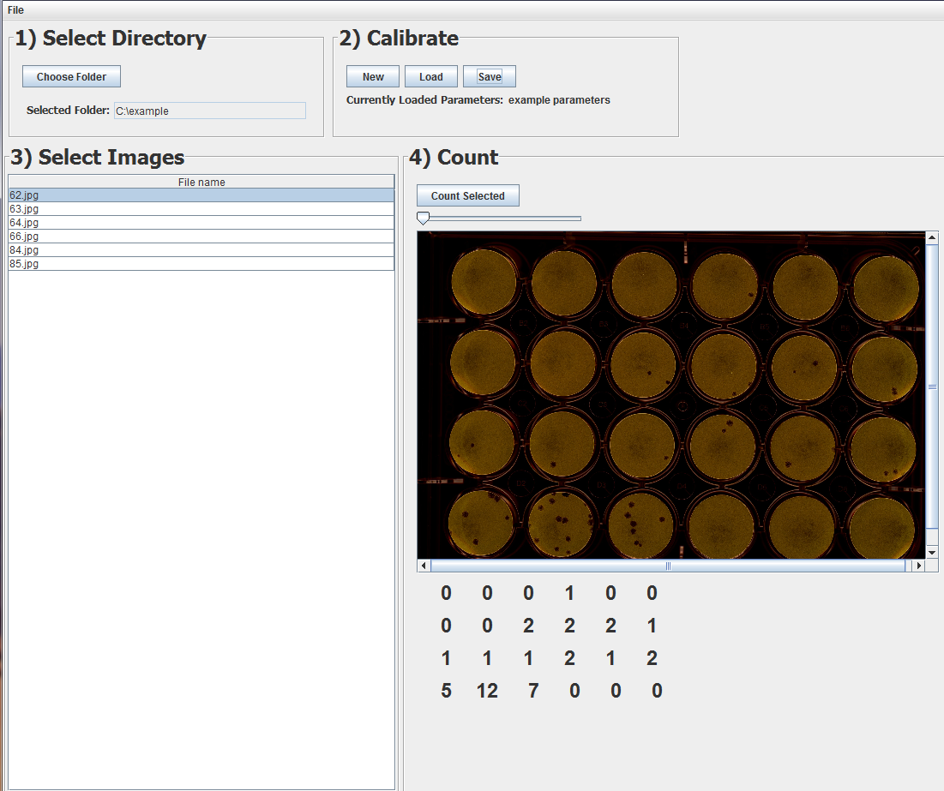
A
B
C
D
E

Figure 11: Graphical User Interface
Users select a directory containing images and then create parameters for a viral plaque study. The plaque counting program is invoked when the user presses the “Count Selected” button (11E). Source code and executables for both the GUI and the viral plaque counting programs are freely available for download at <insert sourceforge URL ref>.
Conclusion

References

[1] (2011,November) Lab Safety Supply. [Online].
Available: http://www.labsafety.com/
[2] (2011,November) Cole-Parmer. [Online].
Available: http://www.coleparmer.com/
[3] (2011,November) Lab Planet. [Online].
Available: http://www.labplanet.com/
[4] K. Claytor, “Development and implementation of an efficient automated cell colony and plaque counter.” University of Illinois Internal Physics Publication, 2008.
[5] D. Mukherjee, “Bacterial colony counting using distance transform,” International Journal of Biomedical Computing, vol. 38, pp. 131–140, 1995.
[6] P. Barber, “Automated counting of mammalian cell colonies,” Phys Med Biol, vol. 46, pp. 63–76, 2001.
[7] N. Otsu, “A threshold selection method from gray-level histograms,” IEEE Transactions on Systems, Man and Cybernetics, vol. 9, pp. 62–66, 1979.
[8] P. Heckbert, A Seed Fill Algorithm. New York: Academic Press, 1990.
[9] J. Serra, Image Analysis and Mathematical Morphology. New York: Academic Press, 1983.
[10] (2011, November) Opencv home page. Willow Garage. [Online]. Available: http://opencv.willowgarage.com/wiki/

Acknowledgements
Thanks to the Southern Research Institute of Frederick Maryland and Mr. Michael Inskeep for providing example plaque images and truth data.

