**Inventory Application:**

Web Portal developed in Angular JS deployed in portal server in Azure Web Apps .

Following Ecommerce APIs are developed in SpringBoot to add the core functionalities.

APIs developed in the SpringBoot are deployed in OpenShift Platform in Azure Cloud.

Angular JS app will consume the APIs to full fill to host the eCommerice requirement.

Example considered for this e-commerce platform is book management.

**Inventory APIs:**

1. Addition of the individual items
2. Update of the items, Update the book
3. Delete of the item
4. Bulk deletes of the items
5. Get the required item, Get the item
6. Get all the items
7. Delete all the items
8. Create bulk order creation of items

Inventory Architecture:

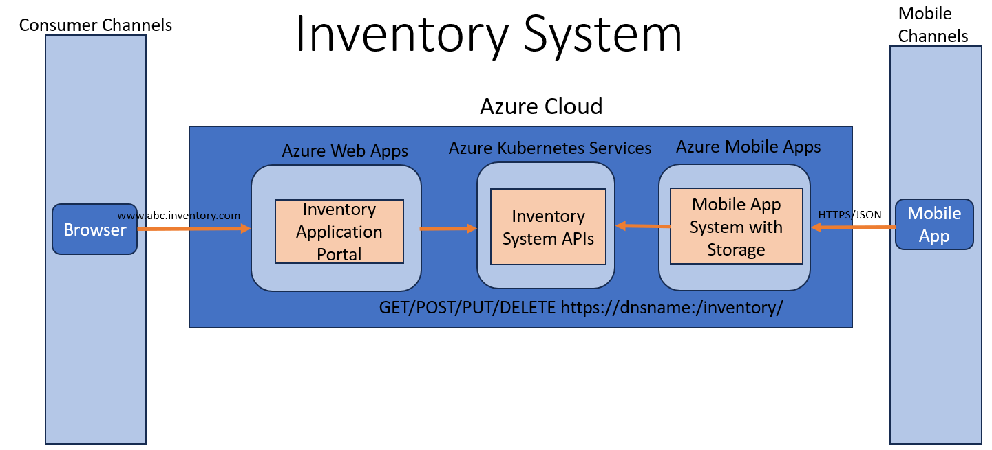

**Add Inventory API:**

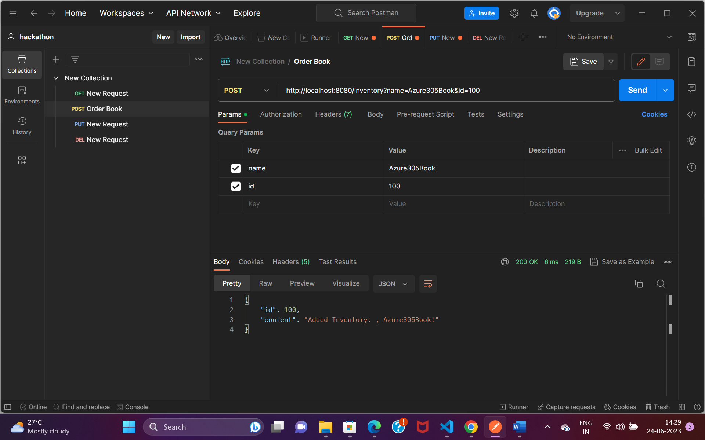

**Retrieve Inventory API:**

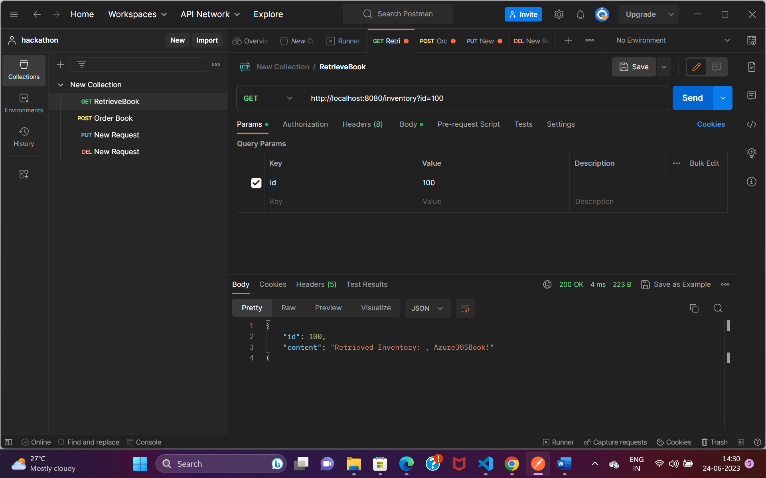

**Update the Book API:**

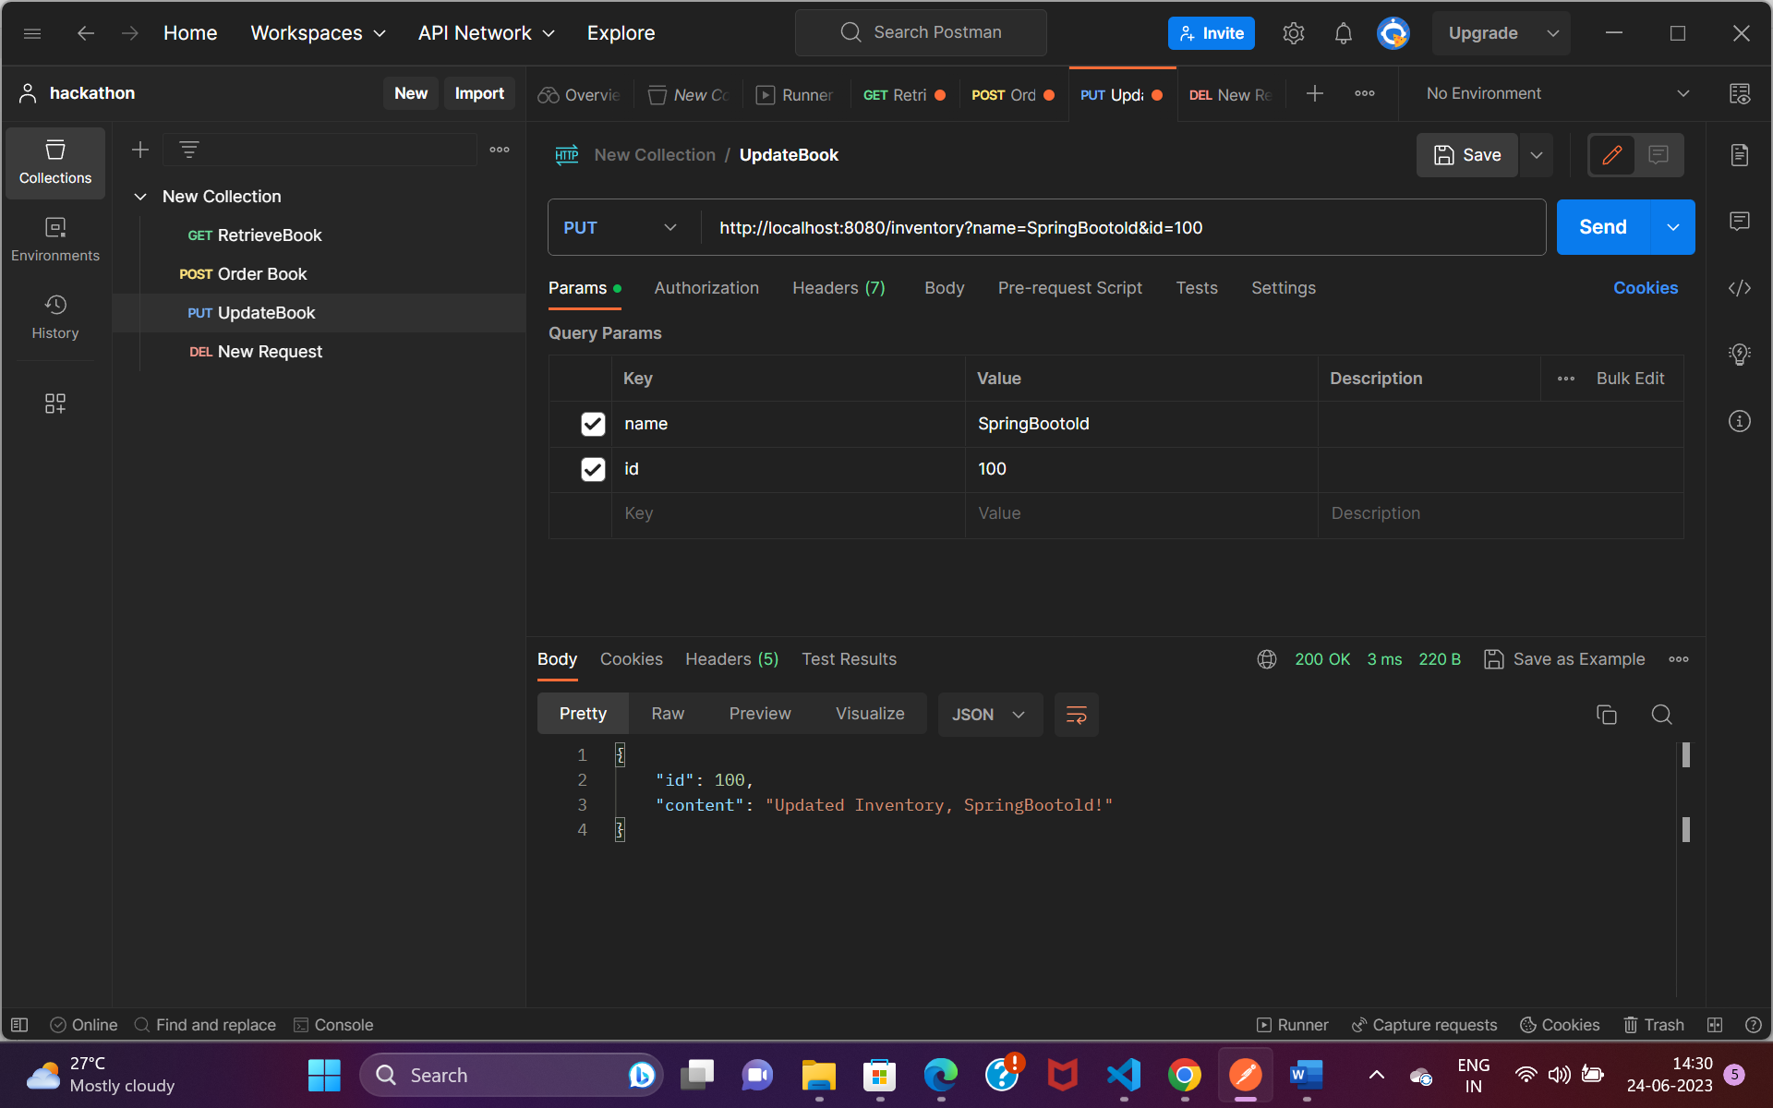

**Retrieve Updated Inventory API:**

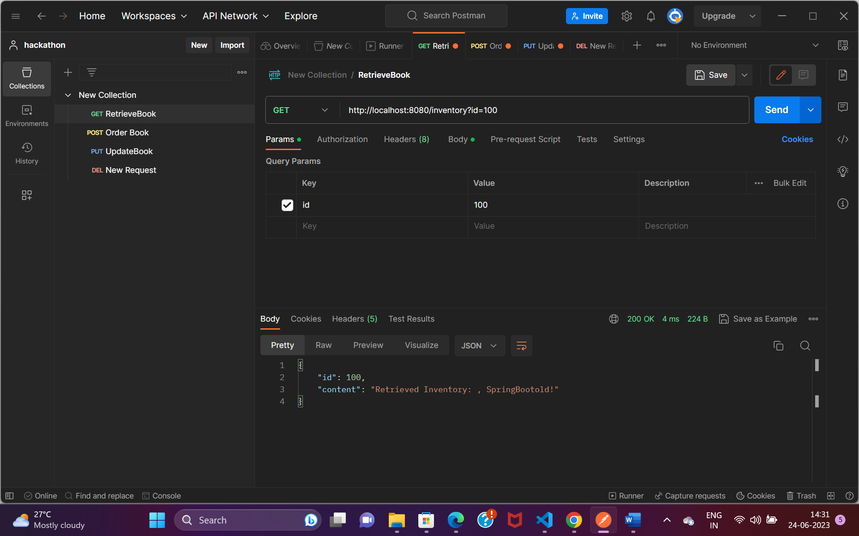

**Delete Inventory API:**

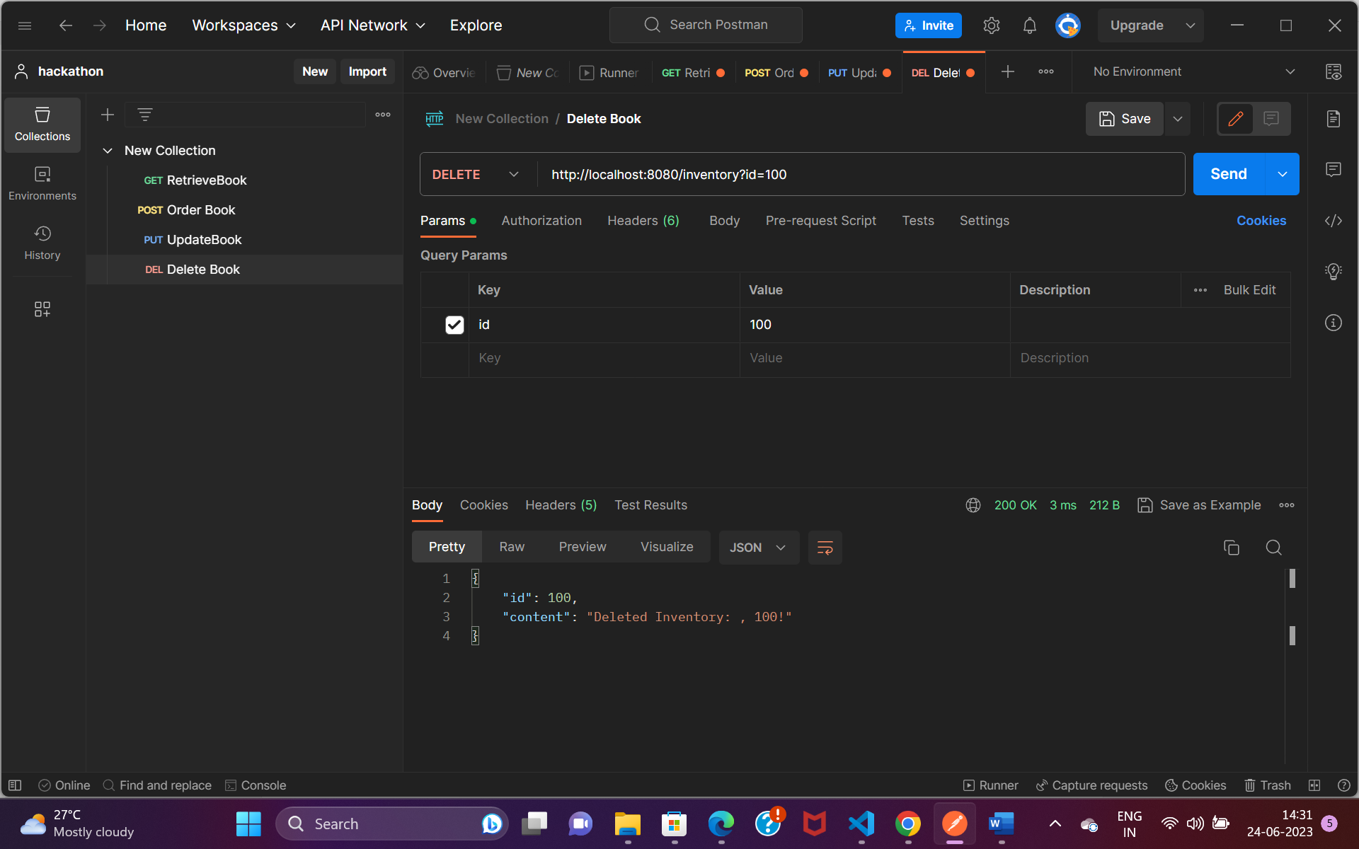

**Retrieve Deleted Inventory API:**

