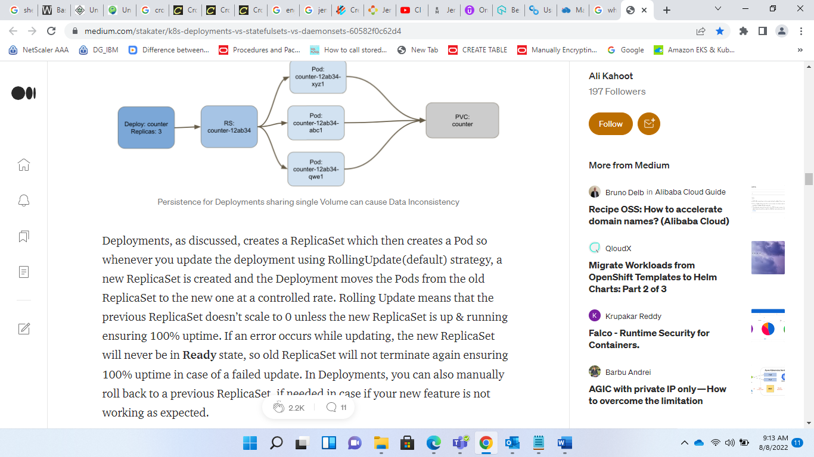

Fig: deployment (stateless applications)

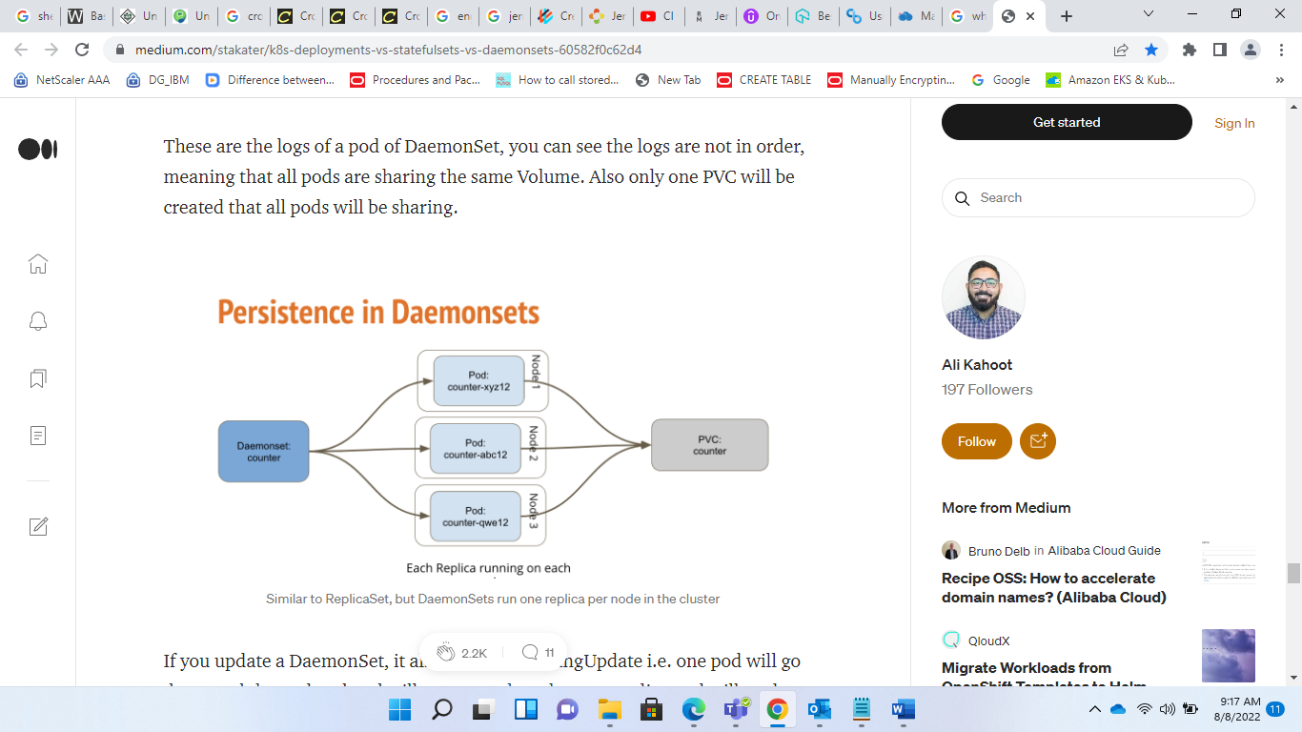

If you update a DaemonSet, it also performs RollingUpdate i.e. one pod will go down and the updated pod will come up, then the next replica pod will go down in same manner e.g. If I change the image of the above DaemonSet, one pod will go down, and when it comes back up with the updated image, only then the next pod will terminate and so on. If an error occurs while updating, so only one pod will be down, all other pods will still be up, running on previous stable version. Unlike Deployments, you cannot roll back your DaemonSet to a previous version.