Program Analysis

Testing the Program

The program was mainly tested by a combination of Visual Studio Code’s debugging feature and printing statements to keep track of the actions of each process. Prior to my first testing, I had remade the given Gantt chart in an MS Excel sheet for Datafile 2 (provided in the folder). This allowed me to visualise each task a process must be performing while simultaneously understanding how both Least Recently Used (LRU) and Clock algorithms work.

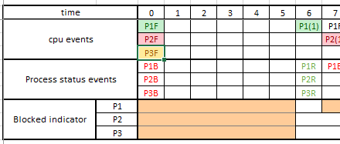

Figure 1: A remake of the Gantt chart was made to understand how to test/debug the program in MS Excel.

Page replacement comparison methods based on results of programs

Although the results of the program are strikingly similar of which process executes a page fault and when despite the added page fault, it is upon closer speculation in debugging where you understand that the pages stored in each process differentiate. This is first apparent on time 122 when the program needs to decide which page to replace as page 3 is not seen in the main memory of the process.

Both algorithms issue a page fault, but the page replacements are performed at different indexes of the process memory. In the LRU algorithm, the process recognises that page 10 is least recently used at index 9, replaces page 3 with page 10 and issues a block. The clock algorithm also realises that the page is not in the page stream so it must perform a replacement. However, the clock algorithm reads for the first index in the memory that has a bit value of 0 and replaces it accordingly at index 4.

The differences in page faults at time 122 is the reason for the additional page fault. At the end of the program, page 5 is still at index 5 in the LRU algorithm whereas page 5 was replaced at time 122 in the Clock algorithm, making the Clock algorithm unable to find page 5 in the process memory.

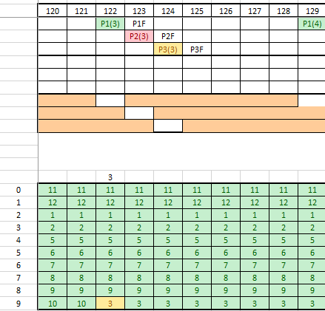 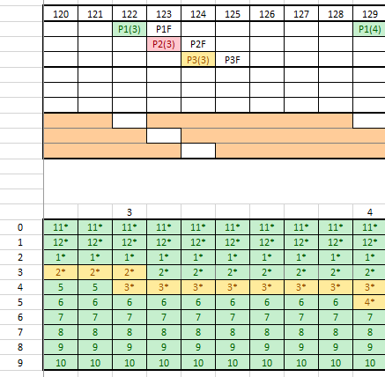

Figure 2: LRU and Clock algorithms displaying the difference in page faults in MS Excel.