2.1 Written Report
1. For each of the programs keep track of how much time you spend designing, coding and correcting errors, and how many errors you need to correct.
2. Keep a log of what proportion of your errors come from design errors and what proportion from coding/implementation errors.
April 8:
- Initial commit, basically copying all the contents from assignment 1 to be used in this assignment as it was allowed and recommended to transfer content across as a base reference.
- Some commenting improvements were needed to be done.
- An empty abstract class was made with no methods as I still needed to learn how abstract classes work.
- Modified input.txt to suit assignment testing. I could not test other shapes at this moment as other shapes could not be recognisable at this stage.
- Semicircle and circle had no content as I was still learning how the program would transfer “S” and “C” data
April 9:
- PA1.java was renamed to PA2.java
- Circle class and Semicircle class testing is finished but needs to be implemented into a linked list.
- ERROR: object syntax error. I’m used to detecting the polygon object but since it’s an abstract class, I could not figure out that it needed to return PlanarShape instead of Polygon.
- Still learning abstract class. At this stage, I kept thinking that abstract classes needed implementation inside the PlanarShape class and not in other classes.
- Changed string return value to have name of polygon “POLY=”. Previously it just returned the points and area.
- ERROR: originDistance() method could not be implemented properly for Circle classes. An absolute value and pointArray[#].distanceFromOrigin() was needed to fix this.
April 10:
- Circle originDistance() is fully fixed.
- Added setX(), setY(), getX() and getY() methods in Point class as it needed to be used in the Circle and SemiCircle class.
- Added skeleton code for Semicircle class using Circle class as a reference.
April 22:
- ERROR: Some methods in the abstract class were implemented properly as a peer reviewed my code and told me how abstract classes work. The fix was that you were only supposed to write the header of the method with no implementation.
- ERROR: Semicircle calculateArea() function could not return proper values. After multiple attempts and changing code, it was difficult to return the proper value of the semicircle. Although the assignment spec had an incorrect output, my code was also incorrect making it more difficult to troubleshoot and fix. The fix was that I needed to fix my radius function as I was making it more difficult by using the extremality points of the semicircle without using the provided point by input.txt
May11:
- Generics were implemented into the Node class and PlanarShape. Converting the classes into generic was not difficult to do. However, extending classes as generic and using methods with different values was difficult to achieve. Visual Studio Code provided value types of the generic method which made it easier to determine which generic value returns what type.
May 12:
- MyPolygons class (which was treated like a Linked List) is renamed to be LinkedList to better suit the requirements.
- ERROR: insertSort() method needed to be fixed. Although my previous assignment returned another empty Linked List which only appends and prepends new incoming nodes, this needed to use an iterator, which made it more difficult to use the previous method from assignment 1. Therefore, a remake of the insertSort() method need to be made. This fix is a longer process:
- Make and implement the iterator function within the Linked List. There was not a lot of problems in this as almost every resource I needed was in the lecture slides (except figuring out which classes implemented which features). My friends in the course drew diagrams to help me understand.
- The insert sort method now needs to be implemented after every new Planar Shape. Therefore, instead of creating and returning a new instance of the unsorted linked list, another sorted linked list was needed to be made at the start of the main file.
- The next step was to determine a way which finds the value of the greater node and to insert the new node before the node with the greater value.
3. Provide a (brief) design of how you would further extend your PA2 so that it specifically included Triangle and Square figures. Draw the UML class diagram for this new program (intricate detail not required). What attribute data do you need in each case?
PA2 would need to read more polygon values which will have their own unique char values (I.e. “T” and “S” for triangle square respectively). The square calculate area formula would be relatively easy and the triangle formula can simply be an extension of the square area formula but halved (similar to the Circle and Semicircle classes in this.assignment).
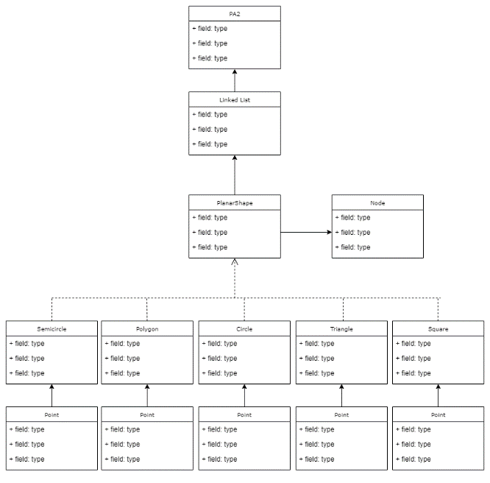
4. Investigate the mathematical structure of an Ellipse on the Cartesian plane. How would you model the Ellipse? How would you then calculate its area and originDistance()? How would this be incorporated into your program? Draw another UML class diagram to show this.
The input.txt file can have “E” to declare that an Ellipse object needs to be created. Following this, it needs the values of the centre of the ellipse. Following the centre of the ellipse needs to have the coordinates of the longer curve and the coordinates of the shorter side of the curve.
Using the 3 coordinates, it becomes easier to calculate the area of the ellipsis. The formula:
$$A=πab$$
Where, A = area
a = length between coordinate of length of longer curve and centre of ellipsis
b = length between coordinate of length of shorter curve and centre of ellipsis
