# Research proposal

**Research proposal STSI Part 4: Quantitative research on Sustainable Development Goals and Sustainability Indicators**

**1: group formed**

Moos Castelijn (9204881)

Mart Boersma (6611699)

Tim Zandee (6962181)

Simon Horst (6363687)

Sammy van de Sluys (6007384)

**2: The sustainable development goal that you choose, and the main target and set of indicators;**

SDG**: 12, Responsible Consumption and Production**

**Target: 12.3**By 2030, halve per capita global food waste at the retail and consumer levels and reduce food losses along production and supply chains, including post-harvest losses

Indicators: Global food Loss and Waste (12.3.1)

2 sub-indicators: Food Loss Index (12.3.1.a), Food Waste Index (12.3.1.b)  
  
**3. Filled out table 1, with approximately 5-10 relevant references. More references are allowed, less references not. If you struggle to find enough relevant literature, adjust topic or broaden scope;**

**Table 1:** Overview of key research components

|  |  |  |  |  |  |  |
| --- | --- | --- | --- | --- | --- | --- |
| Author(s) | Title | Main SDG | Main Target | Set of Indicators and/or data | Gap in Knowledge | Main findings & next step |
| (Wang, Ghadimi, Lim, & Tseng, 2019) | A literature review of sustainable consumption and production: A comparative analysis in developed and developing economies | 12 | general | 12.3 | According to the article, top-down activity in sustainable consumption and production is mostly missing in developing countries. |  |
| (FAO, 2022b) | Food Loss and Waste Database | 12 | 3 | 12.3.1.a | Food Loss data shows the largest percentages of food loss in African regions. |  |
| (FAO, 2022a) | Indicator 12.3.1 - Global Food Loss and Waste | 12 | 3 | 12.3.1.b | Data shows in what parts of the food supply chain losses are the largest. |  |
| (Parfitt, Barthel, & Macnaughton, 2010) | Food waste within food supply chains: Quantification and potential for change to 2050 | 12 | 3 | 12.3.1.a |  | Food waste data from developing countries obsolete, BRIC also uncertain |
| (Zakari, Tawiah, Khan, Alvarado, & Li, 2022) | Ensuring sustainable consumption and production pattern in Africa: Evidence from green energy perspectives | 12 | 3 | 12.3.1 |  | Article suggests that improvements of green energy technology and implementation has positive influence on sustainable consumption and production om Africa |
| (UNEP, 2021) | UNEP Food Waste Index Report 2021 | 12 | 3 | 12.3.1.b - Food Waste Index | Global food waste data availability, especially in lower income countries |  |
| (Chan, Weitz, Persson, & Trimmer, 2018) | SDG 12: Responsible consumption and production. A review of research needs. Technical annex to the Formas report forskning för agenda, 2030. | 12 | all | 12.3 | resistant crop varieties; better packing and transport; reducing pests and diseases in stored food; and low-cost, efficient cooling and refrigeration facilities suited to developing country contexts; and productive reuse of nutrients or energy in food that spoils. |  |

**4. Causal loop diagram or conceptual framework: the graph/diagram you produced that frames the**  
**research project and identifies which part of the gap in knowledge you will be addressing;**

Currently the largest improvements on SDG 12.3 can be made on food loss in Africa. Data shows loss is highest here, and these countries can still develop to be impactful in worldwide food loss due to its large population.

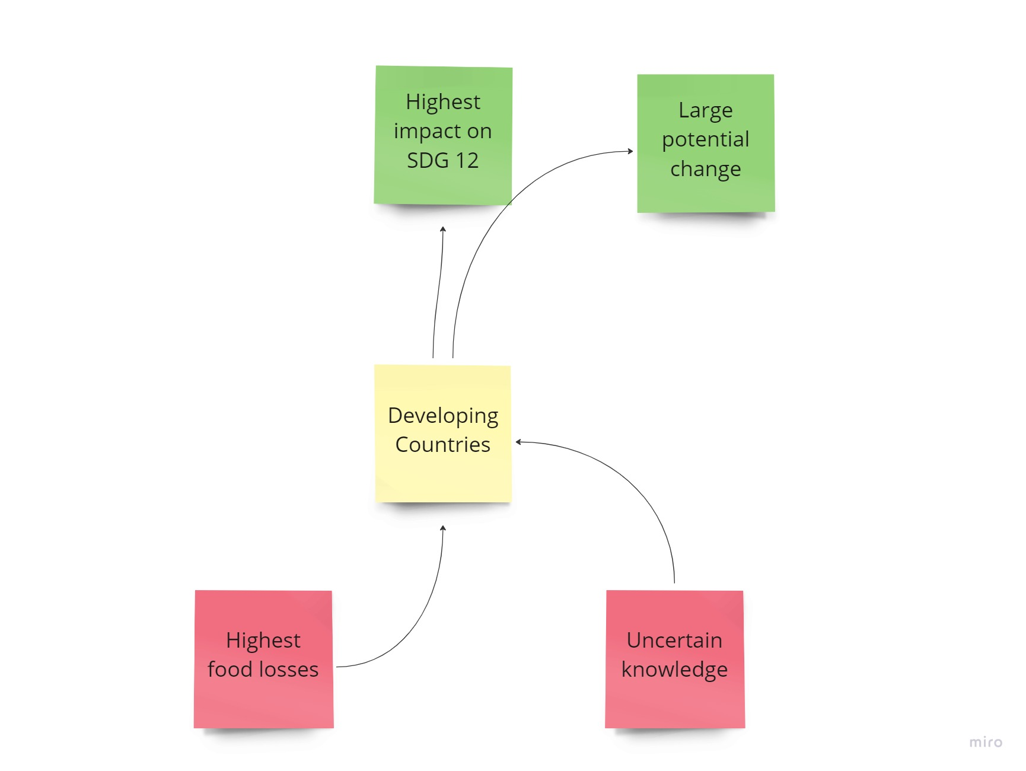  
**5. Reference list of all papers in the Table 1.**

Chan, S., Weitz, N., Persson, Å., & Trimmer, C. (2018). *Stockholm Environment Institute SDG 12: Responsible Consumption and Production-A Review of Research Needs 1 1 SDG 12: Responsible Consumption and Production A review of research needs Annex to the Formas report Forskning för Agenda 2030: Översikt av forskningsbehov och vägar framåt*.

FAO. (2022a). 12.3.1 Global food losses | Sustainable Development Goals | Food and Agriculture Organization of the United Nations. Retrieved December 20, 2022, from https://www.fao.org/sustainable-development-goals/indicators/1231/en/

FAO. (2022b). Food Loss and Waste Database | Technical Platform on the Measurement and Reduction of Food Loss and Waste | Food and Agriculture Organization of the United Nations.

Parfitt, J., Barthel, M., & Macnaughton, S. (2010). Food waste within food supply chains: quantification and potential for change to 2050. *Philosophical Transactions of the Royal Society B: Biological Sciences*, *365*(1554), 3065–3081. https://doi.org/10.1098/rstb.2010.0126

UNEP. (2021). UNEP Food Waste Index Report 2021 | UNEP - UN Environment Programme. Retrieved December 20, 2022, from https://www.unep.org/resources/report/unep-food-waste-index-report-2021

Wang, C., Ghadimi, P., Lim, M. K., & Tseng, M. L. (2019). A literature review of sustainable consumption and production: A comparative analysis in developed and developing economies. *Journal of Cleaner Production*, *206*, 741–754. https://doi.org/10.1016/J.JCLEPRO.2018.09.172

Zakari, A., Tawiah, V., Khan, I., Alvarado, R., & Li, G. (2022). Ensuring sustainable consumption and production pattern in Africa: Evidence from green energy perspectives. *Energy Policy*, *169*, 113183. https://doi.org/10.1016/J.ENPOL.2022.113183

# Step 2.1: Define gap in knowledge

There is a lot already written on Food Waste and Food Losses (FWL), its relationship with GDP and poverty is examined at large, leading others to the conclusion that developing countries have a higher loss rate. However, it is known that in general, developing countries have a warmer climate, and higher temperatures can also lead to food spoilage, causing us to wonder whether it isn’t the warmer temperature rather than increased poverty that is causing the increased food loss. This has not been examined but could prove to be an important confounder when considering the Food loss-poverty relationship.

# Step 2.2: Develop a quantitative research question

Research question: What is the relationship between temperature and food loss, and can this be separated from the GDP?

**Indicator 12.3.1 - Global Food Loss and Waste**

SDG target 12.3 has two components, Losses and Waste that should be measured by two separate indicators.

**Sub-Indicator 12.3.1.a - Food Loss Index**

101.2 (2020), 98.7 (2016)

The Food Loss Index (FLI) focuses on food losses that occur from production up to (and not including) the retail level. It measures the changes in percentage losses for a basket of 10 main commodities by country in comparison with a base period. The FLI will contribute to measure progress towards SDG Target 12.3.

**Sub-Indicator 12.3.1.b - Food Waste Index**

A proposal for measuring Food Waste, which comprises the retail and consumption levels is under development. UN Environment is taking the lead on this sub-indicator.

The reasoning for choosing food loss as an indicator is that we expect food loss to be more correlated to temperature compared to food waste, as the processes that accumulate food loss require more cooling processes and similar steps in which conservability is affected. Due to temperature increases often accelerating food decay, this is also a relevant factor.

# Step 2.3: Develop the analytical framework

## Part 1: Data Gathering

We will conduct this study by first gathering the needed data. Data about average annual temperatures, national Food Loss Indexes. Data will be selected for Australia, Malaysia, Saudi Arabia, Kyrgyzstan, Uzbekistan, South Africa, Ecuador, Mali, Cambodia, Netherlands, USA and New Zealand. These countries are chosen because they have either a high GDP and a high average temperature (high-high) or a low GDP and a low average temperature (low-low), and a few of the 2 other situations which serve as reference points. If the high-high (high GDP & high average temperature) countries also have a high food loss index it can be inferred that food loss is more correlated with food temperature than GDP and vice versa. A similar line of reasoning can be used for the low-low countries: if these have a high food loss, the hypothesis that food loss is more associated with GDP and vice versa. The Netherlands represents a wealthy country with high GDP and low average annual temperature. Venezuela is a country situated on the equator and has a high average annual temperature. However, Venezuela has a moderate GDP. Kyrgyzstan is located below Kazakhstan in central Asia and is a poor country with low GDP. The average annual temperature is moderate and slightly higher than the average annual temperature of the Netherlands. Tajikistan lies next to Kyrgyzstan and is similar to Kyrgyzstan. We have chosen to include Tajikistan, so this research includes more data points for less developed countries with moderate temperatures. Next, we have picked Afghanistan. This is a country located at the crossroads of Central and South Asia. Afghanistan is characterised by high average annual temperature and low GDP. Lastly, we have selected Saudi Arabia. This is a country with high average annual temperatures and high GDP.

|  |  |  |  |
| --- | --- | --- | --- |
| **High T - High GDP** | **Low T – Low GDP** | **High T - Low GDP** | **Low T – High GDP** |
| Australia | Kyrgyzstan | Ecuador | Netherlands |
| Malaysia | Uzbekistan | Mali | USA |
| Saudi Arabia | South Africa | Cambodia | New Zealand |

## Part 2: Data Analysis

After gathering all the needed data, we will utilise Excel for the data-processing, visualisation and analysis. We will perform a linear regression on the data in order to calculate possible relationships and correlation.  After this step, we will analyse the differences in relationships between Temperature and Food Loss Index and report the results using multiple figures.

The relationships we are looking for are mostly correlation between the average annual temperature of a country and the percentage of food loss that country has. Comparing these results with the GDP of these countries can show if GDP is an important factor, more than temperature, in food loss.

## Step 3: Discussing and Concluding of the Results

The last step of this report will be formulating the discussion and conclusions that can be derived from this research. Discussing our hypothesis, and reasoning why it is or is not correct.

**Notes:**

Food Loss is defined as food losses from production to retail. However if the place where production takes place is different from the place where there is consumption there is a large transport component, and in other places this might be missing. This is a factor which could obscure our results.

In the future, the way that the countries are selected could change. Now it is obtained by looking at two graphs but more rigorous methods could be used for this.

It is difficult to find countries that are rich and have a high mean temperature. Interesting discussion point, and something to be researched possibly. The current selection of countries is prone to change, as while doing research we can find more interesting countries to compare.

Xue, L., Liu, G., Parfitt, J., Liu, X., Van Herpen, E., Stenmarck, Å., ... & Cheng, S. (2017). Missing food, missing data? A critical review of global food losses and food waste data. *Environmental science & technology*, *51*(12), 6618-6633.