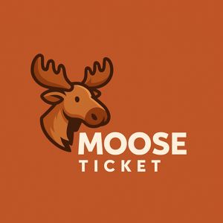

# MooseTicket Inc.

## MooseTicket App Store Disclaimers

# 1. PLATFORM COMPLIANCE

You must comply with the Apple App Store and Google Play policies.

# 2. EXPORT COMPLIANCE

You confirm you’re not on a restricted party list or in a banned country.

# 3. REFUNDS

Handled by the app store provider.

# 4. NO ENDORSEMENT

Apple and Google are not responsible for MooseTicket’s performance.

# 5. LEGAL USE

You agree to use the app only where legally permissible.