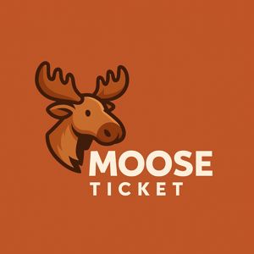

# MooseTicket Inc.

## MooseTicket Cookie Policy

# 1. USE OF COOKIES

We use cookies for performance, preferences, and analytics. Essential cookies cannot be disabled.

# 2. THIRD-PARTY COOKIES

Services like Google Analytics may place their own cookies.

# 3. CONTROL

You may disable cookies in your browser, though the app may not function properly.

# 4. LIABILITY

We are not responsible for third-party cookie behavior.

# 5. UPDATES

Policy will be updated periodically.