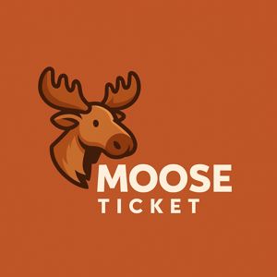

# MooseTicket Inc.

## MooseTicket EULA

# 1. LICENSE GRANT

Limited, revocable license for personal use. No resale or redistribution.

# 2. RESTRICTIONS

No reverse engineering or unauthorized data access.

# 3. NO WARRANTY

The app is provided 'as is' and we disclaim all implied warranties.

# 4. LIMITATION OF LIABILITY

We are not liable for any loss of data, income, or legal penalties arising from app use.

# 5. TERMINATION

Your license ends upon violation. We may suspend or restrict access without liability.

# 6. GOVERNING LAW

Ontario law or your U.S. state applies. Binding arbitration required.

# 7. CONTACT

support@mooseticket.com